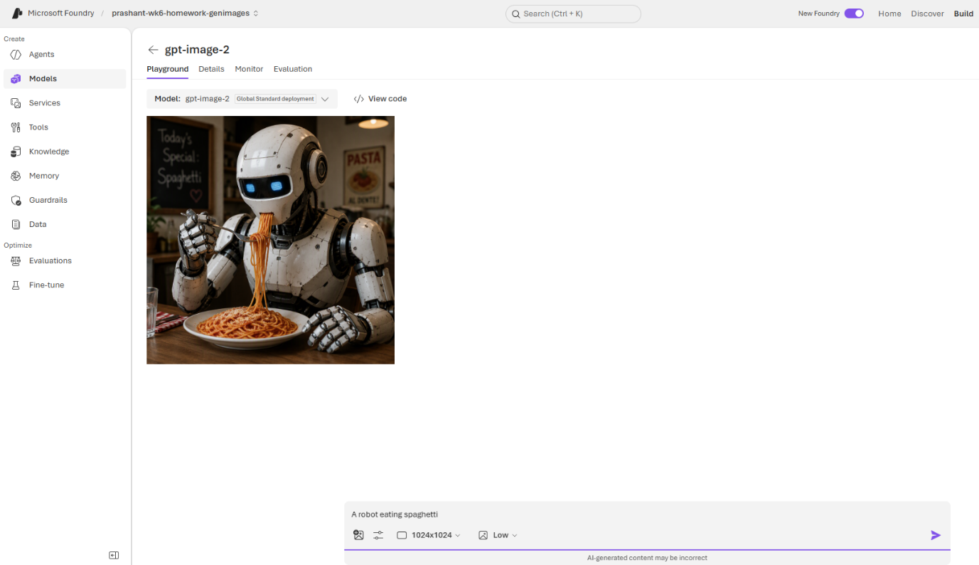
- A robot eating spaghetti

2. Show the robot in a restaurant
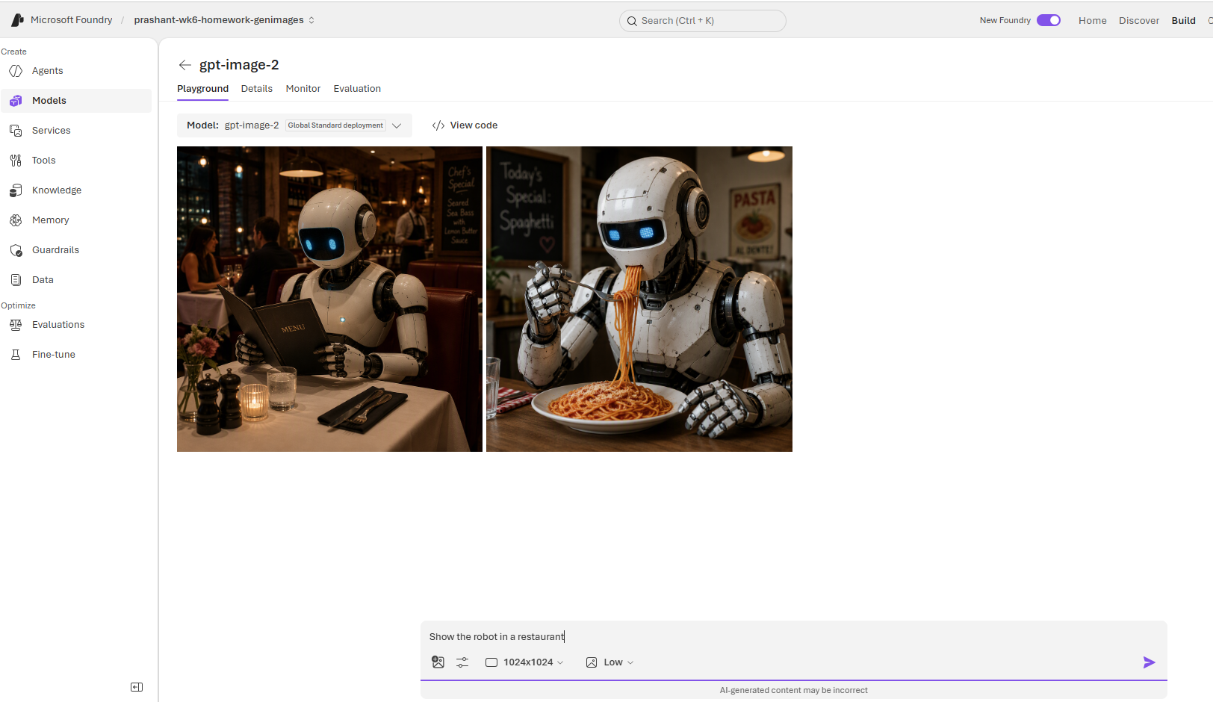

3. A robot eating spaghetti.Show the robot in a restaurant
