A synopsis for

**Developing the Social Networking Site.**

Orchid International College

Submitted Date: 2016, July 8th

Submitted By: Submitted To:

Prason Ghimire Department of Management

Roll: 17(5889/14) **Orchid Int’l College**

Sec: B **Bijayachowk, gaushala**

**Abstract**

This project is about the procedure and work performed for the development of the Online Social Networking Site named “surfZone”.

The conceived system is meant for connecting the people around the globe through the friendly interface where the client will be interacting through the given interface. The system will allows for sharing the thoughts and their daily event to keep others updated and self updating about the outside world as well.

The security of the every connected client’s information like contact number, friend lists, transferred information, emails, and so on, won’t be leaked to any other third party entity, until and unless they allow for it by storing it under the database system.

This social networking system will also have an ability of message transferring and attachment sharing of the limited size and extension.

Table of Contents

**1. Problem of Statement 4**

**2. Designing and development tools: 4**

**2.1 Front-end technology: 4**

**2.2 Back-end technology: 4**

**3. System modules:………………………………………………………………………….5**

**4. Database schema 5**

**5. Schema designing using ER-Model (surfZone) 8**

**6. Relational Table(surfZone) 9**

1. **Problem of Statement**

The main object of building this system is for the connecting people through the internet which has been proven the cost effective way for distant communication. The connected client will be able to transfer the text messages, upload images, transfer the other supported attachment as the means of communication. So this system will provide the client with the virtual platforms so sharing the news, views, thoughts and information.

1. **Designing and development tools:**

The needed designing and development tools support for the the system are broadly categorize as the Front-end and Back-end technology.

2.1 **Front-end technology:** The need front end system for developing this system are:

1. **HTML:** I had follow the syntax and rules of the HTML5 for the structuring the layout of the website. Using the HTML5 hybrid layout has been embedded in this system.
2. **CSS:** CSS tool’s syntax has been used for the decoration and presentation of the web contents.
3. **PHP:** PHP version 5 syntax and script rules has been followed for defining the operation in the system and allowing the dynamic content appearance.

Besides, the developers will require the complete server supported system with the database attached with it to design the system. This system will be developed via the plain text Editor (Notepad++ v 6.9) using the necessary scripting and markup language on Microsoft window based operating system.

2.2  **Back-end technology:** The need front end system for developing this system are:

1. **MySQL:** MySQL version 6.1 has been used to process the database queries embedded in the PHP script.
2. **Data dictionary:** Data dictionary implemented with the database system is used to keep track of the every records, schema definition used in the system so as to control for the authorized access, efficient query processing as per the user request.
3. **Server(Apache) :** The necessary data and scripts will be on the server system. Apache is supported web server for this system. Server will process the user request for the specific web page to response with the appropriate page script as response.
4. **System modules:**
   1. **Log-In page :**  This particular interface will allow for the user to enter the social network. It will act as the entrance gate that will only allow the authorized user to enter the social network. Access will be granted via the User-Name and Password verification.

Besides, for new account, users will have option for signing up for the new account by providing some of the specified detail about them like name, DOB, password, email, phone, address and like. In brief, this section will consist of the web form to collect the user information.

* 1. **Home page:**  This particular interface will be the first page to display after the log in where the user will see the shared files, post, and other attachment from their friend circle.
  2. **Profile :** This particular interface will consist of the every such details about the users that was provided during the sign-up process. In case of some updated information it will be shown accordingly.
  3. **Message :** This particular interface will allows the users to share the news, views, thought, and other information to specific friend only as the personal message. In brief, it is the personal messaging section.
  4. **File upload module:** This module will consist of the script that will allows for uploading the files and other attachment by the users. Besides, for upload only some specific file format and with some limited size will be allowed.
  5. **Validation module:** This module include the separate PHP script through which every input provided by the user will be validated so that they meet every defined domain, integrity and other constraints. The main purpose for this module is to restrict any kind of the lavish user or data to enter the developed system environment. Validation will also be done for the log-in module and file upload module.

1. **database Schema :**  The schema definition along with the data types and other properties of the tables that is to be stored in the database is as presented below along with some other constraints that will be used in the designing process of the system.

**users table**

|  |  |  |  |  |  |
| --- | --- | --- | --- | --- | --- |
| Fields | Type | Null | Key | Default | Extra |
| userId  DOB  Gender  firstName  lastName | Bigint  Date  Enum  Varchar(15)  Varchar(15) | No  No  No  No  No | Pri | NULL  NULL  NULL  NULL  NULL | Auto_increment |

**status table**

|  |  |  |  |  |  |
| --- | --- | --- | --- | --- | --- |
| Fields | Type | Null | Key | Default | Extra |
| statusId  content  userId | Bigint  Varchar(300)  Bigint | NO  NO  NO | PRI  MUL | NULL  NULL  NULL | Auto_increment |

**files table**

|  |  |  |  |  |  |
| --- | --- | --- | --- | --- | --- |
| Fields | Type | Null | Key | Default | Extra |
| fileId  filename  fileSize  extension  uploadTime  userId | Bigint  Varchar(20)  Int  Varchar(5)  Datetime  Bigint | NO  NO  NO  NO  NO  NO | PRI  MUL | NULL  NULL  NULL NULL  NULL  NULL | Auto_increment |

**messages table**

|  |  |  |  |  |  |
| --- | --- | --- | --- | --- | --- |
| Fields | Type | Null | Key | Default | Extra |
| messageId  description  userId | Bigint  Varchar(300)  Bigint | NO  NO  NO | PRI  MUL | NULL  NULL  NULL | Auto_increment |

**phone table**

|  |  |  |  |  |  |
| --- | --- | --- | --- | --- | --- |
| Fields | Type | Null | Key | Default | Extra |
| cellNo  home  work  userId | Bigint  Bigint  Bigint  Bigint | NO  NO  NO  NO | PRI  MUL | NULL  NULL  NULL NULL | Auto_increment |

**update table**

|  |  |  |  |  |  |
| --- | --- | --- | --- | --- | --- |
| Fields | Type | Null | Key | Default | Extra |
| userId  statusId  updateTime | Bigint  Bigint  Datetime | NO  NO  NO | MUL  MUL | NULL  NULL  NULL |  |

**uploads table**

|  |  |  |  |  |  |
| --- | --- | --- | --- | --- | --- |
| Fields | Type | Null | Key | Default | Extra |
| userId  fileId  uploadTime | Bigint  Bigint  Date | NO  NO  NO | MUL  MUL | NULL  NULL  NULL |  |

**post table**

|  |  |  |  |  |  |
| --- | --- | --- | --- | --- | --- |
| Fields | Type | Null | Key | Default | Extra |
| userId  messageId  recTime  sentTime | Bigint  Bigint  Date  Date | NO  NO  NO  NO | MUL  MUL | NULL  NULL  NULL  NULL |  |

**friends table**

|  |  |  |  |  |  |
| --- | --- | --- | --- | --- | --- |
| Fields | Type | Null | Key | Default | Extra |
| friendId  fren_name  fren_age  fren_type  fren_gender  friendshipTime  userId  messageId  fileId | Bigint  Varchar(30)  Int  Enum  Enum  Int  Bigint  Bigint  Bigint | NO  NO  NO  NO  NO  NO  NO  NO  NO | PRI  MUL  MUL | NULL  NULL  NULL  NULL NULL  NULL  NULL  NULL  NULL | Auto_increment |

**makes table**

|  |  |  |  |  |  |
| --- | --- | --- | --- | --- | --- |
| Fields | Type | Null | Key | Default | Extra |
| userId  friendId  status | Bigint  Bigint  Enum | NO  NO  NO | MUL  MUL | NULL  NULL  NULL |  |

# Schema designing using ER-Model (surfZone)

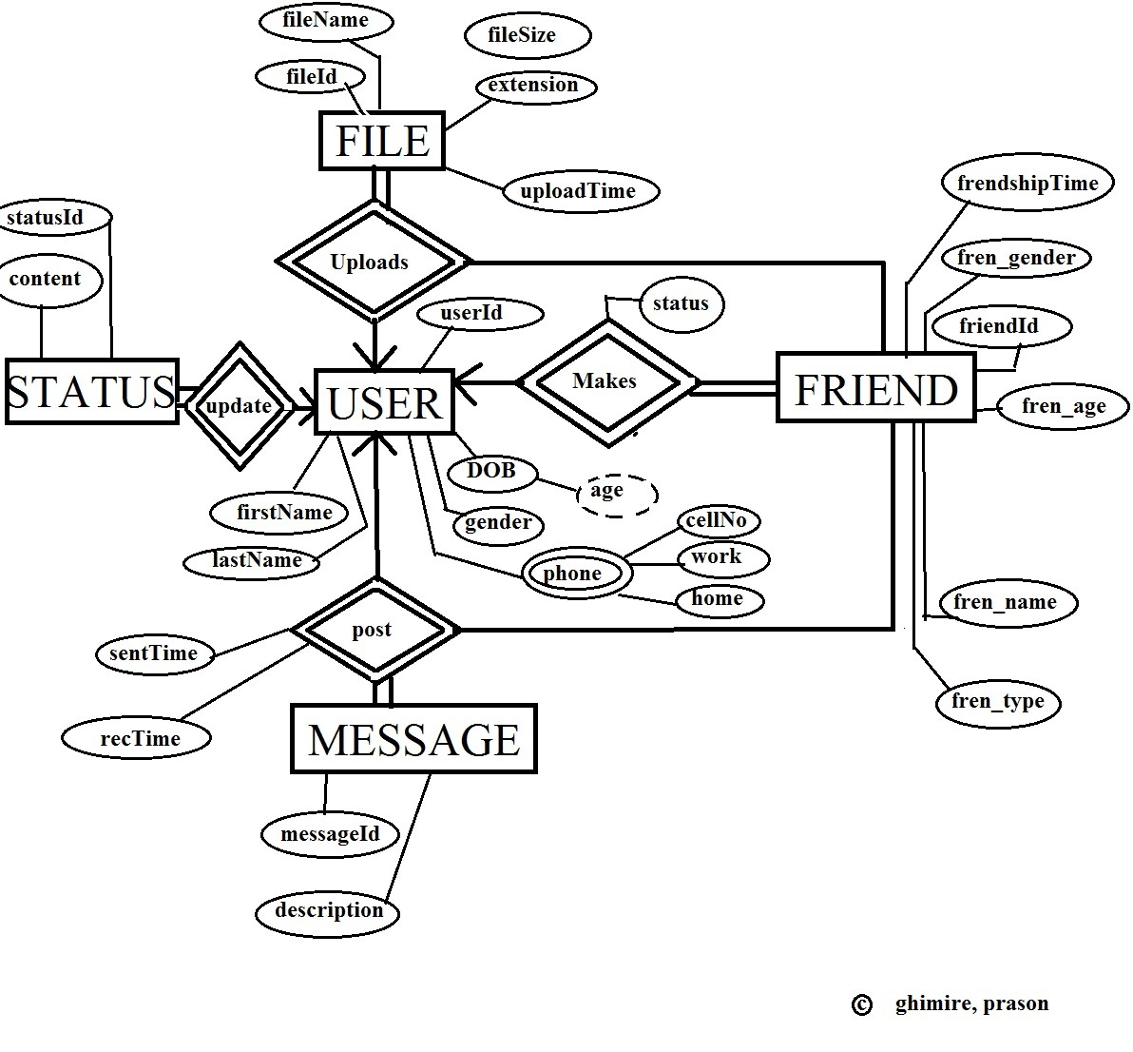

# Relational Table(surfZone)

