Definition:

<http://www.techburps.com/cassandra/what-is-apache-cassandra/56/>

download

<http://www.apache.org/dyn/closer.lua/cassandra/3.0.15/apache-cassandra-3.0.15-bin.tar.gz>

unzip 🡪 conf 🡪 Cassandra.yaml

change cluster name

Add datafile directory

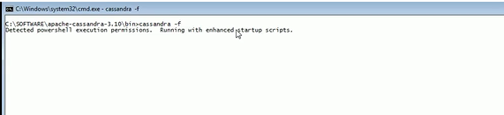

Status

