* pip3 install --upgrade pip
* pip3 install jupyter

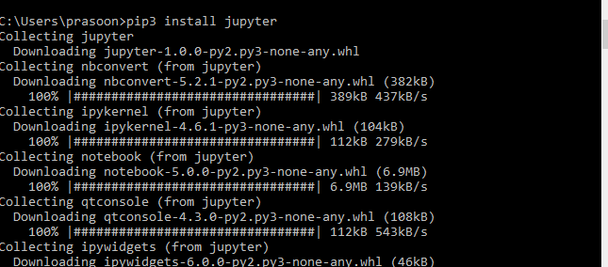

jupyter notebook