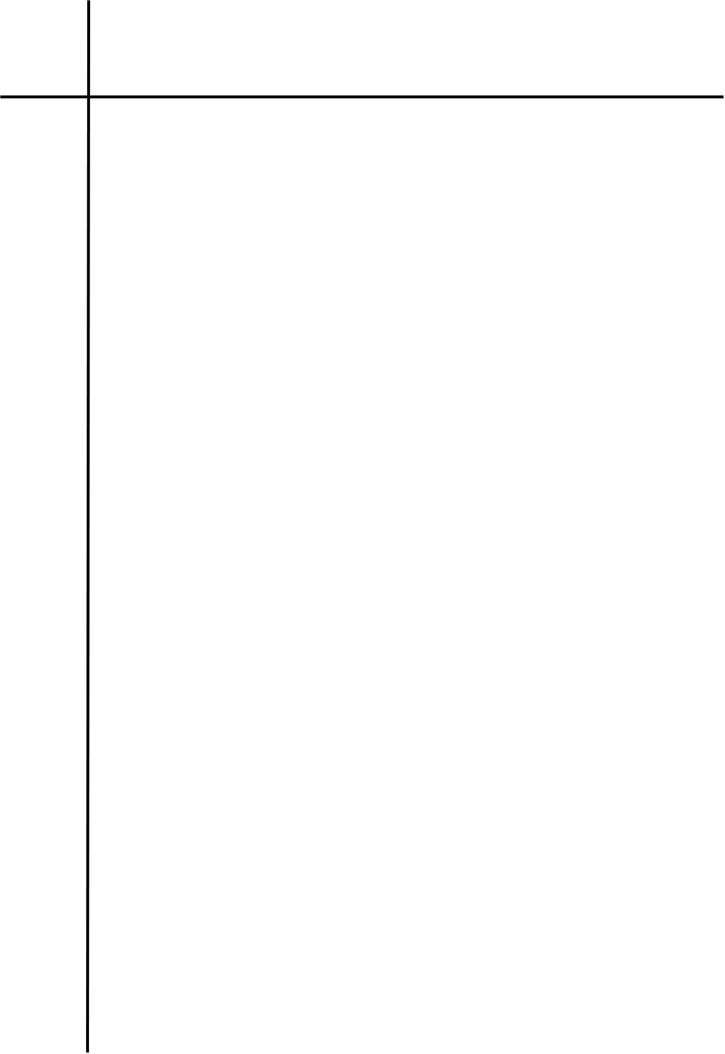
Source Code

#LAB 3.4 Regular Expression for Identifying the Structure of Input (a+b)*aa(a+b)*
import re

def identify(str):
pattern=r"^[ab]*aa[ab]*$"

return re.fullmatch(pattern,str)

str=input("Enter a string to test: ")
if identify(str):
print("Accepted")
else:
print("Rejected")

Output
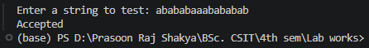
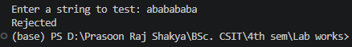

Conclusion
The program successfully implements the regular expression (a+b)*aa(a+b)* over the alphabet {a,b}. It accepts strings containing aa and rejects strings that do not satisfy the required structure.

