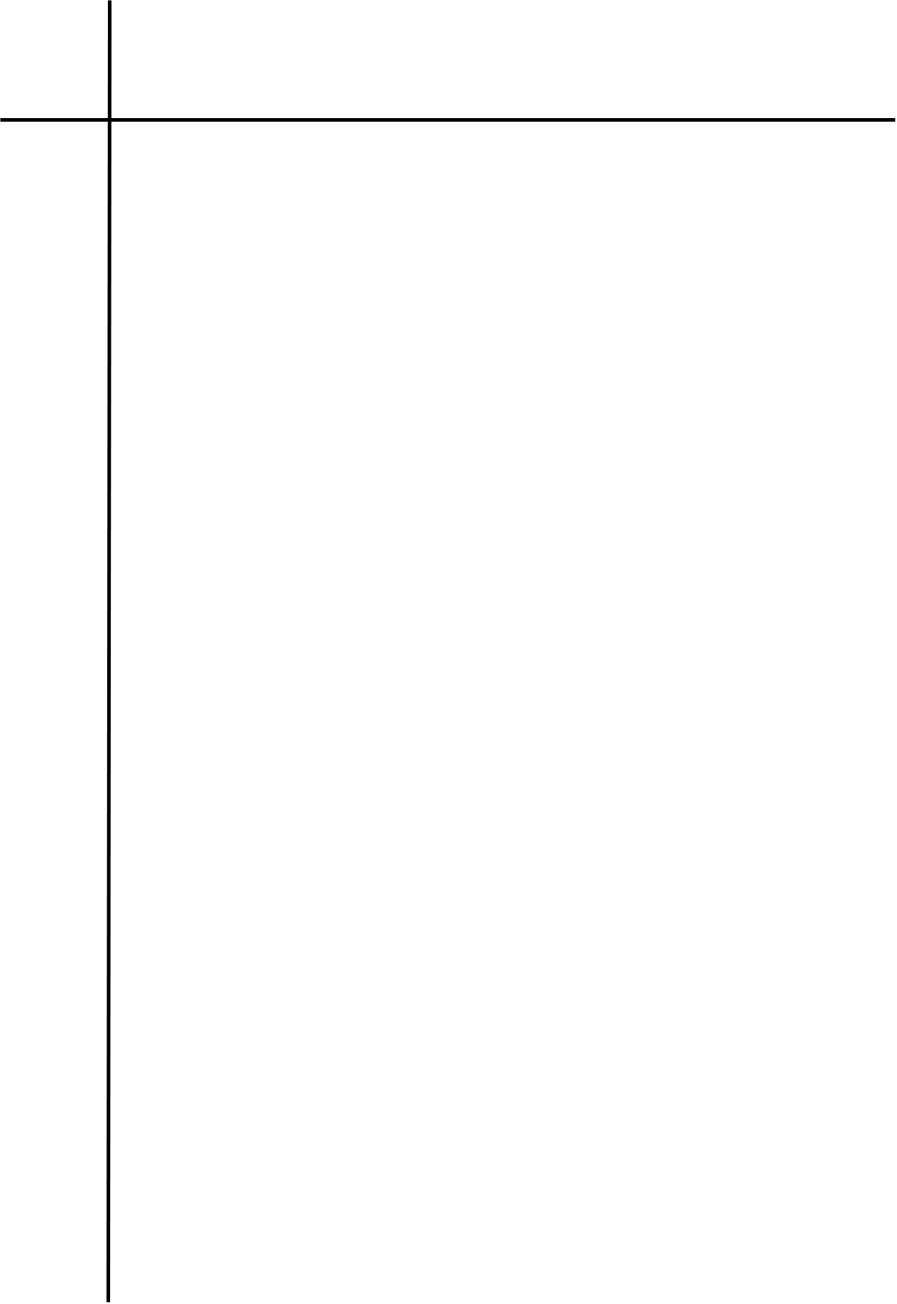
Source Code
# PDA (Pushdown Automaton) for L = { a^n b^n | n >= 0 } over {a, b}
Z0 = "$"
A = "A"

def pda(string: str) -> bool:
stack = [Z0]
state = "q0"

print(f"{'Symbol':<8}{'State':<8}Stack (top -> bottom)")
print(f"{'-':<8}{'q0':<8}{''.join(reversed(stack))}")

for ch in string:
top = stack[-1]

if state == "q0":
if ch == "a":
stack.append(A)
elif ch == "b":
if top != A:
return False
stack.pop()
state = "q1"
else:
print(f"Invalid symbol: {ch!r}")
return False

elif state == "q1":
if ch == "b":
if top != A:
return False
stack.pop()
else:
return False

print(f"{ch:<8}{state:<8}{''.join(reversed(stack))}")

return len(stack) == 1 and stack[0] == Z0

s = input("Enter a string over {a, b}: ")

if pda(s):
print("\nAccepted")
else:
print("\nRejected")

Output
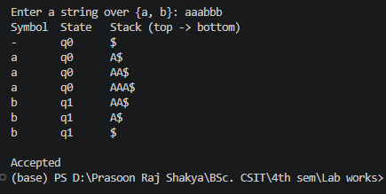
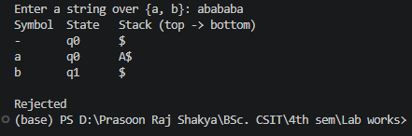

Conclusion
The program successfully implements a PDA that accepts strings of the form aⁿbⁿ with equal numbers of as followed by bs. It rejects strings with unequal numbers or an incorrect ordering of symbols.

