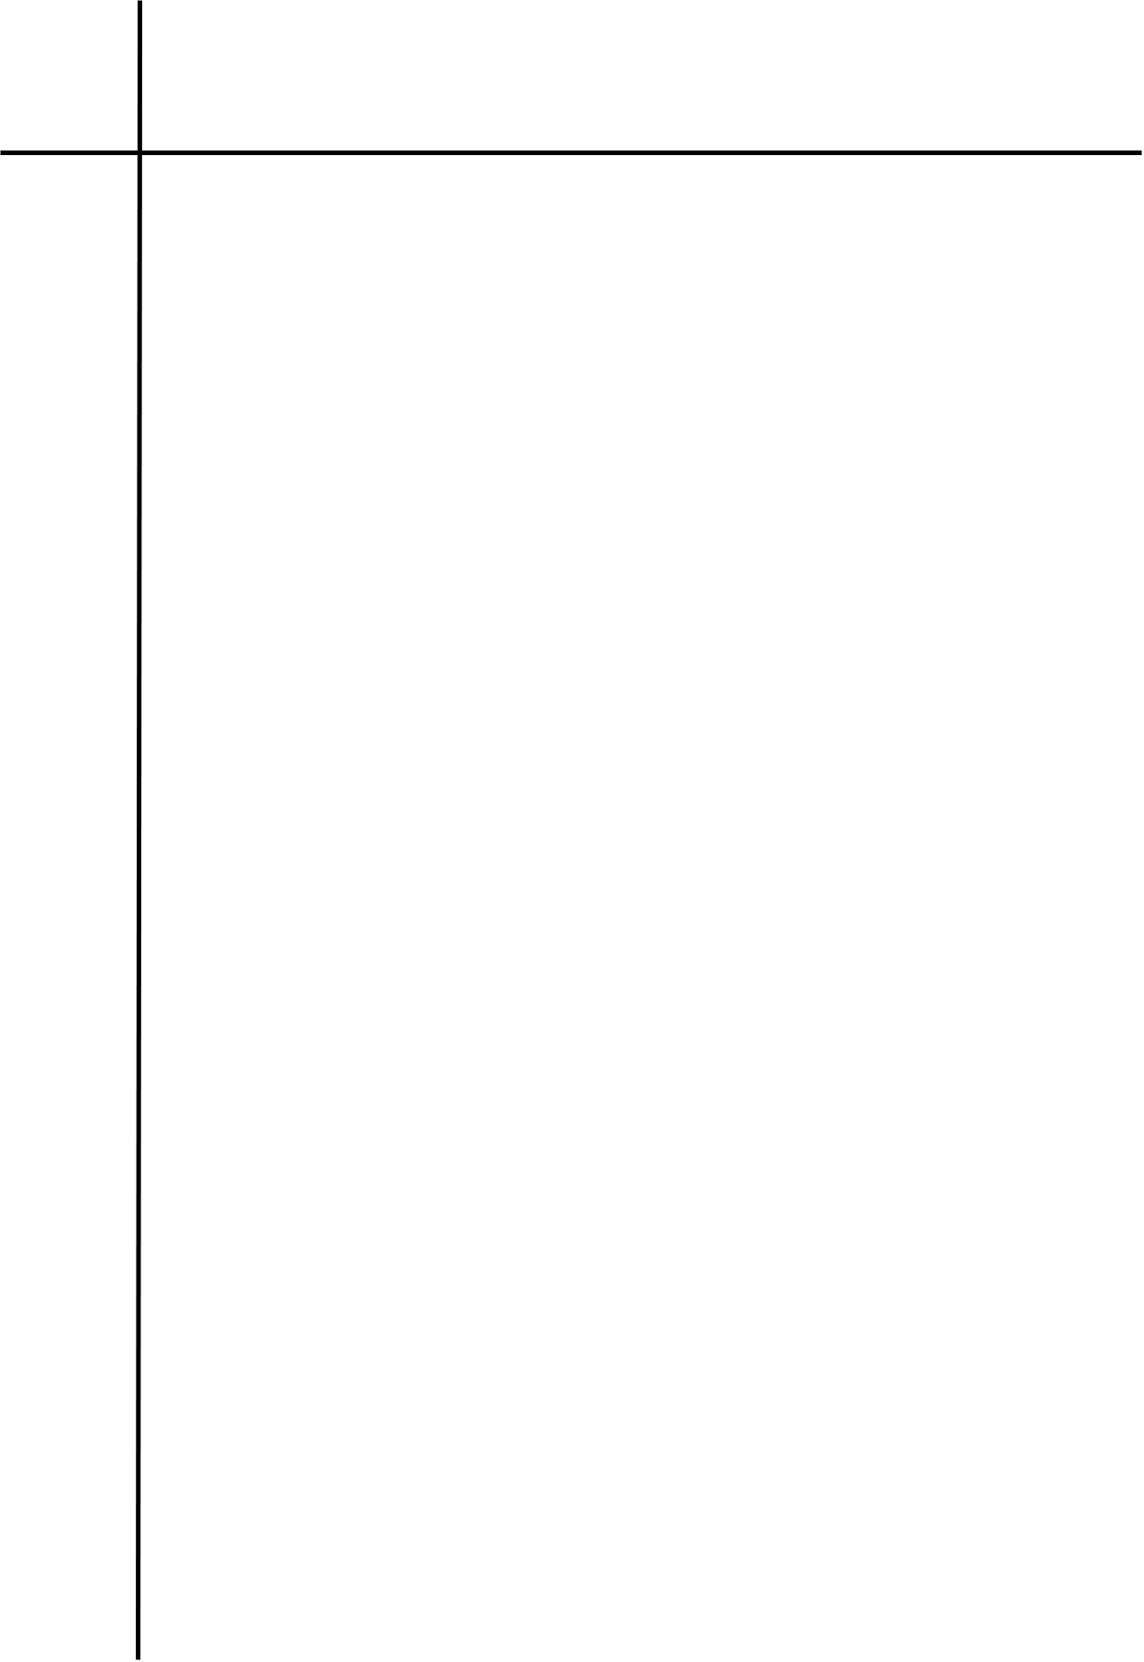
Source Code
# Turing Machine (TM) for L = { a^n b^n c^n | n >= 1 } over {a, b, c}
def turing_machine(string: str) -> bool:
tape = list(string)
head = 0

if not tape or any(ch not in "abc" for ch in tape):
return False

print(f"Input : {string}")
print(f"Start : {''.join(tape)}")
pass_no = 0

while True:
head = 0
while head < len(tape) and tape[head] == "X":
head += 1

if head == len(tape) or tape[head] != "a":
break

tape[head] = "X"

head += 1
while head < len(tape) and tape[head] in ("a", "X", "Y"):
head += 1
if head >= len(tape) or tape[head] != "b":
return False
tape[head] = "Y"

head += 1
while head < len(tape) and tape[head] in ("b", "Y", "Z"):
head += 1
if head >= len(tape) or tape[head] != "c":
return False
tape[head] = "Z"

pass_no += 1
print(f"Pass {pass_no}: {''.join(tape)}")

if any(ch in "abc" for ch in tape):
return False
return True

string = input("Enter a string over {a, b, c}: ")

if turing_machine(string):
print("\nAccepted")
else:
print("\nRejected")

Output
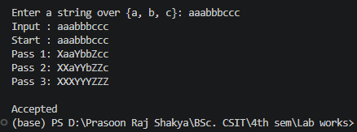
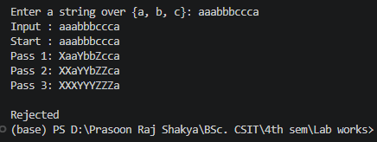

Conclusion
The program successfully simulates a Turing Machine that verifies equal numbers of a, b, and c in the required order. It accepts strings belonging to aⁿbⁿcⁿ and rejects strings with unequal counts or incorrect symbol ordering.

