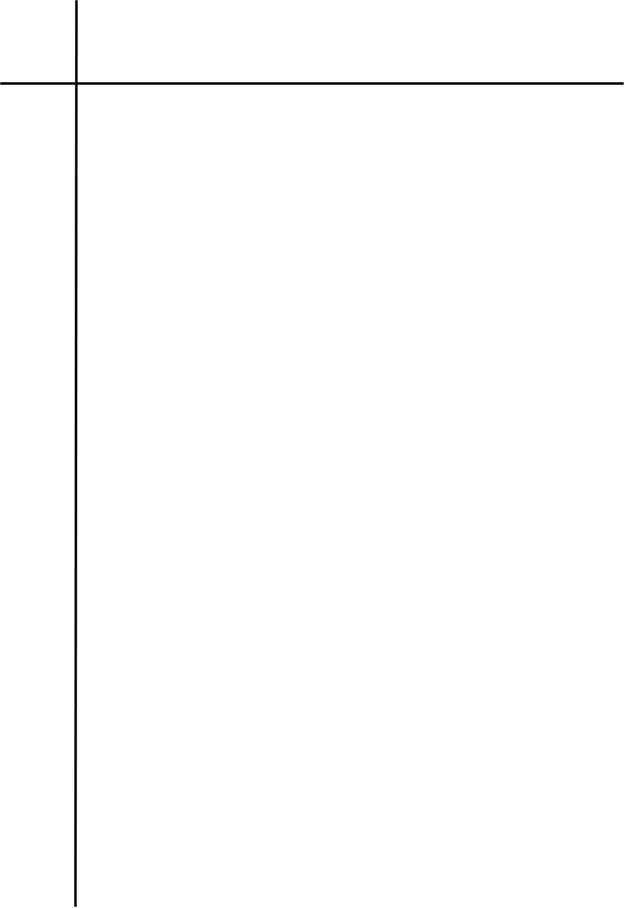
Source Code

#LAB 3.2 Implement Program that identifies valid Gmail.
import re

gmail_pattern = r"^[a-z0-9](\.?[a-z0-9]){5,29}@g(oogle)?mail\.com$"

email = input("Enter a mail: ")

email = email.strip().lower()

if re.fullmatch(gmail_pattern, email):
print("valid gmail address")
else:
print("invalid gmail address")




Output
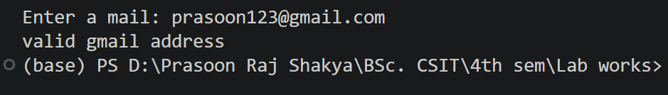
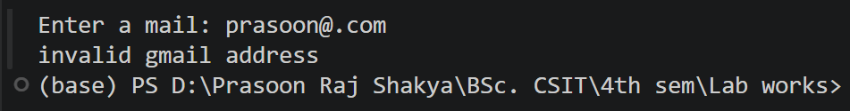

Conclusion
The program successfully validates whether an input follows the specified Gmail address pattern. Regular expressions provide an efficient method for checking the required email format. Thus, valid and invalid Gmail addresses can be identified successfully.

