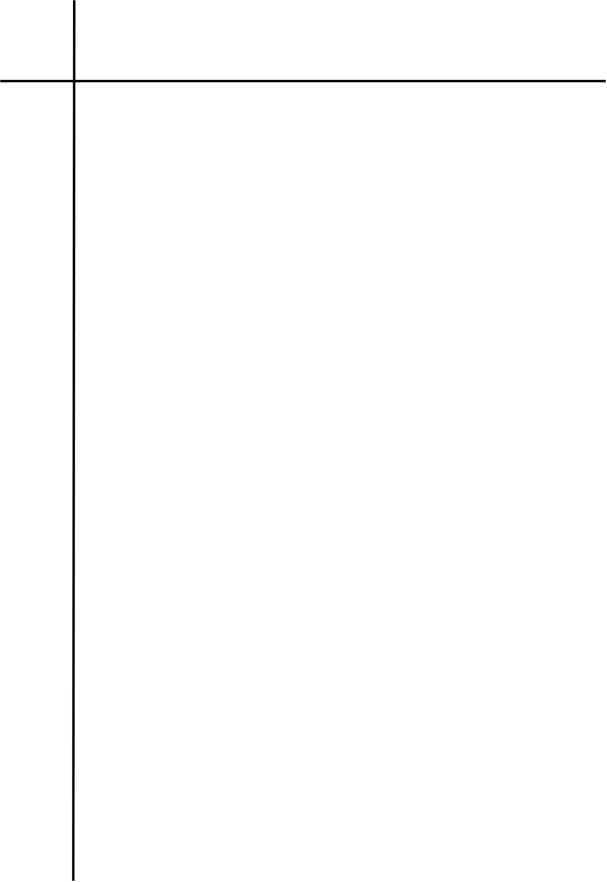
Source Code

#LAB 3.3 Implement Program that identifies valid MAC address
import re

def validMAC(string: str) -> bool:
pattern = r"^([0-9A-Fa-f]{2}[-:]){5}([0-9A-Fa-f]{2})$"

return re.fullmatch(pattern, string)

mac = input("Enter MAC address to check: ")
if validMAC(mac):
print("Valid MAC address")
else:
print("Invalid MAC address")




Output
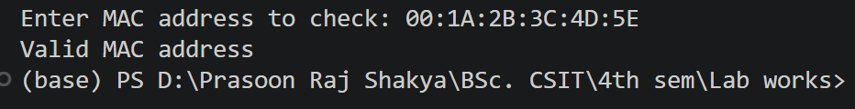
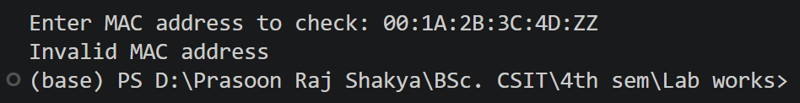

Conclusion
The program successfully identifies whether an input string follows the specified MAC address format. Regular expressions provide an efficient method for validating hexadecimal groups and separators. Thus, valid and invalid MAC addresses can be identified successfully.

