In [1]:

*#####*

*# AUTHOR: Prastab Dhakal # FILENAME: main.py*

*# SPECIFICATION:*

*# To prepare a dataset for analysis, to build and evaluate a model using logistic regre # make 5 logistic regression models and train with 70-30 and 60-40 train-test set,*

*# find the best model to perform prediction on whole dataset, # analyze with ROC curve, PR Curve and cross validation.*

*# FOR: CS 4331 Machine Learning and Information Security Section 001 #####*

In [2]:

**import** pandas **as** pd **import** numpy **as** np **import** seaborn **as** sns

**import** matplotlib.pyplot **as** plt

**from** sklearn.model_selection **import** train_test_split **from** sklearn.linear_model **import** LogisticRegression **from** sklearn **import** metrics

**from** sklearn.model_selection **import** KFold

**from** sklearn.model_selection **import** cross_val_score

**from** sklearn.model_selection **import** cross_val_predict

In [3]:

*# The function reads the given file from path and stores in datafile dataframe # datafile : A datafile dataframe containing attributes from A1 to a8*

datafile **=** pd**.**read_csv('datafile.csv')

In [4]:

*#plotting entire dataframe using pandas scatter_matrix*

pd**.**plotting**.**scatter_matrix(datafile) plt**.**show()

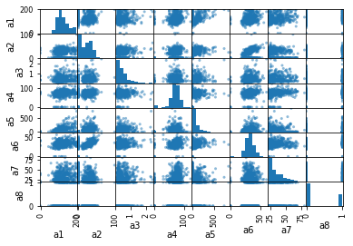

In [5]:

*#plotting 4 columns at a time using pandas scatter_matrix*

**for** i **in** range (5):

df **=**datafile**.**iloc[:,[i,i**+**1,i**+**2,i**+**3]] *#select everything from columns i,i+1,i+2,i+3]*

pd**.**plotting**.**scatter_matrix(df) plt**.**show()

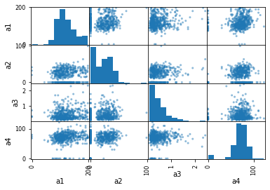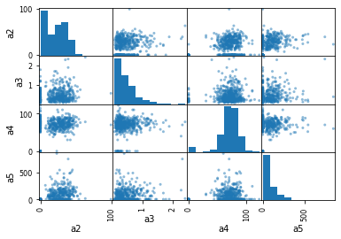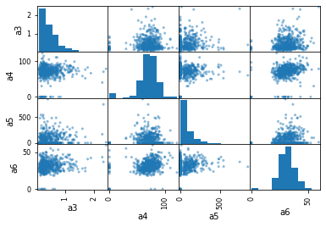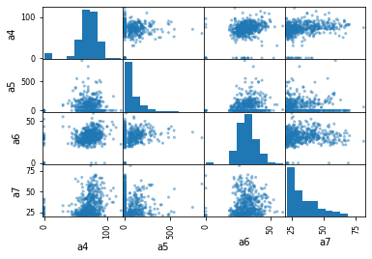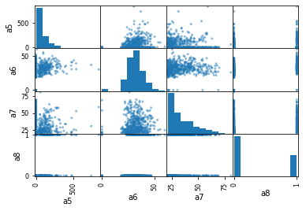

In [6]:

*# barplot between a1 and a2 column with blue color palette* sns**.**barplot(x**=**"a1", y**=**"a2", data**=**datafile,palette**=**"Blues_d") plt**.**show()

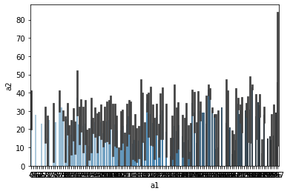

In [7]:

*# snsdata contains data of 4 features of datafile*

snsdata **=** datafile[['a1','a2','a3','a4']] g **=** sns**.**PairGrid(snsdata) *#pairing*

g**.**map(sns**.**scatterplot) *#scatterplot*

plt**.**show()

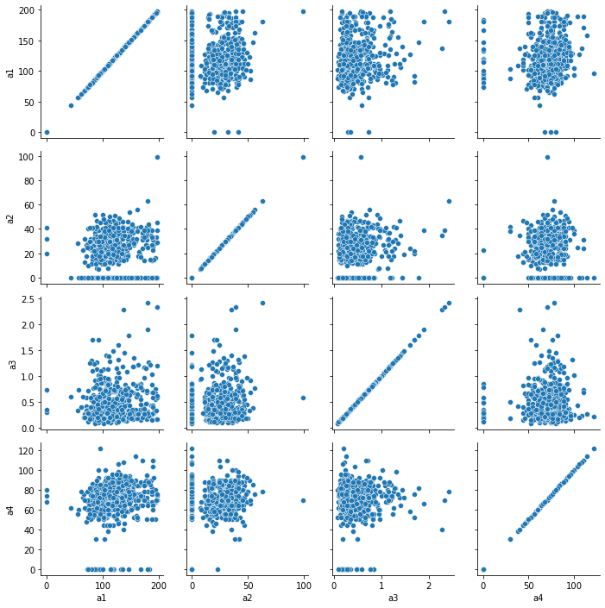

In [8]:

*# snsdata contains data of 4 features of datafile*

snsdata **=** datafile[['a5','a6','a7','a8']] g **=** sns**.**PairGrid(snsdata) *#pairing* g**.**map(sns**.**scatterplot) *#scatterplot* plt**.**show()

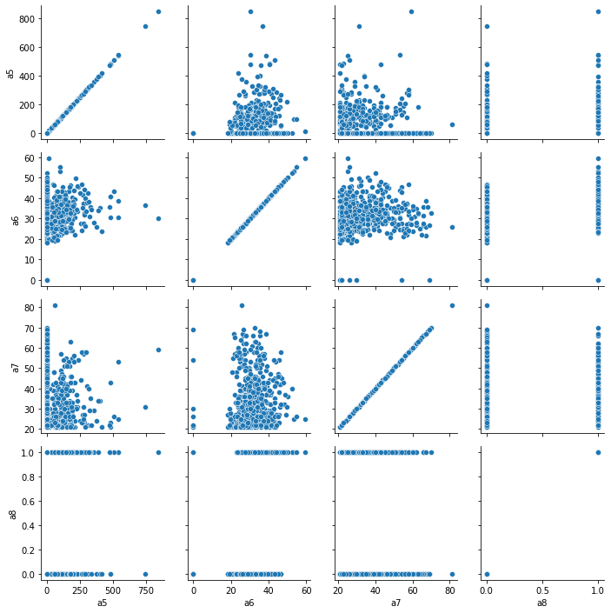

In [9]:

*# extract the column a8 contents from dataframe and convert to numpy array*

df_a8 **=** pd**.**DataFrame(data**=**datafile,columns**=**['a8']) df_a8**.**to_numpy()

print("The number of 0's in a8 column is", np**.**count_nonzero(df_a8 **<** 1)) print("The number of 1's in a8 column is", np**.**count_nonzero(df_a8 **==**1))

print("The difference between number of 0's and number of 1's in a8 column is", np**.**coun

In [10]:

The number of 0's in a8 column is 326 The number of 1's in a8 column is 174

The difference between number of 0's and number of 1's in a8 column is 152

*# Make a new dataframe by selecting randomly 150 of the rows where a8=1 and 150 of the*

*#a dataframe df of elements from datafile dataframe*

df**=** datafile

*# #separate dataframe allzero_df that has a8 colum with value 0*

allzero_df **=** df**.**loc[df['a8'] **==** 0]

*# #separate dataframe allone_df that has a8 colum with value 1*

allone_df **=**df**.**loc[df['a8'] **==** 1]

*# # #150 random sampled dataframe stored in rzero150_df from dataframe allzero_df*

rzero150_df **=** allzero_df**.**sample(n**=**150)

*# # #150 random sampled dataframe stored in rone150_df from dataframe allone_df*

rone150_df **=** allone_df**.**sample(n**=**150)

*#newdataframe with 300 data after appending rone150_df to rzero150_df*

newdataframe **=** rzero150_df**.**append(rone150_df) *#we will use this dataframe everywhere*

In [11]:

*####*

*# NAME: my_logreg_training_model*

*# PARAMETERS: attributeList,targetAttributeList,test_size*

*# PURPOSE: The function is a logistic regression training model and trains and tests da # PRECONDITION: must send all parameters, attributeList as a list of attribute/features # POSTCONDITION: accuracy,attributeList,targetAttributeList values are returned so that ####*

**def** my_logreg_training_model(attributeList,targetAttributeList,test_size):

train, test **=** train_test_split(newdataframe,test_size**=**test_size,random_state **=** 7)

*#split the training set into the X attributes and Y target attribute*

X_train **=** pd**.**DataFrame(train[attributeList]) Y_train **=** pd**.**DataFrame(train[targetAttributeList]) *#enable the logistic regression model*

logreg **=** LogisticRegression(max_iter**=**5000)

*#build the logistic regression model*

res **=** logreg**.**fit(X_train,Y_train**.**values**.**ravel()) *#Y transformed to 1-d array from*

print("\nCoefficients: ",res**.**coef_)

*#split the test set into the X attributes and Y target attribute*

X_test **=** pd**.**DataFrame(test[attributeList]) Y_test **=** pd**.**DataFrame(test[targetAttributeList]) *#predict the y value on the test set*

y_pred **=** logreg**.**predict(X_test)

*#construct a confusion table*

table **=** metrics**.**confusion_matrix(test[targetAttributeList]**.**to_numpy(),y_pred,labels print("\nConfusion Table")

print(table)

*#calculate the true positive rate*

*#set tpr to the true positive rate TP/(TP+FN) using tab*

tpr **=** table[0,0]**/**(table[0,0]**+**table[1,0])

*#calculate the true negative rate*

*#set tnr to the true negative rate TN/(TN+FP) using tab*

tnr **=** table[1,1]**/**(table[1,1]**+**table[0,1])

*#calculate the accuracy (TP+TN)/(TP+TN+FP+FN)*

accuracy **=** (table[0,0]**+**table[1,1])**/**(table[0,0]**+**table[1,1]**+**table[0,1]**+**table[1,0])

*#set accuracy using table*

print("\naccuracy = ",accuracy)

**return** accuracy,attributeList,targetAttributeList

In [12]:

*# maxAccuracy : a variable to store the maximum accuracy of the curent model*

maxAccuracy **=** 0

*# maxAttributeList : a list to store Attribute list of the model with maximum accuracy*

maxAttributeList **=** []

*# maxTargetAttributeList : a list to store Attribute list of the model with maximum acc*

maxTargetAttributeList **=** []

In [13]:

*####*

*# NAME: my_complete_model # PARAMETERS: none*

*# PURPOSE: The function is run to perform all the tasks. All the functions and calculat*

*# PRECONDITION: must be called to execute # POSTCONDITION: expect overall result ####*

**def** my_complete_model():

**global** maxAccuracy,maxAttributeList,maxTargetAttributeList

*####*

*# NAME: store_attribute_result*

*# PARAMETERS: Maxaccuracy, accuracy,attributeList,targetAttributeList*

*# PRECONDITION: must send all parameters,maximum accuracy as Maxaccuracy, current a # POSTCONDITION: maxAccuracy,attributeList,targetAttributeList values are globally ####*

**def** store_attribute_result(Maxaccuracy, accuracy,attributeList,targetAttributeList)

**global** maxAccuracy,maxAttributeList,maxTargetAttributeList

*# update and set all parameters, if value of maxaccuracy is less than or equal*

**if** Maxaccuracy **<=** accuracy: maxAccuracy**=** accuracy maxAttributeList **=** attributeList

maxTargetAttributeList **=** targetAttributeList

*####*

*# NAME: run_my_models*

*# PARAMETERS: test_size*

*# PURPOSE: The function is written to call the my_logreg_training_model on the set # PRECONDITION: must send test case in decimal, 0- 1, 0.3 represents 30%*

*# POSTCONDITION: accuracy,attributeList,targetAttributeList are updated for max acc ####*

**def** run_my_models(test_size):

*# print train-test split percentage*

print('With train-test ',100**-**test_size**\***100,'% - ',test_size**\***100,'%')

*#for 5 models*

*#call my_logreg_training_model and get and store accuracy,attributeList,targetA* accuracy,attributeList,targetAttributeList **=** my_logreg_training_model(['a1','a2 *#call store_attribute_result and send maxAccuracy, accuracy,attributeList,targe* store_attribute_result(maxAccuracy, accuracy,attributeList,targetAttributeList)

accuracy,attributeList,targetAttributeList **=** my_logreg_training_model(['a1','a2 store_attribute_result(maxAccuracy, accuracy,attributeList,targetAttributeList)

accuracy,attributeList,targetAttributeList **=** my_logreg_training_model(['a3','a4 store_attribute_result(maxAccuracy, accuracy,attributeList,targetAttributeList)

accuracy,attributeList,targetAttributeList **=** my_logreg_training_model(['a2','a5 store_attribute_result(maxAccuracy, accuracy,attributeList,targetAttributeList)

accuracy,attributeList,targetAttributeList **=** my_logreg_training_model(['a1','a3 store_attribute_result(maxAccuracy, accuracy,attributeList,targetAttributeList)

print('***********','End of',100**-**test_size**\***100,'% - ',test_size**\***100,'%', 'train

*#call run_my_models with test_size =.3 on 5 models*

run_my_models(test_size**=.**3)

*#again call run_my_models with test_size =.4 on 5 models*

run_my_models(test_size**=.**4)

print()

print('The best model has:') print('Accuracy: ',maxAccuracy) print('Attribute:',maxAttributeList)

print('Target Attribute:',maxTargetAttributeList) print()

print('***********','Running the best model in newdataframe','*****************')

*####*

*# NAME: best_logreg_model*

*# PARAMETERS: attributes,targetAttribute*

*# PURPOSE: The function will run the best logistic regression training model dynami # It gives us the confusion matrix, accuracy, roc curve, pr curve and cross validat # PRECONDITION: must send all parameters, attributes,targetAttribute and the datafr # POSTCONDITION: -*

*####*

**def** best_logreg_model(attributes,targetAttribute):

*#predict on newdataframe*

*#fill in statements to set X_attribute and Y_target_attribute* X_attribute **=** pd**.**DataFrame(newdataframe[attributes]) Y_target_attribute **=** pd**.**DataFrame(newdataframe[targetAttribute])

*#enable the logistic regression model* logreg **=** LogisticRegression(max_iter**=**5000) *#build the logistic regression model*

model **=** logreg**.**fit(X_attribute,Y_target_attribute**.**values**.**ravel()) *#Y transform*

print("\nCoefficients: ",model**.**coef_)

*#fill in statement to set y_pred_newdataframe using predict*

y_pred_newdataframe **=** logreg**.**predict(X_attribute)

table **=** metrics**.**confusion_matrix(newdataframe[targetAttribute]**.**to_numpy(),y_pre print("\nConfusion Table for newdataframe")

print(table)

*#calculate the true positive rate*

*#set tpr to the true positive rate TP/(TP+FN) using tab*

tpr **=** table[0,0]**/**(table[0,0]**+**table[1,0])

*#calculate the true negative rate*

*#set tnr to the true negative rate TN/(TN+FP) using tab*

tnr **=** table[1,1]**/**(table[1,1]**+**table[0,1])

*#calculate the accuracy (TP+TN)/(TP+TN+FP+FN)*

accuracy **=** (table[0,0]**+**table[1,1])**/**(table[0,0]**+**table[1,1]**+**table[0,1]**+**table[1,0]

*#set accuracy using table*

print("\naccuracy = ",accuracy)

*#ROC Curve: Receiver Operating Characteristic #construct the ROC curve*

y_pred_probability **=** logreg**.**predict_proba(X_attribute)[::,1]

fpr, tpr, _ **=** metrics**.**roc_curve(Y_target_attribute,y_pred_probability) auc **=** metrics**.**roc_auc_score(Y_target_attribute,y_pred_probability) plt**.**plot(fpr,tpr,label**=**"data, auc="**+**str(auc))

plt**.**xlabel('False Positive Rate') plt**.**ylabel('True Positive Rate') plt**.**title('ROC Curve') plt**.**legend(loc**=**4)

plt**.**show()

print("\n The value of AUC obtained from ROC Curve is", auc,"that means the are

*#construct the precision/recall curve*

prec, rec, _ **=** metrics**.**precision_recall_curve(Y_target_attribute,y_pred_probabi auc **=** metrics**.**auc(rec,prec)

plt**.**plot(rec,prec,label**=**"data, auc="**+**str(auc)) plt**.**xlabel('Recall')

plt**.**ylabel('Precision') plt**.**title('PR Curve') plt**.**ylim(0,1.1) plt**.**legend(loc**=**4) plt**.**show()

print("\n The precision-recall curve shows the tradeoff between precision and r

*#perform n-fold cross-validation with folds ####*

*# NAME: cross_validation # PARAMETERS: folds*

*# PURPOSE: The function will perform cross validation based on the folds sent, # PRECONDITION: must send all parameters, folds must be integer*

*####*

**def** cross_validation(folds): nfolds **=** folds

*#instance that splits a dataset into n folds, shuffles prior to the split,*

cv **=** KFold(n_splits**=**nfolds, random_state**=**1, shuffle**=True**)

scores **=** cross_val_score(logreg,X_attribute,Y_target_attribute,scoring**=**'acc

*#prediction values*

y_pred **=** cross_val_predict(logreg,X_attribute,Y_target_attribute,cv**=**cv,n_jo

*#construct confusion matrix*

table **=** metrics**.**confusion_matrix(newdataframe['a8']**.**to_numpy(),y_pred,label print("\nConfusion Table: ")

print(table) print("\nAccuracies: ",scores)

print("\nAverage Accuracy: ",np**.**mean(scores))

*#call cross_validation with folds = 5*

cross_validation(5)

*#call cross_validation with folds = 4*

cross_validation(4)

*#call best_logreg_model with maxAttributeList,maxTargetAttributeList as parameters*

best_logreg_model(maxAttributeList,maxTargetAttributeList)

*#Save the new dataframe to a file called “newdatafile.csv” (without a row name colu*

newdataframe**.**to_csv("newdatafile.csv",index**=False**)

In [14]:

*#program starts here #call my_complete_model* my_complete_model()

With train-test 70.0 % - 30.0 %

Coefficients: [[ 0.02345191 -0.00686067 0.50822297 -0.01321778 0.00055883 0.1222862

7

0.0243992 ]]

Confusion Table [[32 15]

[11 32]]

accuracy = 0.7111111111111111

Coefficients: [[0.0281411 0.01015791 0.54402168]]

Confusion Table

[[36 11]

[13 30]]

accuracy = 0.7333333333333333

Coefficients: [[ 0.46910636 -0.01095695 0.00202024 0.11928102 0.03937562]]

Confusion Table [[32 15]

[17 26]]

accuracy = 0.6444444444444445

Coefficients: [[0.00201696 0.00350088]]

Confusion Table [[25 22]

[20 23]]

accuracy = 0.5333333333333333

Coefficients: [[0.02520541 0.56598328 0.00183934 0.01544334]]

Confusion Table [[33 14]

[11 32]]

accuracy = 0.7222222222222222

*********** End of 70.0 % - 30.0 % train-test run ***************** With train-test 60.0 % - 40.0 %

Coefficients: [[ 0.02447322 -0.00540238 0.58829834 -0.00867462 -0.00087688 0.1316930

8

0.02255879]]

Confusion Table [[43 19]

[18 40]]

accuracy = 0.6916666666666667

Coefficients: [[0.02926076 0.01074265 0.61512115]]

Confusion Table [[44 18]

[16 42]]

accuracy = 0.7166666666666667

Coefficients: [[ 0.58464257 -0.00819144 0.0010373 0.12815586 0.03879217]]

Confusion Table [[43 19]

[26 32]]

accuracy = 0.625

Coefficients: [[0.00483837 0.00283567]]

Confusion Table [[33 29]

[26 32]]

accuracy = 0.5416666666666666

Coefficients: [[0.02691146 0.69360831 0.00090123 0.01426464]]

Confusion Table [[43 19]

[14 44]]

accuracy = 0.725

*********** End of 60.0 % - 40.0 % train-test run *****************

The best model has:

Accuracy: 0.7333333333333333

Attribute: ['a1', 'a2', 'a3'] Target Attribute: ['a8']

*********** Running the best model in newdataframe ***************** Coefficients: [[0.03224835 0.00465938 0.77837273]]

Confusion Table for newdataframe [[101 49]

[ 35 115]]

accuracy = 0.72

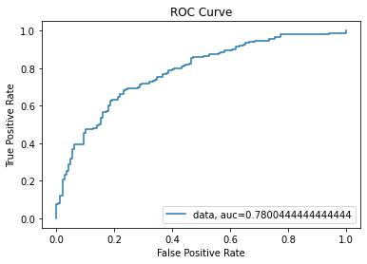

The value of AUC obtained from ROC Curve is 0.7800444444444444 that means the area unde r the curve is 0.7800444444444444 This means the model performs better than a random cla ssifier with AUC is equals to 0.5. The nearer the value of AUC to 1, the better it is. T he area under the curve also represents how well the model performs with the given thres hold

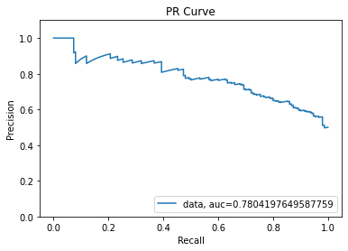

The precision-recall curve shows the tradeoff between precision and recall for differen t threshold. The value of AUC obtained from PR Curve is 0.7804197649587759 that means th e high value of this area signifies high value of precision and recall. The high value of precision and high value of recall signify that the classifier has low false positive rate and low false negative rate respectively.

Confusion Table:

[[ 98 52]

[ 35 115]]

Accuracies: [0.8 0.71666667 0.68333333 0.7 0.65 ]

Average Accuracy: 0.7100000000000001 Confusion Table:

[[ 99 51]

[ 38 112]]

Accuracies: [0.74666667 0.76 0.65333333 0.65333333]

Average Accuracy: 0.7033333333333334

In [16]:

*#Answer the following questions at the end of your script file using comments: # 1. Which train-test split worked best for you? 70-30 or another? Why?*

*# Answer: In the current run, among the 70 - 30 and 60 - 40 train-test split, the 70 -*

*# 2. Which logistic regression model worked best of the five you tried? Why?*

*# Answer: In the current run, among the five logistic regression model that we created*

*# 3. What does the resulting ROC curve tell you about the model?*

*# The value of AUC obtained from ROC Curve is 0.7800444444444444 that means the area u*

*# 4. What does the resulting PR curve tell you about the model.*

*# The precision-recall curve shows the tradeoff between precision and recall for differ*

*# 5. Which size fold worked the best? Why?*

*# The size fold of five work best for me than the size of four because it groups the da # If we use four folds our data would be 300/4 = 75 . Each It's time the model is train*

*#*

In [ ]: