MONGODB ASSIGNMENT- A

- Create a new database called student_management.

use student_management

- Create a collection called students in the student_management database.

db.createCollection("students")

3. Insert at least five student records into the students collection. Each record should have the following fields:
- student_id (integer)
- name (string)
- age (integer)
- department (string)
- courses (array of strings)
- grade (string)
db.students.insertMany([
- {
- student_id: 101,
- name: "Aman Sharma",
- age: 20,
- department: "Computer Science",
- courses: ["Database Systems", "Data Structures"],
- grade: "A"
- },
- {
- student_id: 102,
- name: "Riya Verma",
- age: 22,
- department: "Information Technology",
- courses: ["Web Development", "Operating Systems"],
- grade: "B"
- },
- {
- student_id: 103,
- name: "Karan Singh",
- age: 23,
- department: "Computer Science",
- courses: ["Database Systems", "Machine Learning"],
- grade: "A"
- },
- {
- student_id: 104,
- name: "Neha Gupta",
- age: 21,
- department: "Electronics",
- courses: ["Digital Systems", "Microprocessors"],
- grade: "C"
- },
- {
- student_id: 105,
- name: "Arjun Mehta",
- age: 24,
- department: "Computer Science",
- courses: ["Algorithms", "Database Systems"],
- grade: "D"
- }
- ])
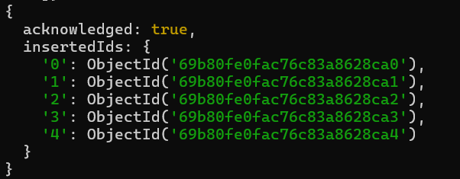
- Query the Collection:
Write queries to perform the following tasks:
- Retrieve all students who are in the "Computer Science" department
db.students.find({ department: "Computer Science" })
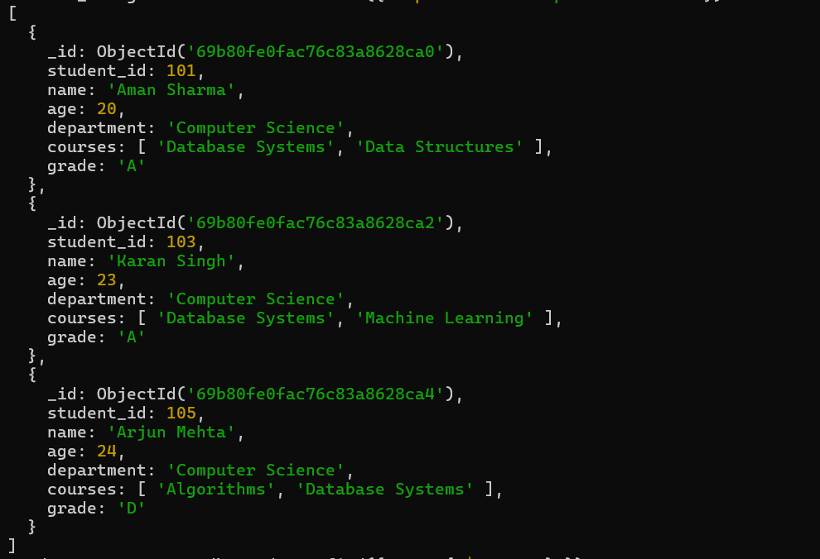

- Retrieve students who have an age greater than 21.

db.students.find({ age: { $gt: 21 } }
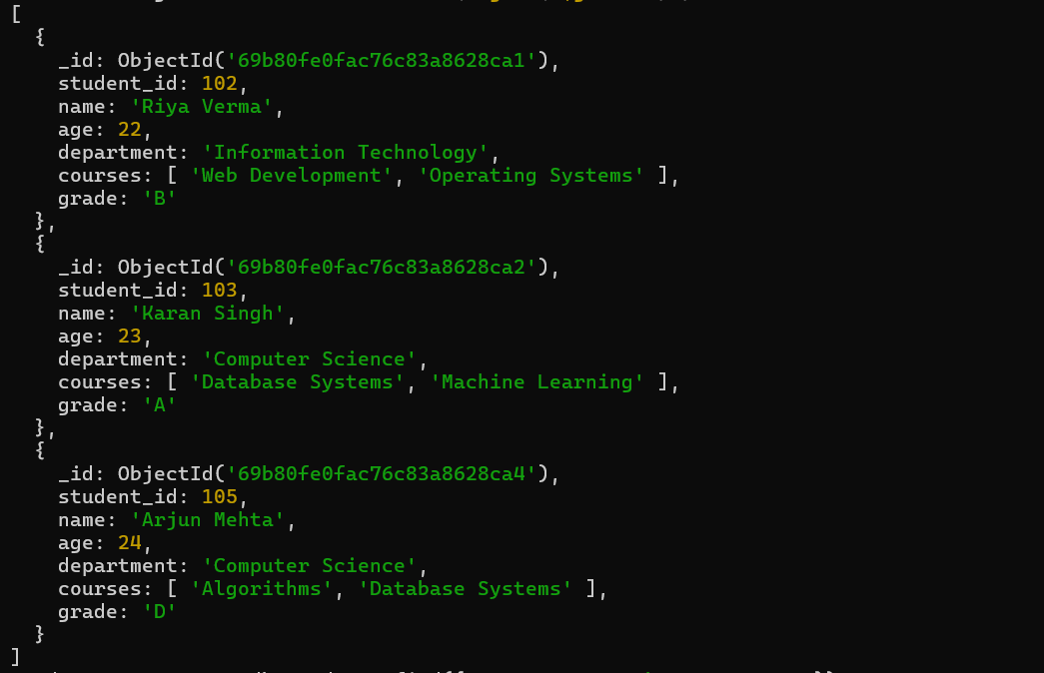

. Retrieve students who are taking the "Database Systems" course.

db.students.find({ courses: "Database Systems" })

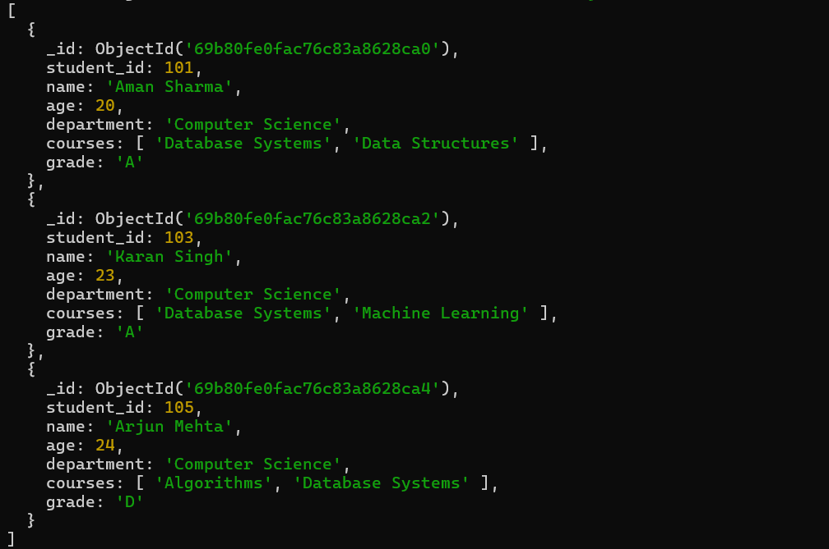

. Retrieve students with a grade of "A.
db.students.find({ grade: "A" })
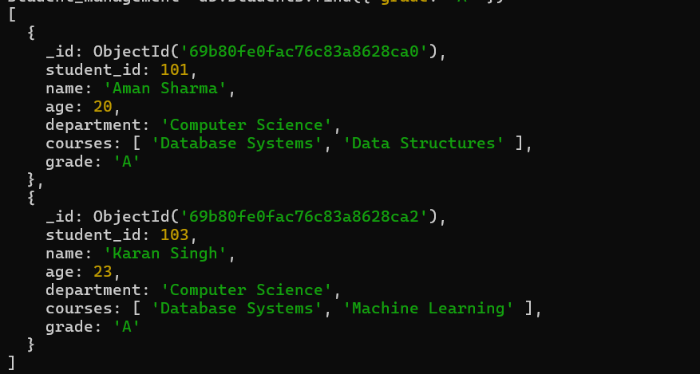

- Update Documents:
- Update the age of a student with student_id 101 to 21.
db.students.updateOne(
{ student_id: 101 },
{ $set: { age: 21 } }
)
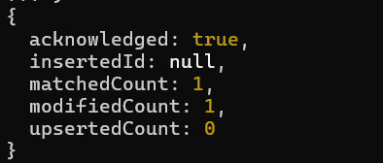
- Add a new course, "Machine Learning", to the courses array for students in the "Computer Science" department.
db.students.updateMany(
{ department: "Computer Science" },
{ $addToSet: { courses: "Machine Learning" } }
)
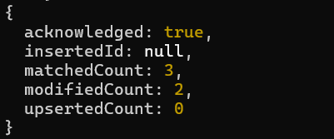
- Delete Documents:
- Delete a student record with student_id 105.
db.students.deleteOne({ student_id: 105 })

- Delete all students who have a grade lower than "C".
db.students.deleteMany({ grade: { $in: ["D", "F"] } })

