MONGODB ASSIGNMENT- B

1.Create a database named university and a collection named students. Insert multiple student documents with fields: name, age, department, and grades.
Use university
db.createCollection("students")
db.students.insertMany([{name:"Alice",age:20,department:"Computer Science",grades:{math:85,english:92}},{name:"Bob",age:21,department:"Physics",grades:{math:88,physics:90}},{name:"Charlie",age:22,department:"Mathematics",grades:{math:95,statistics:89}}])
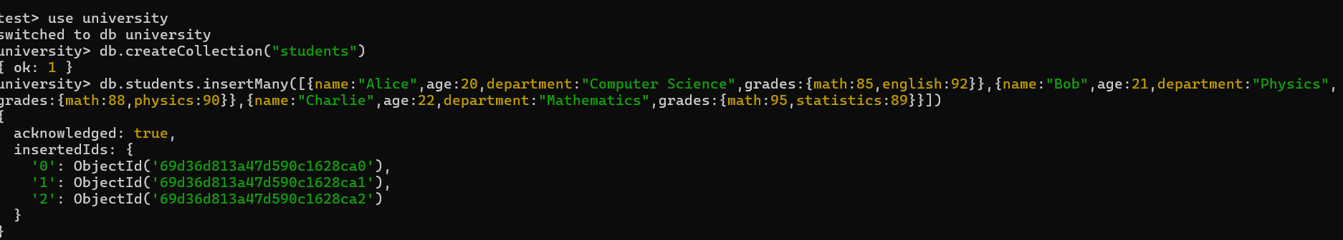

2.Write a query to display all students who are in the Computer Science department.
db.students.find({department:”Computer Science”})
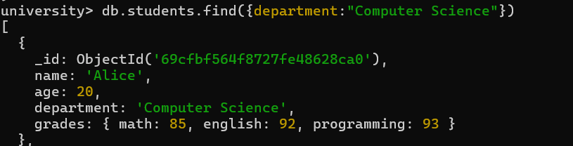
3.Write a query to update the grades of a student named Alice by adding a new subject programming with a grade of 93.
db.students.updateOne({name:”Alice”},{$set:{“grades.programming”:93}})
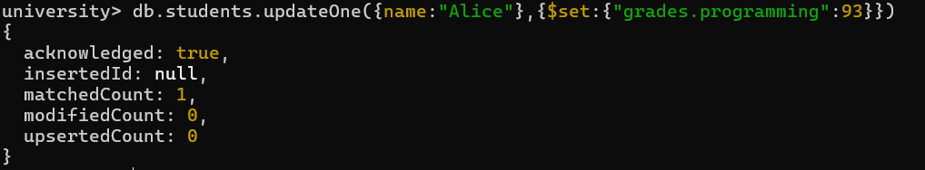

4.Write a query to increment the age of all students by 1.

db.students.updateMany({},{$inc:{age:1}})

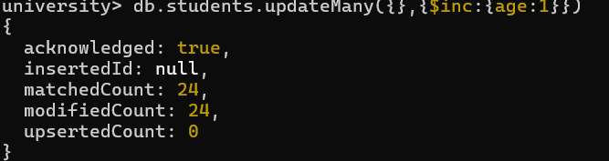

5.Write a query to delete all students who are 23 years old.
db.students.deleteMany({age:23})

7.Write an aggregation query to group students by their department and calculate the average age in each department.
db.students.aggregate([{$group:{_id:"$department",averageAge:{$avg:"$age"}}}])
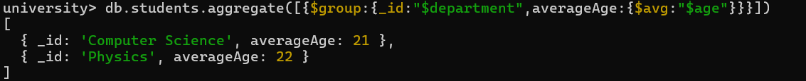

8.Write a query to find all students who have scored more than 90 in any subject.
db.students.find({$or:[{"grades.math":{$gt:90}},{"grades.english":{$gt:90}},{"grades.physics":{$gt:90}},{"grades.statistics":{$gt:90}},{"grades.programming":{$gt:90}}]})
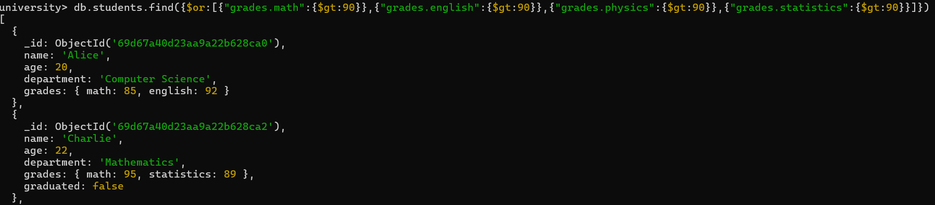

9.Write a query to add a new field graduated set to false for all students who are in the Mathematics department.

db.students.updateMany({department:"Mathematics"},{$set:{graduated:false}})

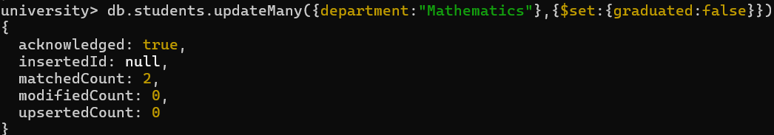
10.How can you retrieve only the name and department fields for all students, excluding the _id field?

db.students.find({},{_id:0,name:1,department:1})

