MONGODB ASSIGNMENT-D

1.Display all employees who have MongoDB skill.

db.employees.find({skills:"MongoDB"})

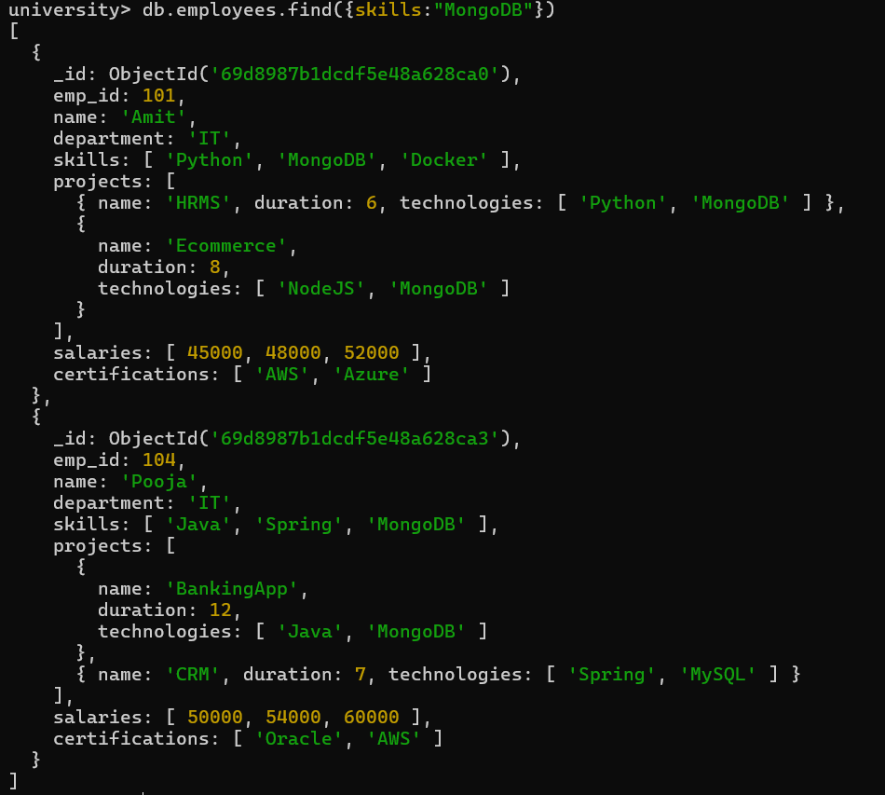

2.Find employees having both Python and MongoDB skills.
db.employees.find({skills:{$all:["Python","MongoDB"]}})

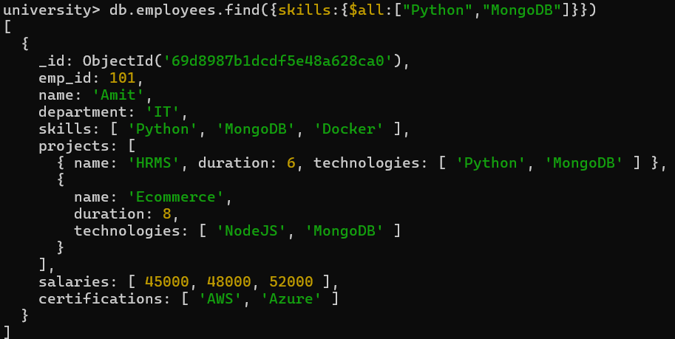

3.Display employees with more than 2 skills.

db.employees.find({$expr:{$gt:[{$size:"$skills"},2]}})

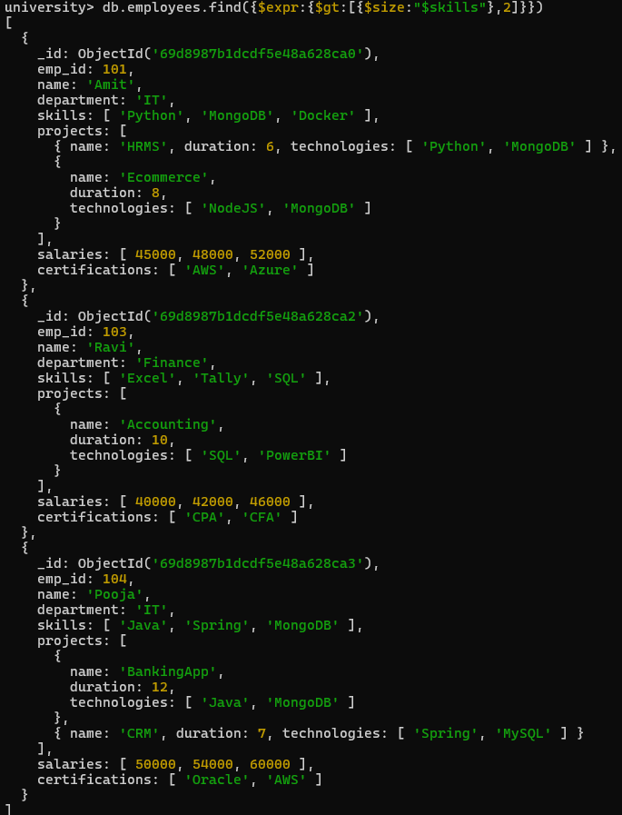

4.Add a new skill "Kubernetes" to Amit.

db.employees.updateOne({name:"Amit"},{$addToSet:{skills:"Kubernetes"}})

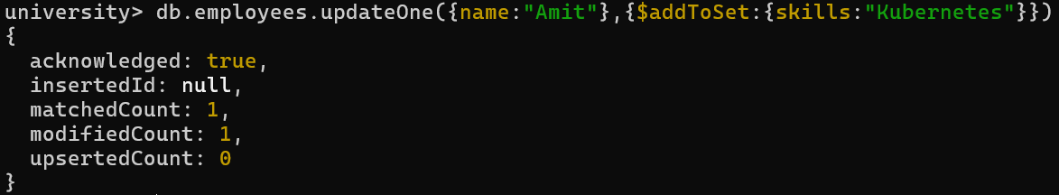

5.Add multiple skills to Pooja.

db.employees.updateOne({name:"Pooja"},{$addToSet:{skills:"React"}})

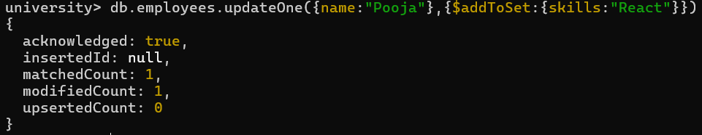
6.Add a certification only if not already present.
db.employees.updateOne({name:"Amit"},{$addToSet:{certifications:"GCP"}})
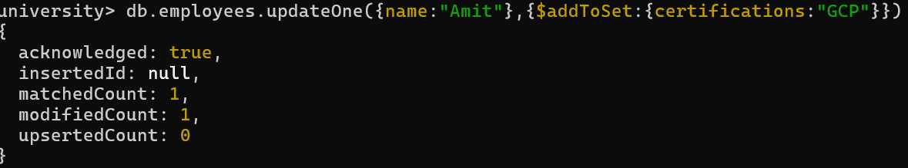
7.Remove "Docker" skill from Amit.

db.employees.updateOne({name:"Amit"},{$pull:{skills:"Docker"}})

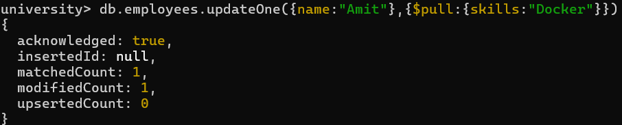

8.Remove multiple salaries less than 45000.

db.employees.updateMany({},{$pull:{salaries:{$lt:45000}}})

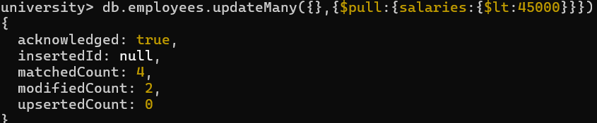

9.Find employees who worked on MongoDB projects.

db.employees.find({"projects.technologies":"MongoDB"})

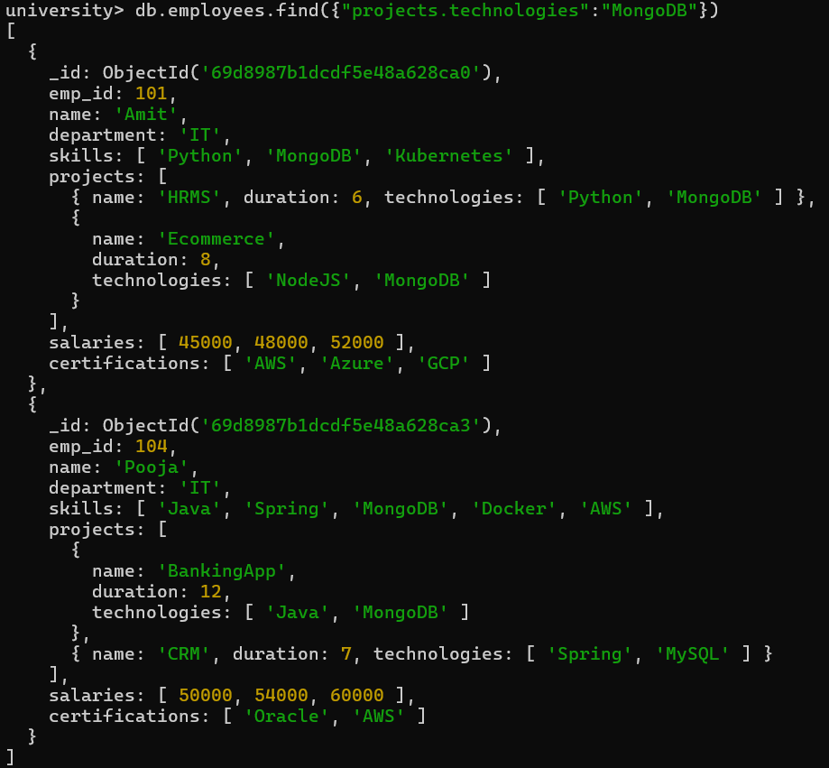

10.Use $elemMatch to find project duration > 6 using MongoDB.

Topic not covered yet.

11.Count number of projects for each employee.

db.employees.aggregate([{$project:{name:1,totalProjects:{$size:"$projects"}}}])

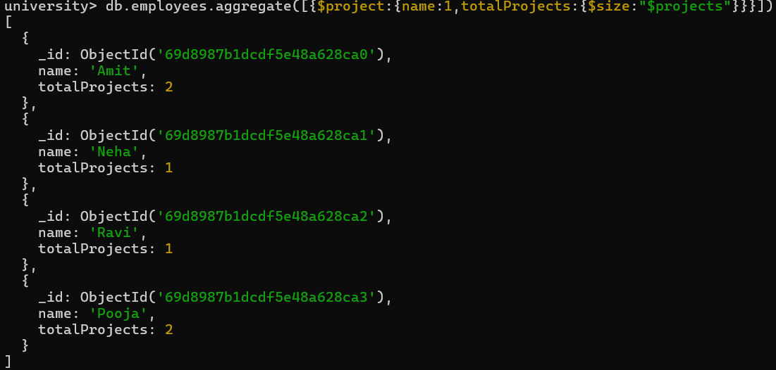

12.Unwind skills array.

Topic not covered yet.

13.List unique skills across company.

Topic not covered yet.

14.Find employees with salary greater than 50000.

db.employees.find({salaries:{$gt:50000}})
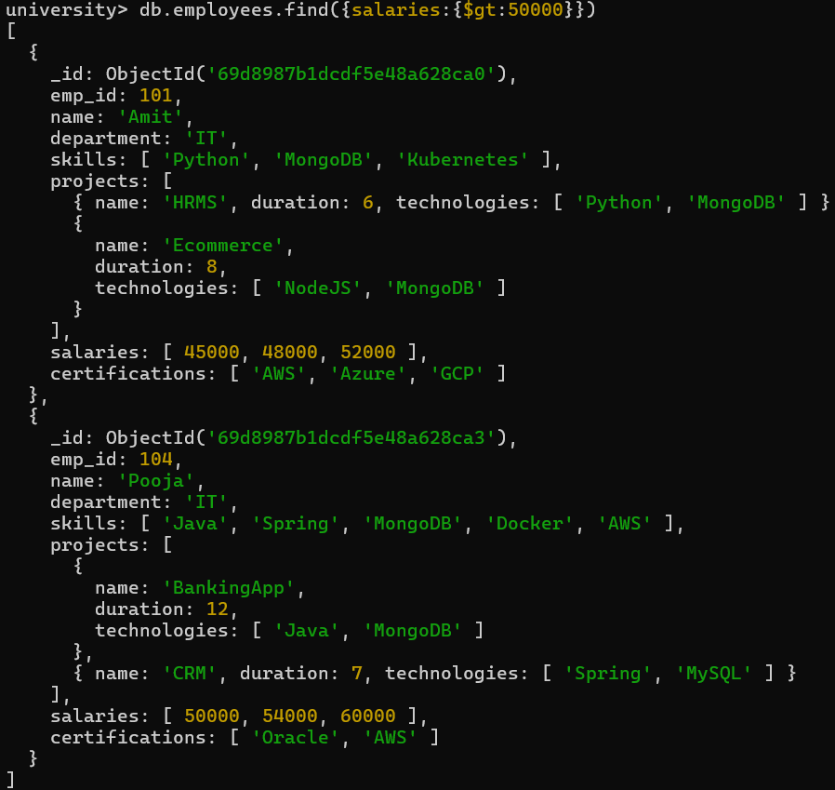
15.Find employees with exactly 2 certifications.

db.employees.find({certifications:{$size:2}})

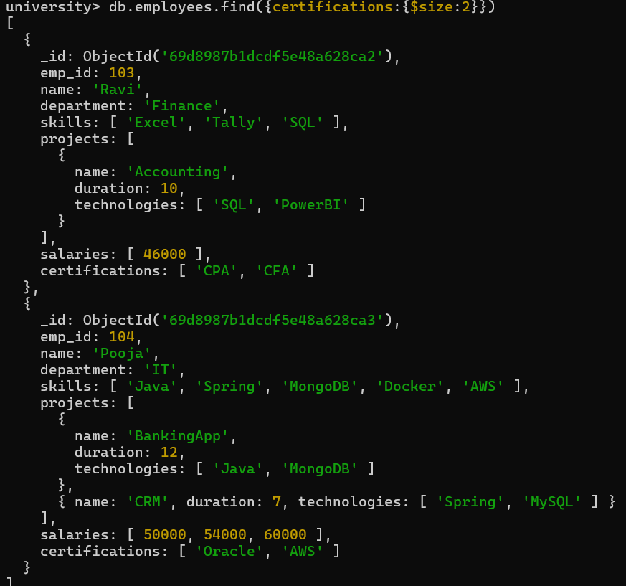

16.Add new project to Ravi.

db.employees.updateOne({name:"Ravi"},{$push:{projects:{name:"BudgetSystem",duration:5,technologies:["SQL"]}}})

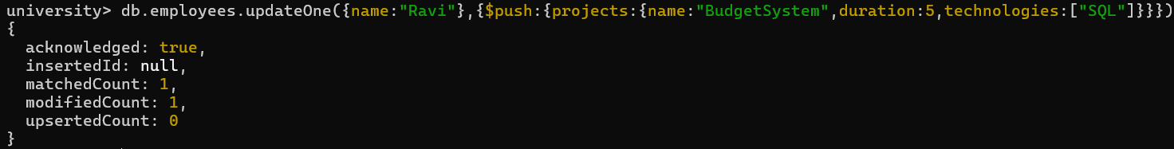

17.Increase all salaries by 10% (array update).

db.employees.updateMany({salaries:{$type:"array"}},{$mul:{"salaries.$[]":1.1}})

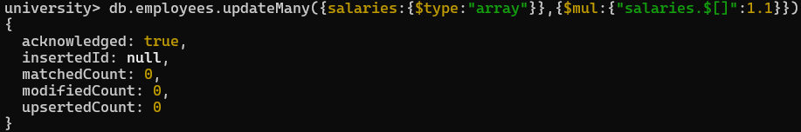
18.Find highest salary of each employee.

db.employees.aggregate([{$project:{name:1,maxSalary:{$max:"$salaries"}}}])

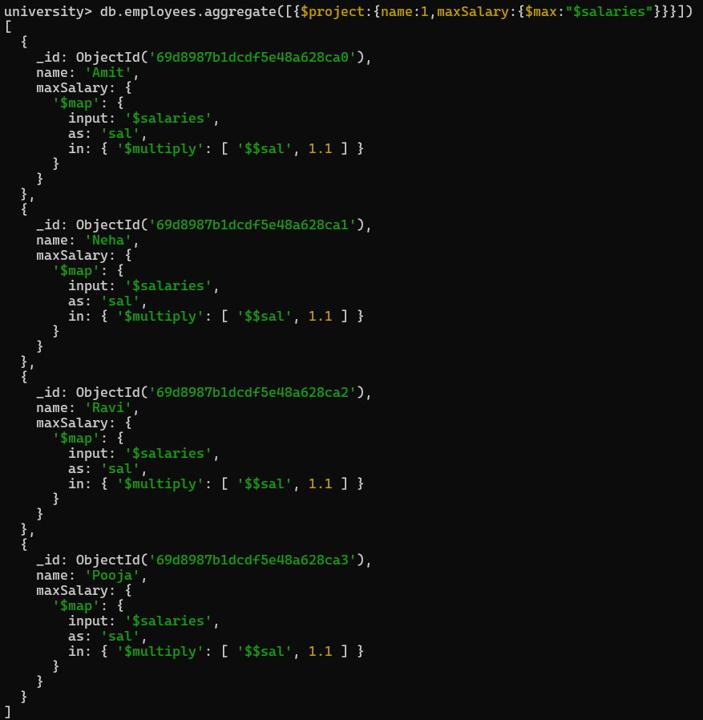
19.Find average salary of employees.
db.employees.aggregate([{$project:{name:1,avgSalary:{$avg:"$salaries"}}}])

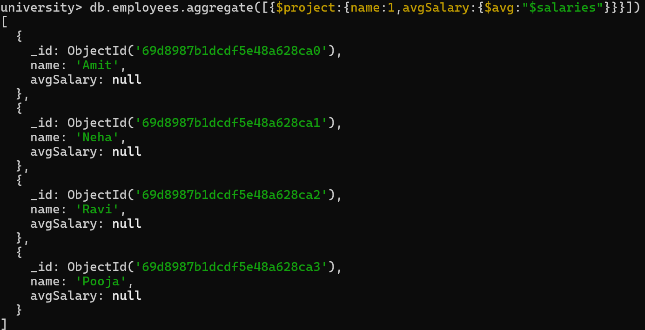

20.Filter projects longer than 6 months.

Topic not covered yet.

21.Find employees who have any of these skills: Java or Python.

db.employees.find({skills:{$in:["Java","Python"]}})

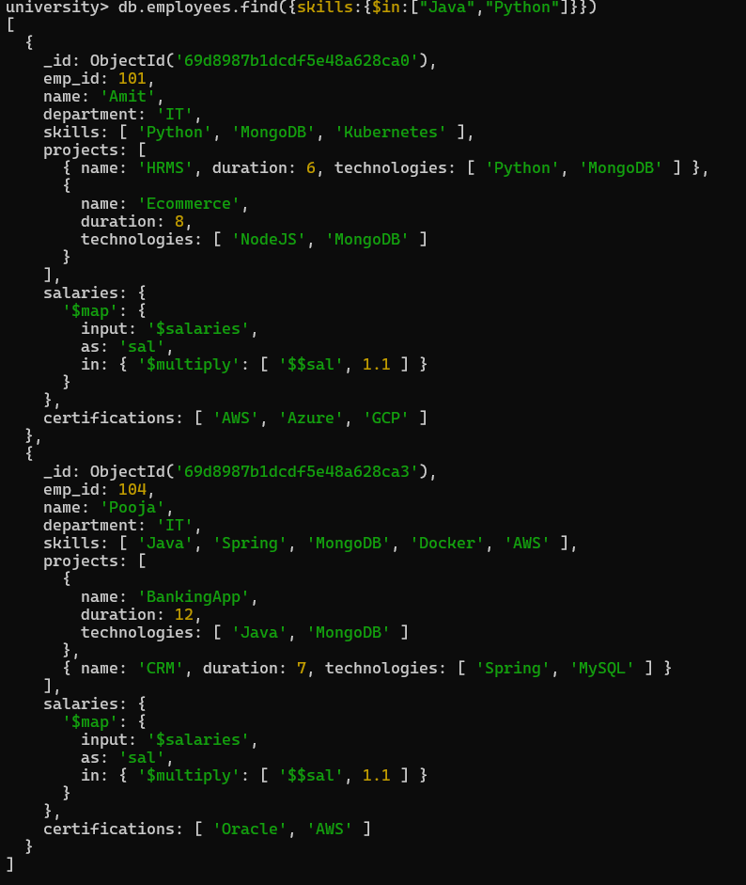

22.Remove last salary entry.

db.employees.updateMany({salaries:{$type:"array"}},{$pop:{salaries:1}})

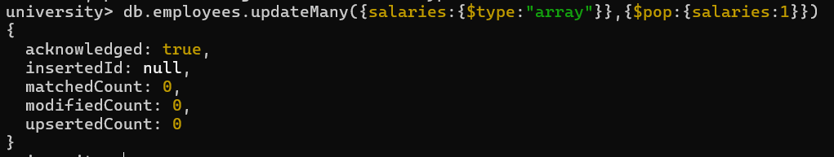

23.Remove first salary entry.

db.employees.updateMany({salaries:{$type:"array"}},{$pop:{salaries:-1}})

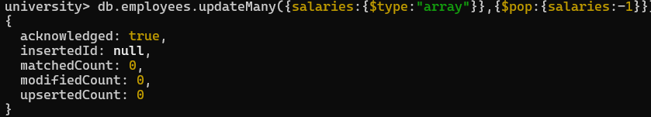
24.Sort salaries array.

Topic not covered yet.

25.Limit salaries array to last 2 entries.

Topic not covered yet.

26.Find total salary paid to each employee.

db.employees.aggregate([{$project:{name:1,totalSalary:{$sum:"$salaries"}}}])

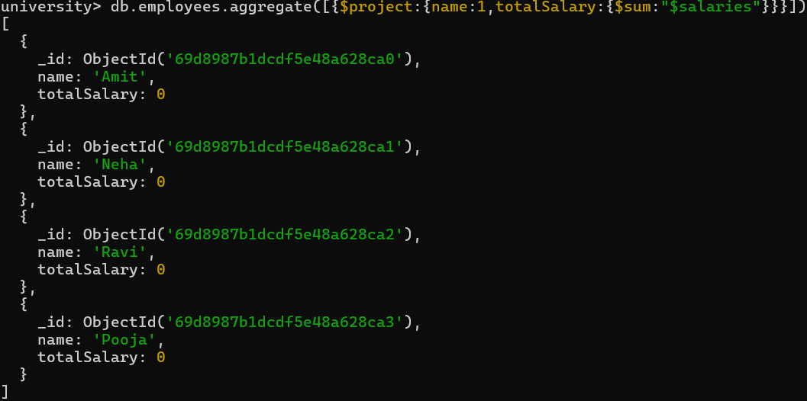

27.Convert skills to uppercase.

Topic not covered yet.

28.Find employees with more than one project.

db.employees.find({$expr:{$gt:[{$size:"$projects"},1]}})

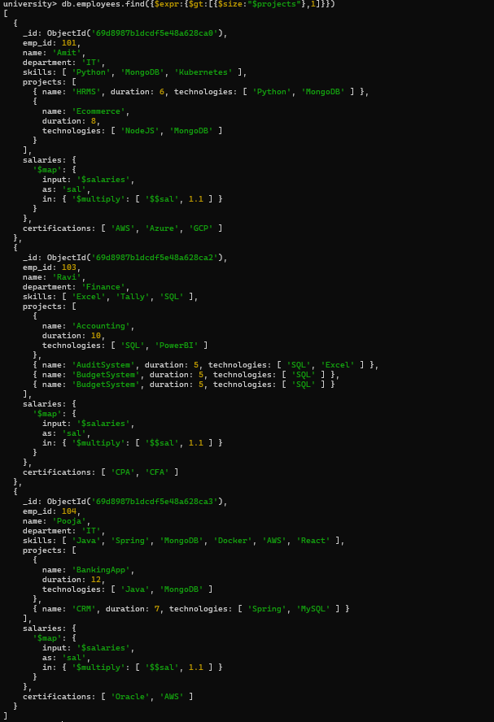

29.Count employees per skill.

Topic not covered yet.
30.Find employees whose all projects use MongoDB.

Topic not covered yet.

