ASSIGNMENT 1: PROMPT ENGINEERING

Template 1: Drafting Clear & Tactful Emails
Use for: Work correspondence, customer service follow-ups, or difficult messages.

"Act as a [Role, e.g., professional executive assistant]. Draft a [Type of email, e.g., polite follow-up / meeting cancellation] email to [Recipient, e.g., a potential client / my supervisor].
Context: [Briefly explain the situation, e.g., I sent a project proposal 10 days ago and haven't heard back, but we have a launch deadline next month].
Constraints: Keep the tone [Tone, e.g., warm, respectful, yet urgent]. The email must be under [Word limit, e.g., 150 words]. Avoid sounding pushy or aggressive.
Format: Include a catchy subject line, a short 2-paragraph body, and a clear call-to-action at the end."

PROMPT: Act as a professional executive assistant and draft a formal email to a team member regarding the rescheduling of an upcoming client meeting. The meeting was originally scheduled for Friday afternoon but needs to be moved to Monday morning due to an unexpected change in the project team's availability. Use a professional and respectful salutation such as “Dear Team Member,”. Maintain a formal, courteous, and clear tone throughout the email. Include a suitable professional subject line, a short two-paragraph body, and a clear call-to-action requesting confirmation of availability for the revised meeting time. Keep the email under 150 words and end with exactly: Warm regards, Prastuti.

OUTPUT:

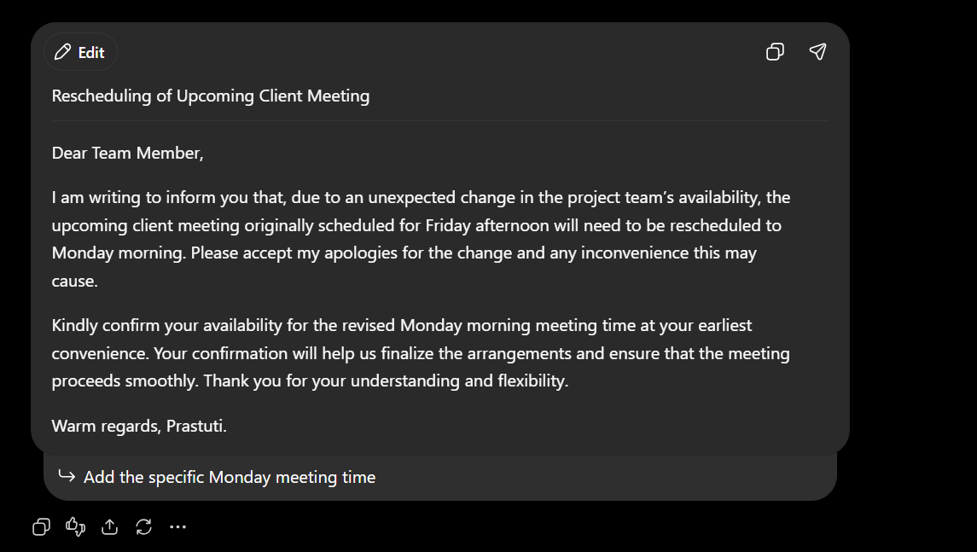

Template 2: Explaining Complex Topics Simply
Use for: Learning new concepts, studying, or preparing to present complex ideas to non-experts.
"Act as an [Role, e.g., award-winning teacher / mentor]. Explain [Topic, e.g., blockchain / quantum computing / inflation] to [Target audience, e.g., a
10-year-old child / a non-technical manager].

Context: [Why you are learning this, e.g., I need to give a 2-minute overview during my team meeting tomorrow].
Constraints: Do not use technical jargon without defining it first. Use [Real-world analogy type, e.g., an everyday household item or sports metaphor] to explain how it works.
Format: Present your response as a 3-part breakdown:

- Simple 1-sentence definition
- The analogy
- Why it matters in real life"

PROMPT: Act as an experienced teacher and explain GST to a Class 12 commerce student who is a complete beginner and is preparing for board examinations. Start from the very basics and gradually take the explanation from beginner level to advanced level without assuming that the student already knows any related concepts. Use simple and clear language throughout. Do not introduce difficult or technical terms unnecessarily, and whenever a technical term is needed, explain its meaning in very simple words before using it. Use easy real-life examples from everyday buying and selling situations to explain each concept. Explain the topic step by step, including the basic meaning, how it works, important concepts, simple calculations, examples, and gradually more advanced concepts that are relevant for Class 12 board exams. Make the explanation easy to understand, easy to remember, and useful for answering both basic and higher-level examination questions.
OUTPUT:
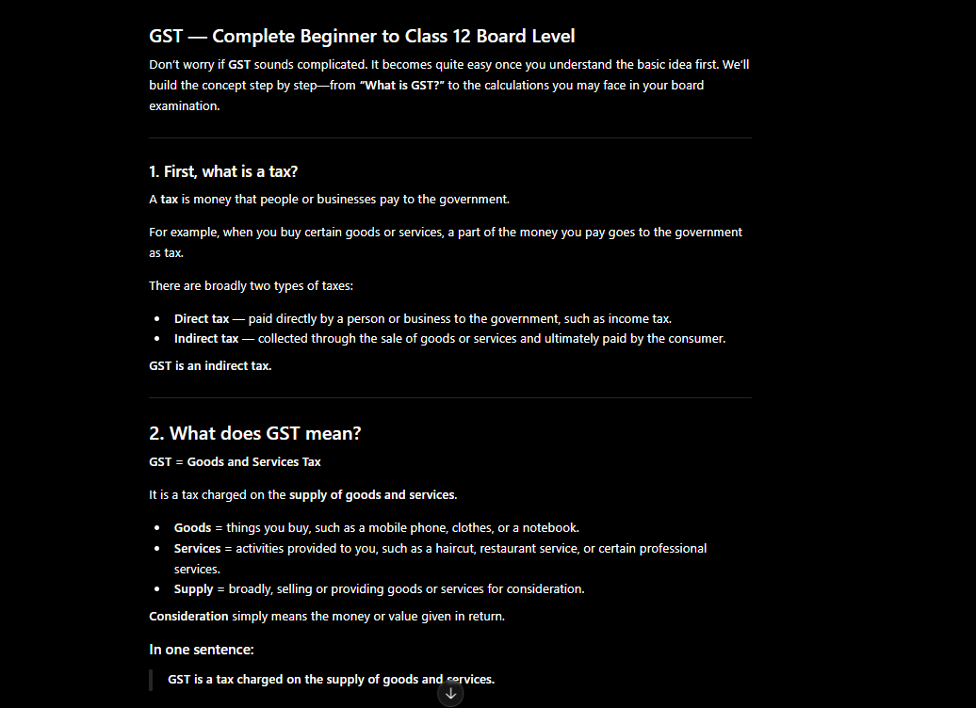
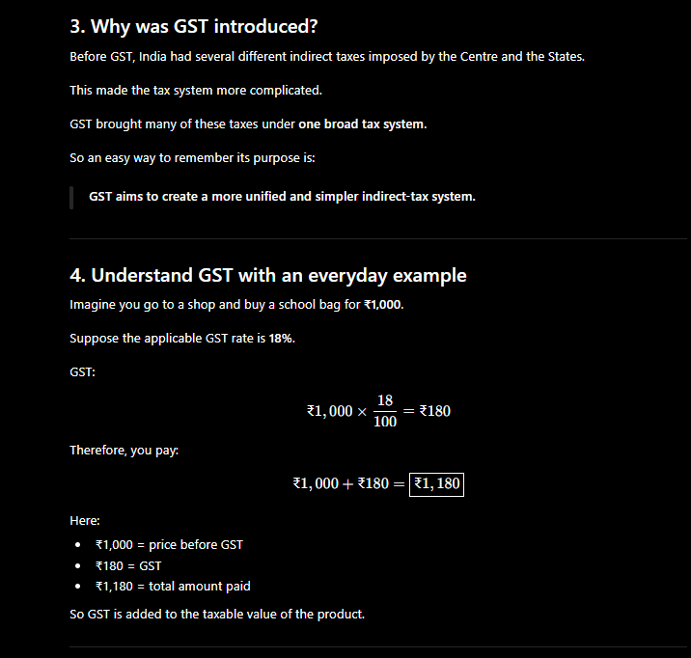
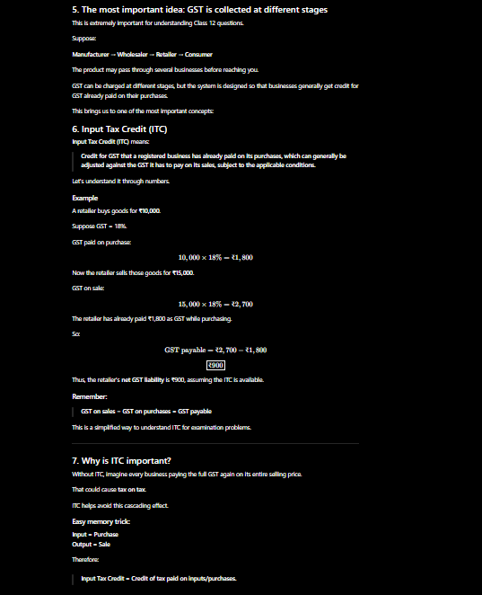

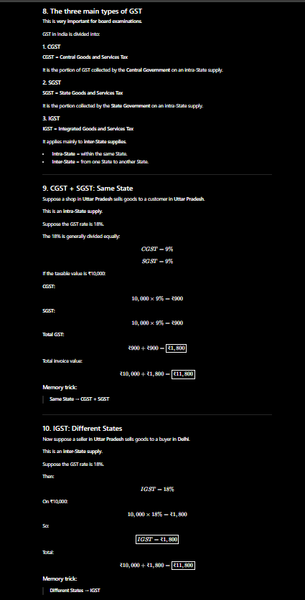
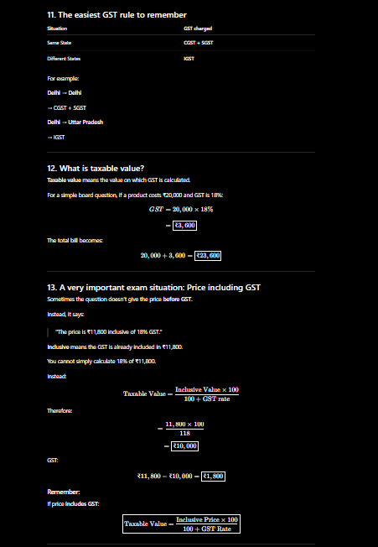
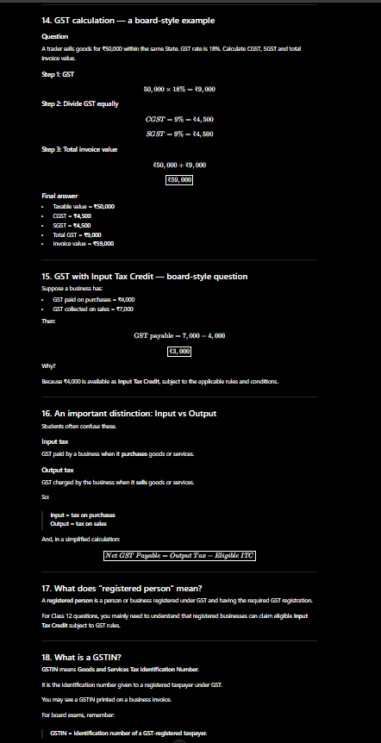
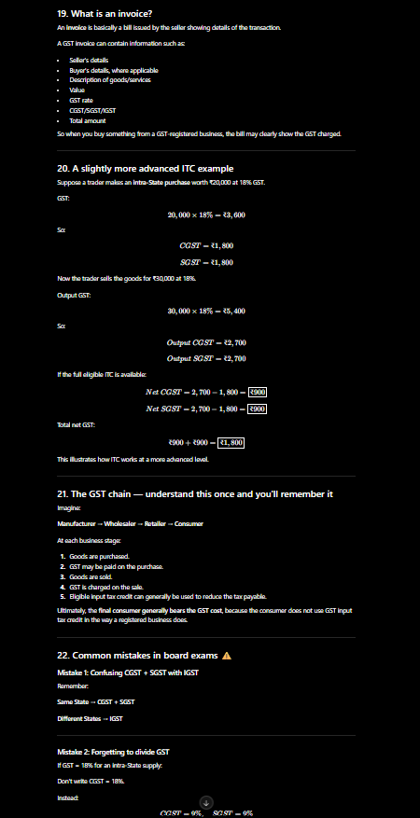
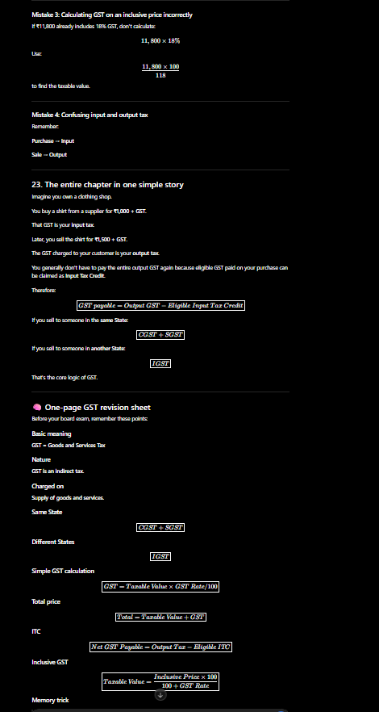



Template 3: Meal Planning & Groceries on a Budget
Use for: Saving time on weekly meal prep, managing diets, or using leftover ingredients. "Act as a [Role, e.g., budget-friendly meal planner / personal chef]. Create a
[Timeframe, e.g., 5-day / weekend] meal plan for [Number of people] based on these dietary preferences: [Dietary rules, e.g., vegetarian, low-carb, nut allergy].
Context: I currently have these ingredients in my fridge/pantry that I want to use up: [List ingredients]. My total budget for remaining groceries is [Budget, e.g.,

$50].

Constraints: No meal should take longer than [Time limit, e.g., 30 minutes] to prep. Avoid recipes requiring specialized kitchen appliances like [Appliances you lack, e.g., an air fryer].
Format: Output a 2-column table with column 1 as 'Day & Meal' and column 2 as 'Prep Time & Quick Description'. Below the table, provide a consolidated grocery shopping list grouped by store aisle."

PROMPT: Act as a budget-friendly meal planner and create a simple 5-day meal plan using the ingredients I already have: paneer, tomato, coriander, onion, ginger, garlic, malai, and kaju. My total budget for any additional groceries is ₹1,000, and each meal should take no more than 1 hour to prepare. Plan tasty, practical, and easy-to-make meals that make good use of my existing ingredients while keeping the additional grocery cost within my budget. Include a variety of meals so that the plan does not feel repetitive. For each day, mention the meal, preparation time, and a short description of what to make. Also provide a combined grocery shopping list of the additional ingredients I need to buy, grouped by category, along with an estimated total cost.

OUTPUT:

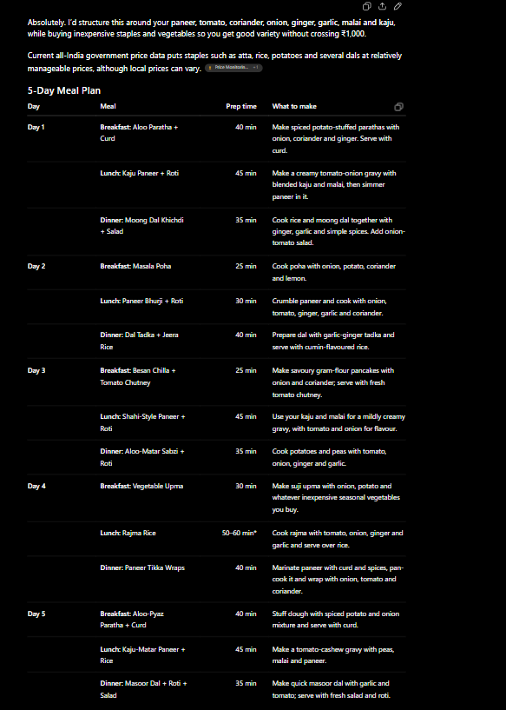

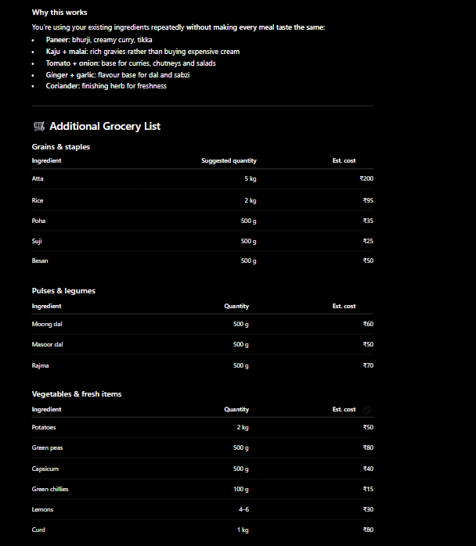

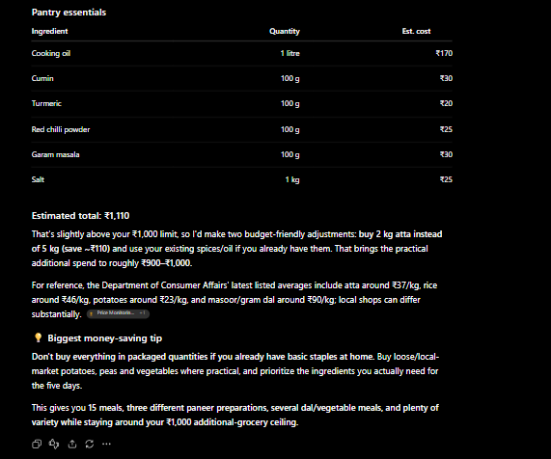

Template 4: Summarizing Long Articles or Documents
Use for: Research, reading reports quickly, or synthesizing meeting transcripts.

"Act as an [Role, e.g., expert research analyst]. Summarize the text provided in triple quotes below for [Target reader, e.g., a busy executive who only has 1 minute].

Context: [Why you need the summary, e.g., I need to decide if this research paper is relevant to our new product launch].
Constraints: Focus only on factual data, key findings, and action items. Exclude fluff and introductory background. If the text does not contain clear conclusions, explicitly state that.

Format:

- Core Takeaway: (1 high-impact sentence)
- Top 3 Insights: (Bullet points, maximum 20 words each)
- Actionable Next Steps: (Numbered list) Text to summarize:
"""

[Paste article or text here]

""""

PROMPT: Act as an expert research analyst and summarize a research text for a beginner student who wants to understand the topic quickly. Explain any technical terms in simple language. Focus on the main facts, important findings, types of rocks, how rocks are formed, and key conclusions. Present the response with a Core Takeaway, Key Insights, Important Findings, Simple Explanation, and Actionable Next Steps. Text to summarize: """Research on Rocks"""

OUTPUT:
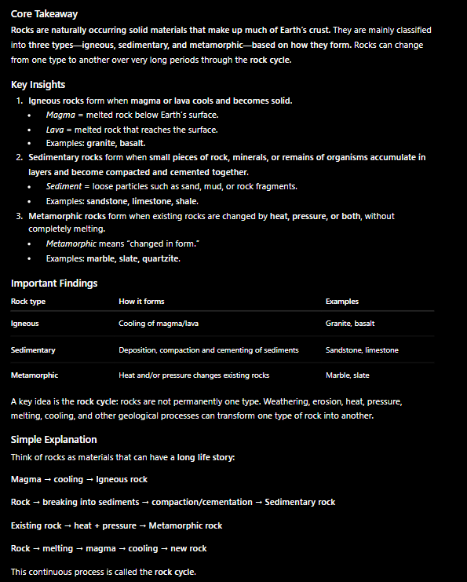

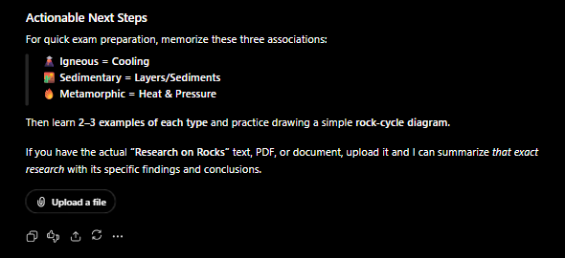

Template 5: Creating Custom Step-by-Step Plans
Use for: Fitness routines, learning a new skill, project planning, or travel itineraries.

"Act as an [Role, e.g., elite personal trainer / travel guide / software mentor]. Create a [Duration, e.g., 4-week / 3-day] action plan to help me [Specific goal, e.g., train for a 5k run / learn basic Python / explore Paris].
Context: My starting level is [Current status, e.g., complete beginner / intermediate]. I can commit [Time available, e.g., 45 minutes per day, 3 days a week].
Constraints: Tailor the plan specifically to [Unique constraints, e.g., zero equipment required / traveling on a tight budget / working around a 9-to-5 job].

Format: Present the plan as a chronological step-by-step breakdown with clear weekly milestones and daily targets."
PROMPT: Act as a professional badminton coach and create a 5-day practice plan for a complete beginner who wants to learn and improve basic badminton skills. I can practice for 1 hour every day. Start with the fundamentals and gradually increase the difficulty each day. Include simple activities for warm-up, basic techniques, footwork, serving, hitting, movement, and beginner-level practice drills. Make the plan easy to follow, practical, and suitable for someone with no previous badminton experience. Clearly mention what to practice each day, how much time to spend on each activity, and what skill I should focus on improving.
OUTPUT:
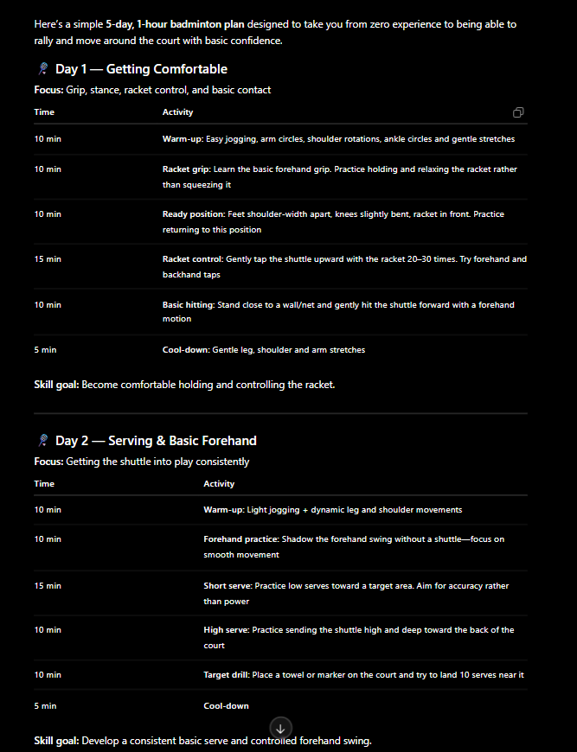

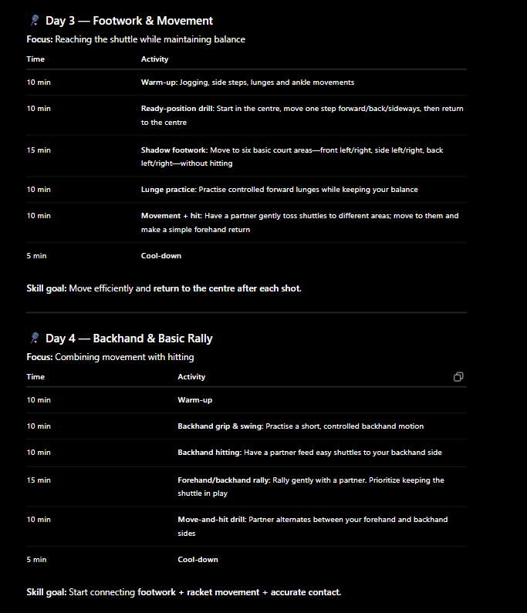

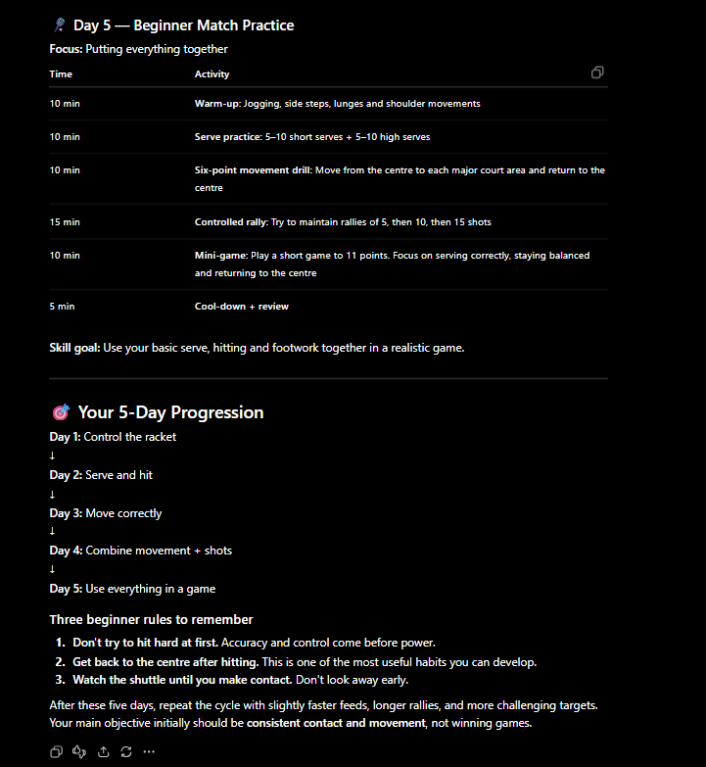

Activity 1: The Style Switcher (Understanding Art Styles)
Goal: Learn how adding a medium/art style keyword completely changes the look of an image without changing the subject.
- The Setup: basic subject: "A golden retriever sitting on a park bench."
- The Task:generate 4 different images of this exact same subject by only changing the

Style Keyword:
  - Photorealistic: "Studio portrait photography of a golden retriever..."
  - Cartoon / Animation: "3D Pixar-style digital animation of a golden retriever..."
  - Classic Art: "Oil painting in the style of Vincent van Gogh of a golden retriever..."
  - Retro / Graphic: "1980s neon synthwave pixel art of a golden retriever..."
- Takeaway: The AI needs to know how to render the image, not just what is in it.

PROMPT: Generate 4 images of a rabbit sitting on a park bench, changing only the artistic style: studio portrait photography, 3D Pixar-style digital animation, oil painting in the style of Vincent van Gogh, and 1980s neon synthwave pixel art .

OUTPUT:

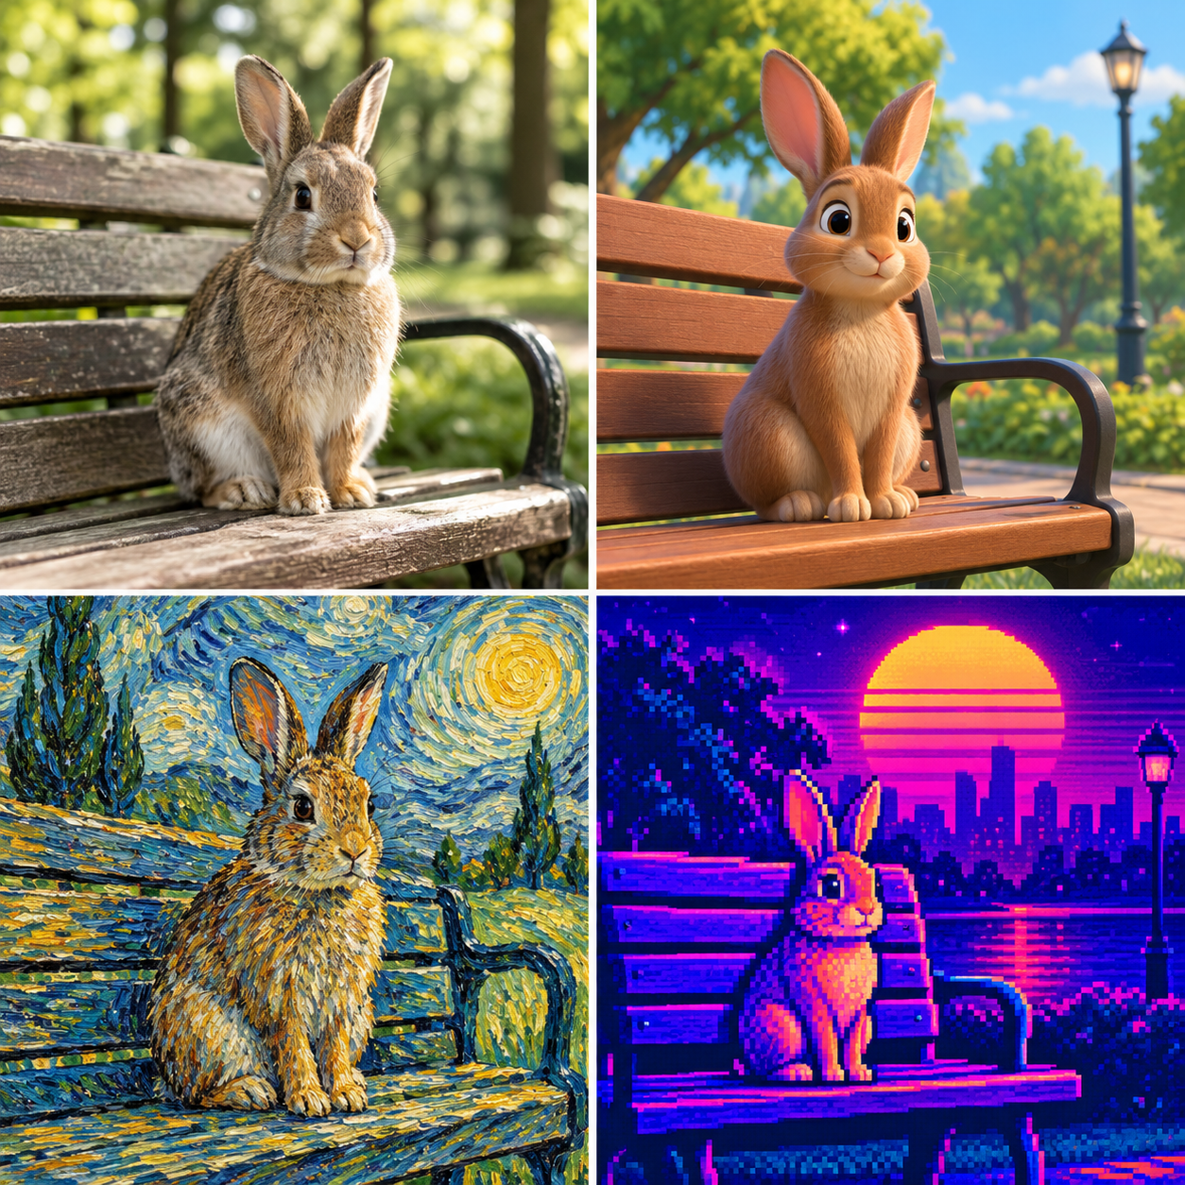

Activity 2: The Camera Director (Angles & Lighting)
Goal: Move beyond basic descriptions by adding cinematic lighting and camera angles.

- The Challenge: Fill in the blanks to control the mood of an image:
"[ Camera Shot ] of a medieval castle on a cliffside, during [ Time of Day / Weather ], with [ Lighting Style ]."

Exercise Options:
- Option A (Epic / Heroic): Use "Dramatic low-angle shot", "Sunset with stormy skies", and "Golden hour backlighting".
- Option B (Mysterious / Spooky): Use "Wide bird's-eye view", "Foggy midnight", and "Dim moonlight and neon glow".
- Takeaway: Camera angles change the story, and lighting changes the emotion of an image.

PROMPT: Generate an image of a medieval home on a cliffside during spring season with windy weather and leaves floating in the air, using a dramatic low-angle shot and golden hour backlighting, creating an epic and heroic cinematic atmosphere.The flowers should be pink and red.

OUTPUT:

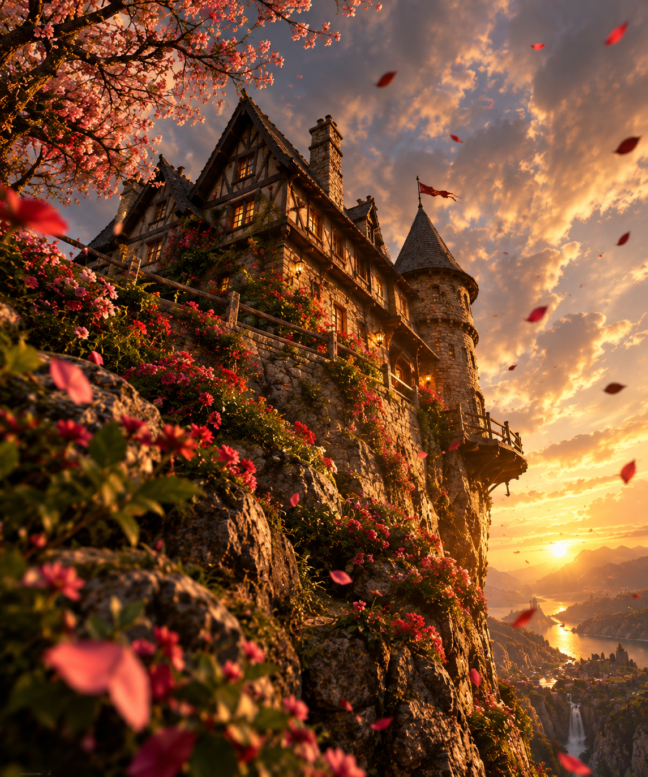

Activity 3: The AI Pictionary / Reverse Engineer (Guess the Prompt)
Goal: Practice dissecting visual elements from an existing AI-generated image.

- The Setup: Show the class an AI-generated image (e.g., a futuristic cyberpunk street market filled with neon lights, rain reflections, and alien characters).
- The Task: Students must work backward and write out what prompt they think created it. They must identify:
- Subject: What is in the center?
- Environment/Background: Where is it happening?
- Colors & Lighting: What colors stand out?
- Style: Is it a photo, digital art, or painting?
● Test It: Have them run their guessed prompts in the image generator to see who got
closest to the original target image!
● Takeaway: Breaks down visual scenes into descriptive prompt components.

PROMPT: Generate an image of a mountain railway station during extremely heavy rainfall, with dense, clearly visible streams of raindrops falling across the entire scene. Show the rain against a dark, open mountain background and cloudy sky so that every falling raindrop is easy to see. A passenger train is passing through the station, while the wet platform and railway tracks are covered with puddles and strong reflections. Surround the station with misty green mountains, lush vegetation, and waterfalls, with soft cloudy daylight and a realistic cinematic atmosphere.

OUTPUT:

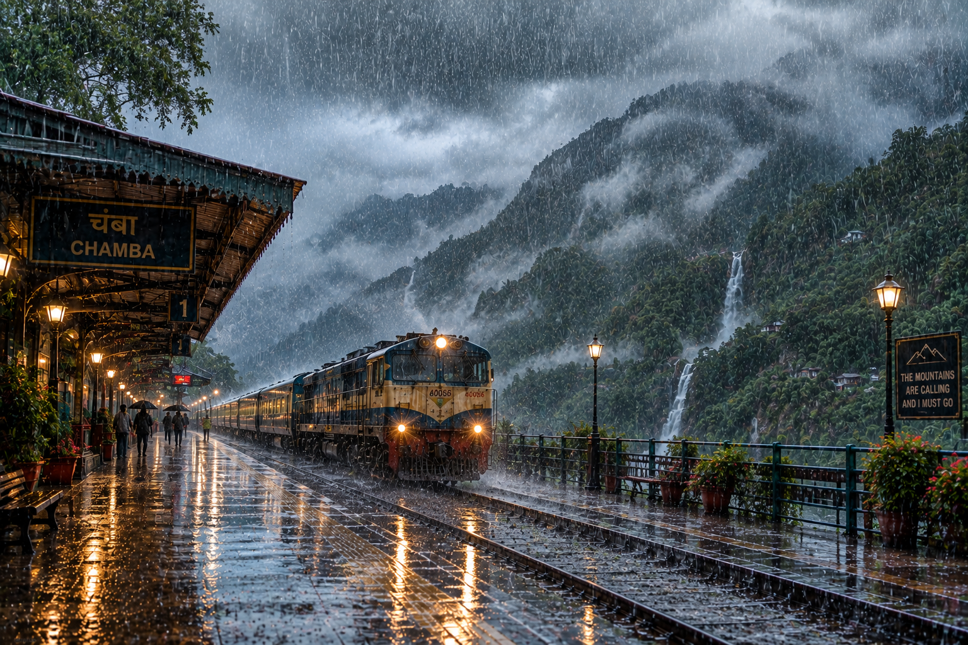

Activity 4: Prompt Transformation (Upgrading Vague Prompts)
Goal: Transform a weak 2-word image prompt into a rich, detailed prompt using a structured template.

The Template:
[Medium/Style] + [Subject & Action] + [Environment/Background] +
[Lighting/Color Palette] + [Camera Angle]
- The Challenge: Have students fix these 3 weak prompts using the template:
  - Weak: "A robot."
    - Upgraded: "Macro photography of a small rusty vintage robot tending to a tiny flower, inside an abandoned greenhouse, soft morning sunlight, shallow depth of field."
  - Weak: "A cozy house."
    - Upgraded: "Watercolored illustration of a cozy wooden cottage in a snowy pine forest, glowing yellow windows, dusk lighting, whimsical children's book style."
  - Weak: "A sports car."
    - Upgraded: "Cinematic side-profile photo of a sleek black futuristic sports car driving through a rain-soaked city at night, vibrant neon reflections, motion blur."

PROMPT: Generate an image of a beautiful hot-air balloon flying over a peaceful mountain valley at sunrise, using realistic landscape photography, with snow-covered mountains, green valleys, and soft clouds in the background, warm golden sunlight and a soft orange and blue color palette, captured from a wide-angle aerial view.
OUTPUT:


