Assignment 6: Role Prompting
Question 1: AI as a Teacher.
Design a role-based prompt that instructs an AI model to act as a Data Science professor and explain the difference between supervised and unsupervised learning.
Tasks:
- Write one prompt without role prompting.
- Rewrite the prompt using role prompting.
- Generate responses using both prompts.
- Compare the responses based on clarity, examples, and level of detail.
Deliverable: Two prompts, two AI responses, and a comparison.
Answers:
1. Prompt Without Role Prompting:
Prompt 1:
Explain the difference between supervised learning and unsupervised learning in machine learning. Include their definitions, examples, and major differences in simple language. Present the comparison in a table.
Output 1:
Supervised learning and unsupervised learning are two main types of machine learning.
- Supervised Learning: It is a type of machine learning in which a model learns from labelled data. The data contains input values and their correct outputs. The model uses this information to predict results for new data.
Example: Predicting whether an email is spam or not spam using previously labelled emails.
Algorithms: Linear Regression, Decision Tree, and Support Vector Machine (SVM).
- Unsupervised Learning: It is a type of machine learning in which a model learns from unlabelled data. It identifies patterns, similarities, and groups in the data without predefined answers.
Example: Grouping customers according to their shopping behaviour.
Algorithms: K-Means Clustering, Hierarchical Clustering, and Principal Component Analysis (PCA).
Basis | Supervised Learning | Unsupervised Learning
Data | Labelled data | Unlabelled data
Goal | Predict outcomes | Discover patterns
Output | Predicted values or classes | Groups or patterns
Example | Spam detection | Customer segmentation
In conclusion, supervised learning uses labelled data to make predictions, while unsupervised learning discovers hidden patterns in unlabelled data.
2. Prompt With Role Prompting:
Prompt 2:
Act as an experienced Data Science professor who teaches undergraduate students. Explain the difference between supervised learning and unsupervised learning in machine learning using simple, student-friendly language. Define both concepts, explain how they work, and provide real-life examples and common algorithms for each. Present the differences in a comparison table and conclude with a short summary to help students understand the concepts easily.
Output 2:
As a Data Science professor, let us understand these two important concepts of machine learning with simple explanations and practical examples.

A. Supervised Learning-
Supervised learning is a machine learning technique in which a model is trained using labelled data. Labelled data contains both the input and the correct output. The model learns the relationship between them and uses it to predict the output for new inputs.
How does it work?
- Collect labelled training data.
- Provide the data to the machine learning model.
- The model learns patterns between inputs and outputs.
- Test the model and use it to predict results for new data.
Real-life example: A bank wants to identify fraudulent transactions. It trains a model using historical transactions labelled as either fraudulent or genuine. The model learns from these examples and predicts whether new transactions may be fraudulent.
Common algorithms:
- Linear Regression — predicts continuous numerical values.
- Logistic Regression — predicts categories, such as yes/no.
- Decision Tree — makes predictions using decision rules.
- Support Vector Machine (SVM) — separates classes or predicts values using learned patterns.

B. Unsupervised Learning-
Unsupervised learning is a machine learning technique in which a model is trained using unlabelled data. The data does not contain predefined correct answers. The model independently identifies patterns, similarities, and relationships in the data.
How does it work?
- Collect unlabelled data.
- Provide the data to the machine learning model.
- The model identifies similarities and patterns.
- Use the discovered patterns to understand the data.
Real-life example: An online shopping company wants to understand its customers. It analyses purchase history, spending habits, and product preferences to group customers with similar behaviour. These groups can help the company create targeted marketing campaigns.
Common algorithms:
- K-Means Clustering — divides data into groups based on similarity.
- Hierarchical Clustering — creates a hierarchy of related groups.
- DBSCAN — identifies dense groups and potential outliers.
- Principal Component Analysis (PCA) — reduces the number of features while preserving as much variation as possible.
In conclusion, role prompting improves the structure, teaching style, and level of detail of an AI-generated response. The first prompt produces a short and useful explanation, whereas the second prompt guides the AI to act as a Data Science professor and provide step-by-step explanations with practical examples. Therefore, role prompting is more suitable for educational tasks when detailed and student-friendly explanations are required.

Comparison of Both Outputs:
Comparison Criteria | Output 1: Without Role Prompting | Output 2: With Role Prompting
Clarity | Clear and easy to understand. | More structured and explains concepts step by step.
Examples | Provides brief examples of spam detection and customer grouping. | Provides detailed, practical examples of fraud detection and customer segmentation.
Level of Detail | Gives basic definitions, algorithms, and a short table. | Includes definitions, working steps, algorithms, applications, and a summary.
Teaching Style | General informational explanation. | Follows a professor-like, student-friendly teaching approach.
Learning Support | Suitable for a quick revision. | Better for understanding the concepts in depth.
Question 2: AI as a Data Analyst.
Create a role prompt that instructs an AI model to act as a Senior Data Analyst and analyze a fictional company's monthly sales performance.
Tasks:
- Define the analyst's role and business objective.
- Provide sample sales data for at least five products.
- Ask the AI to identify the best-selling and worst-performing products.
- Ask for three business recommendations.
- Evaluate whether the AI's conclusions match the supplied data.
Deliverable: Role prompt, sample dataset, analysis, and recommendations.
Answers:
Prompt:
Act as a Senior Data Analyst with expertise in sales analysis, business intelligence, and data-driven decision-making.
You are working for SmartTech Solutions, a fictional electronics company. Your objective is to analyze the company's monthly sales performance for September 2026 using the supplied dataset.
Tasks:
- Calculate and review the total revenue and units sold for all products.
- Identify the best-selling product based on units sold.
- Identify the worst-performing product based on units sold and revenue.
- Compare the revenue generated by all five products.
- Identify important sales patterns and explain what they mean for the business.
- Provide three practical business recommendations to improve sales performance.
- Verify that every conclusion matches the supplied data. Do not make assumptions about profit, customer satisfaction, or market demand because this information is not provided.
Present the results in simple, professional language using tables, clear explanations, and actionable recommendations.
Dataset:
- Laptop: 50 units sold at ₹45,000 per unit.
- Smartphone: 120 units sold at ₹20,000 per unit.
- Headphones: 200 units sold at ₹1,500 per unit.
- Smartwatch: 40 units sold at ₹5,000 per unit.
- Keyboard: 80 units sold at ₹1,000 per unit.
Output:

Overall Sales Performance-
The company sold 490 units across five products and generated total revenue of ₹52,30,000 (₹52.3 lakh) in September 2026.
Product | Units Sold | Total Revenue | Revenue Share
Laptop | 50 | ₹22,50,000 | 43.02%
Smartphone | 120 | ₹24,00,000 | 45.89%
Headphones | 200 | ₹3,00,000 | 5.74%
Smartwatch | 40 | ₹2,00,000 | 3.82%
Keyboard | 80 | ₹80,000 | 1.53%
Total | 490 | ₹52,30,000 | 100%
Revenue by product.
Monthly Revenue by Product.
Total revenue generated by each product in September 2026.
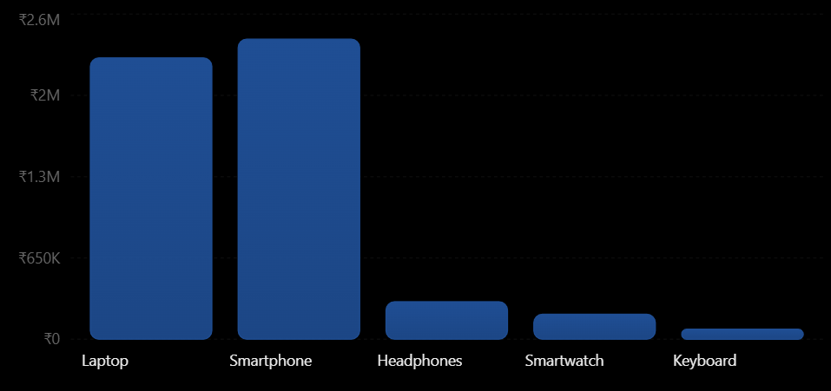

Best-Selling and Worst-Performing Products-
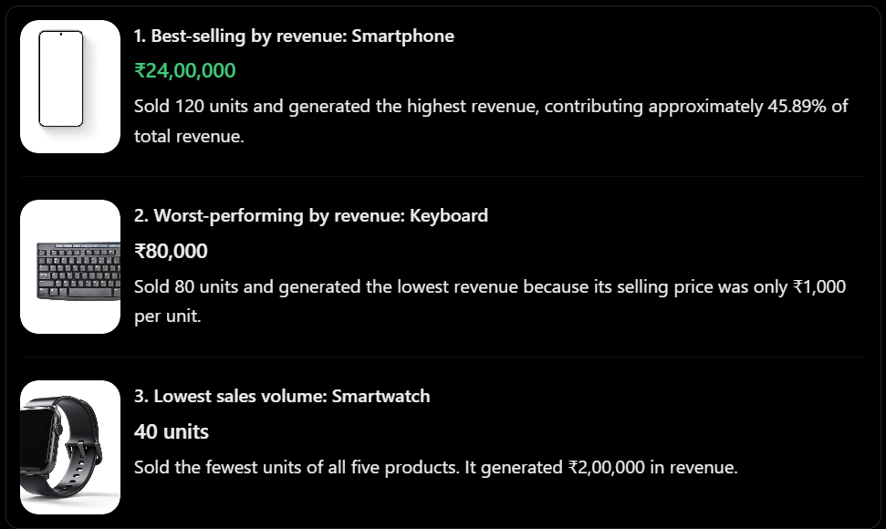
Important observation: The best-selling product depends on the measurement used. Headphones sold the most units (200), smartphones generated the most revenue (₹24 lakh), and keyboards generated the least revenue (₹80,000). Smartwatches had the lowest unit sales.

Three Business Recommendations-
Recommendation 1: Focus on smartphone and laptop sales.
Smartphones and laptops together generated ₹46,50,000, or approximately 88.91% of total revenue. The company should monitor stock availability and consider targeted promotions for these products.
Recommendation 2: Investigate low smartwatch sales.
Smartwatches sold only 40 units, the lowest volume among the five products. The company should investigate customer feedback, pricing, product visibility, and competing offers before deciding whether to change its marketing strategy.
Recommendation 3: Increase keyboard revenue through bundled offers.
Keyboards generated the lowest revenue at ₹80,000. The company could test keyboard bundles with laptops, offer suitable discounts, or promote keyboards as accessories. It should evaluate the results before expanding the strategy.

Evaluation: Do the Conclusions Match the Data?
AI Conclusion | Evidence from Dataset | Evaluation
Smartphones generated the highest revenue. | ₹24,00,000 | Correct
Headphones sold the most units. | 200 units | Correct
Keyboards generated the lowest revenue. | ₹80,000 | Correct
Smartwatches had the lowest unit sales. | 40 units | Correct
Smartphones and laptops generated about 88.91% of revenue. | ₹46,50,000 ÷ ₹52,30,000 × 100 | Correct
The recommendations are reasonable suggestions based on the data, but they are not proven outcomes. More information about profit margins, inventory, customer feedback, and marketing costs would be needed to determine which strategy would be most effective.

Final Conclusion-
The analysis shows that SmartTech Solutions generated ₹52.3 lakh in monthly revenue. Smartphones were the leading product by revenue, while headphones were the leading product by units sold. Keyboards generated the lowest revenue, and smartwatches had the lowest sales volume.
The role prompt helped the AI organize the dataset, calculate performance indicators, distinguish between sales volume and revenue, and provide practical business recommendations. The main findings match the supplied data, demonstrating how role prompting can support structured data analysis and business decision-making.
Question 3: AI as a Python Developer.
Develop a role-based prompt that instructs an AI model to act as an experienced Python developer and create a student marks management program.
Tasks:
- Ask the AI to generate a Python program that accepts marks for five subjects.
- Calculate total marks, percentage, and grade.
- Request code comments and a step-by-step explanation.
- Test the generated code with at least three different inputs.
- Identify and correct any errors in the output.
Deliverable: Prompt, generated code, test cases, and results.
Answer:
Prompt:
Act as an experienced Python developer and programming instructor.
Create a simple, beginner-friendly Python program for a Student Marks Management System.
Requirements:
- Accept marks for five subjects from the user.
- Assume each subject carries a maximum of 100 marks.
- Calculate the total marks out of 500.
- Calculate the percentage.
- Assign a grade using the following rules:
  - 90% and above: Grade A+
  - 80% to below 90%: Grade A
  - 70% to below 80%: Grade B
  - 60% to below 70%: Grade C
  - 40% to below 60%: Grade D
  - Below 40%: Grade F
- Validate the input so that marks must be numeric and between 0 and 100.
- Include meaningful comments in the code.
- Explain the program step by step in simple language.
- Test the program with at least three different sets of inputs, including a high score, an average score, and a failing score.
- Identify and correct any coding errors if they occur.
Use basic Python concepts such as input(), float(), conditional statements, loops, and arithmetic operations. Keep the program easy for a beginner to understand.
Output:

Generated Python Code-
The following program uses a loop to collect marks, validates the input, calculates the result, and displays the grade.

# Student Marks Management System
# Store the names of five subjects
subjects = ["Python", "Mathematics", "Data Science",
"Computer Networks", "Statistics"]
# Create an empty list to store marks
marks = []
# Accept and validate marks for each subject
for subject in subjects:
while True:
try:
mark = float(input(f"Enter marks for {subject} (0-100): "))
# Check whether marks are within the valid range
if 0 <= mark <= 100:
marks.append(mark)
break
else:
print("Error: Marks must be between 0 and 100.")

except ValueError:
print("Error: Please enter a valid number.")
# Calculate total marks and percentage
total = sum(marks)
percentage = (total / 500) * 100
# Assign a grade based on the percentage
if percentage >= 90:
grade = "A+"
elif percentage >= 80:
grade = "A"
elif percentage >= 70:
grade = "B"
elif percentage >= 60:
grade = "C"
elif percentage >= 40:
grade = "D"
else:
grade = "F"
# Display the final result
print("\n----- Student Result -----")
print("Total Marks:", total, "/ 500")
print("Percentage:", round(percentage, 2), "%")
print("Grade:", grade)
Step-by-Step Explanation-
- Create the subject list: The program stores five subject names in a list.
- Collect marks: A for loop asks the user to enter marks for each subject.
- Validate input: The if condition checks that marks are between 0 and 100. The try-except block handles non-numeric input, such as letters.
- Calculate total: The sum() function adds all five marks.
\[ \text{Total} = m_1+m_2+m_3+m_4+m_5 \]
5. Calculate percentage: The total is divided by 500 and multiplied by 100.
\[ \text{Percentage}=\frac{\text{Total Marks}}{500}\times100 \]
- Assign a grade: The if-elif-else statements compare the percentage against the grade boundaries.
- Display the result: The program prints the total, percentage, and grade. round(percentage, 2) displays the percentage to two decimal places.

Test Cases and Results-
The program is tested using three different sets of inputs.
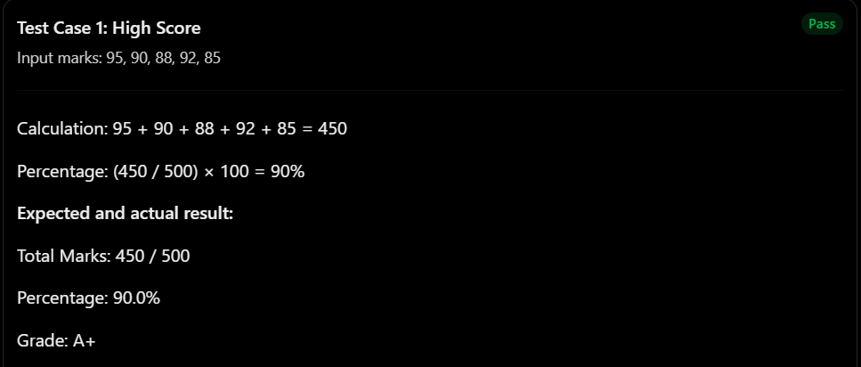
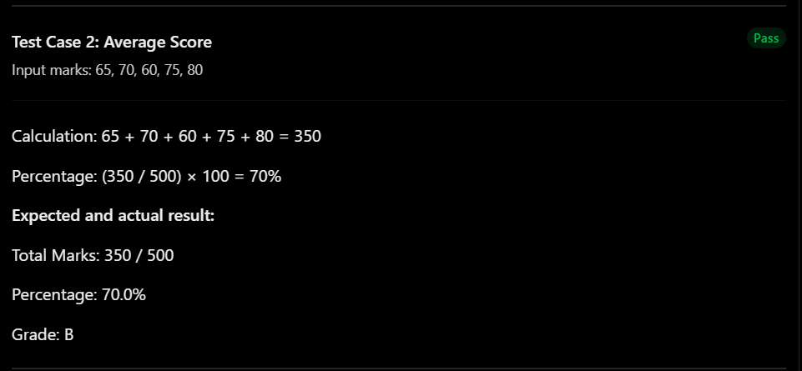
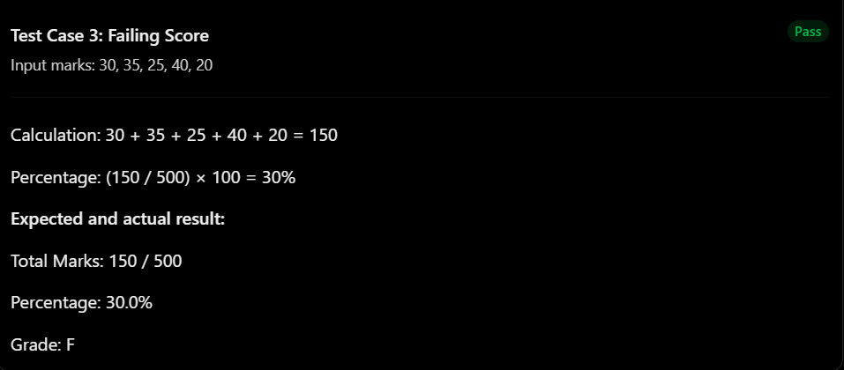

Additional validation tests-
Input | Expected program behaviour
-5 | Reject the marks and ask again.
105 | Reject the marks and ask again.
abc | Display an error message and ask again.
75 | Accept the marks.
These tests verify that the program handles invalid inputs without crashing.

Identifying and Correcting Errors-
During development, the following common errors should be checked.
Possible error | Correction
Using input() without converting the input to a number | Use float(input(...)) to accept numeric marks.
Accepting marks above 100 or below 0 | Add the condition 0 <= mark <= 100.
Dividing by 5 instead of 500 when calculating percentage | Use (total / 500) * 100.
Checking lower grades before higher grades | Check grade conditions from highest to lowest.
Program crashes when the user enters text | Use try-except ValueError.
Correction example: An incorrect grade calculation might check percentage >= 40 first. A score of 90% would then incorrectly receive Grade D. Placing the percentage >= 90 condition first fixes the problem.
The generated program already includes these corrections. The three test cases produce the expected grades, and the validation checks handle invalid marks.

Final Conclusion-
This question demonstrates how role prompting can guide an AI model to generate structured, beginner-friendly Python code. The Student Marks Management System accepts marks for five subjects, calculates the total and percentage, assigns grades, and validates user input.
Testing with high, average, and failing scores confirms that the calculations and grade conditions work as expected. Input validation also makes the program more reliable. Role prompting is therefore useful for generating code that includes explanations, testing, and basic error handling.

Question 4: AI as a Digital Marketing Expert.
Create a role prompt that instructs an AI model to act as a digital marketing strategist and develop a promotional campaign for a new online learning platform.
Tasks:
- Define the marketing role and target audience.
- Generate a seven-day social media content plan.
- Ask the AI to create captions, hashtags, and calls to action.
- Generate two versions of the prompt with different marketing roles or approaches.
- Compare the campaign ideas and justify which version is more suitable.
Deliverable: Two role prompts, campaign plans, and a comparison report.
Answers:
Prompt 1:
Act as a senior digital marketing strategist specializing in education technology and online learning platforms.
Your task is to create a seven-day promotional social media campaign for LearnSphere, a new online learning platform offering courses in Python, Artificial Intelligence, Data Science, and digital marketing.
Target audience: College students, fresh graduates, job seekers, and young professionals aged 18–25 who want to develop practical skills and improve their career opportunities.
Marketing objectives:
- Increase brand awareness and website traffic.
- Generate course sign-ups and enrollments.
- Communicate the value of practical, career-oriented learning.
Create a seven-day content calendar. For each day, provide:
- The content topic and objective.
- A social media post caption.
- Relevant hashtags.
- A clear call to action (CTA).
- A suggested content format, such as a carousel, Reel, infographic, or testimonial.
Use a professional, informative, and persuasive tone. Highlight practical skills, flexible learning, and career development. Avoid making unsupported claims about job placements, salaries, or guaranteed employment.
Conclude with two recommendations for measuring campaign performance and improving conversions.
Output 1:

Campaign Plan 1: Career-Focused Approach-
Marketing style: Professional, informative, and results-oriented.
Day | Content and Format | Caption | Hashtags | CTA
1. | Platform launch — Instagram Reel | “Meet LearnSphere! Your next step toward learning practical digital skills starts here.” | #LearnSphere #OnlineLearning #SkillDevelopment | Explore our courses today!
2. | Python introduction — Carousel | “New to coding? Start learning Python one step at a time and build your programming foundation.” | #PythonForBeginners #LearnPython #Coding | Discover our Python course.
3. | AI and Data Science — Infographic | “Curious about AI and Data Science? Start exploring the skills shaping today's digital world.” | #ArtificialIntelligence #DataScience #FutureSkills | Find a course that interests you.
4. | Learning benefits — Carousel | “Build your knowledge with structured lessons and learn at a pace that works for you.” | #OnlineEducation #LearnEveryday #Upskill | Visit LearnSphere to learn more.
5. | Sample lesson — Short video | “See what learning with LearnSphere looks like. Start with the basics and keep building your skills.” | #LearningJourney #TechSkills #LearnOnline | Watch and explore our courses.
6. | Student learning goals — Graphic | “Small learning steps can move you closer to your goals. What skill will you learn next?” | #StudentLife #CareerGrowth #SkillBuilding | Choose your next skill today.
7. | Weekly campaign recap — Carousel | “One week, new possibilities. Explore courses in Python, AI, Data Science, and digital marketing.” | #LearnSphere #CareerDevelopment #OnlineCourses | Browse courses and sign up.
Prompt 2:
Act as a creative social media marketing expert who specializes in storytelling, short-form videos, student engagement, and online community building.
Develop a seven-day social media campaign for LearnSphere, a new online learning platform that offers beginner-friendly courses in Python, Artificial Intelligence, Data Science, and digital marketing.
Target audience: College students, fresh graduates, and young people aged 18–25 who enjoy relatable content, want to learn new skills, and may feel uncertain about where to begin.
Marketing objectives:
- Make the LearnSphere brand memorable.
- Encourage comments, shares, saves, and audience participation.
- Build trust and motivate interested users to explore courses.
Create a seven-day content calendar. For each day, include:
- A creative topic and content format.
- An engaging, relatable caption.
- Relevant hashtags.
- A clear call to action.
- An idea for encouraging audience interaction.
Use a friendly, conversational, motivating tone. Include relatable student situations, quizzes, polls, challenges, and short videos. Keep captions suitable for Instagram and other social media platforms. Do not invent testimonials, learner success stories, or unsupported promises about careers.
Finish by explaining how the campaign can build an online learning community and convert interested followers into course visitors.
Output 2:

Campaign Plan 2: Creative and Engagement-Focused Approach-
Marketing style: Relatable, interactive, entertaining, and community-driven.
Day | Content and Format | Caption | Hashtags | CTA
1. | Launch Reel | “POV: You finally decide to learn that skill you've been postponing. Welcome to LearnSphere!” | #LearnSphere #StudentLife #NewBeginnings | Follow us for your learning journey.
2. | Coding meme — Image | “When your code finally runs without an error. That feeling deserves a celebration!” | #CodingMemes #PythonLife #LearnToCode | Tag a friend who codes!
3. | AI quiz — Instagram Story | “Quick quiz: Which technology helps computers learn patterns from data? Test your AI knowledge!” | #AIQuiz #ArtificialIntelligence #TechLearning | Vote in our poll.
4. | Skill challenge — Reel | “Your challenge: Spend 15 minutes learning something new today. What skill are you choosing?” | #LearningChallenge #DailyLearning #SkillUp | Comment with your chosen skill.
5. | Behind-the-scenes lesson — Reel | “Big topics become easier when you start with the basics. Let's learn one concept at a time.” | #LearnWithMe #StudyMotivation #OnlineLearning | Save this post for study time.
6. | Audience poll — Stories | “Choose your next learning adventure: Python, AI, Data Science, or Digital Marketing?” | #LearnSphere #StudentCommunity #FutureSkills | Vote and share your choice.
7. | Weekly recap — Reel | “Seven days of ideas, skills, and new beginnings. Your learning journey can start today!” | #LearnSphere #LearnSomethingNew #GrowthMindset | Visit our profile and explore courses.

Comparison of the Two Campaigns-
Evaluation Criteria | Prompt 1: Career-Focused | Prompt 2: Creative and Community-Focused
Marketing role | Senior digital marketing strategist | Creative social media marketing expert
Main objective | Website visits and course enrollment | Engagement and brand awareness
Tone | Professional and informative | Friendly and relatable
Content style | Educational carousels, infographics, and course previews | Memes, quizzes, polls, and Reels
Audience engagement | Encourages course exploration | Encourages comments, shares, and participation
Strength | Communicates course value clearly | Makes the brand memorable and encourages interaction
Limitation | May feel less entertaining | Engagement may not always lead to enrollments
Best use | Driving qualified traffic and sign-ups | Building an audience and growing brand awareness

Final Conclusion-
This question demonstrates how different role prompts can produce different marketing strategies for the same business. The career-focused prompt emphasizes educational value, website traffic, and enrollment, while the creative prompt emphasizes audience engagement, relatability, and community building.
Role prompting allows an AI model to adapt its tone, content ideas, and recommendations to a specific marketing objective. Combining both approaches can help LearnSphere build brand awareness while encouraging potential learners to explore and enroll in its courses.
Question 5: Multi-Role Prompting Challenge.
Use role prompting to solve a real-world problem by assigning three different roles to an AI model.
Scenario: A college wants to increase student attendance and classroom participation.
Tasks:
- Create a prompt for an Academic Coordinator to identify possible causes of low attendance.
- Create a prompt for a Data Analyst to analyze fictional student attendance data.
- Create a prompt for an Education Consultant to recommend practical improvement strategies.
- Compare the responses generated by all three roles.
- Combine the findings into a final action plan for the college.
Deliverable: Three role prompts, AI-generated responses, and a consolidated action plan.
Answers:
Prompt 1:
Act as an experienced Academic Coordinator at a college. Your task is to investigate why students have low attendance and limited classroom participation.
Identify possible causes, including teaching methods, timetable issues, transportation difficulties, academic pressure, lack of motivation, classroom environment, and personal responsibilities.
Explain how these factors may affect students. Suggest questions the college should ask students and teachers to understand the problem better.
Present your response in simple language, organize the causes into categories, and recommend initial steps the college can take. Do not assume that all students have the same difficulties or blame students without evidence.
Output 1:
As an Academic Coordinator, I would investigate the issue by gathering feedback from students, teachers, and department heads.
Possible causes of low attendance-
Category | Possible Cause | Effect on Students
Academic | Difficult subjects or unclear explanations | Students may lose interest or feel discouraged.
Teaching methods | Long lectures with limited interaction | Students may become less engaged.
Timetable | Early classes or long gaps between lectures | Students may struggle to attend regularly.
Personal factors | Family responsibilities or personal difficulties | Students may miss classes due to circumstances beyond their control.
Transportation | Long commuting distances or unreliable transport | Students may arrive late or miss classes.
Motivation | Students do not understand the practical value of lessons | They may not see a reason to attend regularly.
Classroom environment | Fear of asking questions or making mistakes | Students may avoid participating.
Questions to investigate-
- What are the main reasons students miss classes?
- Do students find the teaching methods understandable and engaging?
- Are timetable and transportation problems affecting attendance?
- Do students feel comfortable asking questions in class?
- Are students aware of attendance requirements and available academic support?
Initial recommendations-
- Conduct an anonymous student survey.
- Hold discussions with class representatives and teachers.
- Review attendance records by subject and time slot.
- Provide a supportive environment where students can discuss their difficulties.
- Identify students who need academic assistance before their performance declines.
The college should identify the actual causes before choosing solutions rather than assuming that low attendance results from laziness or lack of discipline.
Prompt 2:
Act as a professional Data Analyst specializing in educational data.
Analyze the following fictional attendance dataset for 100 college students. Each attendance percentage represents the proportion of classes attended during a semester.
Student Group | Number of Students | Average Attendance
Group A | 25 | 92%
Group B | 30 | 78%
Group C | 25 | 61%
Group D | 20 | 43%
Tasks:
- Calculate the overall average attendance percentage, weighted by the number of students in each group.
- Identify the groups with the highest and lowest attendance.
- Explain the patterns in the data.
- Recommend what additional data should be collected to understand low attendance.
- Provide data-driven suggestions for improving attendance and classroom participation.
Use tables and simple explanations. Clearly distinguish between findings supported by the dataset and possible explanations that require further investigation.
Output 2:
A. Overall attendance analysis-
The overall average must account for the number of students in each group.
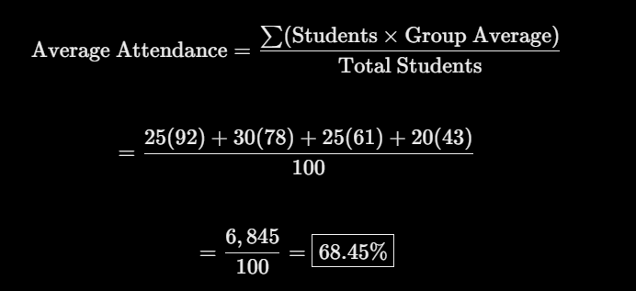
The overall weighted average attendance is 68.45%.
B. Group comparison-
Student Group | Students | Average Attendance | Observation
Group A | 25 | 92% | Highest attendance
Group B | 30 | 78% | Relatively high attendance
Group C | 25 | 61% | Attendance needs improvement
Group D | 20 | 43% | Lowest attendance
Average attendance by group.
Student Attendance by Group.
Fictional group averages for a semester.
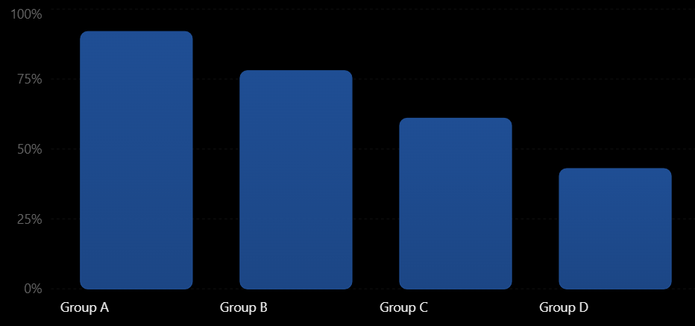
C. Key findings-
- Group A has the highest average attendance at 92%.
- Group D has the lowest average attendance at 43%, making it a priority for further investigation.
- Groups C and D average 61% and 43%, respectively, suggesting that attendance challenges may affect a substantial portion of the student population.
- The difference between Groups A and D is 49 percentage points.
D. Additional data required-
The dataset shows where attendance is low, but it does not explain why. The college should collect:
- Attendance by subject, day, and time slot.
- Anonymous student feedback on barriers to attending.
- Course performance and classroom participation data.
- Transportation and timetable difficulties, where students choose to disclose them.
- Teaching-method feedback and access to learning resources.
E. Data-driven recommendations-
- Investigate Group D first to understand its specific difficulties.
- Compare attendance across subjects and time slots to find recurring patterns.
- Track attendance and participation monthly to determine whether interventions are working.
- Compare results before and after introducing changes rather than assuming the changes caused improvement.
These conclusions are limited to the fictional data provided. The group labels do not establish the causes of low attendance, and the group averages do not reveal individual students' attendance rates.
Prompt 3:
Act as an experienced Education Consultant specializing in student engagement, classroom participation, and academic improvement.
A college is experiencing low student attendance and limited classroom participation. A fictional attendance analysis shows an overall average of 68.45%, with Group D having the lowest average at 43% and Group C at 61%.
Develop a practical improvement strategy for the college.
Your tasks:
- Recommend methods to improve student attendance.
- Suggest interactive teaching techniques to increase classroom participation.
- Explain how teachers, academic coordinators, and college management should contribute.
- Propose a 30-day implementation plan.
- Define measurable indicators to evaluate progress.
Prioritize affordable, inclusive, and student-friendly strategies. Avoid relying only on punishment or strict attendance rules. Explain how the college can use student feedback and attendance data to refine its approach.
Output 3:
As an Education Consultant, I recommend a supportive approach that combines engaging teaching methods, early intervention, and regular progress monitoring.
A. Practical improvement strategies-
Strategy | Implementation | Expected Benefit
Interactive teaching | Use quizzes, discussions, demonstrations, and group activities. | Makes lessons more engaging.
Student mentoring | Assign faculty mentors to students who need support. | Helps identify and address attendance barriers.
Early alerts | Contact students when attendance begins to decline. | Enables timely assistance.
Flexible academic support | Offer doubt-clearing sessions and revision classes. | Helps students who struggle with coursework.
Student feedback | Conduct anonymous surveys and class discussions. | Helps the college identify actual problems.
Recognition | Acknowledge consistent effort and improved participation. | Encourages positive habits without shaming students.
Timetable review | Investigate recurring problems with class timings and gaps. | May reduce avoidable attendance barriers.
B. Improving classroom participation-
Teachers should create an environment where students feel comfortable contributing. They can:
- Start lessons with a short question or quiz.
- Include pair discussions and small-group activities.
- Use real-world examples connected to students' interests.
- Invite questions without embarrassing students for incorrect answers.
- Offer different ways to participate, including written responses and digital polls.
C. Responsibilities-
- Academic Coordinator: Review attendance records, coordinate surveys, and follow up with departments.
- Teachers: Use interactive lessons, monitor participation, and offer academic support.
- College Management: Review timetable issues, provide resources, and support mentoring initiatives.
- Students: Share feedback, communicate barriers where possible, and participate in improvement activities.
D. Suggested 30-day plan-
Period | Action
Days 1–7 | Review attendance data, survey students, and identify major barriers.
Days 8–14 | Introduce interactive lessons, mentoring, and early-warning follow-ups.
Days 15–21 | Review attendance trends, gather feedback, and adjust teaching methods.
Days 22–30 | Compare results with the baseline and decide which strategies to continue.
E. Success indicators-
The college should measure attendance percentage, participation in classroom activities, student survey responses, and the number of students receiving academic support.
An initial target could be to increase overall attendance from 68.45% to 73% within 30 days, provided that the college verifies its baseline data and monitors results consistently. This is a proposed target, not a guaranteed outcome.
The college should evaluate progress alongside student feedback to ensure that any increase in attendance is accompanied by meaningful participation and a supportive learning environment.

Consolidated Action Plan for the College-
The college can combine the findings into the following plan.
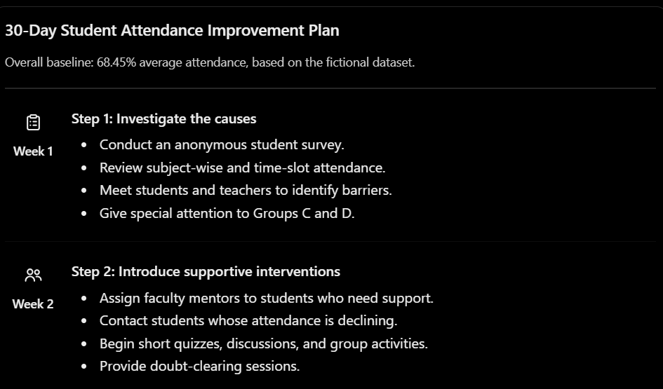
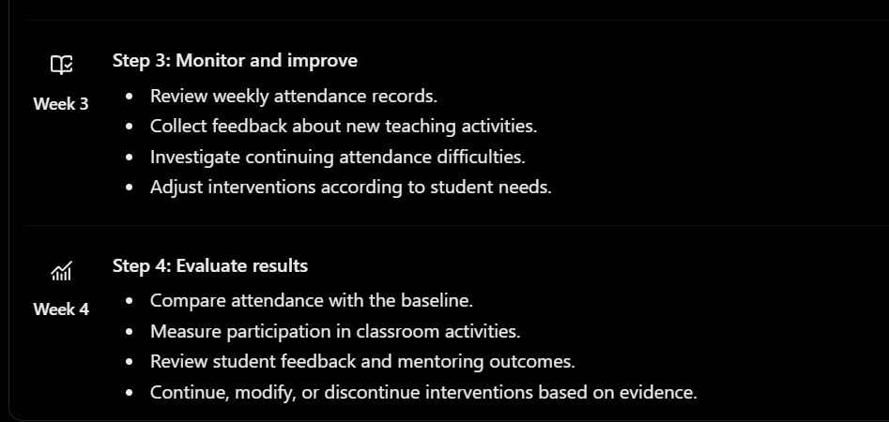

Proposed Performance Indicators-
Indicator | Baseline | Proposed 30-Day Target
Overall average attendance | 68.45% | 73%
Group C attendance | 61% | 66%
Group D attendance | 43% | 50%
Classroom participation | Not measured | Establish baseline in Week 1 and aim for improvement
Student feedback | Not collected | Complete an initial survey and a follow-up survey
These are proposed targets for planning purposes, not predictions. The college should consider class schedules, student circumstances, and the number of teaching days when interpreting the results.

Interpretation-
The three roles complement one another. The Academic Coordinator identifies questions that need answers, the Data Analyst uses evidence to prioritize areas of concern, and the Education Consultant translates the findings into practical interventions.
No single role provides a complete solution on its own. Combining the three perspectives produces a more balanced and evidence-based approach.

Comparison of Responses Generated by All Three Roles-
Evaluation Criteria | Academic Coordinator | Data Analyst | Education Consultant
Main focus | Identifying possible causes | Measuring and interpreting attendance | Designing improvement strategies
Approach | Surveys, interviews, and academic reviews | Calculations, comparisons, and trends | Practical interventions and implementation
Main finding | Attendance may be affected by academic, personal, and environmental factors. | Overall attendance is 68.45%, with Group D lowest at 43%. | A combination of student support and interactive teaching may help improve attendance.
Main contribution | Explains what needs investigation | Identifies where intervention may be most needed | Explains how the college can respond
Limitation | Possible causes are not yet verified | Data alone cannot explain the reasons | Strategies need to be tested and evaluated
Best use | Diagnosing the problem | Setting priorities and measuring progress | Implementing and evaluating solutions

Final Conclusion-
This assignment demonstrates the value of multi-role prompting in solving a real-world educational problem.
- The Academic Coordinator identifies possible reasons for low attendance.
- The Data Analyst calculates attendance averages and identifies groups that need attention.
- The Education Consultant develops practical strategies and a measurable implementation plan.
By combining these perspectives, the college can move from identifying a problem to implementing and evaluating solutions. The recommended approach focuses on evidence, student support, interactive teaching, and continuous monitoring rather than punishment alone.
Multi-role prompting helps an AI model examine a problem from different professional perspectives, resulting in a more complete and actionable solution.

