**A2: Agent-based control of a production system**

[Return to: Multi-agent sys...](https://moodle2.tut.fi/course/view.php?id=10230&sesskey=yLIIimzglm#section-2)

**Environment**:

* Production line simulator  
-- [http://escop.rd.tut.fi:3000](http://escop.rd.tut.fi:3000/)  
* The physical line  
-- Located in Ri208.  
* Node.js  
-- <https://nodejs.org/en/>  
* Visual Paradigm (Community Edition)  
-- <https://www.visual-paradigm.com/download/community.jsp>  
* WebStorm IDE  
-- <https://www.jetbrains.com/student/>

**Skills to be attained and checked**:  
* Understanding of MAS principles - where and how to apply it.  
* Ability to model and solve problem using the MAS methodology.  
* Ability to apply the MAS methodology for distributed automation systems.  
  
**Task description**:

The production system (physically located in Ri208, simulator of the system - [http://escop.rd.tut.fi:3000](http://escop.rd.tut.fi:3000/)) is composed of 12 work stations. The line makes mobile phones that can come in 729 variations (3 screen shapes * 3 colours * 3 keyboard shapes * 3 colours * 3 frame shapes * 3 colours). 10 workstations (WS2-WS6; WS8-WS12) are in charge of making mentioned frames, screens and keyboards. A product can be seen as a combination of a frame, a screen and a keyboard.

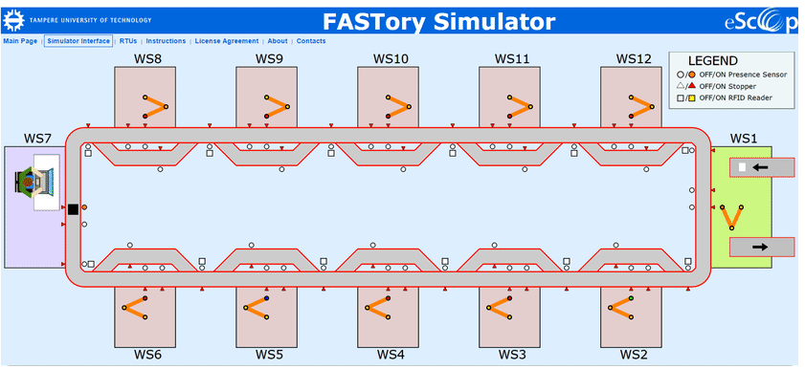

The line should be controlled using MAS (Multi-Agent System). You have to identify what is an agent in the context of given production line, then implement the agents using Node.js and demonstrate the approach by actually controlling the line.

As a system receives an order to make a mobile phone, the agents should negotiate between each other developing the way to make the phone and then executing actual production of the phone.

**Report**:

The report for a group of maximum 3 people should be submitted as a single ZIP file (only ZIP allowed):  
* Report (doc or pdf) presenting design diagrams and explanations how your solution works - how you identified the agents, their behaviours and messaging. UML sequence diagrams must be used for explanation of protocols and messaging between the agents. +Involvement of each group member (everyone in the group should understand and be able to explain different artefacts of the assignments).  
* Code - implementation of the agents - the project, with the explanations (README.txt), which would be possible to run to check your work.  
* Video (can be taken with a mobile phone or screen capturing software) telling about basic features of the MAS solution you have developed.

DL:**Thu. 27.04., 15:00** (server time) [No-**no**extensions will be available]