Reproducible AI-Assisted Earthquake Early Warning Research for Western Seismic Regions
  - Method Development on a California FDSN Pilot with Transfer Path to European Networks
29 July 2026
Table of Contents

Reproducible AI-Assisted Earthquake Early Warning Research for Western Seismic Regions

Method Development on a California FDSN Pilot with Transfer Path to European Networks
Final Research Proposal and Technical Report (Deliverable D-F1)
AMGCR Earthquake Research
29 July 2026

Certificate and programme statement
This report is submitted in partial fulfilment of research requirements for the Swiss certificate programme in Assessment and Management of Geological and Climate Related Risk (AMGCR), as defined in docs/PROJECT_CHARTER.md and docs/RESEARCH_DIRECTION.md.
The primary long-term research focus of the programme is Earthquake Early Warning (EEW) methodology for European seismic networks. The United States (California) FDSN pilot documented herein is a completed methods laboratory, not the intended final deployment geography.
All quantitative results in this document are drawn from existing repository artefacts and phase reports dated 2026-07-29. This final report does not re-run analysis scripts or introduce new scientific computations.
Evidence note: The repository does not record a student author name or CERG edition number. Programme affiliation text above is taken from reports/Research_Proposal_v1.md and docs/PROJECT_CHARTER.md only.

Executive summary
The AMGCR Earthquake Research project delivers a documented, script-driven workflow from FDSN earthquake catalogues and waveforms to machine-learning-ready features, aligned with European expectations for transparent natural-hazard research. Using ObsPy and public USGS (events) and EarthScope (waveforms) services, the pilot acquired eight vertical broadband (BHZ) MiniSEED recordings (magnitudes 4.05–4.87, 2024), performed exploratory data analysis, STA/LTA-based onsite metrics, band-limited preprocessing, and extraction of an 8×18 feature matrix.
Main findings (completed pilot):
- A reproducible end-to-end chain exists from manifest CSV through tables, JSON summaries, and figures under reports/.
- Raw amplitudes in digital counts vary by orders of magnitude across events and stations (CI.ADO vs CI.USC), reflecting path, site, and gain—not a homogeneous magnitude–amplitude relation at N=8.
- P-wave trigger times from STA/LTA range 10.15–55.15 s after trace start; late picks on several records indicate trigger limitations without pre-event windows or analyst validation.
- Preprocessing improves visual clarity and band-limited SNR proxies (mean peak-SNR 137 raw → 1684 filtered), but instrument response removal was not applied (0/8); amplitudes remain in counts, not physical ground-motion units.
- Feature statistics and correlations are illustrative only at eight events; amplitude-derived features are highly collinear, while crest factor, entropies, and zero-crossing rate offer complementary shape information.
EarthESND (Joshi, Singh, and Raman, 2026) is retained as a complete reference implementation (88 passing tests on a full checkout) for future comparative ML studies—not as the geographic or scientific endpoint of this certificate work.
European context: The same manifest-and-report pattern is proposed for ORFEUS/EIDA-class archives. No European waveform dataset is included in the completed pilot.
Submission artefacts: Raw MiniSEED, local acquisition logs, and generated PNG figures may be absent from Git clones (.gitignore); see Appendix C and docs/FINAL_DELIVERABLE_AUDIT.md.

Abstract
Earthquake Early Warning (EEW) delivers rapid estimates of ground shaking ahead of destructive S-wave arrival, combining seismological data acquisition, onsite triggering, signal processing, and increasingly machine-learning-based magnitude and intensity prediction. European programmes require transparent, reproducible workflows that can be audited, extended across national networks, and aligned with open data policies, yet many published pipelines remain tied to region-specific archives or proprietary tooling.
This report presents the AMGCR Earthquake Research project: a European-focused certificate programme whose primary long-term target is EEW-oriented analysis on European seismic networks, while California serves as the completed pilot implementation for method validation. Using ObsPy and FDSN services (USGS event metadata; EarthScope waveforms), we acquired eight MiniSEED recordings (magnitude 4.05–4.87, 2024), executed exploratory data analysis, STA/LTA-based signal characterisation, documented preprocessing, and extraction of an 8×18 feature matrix. Results confirm a reproducible path from raw waveforms to machine-learning-ready descriptors, while exposing limitations—origin-aligned download windows, absent instrument response correction in the pilot run, small sample size, and station-selection bias—that must be addressed before operational European deployment.
The repository retains a complete EarthESND reference implementation (echo state network with dendritic readout) only as a literature and architecture benchmark, not as the programme’s scientific endpoint. Proposed future work includes scaling datasets, integrating ORFEUS/EIDA-class European archives, response-corrected amplitudes, and comparative evaluation of modern onsite AI models including EarthESND-inspired designs on Western data.
Keywords: earthquake early warning; ObsPy; FDSN; reproducible research; feature engineering; Europe; California pilot; machine learning; STA/LTA; EarthScope; USGS

Table of contents
- Introduction
- Literature review
- Research gap
- Objectives
- Dataset
- Methodology
- California pilot workflow and execution
- Results
- Discussion
- Limitations and threats to validity
- European context and transfer
- Future work and expected outcomes
- Conclusion
- References
- Statement of evidence support
- Appendix A — Pilot event and station tables
- Appendix B — Reproducibility statement (D-S1)
- Appendix C — Data availability and ethics statement (D-S2)
- Appendix D — Supplementary per-event figures
- Appendix E — Machine-readable summary index

List of figures
Figure | File | Section
Figure 1 | figures/example_waveform_raw.png | §8.1
Figure 2 | figures/magnitude_histogram.png | §8.1
Figure 3 | figures/events_over_time.png | §8.1
Figure 4 | figures/station_usage_frequency.png | §8.1
Figure 5 | figures/signal_analysis_ci40675215.png | §8.2
Figure 6 | figures/signal_analysis_ci40699207.png | §8.2
Figure 7 | figures/preprocessing_ci40675215.png | §8.3
Figure 8 | figures/preprocessing_ci40699207.png | §8.3
Figure 9 | figures/feature_engineering_fft_spectra.png | §8.4
Figure 10 | figures/feature_correlation_heatmap.png | §8.4
Figure 11 | figures/feature_distributions.png | §8.4
Figure 12 | figures/feature_boxplots_by_station.png | §8.4
Figure D1–D6 | figures/signal_analysis_ci40593503.png … (see Appendix D) | Appendix D
Figure D7–D12 | figures/preprocessing_ci40593503.png … (see Appendix D) | Appendix D
All paths relative to this file’s directory (reports/). Full set: 24 PNGs per docs/FINAL_DELIVERABLE_AUDIT.md.

List of tables
Table | Source | Section
Table 1 | Pilot dataset attributes | §5.1
Table 2 | FDSN query parameters (summary) | §5.2
Table 3 | Objectives and status | §4
Table 4 | Preprocessing parameters | §6.4
Table 5 | Aggregate signal metrics | §8.2
Table 6 | Station-level signal contrasts | §8.2
Table 7 | Preprocessing SNR aggregates | §8.3
Table 8 | Feature domains (18 features) | §6.5
Table 9 | Threats to validity | §10.2
Table A1 | Event summary | Appendix A
Table A2 | Station summary | Appendix A
Full CSV exports: reports/tables/ and reports/features/feature_matrix.csv.

1. Introduction

1.1 Motivation
Damaging earthquakes remain a major risk in Europe and adjacent regions, from the Mediterranean belt to the Alps and anthropogenic seismicity associated with industrial activity. EEW systems mitigate harm by issuing alerts seconds to tens of seconds before strong shaking arrives at a site, based on P-wave detection, rapid magnitude estimation, and ground-motion prediction. Public acceptance, regulatory frameworks, and civil-protection integration—in Switzerland and across the EU—increasingly expect documented, open methodologies rather than black-box prototypes.

1.2 Programme positioning
The project was initiated within a Swiss certificate programme in geophysical risk assessment, aligned with European expectations for traceable analysis (open data, documented processing, explicit limitations). Initial effort targeted reproduction of the EarthESND architecture (Joshi, Singh, and Raman, 2026), producing a test-backed reference codebase preserved for methodological comparison only. Programme guidance subsequently reframed the work toward a logical European EEW research project with real waveforms, theory, visualisation, tables, and formal reporting—using California FDSN data as a completed pilot laboratory (docs/PROJECT_CHARTER.md, docs/RESEARCH_DIRECTION.md).

1.3 Scope of this document
This final report (D-F1) supersedes reports/Research_Proposal_v1.md as the submission-oriented consolidation. It synthesises completed pilot work (acquisition through interpretation) and proposed extensions (European data, scale, AI evaluation, real-time paths). Sources: phase reports under docs/, artefacts under reports/, docs/REPRODUCIBILITY_STATEMENT.md, docs/DATA_AVAILABILITY_STATEMENT.md, and docs/FINAL_DELIVERABLE_AUDIT.md.

1.4 Document control
Field | Value
Deliverable | D-F1 Final Research Proposal / Technical Report
Version | 1.0
Date | 29 July 2026
Prior version | Research Proposal v1.0 (reports/Research_Proposal_v1.md)
Pilot freeze date | 2026-07-29 (phase reports)

2. Literature review

2.1 Earthquake Early Warning fundamentals
Classical EEW relies on onsite algorithms that detect P-wave onset via STA/LTA ratio tests or similar triggers, then estimate magnitude and alert levels from early windows of acceleration or velocity (Allen and Kanamori, 2003; Hoshiba et al., 2008). Key trade-offs include detection latency, false alarm rate, and magnitude saturation for large events. European deployments emphasise standardised metadata, latency budgets, and uncertainty communication to end users.

2.2 Open seismological software and data
ObsPy (Krischer et al., 2015) provides a standard interface for MiniSEED, FDSN web services, detrending, filtering, and instrument correction. FDSN federates event and waveform services; in this project, USGS supplies catalogues and EarthScope supplies waveforms (docs/IRIS_DATASET_REPORT.md). The same abstraction is intended for European endpoints (ORFEUS, EIDA, national nodes).

2.3 Machine learning in onsite EEW
Deep learning and reservoir computing approaches learn magnitude or intensity from early waveform segments but require large, diverse training sets and careful handling of site effects and instrument response. EarthESND proposes a multiscale ESN with DENN readout for onsite magnitude estimation in a Japan K-NET context. In AMGCR, EarthESND is implemented as reference pipeline code (src/, automated tests) for architecture comparison, not as the primary certificate geographic focus.

2.4 Reproducibility in computational seismology
Reproducible EEW research demands versioned download parameters, manifests, processing configs, and analysis scripts. This project institutionalises that pattern through CSV manifests, JSON summaries, and phase reports.

2.5 European and Swiss context
ORFEUS, EIDA, and member-state networks provide the intended long-term data plane. The California pilot functions as a methods prototype while the scientific narrative remains Europe-forward (docs/PROJECT_CHARTER.md).

3. Research gap
- European programme need vs. Japan-centric ML papers: Transferable, documented workflows for European FDSN data are less commonly packaged for certificate-level research.
- End-to-end openness: Many studies lack full artifact trails from raw MiniSEED to feature matrices.
- Separation of benchmark code and active science: This project decouples EarthESND software completion from Western pilot analysis (docs/RESEARCH_DIRECTION.md).
- Pilot-scale validity: Small-N pilots illustrate methodology but cannot support operational EEW claims—the gap to validated European input remains explicit.

4. Objectives

4.1 Primary objective (programme)
Develop a reproducible, AI-ready EEW research workflow aimed ultimately at European seismic networks, documented for a Swiss/European research audience.

4.2 Secondary objective (pilot — completed)
Implement and validate the workflow on a California IRIS/EarthScope pilot: acquisition, EDA, signal analysis, preprocessing, feature engineering, and interpretation.

4.3 Specific objectives
Table 3 — Objectives and status
ID | Objective | Status
O1 | FDSN-based download of real earthquake waveforms with ObsPy | Completed
O2 | Exploratory dataset characterisation | Completed
O3 | Onsite-style signal metrics and STA/LTA P-wave analysis | Completed
O4 | Documented preprocessing chain toward ML inputs | Completed (response step 0/8; documented)
O5 | Multi-domain feature matrix for EEW/ML experiments | Completed (8×18)
O6 | Scientific interpretation and European transfer narrative | Completed
O7 | European FDSN pilot and scaled catalogues | Proposed
O8 | AI model training on Western data | Proposed
O9 | Real-time / latency-oriented prototype | Proposed
O10 | Research Proposal & Technical Report | Completed (v1); superseded by this D-F1 report

5. Dataset

5.1 Completed California pilot
Table 1 — Pilot dataset attributes (sources: docs/IRIS_DATASET_REPORT.md, docs/EDA_REPORT.md, reports/eda/dataset_summary.json)
Attribute | Value
Region | California bounding box, 2024
Event provider | USGS FDSN Event
Waveform provider | EarthScope (Client("EARTHSCOPE"))
Events in manifest | 8
Magnitude range | 4.05 – 4.87 (mw, ml)
Origin times (UTC) | 2024-05-01 – 2024-10-25
Channel | BHZ
Sampling rate | 40 Hz
Window | 300 s from catalog origin time
Stations (manifest) | CI.ADO (6 events), CI.USC (2 events)
Manifest path | data/manifests/iris_california_pilot_events.csv
Raw waveforms (local) | data/raw/iris/
Legacy files: EDA recorded twelve MiniSEED files on disk at run time; four lie outside the current manifest (reports/eda/mseed_file_inspection.csv). All completed analyses use eight manifest-linked records only.

5.2 FDSN acquisition parameters (summary)
Table 2 — FDSN query parameters (from docs/IRIS_DATASET_REPORT.md)
Parameter | Event search (USGS) | Waveform download (EarthScope)
Time window | 2024-01-01 – 2024-12-31 | 300 s from origin
Latitude | 32.5° – 42.0° N | —
Longitude | −124.5° – −114.0° E | —
Magnitude | 4.0 – 7.5 | —
Networks (candidates) | — | CI, NC, BK
Channel | — | BHZ (may try HHZ/EHZ)
Stations per event | — | 1 (first successful candidate)
Catalog matches (query) | 41 | —
Events retained | 8 | 8 waveforms
Station selection uses a fixed distance-ranked candidate list; this is not uniform network sampling.

5.3 European dataset (proposed)
No European waveforms are included. Future work is expected to mirror manifest and report patterns for EIDA/ORFEUS (docs/PROJECT_CHARTER.md, docs/ROADMAP.md).

5.4 Published tables and matrices
- reports/tables/event_summary.csv, station_summary.csv
- reports/tables/signal_analysis_per_event.csv
- reports/tables/preprocessing_quality_metrics.csv
- reports/features/feature_matrix.csv, reports/tables/feature_correlation_matrix.csv

6. Methodology

6.1 Acquisition (completed)
Script: scripts/download/download_iris_california_pilot.py. Events from USGS; waveforms from EarthScope dataselect. Parameters and results: docs/IRIS_DATASET_REPORT.md, logs/iris_california_pilot_summary.json (local, gitignored).

6.2 Exploratory data analysis (Phase A.1)
Script: scripts/analysis/run_california_pilot_eda.py. ObsPy inspection of all .mseed under data/raw/iris/; cohort summaries for manifest events only (docs/EDA_REPORT.md).

6.3 Signal analysis (Phase A.2)
Script: scripts/analysis/run_california_signal_analysis.py. Per trace: peak/RMS amplitudes, noise RMS from 0–5 s proxy, peak SNR, STA/LTA P pick (STA 0.5 s, LTA 10 s, threshold 2.5, ObsPy classic_sta_lta), signal duration (docs/SIGNAL_ANALYSIS_REPORT.md).

6.4 Preprocessing (Phase B.1)
Script: scripts/analysis/run_california_preprocessing.py. Frozen config: reports/preprocessing/preprocessing_config.json.
Table 4 — Preprocessing parameters
Step | Setting
Demean | Mean removal
Detrend | Linear
Taper | Hann, 5%
Band-pass | 0.1–15 Hz, four corners, zero-phase
Instrument response | EarthScope level=response → velocity (attempted)
Normalisation | Peak absolute amplitude
Outcome: Response removal 0/8 applied (skipped); filtered traces remain in counts (docs/PREPROCESSING_REPORT.md §4). Stages: reports/preprocessing/<short_id>_stages.npz.

6.5 Feature engineering (Phase B.2)
Script: scripts/analysis/run_california_feature_engineering.py. 18 features from filtered traces; P times from Phase A.2 metrics JSON (docs/FEATURE_ENGINEERING_REPORT.md).
Table 8 — Feature domains (18 features)
Domain | Count | Examples (repository names)
Time-domain | 9 | peak_amplitude, rms, crest_factor, zero_crossing_rate_hz, signal_entropy, …
Frequency-domain | 5 | dominant_frequency_hz, spectral_centroid_hz, spectral_bandwidth_hz, spectral_rolloff_95_hz, spectral_entropy
Earthquake-related | 4 | p_arrival_time_s, signal_duration_s, pgm_proxy_counts, arias_intensity_counts2_s_proxy
FFT spectra are figure-only (not matrix columns). PGM and Arias entries are counts-based proxies, not physical PGA or standard Arias intensity.

6.6 EarthESND reference (not primary experiment)
Full EarthESND-aligned implementation in src/ with 88 passing tests on a complete checkout. K-NET scientific reproduction is not started. California pilot results did not use EarthESND modules (docs/RESULTS_AND_DISCUSSION.md §1).

7. California pilot workflow and execution
[Completed] USGS + EarthScope download → MiniSEED + CSV manifest
[Completed] Phase A.1 EDA → reports/eda/, four summary figures
[Completed] Phase A.2 Signal analysis → STA/LTA, SNR, eight four-panel figures
[Completed] Phase B.1 Preprocessing → stage NPZ, eight comparison figures
[Completed] Phase B.2 Features → 8×18 matrix, four feature figures
[Completed] Phase C Interpretation → docs/RESULTS_AND_DISCUSSION.md
[Completed] Deliverable 1 → Research_Proposal_v1.md
[Completed] D-S1/D-S2 → Reproducibility & data availability statements
[Completed] D-F1 → this document
[Proposed] European acquisition, response cache, larger N, ML, real-time
Reproduction commands: Appendix B. The EarthESND reference track remains optional (docs/PAPER_REPRODUCTION.md).

8. Results
Primary synthesis: docs/RESULTS_AND_DISCUSSION.md. No new numbers below.

8.1 Exploratory data analysis
Eight events occupy a narrow M 4–5 band; CI.ADO supplies six of eight traces. Figures 1–4 summarise raw example, magnitude distribution, temporal coverage, and station usage.
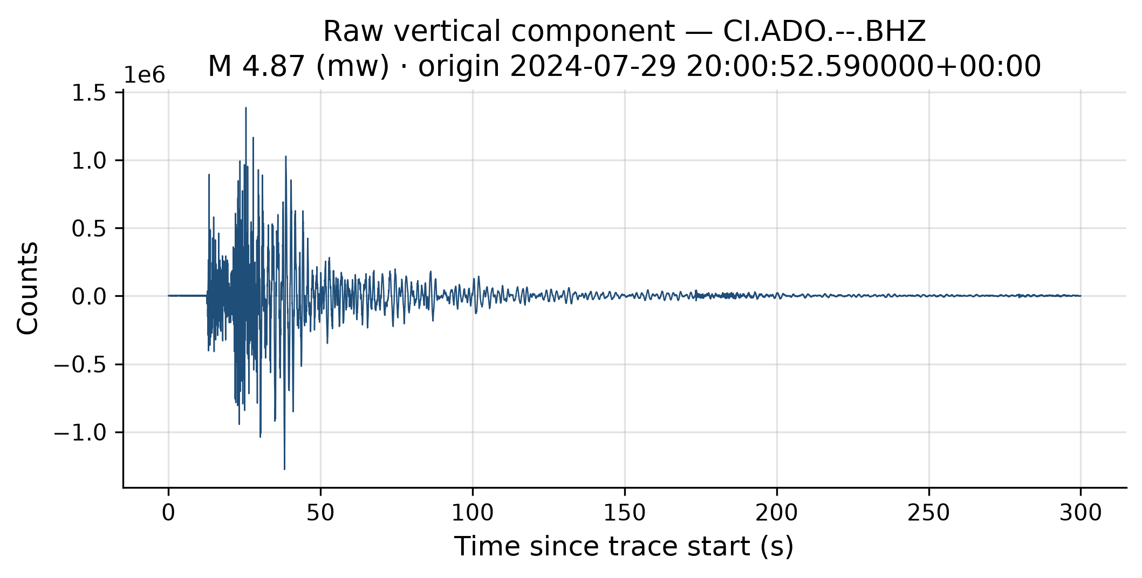
Figure 1: Raw BHZ record (highest pilot magnitude M 4.87, CI.ADO); amplitudes in digital counts, 300 s window from trace start.
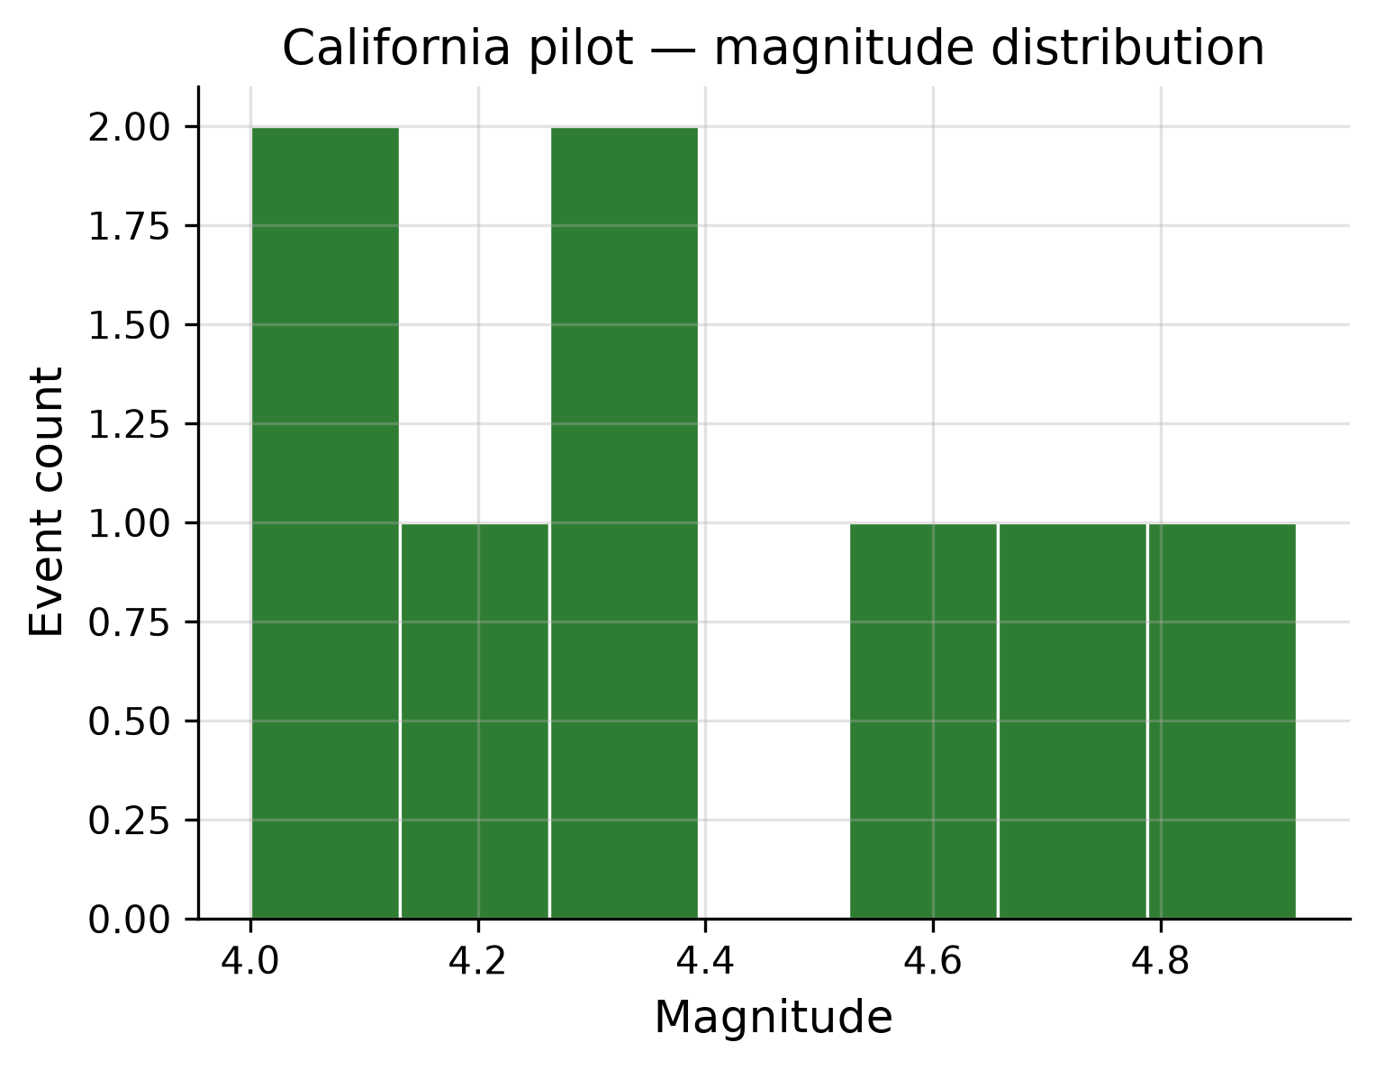
Figure 2: Magnitude distribution for eight manifest events.
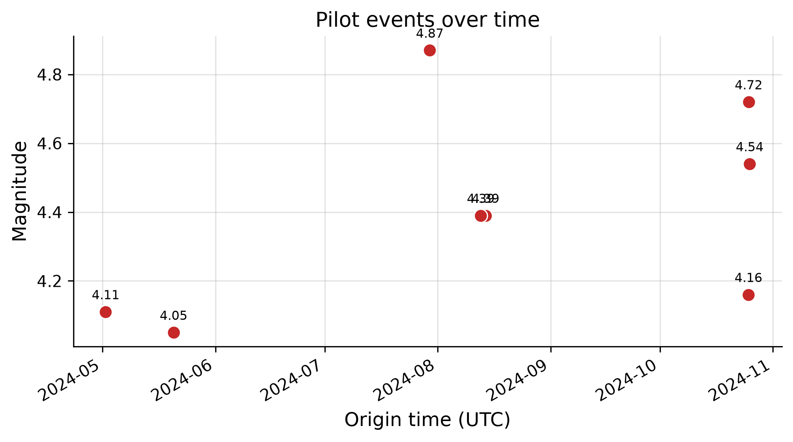
Figure 3: Origin time versus magnitude for manifest events.
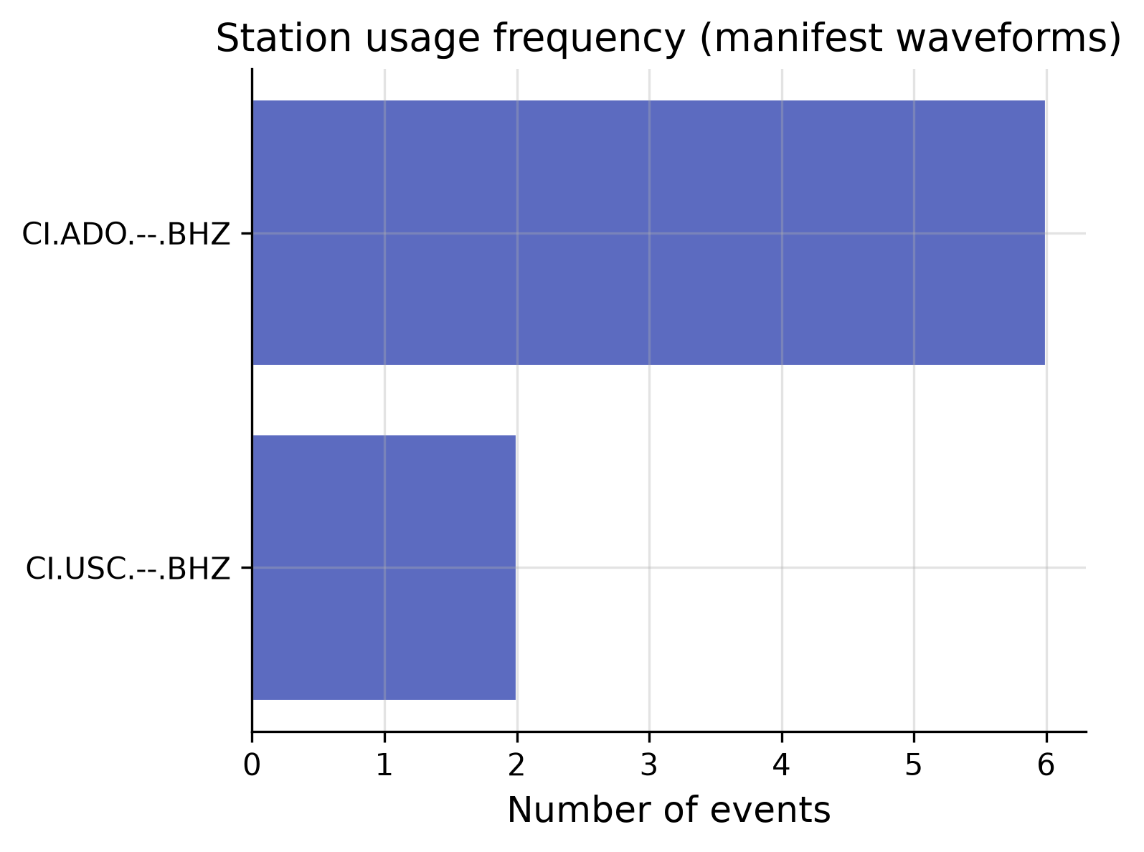
Figure 4: Station usage frequency (CI.ADO vs CI.USC).
Interpretation (docs/RESULTS_AND_DISCUSSION.md §2.3): The histogram reflects query cutoffs, not regional completeness. Temporal gaps reflect download success. ADO dominance is structural bias from the acquisition script.

8.2 Signal analysis and waveform behaviour
Peak raw amplitudes span approximately 1.7×10⁴ to 3.5×10⁶ counts (reports/signal_analysis/signal_analysis_summary.json).
Table 5 — Aggregate signal metrics (8 events)
Quantity | Value
P pick (s from trace start) | 10.15 – 55.15 (mean 31.3)
SNR (peak), raw | 6.3 – 778 (median 49.9)
Signal duration (post-P proxy) | 0 – 289.5 s (mean 183.2)
Table 6 — Station contrasts (signal_analysis_summary.json)
Station | n | Mean SNR (peak) | Mean P pick (s) | Mean peak (counts)
CI.ADO | 6 | 169 | 30.5 | 2.98×10⁵
CI.USC | 2 | 42 | 33.6 | 1.83×10⁶
Figure 5 shows ci40675215 (M 4.87, high SNR, early pick ~10.2 s). Figure 6 shows ci40699207 at CI.USC (SNR ~6, duration 0 s), illustrating noise-window contamination when downloads start at origin time.
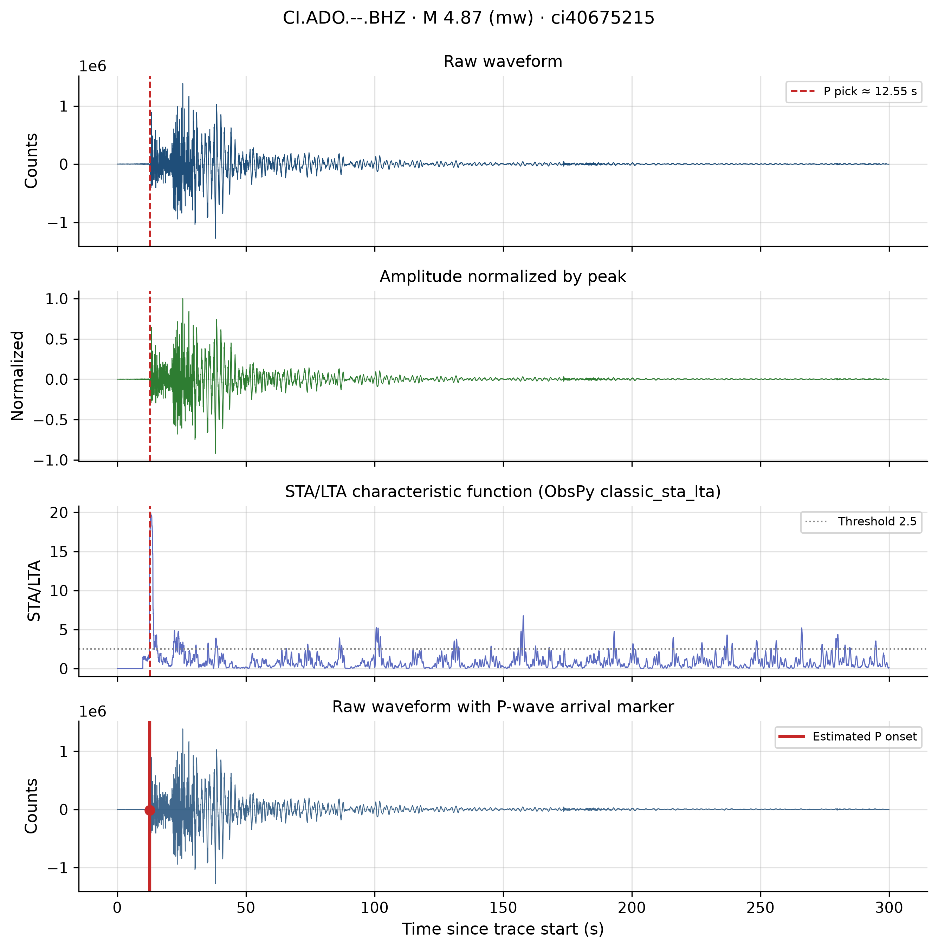
Figure 5: Signal analysis panels for ci40675215 (raw, normalized, STA/LTA, P marker).
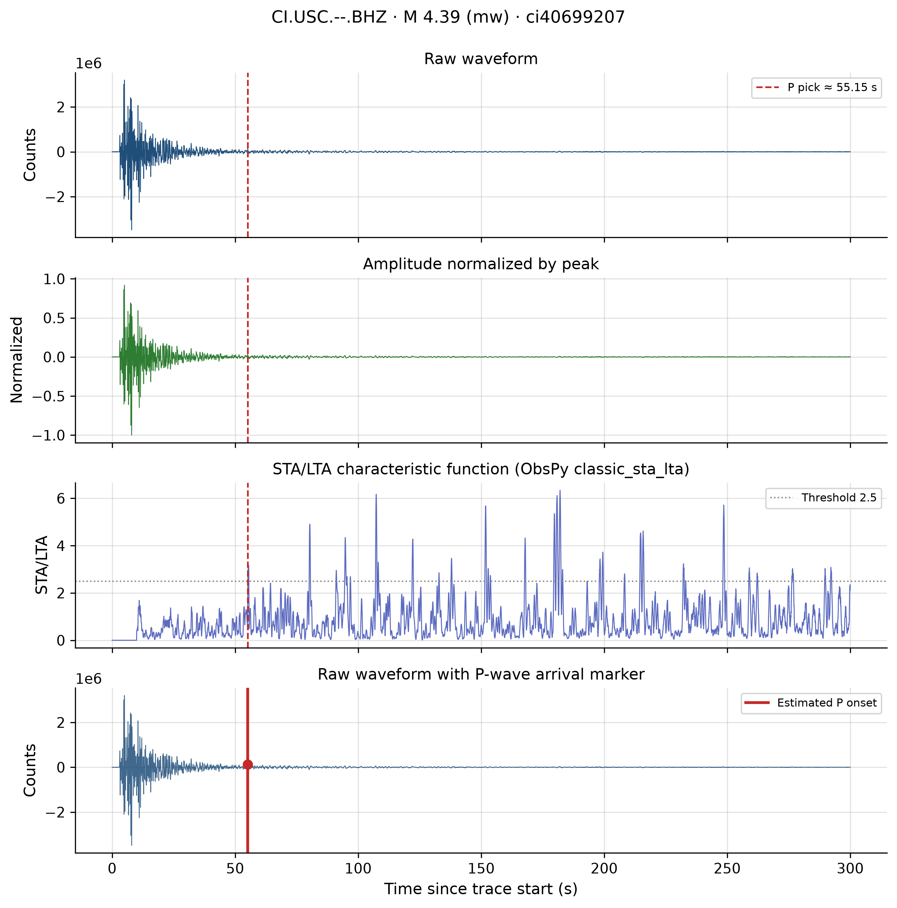
Figure 6: Signal analysis panels for ci40699207 (low peak-SNR case at USC).

8.3 Preprocessing
Table 7 — Aggregate peak-SNR proxy
Stage | Mean SNR (peak)
Raw | 137
Filtered (pre-normalization) | 1684
Filtered/raw SNR ratio range 2.5–27.6 (mean 17.1). Figures 7–8 show four-panel progressions (raw → detrended → filtered → normalized) for the same events as Figures 5–6.
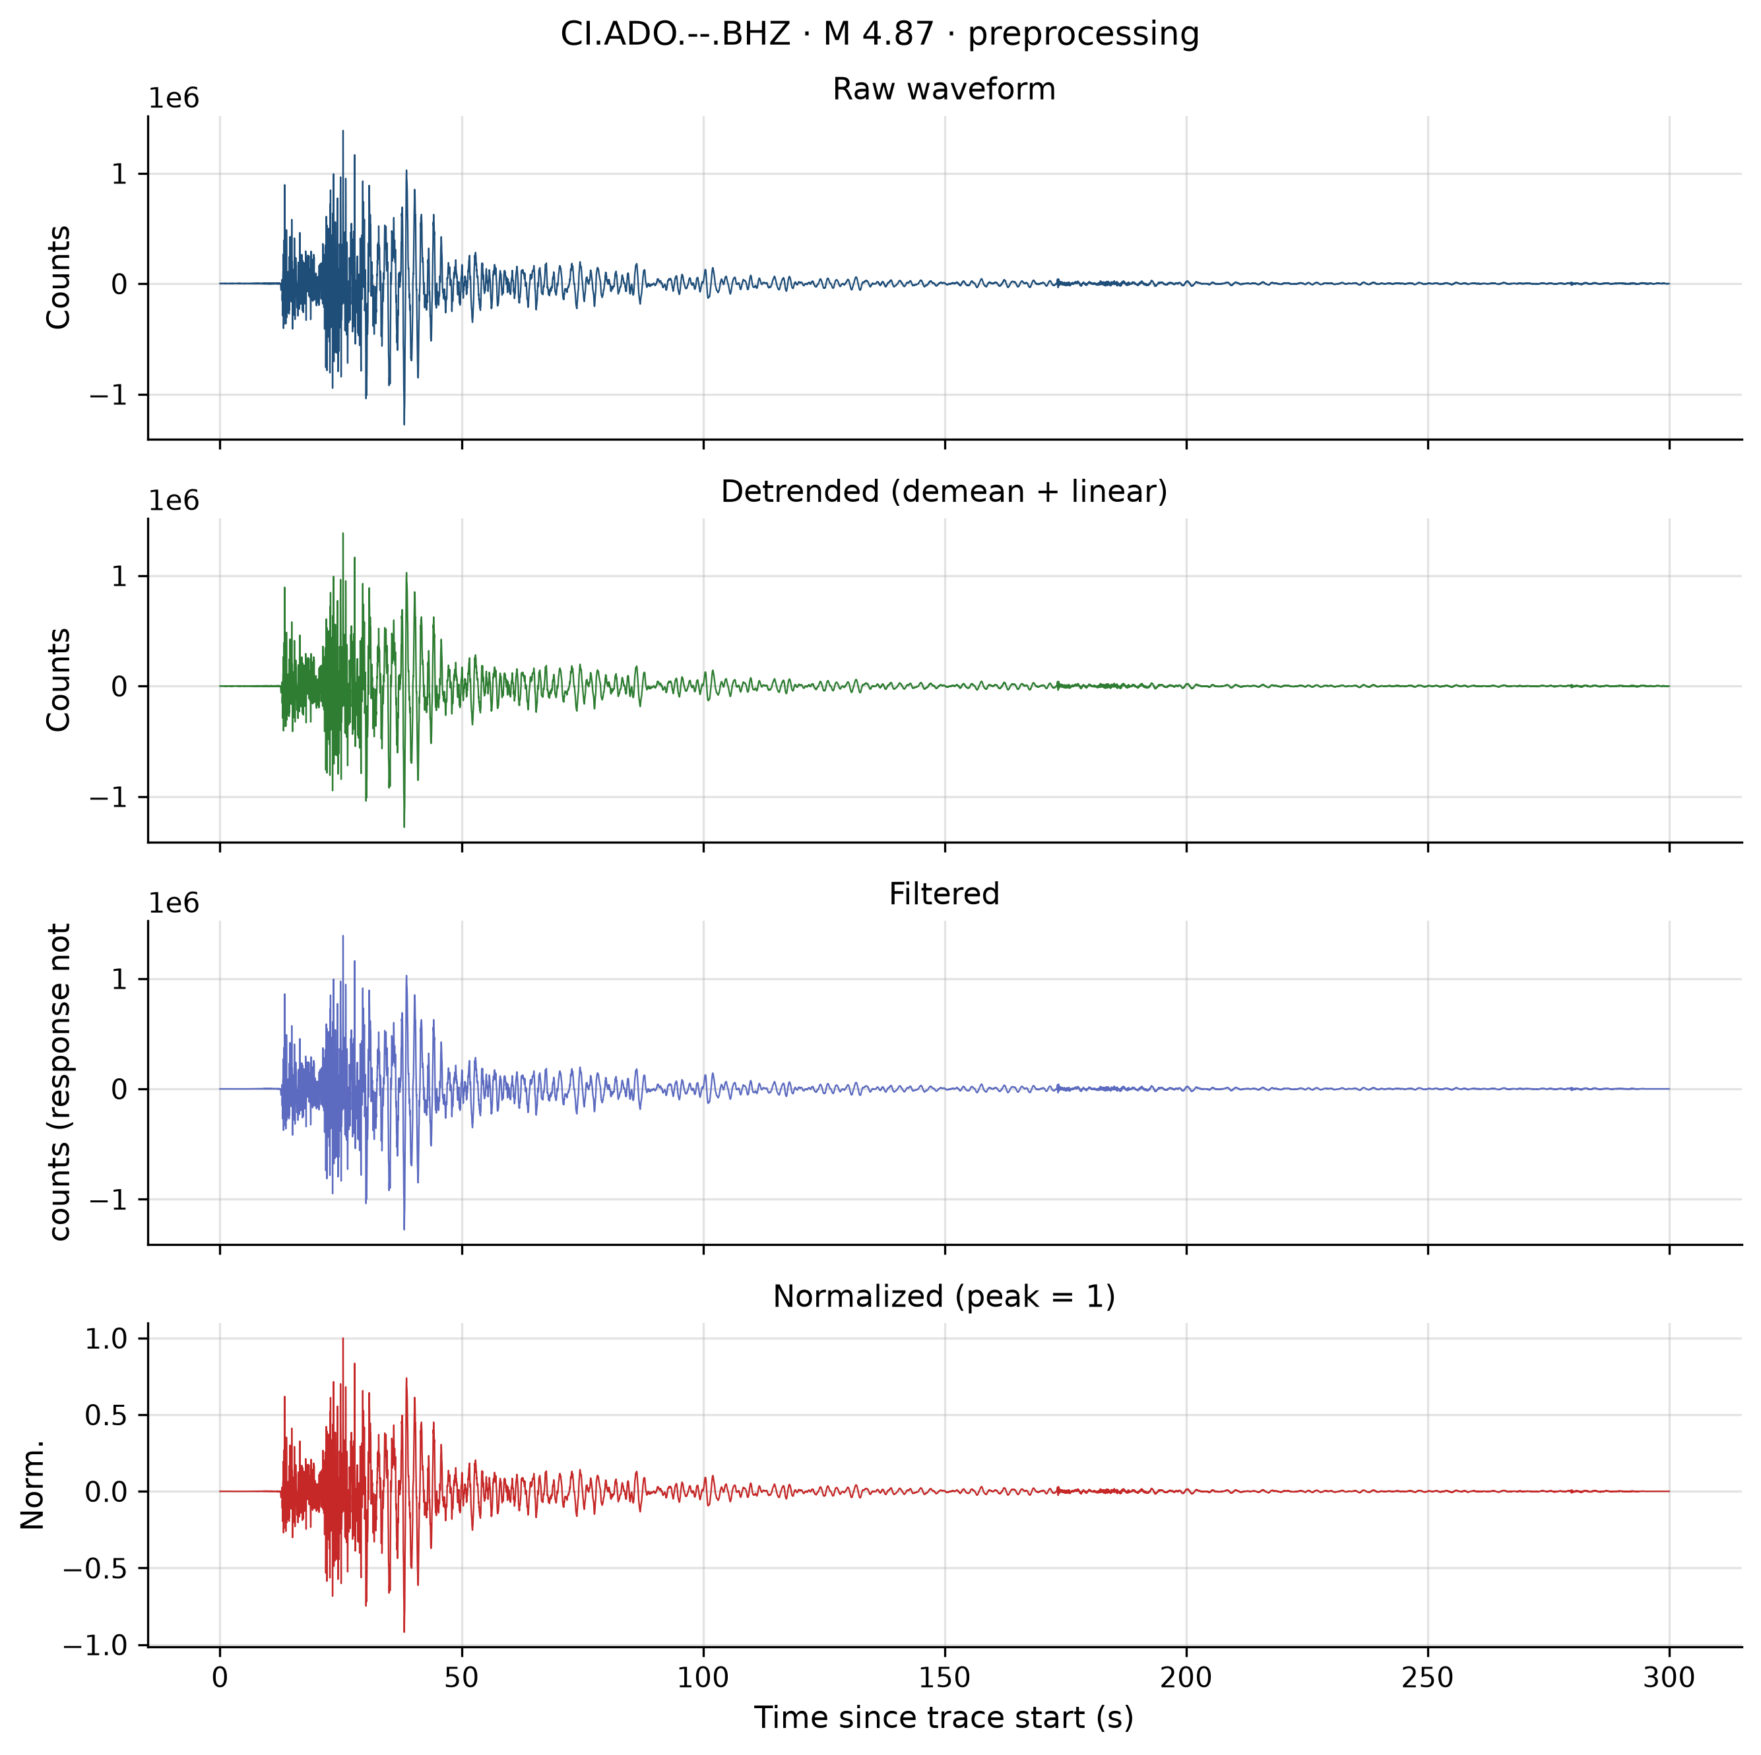
Figure 7: Preprocessing stages for ci40675215.
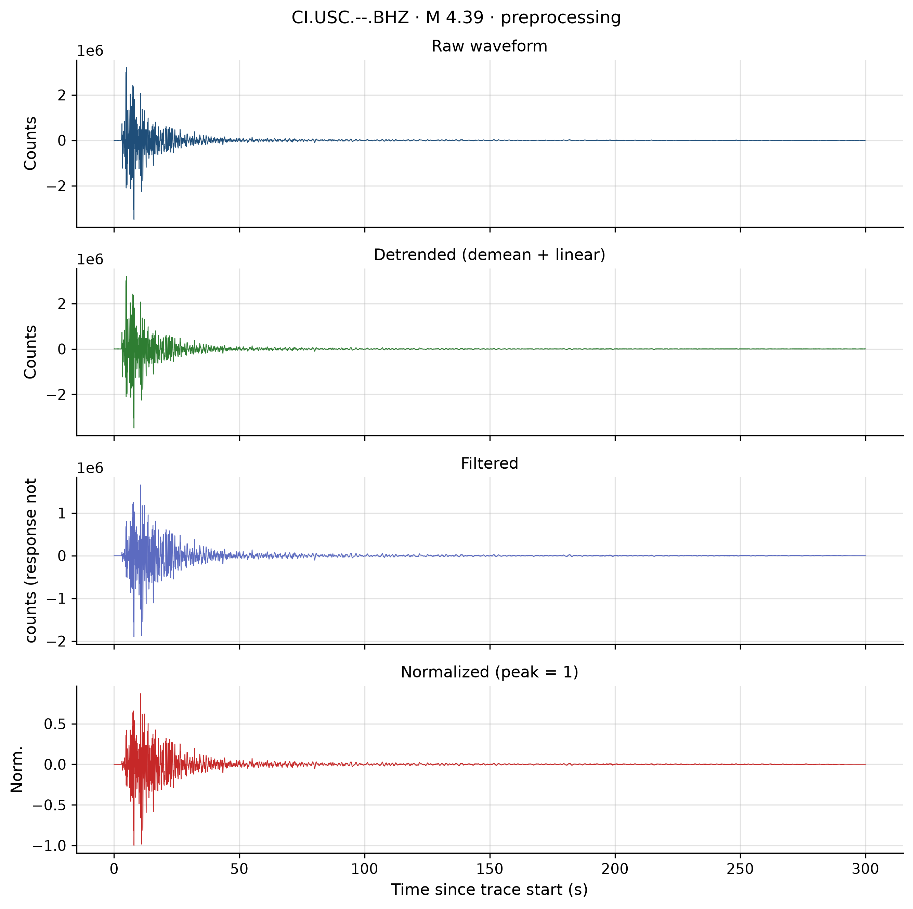
Figure 8: Preprocessing stages for ci40699207.
Interpretation: Visual stabilisation supports ML-oriented comparison; without response correction, filtered counts are not physical velocity/acceleration for magnitude estimation.

8.4 Feature engineering
The 8×18 matrix is stored in reports/features/feature_matrix.csv. Crest factor cohort mean ≈ 11.4; dominant frequency and spectral centroid cluster near ~2.3–2.6 Hz (reports/features/feature_summary.json), consistent with the 0.1–15 Hz band-pass.
Strong collinearity links amplitude-derived features; crest factor, signal entropy, spectral entropy, and zero_crossing_rate_hz provide partially independent shape information at N=8 only.
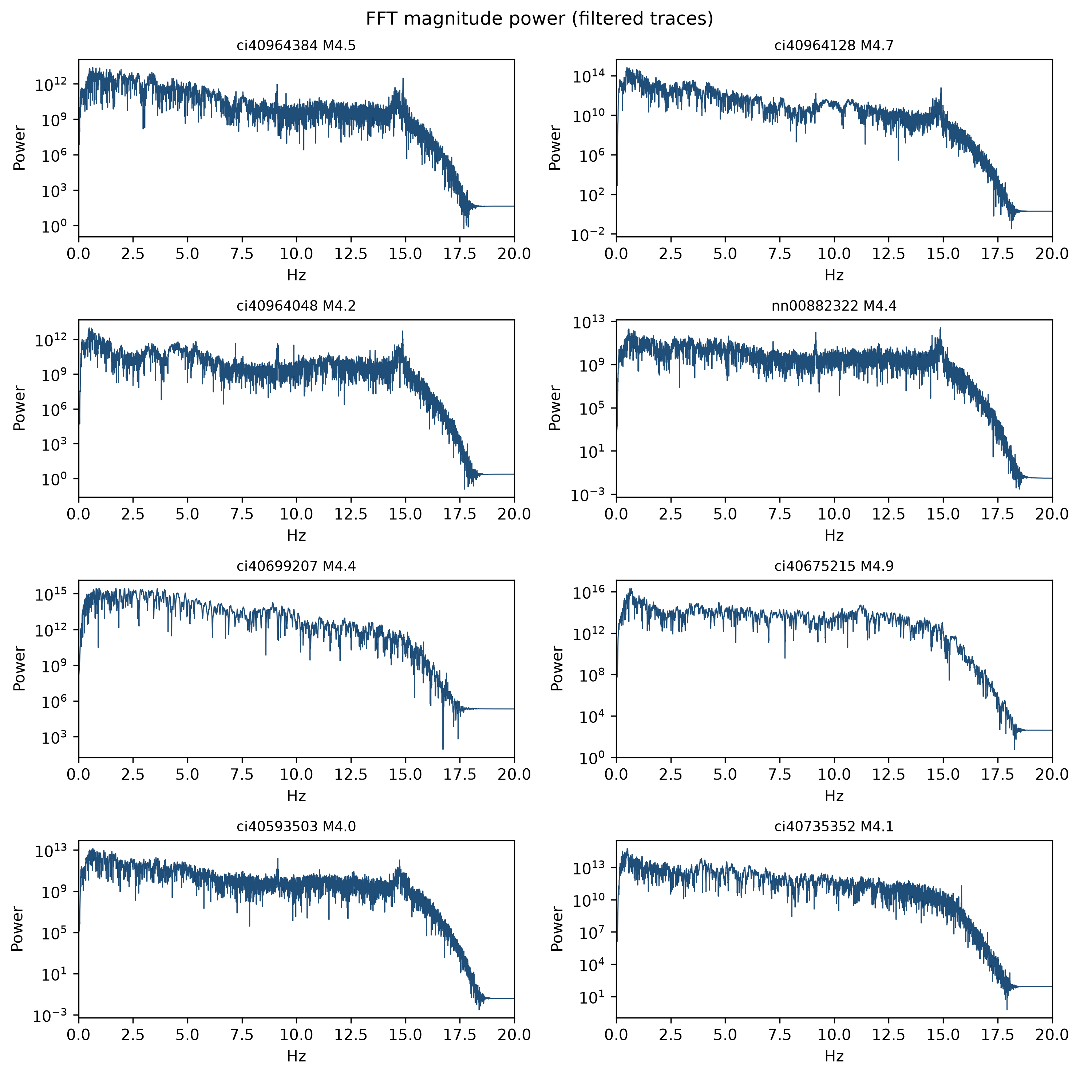
Figure 9: Per-event FFT power spectra (filtered traces).
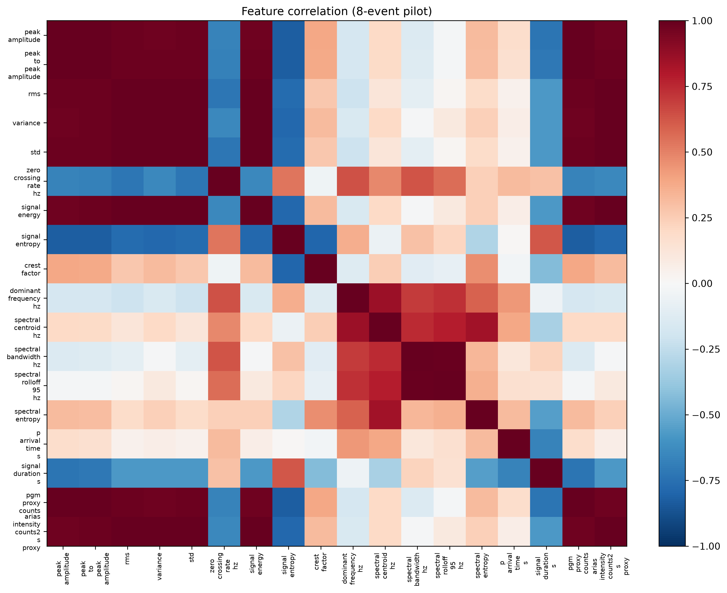
Figure 10: Pearson correlation heatmap (18 features, 8 samples).
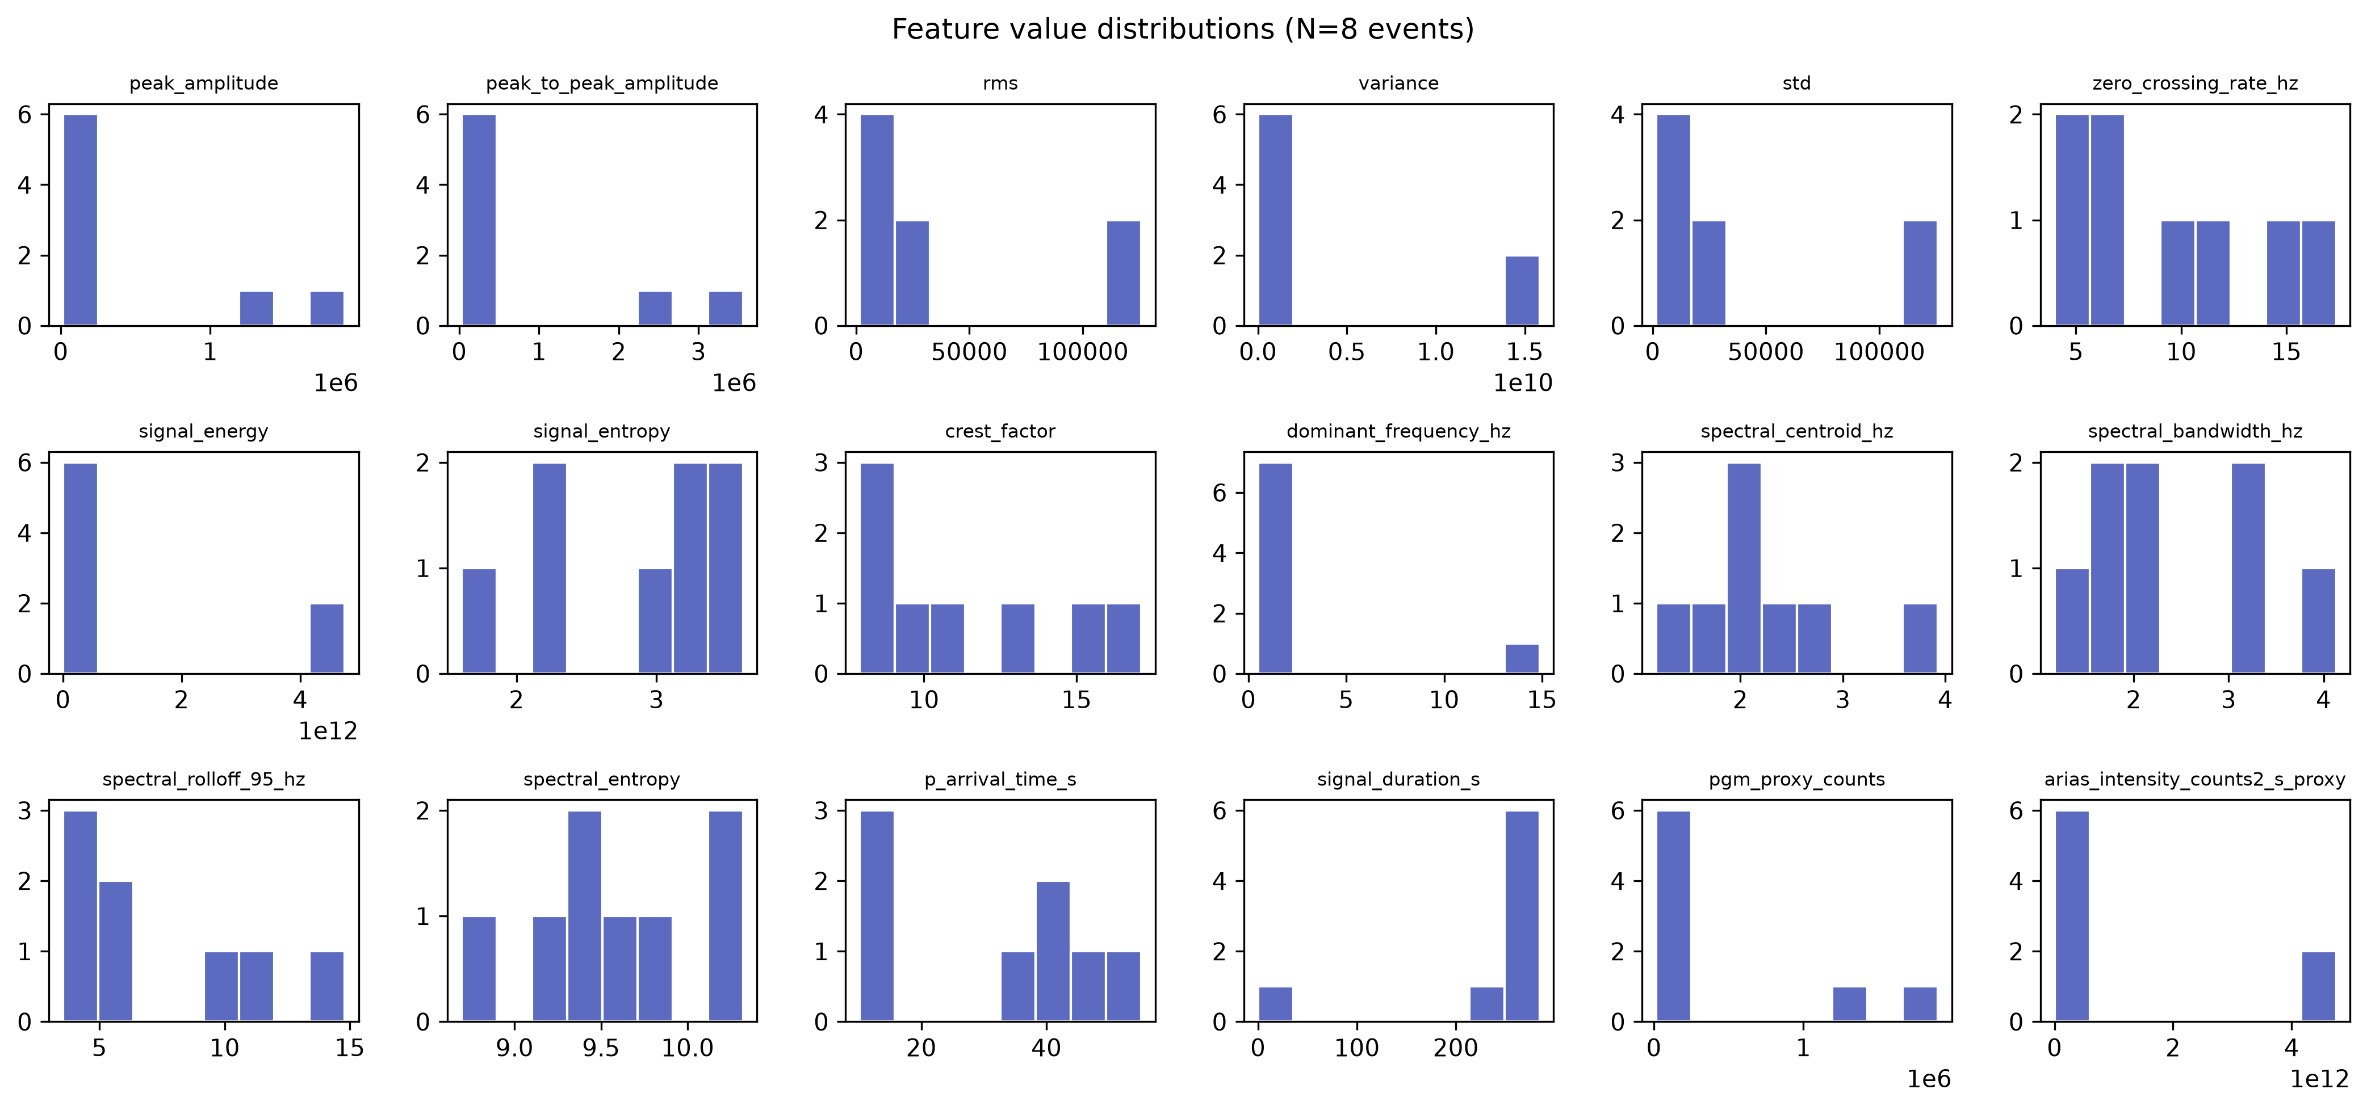
Figure 11: Per-feature distributions.
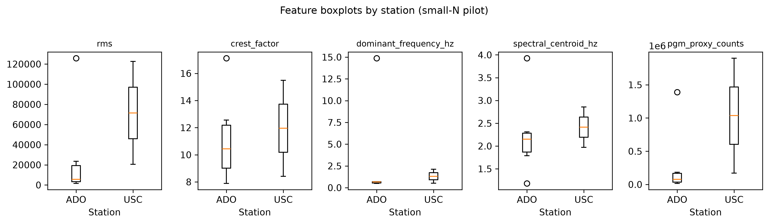
Figure 12: Selected features by station (ADO vs USC).

9. Discussion

9.1 Integration of phases
The pilot demonstrates a script-driven, documented path from FDSN services to tabular ML inputs and normalized NPZ stages, satisfying certificate requirements for ObsPy, real data, graphs, and tables (docs/RESULTS_AND_DISCUSSION.md §8).

9.2 Onsite triggering and warning-time budgets
STA/LTA panels connect classroom EEW theory to P-time features, but late picks and origin-aligned noise show that trigger parameters cannot be tuned on this dataset alone without pre-event windows and validation.

9.3 ML readiness versus generalisation
The feature matrix is suitable for pilot baselines (e.g., linear models, random forests) only in an exploratory sense. No ML training or hold-out evaluation was performed in the completed pilot—no predictive performance metrics are reported in repository artefacts.
Evidence note: Any statement implying model accuracy or operational detection probability would be unsupported; this report claims feature extraction only.

9.4 Relation to EarthESND
Reference code enables future architecture comparison on Western tensors with an explicit deviation log from Japan-centric paper tables. It does not validate EarthESND on California data in the completed work.

10. Limitations and threats to validity

10.1 Pilot limitations (California)
- N = 8 — no reliable generalisation or correlation inference.
- Single component (BHZ).
- Origin-aligned windows — biased noise and SNR.
- No response removal (0/8).
- Station selection bias (ADO-heavy; USC n=2).
- Mixed magnitude types (mw, ml).
- Four legacy MiniSEED files on disk outside manifest.
- Unvalidated P picks.
- Not comparable to EarthESND K-NET metrics.
(Source: docs/RESULTS_AND_DISCUSSION.md §6.)

10.2 Threats to validity
Table 9 — Threats and mitigations (from docs/RESULTS_AND_DISCUSSION.md §7)
Threat | Description | Mitigation (proposed)
Construct validity | Counts used where physical motion required | StationXML cache; response removal
Internal validity | SNR inflated after filtering with fixed noise window | Pre-origin download windows
External validity | California CI ≠ European networks | EIDA/ORFEUS pilot with same scripts
Statistical conclusion validity | N=8 | Larger catalogues; bootstrap CIs
Selection bias | First-eight successful downloads | Stratified sampling
Confirmation bias | Fixed STA/LTA threshold | Threshold sweeps; ML picks

11. European context and transfer
Europe is the primary programme focus; California validates methods, not deployment geography (docs/PROJECT_CHARTER.md).
Why the pilot supports European goals (docs/RESULTS_AND_DISCUSSION.md §9):
- Demonstrates ObsPy/FDSN reproducibility.
- Surfaces pitfalls (origin-aligned windows, response metadata, station bias) relevant to ORFEUS/EIDA integration.
- Delivers figures and tables for methodology chapters while European catalogues are scoped.
Transfer plan (proposed): Reuse manifest CSV structure, phase report templates, and scripts/ layout with European endpoint configuration; document licensing, magnitude conventions, and channel choices per network.
Expected challenges (proposed): Fragmented access policies, lower event rates in some regions, heterogeneous station density, accelerometer vs broadband mix, regulatory metadata (docs/RESULTS_AND_DISCUSSION.md §9.3).
Expected benefits (proposed): Cross-region feature comparison, open artifact trails, alignment with Swiss/European EEW research narratives.

12. Future work and expected outcomes

12.1 Already achieved
- Documented California FDSN acquisition and full analysis chain.
- Phase reports, reports/ artefacts, Research Proposal v1, D-S1/D-S2, and this D-F1 report.
- EarthESND reference codebase for comparative studies (not primary objective).

12.2 Proposed extensions
Direction | Objective
Larger catalogues | 50–200+ events; stratified splits
European FDSN pilot | EIDA/ORFEUS manifests and reports
Instrumentation | Response correction; 3-component data; pre-event noise
AI models | Tabular and waveform baselines; EarthESND-inspired comparisons with deviation log
Real-time EEW | SeedLink simulation; latency budgets
Formal publication | European transfer with uncertainty quantification
(Source: docs/RESULTS_AND_DISCUSSION.md §10, reports/Research_Proposal_v1.md §11.)

13. Conclusion
- A reproducible chain from FDSN acquisition to an 8×18 feature matrix is established for the California pilot.
- Raw waveforms exhibit strong station/path effects and heterogeneous STA/LTA pick times; ADO dominates sampling.
- Preprocessing improves interpretability and band-limited SNR proxies, but response removal failed for all eight traces—physical amplitude EEW is not yet supported.
- Features combine time, frequency, and pick-based descriptors; correlations show redundancy among amplitude metrics and value in shape statistics at pilot scale.
- Validity threats must be addressed before operational or publication-grade EEW claims.
- California proves the method; Europe is the intended context for scaled deployment with network-specific metadata discipline.

14. References
Allen, R. M., and Kanamori, H. (2003). The potential for earthquake early warning in southern California. Science, 300(5620), 786–788.
Hoshiba, M., Iwakiri, K., Hayashimoto, N., Shimoyama, T., Hirano, K., Yamada, Y., Ishigaki, Y., and Kikuta, H. (2008). Outline of the 2007–2008 earthquake early warning experiments in Japan. Earth Planets Space, 60, 123–129.
Joshi, A., Singh, A. P., and Raman, B. (2026). EarthESND: Lightweight multiscale echo state network with dendritic neural network readout for earthquake early warning. Computers and Electrical Engineering (reference implementation: docs/EARTHESND_REVERSE_ENGINEERING.md; not primary geographic objective).
Krischer, L., Megies, T., Barsch, R., Beyreuther, M., Lecocq, T., Caudron, C., and Wassermann, J. (2015). ObsPy: A bridge for earthquake science. Seismological Research Letters, 86(3), 765–771.
International Federation of Digital Seismograph Networks (FDSN). FDSN web services specification. https://www.fdsn.org/webservices/
EarthScope Consortium. Data services. https://www.earthscope.org/
U.S. Geological Survey. Earthquake Hazards Program — FDSN event web service. https://earthquake.usgs.gov
ORFEUS Data Center / EIDA. European integrated waveform archives. https://www.orfeus-eu.org/
Project documentation: docs/PROJECT_CHARTER.md; docs/RESEARCH_DIRECTION.md; docs/IRIS_DATASET_REPORT.md; docs/EDA_REPORT.md; docs/SIGNAL_ANALYSIS_REPORT.md; docs/PREPROCESSING_REPORT.md; docs/FEATURE_ENGINEERING_REPORT.md; docs/RESULTS_AND_DISCUSSION.md; docs/REPRODUCIBILITY_STATEMENT.md; docs/DATA_AVAILABILITY_STATEMENT.md; docs/FINAL_DELIVERABLE_AUDIT.md.

15. Statement of evidence support
Statement class | Support
Numeric results (SNR, picks, magnitudes, feature means) | Supported — JSON/CSV cited in phase reports and summarised in §8
Figure content | Supported — PNG paths verified in docs/FINAL_DELIVERABLE_AUDIT.md (24/24 local)
ML model performance | Not claimed — no training artefacts in repository
Operational EEW deployment | Not claimed — explicitly out of scope
European dataset results | Not claimed — proposed only
Author name / CERG edition | Not in repository — placeholder avoided; programme name from charter only
EarthESND 88 tests | Supported — docs/PROJECT_CHARTER.md, README.md
Git clone contains all PNG/MiniSEED | Qualified — audit WARNING; see Appendix C

Appendix A — Pilot event and station tables
Table A1 — Event summary (full CSV: reports/tables/event_summary.csv)
short_id | Magnitude | Type | Station | Origin (UTC)
ci40964384 | 4.54 | ml | CI.ADO | 2024-10-25 15:04:23
ci40964128 | 4.72 | mw | CI.ADO | 2024-10-25 08:05:08
ci40964048 | 4.16 | mw | CI.ADO | 2024-10-25 06:52:08
nn00882322 | 4.39 | ml | CI.ADO | 2024-08-14 03:06:35
ci40699207 | 4.39 | mw | CI.USC | 2024-08-12 19:20:24
ci40675215 | 4.87 | mw | CI.ADO | 2024-07-29 20:00:52
ci40593503 | 4.05 | mw | CI.ADO | 2024-05-20 12:17:36
ci40735352 | 4.11 | mw | CI.USC | 2024-05-01 20:49:00
Table A2 — Station summary (reports/tables/station_summary.csv)
Station | Events | Mean fs (Hz) | Duration (s)
CI.ADO.–.BHZ | 6 | 40.0 | 300.0
CI.USC.–.BHZ | 2 | 40.0 | 300.0

Appendix B — Reproducibility statement (D-S1)
The following text is the repository reproducibility statement (docs/REPRODUCIBILITY_STATEMENT.md), included for submission. Figure paths in that file use repository-root notation; PNG outputs appear under reports/figures/ relative to this report.

B.1 What this workflow reproduces
The pilot chain in scripts/download/ and scripts/analysis/ produces: manifest and MiniSEED (when downloaded); EDA summaries and four figures; signal metrics, eight figures, and CSV; preprocessing NPZ, eight figures, QC table; 8×18 feature matrix and four feature figures. Interpretation is in phase docs and prior proposals. California results did not use EarthESND src/ modules.

B.2 Software environment
Python ≥ 3.11; ObsPy, NumPy, Pandas, Matplotlib, SciPy, PyYAML per pyproject.toml. Suggested install: pip install -e ".[dev]" from repository root. No separate requirements.txt.

B.3 Execution order
python scripts/download/download_iris_california_pilot.py --event-count 8 --min-events 5
python scripts/analysis/run_california_pilot_eda.py
python scripts/analysis/run_california_signal_analysis.py
python scripts/analysis/run_california_preprocessing.py
python scripts/analysis/run_california_feature_engineering.py
Defaults: data/raw/iris/, data/manifests/iris_california_pilot_events.csv, logs/iris_california_pilot_summary.json. Preprocessing config: reports/preprocessing/preprocessing_config.json.

B.4 Included vs excluded artefacts
Typically in Git: scripts, manifest, phase docs, reports/tables/, JSON summaries, NPZ, feature matrix (see audit).
Gitignored: data/raw/, logs/, figures/ (includes reports/figures/). Fresh clones must regenerate or use a separate archive (docs/FINAL_DELIVERABLE_AUDIT.md).

B.5 Reproducibility limitations
FDSN rerun variability; fixed station list; origin-aligned windows; 0/8 response removal; N=8; EarthESND not on pilot path; PNGs may differ slightly by library version.

B.6 Verification
Compare to reports/eda/dataset_summary.json, reports/signal_analysis/signal_analysis_summary.json, reports/preprocessing/preprocessing_summary.json, reports/features/feature_summary.json.

Appendix C — Data availability and ethics statement (D-S2)
Condensed from docs/DATA_AVAILABILITY_STATEMENT.md for this submission package.

C.1 Data sources
Role | Provider | Access
Catalog | USGS FDSN Event | Public — https://earthquake.usgs.gov
Waveforms | EarthScope | Public FDSN — https://service.earthscope.org
Query details: docs/IRIS_DATASET_REPORT.md. Eight events, magnitudes 4.05–4.87, CI.ADO (6) / CI.USC (2). No credentials required.

C.2 Repository availability
In Git (typical): manifest, derived reports/ products, scripts, documentation.
Not in Git: raw MiniSEED (data/raw/), logs (logs/), figures (reports/figures/ per .gitignore rule figures/).
Regeneration: download script + analysis pipeline (Appendix B).

C.3 Ethics
Public seismic data only; no human subjects; cite USGS, EarthScope, and FDSN terms. GDPR note applies to future European integrations, not the completed California pilot.

C.4 Data-use limitations
BHZ only; N=8; ADO bias; legacy files outside manifest; counts not physical motion; not EarthESND geography.
Full citations: see docs/DATA_AVAILABILITY_STATEMENT.md §7 and §14 of this report.

Appendix D — Supplementary per-event figures
Remaining signal analysis panels (four-panel: raw, normalized, STA/LTA, P marker):
Fig. | File
D1 | figures/signal_analysis_ci40593503.png
D2 | figures/signal_analysis_ci40735352.png
D3 | figures/signal_analysis_ci40964048.png
D4 | figures/signal_analysis_ci40964128.png
D5 | figures/signal_analysis_ci40964384.png
D6 | figures/signal_analysis_nn00882322.png
Remaining preprocessing panels (raw → detrended → filtered → normalized):
Fig. | File
D7 | figures/preprocessing_ci40593503.png
D8 | figures/preprocessing_ci40735352.png
D9 | figures/preprocessing_ci40964048.png
D10 | figures/preprocessing_ci40964128.png
D11 | figures/preprocessing_ci40964384.png
D12 | figures/preprocessing_nn00882322.png
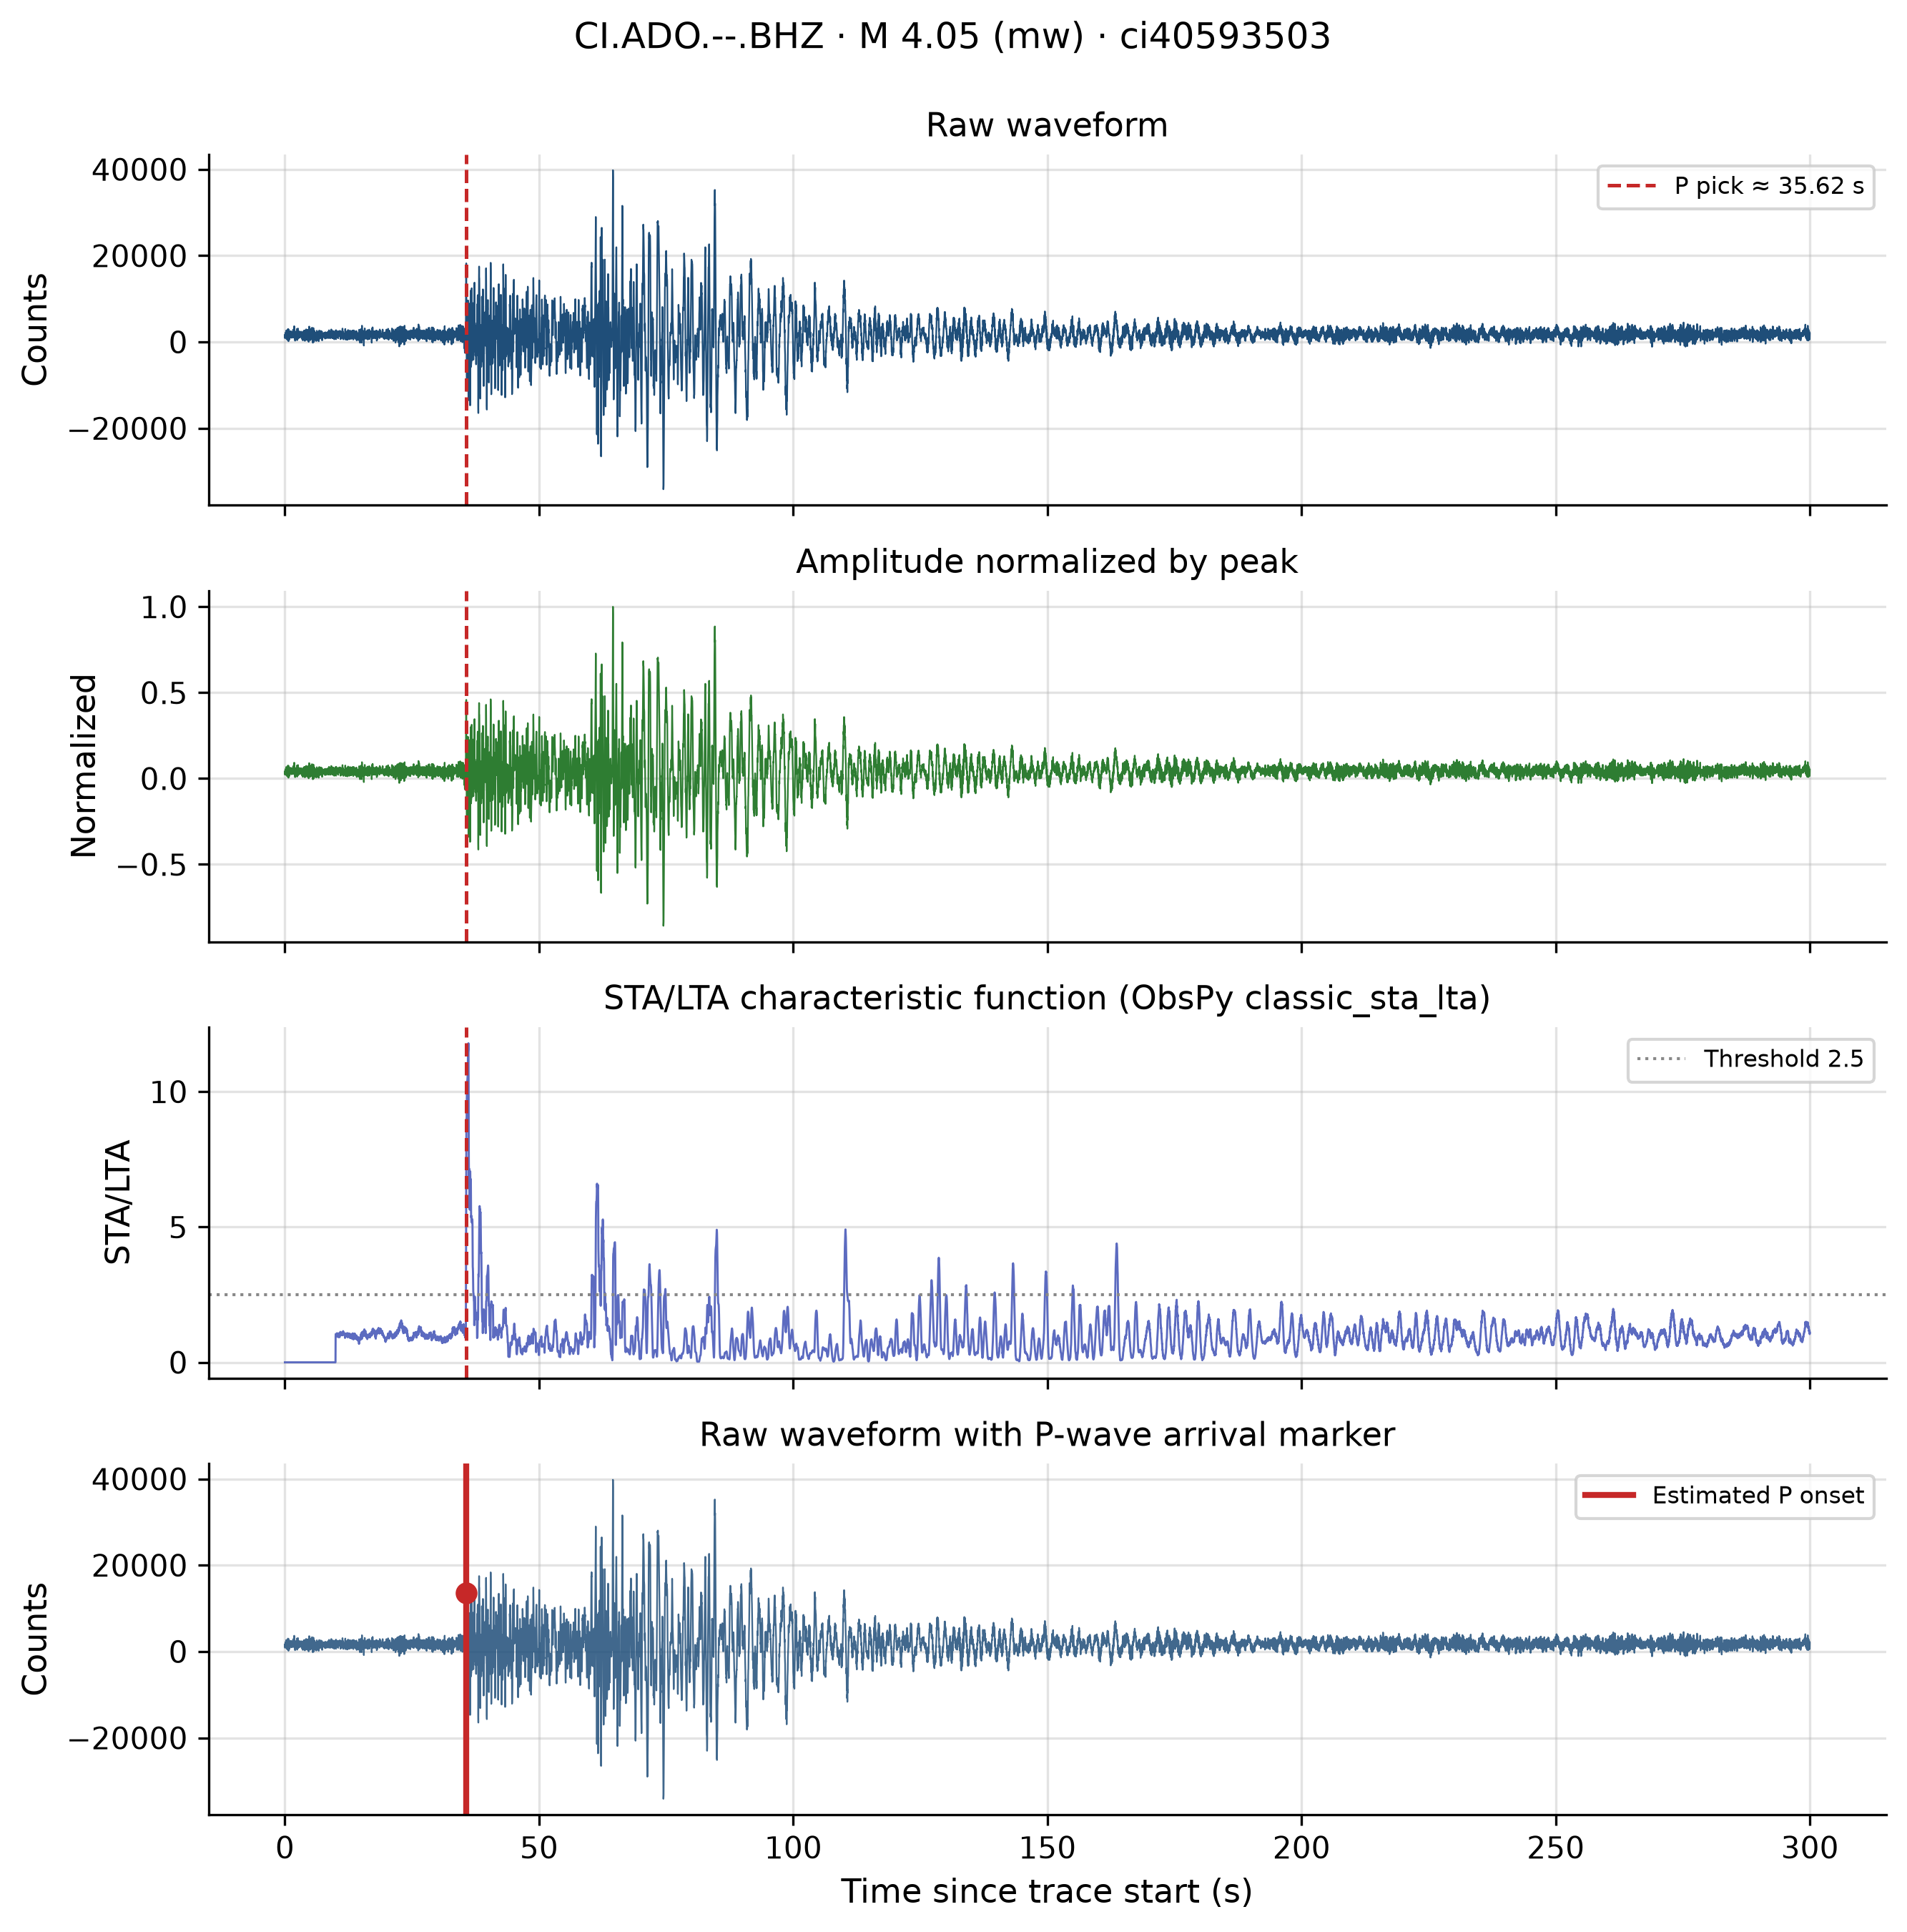
Figure D1: Signal analysis — ci40593503.
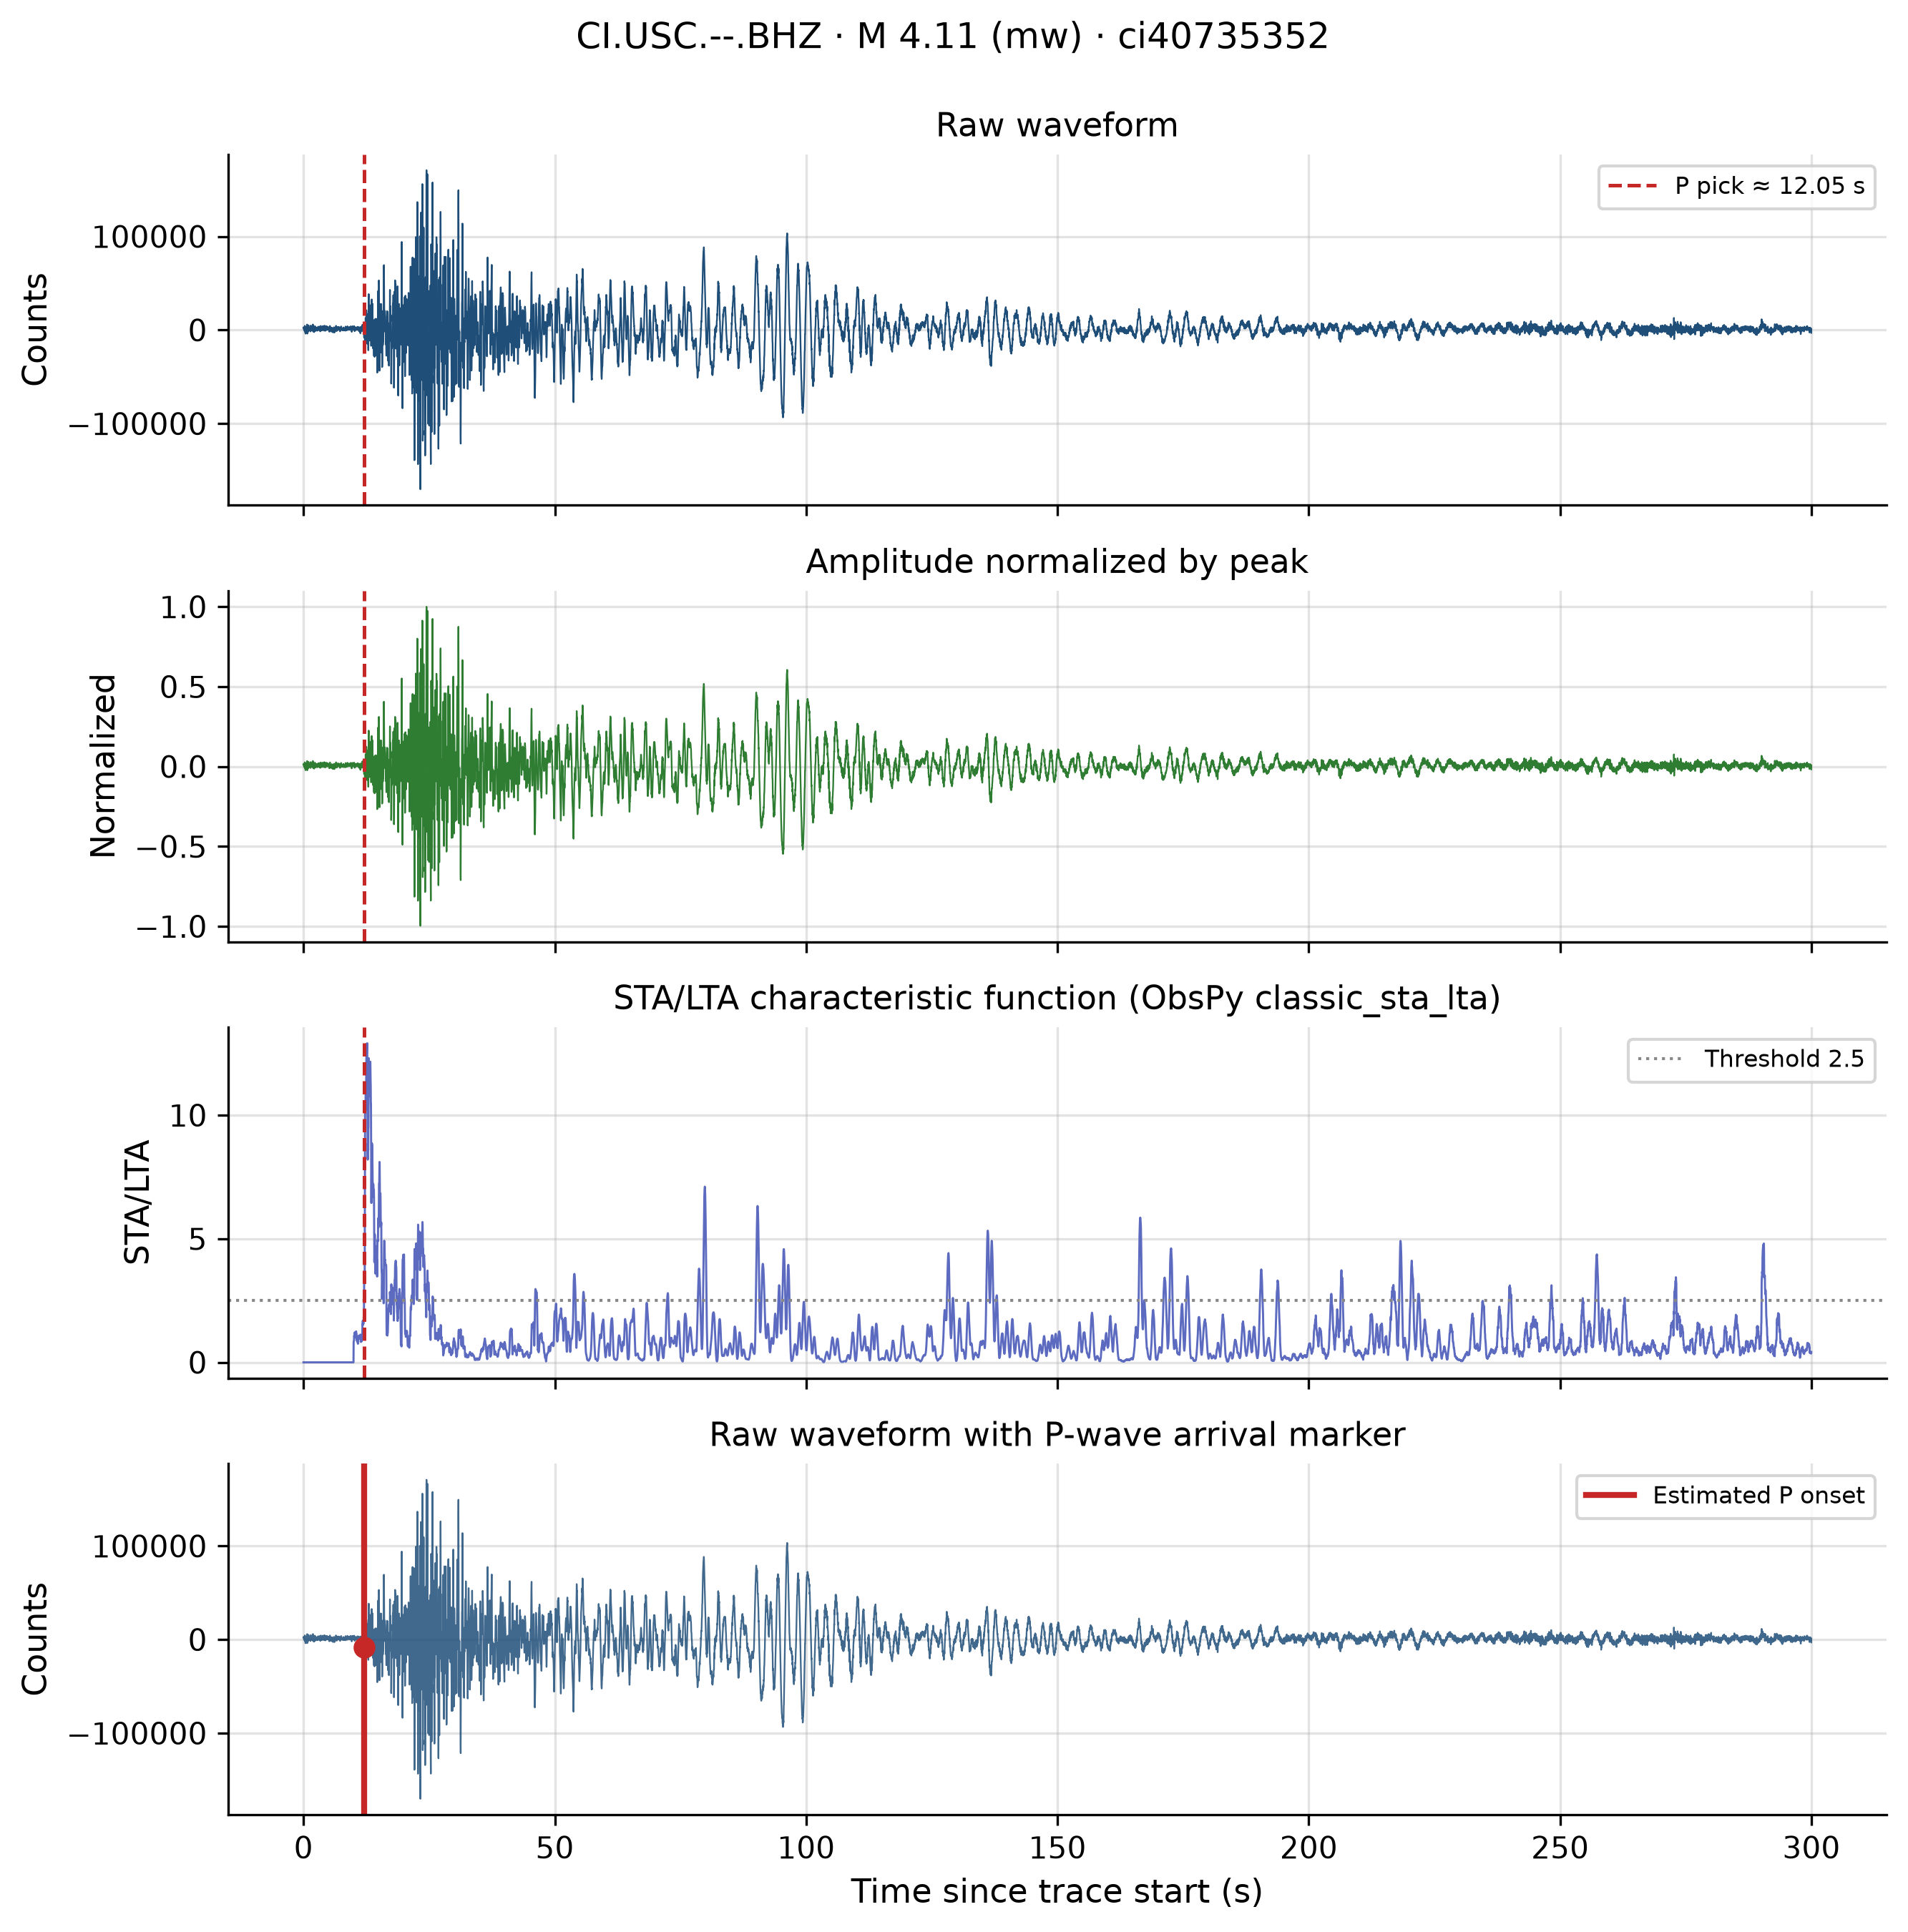
Figure D2: Signal analysis — ci40735352.
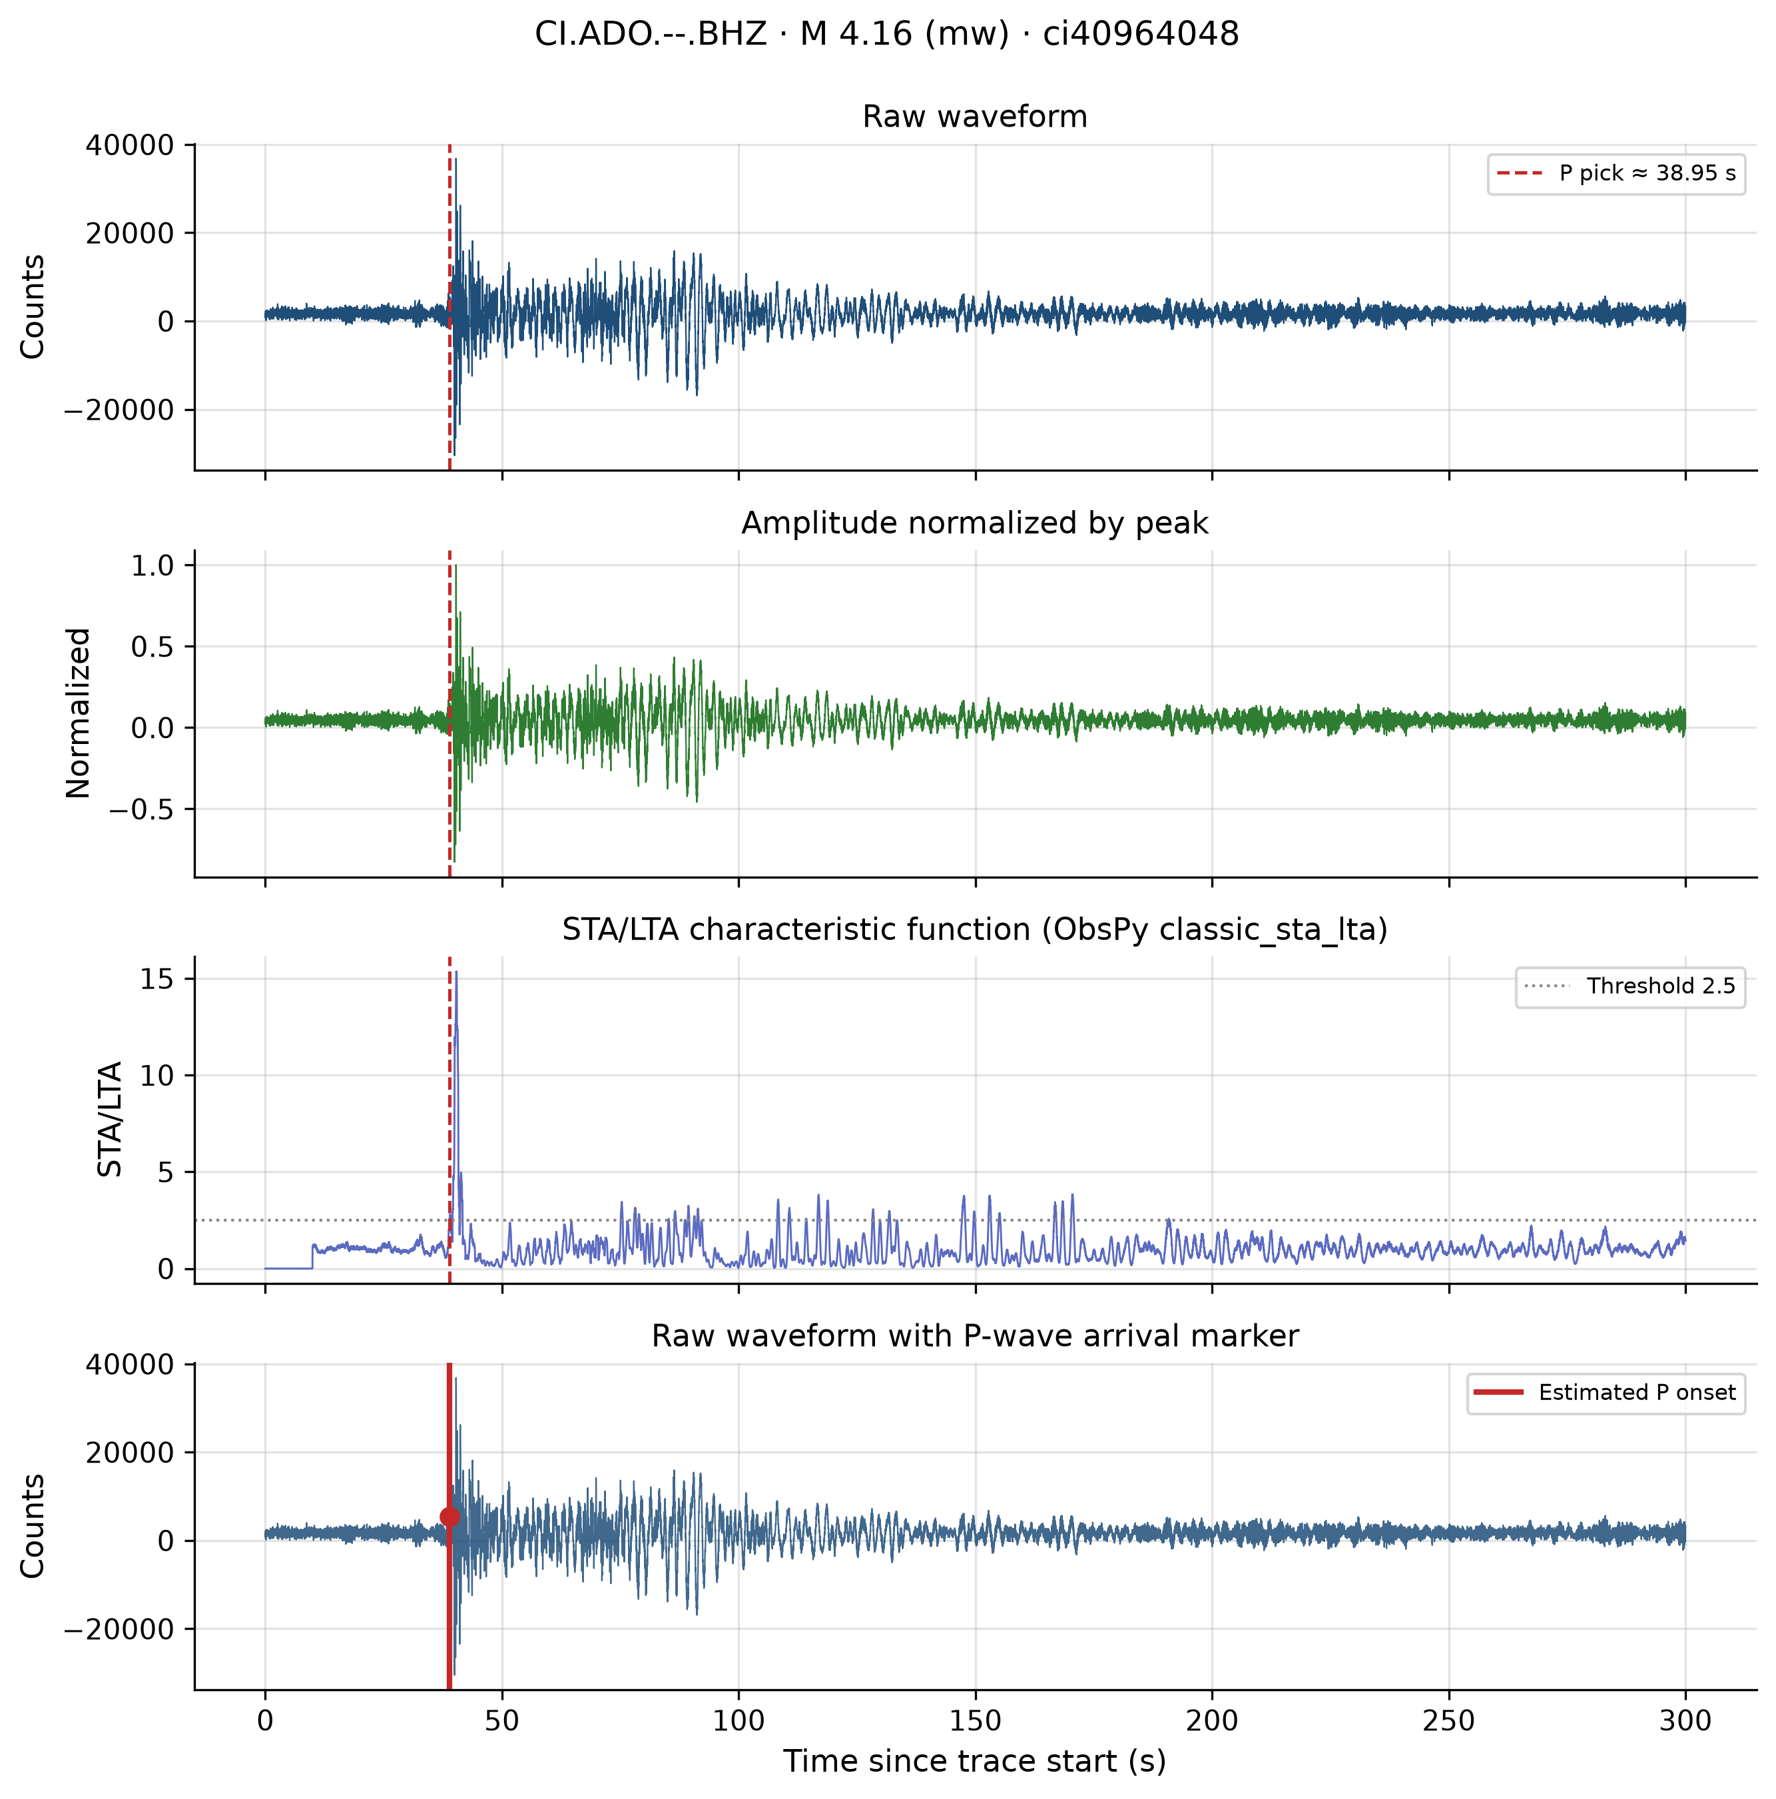
Figure D3: Signal analysis — ci40964048.
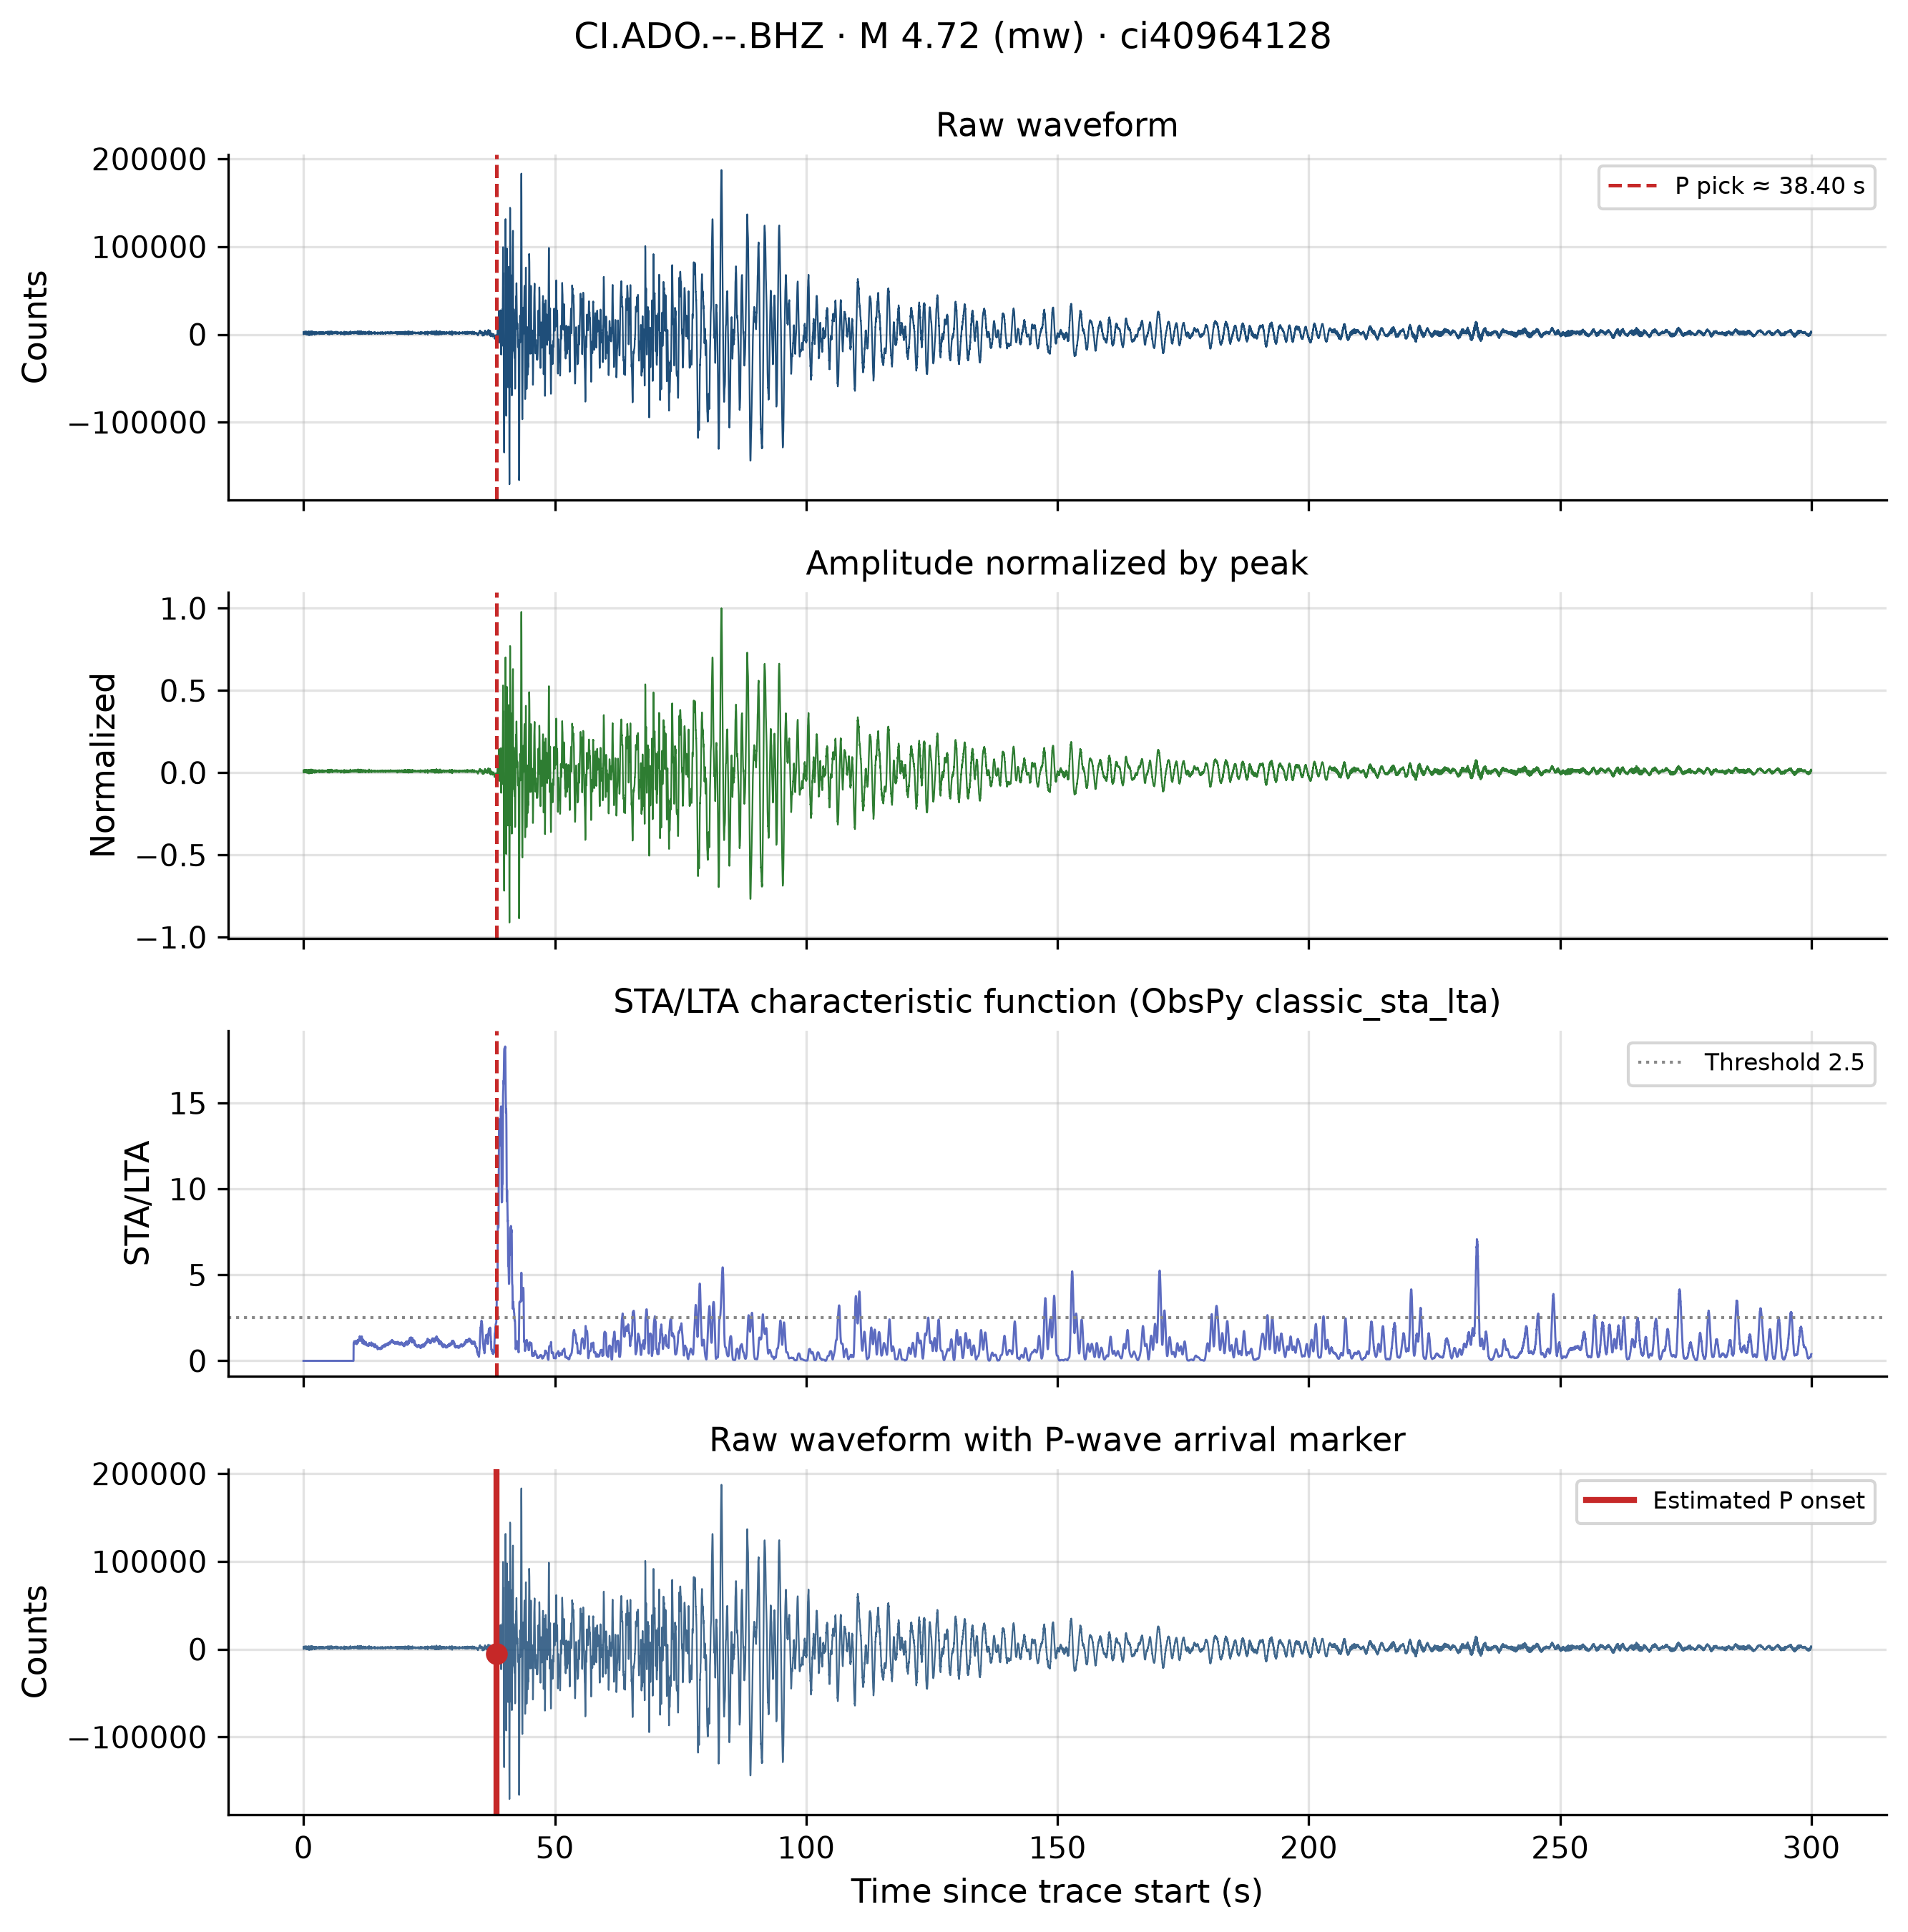
Figure D4: Signal analysis — ci40964128.
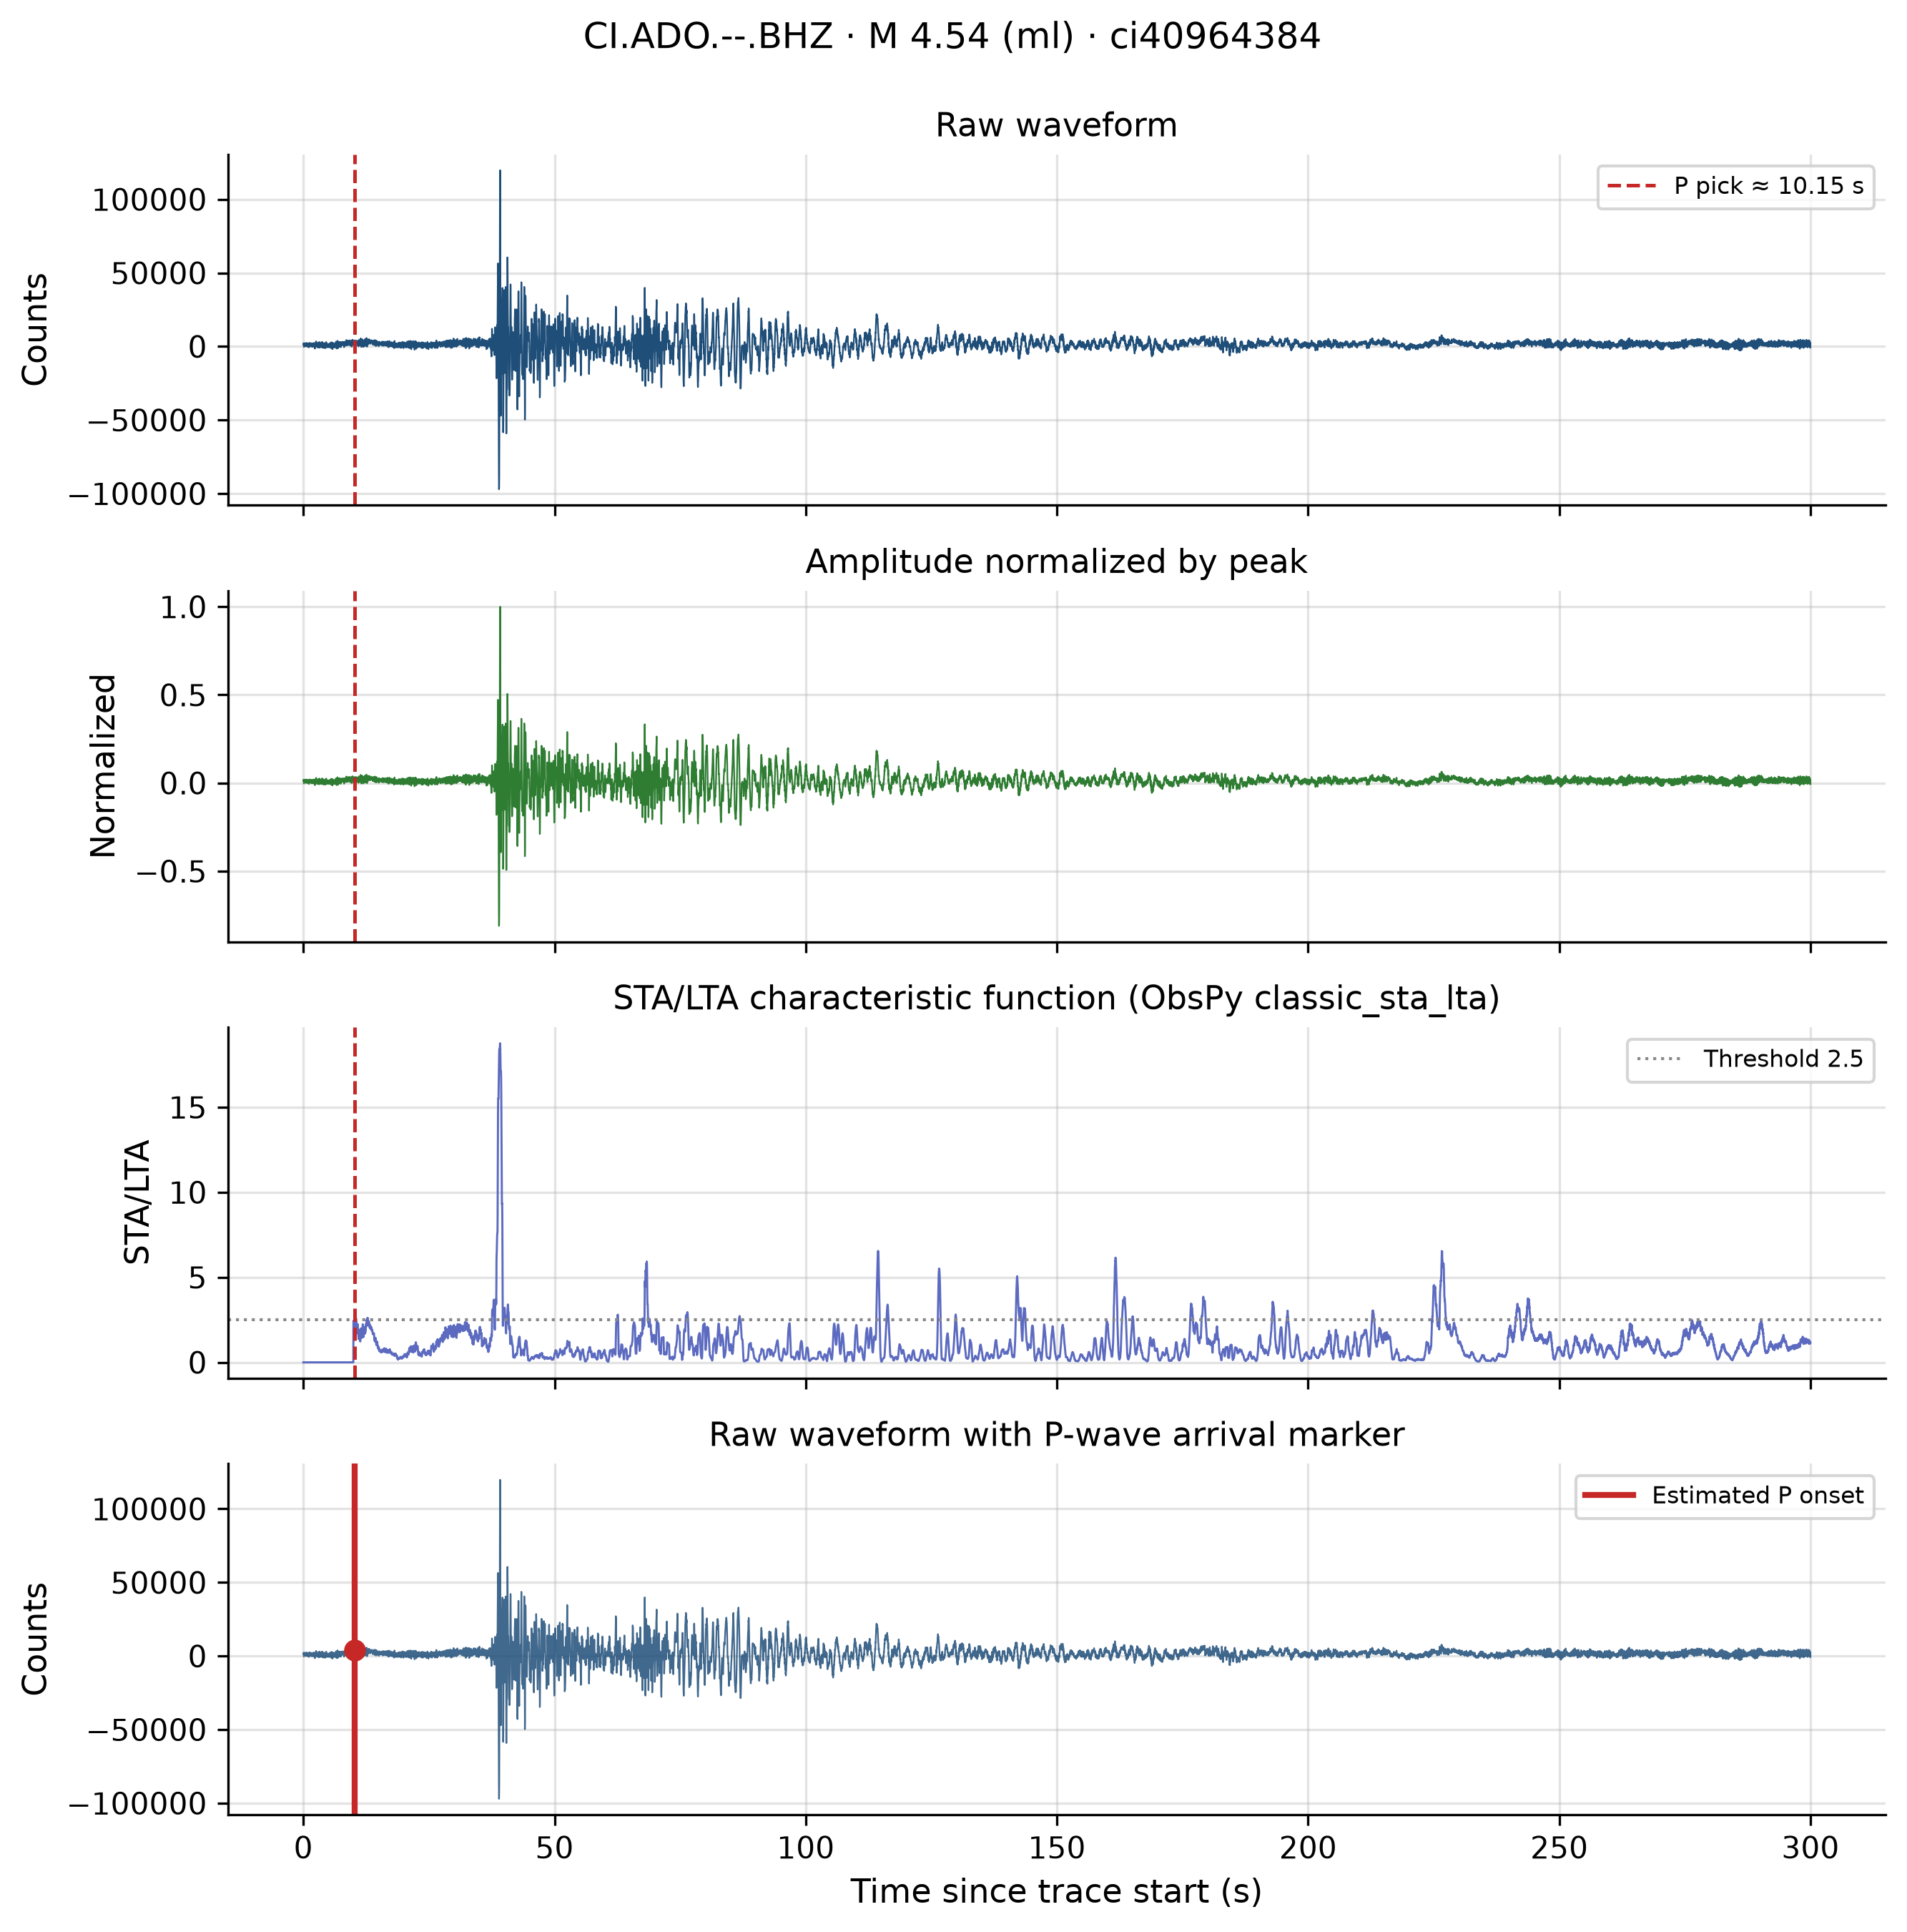
Figure D5: Signal analysis — ci40964384.
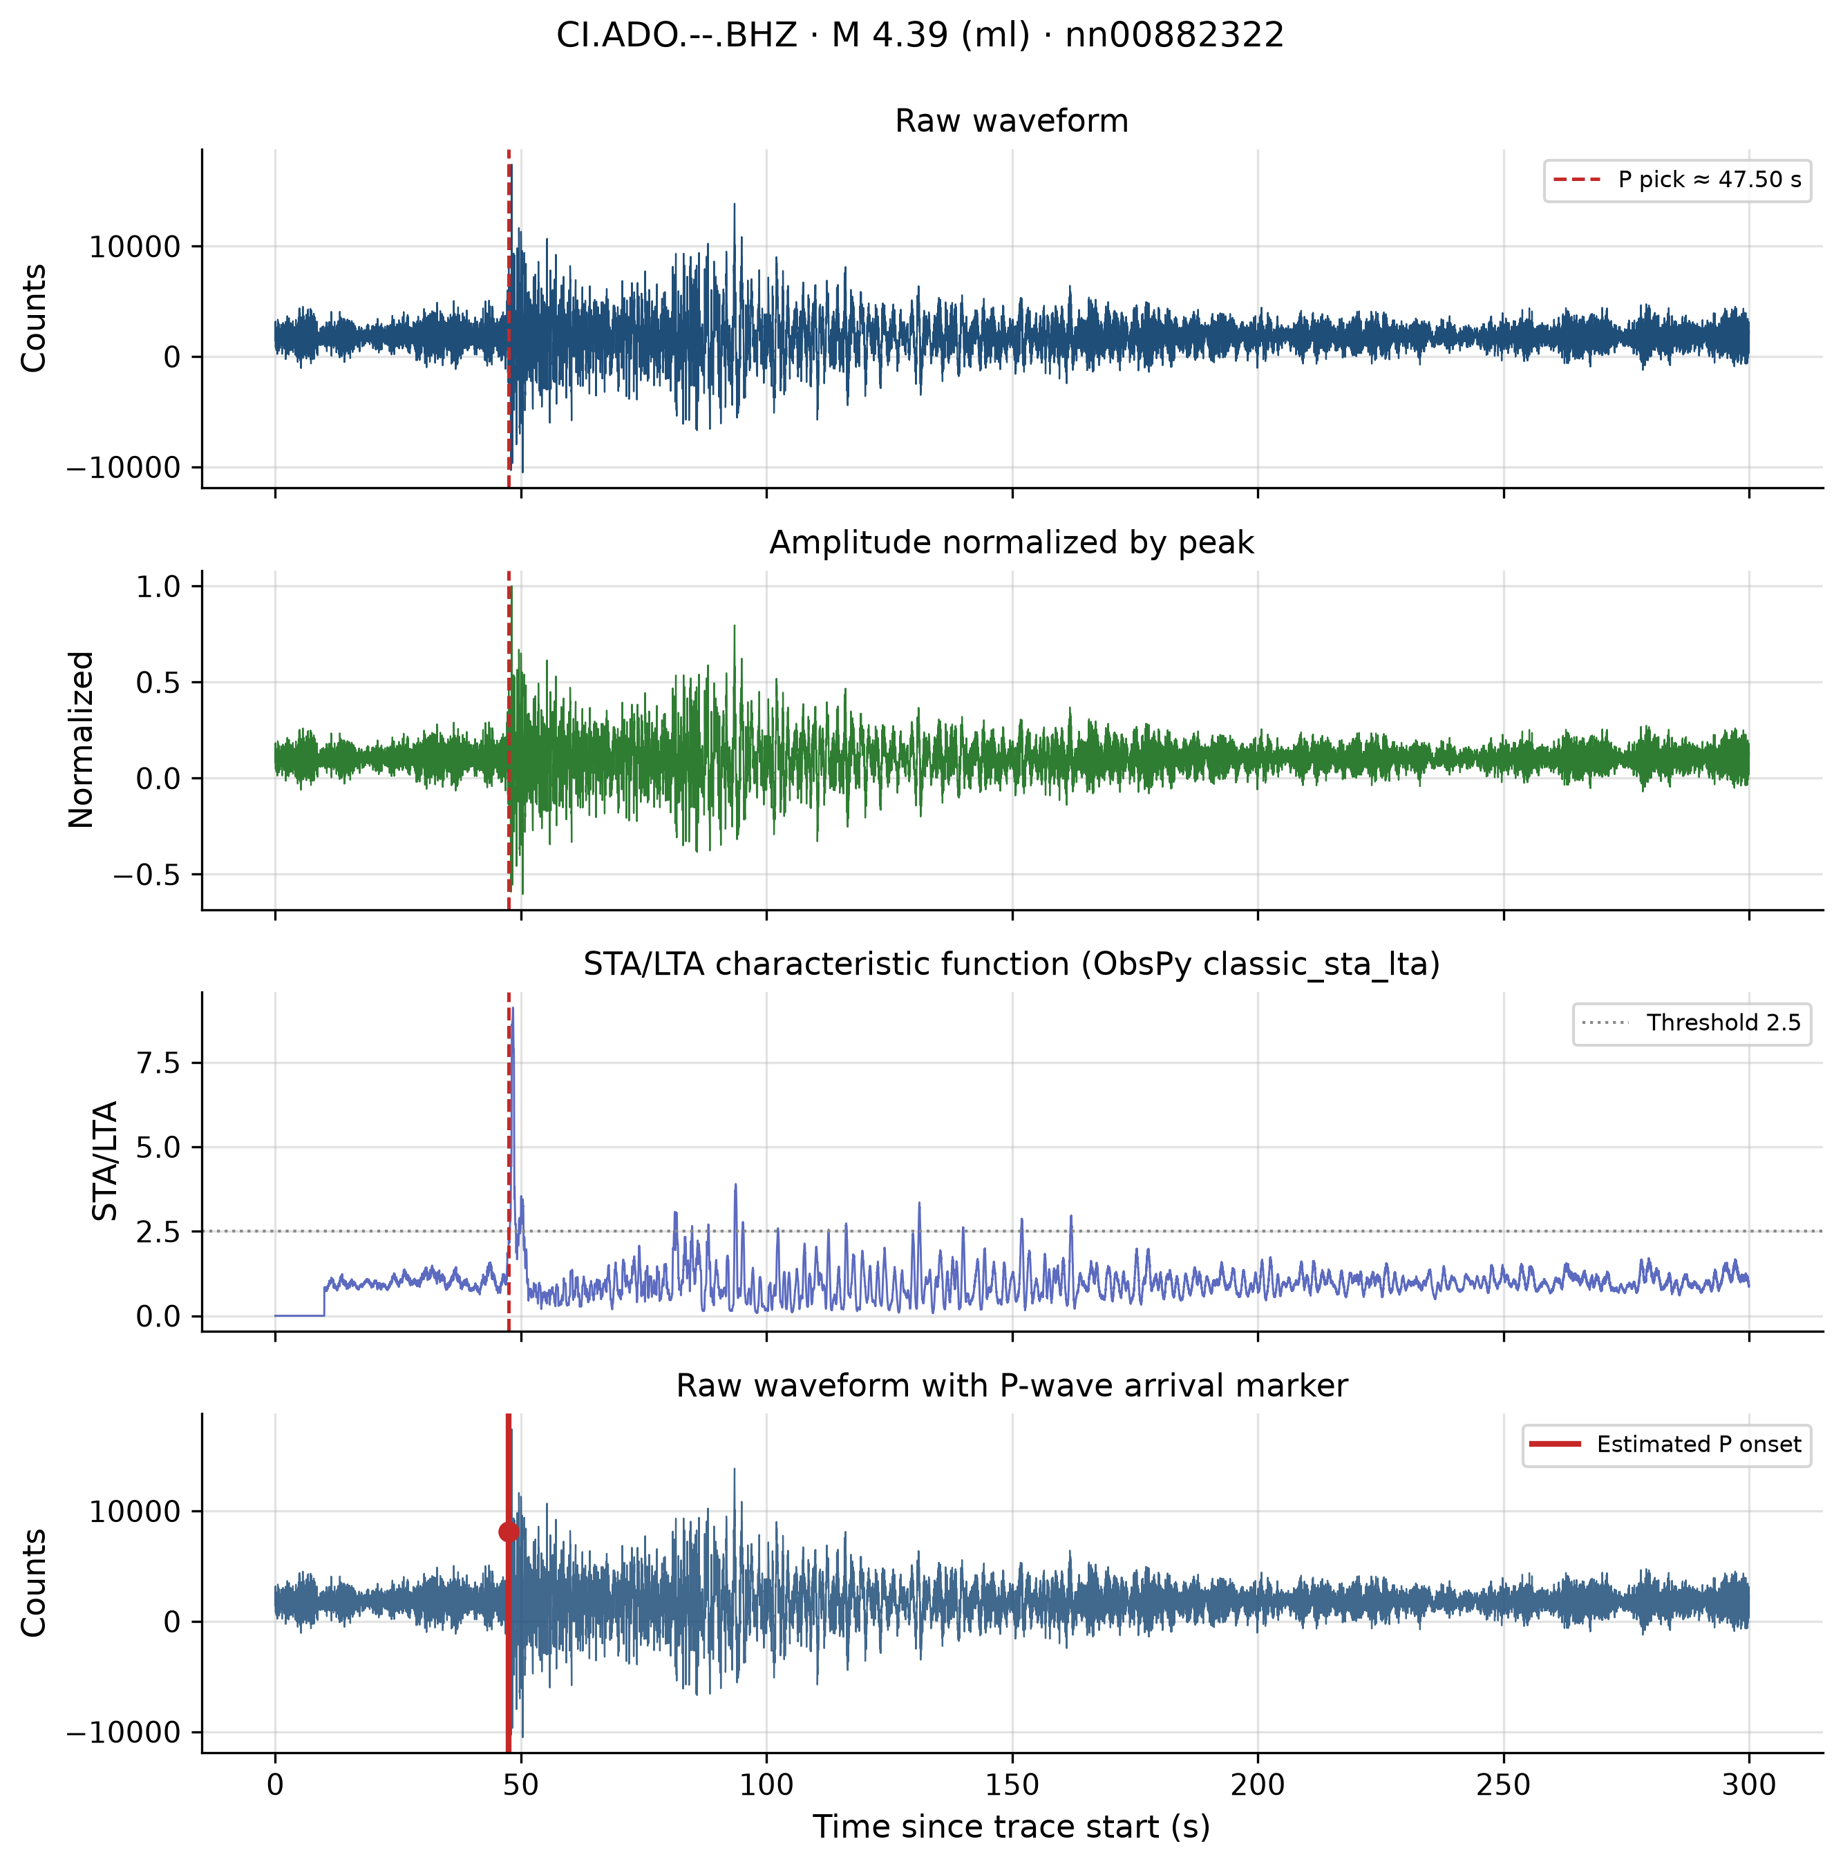
Figure D6: Signal analysis — nn00882322.
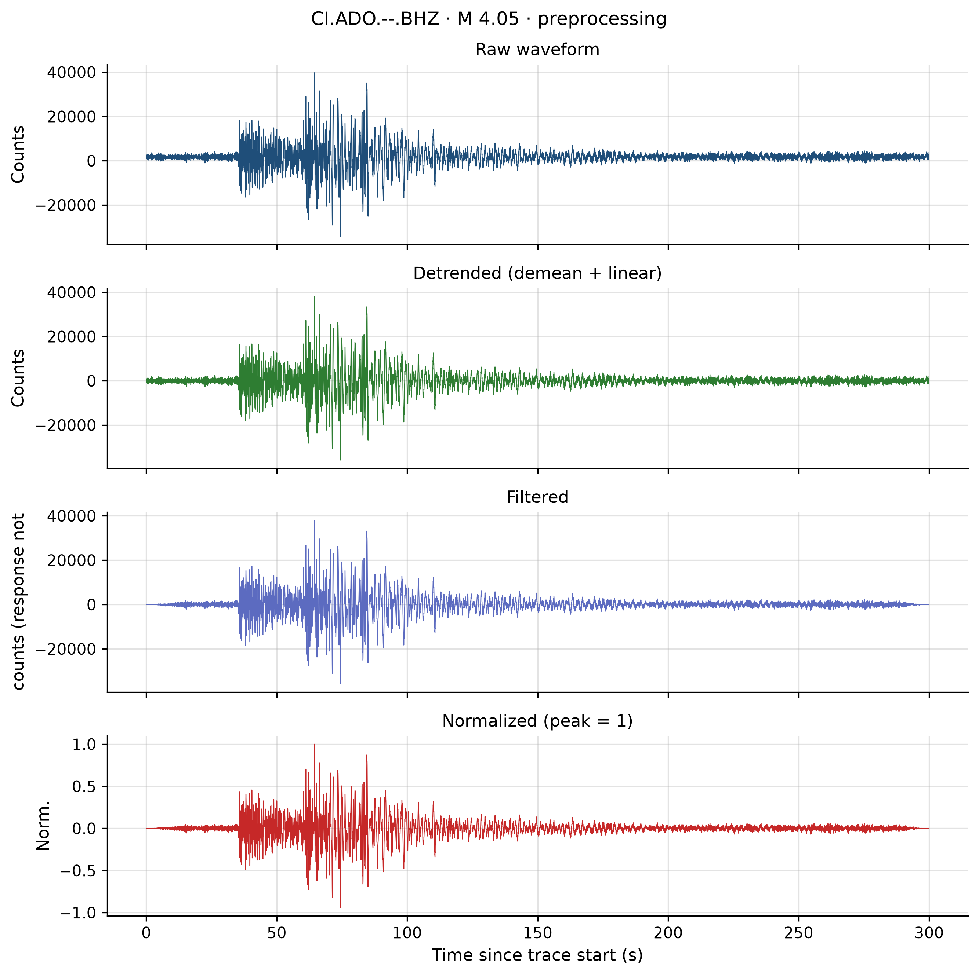
Figure D7: Preprocessing — ci40593503.
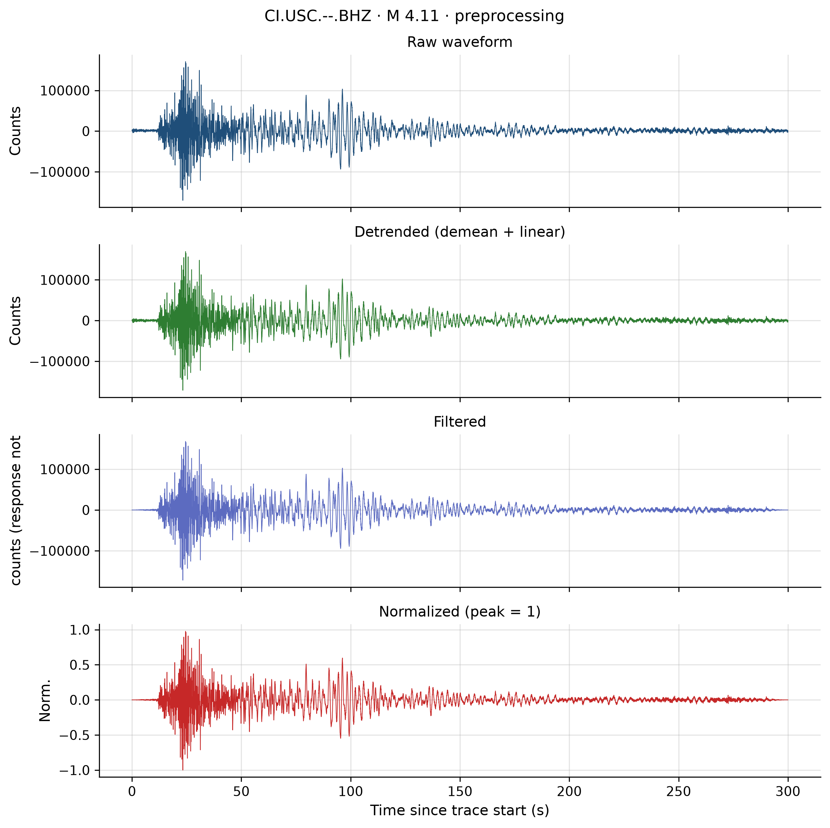
Figure D8: Preprocessing — ci40735352.
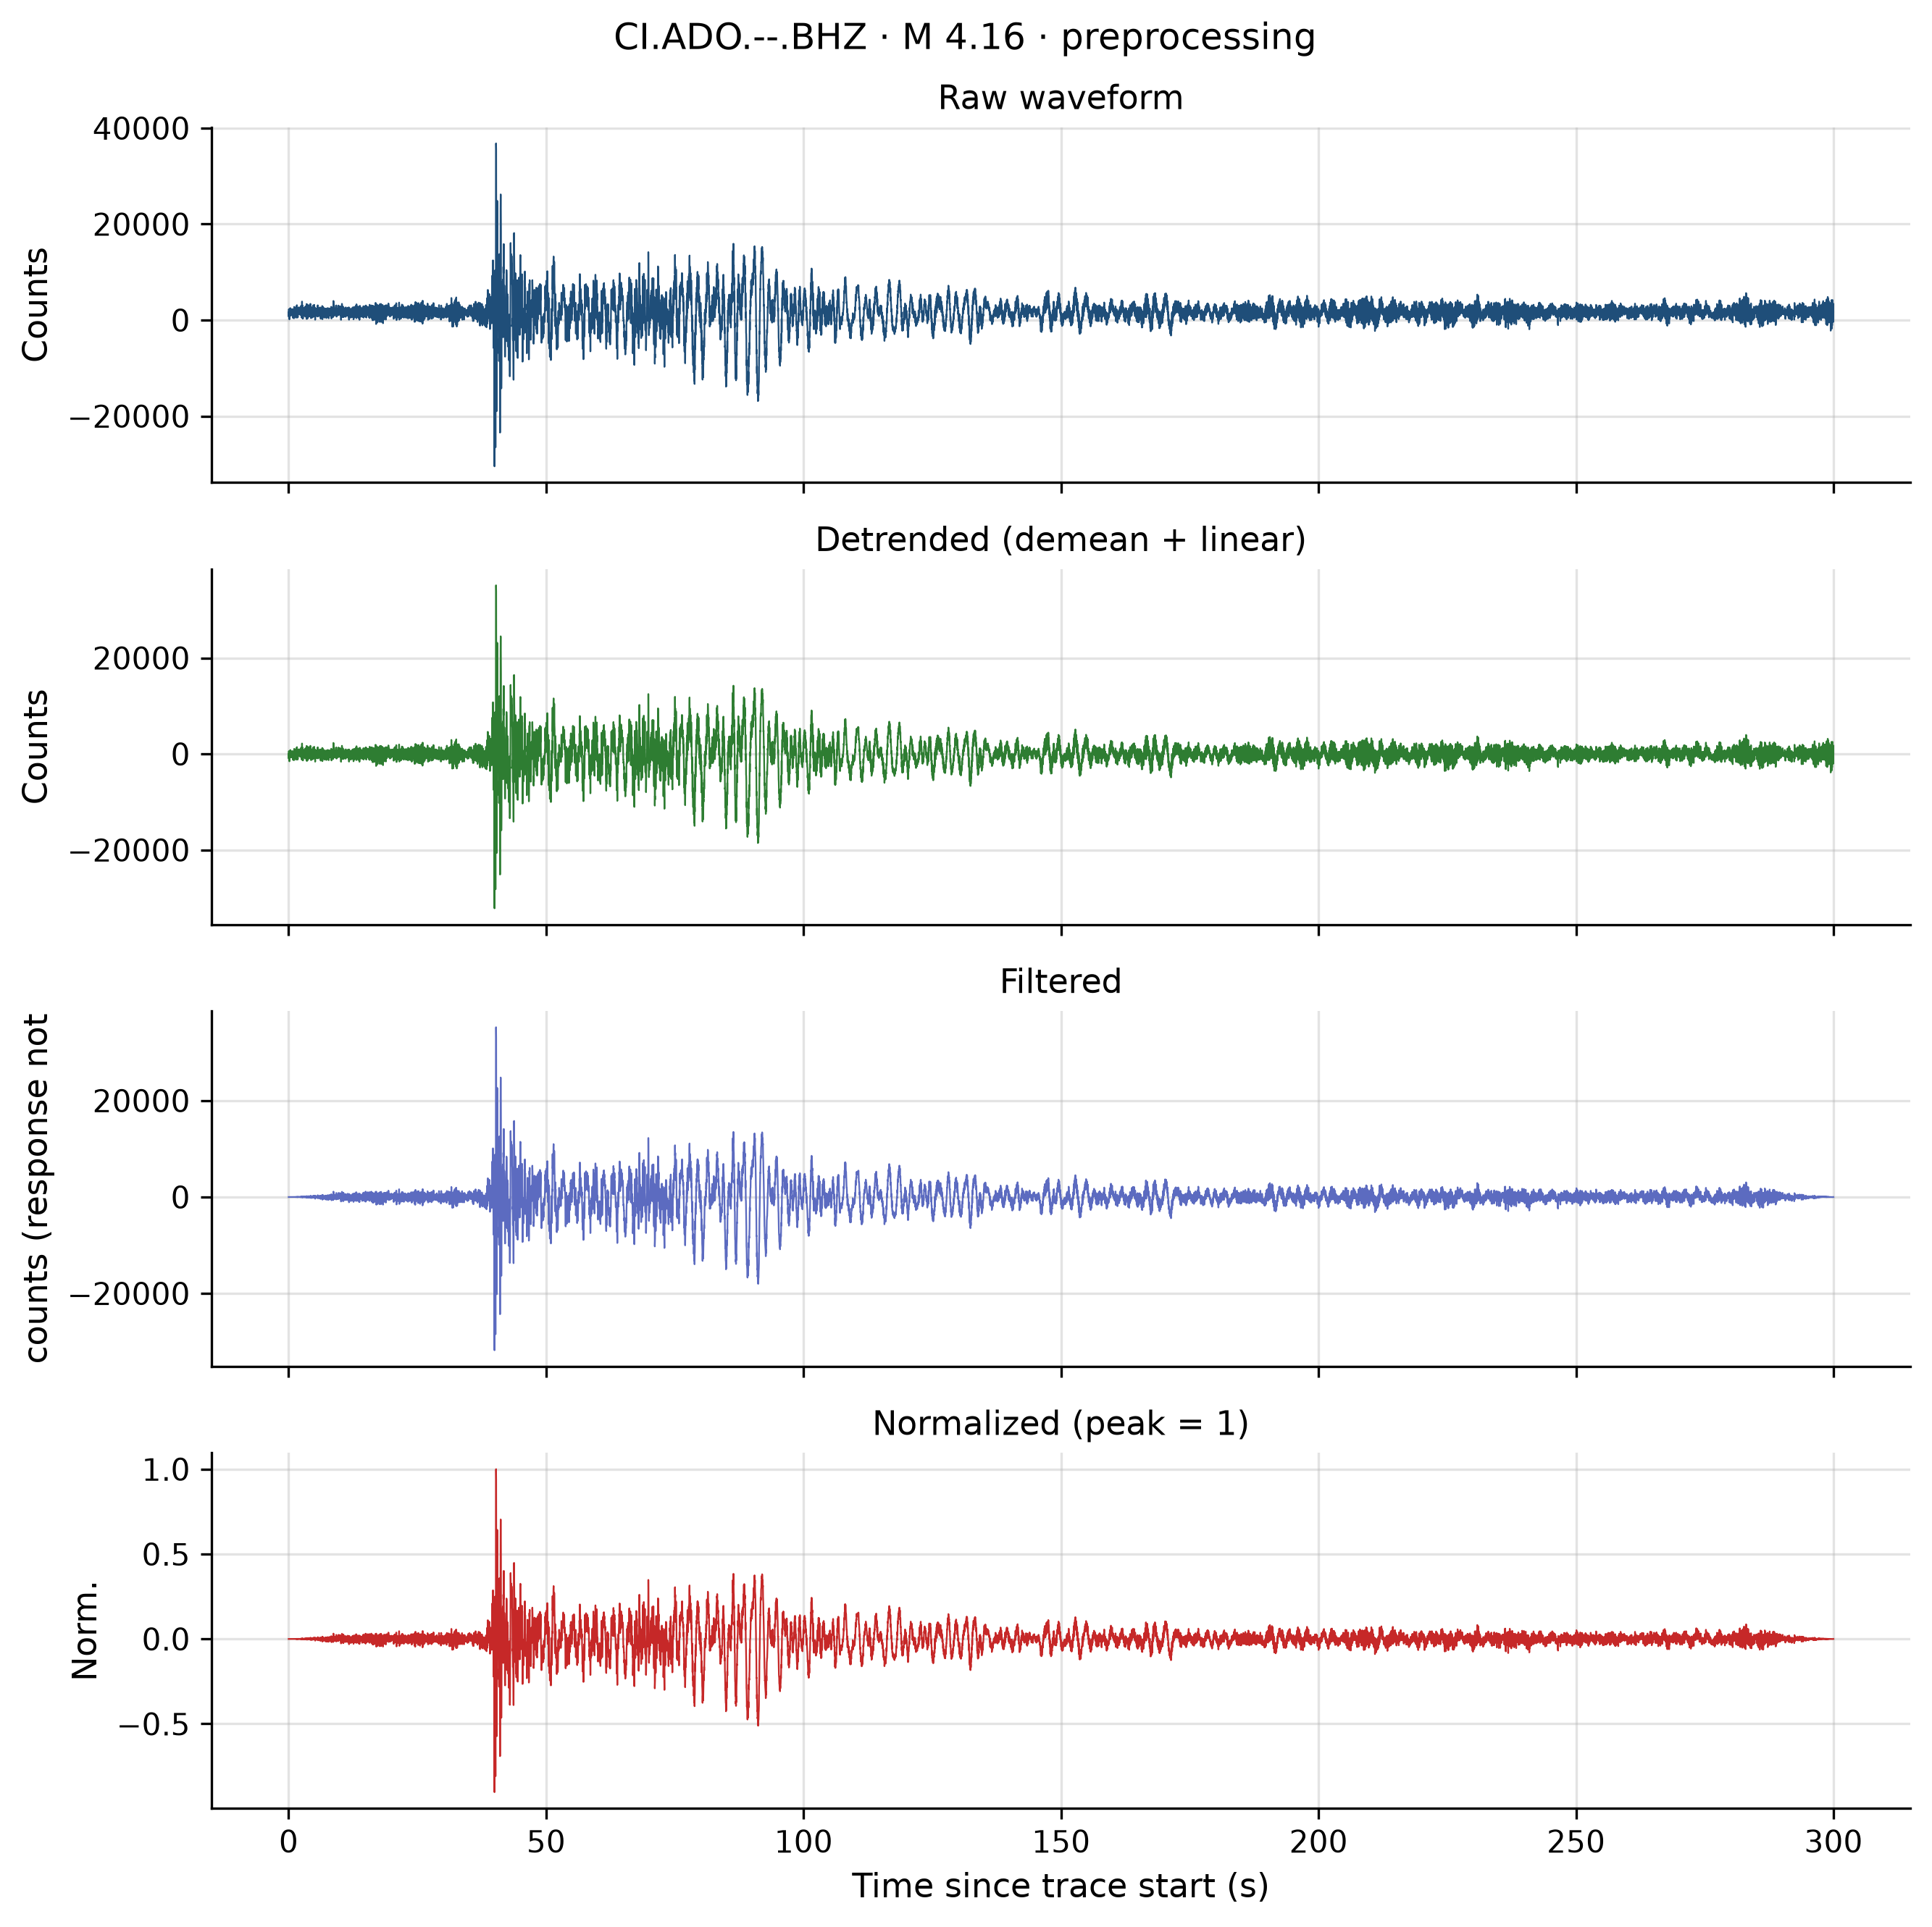
Figure D9: Preprocessing — ci40964048.
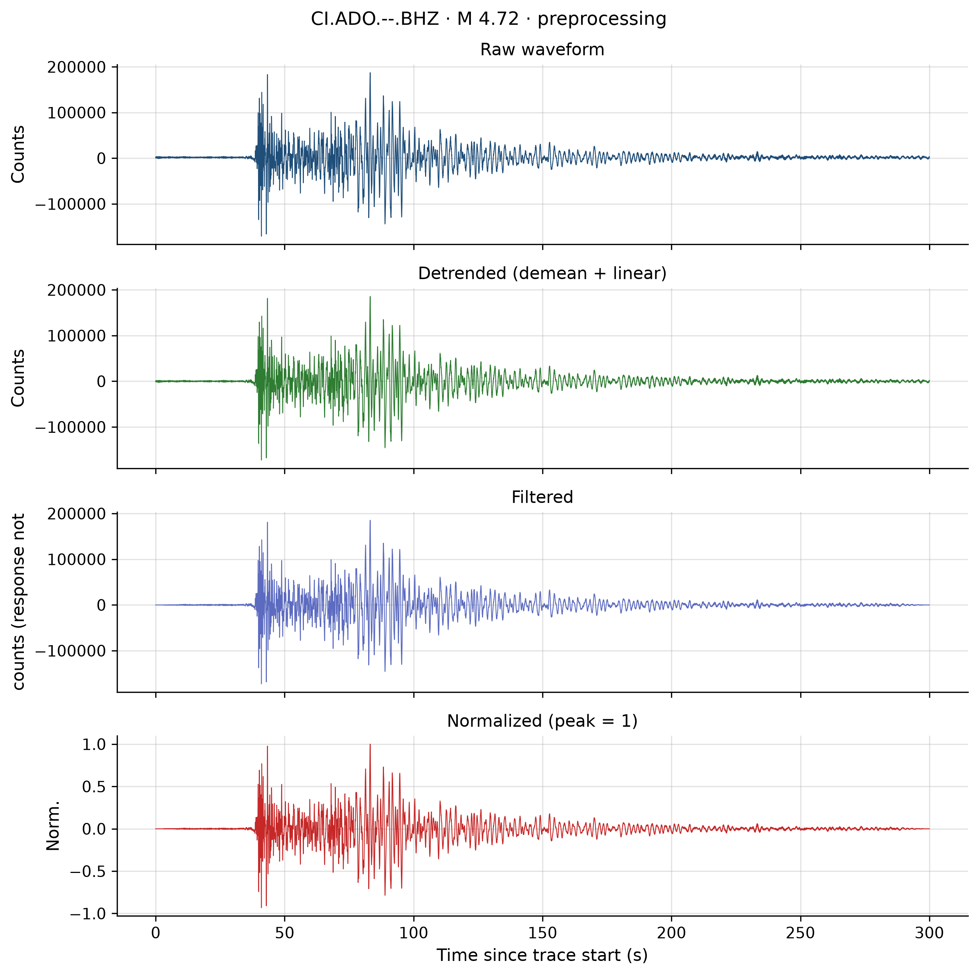
Figure D10: Preprocessing — ci40964128.
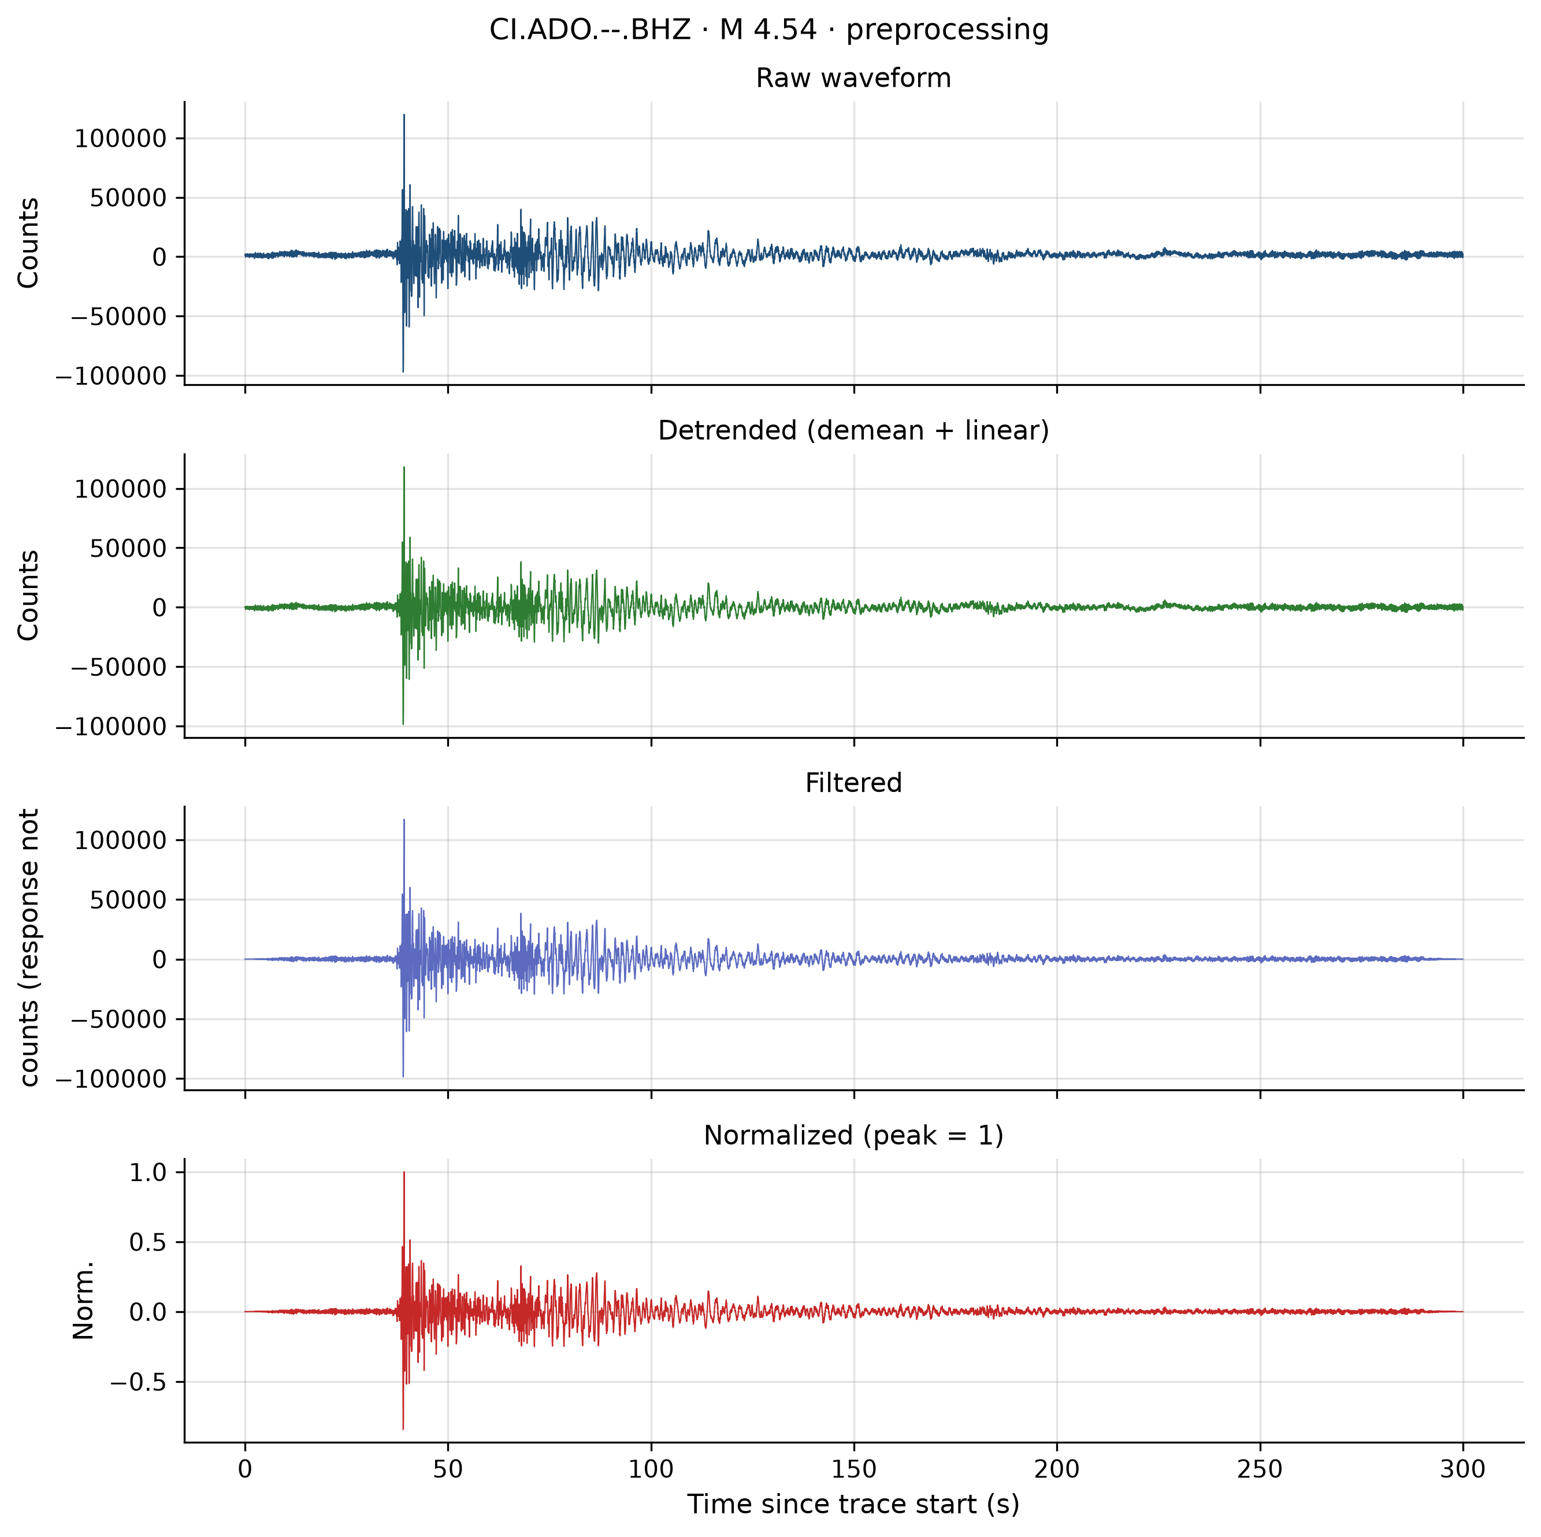
Figure D11: Preprocessing — ci40964384.
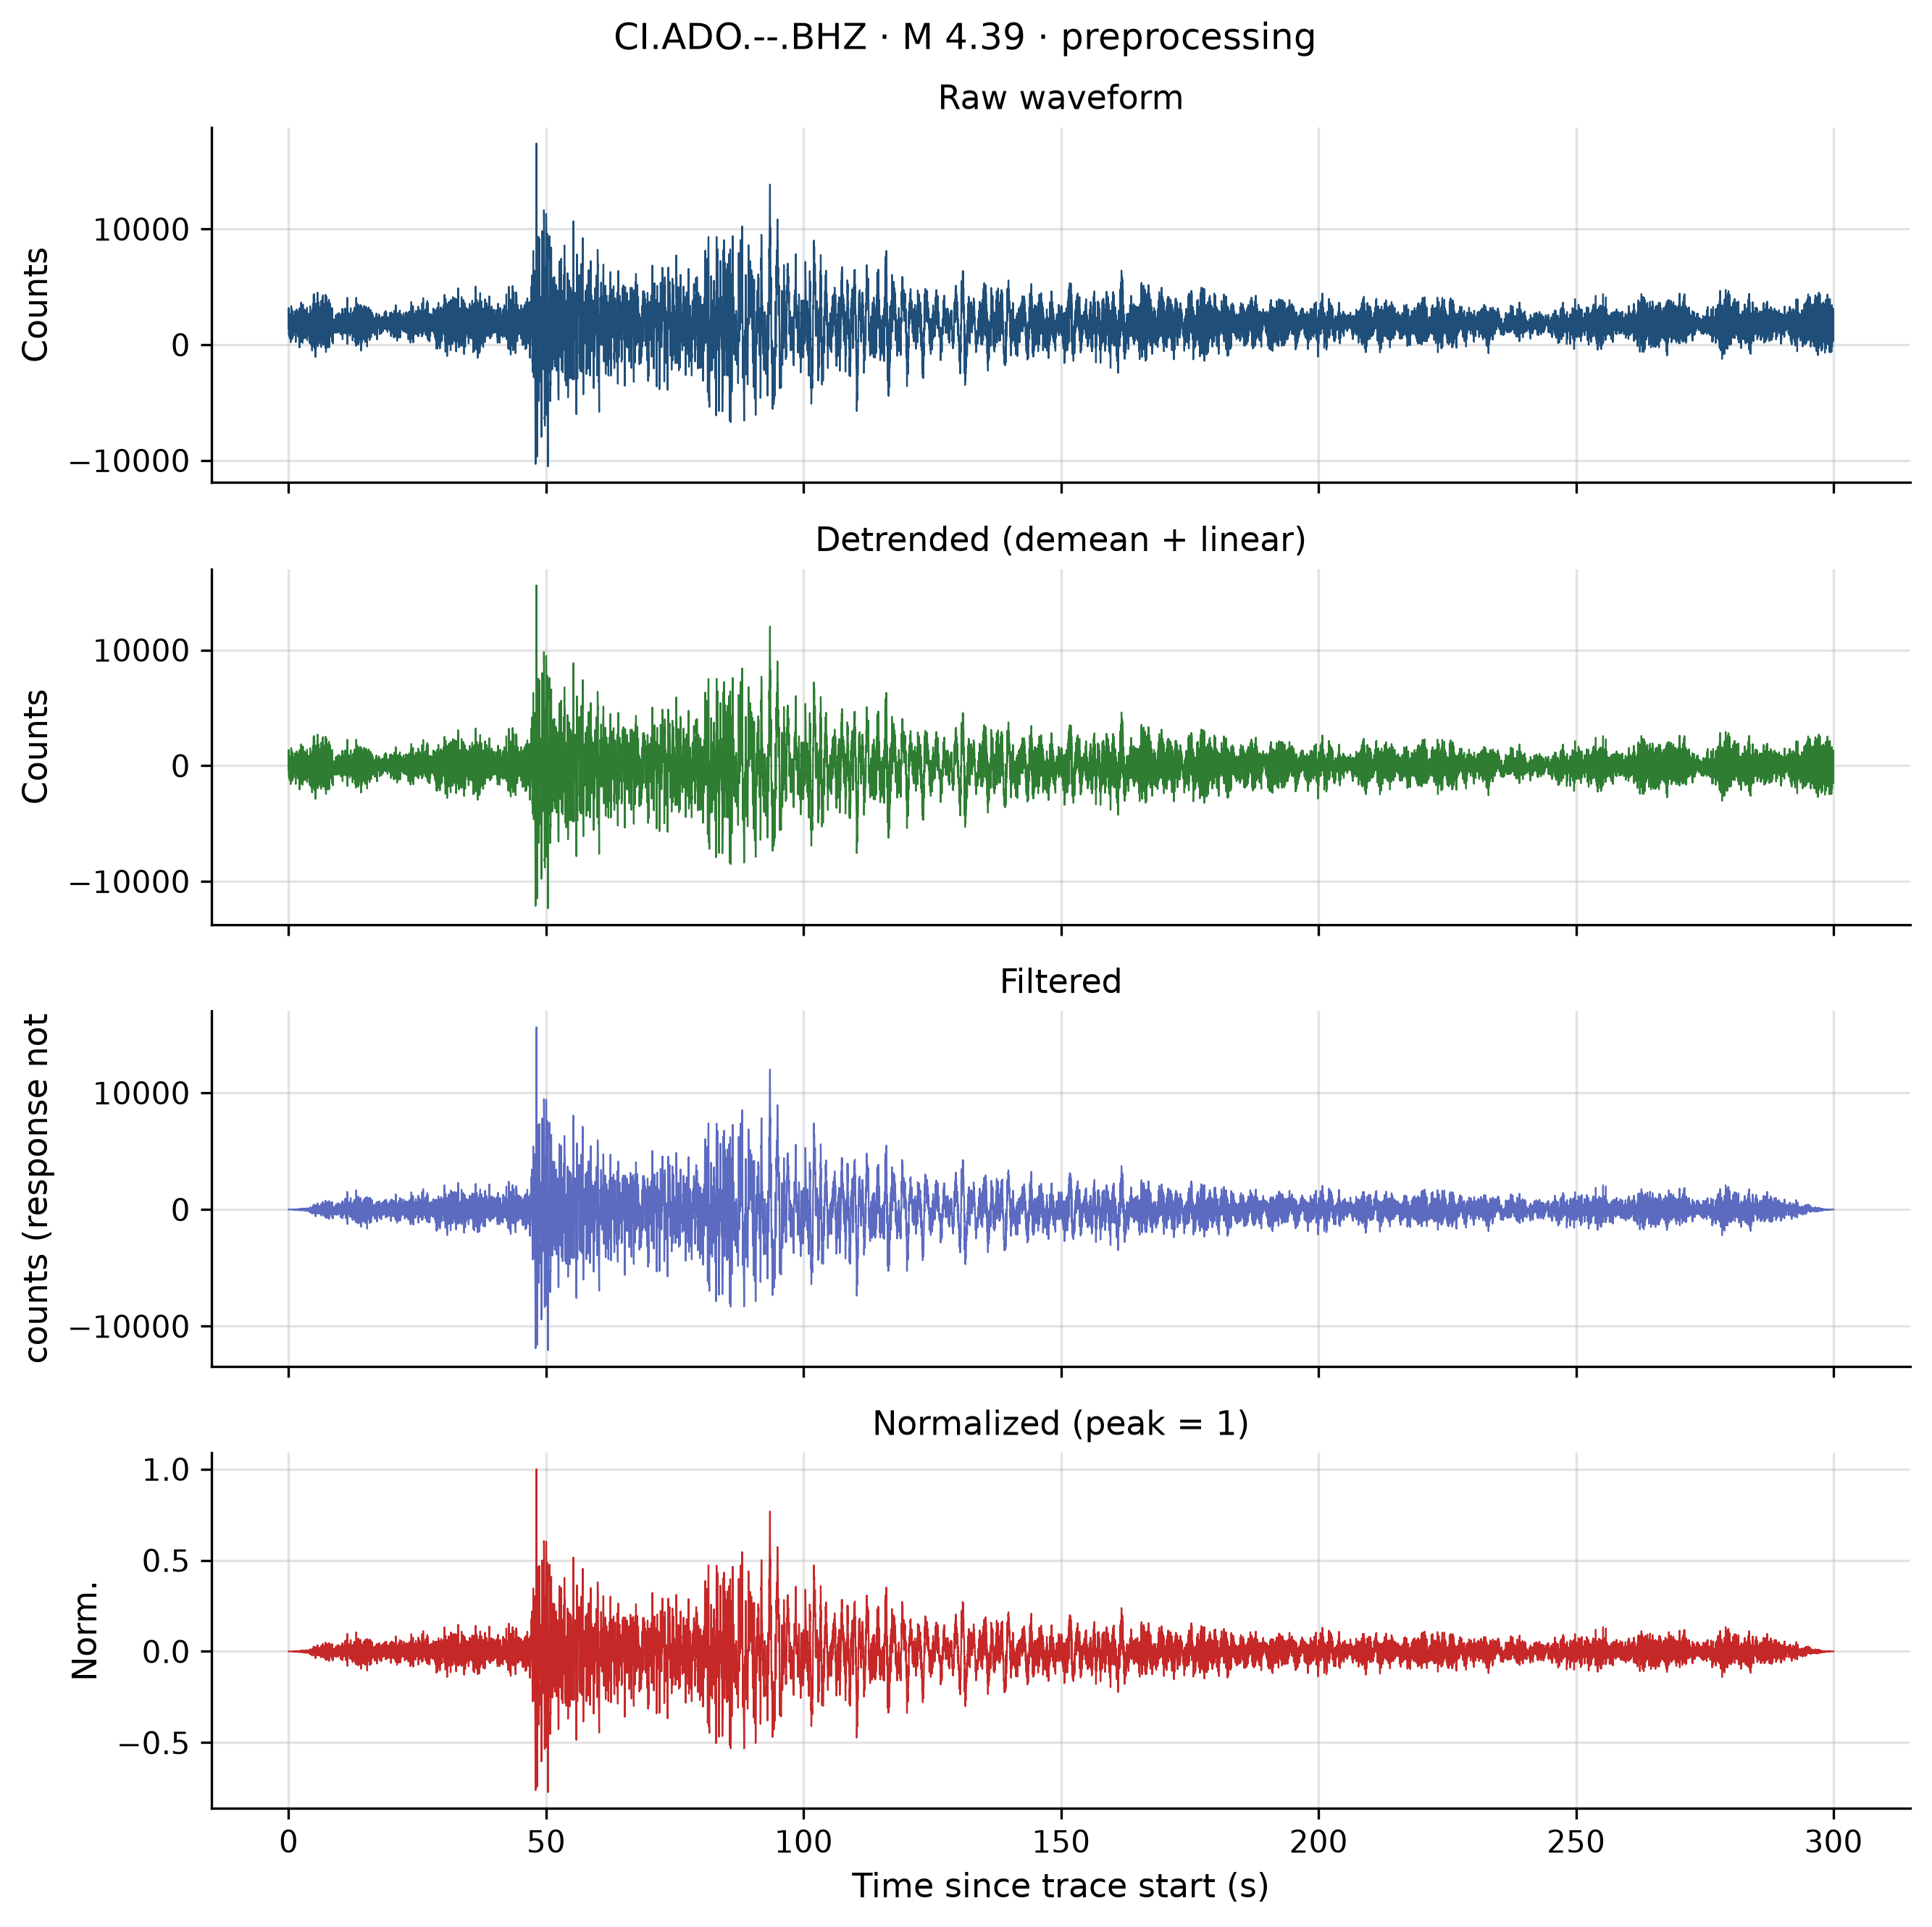
Figure D12: Preprocessing — nn00882322.

Appendix E — Machine-readable summary index
File | Content
reports/eda/dataset_summary.json | EDA cohort statistics
reports/signal_analysis/signal_analysis_summary.json | Signal aggregates
reports/preprocessing/preprocessing_summary.json | Preprocessing aggregates
reports/features/feature_summary.json | Feature cohort statistics
reports/preprocessing/preprocessing_config.json | Frozen B.1 parameters

Document control: Final Research Proposal and Technical Report (D-F1) v1.0 — AMGCR Earthquake Research, 29 July 2026. Supersedes Deliverable 1 (reports/Research_Proposal_v1.md) for submission packaging. No source code modified to produce this document.

