Assignment 2: AWS EC2 Virtual Machine
Auto Scaling & Security Configuration
Submitted by: Prasun Kumar Tripathi
Course: Cloud Computing | Date: 01 March 2026

1. Objective
This assignment demonstrates setting up a cloud infrastructure on Amazon Web Services (AWS). The goal is to create an EC2 virtual machine, configure an Auto Scaling Group with CPU-based scaling policies, attach an Application Load Balancer, and enforce security using IAM roles and Security Group firewall rules.
Video Demo Link:
https://youtu.be/URprMfupTwg

2. Architecture Overview
The following AWS services work together in this setup:
- EC2 Instance — the virtual machine (web server)
- Launch Template — blueprint used to create new VMs during scaling
- Auto Scaling Group (ASG) — automatically adds/removes VMs based on CPU load
- Application Load Balancer (ALB) — distributes incoming traffic across all VMs
- Security Groups — firewall rules controlling allowed/denied traffic
- IAM Role — restricts what the EC2 instance is allowed to do

Architecture Diagram:

┌─────────────────────────────────────────────────────────────────┐
│ Amazon Web Services (AWS) │
│ │
│ Internet ──► Application Load Balancer (web-server-lb) │
│ │ │
│ ▼ │
│ Auto Scaling Group (web-server-asg) │
│ ┌───────────────────────────┐ │
│ │ EC2-1 EC2-2 EC2-3 │ Min:1 Max:3 │
│ │ (web-server instances) │ │
│ └───────────┬───────────────┘ │
│ │ │
│ CloudWatch Monitoring │
│ CPU > 70% ──► Scale OUT (add VM) │
│ CPU < 70% ──► Scale IN (remove VM) │
│ │
│ Security Group: Allow HTTP:80, HTTPS:443, SSH from My IP only │
│ IAM Role: web-server-role (CloudWatch permissions) │
└─────────────────────────────────────────────────────────────────┘

3. Phase 1 — Creating the EC2 Virtual Machine

3.1 Launching the EC2 Instance
Navigate to the AWS Console → search EC2 → click Launch Instance and configure as follows:

Step 1: Name the instance
In the "Name and tags" field, enter: web-server

Step 2: Choose Operating System
Under Application and OS Images, select Amazon Linux 2023 (Free tier eligible )

Step 3: Choose Instance Type
Select t3.micro — Free tier eligible, 2 vCPU, 1GB RAM

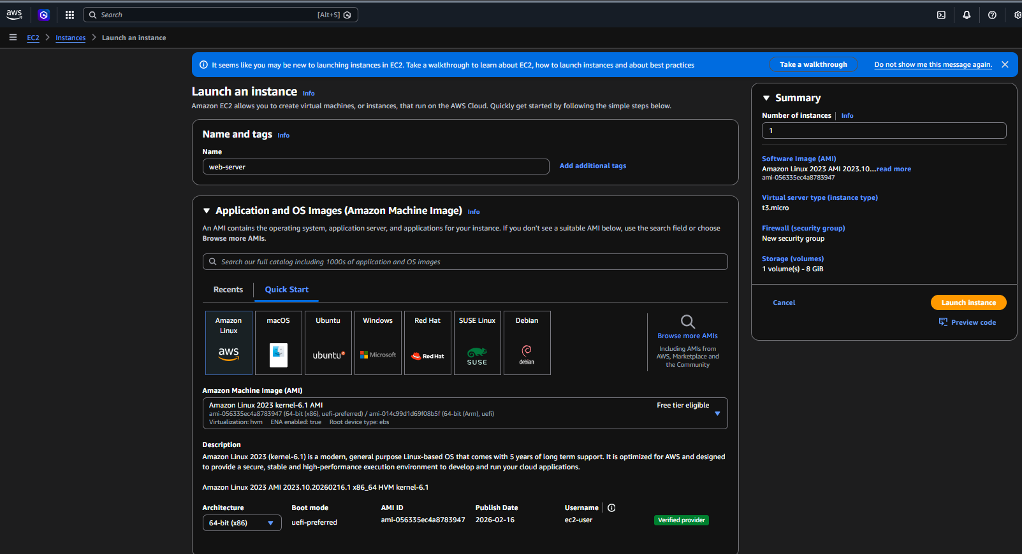

Step 4: Create Key Pair
- Click Create new key pair
- Name: my-key
- Type: RSA, Format: .pem
- Click Create key pair — save the downloaded my-key.pem file safely!

Step 5: Network Settings
- Auto-assign public IP: Enable
- Create security group, name it: web-server-sg
- SSH (port 22): Source = My IP only
- HTTP (port 80): Source = Anywhere 0.0.0.0/0
- HTTPS (port 443): Source = Anywhere 0.0.0.0/0

Step 6: Storage
Leave default: 8 GiB gp3 — no changes needed

Step 7: Launch
Click the orange Launch Instance button. Wait 1-2 minutes until Instance State shows Running and Status Check shows 2/2 checks passed

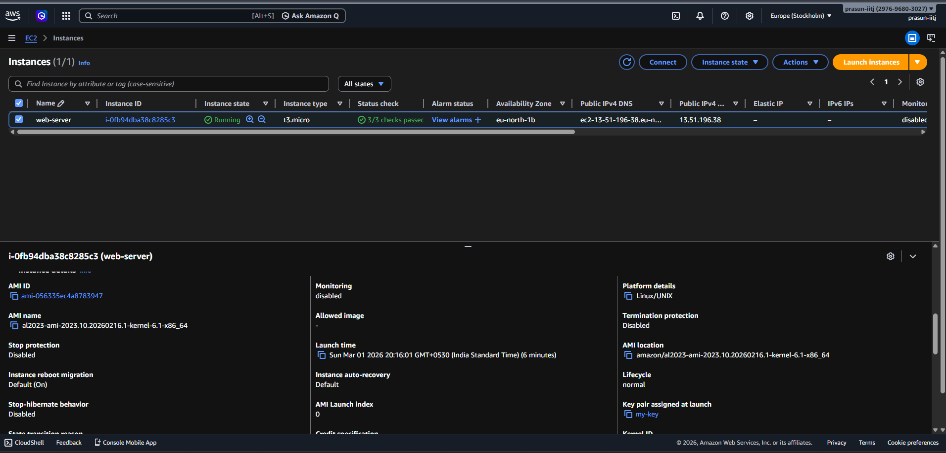

4. Phase 2 — Auto Scaling Configuration

4.1 Create Launch Template
The launch template is the blueprint AWS uses to create new identical VMs during scaling.

- Go to EC2 → Launch Templates → Create launch template
- Launch template name: web-server-template
- Description: Version 1 - Web server template
- Tick: Provide guidance for use with EC2 Auto Scaling
- AMI: Amazon Linux 2023 (same as before)
- Instance type: t3.micro
- Key pair: my-key
- Security group: Select existing → launch-wizard-1
- Click Create launch template

4.2 Create Auto Scaling Group
The Auto Scaling Group manages a fleet of EC2 instances and automatically scales them up or down.

- Click Create Auto Scaling group from the success screen
- Name: web-server-asg
- Launch template: web-server-template (auto-selected)
- Network: Select all 3 Availability Zones (eu-north-1a, 1b, 1c)

4.3 Load Balancer Setup
The Application Load Balancer distributes incoming web traffic across all running EC2 instances.

- Load balancing: Attach to a new load balancer
- Type: Application Load Balancer
- Name: web-server-lb
- Scheme: Internet-facing
- Target group name: web-server-tg
- Health checks: Enable both EC2 and ELB health checks

4.4 Scaling Policy
This policy tells AWS when to automatically add or remove instances based on CPU usage.

Setting | Value | What It Means
Desired capacity | 1 | Start with 1 VM
Minimum capacity | 1 | Never go below 1 VM
Maximum capacity | 3 | Never exceed 3 VMs
Policy type | Target tracking | Auto add/remove VMs
Metric | Average CPU Utilization | Watches CPU usage
Target value | 70% | Scale out above 70% CPU
Instance warmup | 300 seconds | Wait 5 mins before counting new VM

5. Phase 3 — IAM Role Configuration
IAM (Identity and Access Management) controls who can do what inside AWS. We create a role with least-privilege access and attach it to the EC2 instance.

5.1 Create IAM Role
Step 1: Go to IAM
Search IAM in top bar → click IAM → click Roles in left sidebar → click Create role

Step 2: Select trusted entity
Trusted entity type → AWS service. Use case → EC2. Click Next.

Step 3: Attach permission policy
Search for CloudWatch → tick CloudWatchAgentServerPolicy → click Next

Step 4: Name and create
Role name: web-server-role → click Create role
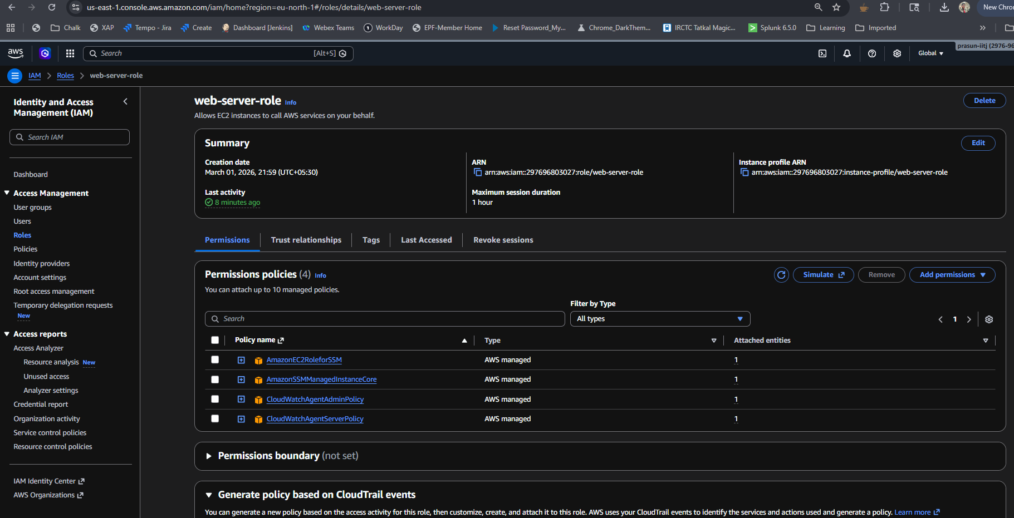

5.2 Attach Role to EC2 Instance
- Go to EC2 → Instances → tick web-server instance
- Click Actions → Security → Modify IAM role
- Select web-server-role from dropdown
- Click Update IAM role

5.3 IAM Roles Summary
Principal | Role / Policy | Access Level
EC2 Instance | CloudWatchAgentServerPolicy | Write metrics to CloudWatch only
Developer User | AmazonEC2ReadOnlyAccess | View instances — no changes allowed
Admin User | AdministratorAccess | Full access to all AWS services

6. Phase 4 — Firewall / Security Group Rules
Security Groups act as a virtual firewall for EC2 instances. They control what traffic is allowed in and out.

6.1 Configure Inbound Rules
- Go to EC2 → Security Groups → click launch-wizard-1
- Click Edit inbound rules
- Set rules exactly as shown in the table below
- Click Save rules

Rule Type | Protocol | Port | Source | Purpose
SSH | TCP | 22 | My IP only | Admin access only
HTTP | TCP | 80 | 0.0.0.0/0 | Allow web traffic
HTTPS | TCP | 443 | 0.0.0.0/0 | Allow secure web traffic
All other ports | ALL | ALL | DENY (not added) | Block everything else

6.2 Configure Outbound Rules
- Click Edit outbound rules
- Keep the default: All traffic → 0.0.0.0/0 (allow all outbound)
- Click Save rules

Note: AWS Security Groups use a default-deny model — any port not explicitly listed in inbound rules is automatically blocked. This means all traffic except HTTP, HTTPS, and SSH from my IP is denied.

7. Phase 5 — Testing Auto Scaling

7.1 Verify Web Server is Running
- Go to EC2 → Instances → copy the Public IPv4 address of web-server
- Open browser and visit: http://13.51.196.38
- We will see the default Amazon Linux web page

7.2 Trigger Auto Scaling with Stress Test
Step 1: Connecting my EC2 instance
Go to EC2 → Instances → select web-server → click Connect → EC2 Instance Connect → Connect. A black terminal opens in our browser.
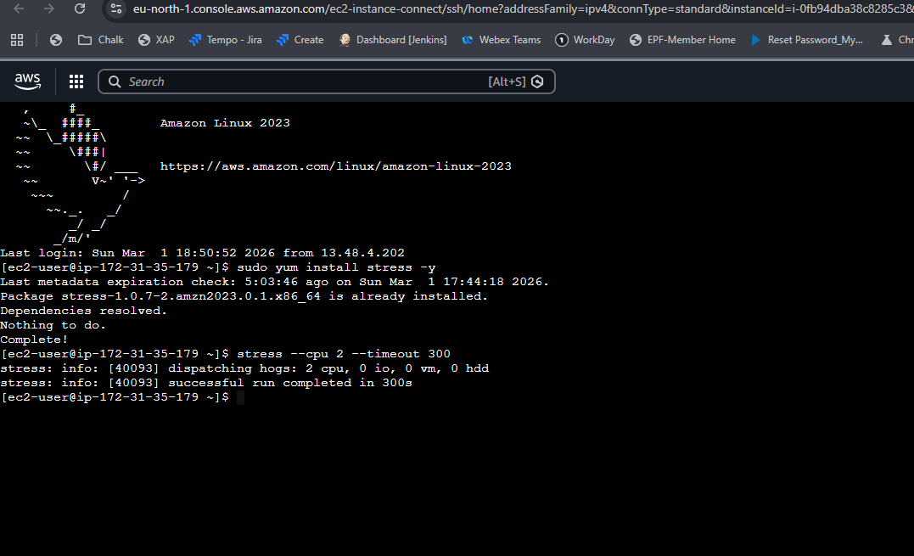

Step 2: Install stress tool
sudo yum install stress -y

Step 3: Run CPU stress test
stress --cpu 4 --timeout 300
This simulates heavy CPU load for 5 minutes (300 seconds), pushing CPU above 70% to trigger scaling.

Step 4: Watch auto scaling happen
- Go to EC2 → Auto Scaling groups → web-server-asg
- Click the Monitoring tab — watch CPU spike above 70%
- Click the Activity tab — you will see new instances being launched automatically!
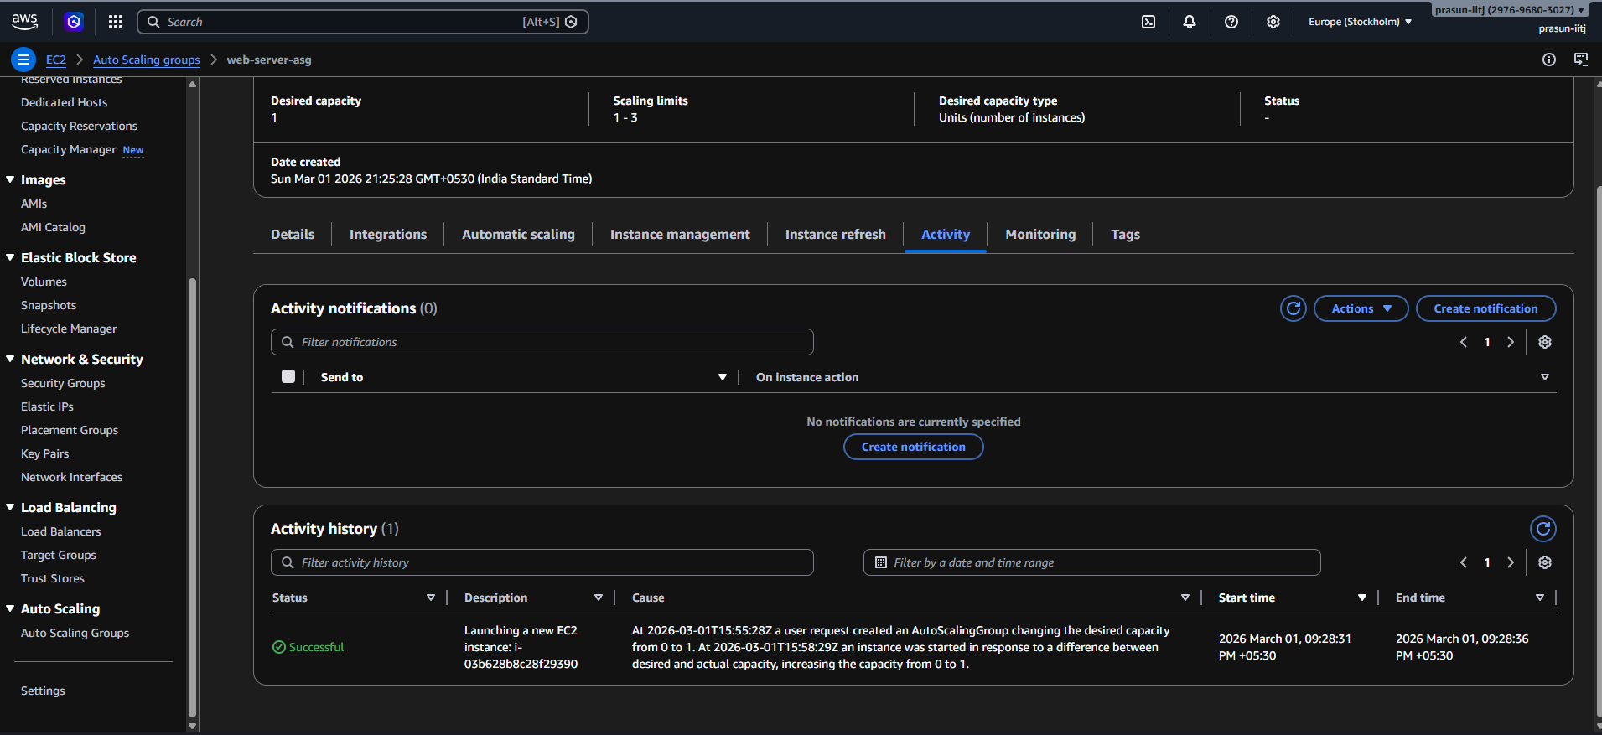

7.3 Expected Results
What To Observe | Expected Result
CPU before stress test | Below 10% — 1 instance running
CPU during stress test | Above 70% — triggers scale out
Instances during stress test | 2 or 3 instances launched automatically
CPU after stress test ends | Drops back below 70%
Instances after cooldown | Scales back down to 1 instance

Various Graphs and Monitoring Details :
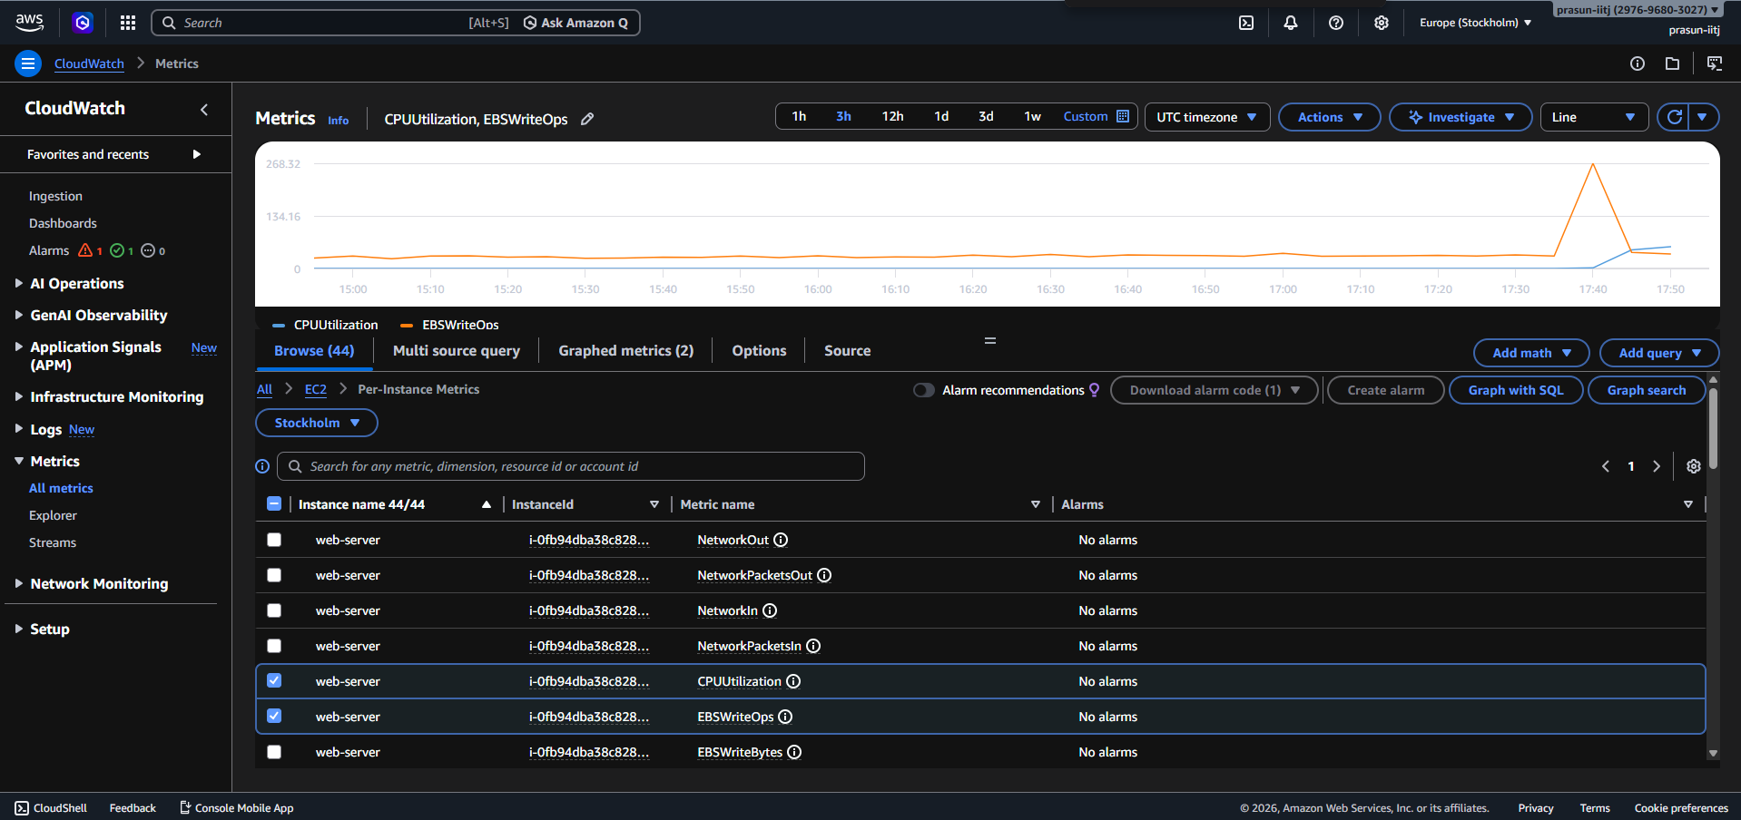

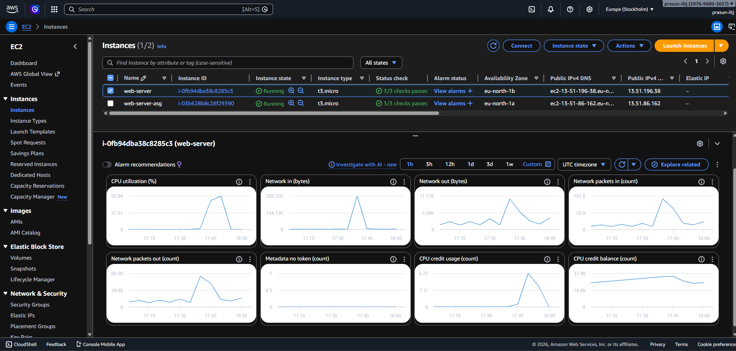

8. Results & Observations
- EC2 Instance: Successfully launched web-server running Amazon Linux 2023 on t3.micro.
- Launch Template: Created web-server-template as the blueprint for the Auto Scaling Group.
- Auto Scaling Group: web-server-asg created with Min 1, Max 3 instances across 3 Availability Zones.
- Load Balancer: web-server-lb (Application Load Balancer) distributing HTTP traffic via web-server-tg target group.
- Scaling Policy: cpu-scaling-policy triggers scale-out at 70% CPU utilization.
- IAM Role: web-server-role attached to EC2 with least-privilege CloudWatch permissions.
- Security Group: HTTP/HTTPS open to internet; SSH restricted to admin IP only; all other ports denied.
- Stress Test: CPU stress test successfully triggered auto scaling — new instances launched within ~2 minutes.

09. Deliverables :

Video Demo Link:
https://youtu.be/URprMfupTwg

