Instructions for compiling and running WarehouseFSM
1. Navigate to the project directory.
2. Compile all java files using 'javac *.java'.
3. Run the project by using 'java WareContext'.

Opening main menu
Once the program is opens it askes if you want to load the previously shaved file.
If there is a previously shaved file select yes or click no
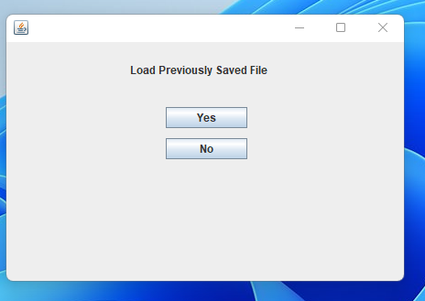

Once you select yes or no option the program launches you to the main menu option
Main Menu
Main Menu has following options.
- Client menu
- Clark menu
- Manager menu
- Save change
- Save and quit program
The different options in main menu are explained below
- Client menu

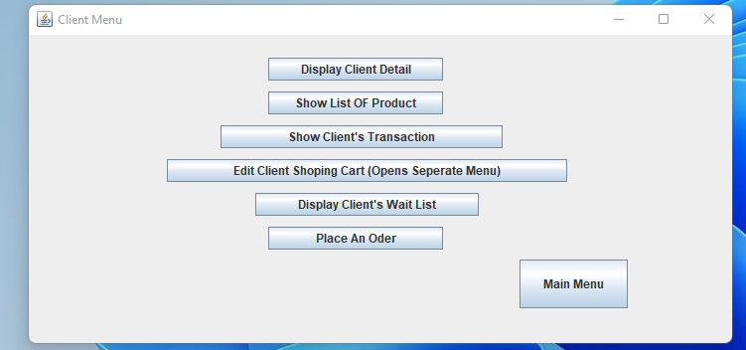
To open client menu, the user has to select a client from the drop down menu. Once a client is selected client menu opens. Client menu has the following options.
- Display Client Detail
This option Displays the detail of the client that the user selected while logging in to client menu.
- Show List of Product
Displays the list of products in the warehouse system
- Show Client’s Transaction
Displays all the payments made and all the odors placed by the client that was selected while logging in to client menu.
- Edit Shopping Cart
Opens client shopping menu to edit the shopping cart of the client selected while logging in to client menu.
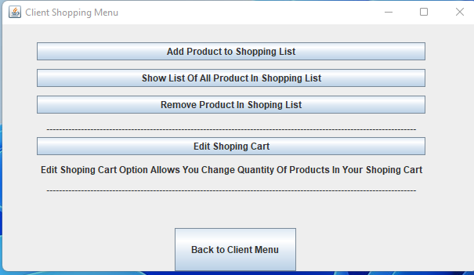
Clients shopping menu has following options
- Add product to shopping list
Adds products to the shopping list of the client that was selected while logging in to client menu.
- Show list of all product in shopping list
Shows the list of products in the shopping cart of the client that was selected while logging in to client menu.
- Remove Products in shopping list of the client that was selected while logging in to client menu.
Remove Products in shopping list
- Edit shopping cart
This option allows user to change the quantity of products in the shopping cart of the client that was selected while logging in to client menu.

- Display Clients wait List
Display the waitlisted orders of the client that was selected while logging in to client menu.
- Place an Order
Place an order for all the products in the shopping cart of the selected while logging in to client menu.

- Clark menu

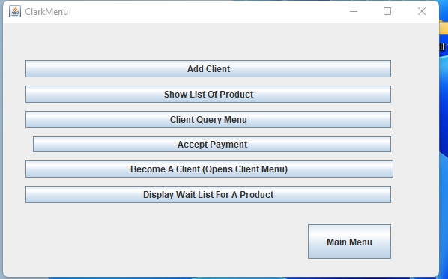
Clark menu has the following options
- Add client
This option adds a new Clients in the warehouse system
- Show list of product
This option displays the list of product in the warehouse system
- Client query menu
Opens Client Query menu
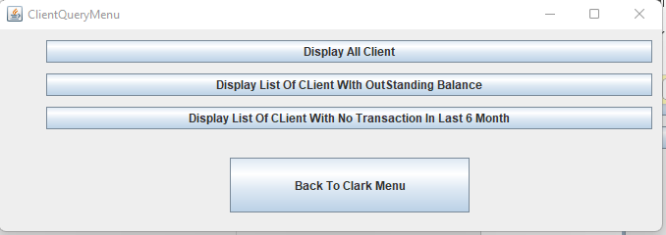

Client Query menu has the following options
- Display all clients
This Option displays all clients in the warehouse system.
- Display List of Clients with outstanding Balance
This option displays List of Clients with outstanding Balance
- Display List of Client With No Transaction In last 6 month
- This option displays List of Client With No Transaction In last 6 month
- Accept Payment
This option allow warehouse to record payments made from clients
- Become a Client
This option opens clients menu
- Display wait list for a product
This option display the details of all the orders what were waiting listed due to un sufficient quantity

- Manager menu
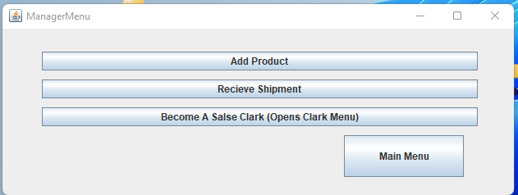
Manager menu has the following options
- Add product
This option adds a new products in the warehouse system
- Receive shipment
When warehouse receives shipment this option is used to update the inventory from the shipment. This option also fulfills the waitlisted orders.
- Become a Salse Clark
This option opens the Clark menu

- Save change
Safes all the changes that was made in the warehouse system
- Save and quit program
Safes all the changes that was made in the warehouse system and closes the program

