Week 1 & Week 2 (Remaining to track)

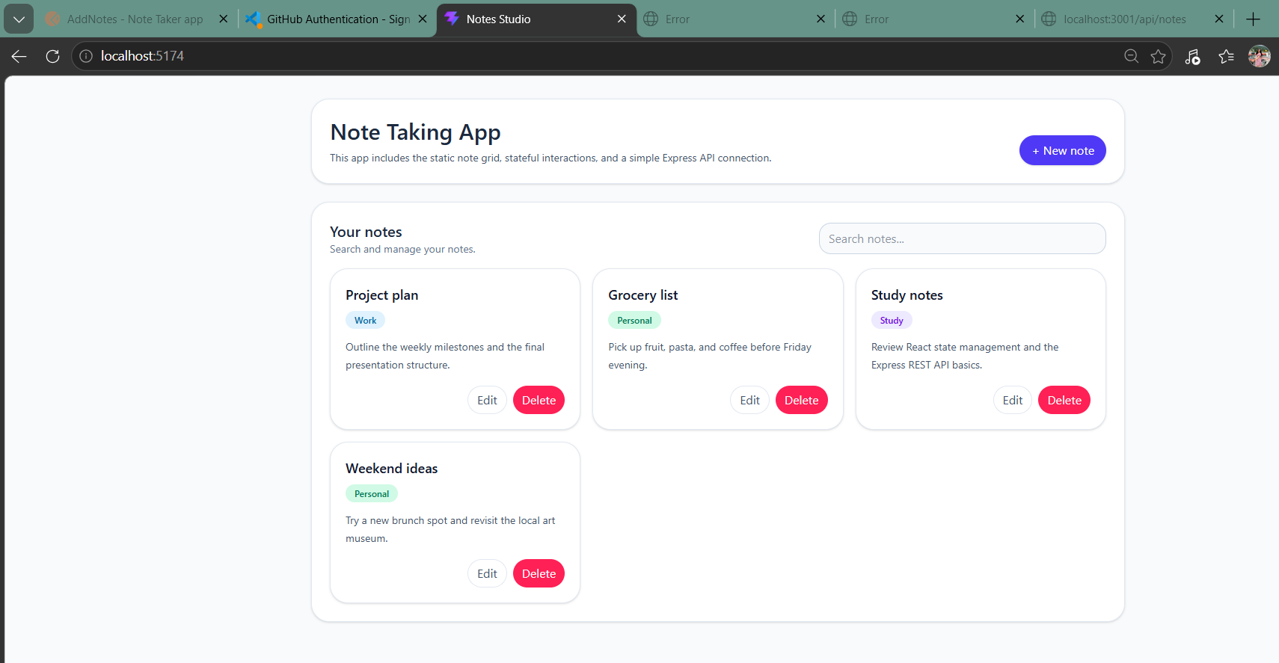

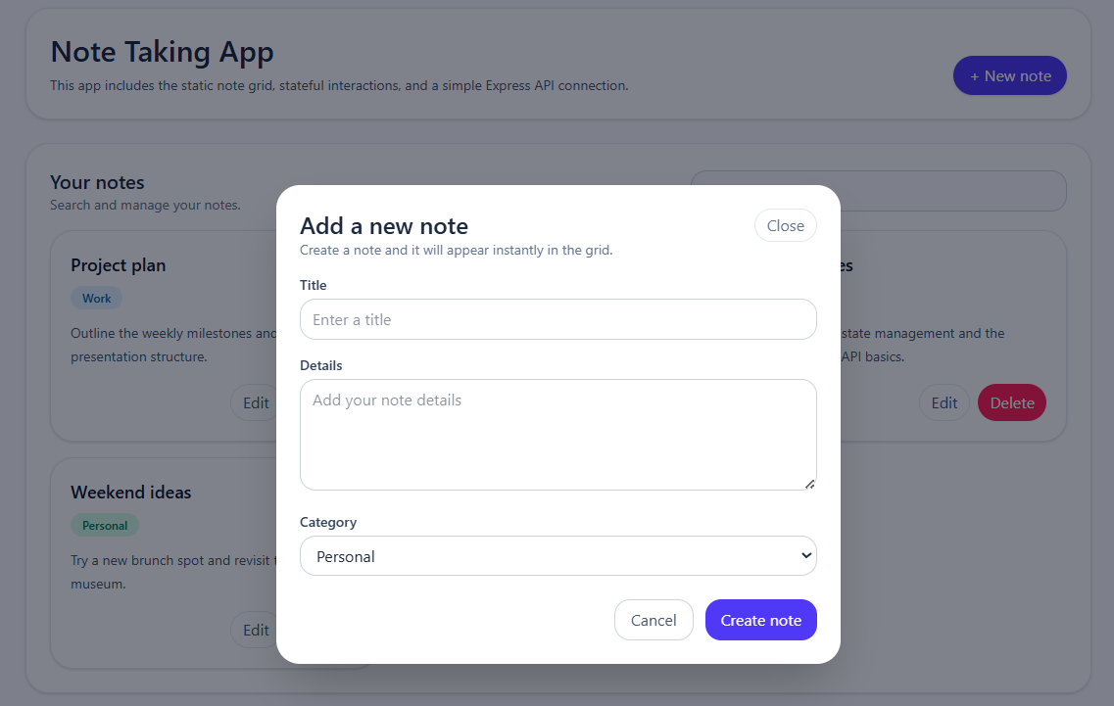

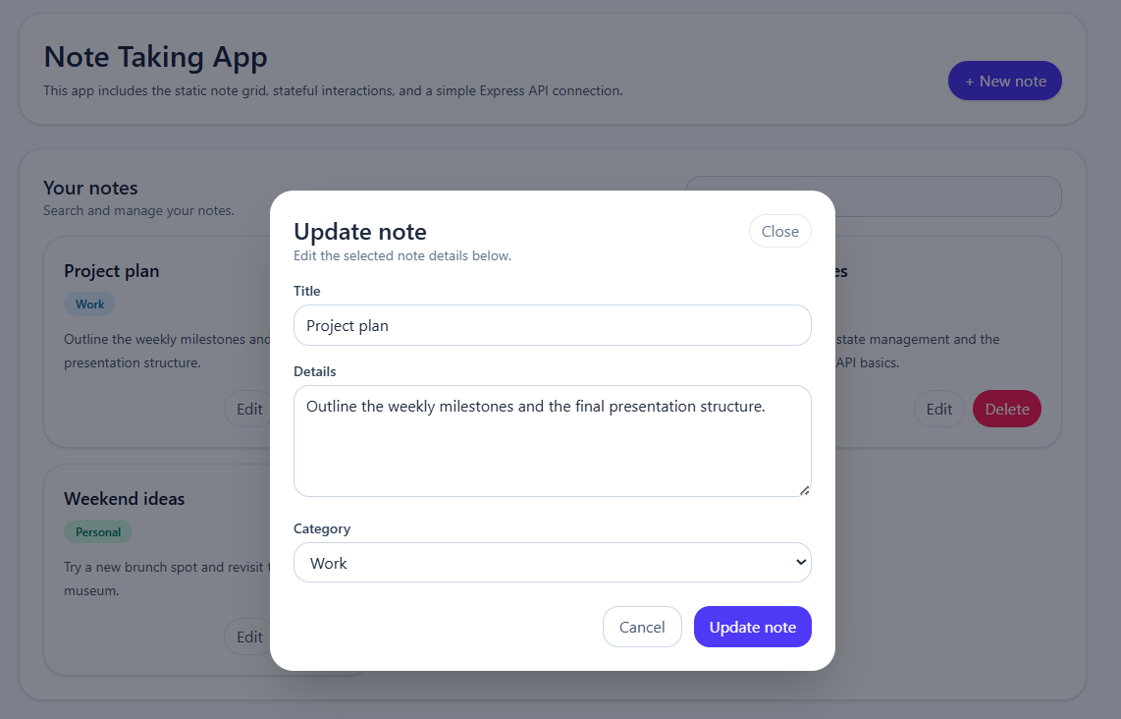

GitHub Link:

https://github.com/prasunamishra/NoteTaker

