

Report Writing
Computational Mathematics

HERALD COLLEGE KATHMANDU

Submitted By:
Prasuna Mishra
Student ID: 2551531

Submitted To:
Module Leader: Uttam Acharya Sir
Tutor: Nabin Acharya Sir

Task 1
Two methods have been used in this task to find roots. They are:
- Bisection Method and
- Newton-Raphson Method
Function 1: 𝑦 = 𝑓(𝑥) =𝑥²−𝑥−1
Function 2: 𝑦 = 𝑓(𝑥) =𝑥³−𝑥²−2𝑥+1
For Function 1
Bisection Method |  | Newton’s Method
[a,b]; #iterations;  Root1 | [a,b]; #iterations;  Root2 | x0; #iterations;  Root1 | x0; #iterations;  Root2
[1,2]; #20;  1.61803341 | [-1,0]; #20;  -0.61803341 | 1; #5;  1.61803399 | -1; #4;  -0.61803399
SciPy Method
x0;  Root1 |  | x0;  Root2
1.61803399 |  | -0.61803399
For Function 2
Bisection Method |  |  | Newton’s Method
[a,b]; #iterations;  Root1 | [a,b]; #iterations;  Root2 | [a,b]; #iterations;  Root3 | x0; #iterations;  Root1 | x0; #iterations;  Root2 | x0; #iterations;  Root3
[-1.5,-1]; #19;  -1.24697971 | [-0.5,0.5]; #20;  0.44504261 | [1.5,2]; #19;  1.80193806 | 0; #3;  0.44504175 | -1; #4;  -1.24697960 | 2; #4;  1.80193774
SciPy Method
x0;  Root1 |  | x0;  Root2 |  | x0;  Root2
-1.24697960 |  | 0.44504187 |  | 1.80193774

Graph of functions:
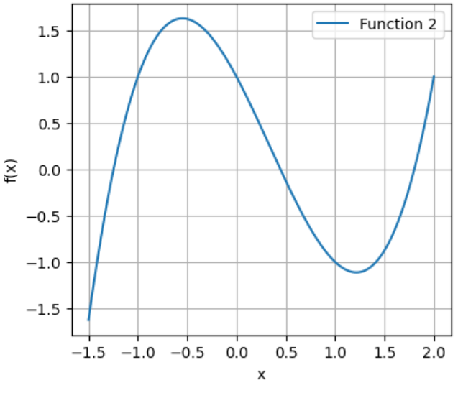
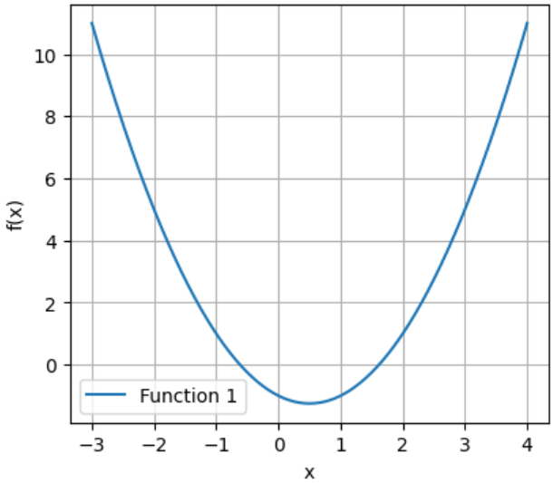
Function 1 Function 2

The Bisection Method(Bracketing Method) is a simple and reliable way to find roots by repeatedly dividing an interval. In this method the function changes sign until the root is narrowed down. It always converges but requires more iterations, so it is slower.
On the other hand, the Newton-Raphson Method uses the slope of the tangent to quickly approach the root. It often reaches the solution in just a few steps. However, it needs a good initial guess and the derivative of the function, otherwise it may fail to converge.
In comparison, the bisection method is slower but guaranteed, while Newton-Raphson is much faster but less reliable.
Both methods have their strengths, Bisection method is always reliable because it keeps halving the interval until the root is found, but it is slow. Newton–Raphson method is much faster (converges quickly) but only if you start with a good guess and can calculate the derivative; otherwise, it may fail.

Task 2
Here also, we have used two methods to find results. They are:
- Midpoint Approximation Method
- Trapezoidal Rule
The intervals is [0,5] and they are divided into small parts.
Function 1: 𝑦 =𝑓(𝑥) = 𝑥 / (𝑥²+1), [0,5]
Function 2: 𝑦 =𝑓(𝑥) = 𝑒^{𝑥}, [0,5]
N | Midpoint Approximation (𝑀_{N}) | Trapezoidal Rule (𝑇_{𝑁}) | Analytical (𝐼) | Abs Error  |𝑀_{𝑁} −𝐼| | Abs Error  |𝑇_{𝑁} −𝐼|
For Function 1
10 | 1.640378 | 1.606865 | 1.629048 | 0.01132983 | 0.02218344
30 | 1.630252 | 1.626645 |  | 0.00120420 | 0.00240351
50 | 1.629480 | 1.628185 |  | 0.00043219 | 0.00086376
100 | 1.629156 | 1.628832 |  | 0.00010791 | 0.00021578
500 | 1.629053 | 1.629040 |  | 0.00000431 | 0.00000863
For Function 2
10 | 145.888729 | 150.471546 | 147.413159 | 1.52443031 | 3.05838690
30 | 147.242680 | 147.754235 |  | 0.17047895 | 0.34107629
50 | 147.351755 | 147.535983 |  | 0.06140424 | 0.12282383
100 | 147.397805 | 147.443869 |  | 0.01535442 | 0.03070980
500 | 147.412545 | 147.414388 |  | 0.00061422 | 0.00122844

Plot of the functions

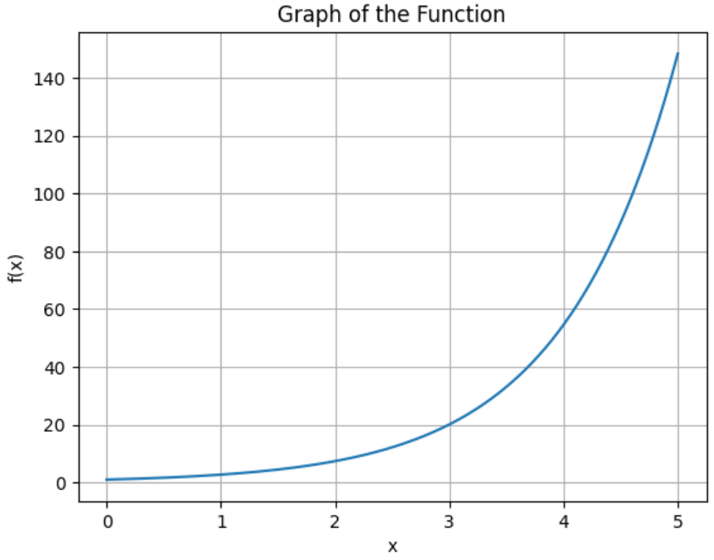
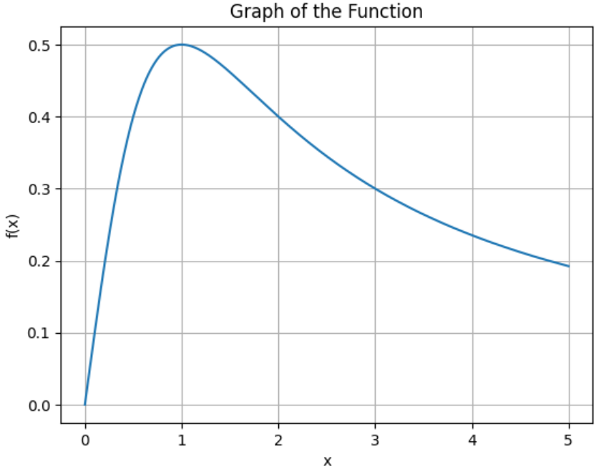
Function 1

Function 2

The Midpoint Approximation Method works by dividing the interval into subintervals and then evaluating the function at the midpoint of each subinterval. These values are then multiplied by the width of the subinterval and summed to approximate the integral.
On the other hand, the Trapezoidal Rule approximates the area under the curve by dividing the interval into subintervals and forming trapezoids under the curve, then summing their areas to estimate the integral.
The Trapezoidal Rule generally gives better accuracy because it divides the curve into smaller trapezoids, effectively following the slope of the function more closely, which reduces error as the number of subintervals increases. The Midpoint Method, while simpler and faster as it directly uses the average height (midpoint value) of the function over subintervals, may not capture the curve’s variation as accurately as trapezoids. Thus, the Trapezoidal Rule tends to provide more precise results for the same number of subintervals.

Conclusion
In conclusion, the Bisection Method is slower but always reliable, while the Newton-Raphson Method is much faster but less reliable without a good initial guess. Similarly, the Midpoint Method is simpler and faster but less accurate, whereas the Trapezoidal Rule generally provides more precise results by better capturing the curve’s shape.

