**Execution Log:**

[RemoteTestNG] detected TestNG version 6.14.2

@UATTesting

Feature: Number validations of Employees, Offices, Licensees, Jurisdictions

Starting ChromeDriver 88.0.4324.96 (68dba2d8a0b149a1d3afac56fa74648032bcf46b-refs/branch-heads/4324@{#1784}) on port 4948

Only local connections are allowed.

Please see https://chromedriver.chromium.org/security-considerations for suggestions on keeping ChromeDriver safe.

ChromeDriver was started successfully.

Scenario: Number of validations through homepage aboutus button # GoogleSearch.feature:3

Given Open Chrome browser and enter Playtech url # googleSearchDef.openChromeBrowserAndEnterUrl()

When Select day, month and year in legal page and enter Site # googleSearchDef.enterLegalData()

Then Home page will be displayed # googleSearchDef.HomePageSection()

When Click About Us button in home page # googleSearchDef.clickHomeAboutusButton()

Then About Us page will be opened # googleSearchDef.AboutUSPageFromHomePage()

When Check Number of Employees Tiles # googleSearchDef.CheckNumberofEmployeesTiles()

Then Number of Employees will be displayed # googleSearchDef.NoOfEmpWillBeDispayed()

When Check Number of Countries Playtech Offices Tiles # googleSearchDef.CheckNumberofCountriesPlaytechOfficesTiles()

Then Number of Playtech Offices will be displayed # googleSearchDef.NumberofPlaytechOfficeswillbedisplayed()

When Check Number of Global licensees Tiles # googleSearchDef.CheckNumberofGloballicenseesTiles()

Then Number of Global licensees will be displayed # googleSearchDef.NumberofGloballicenseeswillbedisplayed()

When Check Number of Regulated Jurisdictions Tiles # googleSearchDef.CheckNumberofRegulatedJurisdictionsTiles()

Then Number of Regulated Jurisdictions will be displayed and close browser # googleSearchDef.NumberofRegulatedJurisdictionswillbedisplayed()

Starting ChromeDriver 88.0.4324.96 (68dba2d8a0b149a1d3afac56fa74648032bcf46b-refs/branch-heads/4324@{#1784}) on port 37444

Only local connections are allowed.

Please see https://chromedriver.chromium.org/security-considerations for suggestions on keeping ChromeDriver safe.

ChromeDriver was started successfully.

Scenario: Number of validations through footer about us link # GoogleSearch.feature:18

Given Open 2nd time Chrome browser and enter Playtech url # googleSearchDef.open2ndTimeChromeBrowserAndEnterUrl()

When Select day, month and year in legal page and enter Site # googleSearchDef.enterLegalData()

Then Home page will be displayed # googleSearchDef.HomePageSection()

When Click About Us button in home page footer # googleSearchDef.ClickAboutUsbuttoninhomepagefooter()

Then About Us page will be opened # googleSearchDef.AboutUSPageFromHomePage()

When Check Number of Employees Tiles # googleSearchDef.CheckNumberofEmployeesTiles()

Then Number of Employees will be displayed # googleSearchDef.NoOfEmpWillBeDispayed()

When Check Number of Countries Playtech Offices Tiles # googleSearchDef.CheckNumberofCountriesPlaytechOfficesTiles()

Then Number of Playtech Offices will be displayed # googleSearchDef.NumberofPlaytechOfficeswillbedisplayed()

When Check Number of Global licensees Tiles # googleSearchDef.CheckNumberofGloballicenseesTiles()

Then Number of Global licensees will be displayed # googleSearchDef.NumberofGloballicenseeswillbedisplayed()

When Check Number of Regulated Jurisdictions Tiles # googleSearchDef.CheckNumberofRegulatedJurisdictionsTiles()

Then Number of Regulated Jurisdictions will be displayed and close browser # googleSearchDef.NumberofRegulatedJurisdictionswillbedisplayed()

2 Scenarios (2 passed)

26 Steps (26 passed)

6m41.886s

===============================================

Suite

Total tests run: 1, Failures: 0, Skips: 0

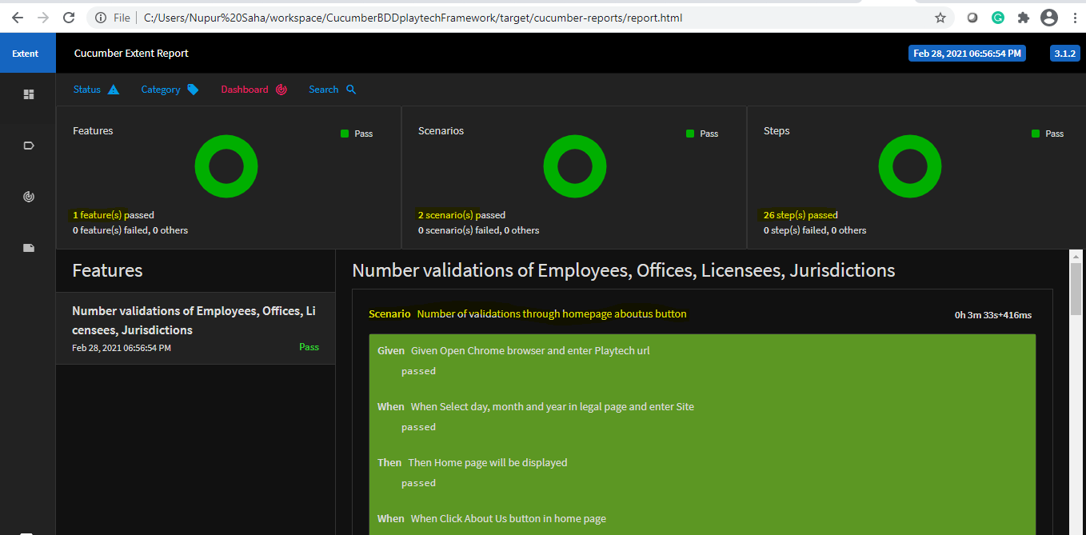

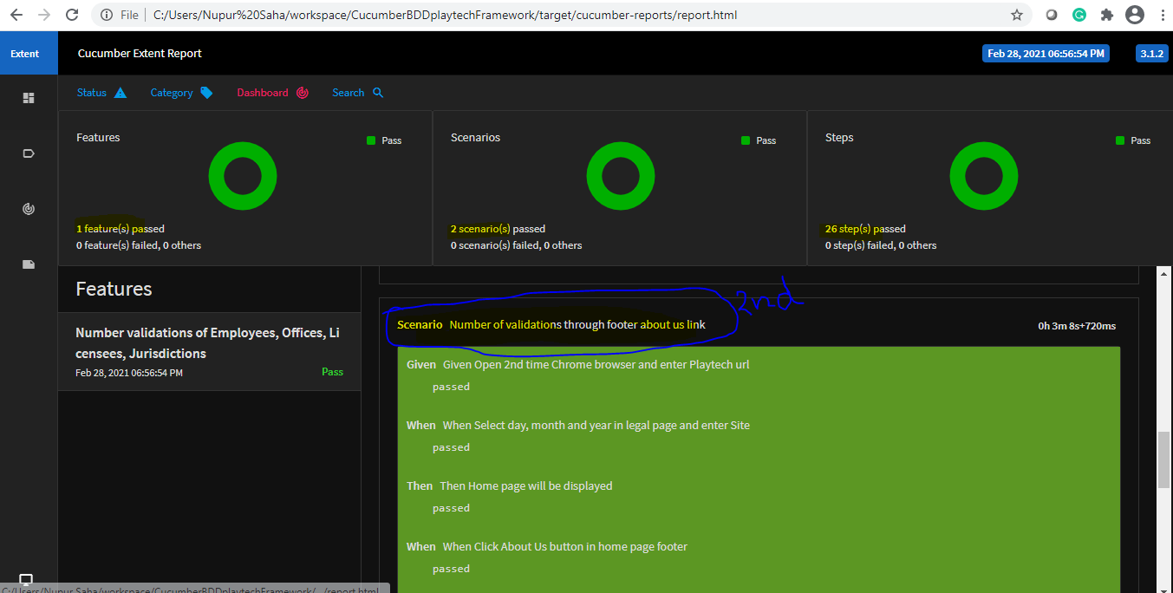

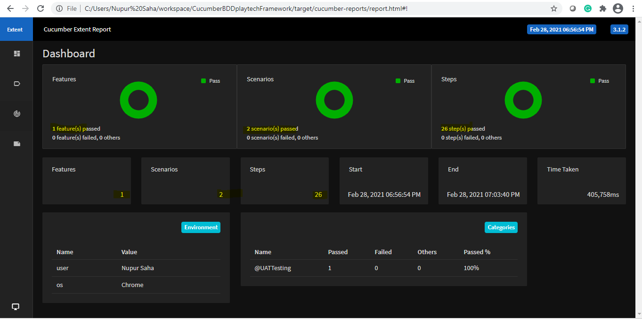

**BDD Feature File:**

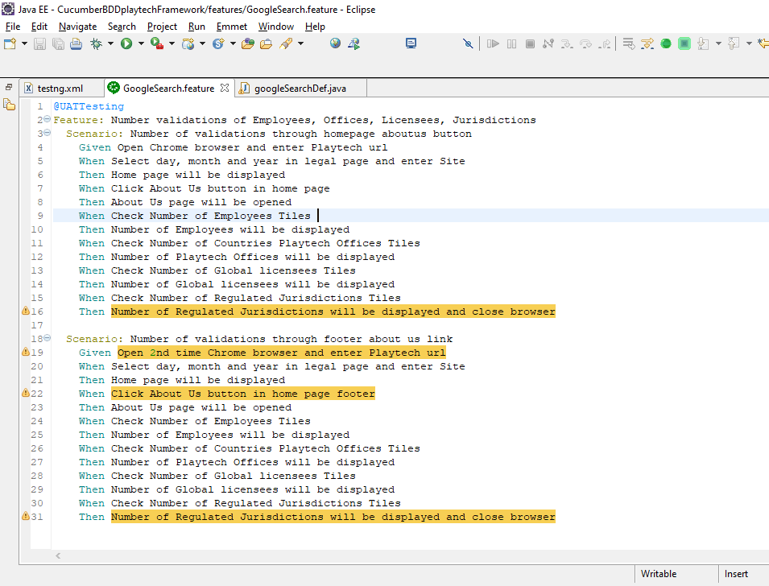

**Selenium BDD Framework Project Architecture:**