InsureWise
CAP – Insurance Application
Technical Design Document
BR04 – Dashboard & Staff User Management
BR05 – Edit Policy & Approve/Reject Policy Application
Document Item | Value
Document Version | 1.0
Date | 22-Sep-2026
Creator | Prasun Sumans
Reviewer | Reshmi Sasidharan
Application | InsureWise Insurance Platform
Frontend | Angular
Backend | Spring Boot / Java
Database | PostgreSQL / Flyway
Storage | AWS S3 for supporting/profile documents where applicable
TDD Template | USERSTORYID_Updated_TDD_Service

Revision History
Date | Version | Revision Description | Creator | Reviewer
22-Sep-2026 | 1.0 | Revised TDD for BR04 and BR05. BR05 scope corrected to Policy Edit and Policy Application approval/rejection; category-management content removed. | Prasun Sumans | Reshmi Sasidharan
 | 1.1 | Post-review changes. | Prasun Sumans | Reshmi Sasidharan
Contents
1. Introduction ........................................................ 4
1.1 Scope ............................................................... 4
1.2 Assumptions ......................................................... 4
1.3 References .......................................................... 4
1.4 Acronyms ............................................................ 4
2. BR04 – Dashboard & Staff User Management ............................ 5
2.1 Component Diagram ................................................... 5
2.2 Key Classes / Components ........................................... 5
2.3 API Endpoint Details ................................................ 5
2.4 API Response Codes .................................................. 6
2.5 API Details .......................................................... 6
2.5.1 Request / Response ............................................... 6
2.5.2 Sequence .......................................................... 6
2.5.3 Request Processing ................................................ 8
2.5.4 Validation ........................................................ 8
2.5.5 Data Mapping ...................................................... 9
2.5.6 Queries ........................................................... 9
3. BR05 – Edit Policy & Approve/Reject Policy Application .............. 9
3.1 Component Diagram ................................................... 9
3.2 Key Classes / Components ........................................... 9
3.3 API Endpoint Details ................................................ 10
3.4 API Response Codes .................................................. 11
3.5 API Details .......................................................... 11
3.5.1 Request / Response ............................................... 11
3.5.2 Sequence .......................................................... 11
3.5.3 Request Processing ................................................ 12
3.5.4 Validation ........................................................ 12
3.5.5 Data Mapping ...................................................... 13
3.5.6 Queries ........................................................... 13
3.7 Policy Application Approval / Rejection – Detailed Design ........ 13
3.7.1 Business Workflow ................................................. 13
3.7.2 Policy Application APIs ........................................... 14
3.7.3 Approval / Rejection State Transition ............................ 14
3.7.4 Backend Processing ................................................ 15
3.7.5 Supporting Document Review ........................................ 15
3.7.6 Approval / Rejection Sequence Diagram ............................ 15
3.7.7 Request / Response ............................................... 17
3.7.8 Validation and Authorization ...................................... 17
3.7.9 Unit-Test Coverage ................................................ 17
3.7.10 Acceptance Criteria Traceability ................................. 18
4. Configuration ........................................................ 19
5. Additional Details ................................................... 19
5.1 Exception Handling .................................................. 19
5.2 Security ............................................................ 19
5.3 Unit Testing Design .................................................. 19
5.4 Git Details .......................................................... 20
6. Acceptance Criteria Traceability ..................................... 20
7. Review Notes .......................................................... 21

1. Introduction
This Technical Design Document describes the supplied Angular and Spring Boot implementation for BR04 and the corrected BR05 scope. It follows the structure of the supplied service TDD and documents the applicable components, APIs, request/response contracts, sequence flows, processing, validation, data mapping, queries, configuration, exception handling, security, testing and traceability.
Scope clarification: the BR05 scope used in this document is Policy Edit and Policy Application approval/rejection. Category Management is excluded from this BR05 TDD.

1.1 Scope
- BR04: Staff dashboard and staff-user management.
- BR04: Staff creation, listing, retrieval, update, deletion and profile-picture support present in the source.
- BR05: Staff editing/updating of existing policy definitions.
- BR05: Staff review of pending policy applications and approval/rejection of applications.
- BR05: Supporting-document retrieval/preview/download from the application-review screen where implemented.
- JWT authentication and STAFF role authorization for protected staff operations.
- PostgreSQL persistence and existing S3-backed document handling.
- Category creation/edit/delete is excluded from this BR05 TDD.

1.2 Assumptions
- Staff user is authenticated before entering protected staff routes.
- Only STAFF users may edit policies or approve/reject policy applications.
- Policy applications are created by customers and initially have PENDING status.
- Only a PENDING policy application is eligible for a staff decision; state-transition validation is handled by PolicyApplicationService/ApplicationStateException.
- Policy update and policy-application decision are separate workflows: editing a policy changes the policy definition; approving/rejecting an application changes the application status.
- PostgreSQL is the persistence layer and Flyway manages schema migrations.

1.3 References
No. | Reference | Use
1 | InsureWise CAP – Insurance Application BRD v1.0, 02-Sep-2026 | Business requirements and acceptance criteria supplied by the user.
2 | USERSTORYID_Updated_TDD_Service | TDD format and section structure.
3 | Backend source archive CAP-CodeFinal.zip | Controllers, services, DTOs, entities, repositories and tests.
4 | Frontend source archive src (2).zip | Angular staff screens, API services and routes.
5 | Flyway SQL migrations in backend source | Policy/application/document database structures.

1.4 Acronyms
Acronym | Description
API | Application Programming Interface
BRD | Business Requirements Document
TDD | Technical Design Document
DTO | Data Transfer Object
DB | Database
JWT | JSON Web Token
S3 | Amazon Simple Storage Service
JPA | Java Persistence API
SPA | Single Page Application

2. BR04 – Dashboard & Staff User Management
The BR04 area provides a staff dashboard and staff-user administration. The supplied BRD describes a dashboard with platform metrics and staff-user management including creation, edit and deletion. The supplied Angular source contains dashboard and manage-user screens; the Spring Boot source contains DashboardController/DashboardService and StaffUserManagementController/StaffUserService.

2.1 Component Diagram
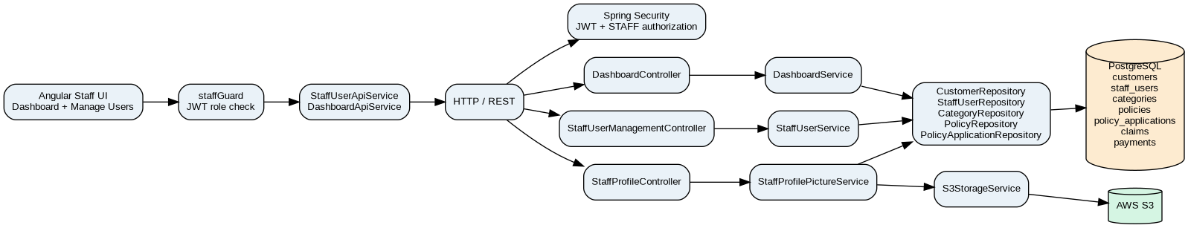

2.2 Key Classes / Components
Layer | Class / Component | Responsibility
Frontend | DashboardComponent | Displays dashboard metrics and staff navigation.
Frontend | ManageUsersListComponent | Lists staff users and handles edit/delete navigation and confirmation.
Frontend | ManageUsersNewComponent | Creates/edits staff users and handles profile-picture interaction.
Frontend | DashboardApiService | Calls GET /api/dashboard/metrics.
Frontend | StaffUserApiService | Calls staff-user CRUD/profile APIs.
Backend | DashboardController | Exposes STAFF-only dashboard metrics endpoint.
Backend | DashboardService | Aggregates customer, staff, category, policy, application, claim and payment counts.
Backend | StaffUserManagementController | Exposes staff CRUD endpoints.
Backend | StaffUserService | Validates email uniqueness, hashes passwords, persists staff users and maps responses.
Backend | StaffProfilePictureService | Handles profile-picture S3 operations and persistence of S3 key.
Backend | StaffUserRepository | JPA persistence and email lookup.

2.3 API Endpoint Details
Method | Endpoint | Auth | Description
POST | /api/staff/users | STAFF | Create staff user.
GET | /api/staff/users | STAFF | List staff users.
GET | /api/staff/users/{id} | STAFF | Get staff user.
GET | /api/staff/users/me | STAFF | Get authenticated staff profile.
PUT | /api/staff/users/{id} | STAFF | Update staff user.
DELETE | /api/staff/users/{id} | STAFF | Delete staff user.
POST | /api/staff/users/{id}/profile-picture | STAFF | Upload/replace profile picture.
DELETE | /api/staff/users/{id}/profile-picture | STAFF | Delete profile picture.
GET | /api/dashboard/metrics | STAFF | Return dashboard metrics.

2.4 API Response Codes
Code | Meaning
200 | Successful GET/PUT operation.
201 | Resource created.
204 | Successful delete/no-content response.
400 | Validation or malformed request.
401 | Authentication failure.
403 | Authenticated user lacks STAFF role.
404 | Requested staff resource not found.
409 | Business conflict such as duplicate email where mapped.
500 | Unexpected server-side failure.

2.5 API Details

2.5.1 Request / Response
StaffCreateRequest: { "fullName": "...", "email": "...", "address": "...", "password": "..." }
StaffUpdateRequest: { "fullName": "...", "email": "...", "address": "...", "password": null/optional }
DashboardMetricsResponse: totalCustomers, totalStaff, totalCategories, totalPolicies, activePolicies, totalApplications, pendingApplications, activeApplications, totalClaims, pendingClaims, totalPayments, successfulPayments

2.5.2 Sequence
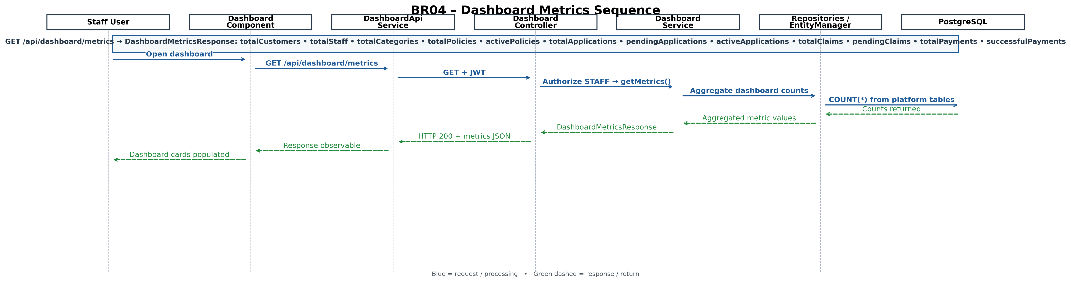
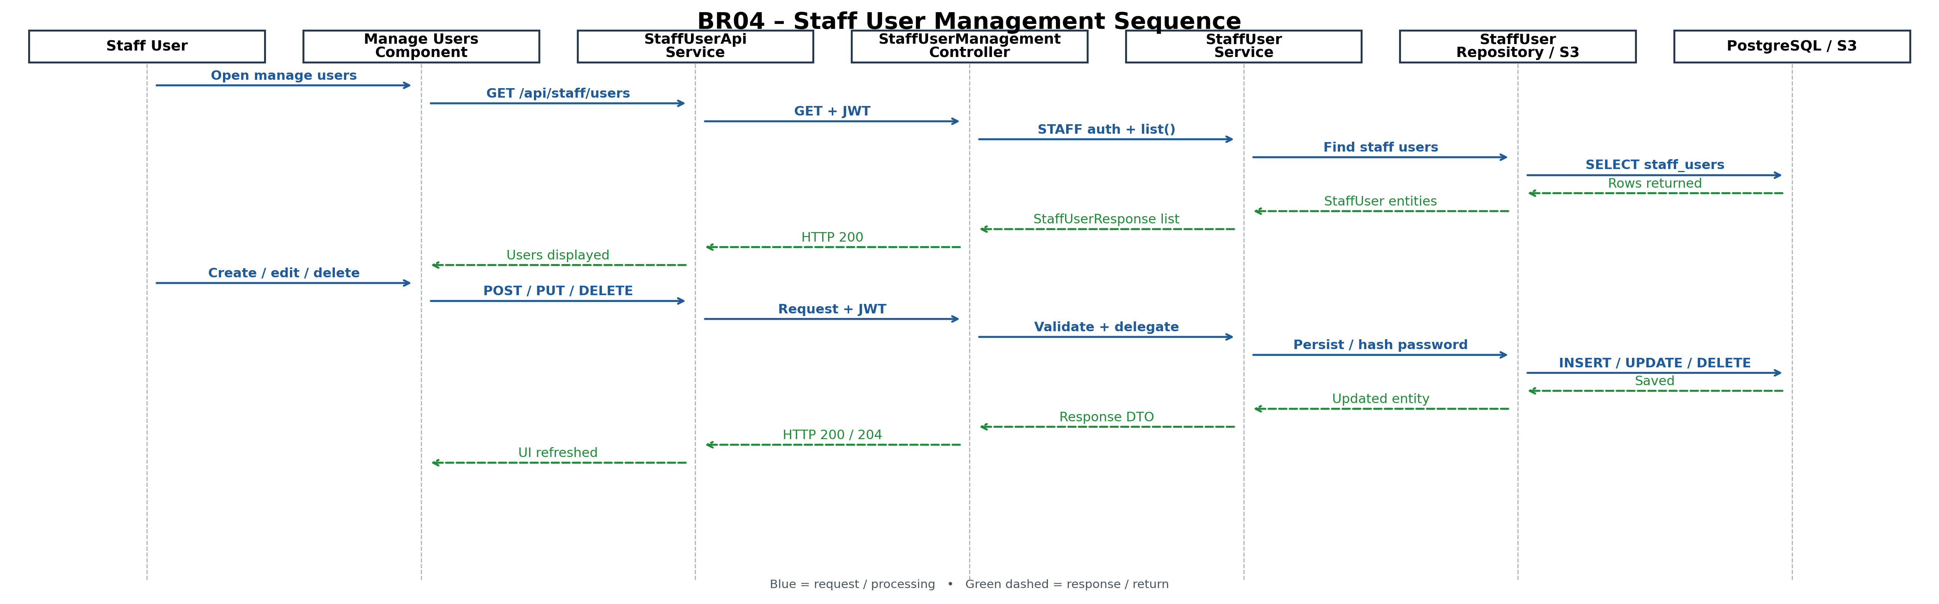

2.5.3 Request Processing
- Staff enters the guarded Angular staff area.
- Angular component calls the corresponding API service.
- Spring Security authenticates the JWT and enforces STAFF authorization.
- Controller delegates to the appropriate service.
- Service validates business rules and invokes repositories/EntityManager.
- PostgreSQL returns/persists data; S3 is used for profile-picture objects where applicable.
- Service maps results to response DTOs.
- Angular displays the result or an error message.

2.5.4 Validation
Field | Rules
Full name | Required; backend max 120; frontend has required/length/name validation.
Email | Required; valid email; duplicate email checked against staff/customer records.
Address | Required; length validation.
Password create | Required and length validated; stored as BCrypt hash.
Password edit | Optional in update request.
Profile picture | Supported image content types and non-empty file; S3-backed.

2.5.5 Data Mapping
API Field | Table | Column | Type
id | staff_users | id | UUID
fullName | staff_users | full_name | VARCHAR(120)
email | staff_users | email | VARCHAR(160)
address | staff_users | address | VARCHAR(240)
password | staff_users | password_hash | VARCHAR(100)
profilePictureUrl | staff_users | profile_picture_s3_key | VARCHAR(600)

2.5.6 Queries
SELECT * FROM staff_users;
SELECT * FROM staff_users WHERE id = :id;
SELECT count(*) FROM customers;
SELECT count(*) FROM staff_users;
SELECT count(*) FROM categories;
SELECT count(*) FROM policies;
SELECT count(*) FROM policy_applications;
SELECT count(*) FROM claims;
SELECT count(*) FROM payments;

3. BR05 – Edit Policy & Approve/Reject Policy Application
This section replaces the earlier Category Management interpretation. BR05 is treated here as two related staff workflows: (1) edit an existing policy definition and (2) review a policy application and approve or reject it. The source implementation has PUT /api/policies/{id} for policy updates and PUT /api/policy-applications/{id}/approve and /reject for staff decisions.

3.1 Component Diagram
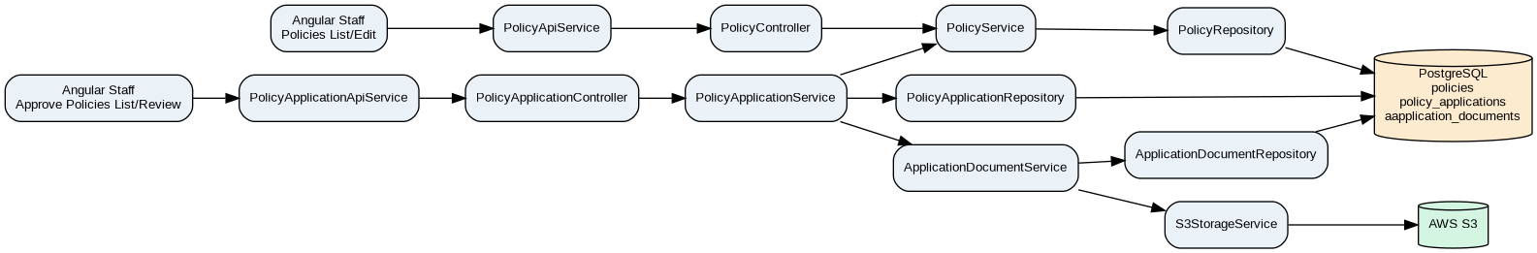

3.2 Key Classes / Components
Layer | Class / Component | Responsibility
Frontend | PoliciesListComponent | Displays staff policy list and navigates to edit.
Frontend | PoliciesNewComponent | Loads an existing policy, pre-populates fields and submits update.
Frontend | PolicyApiService | Calls GET/PUT /api/policies and maintains staff policy cache.
Frontend | ApprovePoliciesListComponent | Lists pending policy applications for staff review.
Frontend | ApprovePoliciesReviewComponent | Loads application details/documents and triggers approve/reject.
Frontend | PolicyApplicationApiService | Lists applications, gets application, approves and rejects.
Frontend | ApplicationDocumentApiService | Loads/opens/downloads supporting application documents.
Backend | PolicyController | Handles policy retrieval and staff policy update.
Backend | PolicyService | Finds policy, resolves category, updates policy fields and maps PolicyResponse.
Backend | PolicyApplicationController | Handles application retrieval and staff approval/rejection.
Backend | PolicyApplicationService | Validates staff decision, transitions application status and persists the application.
Backend | PolicyApplicationRepository | Loads/saves applications and supports status filtering.
Backend | ApplicationDocumentService | Retrieves supporting-document metadata/content URLs.
Backend | S3StorageService | Provides S3-backed document access where configured.

3.3 API Endpoint Details
Method | Endpoint | Auth | Description
GET | /api/policies | CUSTOMER/STAFF | Retrieve policy list exposed by the backend.
GET | /api/policies/{id} | CUSTOMER/STAFF | Retrieve a policy by ID.
PUT | /api/policies/{id} | STAFF | Edit/update an existing policy.
GET | /api/policy-applications  Angular source | CUSTOMER/STAFF | List applications; staff can filter by status. Supplied backend controller mapping is /api/applications; this path mismatch must be aligned.
GET | /api/policy-applications/{id}  Angular source | CUSTOMER/STAFF | Retrieve application details. Supplied backend controller mapping is /api/applications; this path mismatch must be aligned.
PUT | /api/policy-applications/{id}/approve  Angular source | STAFF | Approve application. Supplied backend controller mapping is /api/applications; this path mismatch must be aligned.
PUT | /api/policy-applications/{id}/reject  Angular source | STAFF | Reject application. Supplied backend controller mapping is /api/applications; this path mismatch must be aligned.
GET | /api/applications/{applicationId}/documents | STAFF/CUSTOMER as authorized | Retrieve application document metadata where implemented.
Source alignment note: the supplied Angular PolicyApplicationApiService uses /api/policy-applications/... endpoints, while the supplied backend PolicyApplicationController source is mapped under /api/applications. The two supplied source versions therefore show an endpoint-path mismatch that must be aligned in integration; this TDD records both rather than assuming they are interchangeable.

3.4 API Response Codes
Code | Meaning / BR05 Case
200 | Policy/application retrieved or updated successfully.
201 | Not expected for the edit/decision operations; resource creation is outside this BR05 scope.
400 | Invalid policy update payload or invalid decision/state transition.
401 | Missing/invalid authentication.
403 | Non-STAFF attempts policy edit or approval/rejection.
404 | Policy/application not found.
409 | Business/state conflict where mapped.
500 | Unexpected service/repository/storage failure.

3.5 API Details

3.5.1 Request / Response
Policy update request:
{
"name": "Updated Policy Name",
"categoryId": "<UUID>",
"coverageAmount": 250000,
"premiumAmount": 4999,
"durationLabel": "1 Year",
"status": "ACTIVE"
}
Policy update response:
{
"id": "<UUID>",
"name": "Updated Policy Name",
"categoryId": "<UUID>",
"categoryName": "Health",
"coverageAmount": 250000,
"premiumAmount": 4999,
"durationLabel": "1 Year",
"status": "ACTIVE"
}
Approve/reject request:
PUT /api/policy-applications/{id}/approve
Body: {}
PUT /api/policy-applications/{id}/reject
Body: {}
Decision response is a PolicyApplicationResponse containing the application identifier/code, customer/application details and updated status.

3.5.2 Sequence
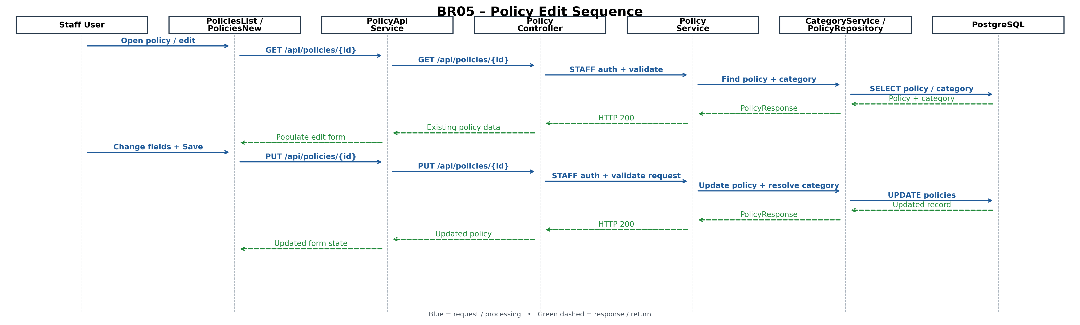

3.5.3 Request Processing
- Staff opens the policy list or pending policy-application list through the protected staff area.
- For policy editing, the UI loads the selected policy and pre-populates the edit form.
- On Save, PolicyApiService sends PUT /api/policies/{id}.
- PolicyController checks STAFF authorization and validates PolicyUpdateRequest.
- PolicyService loads the policy, resolves the requested category through CategoryService, updates policy fields and maps the response.
- For application review, PolicyApplicationApiService loads the selected application and its supporting documents.
- On Approve or Reject, the review component asks for confirmation and the supplied Angular source sends PUT /api/policy-applications/{id}/approve or /reject. The supplied backend PolicyApplicationController is mapped under /api/applications, so the integration path must be aligned.
- PolicyApplicationController checks STAFF authorization and delegates to PolicyApplicationService.
- PolicyApplicationService verifies the application exists and the requested state transition is valid, changes the application status and saves it.
- The updated policy/application response is returned to Angular and the review screen displays the success/error result.

3.5.4 Validation
Rule | Implementation
Policy ID must exist | PolicyService.findPolicyEntity(id) throws PolicyNotFoundException when absent.
Policy update fields | PolicyUpdateRequest uses validation annotations for required name/category/coverage/premium/duration/status.
Coverage > 0 | DTO validation and database CHECK constraint in the policy schema.
Premium > 0 | DTO validation and database CHECK constraint in the policy schema.
Category exists | PolicyService resolves categoryId using CategoryService.find().
Application ID must exist | PolicyApplicationService loads the application and throws ApplicationNotFoundException when absent.
Decision must be valid | PolicyApplicationDecisionRequest is validated and the service checks application state.
Only STAFF may decide | Controller endpoints use @PreAuthorize("hasRole('STAFF')").
Approve/Reject confirmation | Angular review component uses window.confirm before sending the decision.

3.5.5 Data Mapping
Element | Table/Entity | Column | Type | Purpose
id | policies | id | UUID | Policy identifier.
name | policies | name | VARCHAR | Policy name.
categoryId | policies | category_id | UUID | Policy category relationship.
coverageAmount | policies | coverage_amount | NUMERIC(14,2) | Coverage amount.
premiumAmount | policies | premium_amount | NUMERIC(10,2) | Premium amount.
durationLabel | policies | duration_label | VARCHAR(40) | Policy duration.
status | policies | status | VARCHAR(20) | Policy status.
applicationId | policy_applications | id | UUID | Application identifier.
applicationCode | policy_applications | application_code | VARCHAR | Business application code.
applicationStatus | policy_applications | status | VARCHAR | PENDING/APPROVED/REJECTED.
policyId | policy_applications | policy_id | UUID | Policy applied for.
customerId | policy_applications | customer_id | UUID | Customer who submitted application.
reviewedBy | policy_applications | reviewed_by | UUID | Staff reviewer where populated by the implementation.
reviewedAt | policy_applications | reviewed_at | TIMESTAMP | Decision timestamp where populated by the implementation.

3.5.6 Database Queries

3.7 Policy Application Approval / Rejection – Detailed Design
This subsection adds the complete Policy Application workflow to BR05 without changing the existing BR04 or Policy Edit sections. The workflow covers staff review of pending applications, supporting-document review, approval/rejection, status transition, decision audit information and the corresponding Angular-to-Spring Boot processing flow.

3.7.1 Business Workflow
1. A customer submits a policy application; the application is created with PENDING status.
2. The staff user opens the Approve Policies screen and retrieves policy applications requiring review.
3. The staff user selects an application and opens its review details.
4. The review screen displays the application information and available supporting documents.
5. The staff user selects Approve or Reject and confirms the action.
6. Angular calls the corresponding Policy Application API.
7. PolicyApplicationController enforces STAFF authorization and delegates the decision to PolicyApplicationService.
8. PolicyApplicationService verifies that the application exists and that the requested decision is a valid state transition.
9. For approval, the application is transitioned to APPROVED and the approval-related decision information is persisted.
10. For rejection, the application is transitioned to REJECTED and the rejection-related decision information is persisted.
11. The updated PolicyApplicationResponse is returned to Angular and the review screen displays the resulting status.

3.7.2 Policy Application APIs
Method | Endpoint | Authorization | Purpose
GET | /api/policy-applications  Angular source | CUSTOMER/STAFF | Retrieve policy applications; staff can retrieve/filter applications for review. Supplied backend controller mapping is /api/applications; this path mismatch must be aligned.
GET | /api/policy-applications/{id}  Angular source | CUSTOMER/STAFF | Retrieve one policy application for the review screen. Supplied backend controller mapping is /api/applications; this path mismatch must be aligned.
PUT | /api/policy-applications/{id}/approve  Angular source | STAFF | Approve the selected policy application. Supplied backend controller mapping is /api/applications; this path mismatch must be aligned.
PUT | /api/policy-applications/{id}/reject  Angular source | STAFF | Reject the selected policy application. Supplied backend controller mapping is /api/applications; this path mismatch must be aligned.

3.7.3 Approval / Rejection State Transition
Current Status | Staff Action | New Status | Technical Processing
PENDING | Approve | APPROVED | PolicyApplicationService validates STAFF decision, calls the application approval operation, persists the application and returns PolicyApplicationResponse.
PENDING | Reject | REJECTED | PolicyApplicationService validates STAFF decision, calls the application rejection operation, persists the application and returns PolicyApplicationResponse.
APPROVED / REJECTED | Approve / Reject again | No valid transition | Application state validation prevents an invalid/repeated decision.
Any status | Customer attempts approval/rejection | No transition | Decision is rejected because the operation is STAFF-only.

3.7.4 Backend Processing
The controller receives the application ID and delegates the decision to PolicyApplicationService. The service obtains the authenticated principal, verifies the staff role, loads the application, validates the requested ApplicationStatus and persists the resulting application state.
Approve / Reject processing:
1. Authenticate JWT principal.
2. Verify principal role is STAFF.
3. Load PolicyApplication by application ID.
4. Validate requested decision status.
5. Apply approve(...) or reject(...) to the application entity.
6. Save through PolicyApplicationRepository.
7. Map the saved entity to PolicyApplicationResponse.
8. Return the response to Angular.

3.7.5 Supporting Document Review
Before making the decision, the staff review screen can access the application's supporting-document information. ApplicationDocument records represent uploaded evidence and contain document metadata such as file name, content type, S3 key, uploading user and timestamps. ApplicationDocumentService and the configured S3 storage service support the document retrieval/preview/download flow used by the application review screen.

3.7.6 Approval / Rejection Sequence Diagram
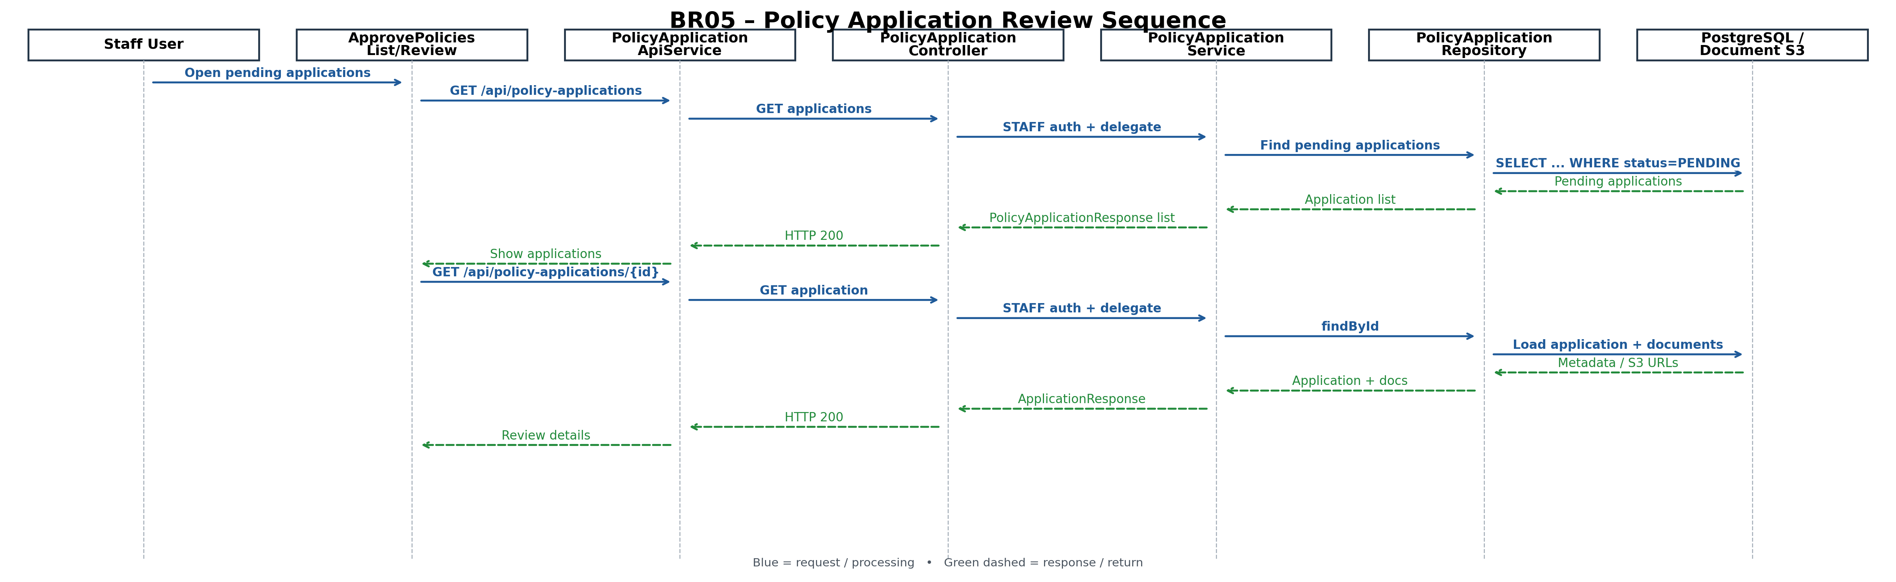
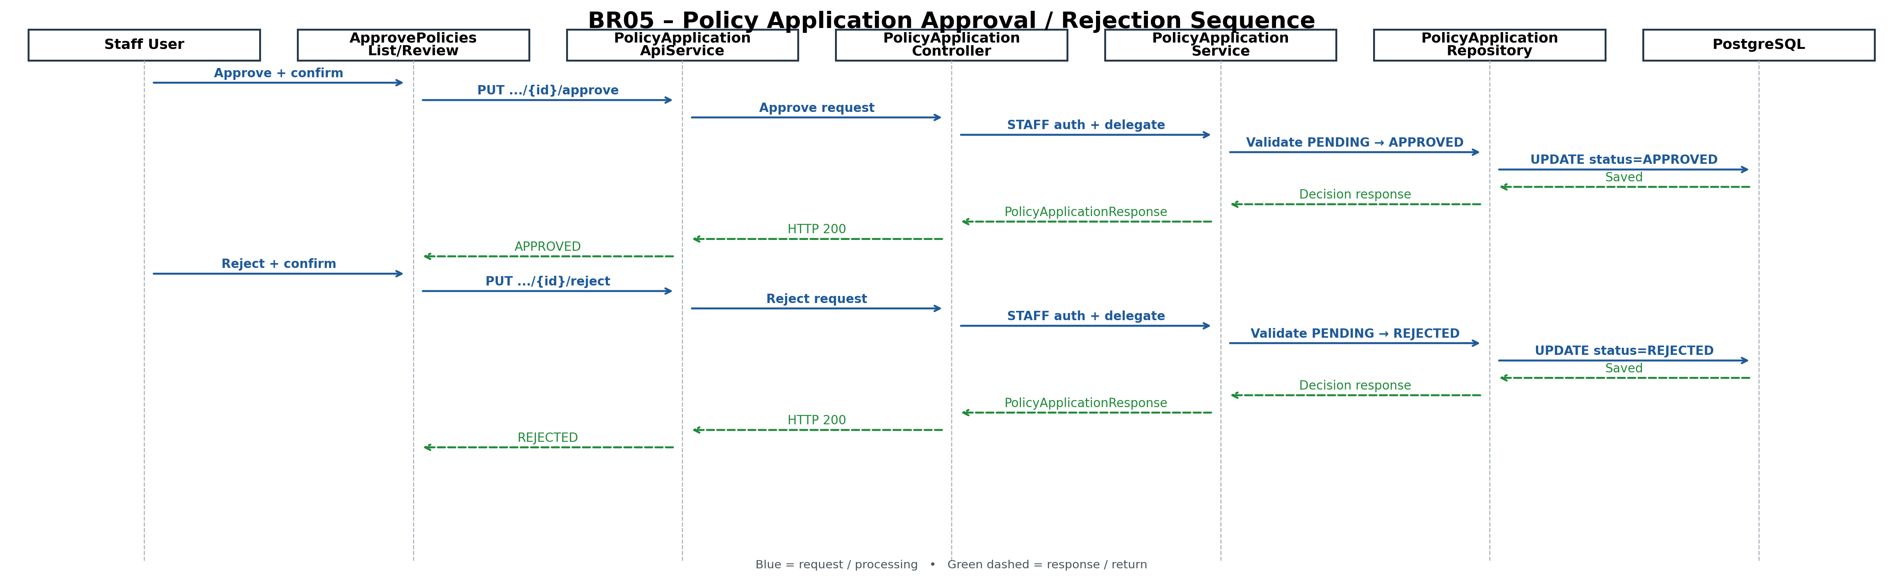

3.7.7 Request / Response
Approve:
PUT /api/policy-applications/{id}/approve
Body: {}
Reject:
PUT /api/policy-applications/{id}/reject
Body: {}
The decision response is PolicyApplicationResponse and contains the application identifier/code, customer/application information and the updated application status.

3.7.8 Validation and Authorization
Validation / Security Rule | Implementation
Application must exist | PolicyApplicationService loads the application and raises the application-not-found exception when the ID is not found.
Decision must be valid | PolicyApplicationDecisionRequest and application-state validation ensure that only valid decision states are processed.
Only STAFF can decide | PolicyApplicationController approval/rejection endpoints require STAFF authorization.
Invalid/repeated transition | PolicyApplicationService/application state validation rejects an invalid state transition.
Confirmation before decision | Angular approval/review flow confirms the staff action before sending the approve/reject request.

3.7.9 Unit-Test Coverage
Test Scenario | Expected Result
Approve pending application as STAFF | Application is saved with APPROVED status and a successful PolicyApplicationResponse is returned.
Reject pending application as STAFF | Application is saved with REJECTED status and a successful PolicyApplicationResponse is returned.
Non-STAFF attempts decision | ApplicationStateException/authorization failure; no application decision is persisted.
Application ID does not exist | ApplicationNotFoundException is returned/handled.
Invalid decision status | ApplicationStateException/validation failure; no status transition occurs.
Angular approve confirmation | API is called only after staff confirms the approval action.
Angular reject confirmation | API is called only after staff confirms the rejection action.

3.7.10 Acceptance Criteria Traceability
Acceptance Requirement | Technical Implementation
Staff can view applications requiring review. | ApprovePoliciesListComponent → PolicyApplicationApiService → PolicyApplicationController → PolicyApplicationService → PolicyApplicationRepository.
Staff can open an application for review. | ApprovePoliciesReviewComponent → GET /api/policy-applications/{id}.
Staff can review supporting evidence. | ApplicationDocumentApiService → ApplicationDocumentService / S3 storage → document preview/download.
Staff can approve an application. | Approve action → PUT /api/policy-applications/{id}/approve → PolicyApplicationService → APPROVED → repository save.
Staff can reject an application. | Reject action → PUT /api/policy-applications/{id}/reject → PolicyApplicationService → REJECTED → repository save.
Only authorized staff can make the decision. | STAFF authorization on the decision endpoints and staff-role validation in the service.
The decision is persisted. | PolicyApplicationRepository saves the updated PolicyApplication entity.
-- Load policy for edit
SELECT * FROM policies WHERE id = :id;
-- Persist policy update
UPDATE policies
SET name = :name,
category_id = :categoryId,
coverage_amount = :coverageAmount,
premium_amount = :premiumAmount,
duration_label = :durationLabel,
status = :status
WHERE id = :id;
-- Load pending applications
SELECT ...
FROM policy_applications
WHERE status = 'PENDING'
ORDER BY created_at DESC;
-- Load application for decision
SELECT * FROM policy_applications WHERE id = :id;
-- Persist approval/rejection
UPDATE policy_applications
SET status = :status, reviewed_by = :staffId, reviewed_at = CURRENT_TIMESTAMP
WHERE id = :id;

4. Configuration

4.1 Application Configuration
Item | Purpose
Java 17 | Backend runtime/source level.
Spring Boot 3.2.5 | Backend framework.
PostgreSQL | Runtime database.
Flyway | Database migrations.
Spring Security | JWT/role authorization.
JJWT | JWT generation/validation.
Springdoc/OpenAPI | Swagger/OpenAPI documentation.
spring-boot-starter-test | JUnit/Mockito testing.

4.2 S3 Configuration
Supporting application documents are represented by ApplicationDocument records containing file name, content type, S3 key, uploader and timestamps. The review screen uses ApplicationDocumentApiService for preview/download. Secrets must be provided through environment/deployment configuration and not committed.

5. Additional Details

5.1 Exception Handling
Exception | Use
PolicyNotFoundException | Requested policy does not exist.
ApplicationNotFoundException | Requested policy application does not exist.
ApplicationStateException | Invalid application state/decision transition or unauthorized business operation.
BusinessException | Unexpected or mapped business failures.
ApplicationDocumentNotFoundException | Requested supporting document is unavailable.
Global validation exception | Invalid request fields return validation error details.

5.2 Security
- JWT authentication is used by the application.
- Policy update endpoint requires STAFF.
- Approve/reject endpoints require STAFF.
- Application list/get endpoints support CUSTOMER/STAFF with service-level ownership/scoping logic.
- Passwords are BCrypt-hashed; no raw password should be persisted.

5.3 Unit Testing Design
The supplied backend already contains PolicyServiceTest and PolicyApplicationServiceTest. The latter explicitly covers approval and rejection for staff, invalid customer decision attempts, pending application creation and other application rules. The test style uses JUnit 5, Mockito, @BeforeEach, @Test and assertions.
Test Class | BR05 Scenarios
PolicyServiceTest | Update policy successfully; policy not found; category resolution; update failure; validation/business exception propagation.
PolicyApplicationServiceTest | Approve pending application; reject pending application; non-STAFF decision rejected; missing application; invalid state transition.
ApprovePoliciesListComponent tests | Load pending applications; API failure; navigation to review.
ApprovePoliciesReviewComponent tests | Load application/documents; approve confirmation; reject confirmation; success; API error; document preview/download.
PoliciesNewComponent tests | Load existing policy; pre-fill form; validation; PUT update; success/error navigation.

5.4 Git Details
The supplied backend archive contains the implementation and test sources. The source snapshot also contains staff policy and approval-review Angular components. The exact remote URL should be copied from the team's current Git configuration at review time.

6. Acceptance Criteria Traceability
BR | Acceptance / User Capability | Technical Design | Evidence / Status
BR04 | Staff can view dashboard metrics. | DashboardComponent → DashboardApiService → DashboardController → DashboardService → repositories/DB. | Implemented in supplied source; metric contract should be reviewed against final BRD wording.
BR04 | Staff can create a staff user with required details. | ManageUsersNewComponent → StaffUserApiService → StaffUserManagementController → StaffUserService → staff_users. | Implemented.
BR04 | Staff can edit staff details using pre-filled form. | ManageUsersList/ManageUsersNew → GET/PUT staff APIs → StaffUserService. | Implemented.
BR04 | Staff can delete a staff user after confirmation. | ManageUsersListComponent confirmation → DELETE API. | Implemented in frontend/backend.
BR05 | Staff can edit an existing policy. | PoliciesListComponent → PoliciesNewComponent → PolicyApiService.update → PUT /api/policies/{id} → PolicyService.updatePolicy. | Implemented in supplied source.
BR05 | Staff can review policy applications. | ApprovePoliciesListComponent → PolicyApplicationApiService.getPending/getById → PolicyApplicationController. | Implemented.
BR05 | Staff can approve a policy application. | ApprovePoliciesReviewComponent confirmation → PUT /api/policy-applications/{id}/approve → PolicyApplicationService → status APPROVED. | Implemented; backend unit test exists.
BR05 | Staff can reject a policy application. | ApprovePoliciesReviewComponent confirmation → PUT /api/policy-applications/{id}/reject → PolicyApplicationService → status REJECTED. | Implemented; backend unit test exists.
BR05 | Staff can view supporting evidence. | ApprovePoliciesReviewComponent → ApplicationDocumentApiService → document service/S3 access. | Implemented in supplied source; exact BRD acceptance wording should be checked during review.

7. Review Notes
- The attached scanned BRD visible in this conversation labels Category Management as BR05 and Approval/Process Claims/View Payments as BR06. This revised TDD does not use that category section because the user has clarified that their assigned BR05 is Policy Edit and Policy Application approval/rejection. The final TDD should be aligned to the authoritative Jira/user-story version used by the project.
- The backend source comments also indicate that PolicyService and PolicyApplicationService had BR05-related methods in the implementation history. The current supplied source contains the policy update endpoint and policy-application approve/reject endpoints.
- Policy edit and policy-application approval are two distinct transactions and should remain separate in the TDD and implementation: policy update changes the policy definition; application approval/rejection changes the application decision.
- Do not add CategoryController/CategoryService/CategoryCreateRequest/CategoryUpdateRequest to the BR05 TDD unless the authoritative BR05 acceptance criteria actually assigns Category Management to this story.
- Before final lead review, replace [Developer Name] and [Project Lead], record the actual Jira/user-story ID, and record any post-review version changes in Revision History.

