PRE-SUBMISSION DOCUMENT
MediCare Health Network | Hospital Readmission Risk Intelligence
Team: Group 21 | Domain: Healthcare Analytics | Date: June 2025

1. Business Problem Understanding and Objective Formulation
Problem Statement
MediCare Health Network, a large multi-specialty healthcare provider, is facing a critical challenge of rising hospital readmission rates — resulting in increased treatment costs, resource strain, declining patient satisfaction, and regulatory financial penalties. Despite investments in EHR systems and clinical infrastructure, the organization lacks a proactive, data-driven mechanism to identify high-risk patients before readmission occurs. Internal reviews confirm that a significant proportion of these readmissions are preventable with timely, targeted post-discharge interventions.
Objective Formulation
🎯 Business Objective: To proactively identify and stratify patients at high risk of readmission at the point of discharge — enabling MediCare to deliver targeted interventions, optimize resource allocation, and reduce avoidable readmissions.
📊 Analytical Objective:
- PCA & LDA — for dimensionality reduction and class separability
- K-Means Clustering — for unsupervised patient risk segmentation (High / Medium / Low)
- Classification Models (Logistic Regression, Decision Tree, KNN, Naive Bayes) — to predict individual readmission risk and identify key clinical driving factors
2. Challenges and Constraints
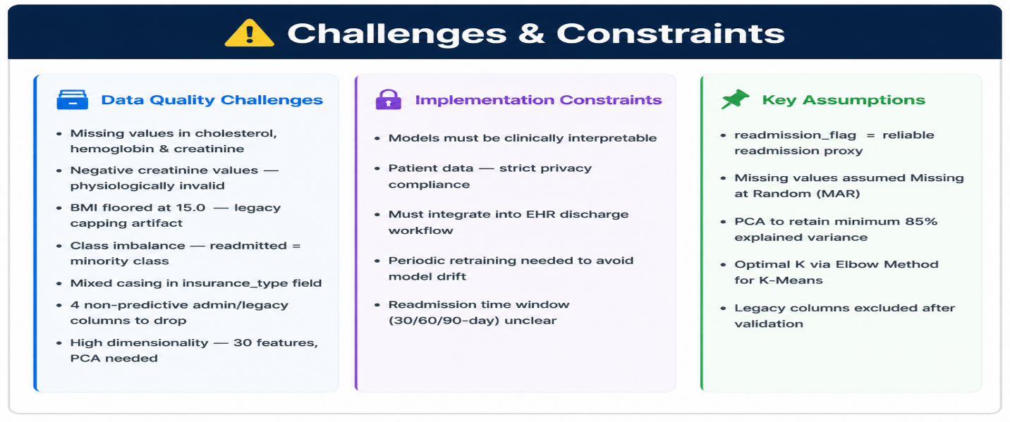
3. Background Study / Literature Review
Through initial exploration of the provided historical patient dataset, the following structure was identified:
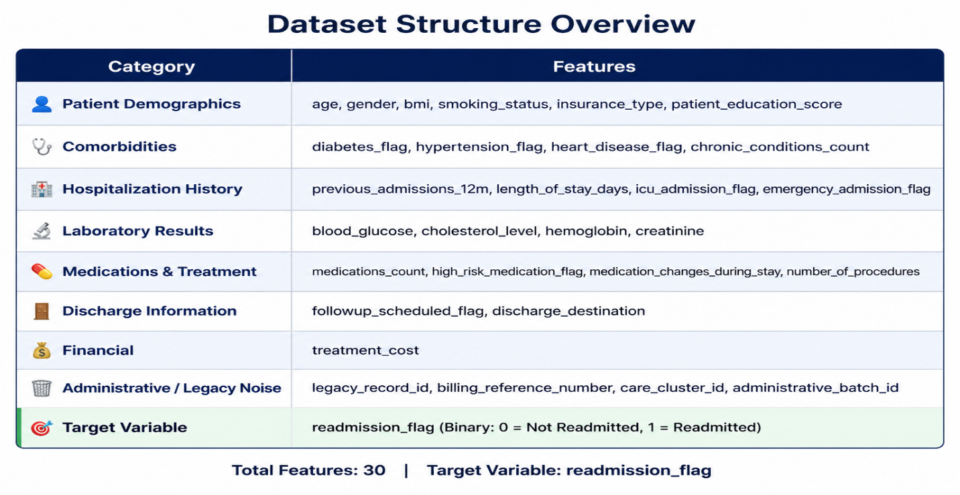
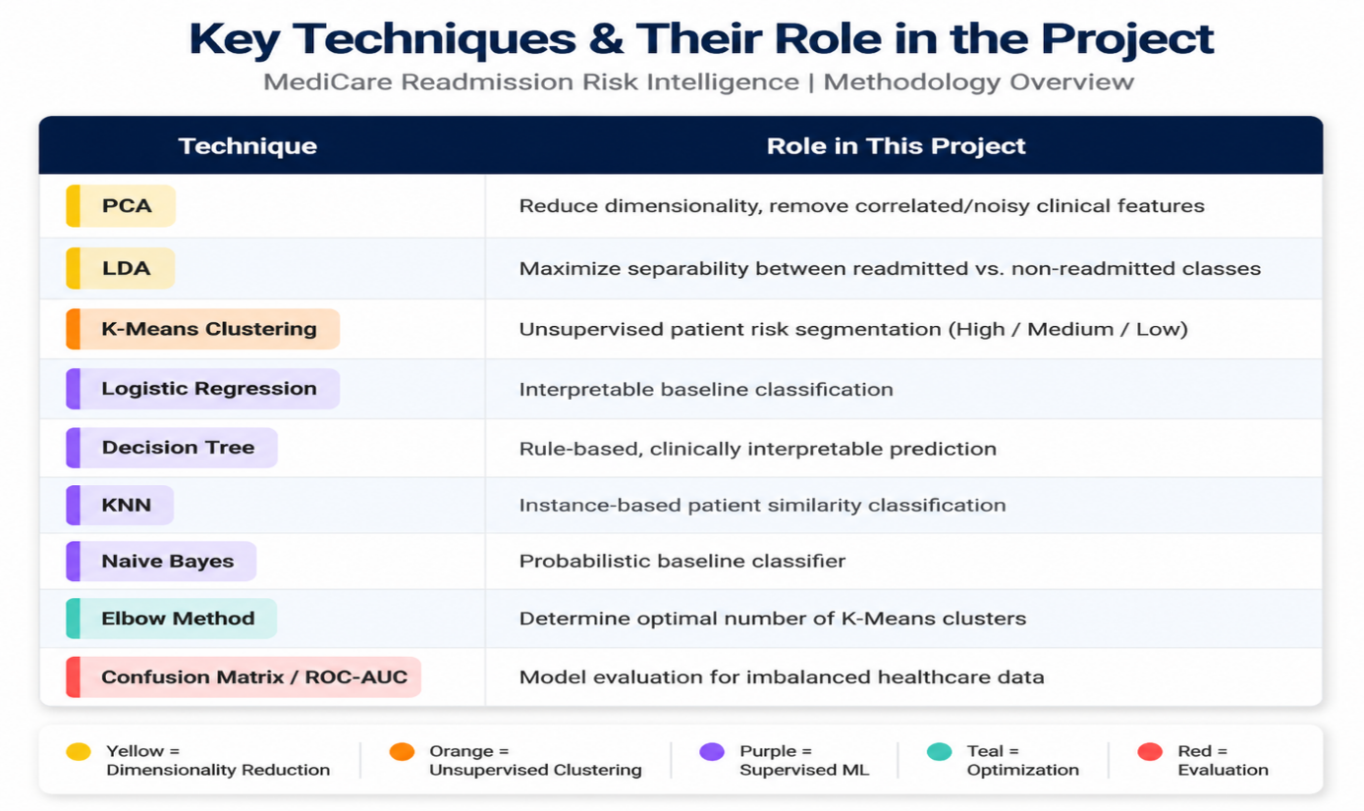

4. PROPOSED METHODOLOGY / SOLUTION APPROACH
The proposed solution follows analytical pipeline combining unsupervised and supervised techniques:
- Dimensionality Reduction (PCA + LDA) to reduce noise and enhance class separability
- Unsupervised Clustering (K-Means) to segment patients into risk groups
- Supervised Classification (Logistic Regression, Decision Tree, KNN, Naive Bayes) to predict individual readmission risk
- Model Evaluation & Selection to identify the best-performing model
- Business Recommendations derived from cluster profiles and model insights
Solution Workflow Diagram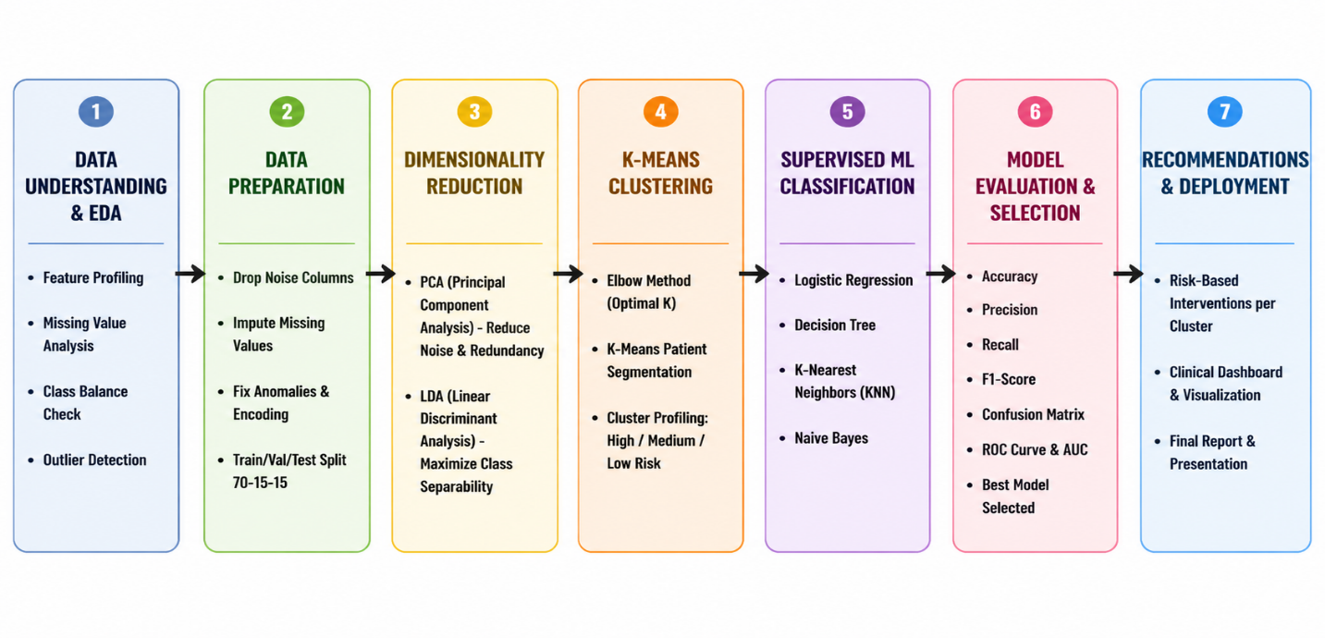
5. PROPOSED TIMELINE
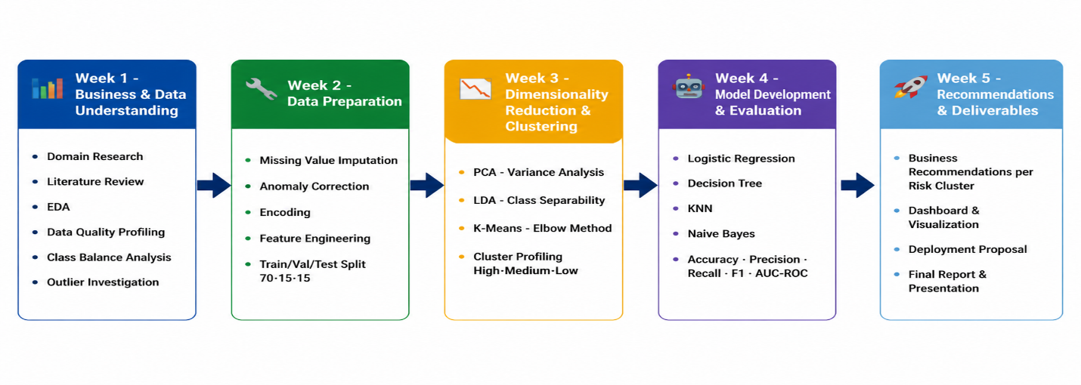

6. Expected Deliverables / Outputs
SNO |  |  | Deliverable | Description
1 |  |  | 📊 Data Analysis Report | EDA findings, data quality assessment, statistical summaries & key pattern insights
2 |  |  | 📉 Dimensionality Reduction Analysis | PCA variance explained plots & LDA class separation visualizations
3 |  |  | 🔵 K-Means Cluster Profiles | Elbow curve, cluster assignments & clinical profiling of High / Medium / Low risk patient segments
4 |  |  | 🤖 ML Classification Models | Trained & evaluated Logistic Regression, Decision Tree, KNN & Naive Bayes models
5 |  |  | 📈 Model Evaluation Report | Confusion matrices, ROC curves, AUC scores & final model selection justification
6 |  |  | 💡 Business Recommendations | Targeted intervention strategies mapped to each patient risk cluster
7 |  |  | 📊 Dashboard / Visualization | Clinical & management-facing visual summary of findings & risk distribution
8 |  |  | 🚀 Deployment Proposal | Roadmap for integrating readmission prediction model into EHR clinical workflows
9 |  |  | 📂 Technical Documentation | Fully reproducible, well-commented Python notebooks with methodology documentation
10 |  |  | 🎤 Final Presentation | Executive-level summary of findings, model performance & estimated business impact

