**Brainfuck IDE**

**Version 1.0**

**Keymap Reference**

**Windows / Linux**

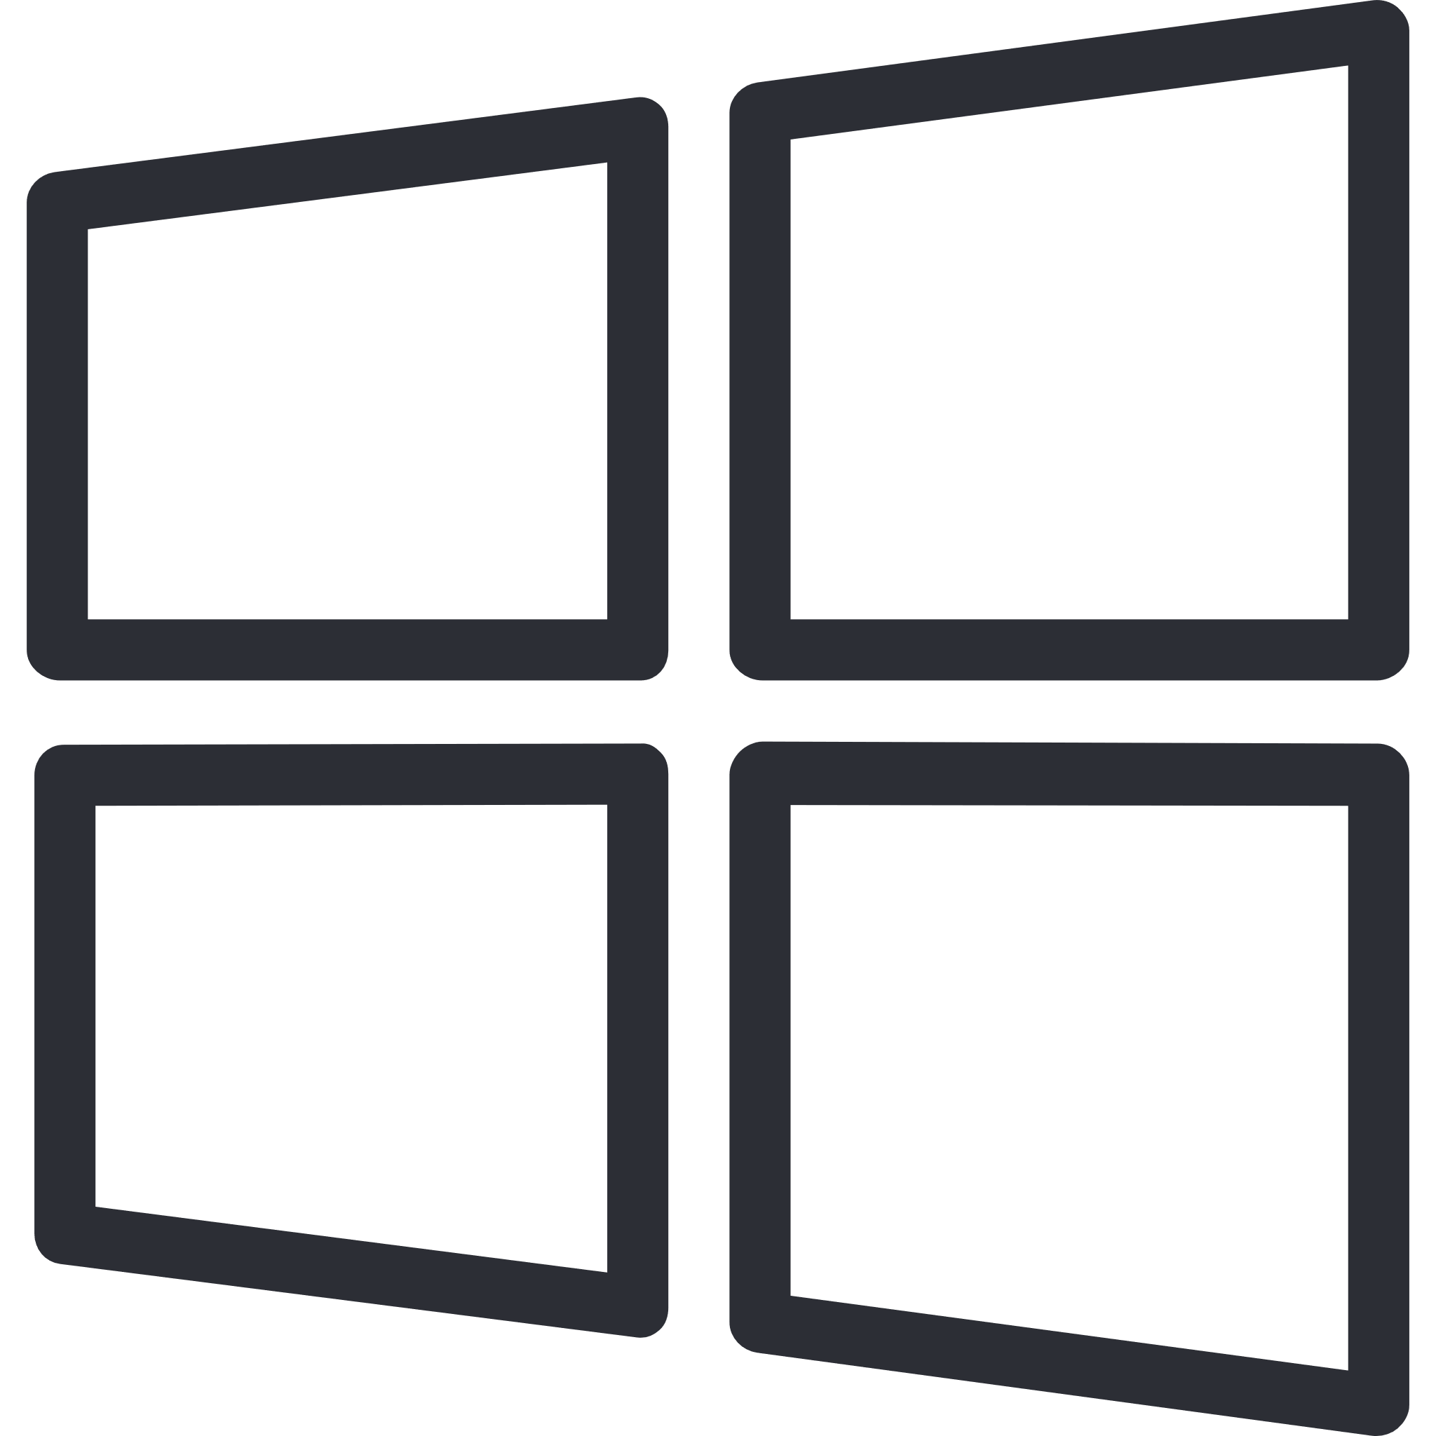 

**File**

|  |  |  |  |
| --- | --- | --- | --- |
| Save | Ctrl + S |  |  |
| Save as | Ctrl + Shift + S |  |  |
| Open | Ctrl + O |  |  |
| New | Ctrl + N |  |  |

**Find and replace**

|  |  |  |  |
| --- | --- | --- | --- |
| Find or replace | Ctrl + F | Ctrl + R | Ctrl + H |
| Find next | F3 |  |  |
| Find previous | Shift + F3 |  |  |

**Editing**

|  |  |  |  |
| --- | --- | --- | --- |
| Undo | Ctrl + Z |  |  |
| Redo | Ctrl + Y | Ctrl + Shift + Z |  |
| Cut | Ctrl + X |  |  |
| Copy | Ctrl + C |  |  |
| Paste | Ctrl + V |  |  |
| Select all | Ctrl + A |  |  |
| Go to line | Ctrl + L |  |  |

**Debugging**

|  |  |  |  |
| --- | --- | --- | --- |
| Run | F9 |  |  |
| Pause | Shift + F9 |  |  |
| Step | F8 |  |  |
| Toggle breakpoints | Shift + F8 |  |  |

**OSX**



**File**

|  |  |  |  |
| --- | --- | --- | --- |
| Save | ⌘ + S |  |  |
| Save as | ⌘ + Shift + S |  |  |
| Open | ⌘ + O |  |  |
| New | ⌘ + N |  |  |

**Find and replace**

|  |  |  |  |
| --- | --- | --- | --- |
| Find or replace | ⌘ + F | ⌘ + R | ⌘ + H |
| Find next | F3 |  |  |
| Find previous | Shift + F3 |  |  |

**Editing**

|  |  |  |  |
| --- | --- | --- | --- |
| Undo | ⌘ + Z |  |  |
| Redo | ⌘ + Y | ⌘ + Shift + Z |  |
| Cut | ⌘ + X |  |  |
| Copy | ⌘ + C |  |  |
| Paste | ⌘ + V |  |  |
| Select all | ⌘ + A |  |  |
| Go to line | ⌘ + L |  |  |

**Debugging**

|  |  |  |  |
| --- | --- | --- | --- |
| Run | F9 |  |  |
| Pause | Shift + F9 |  |  |
| Step | F8 |  |  |
| Toggle breakpoints | Shift + F8 |  |  |