First create a folder on Virtual Server assigned to you.

Use following link to create folder.

<http://systemhostingportal.it.att.com/>

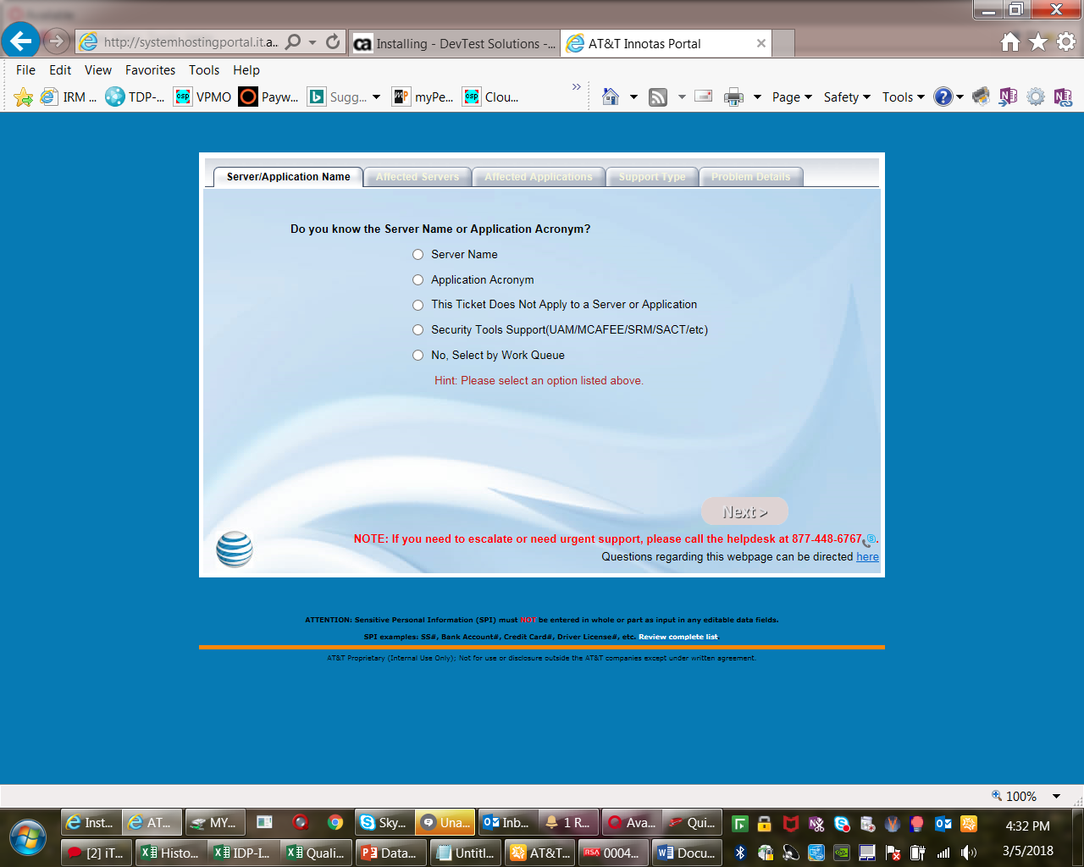

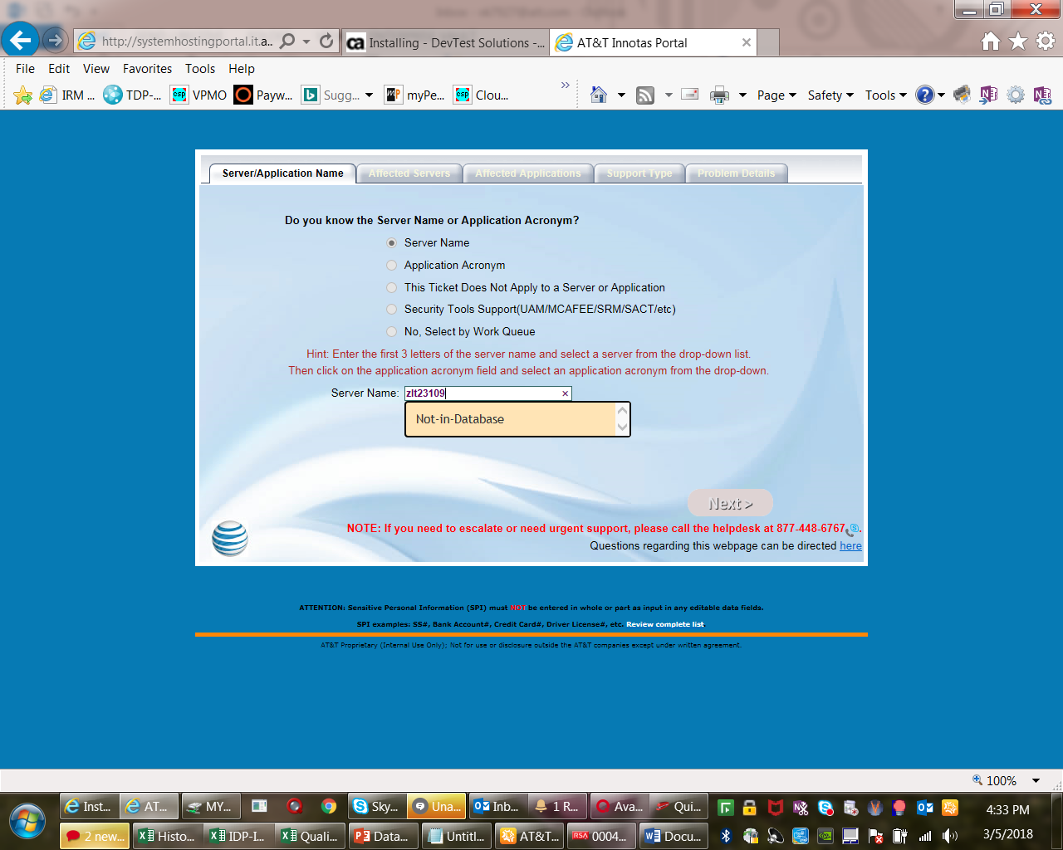

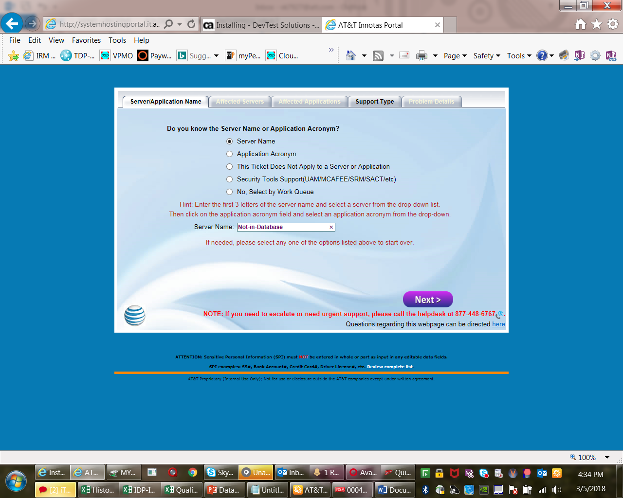

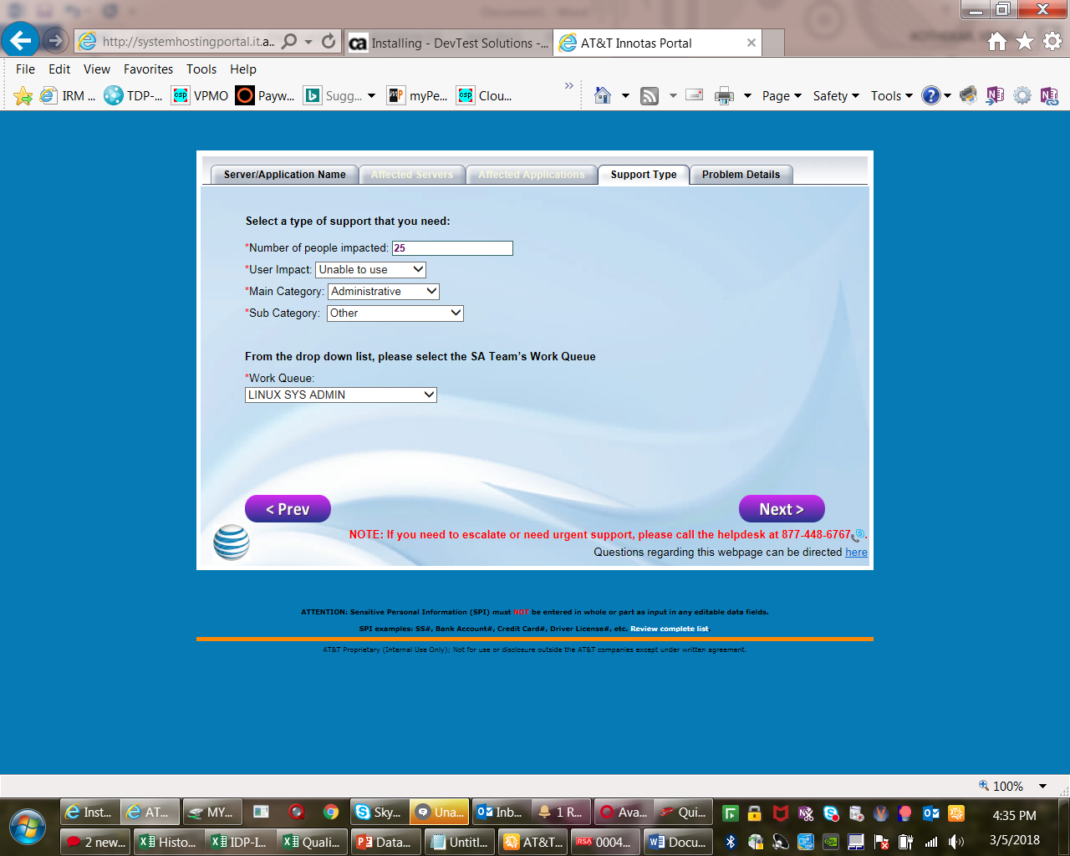

Problem Summary:

Need to create a folder.

Problem detail

Create a Folder Named "DevTest" under path /opt/app and grant full access to this folder.

We need this to be done on the three servers mentioned below:

zlt23222.vci.att.com

zlt23223.vci.att.com

zlt23224.vci.att.com

Also we would need full access to this "DevTest" folder on mech id “m04421” as we have to install multiple software's and application installation.

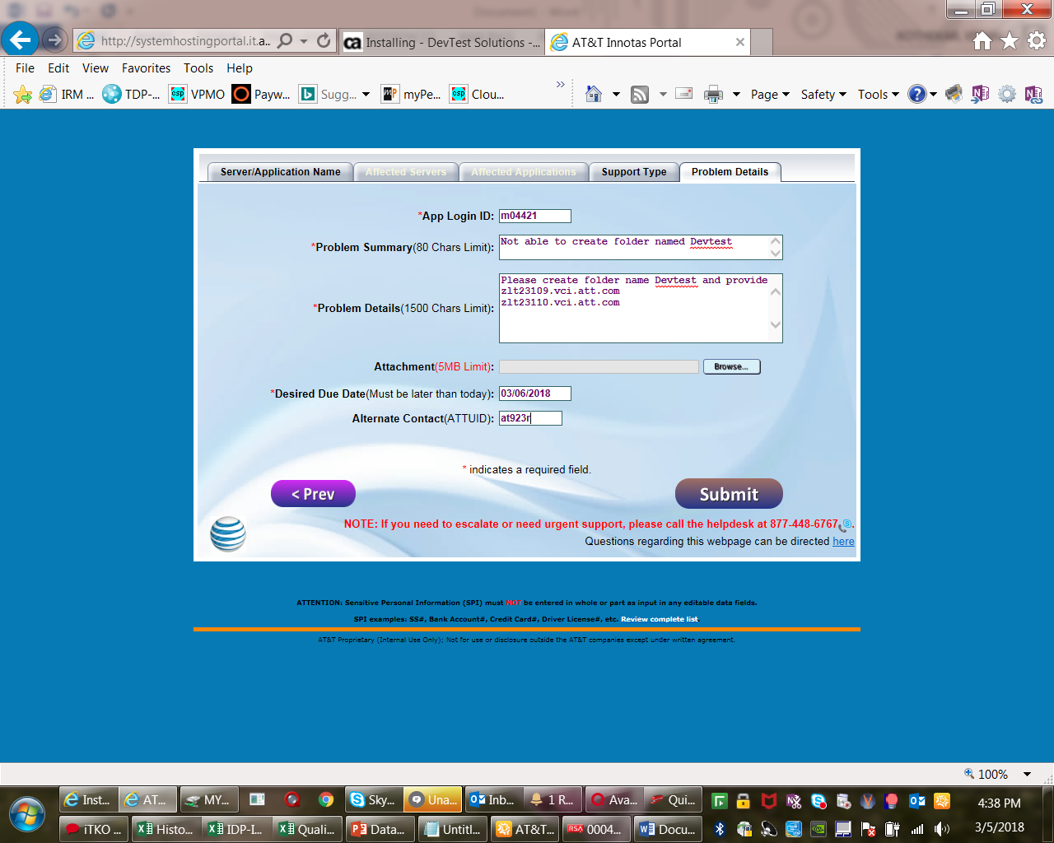

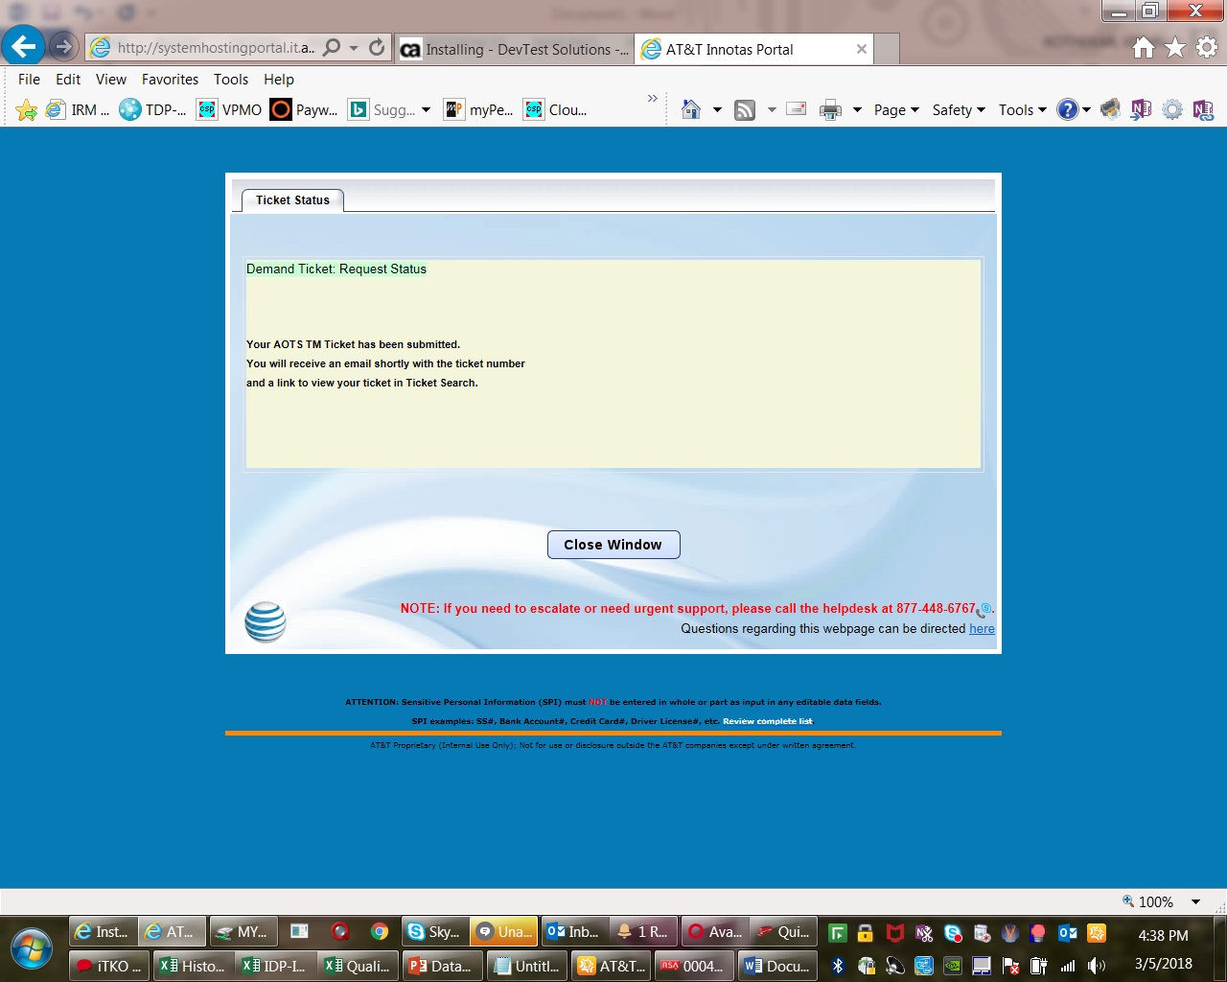

**DevTest 10 Installation Steps:-**

1. Copy the Installer (devtest_linux_x64.sh) and license file (devtestlic.xml) from the below server.

(zlt16684.vci.att.com - /opt/app/Lisa/Installers/DevTest10)

1. Run the below command and installation will start. Make sure that you are using correct linux installation version. For Linux 64 bit we are using.

./ devtest_linux_x64.sh

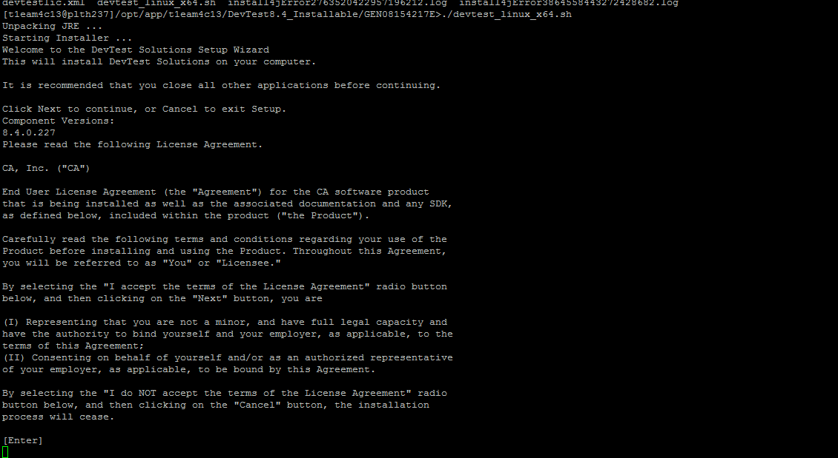

1. On couple of next screen you just need to click Enter until you see screen for accepting Terms and condition, Press 1 and hit Enter for accepting
2. .

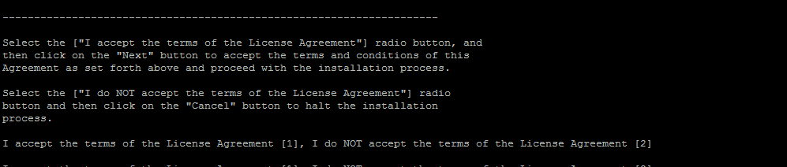

1. Next screen will ask for DevTest installation path, give it like /opt/app/DevTest/CA/DevTest



1. Press 1 and Hit enter from next screen to install Local DevTest instead of shared.

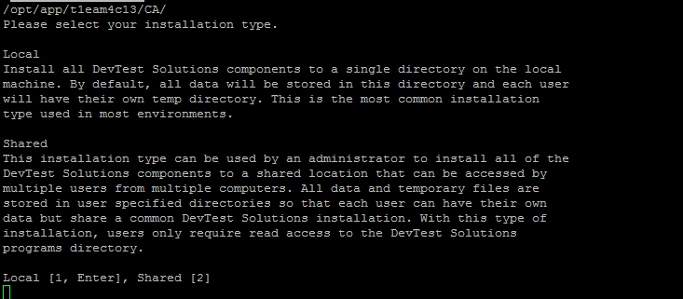

1. Hit Enter from next screen as we have to install both Workstation and Server

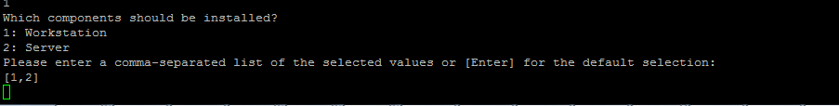

1. Hit 1 and enter from next screen and you will see license path, check if license path is correct or not? If correct then hit enter



1. Next screen will ask for Demo Server so just press 1 and hit enter

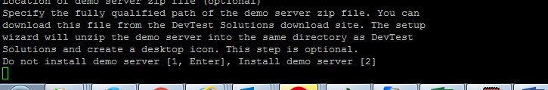

1. Next screen will be for symlinks, select n (NO)

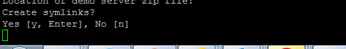

1. Select N from desktop icon screen.

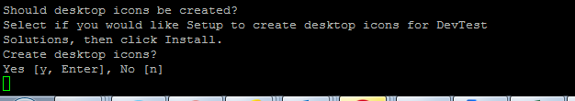

1. Sit Back and wait for installation to complete

**Important steps before starting any services.**

1. **Lisa.Properties** **changes**.
2. Replace all localhost/127.0.0.1/0.0.0.0/192.168.1.1 with local ip address
3. Change VSE name for ex. lisa.vseName=VSE-225
4. If we are having other Enterprise Dashboard running on same host but on different vtier then we can use same enterprise dashboard to configure other registry and VSEs. For that please add below line for where ip will be of vtier where enterprise dashboard is running.

lisa.enterprisedashboard.service.url=tcp://**<ipaddress>:**2003/EnterpriseDashboard

If there is no other enterprise dashboard running then provide local ip address.

1. **local.Properties changes.**
2. Add lisa.net.bindToAddress=<local ip address> for ex. 130.9.203.226 at the end of local.properties file.
3. Replace all localhost/127.0.0.1/0.0.0.0/192.168.1.1 with ip address
4. Copy cef_keystore file from any server and place it under CA/DevTest folder and add below line for SSL

ssl.client.cert.path=/opt/app/<vtier>/CA/DevTest/cef_keystore

ssl.client.cert.pass.encrypted=d2ff9c378928b9f3e4c8daf0487c9eaa

ssl.client.key.pass.encrypted=d2ff9c378928b9f3e4c8daf0487c9eaa

ssl.client.alias=ibmwebspheremqm68015q

1. **phoenix.Properties changes.**
2. Replace all localhost with ip address and uncomment below lines
   * reshub.hostname
   * registry.host
3. **VirtualServiceEnvironmentService.vmoptions changes.**
   1. Remove below line if present in file

-Dphoenix.webserver.bindaddress=<localipaddress>

* 1. Add below line

-Dlisa.vseName=tcp://<localipaddress>:2013/<VSEName>

For Ex. -Dlisa.vseName=tcp://130.9.203.226:2013/VSE-226

* 1. Also add

-Xms2048m

-Xmx2048m

1. **RegistryService.vmoptions changes.**
   1. Add below line

-Dlisa.registryName=tcp:// <localipaddress>:2010/Registry

1. **PortalService.vmoptions changes.**
   1. Add below line

-Dphoenix.webserver.bindaddress=<localipaddress>

1. **BrokerService.vmoptions changes.**
   1. Add below line

-Dlisa.pathfinder.broker.host=<localipaddress>

1. **logging.properties changes.**
   1. log4j.additivity.VSE=**true**
2. **Jar to be copied**
   1. Copy below jar to location /opt/app/<vtier>/CA/DevTest/lib/shared
      1. StubValidationDPH.jar
      2. attProtocol.jar
   2. Copy below jar to location /opt/app/<vtier>/CA/DevTest/hotDeploy
      1. vse-batch-manager-6.0.jar

**How to add registry in Enterprise Dashboard.**

1. Open the Enterprise Dashboard.
2. Click **Options** in the upper right corner of the **Enterprise Dashboard** main window.
3. Select **Configure**.  
   The Registry Configuration window opens with the Configure Registry fields blank.

**Note:** To return to the main window, click **Go back to registry view** Back button to return to the registry view of the Enterprise Dashboardat the top right corner of the page or click **Overview** in the breadcrumbs in the top left corner of the page.

1. Click **Add Registry** in the Registry Configuration window. Click **Yes** to confirm.
2. Complete the following fields:
   * **Registry URL**  
     The URL of the registry. This field is required.  
     **Example:**

tcp://*hostname*:2010/Registry

To validate the URL, click **Validate**.

* + **Registry Name**  
    The common name or nickname for this registry.  
    **Example:**

MyRegistry@*hostname*:2010

* + **Display Registry**  
    Select **Active** to display this registry in the main panel of the dashboard, or **Hidden** to hide this registry. This parameter also controls which folder on the left side contains this registry.

1. Click **Save** to add the registry to the dashboard.