1. STEPS TO START DEVTEST8.4

1-Start the Enterprise Dashboard Server.

2-Start each registry.

3-Start the Portal.

Start the following components in any order:

4-Broker

5-Virtual Service Environment

If used on the DevTest Server:

6-Workstation

1. We should check status of Services (registry, Broker, Portal, VSE…etc) by command ./PortalService Status

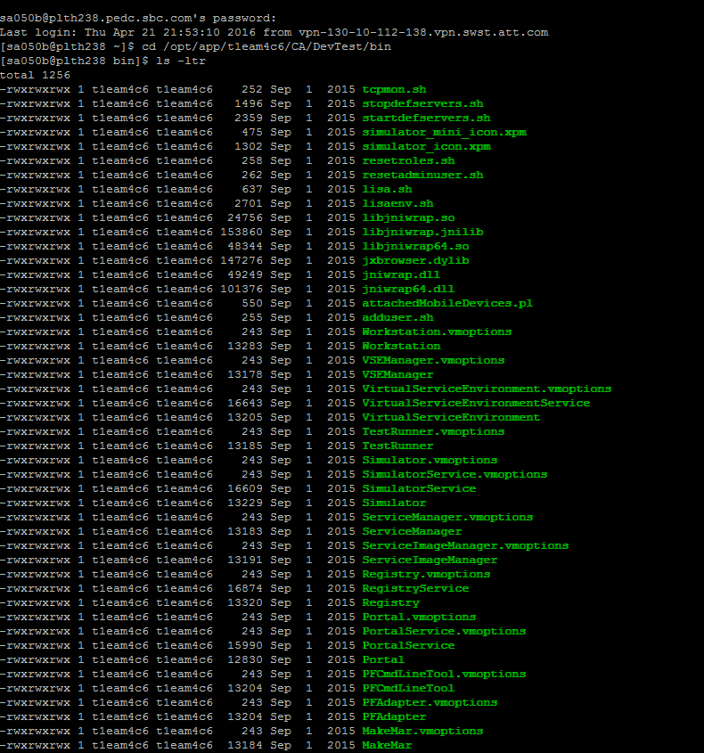

1. For checking status/stop or start services (Broker, registry…etc) we should use ./{serviceName}Service status/stop/start



1. Now we should check recorders are starting mode or not

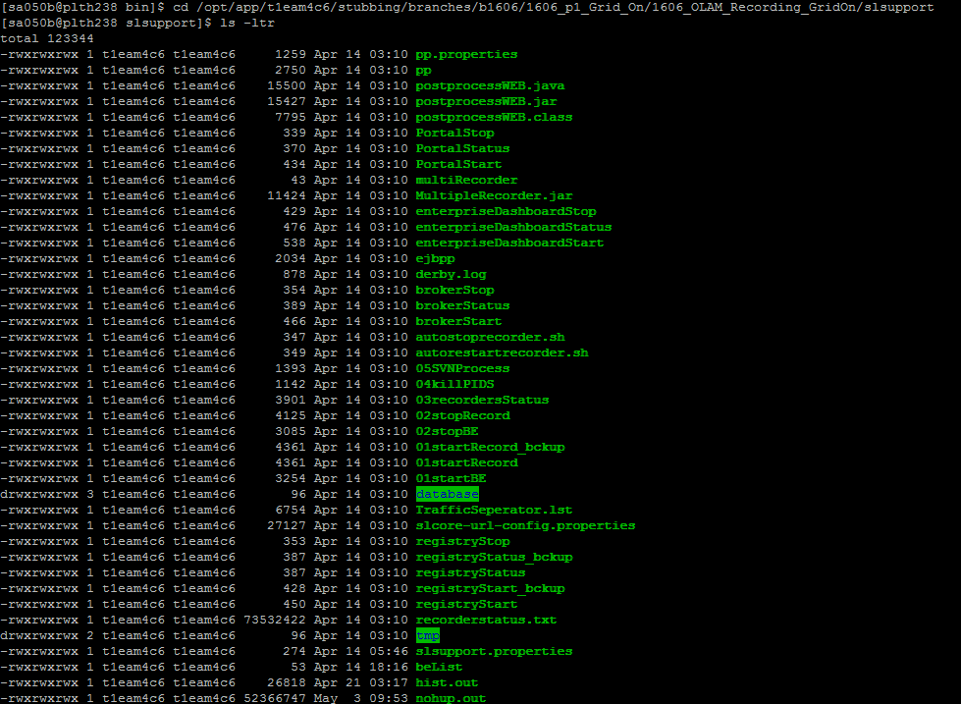

1. Steps for maintenance

1)recordersStatus---->./03recordersStatus ALL ( To check if recorders are up and running)

2)stop recorder----->./02stopRecord

3)recordersStatus---->./03recordersStatus ALL (To check if all the recorders are stopped, if not go to step 4 and 5)

4)kill running recorder---->kill -9 "PID from recorder status"

4)recordersStatus---->./03recordersStatus ALL

5)start Recorder----->./01startRecord

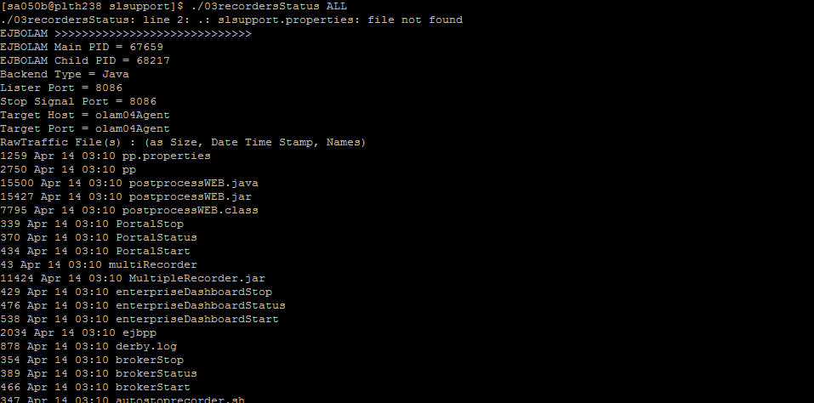

1. Now we should check rawTraffic file by using WinScp, If File is creating that means, recording is working fine



1. If RawTraffic file is not creating than we should open ATK.exe from C:\CA\DevTest\bin folder.

We should change ipaddress in BrokerUrl

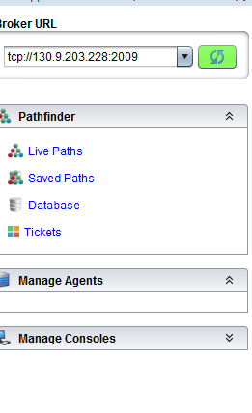

1. We should check classes are under virtulized mode or not. Click Agent name and then VS Play and then put .\*Stub in serch box and click refresh. Passthrough should be enable for recording

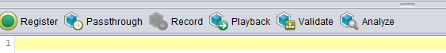

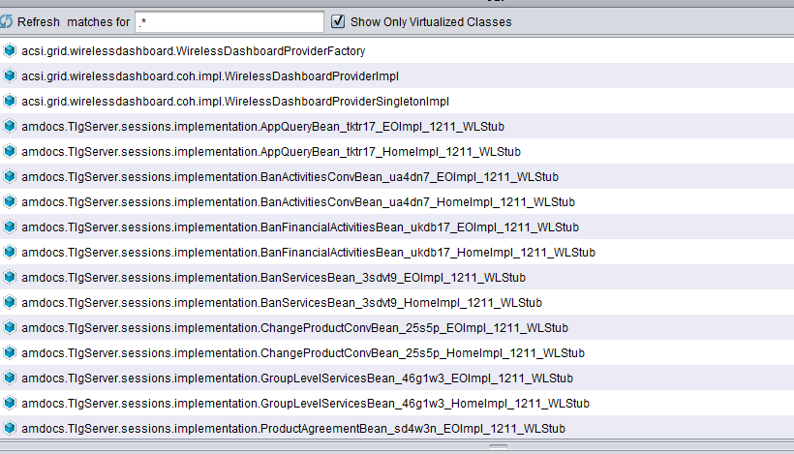

1. If everything is fine then we should use these commands, By these commend we will know how many services are running on. If we get any unnecessary services then we should kill and then again restart all services from scratch and restart the recorders

ps -ef | grep t1eam4c6 ----For particulat Vtier

ps -ef | grep olam04—For specific agent

1. You can also follow below steps to check issues.

ps -ef | grep t1eam4c6 ----You will get all running process

crontab –e ------Just check cron job running on the box

Kill all unnecessary process by using Kill -9 command