Check the Udemy course
----------------------------------------------------
Tutorial 5:
Explains why vmWare is expensive in terms of resources. Each VM has its own copy of OS, sometimes the same OS (ex: Linux). So it eats up space in the hard disk drive, because each VM have its own copy of OS say Linux, hence duplicating the OS in HDD.
VMs does not generally have a common config file. Hence there is no single source of truth using which we can setup VM. On the other hand, containers can be setup using a config file which can then be used by others also to spin up a container at their individual machines. Hence distribution and sharing is easy for containers.

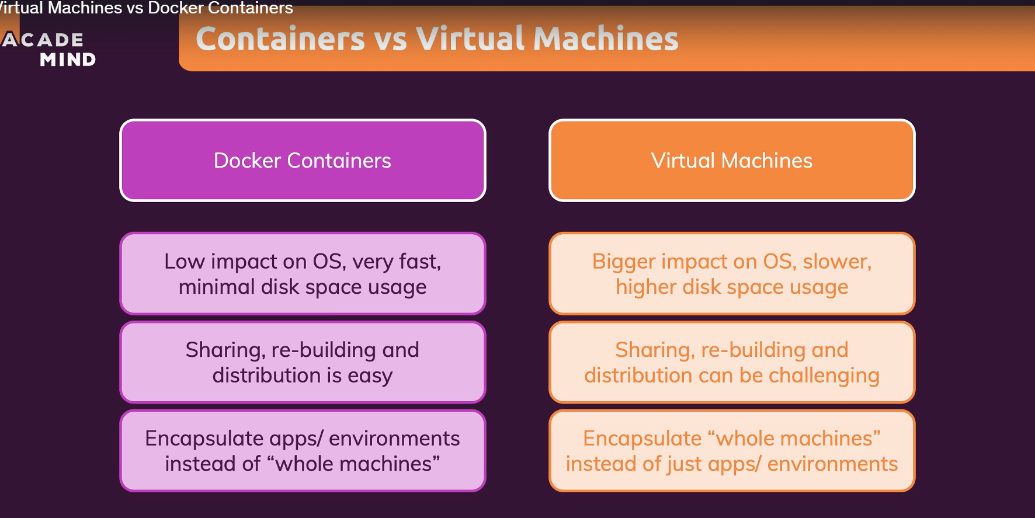
---------------------------------------------------------------------------------------------
Tutorial 13:
How to run sample docker project. Also check out the git project docker-sample in prat/21.
---------------------------------------------------------------------------------------------
Tutorial 19:
Images vs Containers
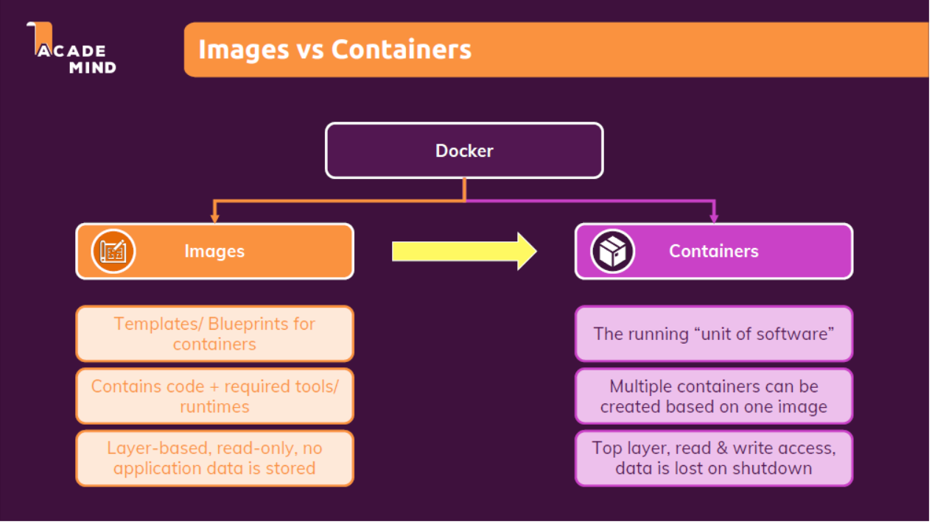
Tutorial 20:
How to run container in interactive mode:
docker run -it node
This command will run the node container in interactive mode where we can run REPL commands.
Tutorial 22 (Important):
A container (and therefore also the image) contains environment+code . Hence your code should go in there. Every image/container has its own internal file system which is completely isolated from the host (machine where docker runs) file system.
Containers also has its own internal networking, which is isolated from the host system.
Explains the difference between RUN and CMD docker commands. RUN commands are run while building the image. CMD commands are run while creating a container from an image.
Tutorial 23:
Whenever we are running a container, we need to expose the port of the container on which the internal application is running. Also we need to map the container port to local host port (since container networking and local machine networking are isolated) so that it is accessible outside.
Tutorial 25:
Images are read only, ie once an image is built from dockerfile it cannot be updated. We have to rebuild and create a new image if there is any change (say in source code).
Tutorial 26:
Images are layered.
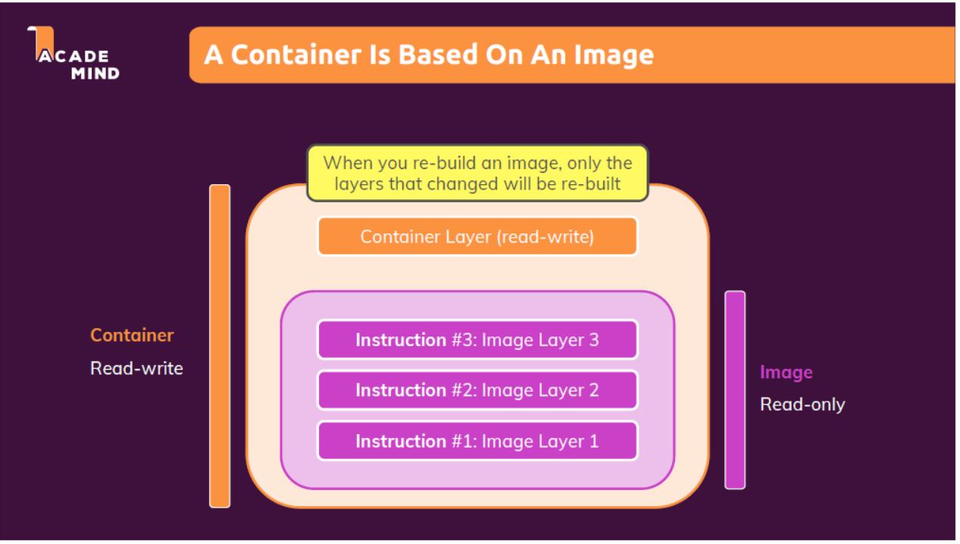
What is system image in computer science?
Ans: https://www.easeus.com/backup-recovery/what-is-a-system-image.html?srsltid=AfmBOor16VPHdAIo2cfZPfjTYq5_iszJgFJz7H5bspb8apI6o2p864Gt

A system image, in short, is a snapshot or an exact copy of an entire hard drive. A system image is a complete backup of everything on your computer's hard drive, so it saves everything, including Windows OS, your system settings, executable files, installed programs and all other files. The biggest advantage of a system image is that if a hard drive crashes or the computer stops working, you can easily restore everything back the way it was, with no need to reinstall Windows and applications.

https://en.wikipedia.org/wiki/System_image

In computing, a system image is a serialized copy of the entire state of a computer system stored in some non-volatile form, such as a binary executable file.

https://docs.docker.com/get-started/docker-concepts/building-images/understanding-image-layers/#stacking-the-layers
Important to understand how image layering works.

Tutorial 27(Important):
A container does not copy the code or environment from the image every time a container is created. A container will use the environment stored in an image and then just add this extra layer on top of it, a running node server process for example, and allocate resources, memory and so on to run the application, but it will not copy that code. So, our Code and the node environment is not getting copied three times here. If we have one image and two containers, it exists only once in the image and to containers, then utilize that image and the code in it.
Tutorial 30(Important):
For “docker run” command, the default mode is attached. For “docker start” command (which starts a stopped container), the default mode is detached.
To attach to a container running in background: docker attach <CONTAINER_NAME>
To run a docker container in detach mode: docker run -p 8000:80 -d <IMAGE_ID>
To see the recent logs of a container without attaching to the container: docker logs <CONTAINER_NAME>
To check the logs in real time (rolling logs): docker logs -f <CONTAINER_NAME>
To start a container in attach mode: docker start -a < CONTAINER_NAME >
To list all the running containers: docket ps
To list all the containers including stopped: docker ps -a

Tutorial 32:
To create a container in interactive mode, ie where we can type some input: docker run -it <IMAGE_ID>
To start a stopped container in interactive mode: docker start -ai <IMAGE_ID> (where -a stands for attached mode, since default of start command is detached)

Tutorial 33:
To list containers: docker ps
To list images: docker images
To remove containers: docker rm <CONTAINER_NAME>
To remove images: docker rmi <IMAGE_ID>
An image cannot be deleted if any corresponding container is running or in stop condition.
To remove all unused images: docker image prune
To remove all unused containers: docker container prune

Tutorial 34:
To remove containers automatically when container is stopped/exited: docker run -p 3000:80 --rm <IMAGE_ID> (--rm is the argument in discussion here)

Tutorial 36:
To copy external file folder to container: docker cp <SOURCE_PATH> <CONTAINER_NAME>:<DESTINATION_PATH_INSIDE_CONTAINER >
For example: docker cp dummy/. boring_vaughan:/test

Tutorial 37:
To name a container while creating: docker run -p 3000:80 --name <CONTAINER_NAME> <IMAGE_ID>
To give name/tag to an image while building: docker build -t <NAME>:<TAG> <IMAGE_ID>
For example: docker build -t goalsapp:latest <IMAGE_ID>
We can also start containers using image tag instead of image id: docker run -p 3000:80 <IMAGE_NAME>:<IMAGE_TAG>

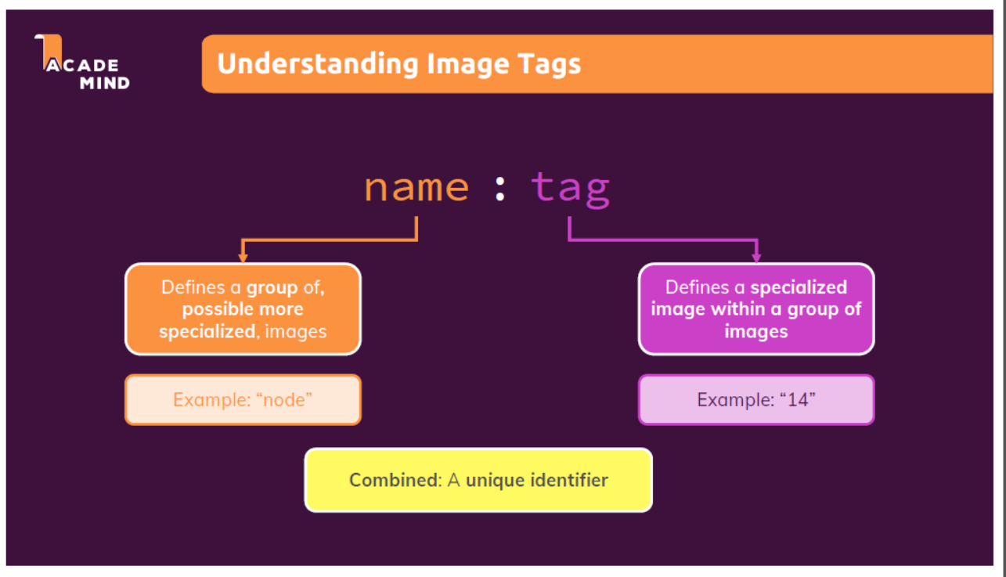

Tutorial 39(Important):
To push a docker image to docker hub (default repository): docker push <IMAGE_NAME>
Tutorial 40:
To pull an image from docker hub: docker pull <IMAGE_NAME>
We can also execute run command for this, in case the image is not already present locally, the run command will first pull and then run the image automatically.

Tutorial 44(Important):
Temporary Data: Images are read-only. When docker creates a container, it creates a read-write layer on top of the image. This layer can write temp data to image’s file system. This data is totally inside the container and not on our local file system.
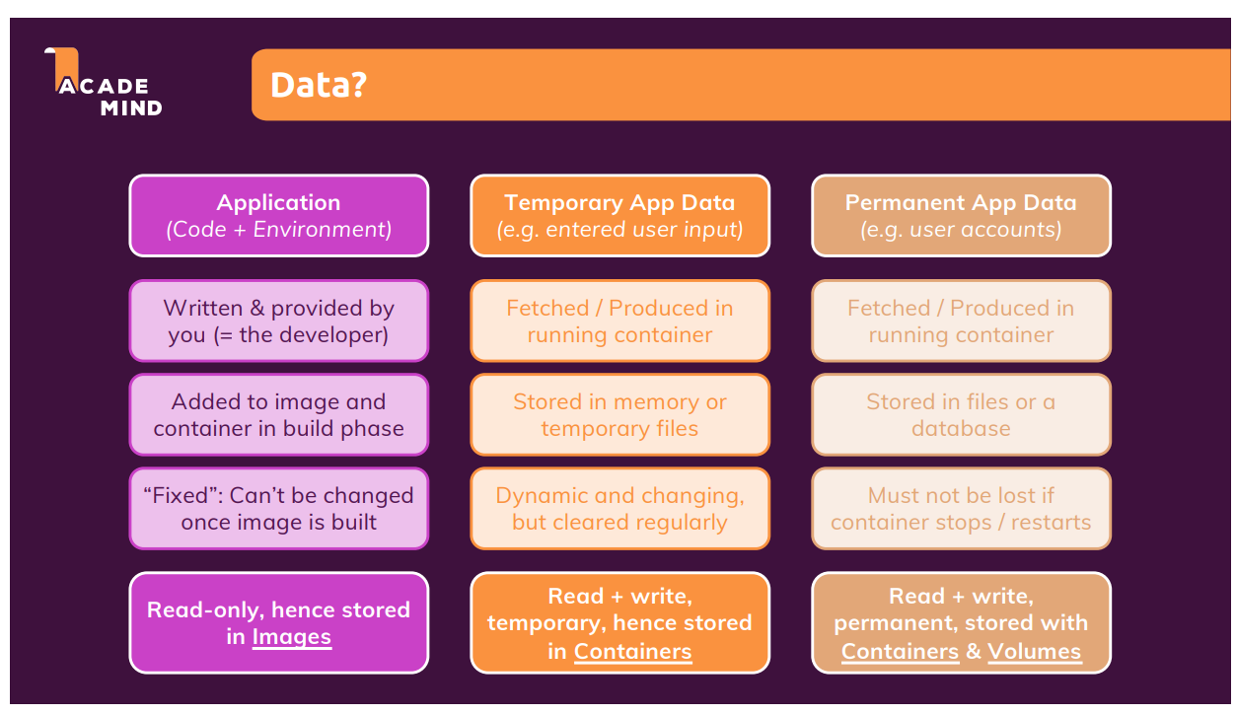

Tutorial 47(Important):
An image has its internal file system which is detached from the host/local file system.
Tutorial 48:
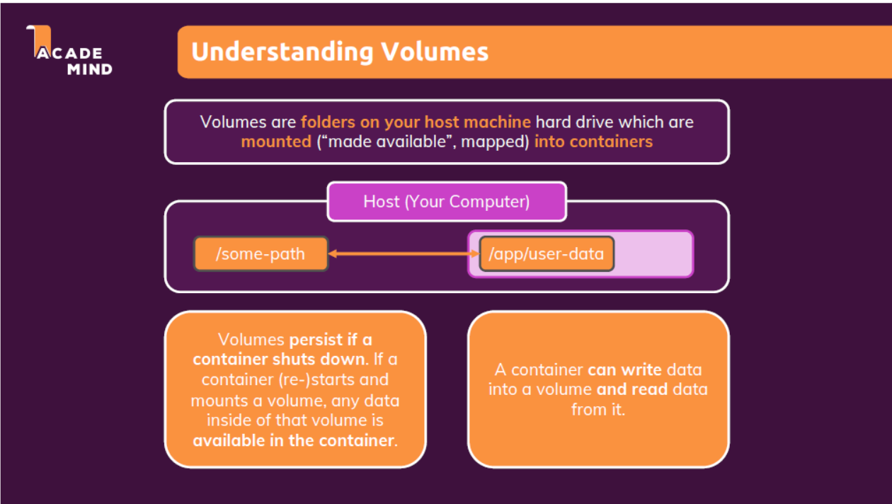

Tutorial 50(Important):
In case of anonymous volumes, for each container a new anonymous volume gets created. This volume is managed by docker. If we delete a container, the corresponding volume gets deleted automatically by docker. A particular anonymous volumes cannot be used by other containers, it is tightly bound to a single container only.
docker volume rm VOL_NAME OR docker volume prune
Anonymous volumes are created in host machine and managed by docker.
Named volumes are persistent volumes in the host machine but managed by docker. These volumes persists data across containers, ie if we stop a container the volume does not get deleted and we can re-attach the volume to a new container.

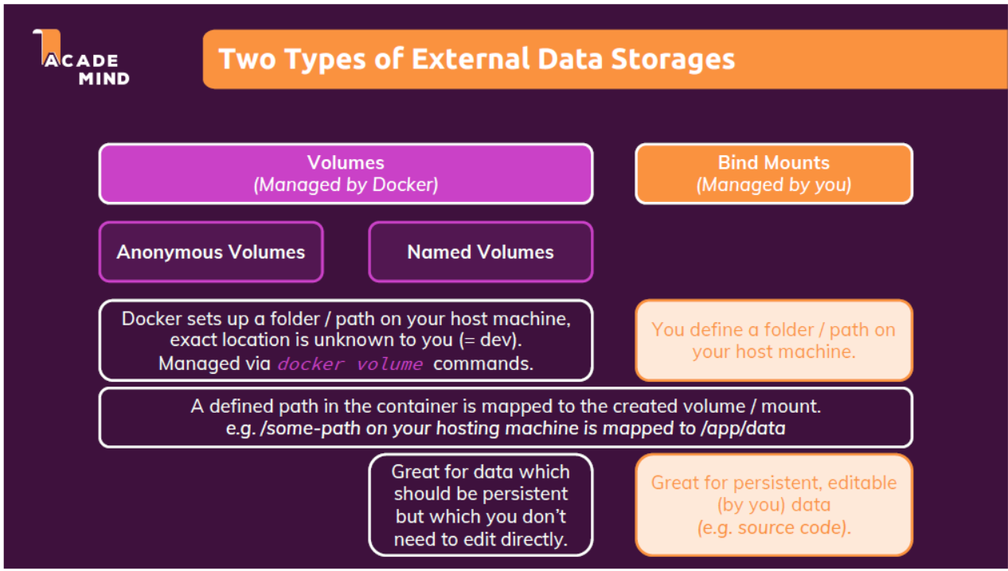

Tutorial 53 and 54(Important):
Bind mounts are physical folders in the host system(managed by the user) that can be mounted inside a foler of the container. The default behaviour of docker is that it will override the contents inside the container folder with the contents inside the host system bind mount folder. Bind Mounts are not managed by docker.
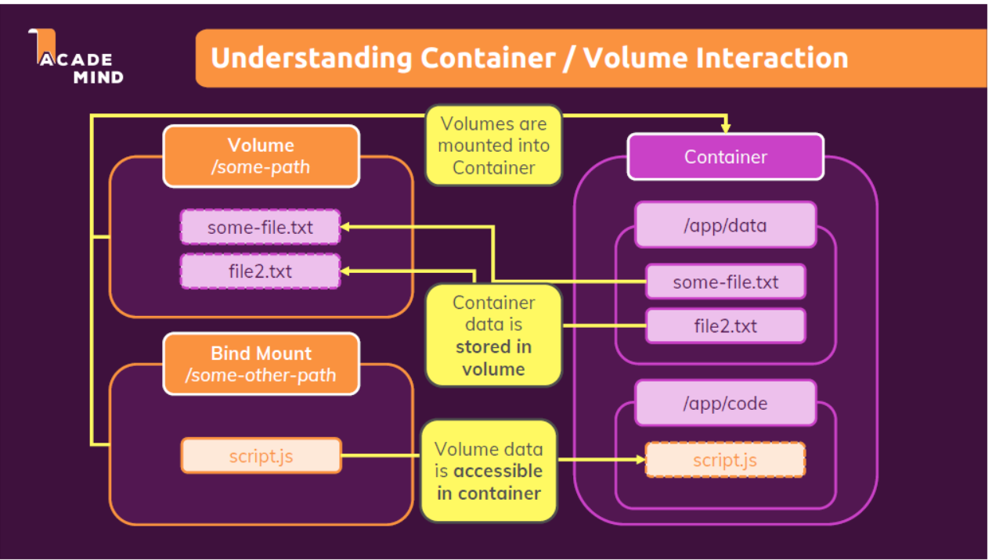

Tutorial 56:
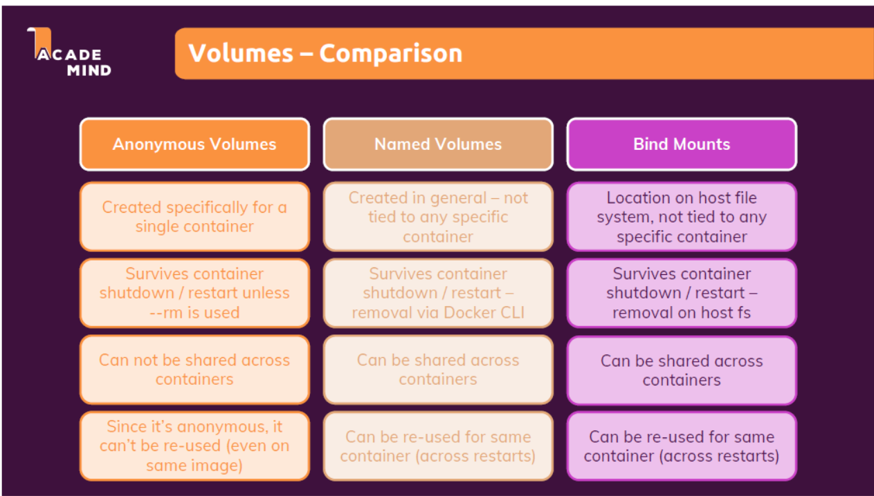

Tutorial 62-ARG and ENV:
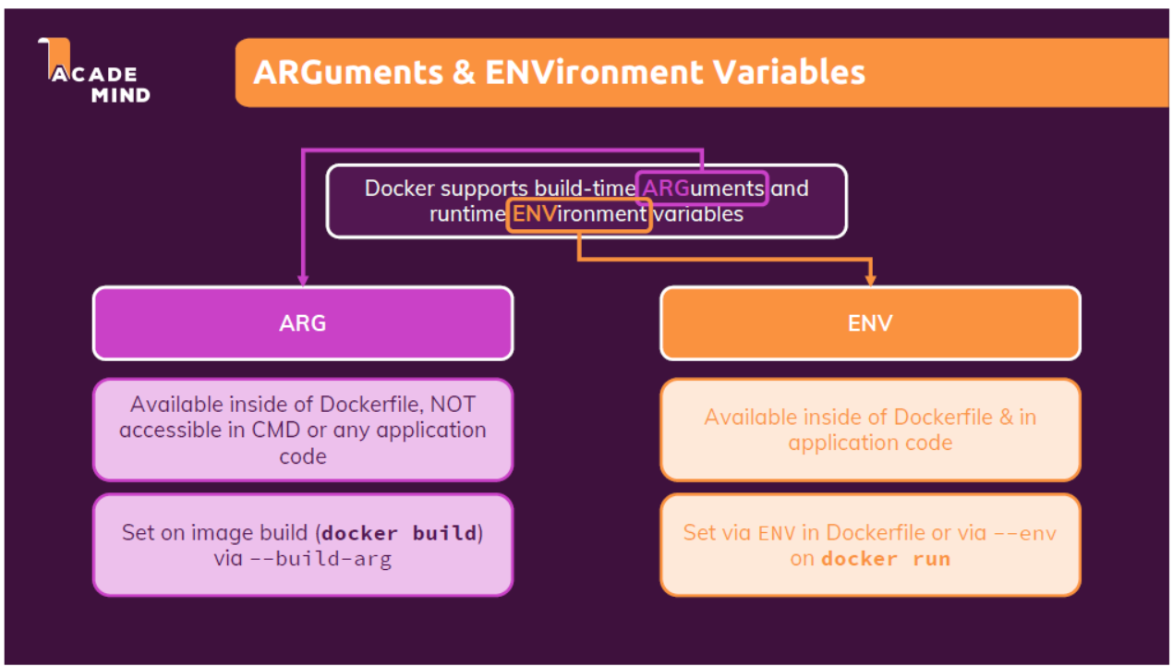
To set the environment variable at run time:
docker run --env PORT:8080 <IMAGE_NAME> OR docker run --env-file <ENV_FILE_NAME> <IMAGE_NAME>
Tutorial 64:
Arguments are available only at build time, they are not available at run time. Hence arguments cannot be accessed from code. Also it cannot be used in CMD command inside dockerfile as CMD is excuted during runtime.
Docker build --build-arg <ARG_NAME>=<ARG_VALUE>

Tutorial 72:
Out of the box, dockerized containers can send requests to world wide web by default. No special setup is required for this.
Tutorial 73:
To communicate to the host machine services from dockerized containers, we need to use host.docker.internal as the host name of url instead of localhost.
Tutorial 75(Important):
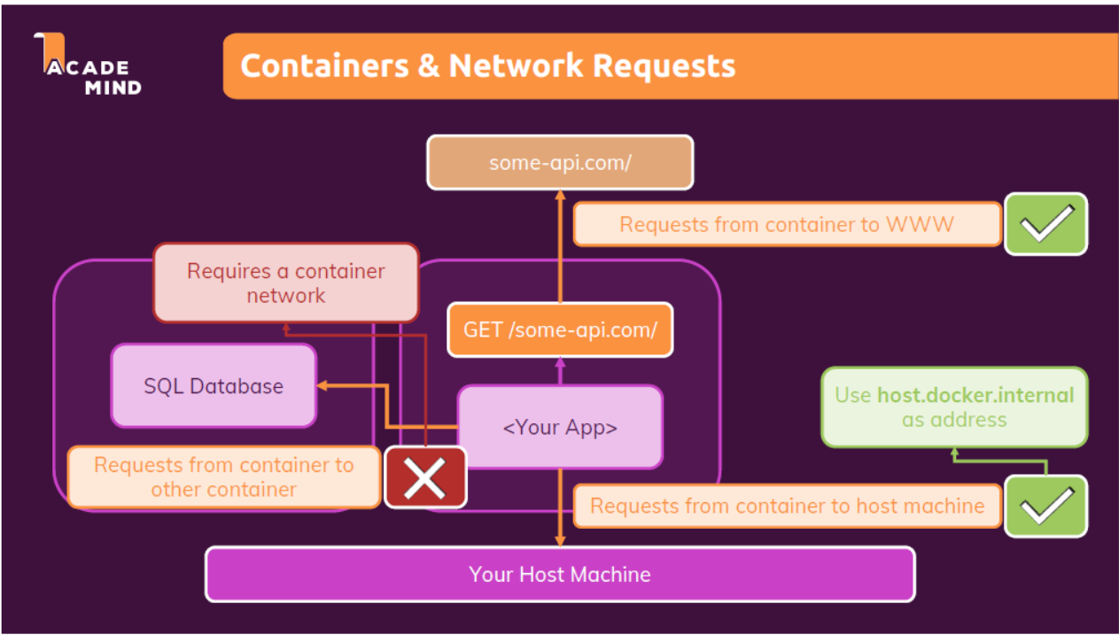
Communication between container can be done in two ways. By using the IP address of the containers(which can be found by running docker container inspect <CONTAINER_NAME> and checking the ipaddress in the config). Or by leveraging docker networks. We can create a network using docker(command: docker network create <NETWORK_NAME>) and then we can run the containers inside that network(by passing --network option in the docker run command). Containers running inside the same network can communicate with each other using container name rather than ip addresses. This is more flexible.
Also, in order for containers residing in the same network to communicate with each other, it is not necessary to expose the ports using -p option. Containers in the same network can talk to each other internally using their internal ports. Exposing ports is only necessary when the container needs to communicate with something outside the container network, ie WWW or even local host, since container’s network is separate than localhost network.
Tutorial 95:
By default, docker compose creates services(containers) with --rm and --d option. Docker compose also creates a default network and adds all the services in that network.
Tutorial 97:
Command to start all the services in compose file: docker-compose up
Command to stop all services in compose file: docker-compose down (This command will stop and remove containers and networks but not volumes)
Command to stop all services and remove volumes: docker-compose down -v
Tutorial 100:
To force image build: docker-compose up –build
To only build the images and not start the containers: docker-compose build

