**University of Mumbai**

**Smart Dustbin Using IOT**

Submitted at the end of semester VII in partial fulfillment of requirements

For the degree of

**Bachelors in Technology**

by

**Pranavkumar Tingare**

**Roll No: 1712060**

**Zoheb Mir**

**Roll No: 1822004**

**Pratik Lodha**

**Roll No: 1822015**

Guide

**Prof. Amrita Naiksatam**



**Department of Electronics Engineering**

**K. J. Somaiya College of Engineering, Mumbai-77**

**(A Constituent College of Somaiya Vidyavihar University)**

**Batch 2017 -2021**

**K. J. Somaiya College of Engineering, Mumbai-77**

(A Constituent College of Somaiya Vidyavihar University)

**Certificate**

This is to certify that the dissertation report entitled **Smart Dustbin Using IOT** submitted by Pranavkumar Tingare, Zoheb Mir, and Pratik Lodha at the end of semester VII of LY B. Tech is a bona fide record for partial fulfillment of requirements for the degree of Bachelors in Technology in Electronics Engineering of University of Mumbai

_________________ _____________________

Guide Head of the Department

_________________

Principal

Date: 13th December 2020

Place: Mumbai-77

**K. J. Somaiya College of Engineering, Mumbai-77**

(Autonomous College Affiliated to University of Mumbai)

**Certificate of Approval of Examiners**

We certify that this dissertation report entitled **Smart Dustbin Using IOT** is bona fide record of project work done by Pranavkumar Tingare, Zoheb Mir, and Pratik Lodhaduring semester VII. This project work is submitted at the end of semester VII in partial fulfillment of requirements for the degree of Bachelors in Technology in Electronics Engineering of University of Mumbai.

___________________________

Internal Examiners

____________________________

External/Internal Examiners

Date: 13th December 2020

Place: Mumbai-77

**K. J. Somaiya College of Engineering, Mumbai-77**

(Autonomous College Affiliated to University of Mumbai)

**DECLARATION**

We declare that this written report submission represents the work done based on our and / or others’ ideas with adequately cited and referenced the original source. We also declare that we have adhered to all principles of intellectual property, academic honesty and integrity as we have not misinterpreted or fabricated or falsified any idea/data/fact/source/original work/ matter in my submission.

We understand that any violation of the above will be cause for disciplinary action by the college and may evoke the penal action from the sources which have not been properly cited or from whom proper permission is not sought.

|  |  |
| --- | --- |
| **C:\Users\INDIA\Downloads\sign.jpg**  **_____________________________**  **Signature of the Student**  **Roll No.1712060** | **C:\Users\INDIA\Downloads\WhatsApp Image 2020-12-12 at 10.28.03 PM.jpeg**  **______________________________**  **Signature of the Student**  **Roll No.1822004** |
| **______________________________**  **Signature of the Student**  **Roll No.1822015** |

**Date: 13th December 2020**

**Place: Mumbai-77**

**ABSTRACT**

We are living in a world that is in a state of constant up-gradation, but there is one ubiquitous problem that we haven’t been able to deal with, the problem that is impeding our advancement to a hygienic, clean and healthy society, is garbage. Mostly in our daily life we encounter dustbins that are excessively full and garbage spilling out of them. This kind of situation is neither good for our environment nor for our advancement. This problem leads to huge number of diseases as large number of insects and mosquitoes breed on the waste accumulated in this garbage. Hence, we developed a project to control the overfilling of the dustbin by making the dustbin smart enough to notify itself for its cleaning. In this project the smart dustbin management system is built on the microcontroller-based system having ultrasonic sensors on each of the four dustbins that will show the current status of garbage on the LCD screen as well as on the mobile.

In recent times, garbage disposal has become a huge cause for concern in the world. A voluminous amount of waste that is generated is disposed by means which have an adverse effect on the environment. The common method of disposal of the waste is by unplanned and uncontrolled open dumping at the landfill sites. This method is injurious to human health, plant and animal life. This harmful method of waste disposal can generate liquid leachate which contaminate surface and ground waters can harbor disease vectors which spread harmful diseases and can degrade aesthetic value of the natural environment and it is an unavailing use of land resources. In India, rag pickers play an important role in the recycling of urban solid waste. Rag pickers and conservancy staff have higher morbidity due to infections of skin, respiratory, gastrointestinal tract and multisystem allergic disorders, in addition to a high prevalence of bites of rodents, dogs and other vermin. Dependency on the rag-pickers can be diminished if segregation takes place at the source of municipal waste generation.

**Contents**

|  |  |  |  |  |
| --- | --- | --- | --- | --- |
| **List of Figures** | | | | Viii |
| **List of Tables** | | | | ix |
| **Nomenclature** | | | | x |
| **1** | **INTRODUCTION** | | | 1 |
|  | 1.1 | | Background | 1 |
|  | 1.2 | | Motivation | 2 |
|  | 1.3 | | Scope of the project | 2 |
| **2** | **LITERATURE SURVEY** | | | 3 |
| **3** | **PROJECT DESIGN** | | | 6 |
|  | 3.1 | | Constructional Details | 6 |
|  | 3.2 | | 3D Model | 8 |
|  | 3.3 | | Block diagram / system diagram | 9 |
|  | 3.4 | | Flow Chart | 11 |
| **4** | **IMPLEMENTATION AND EXPERIMENTATION** | | | 12 |
|  | 4.1 | Hardware Requirements | | 12 |
|  | 4.2 | Software Requirements | | 18 |
|  | 4.3 | Circuit Diagram | | 19 |
|  | 4.4 | Testing And Simulation | | 20 |
| **5** | **ADVANTAGES AND CHALLENGES** | | | 25 |
|  | 5.1 | Advantages | | 25 |
|  | 5.2 | Challenges | | 25 |
| **6** | **CONCLUSIONS AND SCOPE FOR FURTHER WORK** | | | 26 |
|  | 6.1 | Conclusions | | 26 |
|  | 6.2 | Scope for further work | | 26 |
| **Bibliography** | | | | 27 |

**LIST OF FIGURES**

|  |  |  |
| --- | --- | --- |
| 3.1 | Construction model | 6 |
| 3.4 | 3D Model | 8 |
| 3.6 | General Block Diagram | 9 |
| 3.7 | Flow Chart | 11 |
| 3.8 | Arduino Uno | 13 |
| 3.9 | ESP8266 | 14 |
| 4.1 | PIR Sensor | 15 |
| 4.2 | HC-SR04 Ultrasonic Sensor | 16 |
| 4.3 | MQ2-Gas Sensor | 17 |
| 4.4 | Stepper Motor | 18 |
| 4.5 | Circuit Diagram | 19 |
| 4.6 | Proteus Simulation of PIR and Stepper Motor | 21 |
| 4.7 | Hardware testing of PIR and Stepper Motor | 21 |
| 4.8 | Proteus Simulation of Ultrasonic Sensor | 22 |
| 4.9 | Hardware testing of Ultrasonic Sensor | 23 |
| 4.10 | Proteus Simulation of Gas Sensor | 24 |
| 4.11 | Hardware testing of Gas Sensor | 24 |

**LIST OF TABLES**

|  |  |  |
| --- | --- | --- |
| 3.1 | Hardware Requirements | 12 |
| 3.2 | Arduino Uno Specification | 13 |
| 4.1 | Ultrasonic Sensor Specification | 16 |
| 4.2 | PIR and Arduino Uno Pin Connection | 20 |
| 4.3 | Arduino Uno and Stepper Motor Pin Connection | 20 |
| 4.4 | Ultrasonic Sensor and Arduino Uno Pin Connection | 22 |
| 4.5 | Gas Sensor and Arduino Uno Pin Connection | 23 |

**NOMENCLATURE**

|  |  |
| --- | --- |
| Arduino Uno | Arduino Uno is a microcontroller board based on the ATmega328P. It has 14 digital input/output pins (of which 6 can be used as PWM outputs), 6 analog inputs, a 16 MHz ceramic resonator, a USB connection, a power jack, an ICSP header and a reset button |
| ESP8266 | The ESP8266 is a very user friendly and low cost device to provide internet connectivity to your projects. The module can work both as a Access point (can create hotspot) and as a station (can connect to Wi-Fi), hence it can easily fetch data and upload it to the internet making Internet of Things as easy as possible |
| Sensors | They are the inputs to the system used for sensing and measuring quantities like gas, distance, human, etc |
| IoT | The Internet of Things, or IoT, refers to the billions of physical devices around the world that are now connected to the internet, all collecting and sharing data. The term IoT is mainly used for devices that wouldn't usually be generally expected to have an internet connection, and that can communicate with the network independently of human action. |
| Smart System | Smart systems incorporate functions of sensing, [actuation](https://en.wikipedia.org/wiki/Actuator), and control in order to describe and analyze a situation, and make decisions based on the available data in a [predictive](https://en.wikipedia.org/wiki/Predictive_analytics) or adaptive manner, thereby performing smart actions |
| Proteus | The Proteus is a software used primarily for electronic design automation and simulation |

**CHAPTER 1**

**INTRODUCTION**

This chapter presents background about waste collection in India. Motivation for the idea about Smart Dustbin using IoT. The Scope of this project idea in accordance to the design we have proposed.

* 1. **Background**

With rapid increase in population, the issues related to sanitation with respect to garbage management are degrading immensely. It creates unhygienic conditions for the citizens in the nearby surrounding, leading to the spread of infectious diseases and illness.

Worldwide interest in Smart Cities has aggrandized, fostered by the need to find effective remedies to the major challenges foreseen for the next years. As one of the application of Smart City, Waste Management in a city is a formidable challenge faced by the public administrations. Waste is defined as any material in which something valuable is not being used or is not usable and represents no economic value to its owner, the waste generator. Depending on the physical state of the waste, they are categorized as solid waste and wet waste. With the proliferation of population, the scenario of cleanliness with respect to waste management has become crucial. Waste management includes planning, collection, transport, treatment, recycle and disposal of waste together with monitoring and regulation. The existing waste management system, where the garbage is collected from the streets, houses and other establishments on quotidian basis, is not able to effectively manage the waste generated.

The main sources of waste are industrial and domestic waste. This project mainly concentrates on domestic waste whose value is unrecognized since people don’t spend time on segregating waste into their basic streams. The wet waste generated can be used to generate biogas, metallic and dry waste can be send for recycling, if metallic waste is left untreated then it becomes a threat to animal and plant lives. If waste is separated at household level then they can be directly sent for recycling instead of sending them to industries first for segregation which becomes a huge task and the waste does not get segregated accurately. The methods adopted for waste segregation in industries is hazardous to human health since it makes use of x-rays and infrared rays. The environmental risks associated with poor waste management are well known and understood. The main aim of the project is to segregate waste at source level to wet, dry and metallic such that waste is not wasted but there value is understood and can be converted to a source of energy, in a cost effective way.

* 1. **Motivation**

With rapid increase in population, the issues related to sanitation with respect to garbage management are degrading immensely. It creates unhygienic conditions for the citizens in the nearby surrounding, leading to the spread of infectious diseases and illness.

Science and technology have advanced our life in many ways. It facilitates the process of industrialization as well as modernization of the world. It has blessed us with many sophisticated devices by facilitating our life.

When the waste is segregated into basic streams such as wet, dry and metallic, the waste has a higher potential of recovery, and consequently, recycled and reused. The wet waste fraction is often converted either into compost or methane-gas or both. Compost can replace demand for chemical fertilizers, and biogas can be used as a source of energy. The metallic waste could be reused or recycled. Even though there are large scale industrial waste segregators present, it is always much better to segregate the waste at the source itself. The benefits of doing so are that a higher quality of the material is retained for recycling which means that more value could be recovered from the waste. The occupational hazard for waste workers is reduced. Also, the segregated waste could be directly sent to the recycling and processing plant instead of sending it to the segregation plant then to the recycling plant.

* 1. **Scope Of The Project**

The aim of this project is to make a fully automatic Smart Dustbin that ensures smart segregation of waste. To design, build and implement a smart dustbin waste segregation. To manage the waste and the dustbin. To promote “Swatch Bharat Abhiyaan” by segregating the waste at its initial stage.

**CHAPTER 2**

**LITERATURE SURVEY**

This chapter presents the literature survey done by the team through different IEEE papers, other published papers and various resources available on the internet.

**Smart Garbage Monitoring System Using Internet Of Things (Iot)**

By Prof. Dr. Sandeep M. Chaware, Shriram Dighe, Akshay Joshi, Namrata Bajare, Rohini Korke [1]–

The Internet of Things (IoT) shall be able to incorporate transparently and seamlessly a large number of different and heterogeneous end systems, while providing open access to selected subsets of data for the development of a plethora of digital services. Building a general architecture for the IoT is hence a very complex task, mainly because of the extremely large variety of devices, link layer technologies, and services that may be involved in such a system. One of the main concerns with our environment has been solid waste management which in addition to disturbing the balance of the environment also has adverse effects on the health of the society. The detection, monitoring and management of wastes is one of the primary problems of the present era. The traditional way of manually monitoring the wastes in waste bins is a complex, cumbersome process and utilizes more human effort, time and cost which is not compatible with the present-day technologies in any way. This an advanced method in which waste management is automated. This project IoT Garbage Monitoring system is a very innovative system which will help to keep the cities clean. This system monitors the garbage bins and informs about the level of garbage collected in the garbage bins via a web page. This web page also sends all information to garbage collection vehicles.

**Iot Based Garbage Monitoring And Sorting System**

By Ms. Pranjali P. Channe, Ms. Rasika M. Butlekar, Prof. D. B. Pohare[2] –

“Swachh Bharat” is a national campaign by the statutory cities and towns to clean the roads streets and infrastructure of the country. When the massive amount of waste material is collected, it is difficult to separate and unhygienic. Now a day’s garbage is separately thrown i.e. dry and wet. The Internet of Things (IoT) shall be able to incorporate transparently and coherently a large number of different and heterogeneous end systems, while providing open access to selected subsets of data for the developing a digital services. Building a general architecture for the IoT is hence a very complex task, mainly because of the extremely large variety of devices, link layer technologies. One of the main concerns with our environment has been solid waste management which in addition to disturbing the balance of the environment also has adverse effects on the health of the society. The detection, monitoring and management of wastes are one of the primary problems of the present period. The traditional way of manually monitoring the wastes in waste bins is a complex, cumbersome process and utilizes more human effort, time and cost which is not compatible with the present-day technologies in any way. This is an advanced method in which waste management is automated. In this “IOT based garbage monitoring and sorting system” The separate the wet and dry garbage using the moisturized sensor. This system is based on the separation and monitoring of garbage using Arduino Uno, Wi-Fi-module, ultrasonic sensor, moisturized sensor, gas sensor. Online identification of the garbage level using IOT, ultrasonic sensor and Wi-Fi module makes this system more effective than other system.

**Iot Based Smart Garbage And Waste Collection Bin**

By S.S. Navghane, M.S. Killedar, Dr.V.M. Rohokale[3] –

Many times, in our city we see that the garbage bins or dustbins placed at public places are overloaded. It creates unhygienic conditions for people as well as ugliness to that place leaving bad smell. To avoid all such situations, we are going to implement a project called IoT Based Smart Garbage and Waste Collection bins. These dustbins are interfaced with microcontroller-based system having IR wireless systems along with central system showing current status of garbage, on mobile web browser with html page by Wi-Fi. Hence the status will be updated on to the html page. Major part of our project depends upon the working of the Wi-Fi module; essential for its implementation. The main aim of this project is to reduce human resources and efforts along with the enhancement of a smart city vision.

**Smart Dustbin**

By B. Rajapandian, K. Madhanamohan, T. Tamilselvi, R. Prithiga[4] –

An exponential increase in Human population possess a huge challenge to garbage management system and hence in sustaining a clean Environment. Many Cities around the World are endangered due to poor garbage management.Our project aims to find a solution by using a Smart Dustbin which is GSM and GPS enabled.It employs an ‘Ultrasonic Sensor’ to prevent overflow of garbage from the dustbin and a ‘Gas sensor’ to sense the presence of bad odour and ensures timely disposal of the unhygienic contents of the Dustbin.Thus, our project aims at prevention of overflowing garbage from the dustbin and also ceasing unhygienic condition from prevailing near it.Thus, our project aims to have an effective and efficient garbage disposal system

**CHAPTER 3**

**PROJECT DESIGN**

This chapter presents the constructional details, 3D model, block diagram along with the working of the smart dustbin and flow chart of the system.

**3.1 Constructional Details**

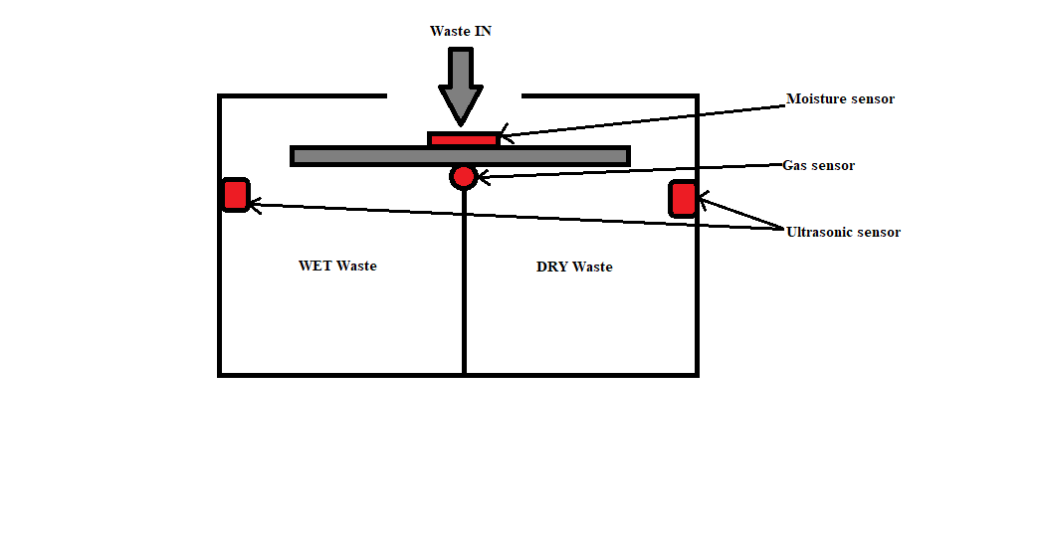

Fig 1 Construction model

A rectangle box structure with an automated closed lid open/closed by a motor, Fig1 shows general structure. The lid is controlled by the microcontroller depending upon someone's proximity in front of dustbin. As garbage is dumped inside dustbin it falls on a plank from where it is segregated to either wet/dry waste can, Plank will tilt right after dry garbage is dumped and will tilt left after wet garbage is dumped. It contains two cans wet and dry they are continuously monitored for the empty space and harmful gases in them. The monitoring process is done by using IOT from which location of dustbin full; dustbin with harmful gases can be informed to the authorities for immediate action.

**3.2 3D Model**

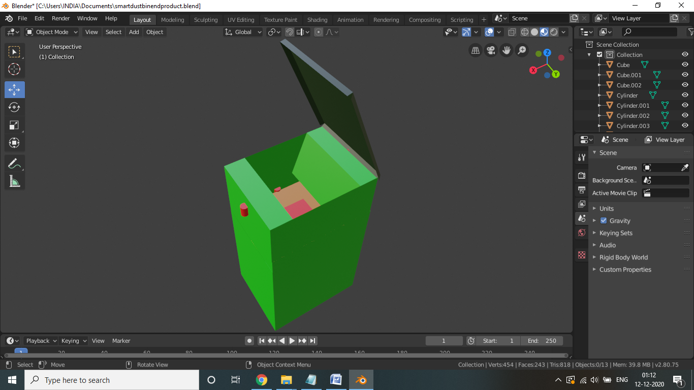

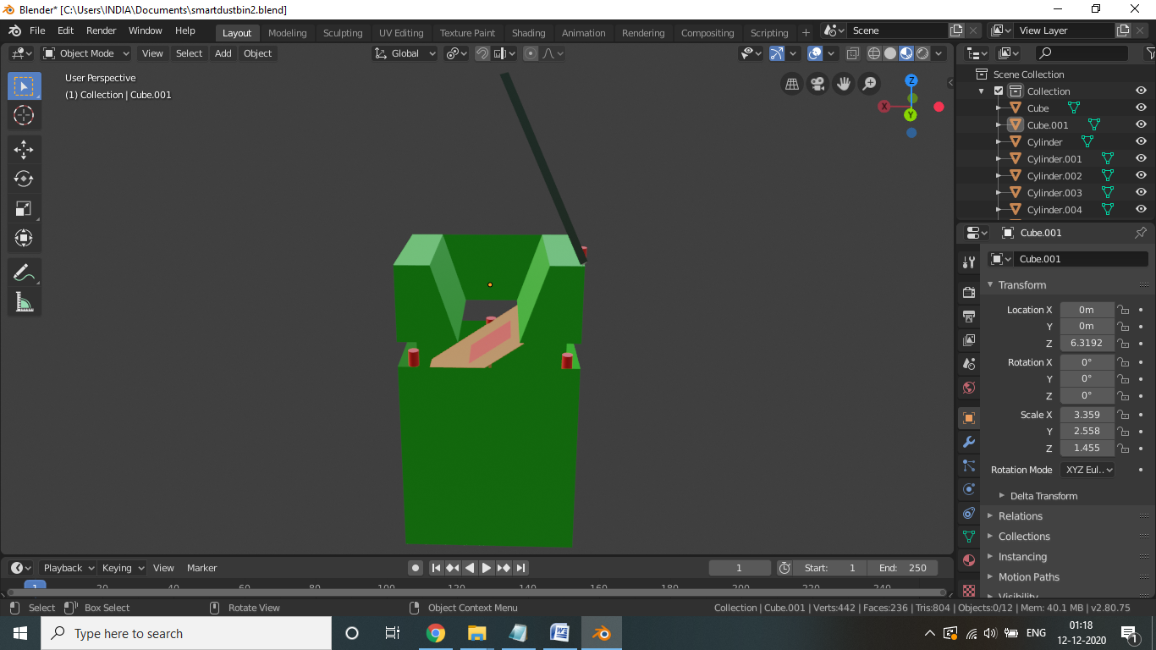

This is the 3D Model of our Smart Dustbin. It is made from blender foundation software. The green color indicates the body of the dustbin, the dark green indicates the door, the Red cylindrical shape objects shows the places of the sensors(PIR, Ultrasonic, Gas) and actuators(stepper motors) and the red plated part is the Moisture sensor with the plank.

**3.3 Block Diagram**

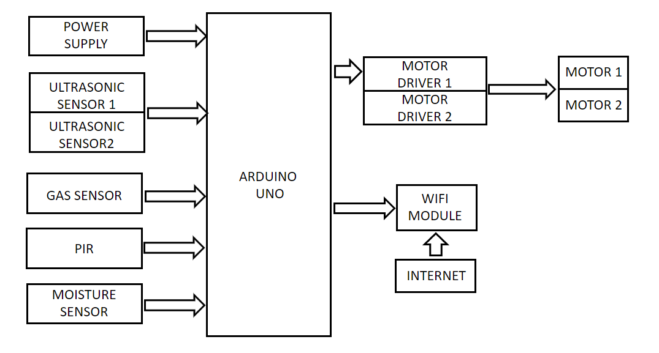

The project has three inputs, three outputs, a power supply(+5v) and a microcontroller. These three inputs are sensors to control functionality of the dustbin. If someone comes close into close proximity of front of the dustbin it will be detected by PIR sensor and it will be informed to the controller. The PIR sensor itself has two slots in it, each slot is made of a special material that is sensitive to IR. When a warm body like a human or animal passes by, it causes a positive differential change between the two halves this is detected by arduino and it opens the lid using stepper motor. Stepper motor is an actuator transforming electric pulse into angular displacement. When receiving a pulse signal from arduino through motor driver(uln2003), the stepper motor will rotate a fixed angle of 120°. A stepper motor that needs 9V and 300mA to operate cannot be powered by an Arduino therefore uln2003 is used. Garbage is then dumped into the dustbin, it falls on the plank which has moisture sensor which will detect, whether it is dry/wet waste. The Moisture Sensor uses capacitance to measure dielectric permittivity of the surrounding medium. The sensor creates a voltage proportional to the dielectric permittivity which is given to arduino to detect wet/dry waste. Depending on whether it’s a dry/wet waste arduino will tilt the plank using 2nd stepper motor to throw garbage into either dry/wet garbage can. Inside both cans ultrasonic sensor is used to monitor whether the can is full or not. Ultrasonic sensors emit short, high-frequency sound pulses at regular intervals. These propagate in the air at the velocity of sound. If they strike an object, then they are reflected back as echo signals to the sensor, which itself computes the distance to the target based on the time-span between emitting the signal and receiving the echo. Two gas sensors are also used to detect any flammable/harmful gases in the respective cans. When the warm body leaves the sensing area, the sensor generates a negative differential change which is supplied to the arduino. Arduino will close the lid using 1st stepper motor. All these details can be continuously monitored using IOT. Wifi module (ESP8266) transmits these properties at regular short intervals. The ESP8266 can be controlled from your local Wi-Fi network or from the internet (after port forwarding). The ESP-01 module has GPIO pins that can be programmed to turn an LED or a relay ON/OFF through the internet. Live location of the dustbin can also be navigated through IOT.

**3.4 Flow Chart**

**Is anyone near?**

**YES**

**Open the lid of the Dustbin using the Motor**

**Wait till the garbage is dumped**

**Is garbage Wet/Dry**

**WET**

**DRY**

**Turn the plank towards Wet side**

**Turn the plank towards Dry side**

**NO**

**Full or Gaseous?**

**YES**

**Alert the Authority using IOT**

**CHAPTER 4**

**IMPLEMENTATION AND EXPERIMENTATION**

This chapter presents the implementations and various experimentations performed by us during this tenure.

**4.1 Hardware Requirements**

|  |  |
| --- | --- |
| **Components** | **Quantity** |
| Arduino Uno | 1 |
| ESP8266 | 1 |
| PIR Sensor | 1 |
| Ultrasonic Sensor(HC- SR04) | 2 |
| Gas Sensor(MQ2) | 1 |
| Moisture Sensor | 1 |
| Stepper Motor | 2 |
| ULN2003 | 2 |
| LED | 1 |
| Connecting wires | 40 |
| Breadboard | 1 |

Description of the main components of Smart Dustbin:

1. **Arduino Uno**

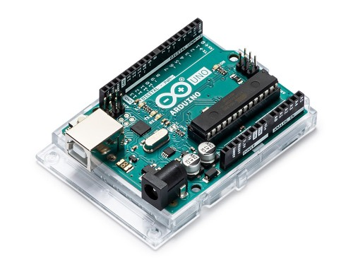

Arduino Uno is a microcontroller board based on the ATmega328P. It has 14 digital input/output pins (of which 6 can be used as PWM outputs), 6 analog inputs, a 16 MHz ceramic resonator, a USB connection, a power jack, an ICSP header and a reset button. It contains everything needed to support the microcontroller; simply connect it to a computer with a USB cable or power it with a AC-to-DC adapter or battery to get started. "Uno" means one in Italian and was chosen to mark the release of Arduino Software (IDE) 1.0. The Uno board is the first in a series of USB Arduino boards, and the reference model for the Arduino platform; for an extensive list of current, past or outdated boards see the Arduino index of boards.

|  |  |
| --- | --- |
| Microcontroller | [ATmega328P](http://ww1.microchip.com/downloads/en/DeviceDoc/ATmega48A-PA-88A-PA-168A-PA-328-P-DS-DS40002061A.pdf) |
| Operating Voltage | 5V |
| Input Voltage (recommended) | 7-12V |
| Input Voltage (limit) | 6-20V |
| Digital I/O Pins | 14 (of which 6 provide PWM output) |
| Analog Input Pins | 6 |
| DC Current per I/O Pin | 20 mA |
| DC Current for 3.3V Pin | 50 mA |
| Flash Memory | 32 KB (ATmega328P) of which 0.5 KB used by bootloader |
| SRAM | 2 KB (ATmega328P) |
| EEPROM | 1 KB (ATmega328P) |
| Clock Speed | 16 MHz |

1. **ESP8266**

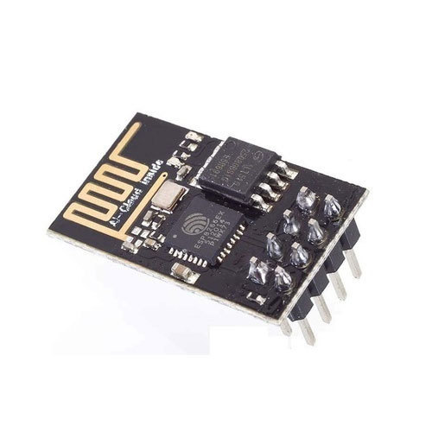

The ESP8266 is a very user friendly and low cost device to provide internet connectivity to your projects. The module can work both as a Access point (can create hotspot) and as a station (can connect to Wi-Fi), hence it can easily fetch data and upload it to the internet making Internet of Things as easy as possible. It can also fetch data from internet using API’s hence your project could access any information that is available in the internet, thus making it smarter. Another exciting feature of this module is that it can be programmed using the Arduino IDE which makes it a lot more user friendly.

Low cost, compact and powerful Wi-Fi Module

Power Supply: +3.3V only

I/O Voltage:  3.6V (max)

I/O source current: 12mA (max)

Built-in low power 32-bit MCU @ 80MHz

512kB Flash Memory

Can be used as Station or Access Point or both combined

1. **PIR Sensor**

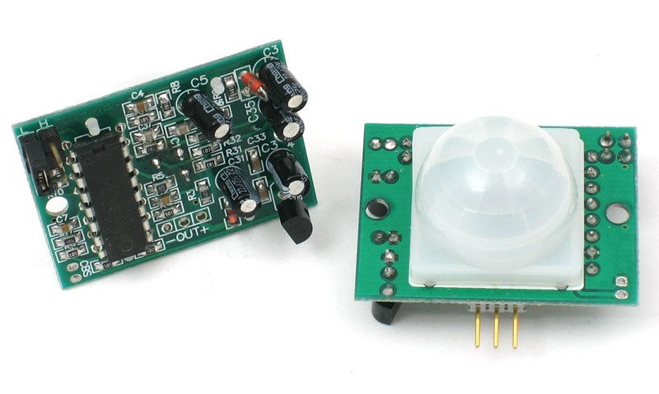

PIR sensors allow you to sense motion, almost always used to detect whether a human has moved in or out of the sensors range. They are small, inexpensive, low-power, easy to use and don't wear out. For that reason they are commonly found in appliances and gadgets used in homes or businesses. They are often referred to as PIR, "Passive Infrared", "Pyroelectric", or "IR motion" sensors.

Output: Digital pulse high (3V) when triggered (motion detected) digital low when idle (no motion detected). Pulse lengths are determined by resistors and capacitors on the PCB and differ from sensor to sensor.

Sensitivity range: up to 20 feet (6 meters) 110° x 70° detection range

Power supply: 5V-12V input voltage for most modules (they have a 3.3V regulator), but 5V is ideal in case the regulator has different specs

1. **Ultrasonic Sensor**

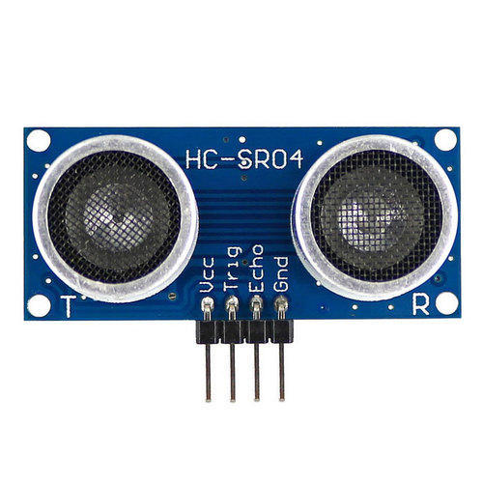

An ultrasonic sensor is an electronic device that measures the distance of a target object by emitting ultrasonic sound waves, and converts the reflected sound into an electrical signal. Ultrasonic waves travel faster than the speed of audible sound (i.e. the sound that humans can hear). Ultrasonic sensors have two main components: the transmitter (which emits the sound using piezoelectric crystals) and the receiver (which encounters the sound after it has travelled to and from the target).

In order to calculate the distance between the sensor and the object, the sensor measures the time it takes between the emission of the sound by the transmitter to its contact with the receiver. The formula for this calculation is [D = ½ T x C](https://www.arrow.com/en/research-and-events/articles/ultrasonic-sensors-how-they-work-and-how-to-use-them-with-arduino) (where D is the distance, T is the time, and C is the speed of sound ~ 343 meters/second).HC-SR04 Ultrasonic (US) sensor is a 4 pin module, whose pin names are Vcc, Trigger, Echo and Ground respectively.

|  |  |
| --- | --- |
| Supply voltage | 5 v |
| Global Current Consumption | 15 mA |
| Ultrasonic Frequency | 40 kHz |
| Maximal Range | 80 cm |
| Minimal Range | 2 cm |
| Resolution | 1 cm |

1. **Gas Sensor**

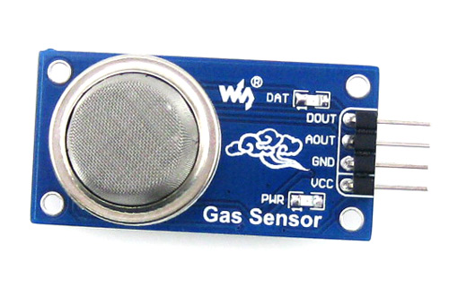

The MQ-2 Gas sensor can detect or measure gasses like LPG, Alcohol, Propane, Hydrogen, CO and even methane. The module version of this sensor comes with a Digital Pin which makes this sensor to operate even without a microcontroller and that comes in handy when you are only trying to detect one particular gas. When it comes to measuring the gas in ppm the analog pin has to be used, the analog pin is also TTL driven and works on 5V and hence can be used with most common microcontrollers.

Analog output voltage: 0V to 5V

Digital Output Voltage: 0V or 5V (TTL Logic)

Preheat duration 20 seconds

The Sensitivity of Digital pin can be varied using the potentiometer

1. **Stepper Motor**

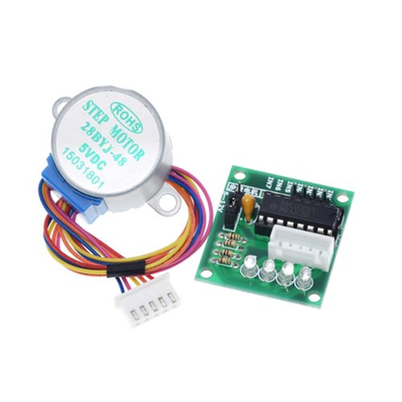

A stepper motor is an electric motor whose main feature is that its shaft rotates by performing steps, that is, by moving by a fixed amount of degrees. It requires separate motor driver IC ULN2003. It operates in steps and in both the directions.

Supply Voltage: 5V DC

Step Angle: 1.8 degree (Full) or 0.9 degree (half)

Current rating: 400mA

**4.2 Software Requirements**

1. Arduino
2. Proteus (for Simulation only)
3. Blender (Only for 3D Modeling)

**4.3 Circuit Diagram**

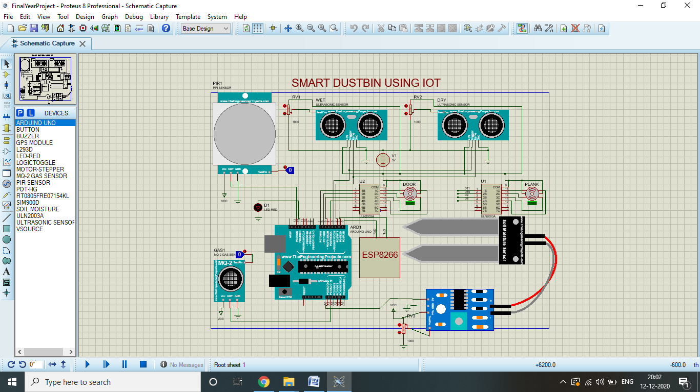

**4.4 Testing and Simulation**

**PIR Sensor and Stepper Motor**

A passive infrared sensor is an electronic sensor that measures infrared (IR) light radiating from objects in its field of view. It works with +5V to +12V DC supply. It has 2 adjustment knobs, sensitivity and time delay.

When a human will be detected near the dustbin, the door of the dustbin will get open by the help of stepper motor and Blue LED gets ON.

|  |  |
| --- | --- |
| **PIR Sensor** | **Arduino Uno** |
| pin 1(VCC) | 5V supply |
| pin 2(DO) | Digital Input pin(D13) |
| pin 3(GND) | Ground |

A stepper motor is an electric motor whose main feature is that its shaft rotates by performing steps, that is, by moving by a fixed amount of degrees. It operates on +5V DC supply, and requires additional motor driver IC (ULN2003).

As the PIR Sensor Sense the human it ON's Stepper Motor to open the door.

|  |  |  |  |
| --- | --- | --- | --- |
| **Arduino Uno** | **ULN2003(i/p)** | **ULN2003(o/p)** | **Motor** |
| D7,D6,D5,D4 | 1,2,3,4 | 16,15,14,13 | A,B,C,D |

**Simulation:-**

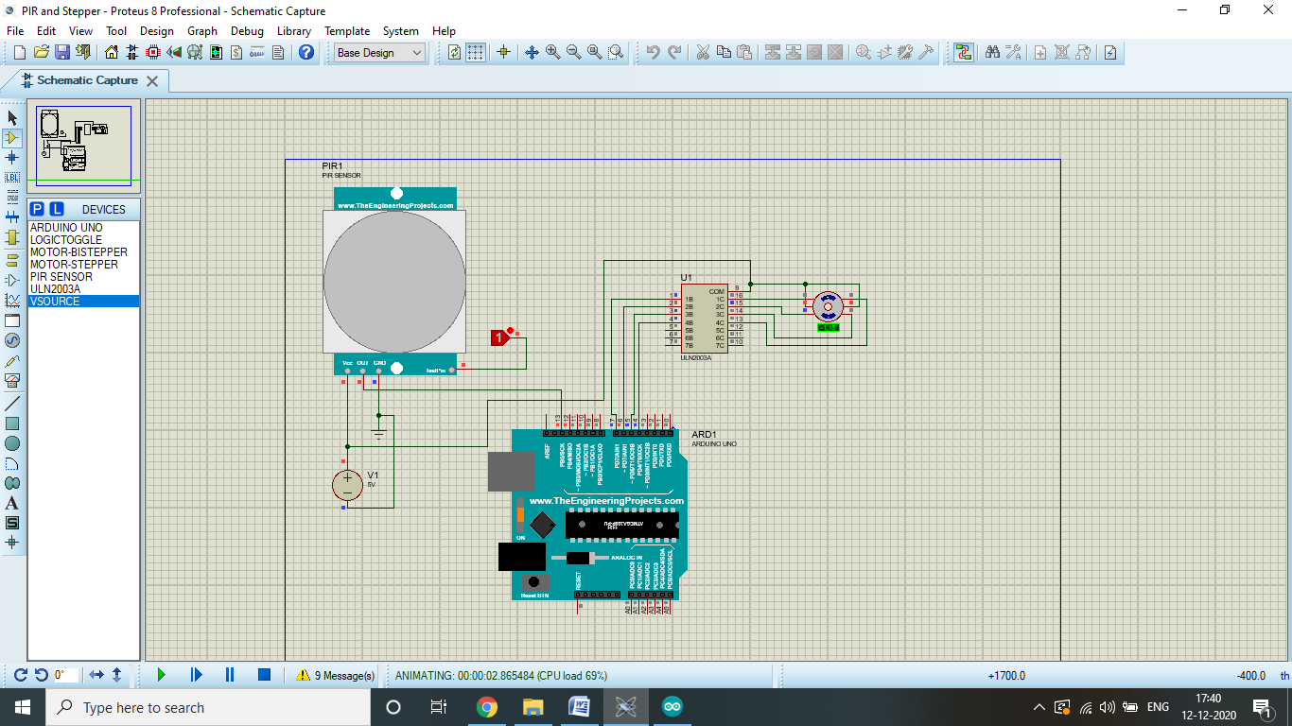**Testing:-**

|  |  |
| --- | --- |
|  |  |

**Ultrasonic Sensor**

This HC-SR04 ultrasonic distance sensor provides 2cm to 400cm of non-contact measurement.

It will indicate "FULL (Red LED ON)" when the distance of waste is less than 26cm

|  |  |
| --- | --- |
| **Ultrasonic Sensor** | **Arduino Uno** |
| pin 1(VCC) | 5V supply |
| pin 2(TRIG) | Digital Input pin(D3) |
| pin 3(ECHO) | Digital Input pin(D2) |
| pin 4(GND) | Ground |

**Simulation:-**

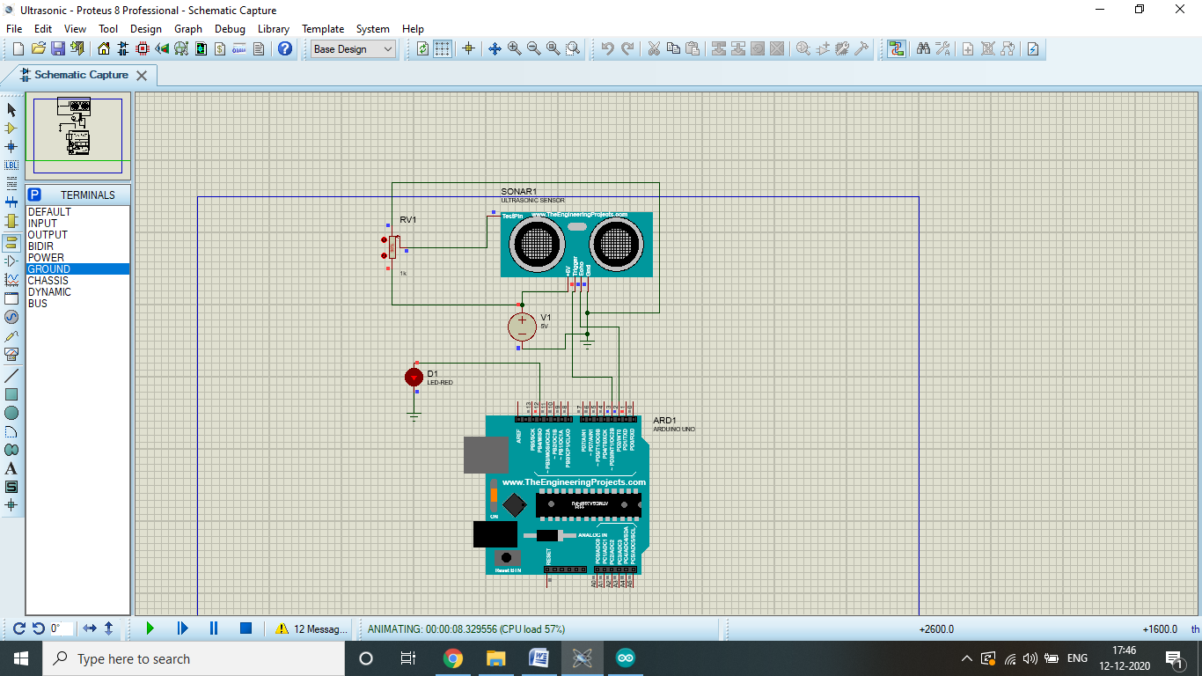

**Testing:-**

|  |  |
| --- | --- |
|  |  |

**Gas Sensor**

MQ2 Operates on +5V DC and gives analog output voltage: 0V to 5V. It is used to Measure or detect LPG, Alcohol, Propane, Hydrogen, CO and even methane. It requires Preheat duration for 20 seconds

When the concentration of gas > 280, Green LED will Glow showing that there is a harmful Gas or Smoke in the Dustbin

|  |  |
| --- | --- |
| **Gas Sensor** | **Arduino Uno** |
| pin 1(VCC) | 5V supply |
| pin 2(GND) | Ground |
| pin 3(DO) | Not connected |
| pin 4(AO) | Analog input pin(A1) |

**Simulation:-**

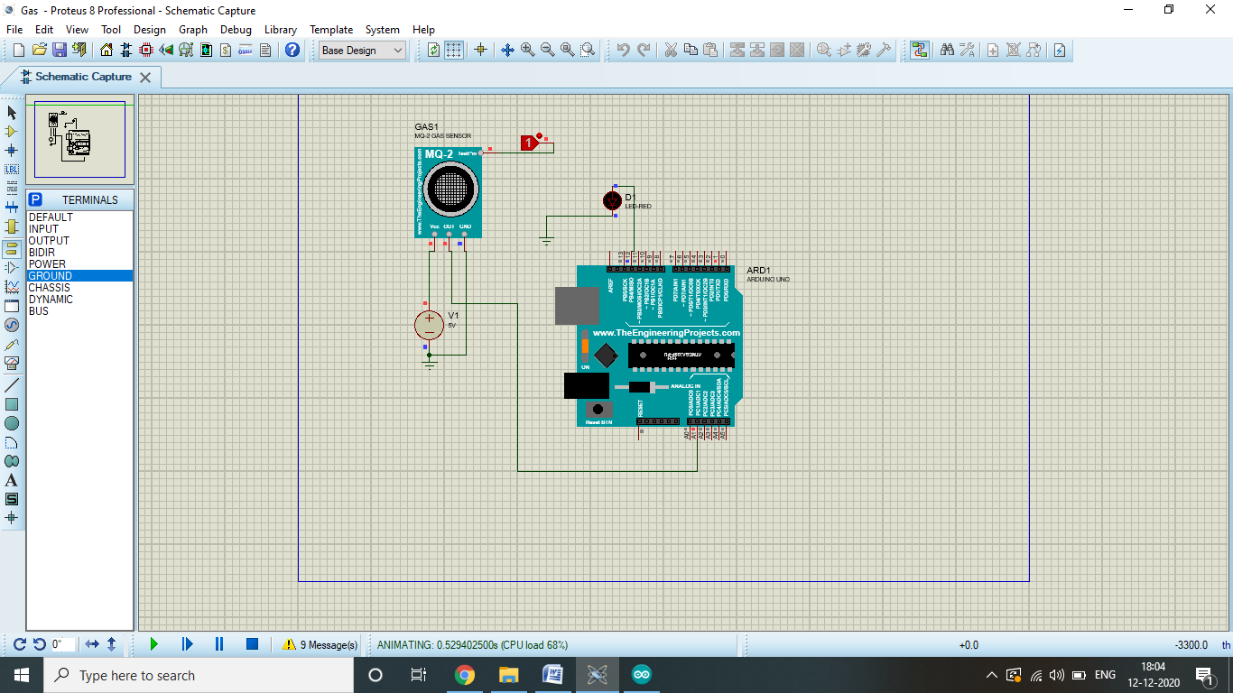

**Testing:-**

|  |  |
| --- | --- |
|  |  |

**CHAPTER 5**

**ADVANTAGES AND CHALLENGES**

**5.1 Advantages**

* Easy and automated segregation of waste.
* Waste level is controllable.
* Due to IOT, automatically gives indication to the authorities, when needed.

**5.2 Challenges**

* Needs continuous power supply.
* Lack of internet facilities in public places.

**CHAPTER 6**

**CONCLUSIONS AND SCOPE FOR FURTHER WORK**

**6.1 Conclusions**

We have hereby tested the Hardware required for our project and we have come to the conclusion that we will be tentatively using ESP8266 for GPS and Wi-Fi and our designed Moisture Sensor for waste segregation.

**6.2 Scope for Further Work**

The smart dustbin project designed will need continuous power supply to function, it is a challenge to provide continuous power supply to every dustbin as there can be malfunction in supply wire. Hence in future this problem can be avoided by using solar power which is a green energy making it environment friendly, however with this problem of securing solar panel and in dark or rain for dustbin to function without solar power are few challenges. In the current scenario of robotics and autopilot cars instead of tracking dustbin manually and locating it, there can be an automated robot which can drive itself to waste recycling plant where it can be used to recycle garbage into useful products, but it also includes risk of accident and collisions on roads with cars, this problem can be solved with an additional small lane for garbage boxes. In disposing wastes electronic waste need to be disposed with care as it is hazardous waste which emits many harmful chemicals. To segregate waste into three categories can be a great addition to this type of garbage box.

**BIBLIOGRAPHY**

1. SMART GARBAGE MONITORING SYSTEM USING INTERNET OF THINGS (IOT) By Prof. Dr. Sandeep M. Chaware, Shriram Dighe, Akshay Joshi, Namrata Bajare, Rohini Korke.:IJIREEICE 2007,ISSN: 2321 – 2004.
2. IOT BASED GARBAGE MONITORING AND SORTING SYSTEM by Ms. Pranjali P. Channe, Ms. Rasika, M. Butlekar, Prof. D. B. Pohare.:IRJET 2018,ISSN: 2395-0072.
3. IOT BASED SMART GARBAGE AND WASTE COLLECTION BIN by S.S.Navghane, M.S.Killedar, Dr.V.M.Rohokale.:IJARECE 2016,ISSN: 2278 – 909X.
4. SMART DUSTBIN by B.Rajapandian, K.Madhanamohan, T.Tamilselvi, R.Prithiga.:IJEAT 2019,ISSN: 2249 – 8958.
5. Prof. R.M.Sahu, Akshay Godase, Pramod Shinde, Reshma Shinde, “Garbage and Street Light Monitoring System Using Internet of Things” International journal of innovative research in electrical, electronics, instrumentation and control engineering, ISSN (Online) 2321 – 2004, Vol. 4, Issue 4, April 2016.
6. Kanchan Mahajan, Prof.J.S.Chitode, “Waste Bin Monitoring System Using Integrated Technologies”, International Journal of Innovative Research in Science, Engineering and Technology (An ISO 3297: 2007 Certified Organization) Vol. 3, Issue 7, July 2014.
7. Yusof, N.M., Jidin, A.Z., Rahim, M.I,“Smart garbage monitoring system for waste management”, MATEC Web of Conferences Engineering Technology International Conference, vol. 97, EDP Sciences (2017)
8. Kumar, N.S., Vuayalakshmi, B., Prarthana, R.J., Shankar, A., “IOT based smart garbage alert system using Arduino UNO.”, Region 10 Conference,TENCON, Singapore, IEEE (2016)
9. Wireless dust bin monitoring and alert system using Arduino,P. Siva Nagendra Reddy ; R. Naresh Naik ; A. Amareshwar Kumar ; S. Nanda Kishor 2017 Second International Conference on Electrical, Computer and Communication Technologies (ICECCT)
10. Automation of Smart waste management using IoT to support “Swachh Bharat Abhiyan” - a practical approach.Bharadwaj ; M. Kumudha ; Gowri Chandra N ; Chaithra G2017 2nd International Conference on Computing and Communications Technologies (ICCCT)
11. IoT based solid waste management system for smart city. Krishna Nirde; Prashant S.Mulay ; Uttam M. Chaskar. 2017 International Conference on Intelligent Computing and Control Systems (ICICCS).
12. <https://youtu.be/F6XndxlJr9A>
13. <https://www.electronicshub.org/smart-dustbin-using-arduino/>
14. <https://www.bioenabletech.com/smartbin-sensors>