→ GERAIS:
ios_base::sync_with_stdio(false);
cin.tie(0);
cout.tie(0);

- Uma sequência a = {a1, a2, a3, …, ak} tem 2^n subconjuntos distintos
- Uma sequência a = {a1, a2, a3, …, ak} tem (n(n – 1))/2 subsequências
- Cardinalidade: o número de elementos em um conjunto

→ TABELA ASCII:
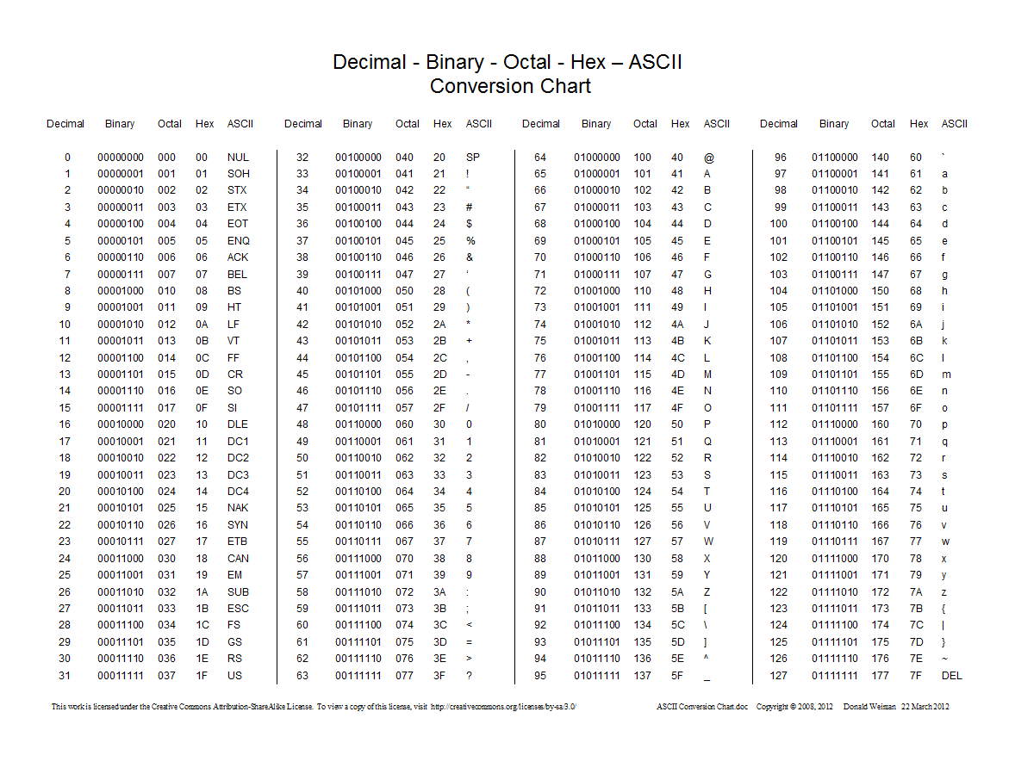

→ Complexidade assintótica

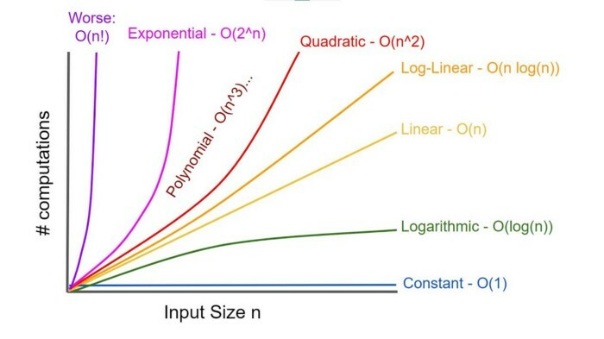
→ C data sizes:

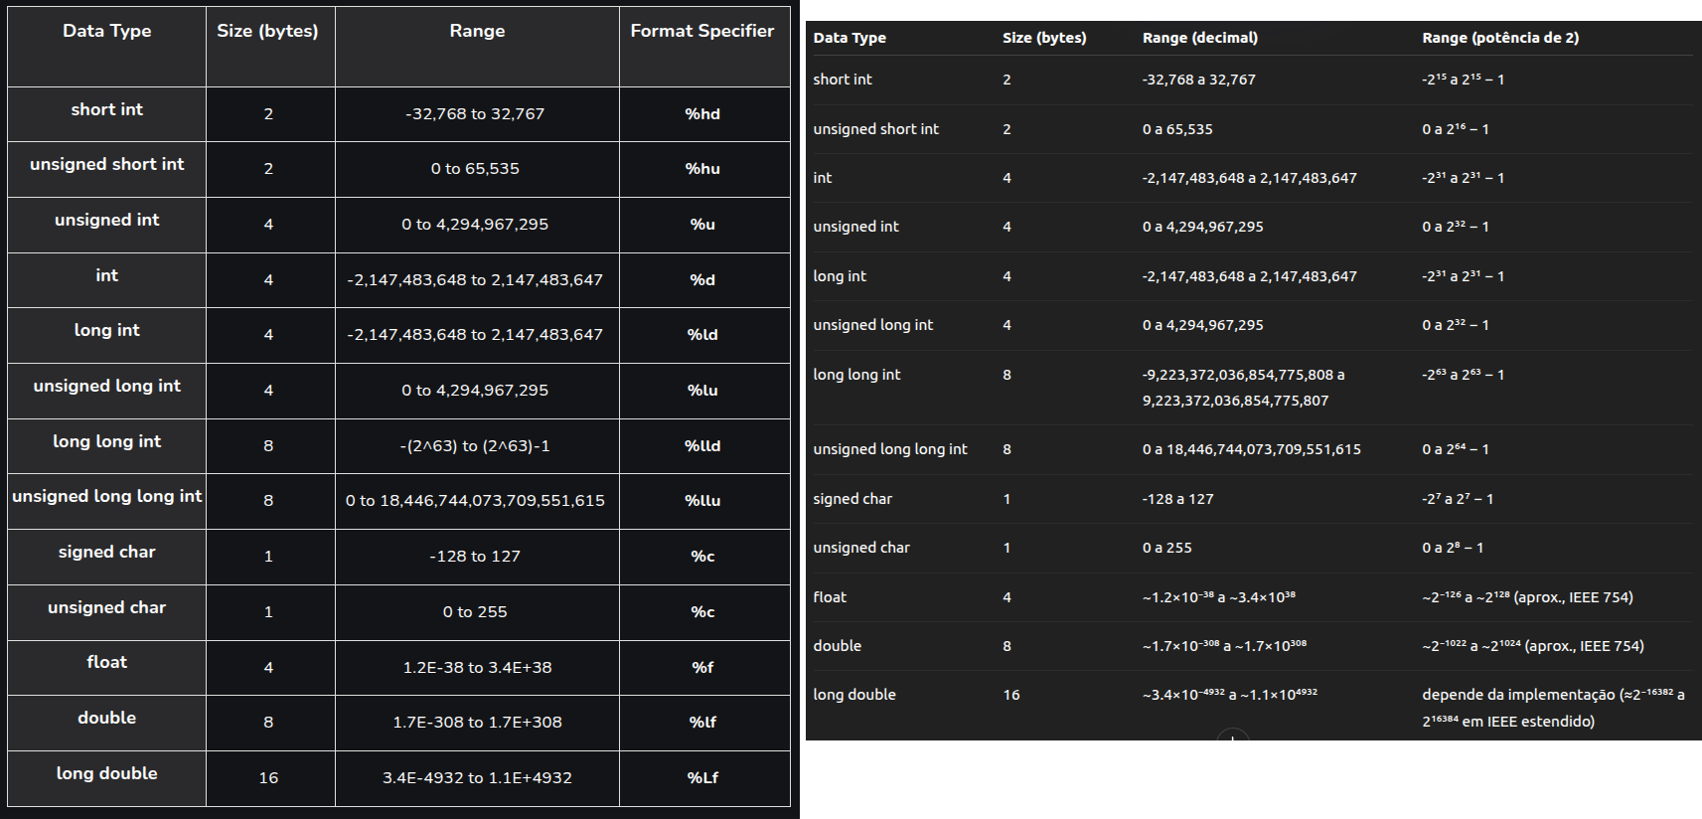

→ Tabela – operadores lógicos
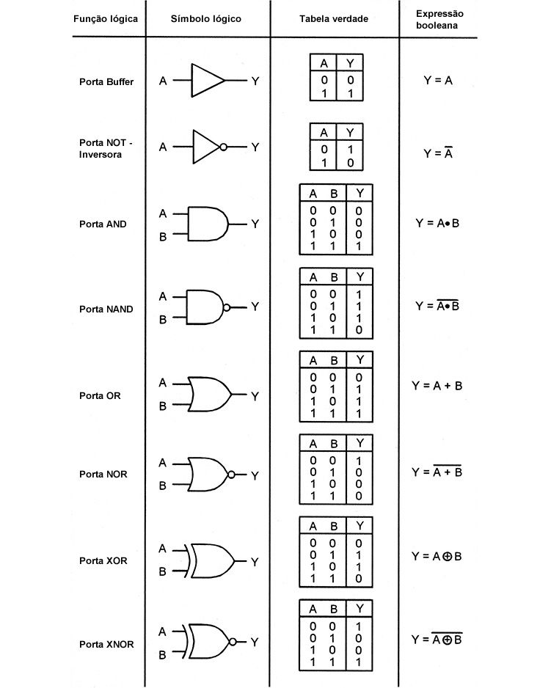

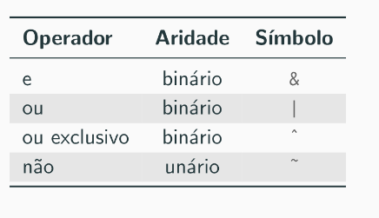

→ STRINGS:
→ HISTOGRAMA (STRING)
#include <iostream>
#include <string>
#include <map>
//#include <bits/stdc++.h>

using namespace std;

map<char, int> hist(const string& s);

int main(int argc, char* argv[2]){
/*if(argc != 2){
cout << "Erro! Compile assim: $ ./histograma s" << endl;
exit(1);
}*/

//string s = argv[1];
string s = "c a s a";
cout << s << endl;
map<char, int> h = hist(s);
for(const auto& c : h)
cout << c.first << ":" << c.second << endl;

return 0;
}

map<char, int> hist(const string& s){
map<char, int> h;

for(auto c : s)
++h[c];

return h;
}

→ HISTOGRAMA (INT)
#include <iostream>
#include <map>
#include <vector>

using namespace std;

int main(){
map<int, int> hist;
vector<int> xs;

for(int i=0; i<5; i++){
int x;
cin >> x;
xs.push_back(x);
}

for(size_t i=0; i<xs.size(); i++){
hist[xs[i]]++;
}

for(const auto &e : hist)
cout << e.first << ":" << e.second << endl;

cout << endl;
return 0;
}

→ DINAMIC PROGRAMING (DP):
→ FIBONACCI TOP DOWN
#include <bits/stdc++.h>

using namespace std;

constexpr int MAX { 200'010 };

int st[MAX];

int F(int N)
{
if (N == 0 or N == 1)
return N;

if (st[N] != -1)
return st[N];

st[N] = F(N - 1) + F(N - 2);

return st[N];
}

int main()
{
ios::sync_with_stdio(false);
memset(st, -1, sizeof st);

int N;
cin >> N;

cout << F(N) << endl;

return 0;
}

→ BINOMIO DE NEWTON TP1
#include <bits/stdc++.h>

using namespace std;
constexpr int MAX { 1'010 };

long long st[MAX][MAX];

long long binom(int n, int m)
{
if (m > n) return 0;

if (m == 0 or m == n) return 1;

if (st[n][m] != -1)
return st[n][m];

st[n][m] = binom(n - 1, m) + binom(n - 1, m - 1);

return st[n][m];
}

int main()
{
int n, m;
cin >> n >> m;

memset(st, -1, sizeof st);

cout << "binom(" << n << "," << m << ") = " << binom(n, m) << endl;

return 0;
}

→ BINOMIO DE NEWTON TP2
#include <bits/stdc++.h>

using namespace std;

constexpr int MAX { 1'010 };
constexpr long long MOD { 1'000'000'007 };

long long st[2*MAX][MAX];

long long binom(int n, int m)
{
if (m > n or m < 0)
return 0;

if (m > n - m)
m = n - m;

if (m == 0 or m == n)
return 1;

if (st[n][m] != -1)
return st[n][m];

auto res = (binom(n - 1, m) + binom(n - 1, m - 1)) % MOD;

st[n][m] = res;
return res;
}

int main()
{
int n, m;
cin >> n >> m;

memset(st, -1, sizeof st);

cout << "binom(" << n << "," << m << ") = " << binom(n, m) << endl;

return 0;
}

→ ILYA AND QUERIES
#include <iostream>
#include <vector>
#include <string>

using namespace std;

int main(){
string s;
int m;

cin >> s >> m;

vector<int> ps(s.size()+1, 0);

for(size_t i=1; i<s.size(); i++)
ps[i+1] = ps[i] + (s.at(i) == s.at(i-1));

while(m--){
int l, r;
cin >> l >> r;
cout << ps.at(r) - ps.at(l) << endl;
}

cout << endl;
return 0;
}

→ MAX RANGE SUM COMPLETE SEARCH
#include <bits/stdc++.h>

using namespace std;

long long oo { 1LL << 62 };

long long MRS(const vector<int>& as)
{
auto N = as.size();
long long ans = -oo;

for (size_t i = 0; i < N; ++i)
{
for (size_t j = i; j < N; ++j)
{
long long sum = 0;

for (size_t k = i; k <= j; ++k)
sum += as[k];

ans = max(ans, sum);
}
}

return ans;
}

int main()
{
int N;
cin >> N;

vector<int> as(N);

for (int i = 0; i < N; ++i)
cin >> as[i];

auto ans = MRS(as);

cout << ans << '\n';

return 0;
}

→ KADANE
#include <bits/stdc++.h>

using namespace std;

int kadane(const vector<int>& as)
{
vector<int> s(as.size());
s[0] = as[0];

for (size_t i = 1; i < as.size(); ++i)
s[i] = max(as[i], s[i - 1] + as[i]);

return *max_element(s.begin(), s.end());
}

int main()
{
int N;
cin >> N;

vector<int> as(N);

for (int i = 0; i < N; ++i)
cin >> as[i];

auto ans = kadane(as);

cout << ans << '\n';

return 0;
}

→ KADANE 2 - “GULOSA”
#include <bits/stdc++.h>

using namespace std;

int kadane(const vector<int>& as)
{
int ans = as[0], sum = ans;

for (size_t i = 1; i < as.size(); ++i)
{
if (sum < 0)
sum = 0;

sum += as[i];
ans = max(ans, sum);
}

return ans;
}

int main()
{
int N;
cin >> N;

vector<int> as(N);

for (int i = 0; i < N; ++i)
cin >> as[i];

auto ans = kadane(as);

cout << ans << '\n';

return 0;
}

→ COIN CHANGE
#include <bits/stdc++.h>

using namespace std;

const int MAX { 1'010'000 }, oo { 1'000'000'010 };
int st[MAX];

int coin_change(int m, const vector<int>& cs)
{
if (m == 0)
return 0;

if (st[m] != -1)
return st[m];

auto res = oo;

for (auto c : cs)
if (c <= m)
res = min(res, coin_change(m - c, cs) + 1);

st[m] = res;
return res;
}

int main()
{
memset(st, -1, sizeof st);

int N, M;
cin >> N >> M;

vector<int> cs(N);

for (int i = 0; i < N; ++i)
cin >> cs[i];

cout << coin_change(M, cs) << '\n';

return 0;
}

→ COIN CHANGE – GULOSO
#include <bits/stdc++.h>

using namespace std;

vector<int> coin_change(int M, const vector<int>& cs)
{
int N = (int) cs.size();
vector<int> xs(N);

for (int i = N - 1; i >= 0; --i)
{
xs[i] = M / cs[i];
M -= (xs[i] * cs[i]);
}

return xs;
}

int main()
{
vector<int> cs { 1, 2, 5, 10, 25, 50 };
int M;

cin >> M;

auto xs = coin_change(M, cs);

for (size_t i = 0; i < cs.size(); ++i)
cout << cs[i] << ": " << xs[i] << '\n';

cout << accumulate(xs.begin(), xs.end(), 0) << " moedas\n";

return 0;
}

