[COMPANY LOGO]

Application Intelligence Report

Comprehensive Analysis and Migration Assessment

Repository: https://github.com/end-of-game/openshift-voting-app

Analysis Date: July 17, 2025

*Generated by Application Intelligence Platform*

Table of Contents

Executive Summary........................................... 3

Application Overview........................................ 4

Component Analysis.......................................... 5

Architecture Assessment..................................... 8

Security Analysis........................................... 10

Git History Analysis........................................ 12

Recommendations............................................. 13

Appendices.................................................. 15

Executive Summary

|  |  |
| --- | --- |
| **Metric** | **Value** |
| Total Components | 8 |
| Programming Languages | java, nodejs, python |
| Containerization Status | 5 containerized |
| Data Sources | 2 |
| Security Findings | 0 |
| Git Commits | 1 |
| Architecture Style | microservices |

Application Overview

This report presents a comprehensive analysis of the application repository. The analysis identified 8 components using 3 different programming languages. The application demonstrates a microservices architecture pattern.

Key Findings

• 📦 8 application components identified

• 🔧 3 programming languages detected: java, nodejs, python

• 🐳 5 components are containerized

• 💾 2 data sources identified

• 🔒 0 security findings require attention

Detailed Analysis

Component Analysis

The analysis identified 8 components across the application:

|  |  |  |  |
| --- | --- | --- | --- |
| **Component** | **Language** | **Type** | **Packaging** |
| vote-s2i | python | Unknown | wheel |
| vote | python | Unknown | docker |
| worker-s2i | java | Unknown | jar |
| result | nodejs | Unknown | docker |
| result-s2i | nodejs | Unknown | npm |
| redis-ephemeral | unknown | Unknown | docker |
| worker | java | Unknown | docker |
| postgresql-ephemeral | unknown | Unknown | docker |

Component: vote-s2i

• Language: python

• Runtime: python

• Build Tool: unknown

• Packaging: wheel

Component: vote

• Language: python

• Runtime: python

• Build Tool: unknown

• Packaging: docker

• Exposed Ports: 8080

• Base Images: python:3.9-slim

Component: worker-s2i

• Language: java

• Runtime: java

• Build Tool: unknown

• Packaging: jar

Component: result

• Language: nodejs

• Runtime: nodejs

• Build Tool: unknown

• Packaging: docker

• Exposed Ports: 8080

• Base Images: node:10-slim

Component: result-s2i

• Language: nodejs

• Runtime: nodejs

• Build Tool: unknown

• Packaging: npm

Component: redis-ephemeral

• Language: unknown

• Runtime: unknown

• Build Tool: unknown

• Packaging: docker

Component: worker

• Language: java

• Runtime: java

• Build Tool: unknown

• Packaging: docker

• Base Images: maven:3.5-jdk-8-alpine, openjdk:8-jre

**Notes:**

• Multiple base images detected: maven:3.5-jdk-8-alpine, openjdk:8-jre. This may indicate multi-stage builds or alternative build strategies.

Component: postgresql-ephemeral

• Language: unknown

• Runtime: unknown

• Build Tool: unknown

• Packaging: docker

Architecture Analysis

Architecture Style: microservices (Confidence: ConfidenceLevel.HIGH)

Reasoning: Multiple components with independent deployment characteristics

**Evidence:**

• Found 8 components

• Multiple deployable components detected

• 5 containerized components

• Multiple deployment configurations

Security Analysis

Security analysis identified 25 findings with 3 base image risks.

**Key Security Findings:**

• Unknown: Pattern detected: eval\( (Severity: CRITICAL)

• Unknown: Pattern detected: eval\( (Severity: CRITICAL)

• Unknown: Pattern detected: eval\( (Severity: CRITICAL)

• Unknown: Pattern detected: eval\( (Severity: CRITICAL)

• Unknown: Pattern detected: eval\( (Severity: CRITICAL)

Git History Analysis

• Total Commits: 1

• Active Contributors: 0

• Recent Activity: inactive

• Code Stability: high

Recommendations

🔴 High Priority Recommendations

• 🔒 Security: 25 critical/high severity vulnerabilities found. Prioritize security remediation.

🟢 Low Priority Recommendations

• 🔍 Component Analysis: 2 components have unknown languages. Review build configurations and source code structure.

• 📊 Development Activity: Low recent activity detected. Consider reviewing development processes and team capacity.

• 🐳 Base Images: 3 base images have known risks. Update to more recent versions.

Appendices

Appendix A: Technical Details

This analysis was generated using the Application Intelligence Platform, which performs comprehensive analysis of application repositories including code structure, infrastructure configuration, and security assessment.

Appendix B: Analysis Methodology

• Component Discovery: Automated scanning of source code and configuration files

• Language Detection: Analysis of file extensions, build configurations, and base images

• Architecture Assessment: Evaluation of deployment patterns and component relationships

• Security Analysis: Scanning for common vulnerabilities and configuration issues

• Git History Analysis: Examination of commit patterns and development activity

Charts and Visualizations

Programming Language Distribution

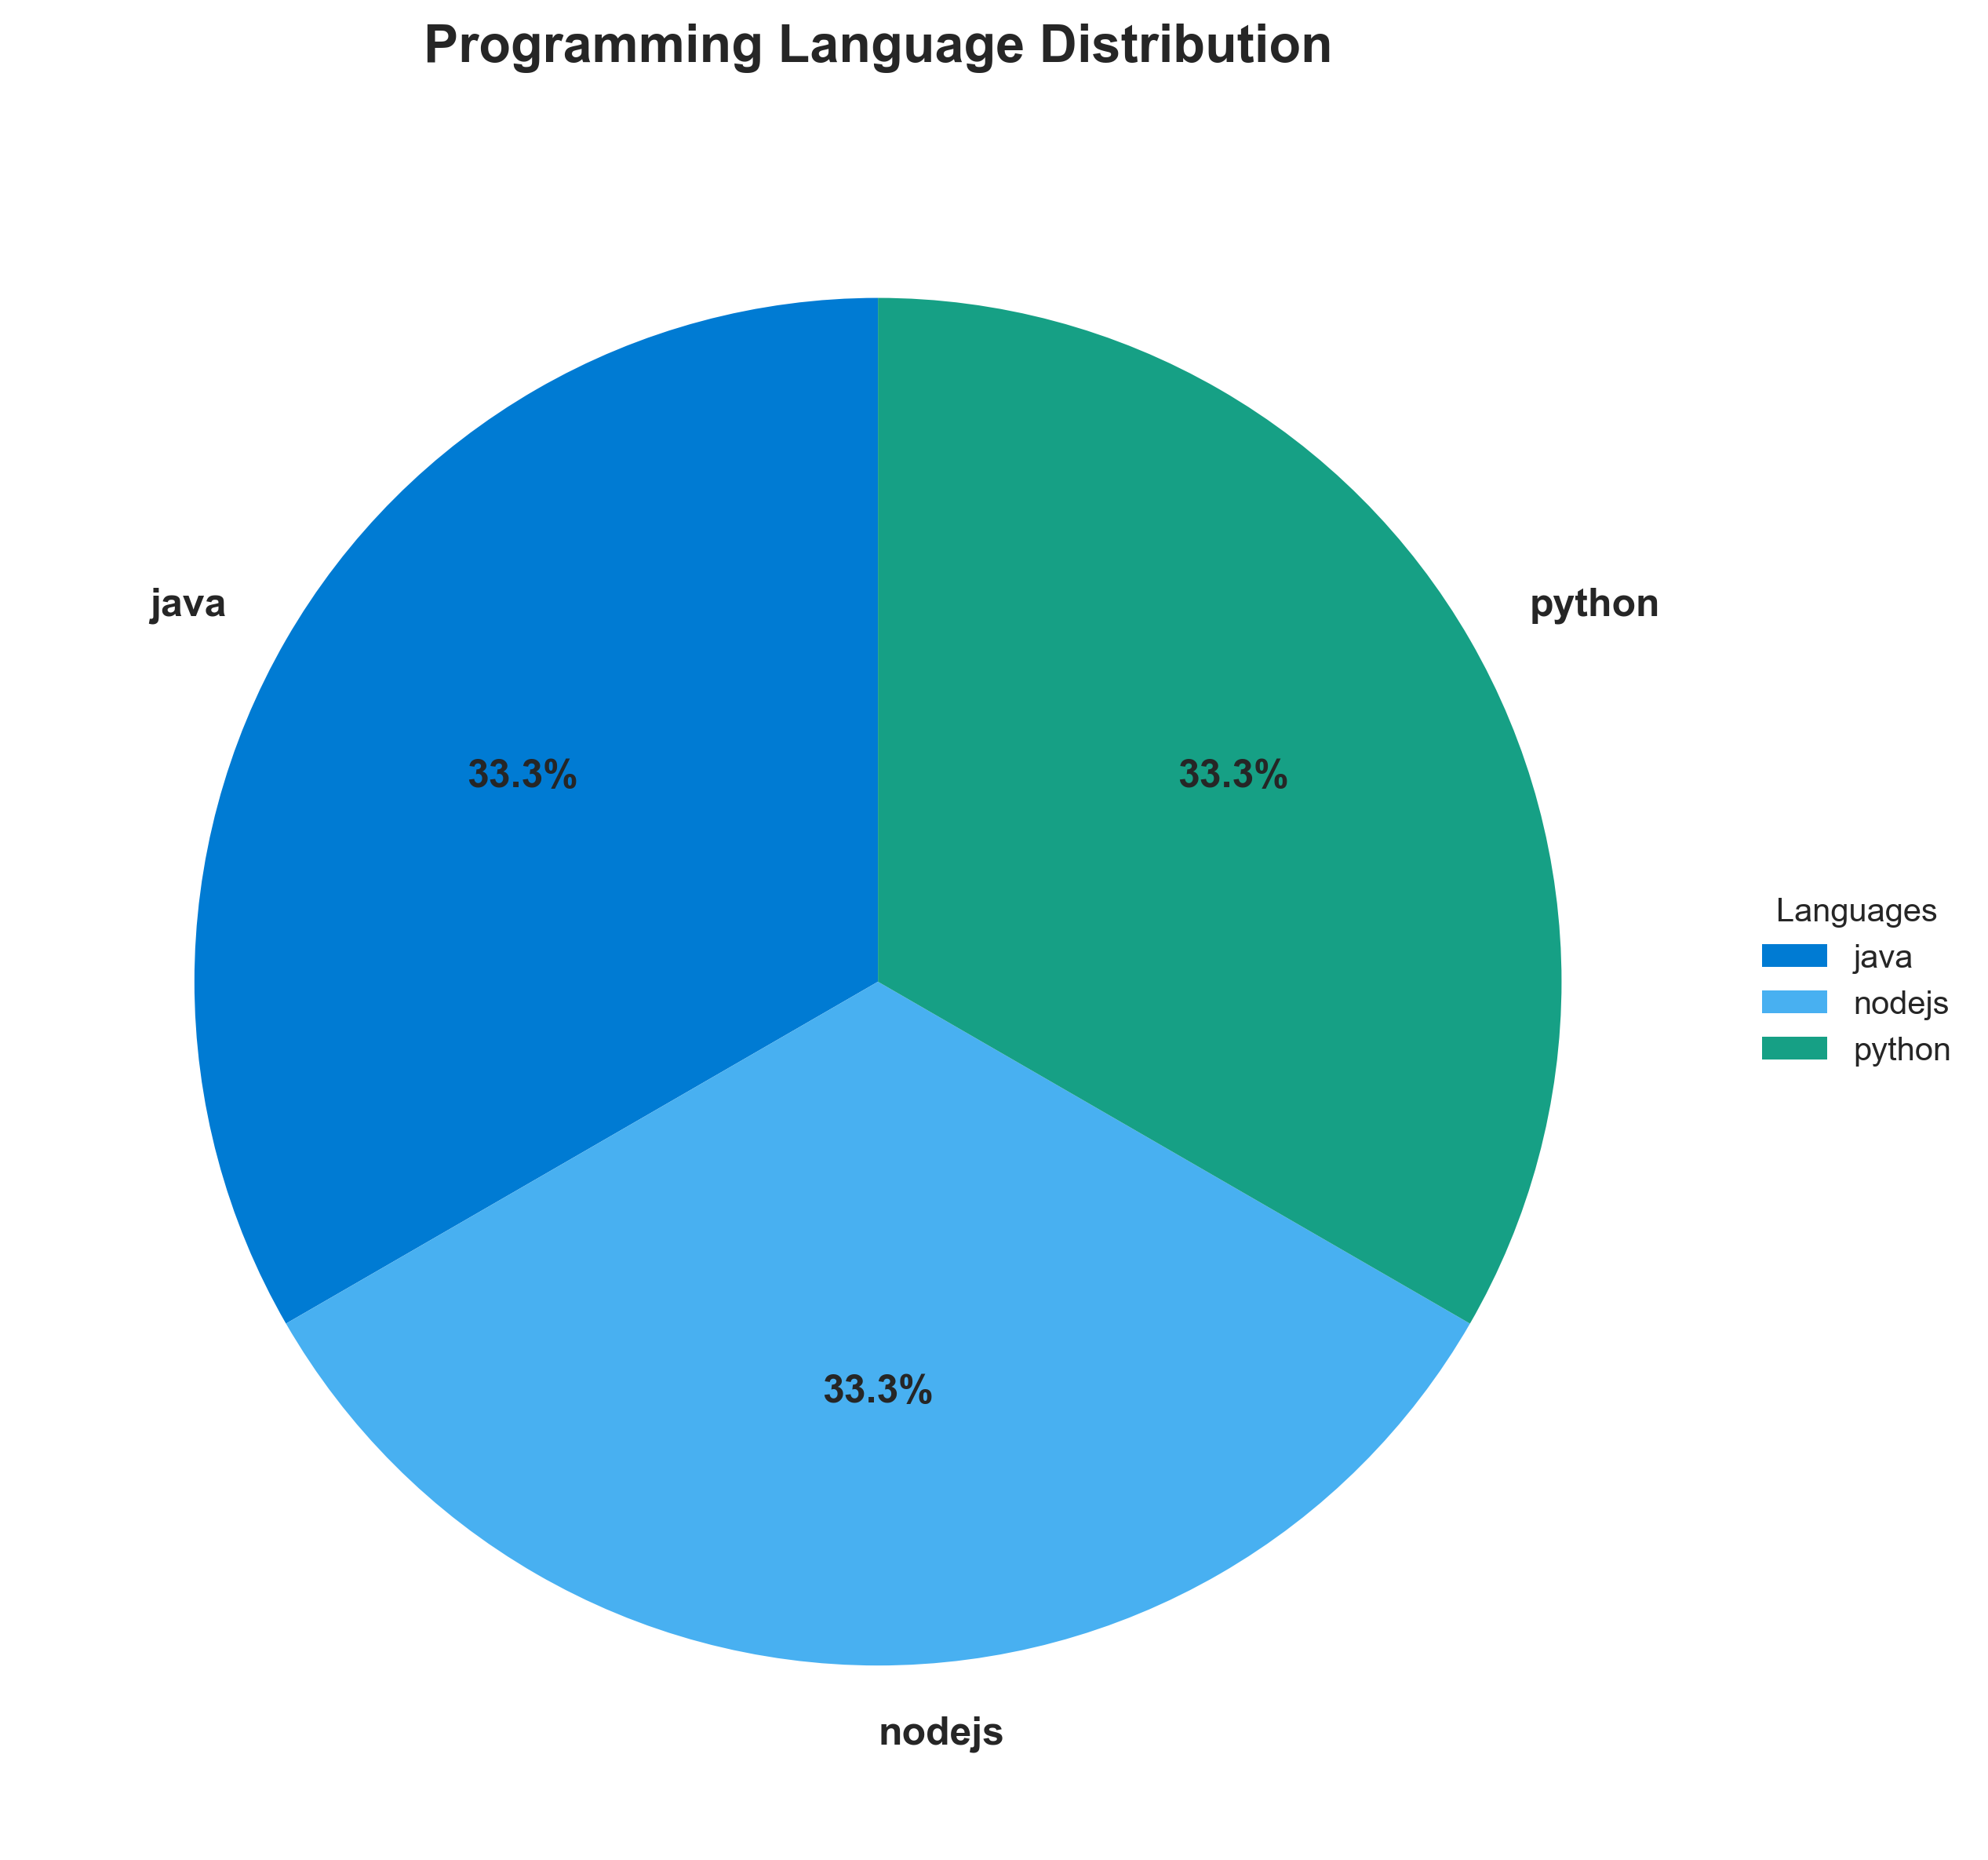

**📊 Context:** This Language Distribution provides visual insights into the application's architecture and operational characteristics.

**📊 Key Insights:** The Language Distribution illustrates key aspects of the application that support technical decision-making and operational planning.

**📊 Business Impact:** Visual representation supports better understanding of system characteristics and aids in strategic planning.

**📊 Recommendations:** Review diagram insights with technical teams to identify optimization opportunities and action items.

**📊 Technical Details:** Diagram type: Language Distribution. Generated from comprehensive application intelligence analysis.

────────────────────────────────────────────────────────────────────────────────

Component Status Overview

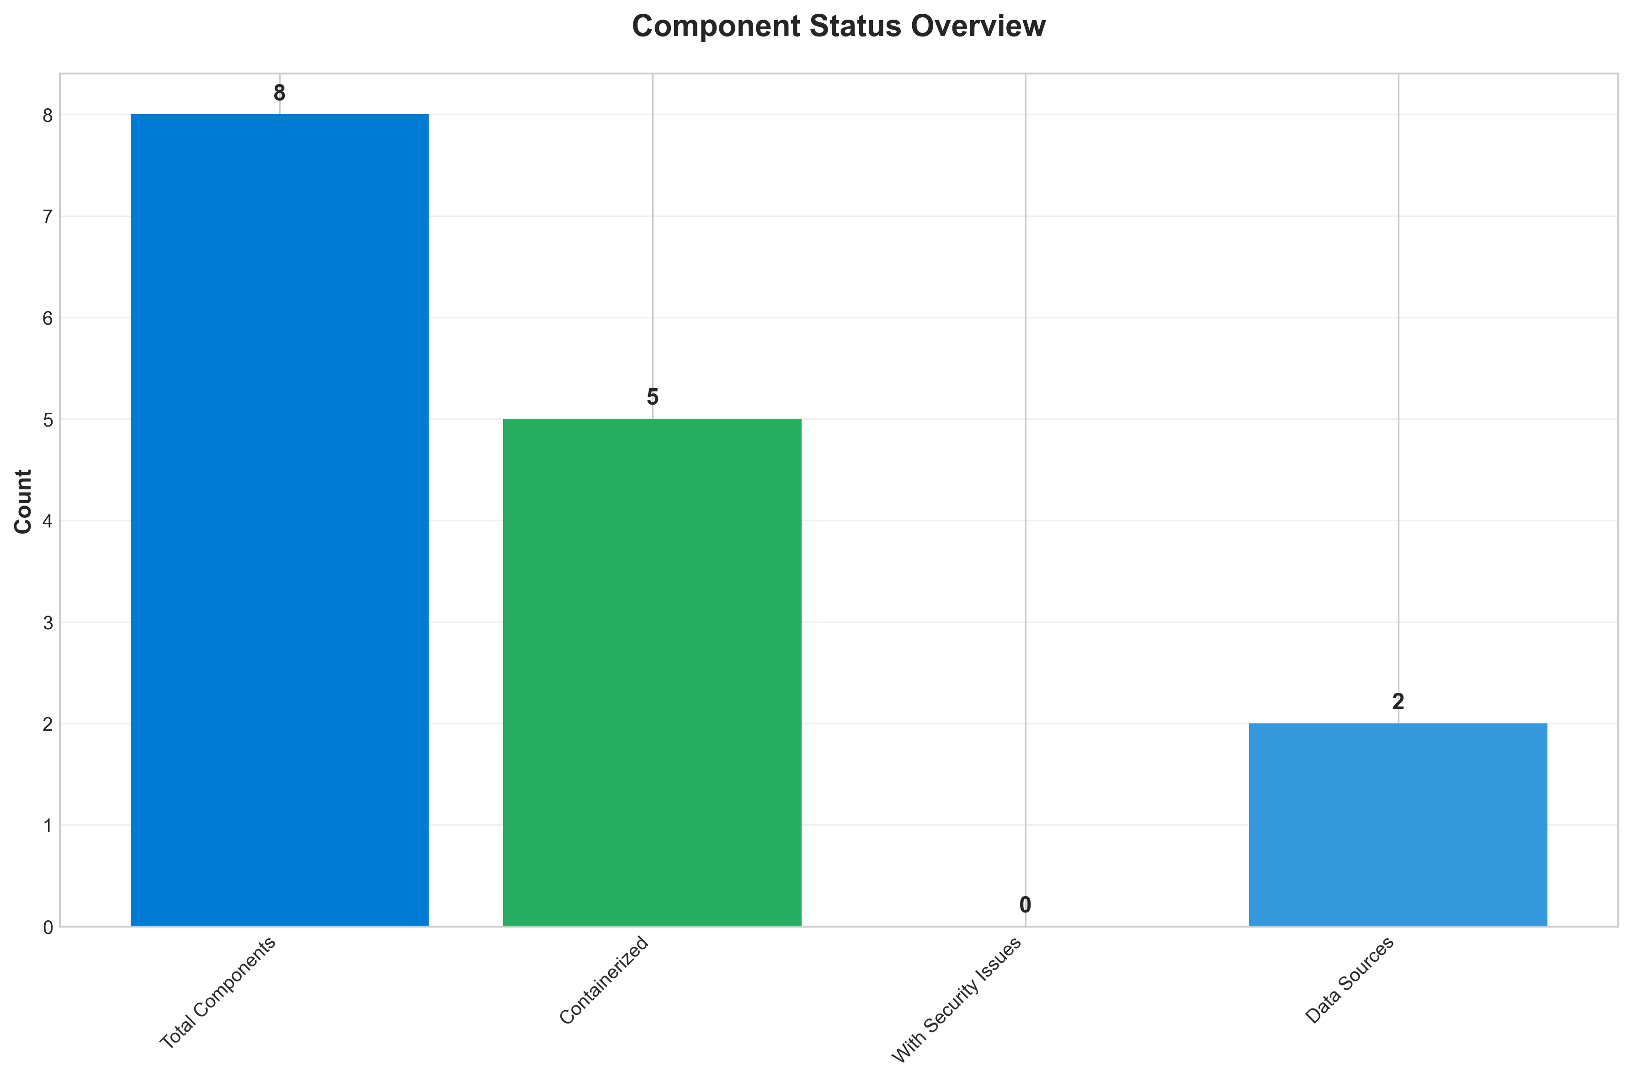

**📊 Context:** This Component Status provides visual insights into the application's architecture and operational characteristics.

**📊 Key Insights:** The Component Status illustrates key aspects of the application that support technical decision-making and operational planning.

**📊 Business Impact:** Visual representation supports better understanding of system characteristics and aids in strategic planning.

**📊 Recommendations:** Review diagram insights with technical teams to identify optimization opportunities and action items.

**📊 Technical Details:** Diagram type: Component Status. Generated from comprehensive application intelligence analysis.

────────────────────────────────────────────────────────────────────────────────

Application Architecture

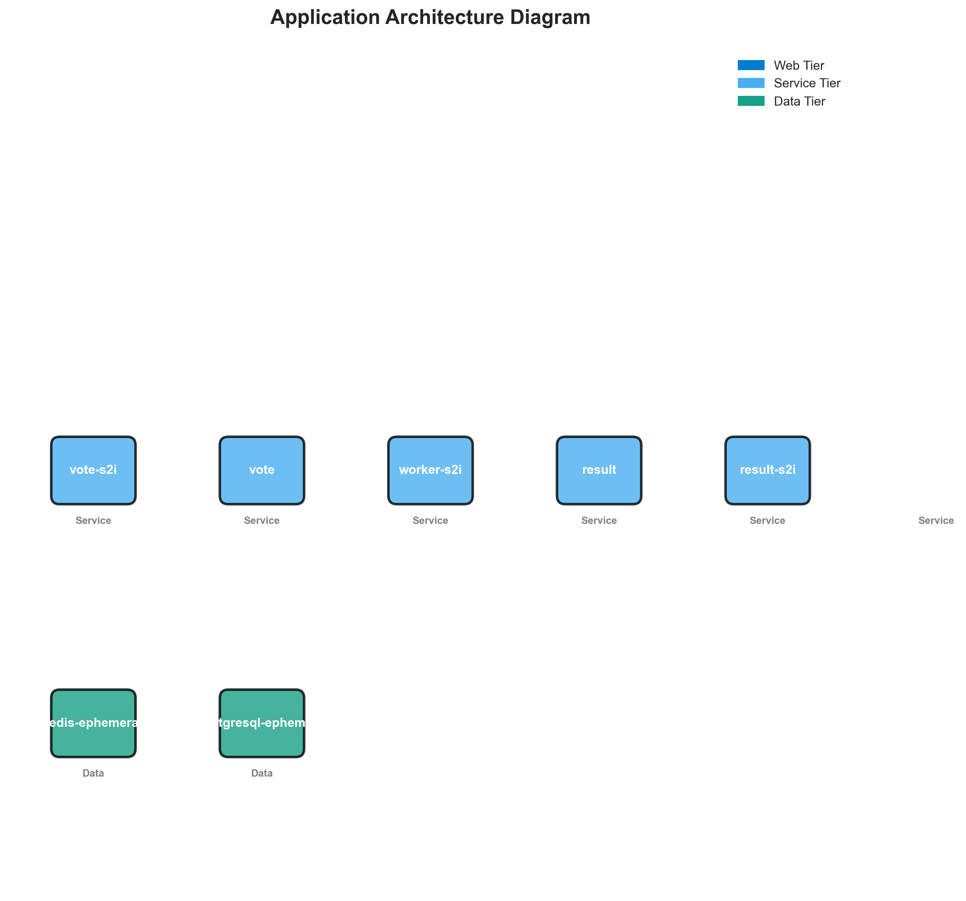

**📊 Context:** This Architecture Diagram provides visual insights into the application's architecture and operational characteristics.

**📊 Key Insights:** The Architecture Diagram illustrates key aspects of the application that support technical decision-making and operational planning.

**📊 Business Impact:** Visual representation supports better understanding of system characteristics and aids in strategic planning.

**📊 Recommendations:** Review diagram insights with technical teams to identify optimization opportunities and action items.

**📊 Technical Details:** Diagram type: Architecture Diagram. Generated from comprehensive application intelligence analysis.

────────────────────────────────────────────────────────────────────────────────

Security Assessment Radar

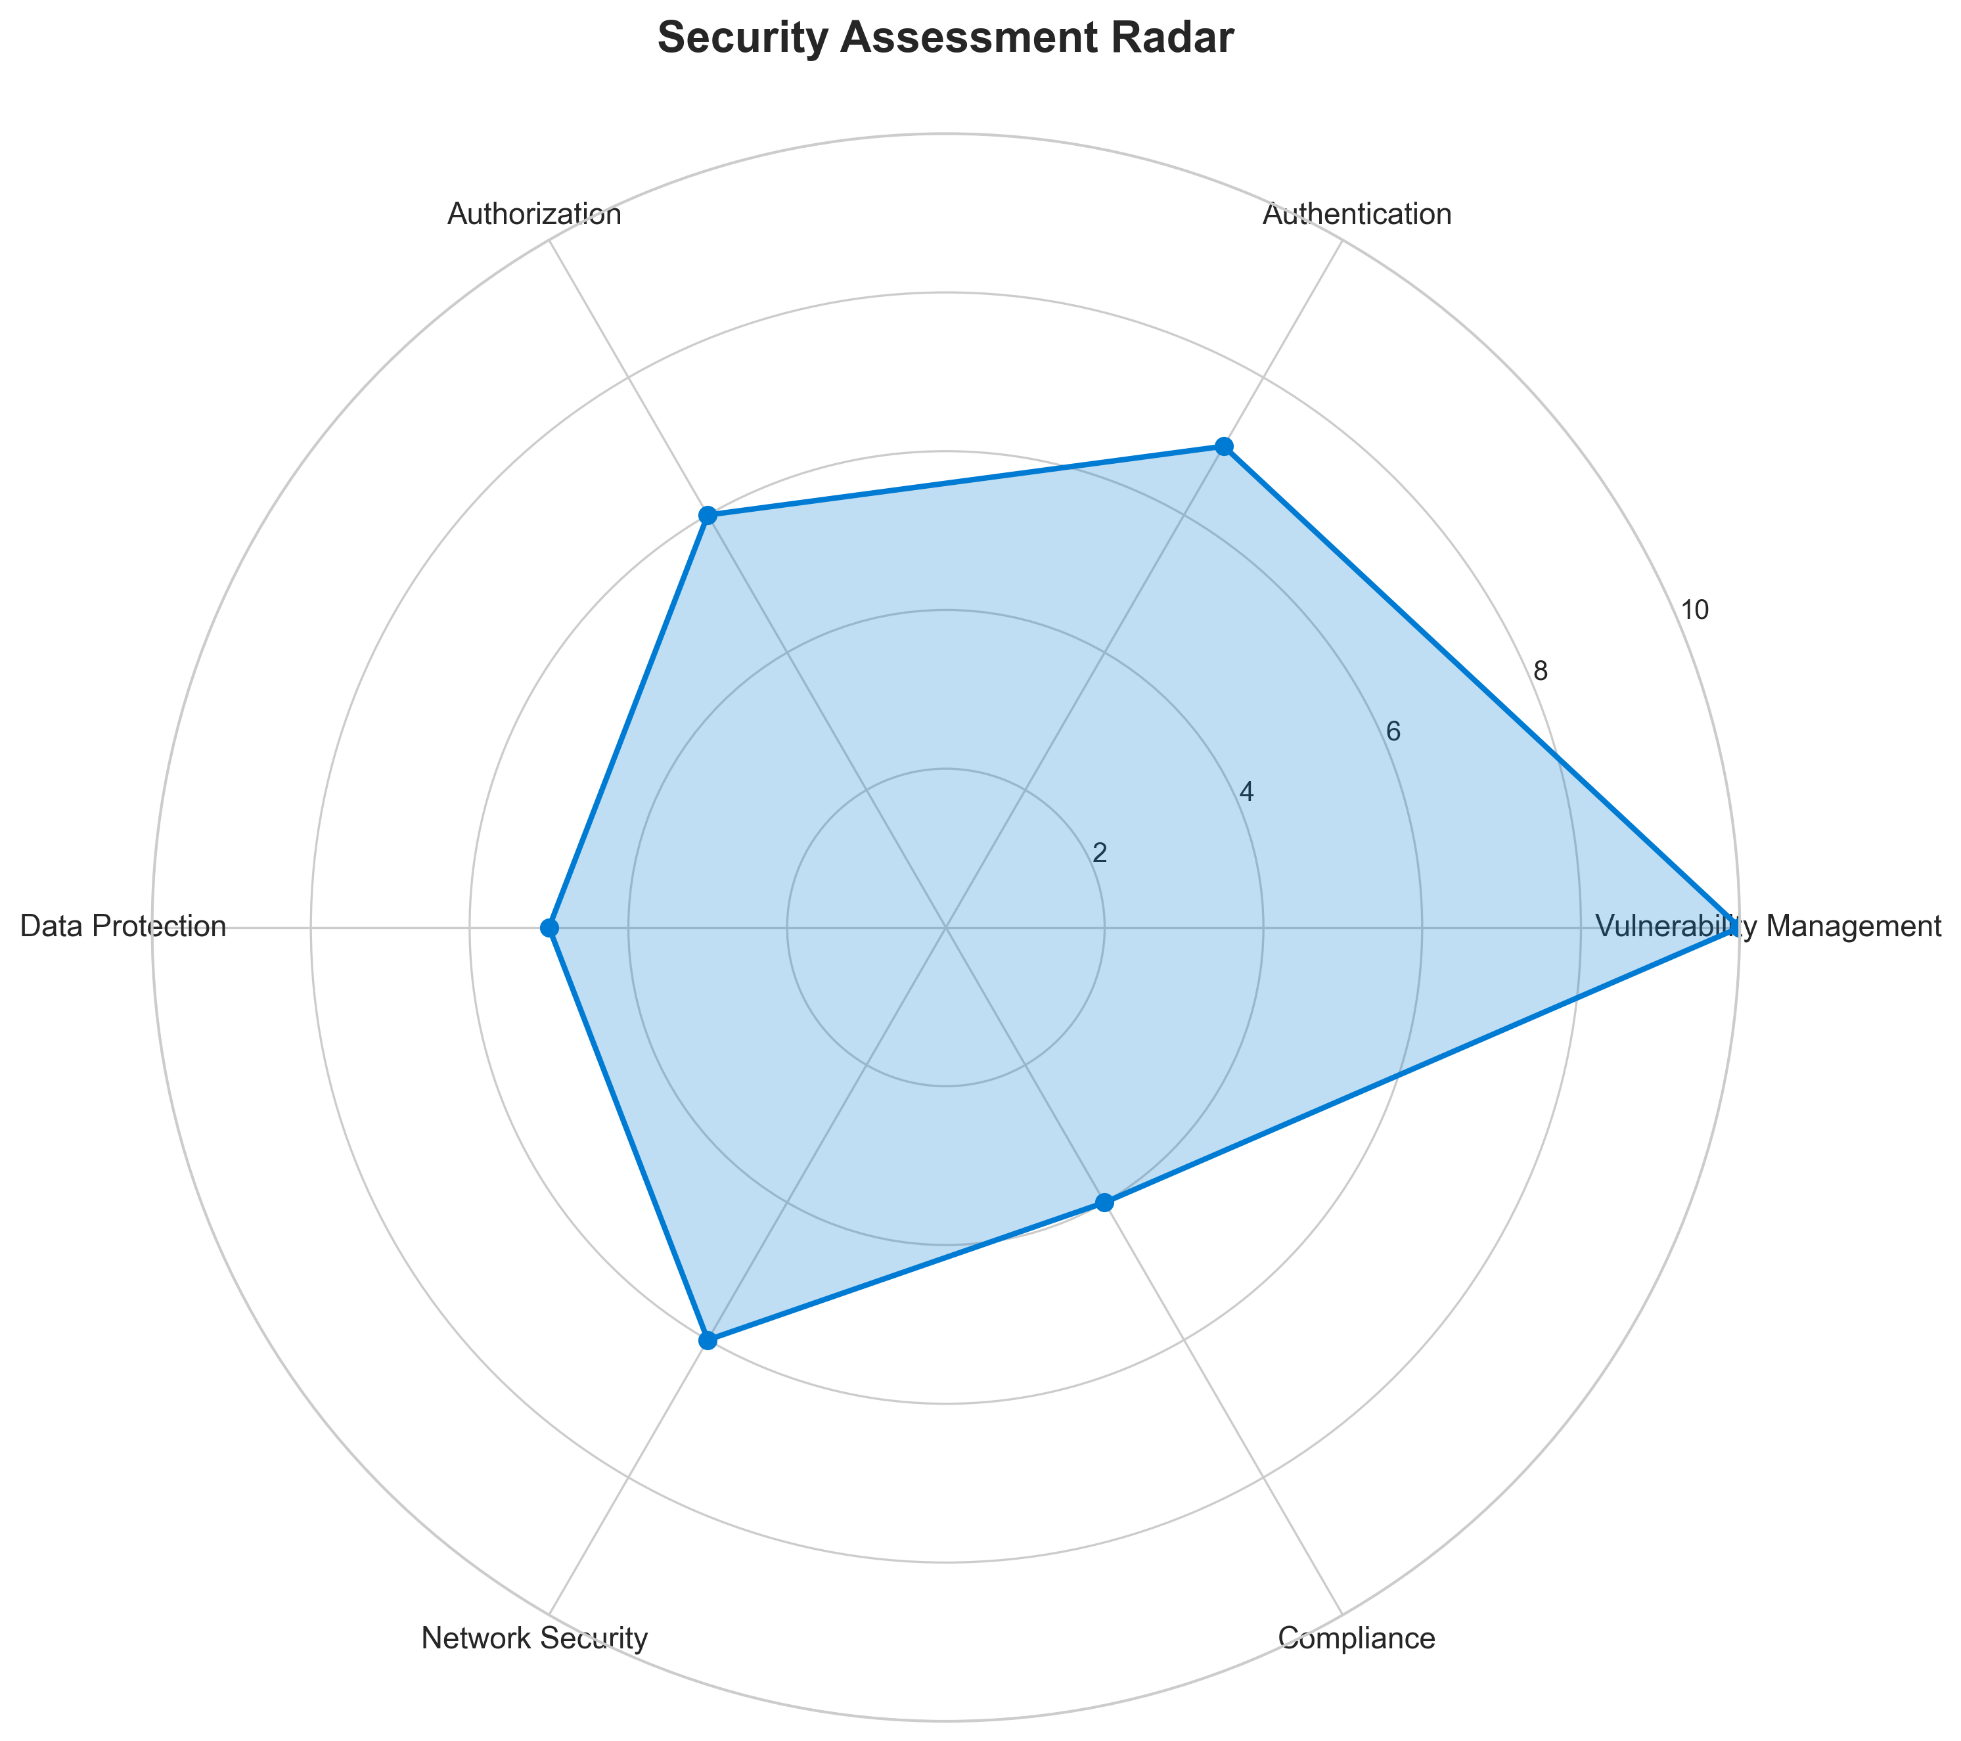

**📊 Context:** This Security Radar provides visual insights into the application's architecture and operational characteristics.

**📊 Key Insights:** The Security Radar illustrates key aspects of the application that support technical decision-making and operational planning.

**📊 Business Impact:** Visual representation supports better understanding of system characteristics and aids in strategic planning.

**📊 Recommendations:** Review diagram insights with technical teams to identify optimization opportunities and action items.

**📊 Technical Details:** Diagram type: Security Radar. Generated from comprehensive application intelligence analysis.

────────────────────────────────────────────────────────────────────────────────

Vulnerability Analysis

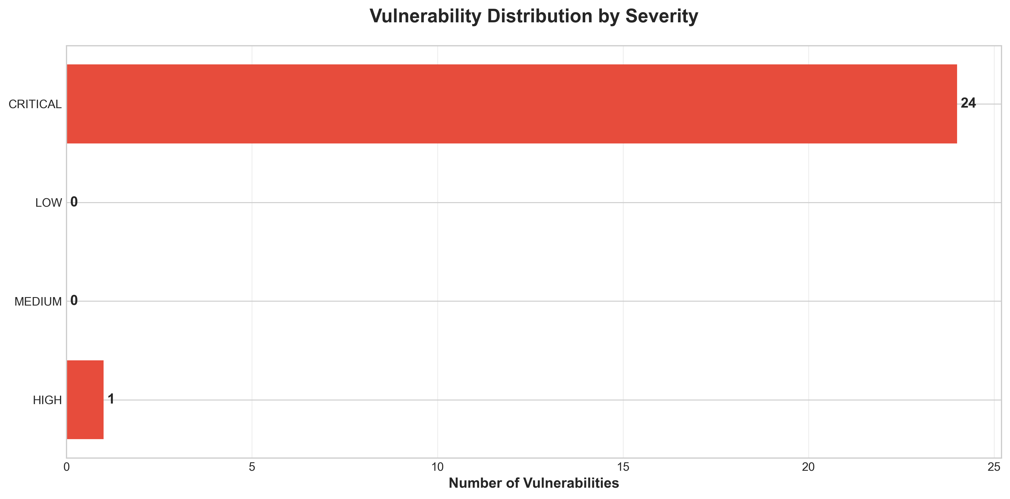

**📊 Context:** This Vulnerability Timeline provides visual insights into the application's architecture and operational characteristics.

**📊 Key Insights:** The Vulnerability Timeline illustrates key aspects of the application that support technical decision-making and operational planning.

**📊 Business Impact:** Visual representation supports better understanding of system characteristics and aids in strategic planning.

**📊 Recommendations:** Review diagram insights with technical teams to identify optimization opportunities and action items.

**📊 Technical Details:** Diagram type: Vulnerability Timeline. Generated from comprehensive application intelligence analysis.

────────────────────────────────────────────────────────────────────────────────

Component Network Topology

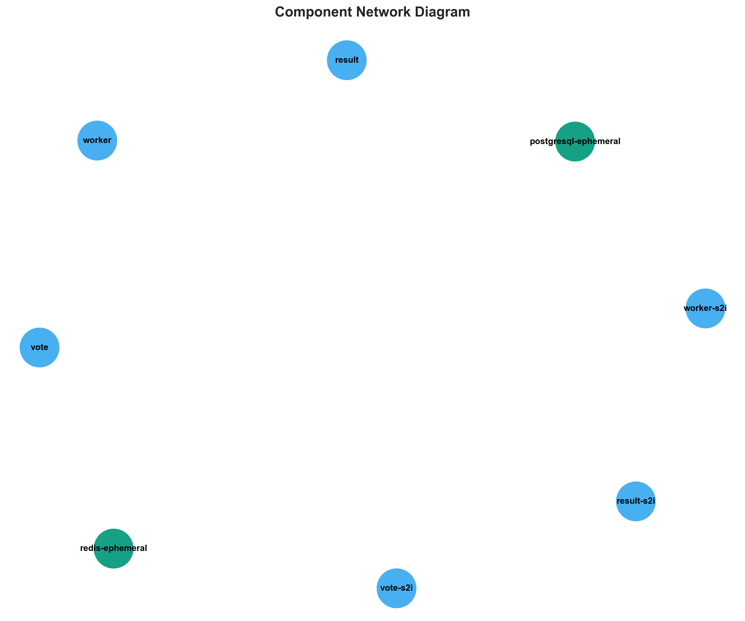

**📊 Context:** This Component Network provides visual insights into the application's architecture and operational characteristics.

**📊 Key Insights:** The Component Network illustrates key aspects of the application that support technical decision-making and operational planning.

**📊 Business Impact:** Visual representation supports better understanding of system characteristics and aids in strategic planning.

**📊 Recommendations:** Review diagram insights with technical teams to identify optimization opportunities and action items.

**📊 Technical Details:** Diagram type: Component Network. Generated from comprehensive application intelligence analysis.

────────────────────────────────────────────────────────────────────────────────

Technology Stack

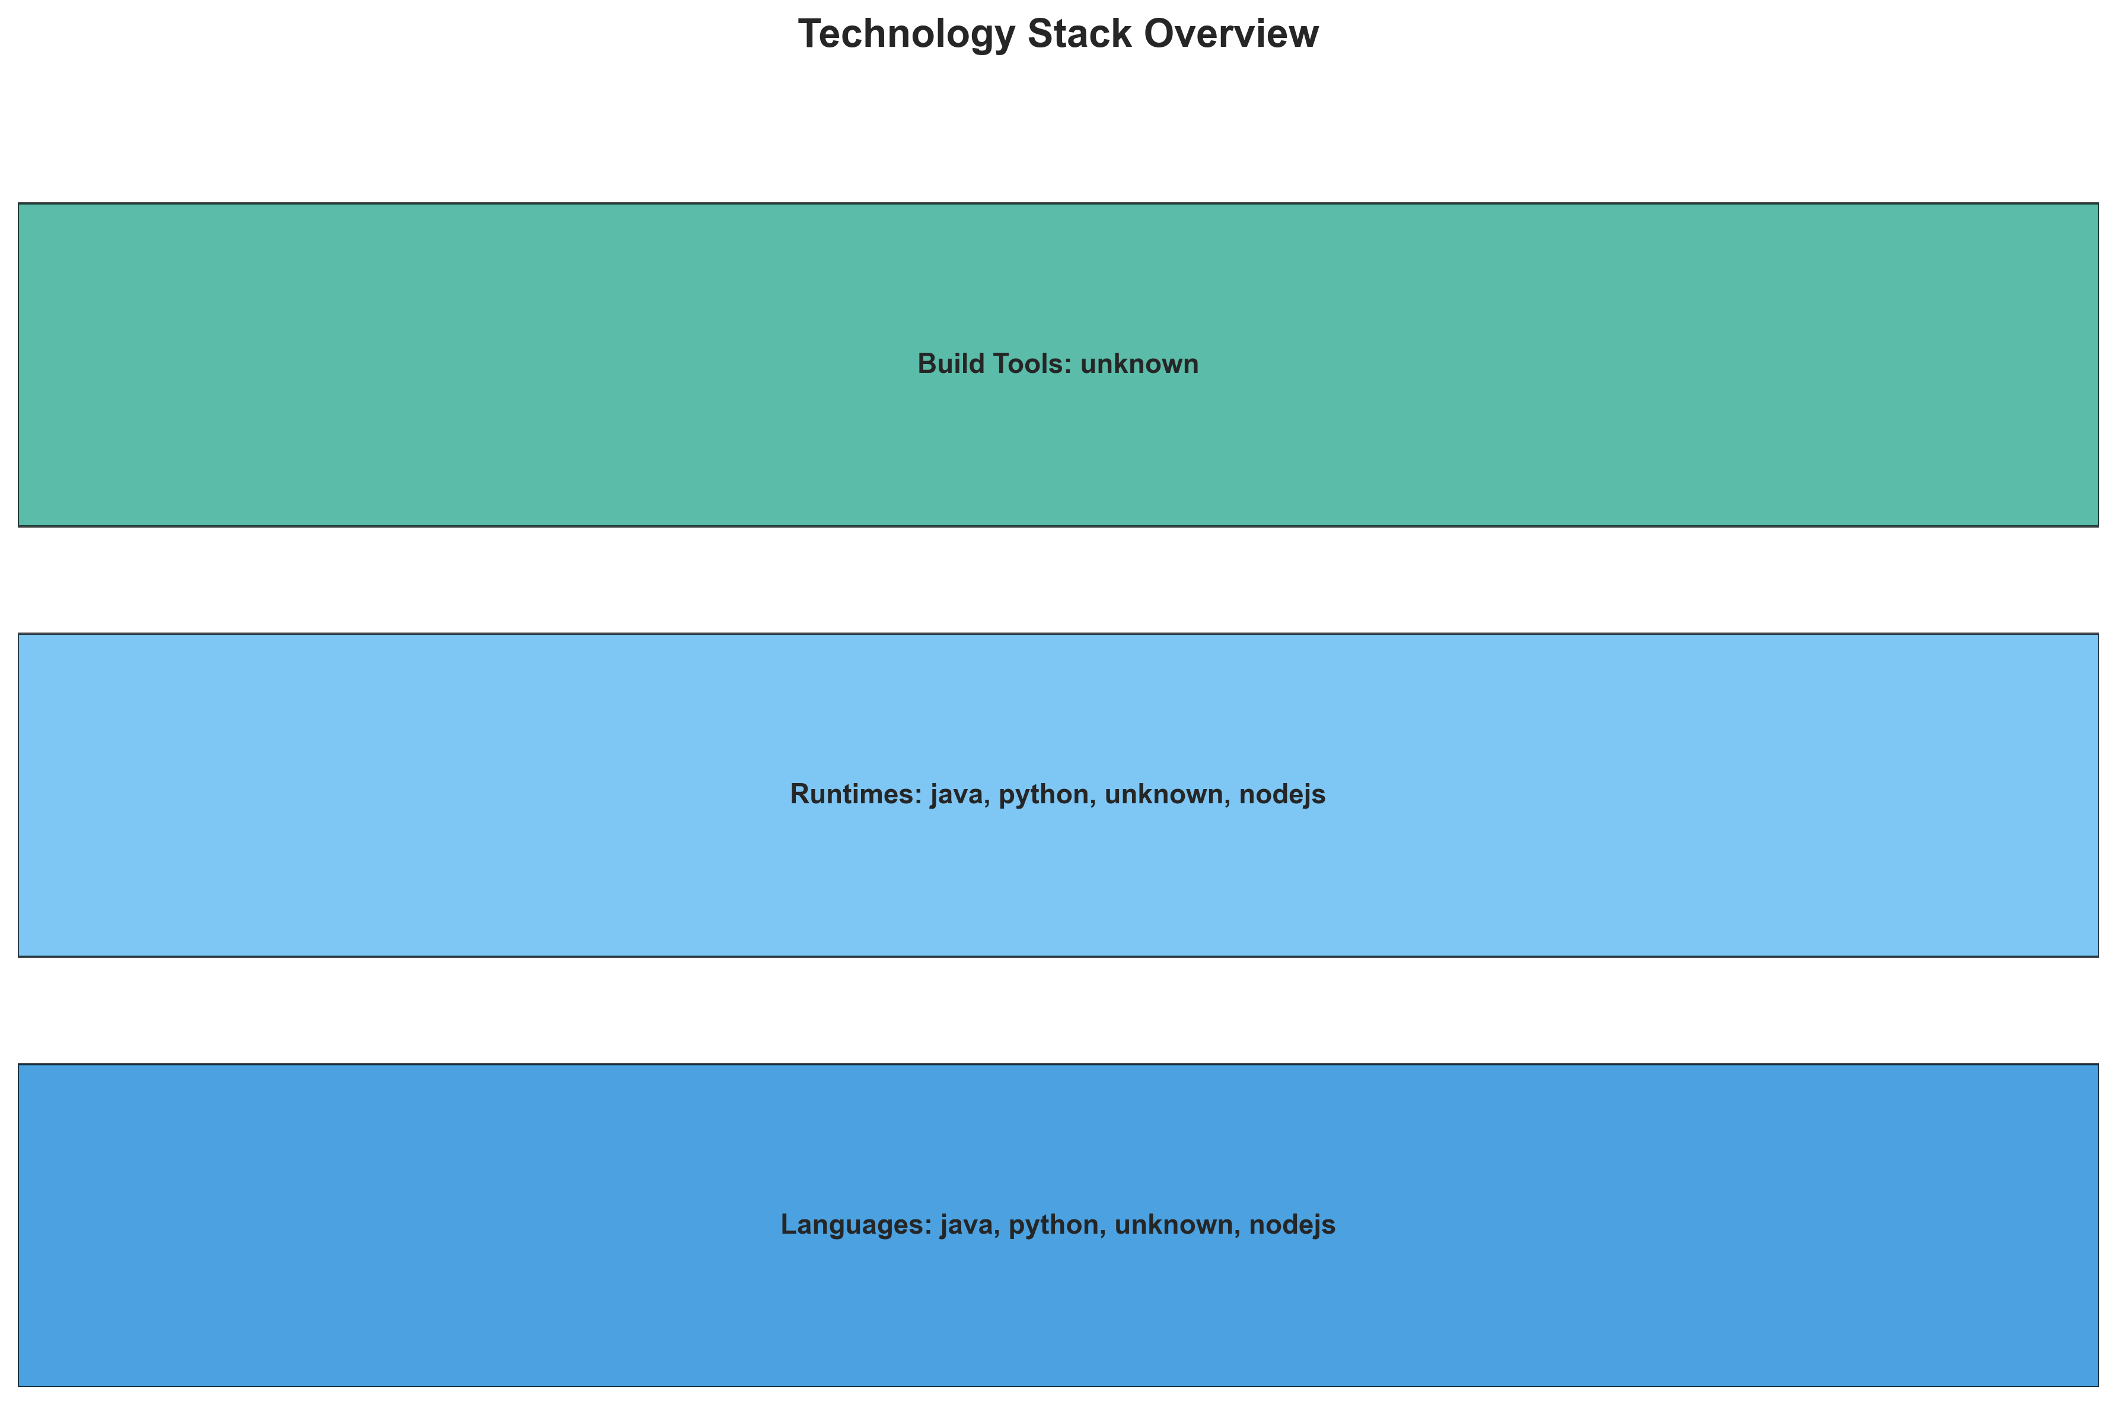

**📊 Context:** This Technology Stack provides visual insights into the application's architecture and operational characteristics.

**📊 Key Insights:** The Technology Stack illustrates key aspects of the application that support technical decision-making and operational planning.

**📊 Business Impact:** Visual representation supports better understanding of system characteristics and aids in strategic planning.

**📊 Recommendations:** Review diagram insights with technical teams to identify optimization opportunities and action items.

**📊 Technical Details:** Diagram type: Technology Stack. Generated from comprehensive application intelligence analysis.

────────────────────────────────────────────────────────────────────────────────

Development Activity Heatmap

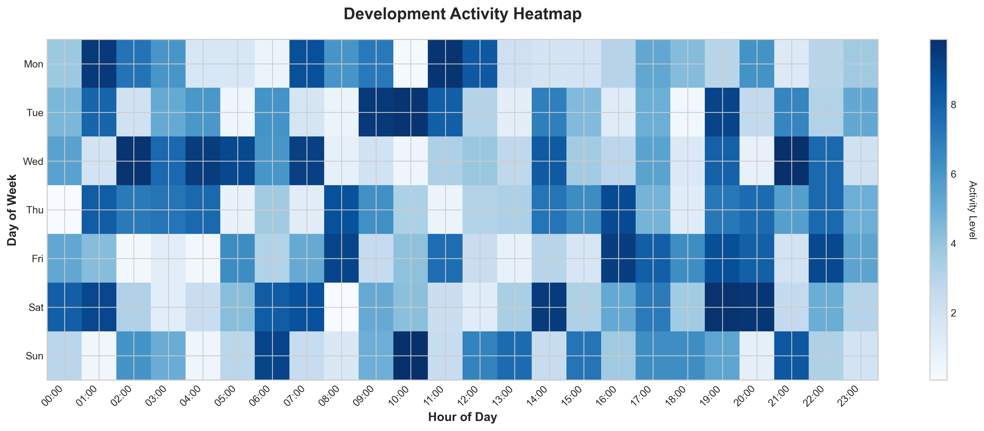

**📊 Context:** This Development Activity provides visual insights into the application's architecture and operational characteristics.

**📊 Key Insights:** The Development Activity illustrates key aspects of the application that support technical decision-making and operational planning.

**📊 Business Impact:** Visual representation supports better understanding of system characteristics and aids in strategic planning.

**📊 Recommendations:** Review diagram insights with technical teams to identify optimization opportunities and action items.

**📊 Technical Details:** Diagram type: Development Activity. Generated from comprehensive application intelligence analysis.

────────────────────────────────────────────────────────────────────────────────

Migration Readiness Assessment

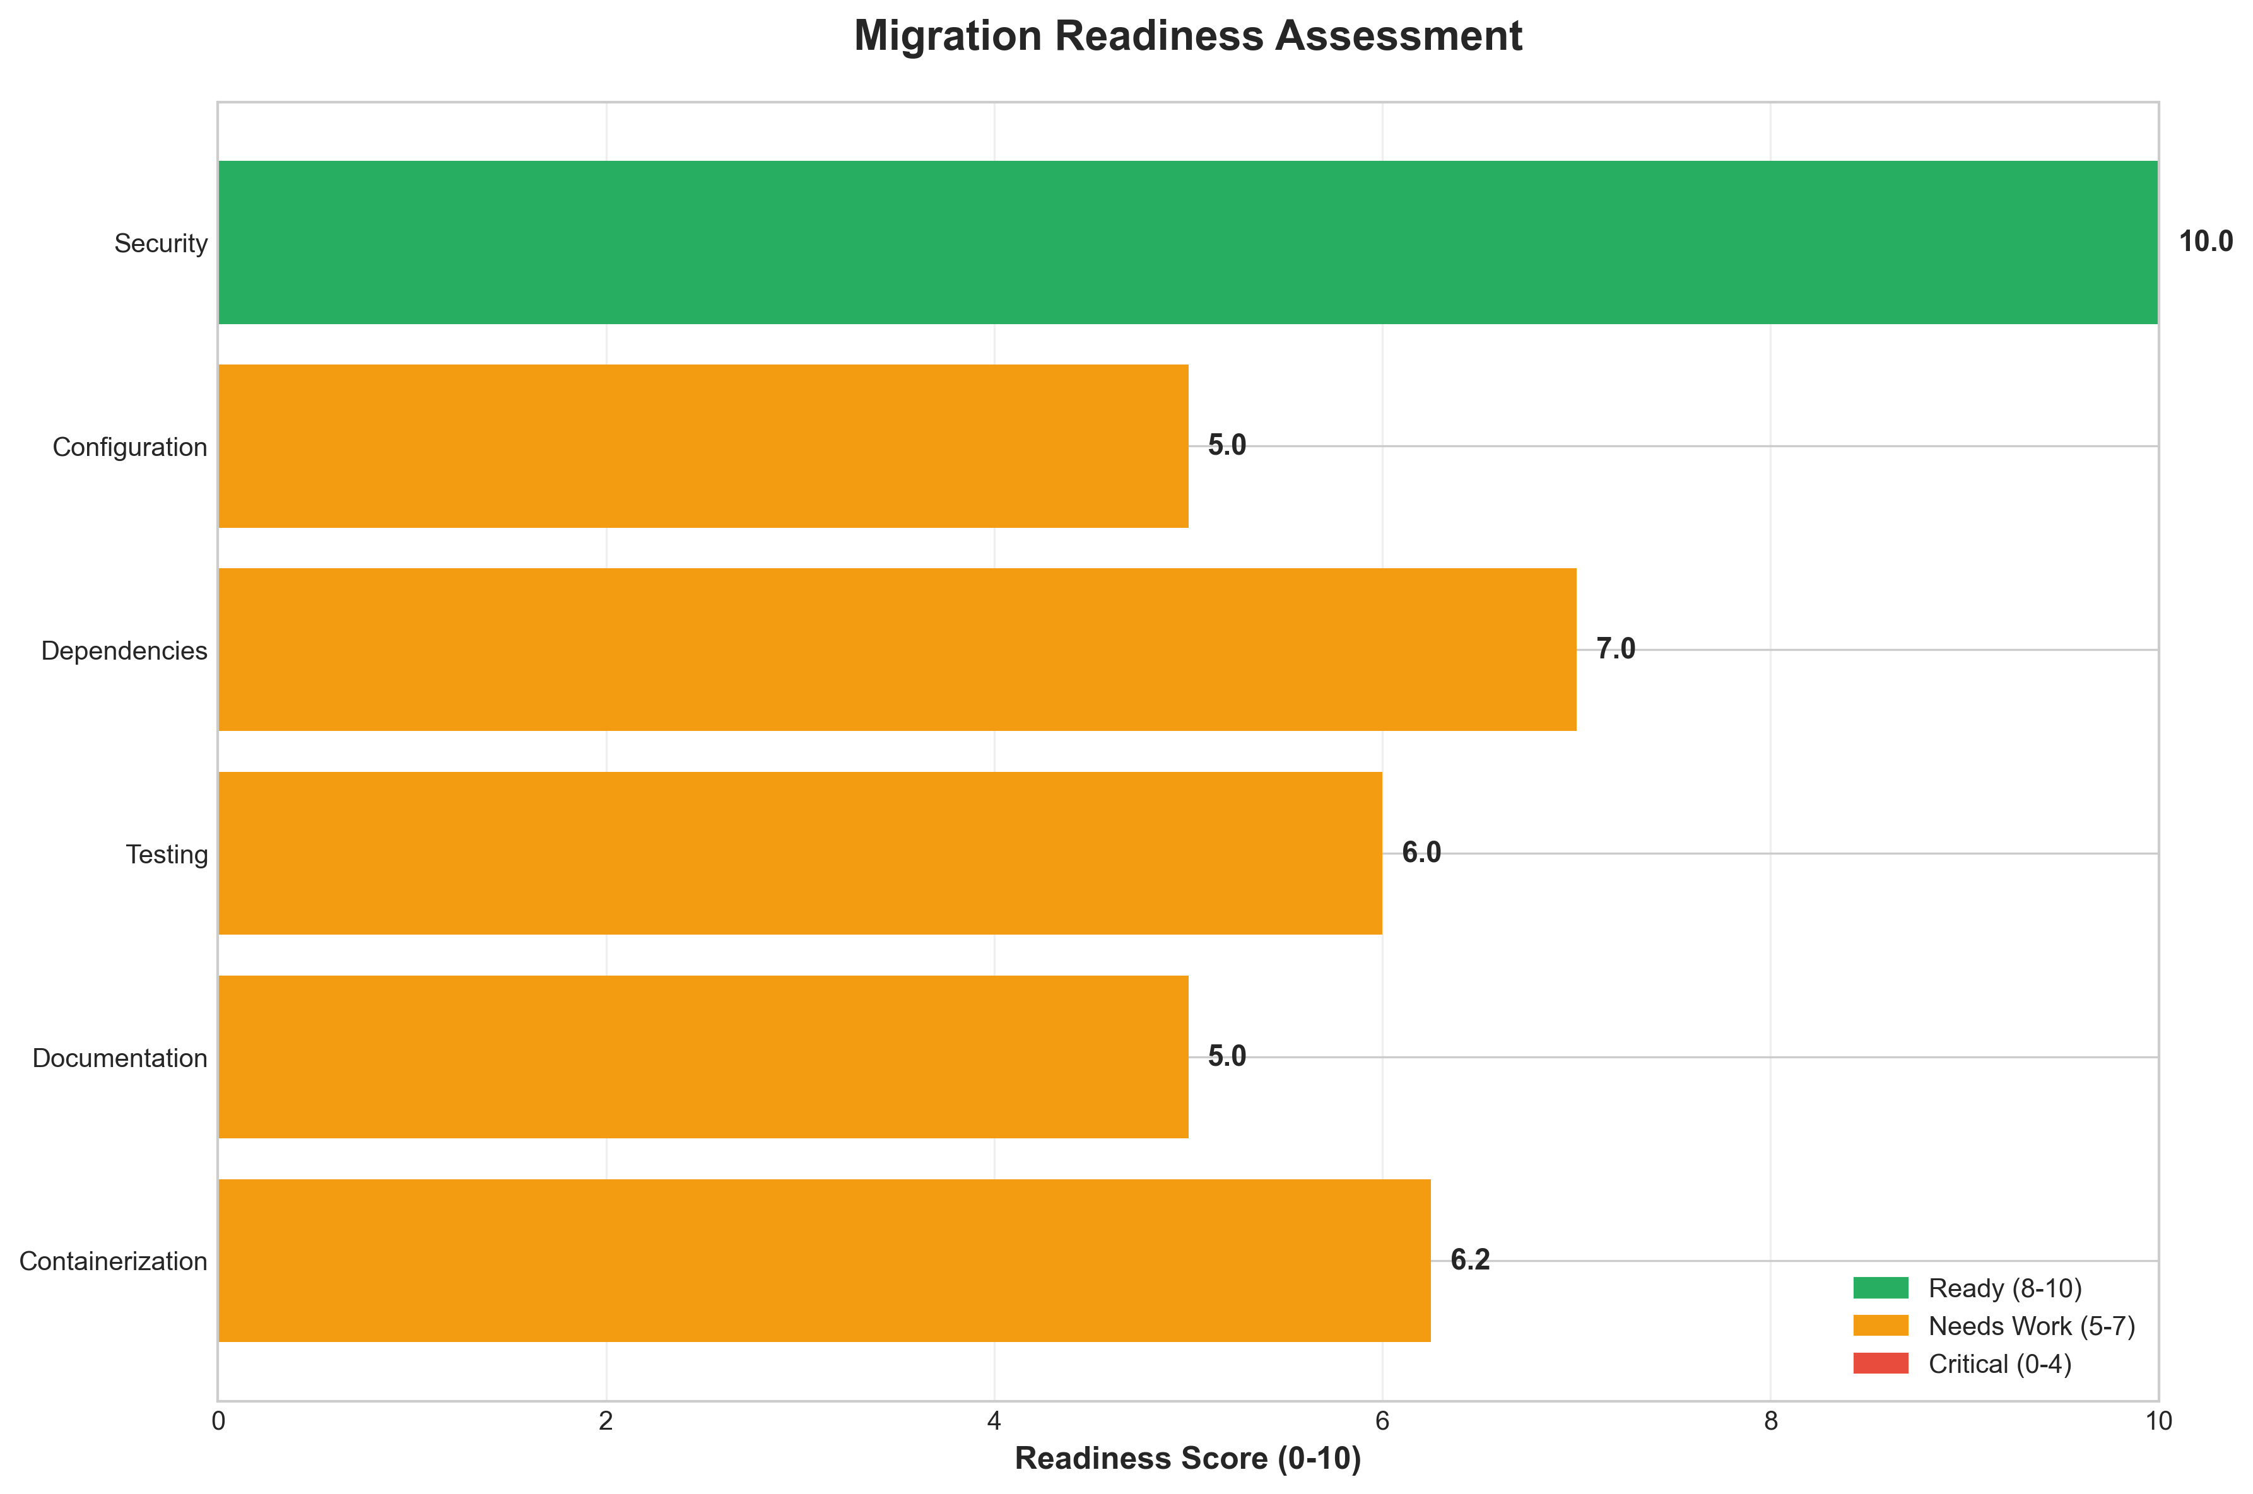

**📊 Context:** This Migration Readiness provides visual insights into the application's architecture and operational characteristics.

**📊 Key Insights:** The Migration Readiness illustrates key aspects of the application that support technical decision-making and operational planning.

**📊 Business Impact:** Visual representation supports better understanding of system characteristics and aids in strategic planning.

**📊 Recommendations:** Review diagram insights with technical teams to identify optimization opportunities and action items.

**📊 Technical Details:** Diagram type: Migration Readiness. Generated from comprehensive application intelligence analysis.

────────────────────────────────────────────────────────────────────────────────

Risk Assessment Matrix

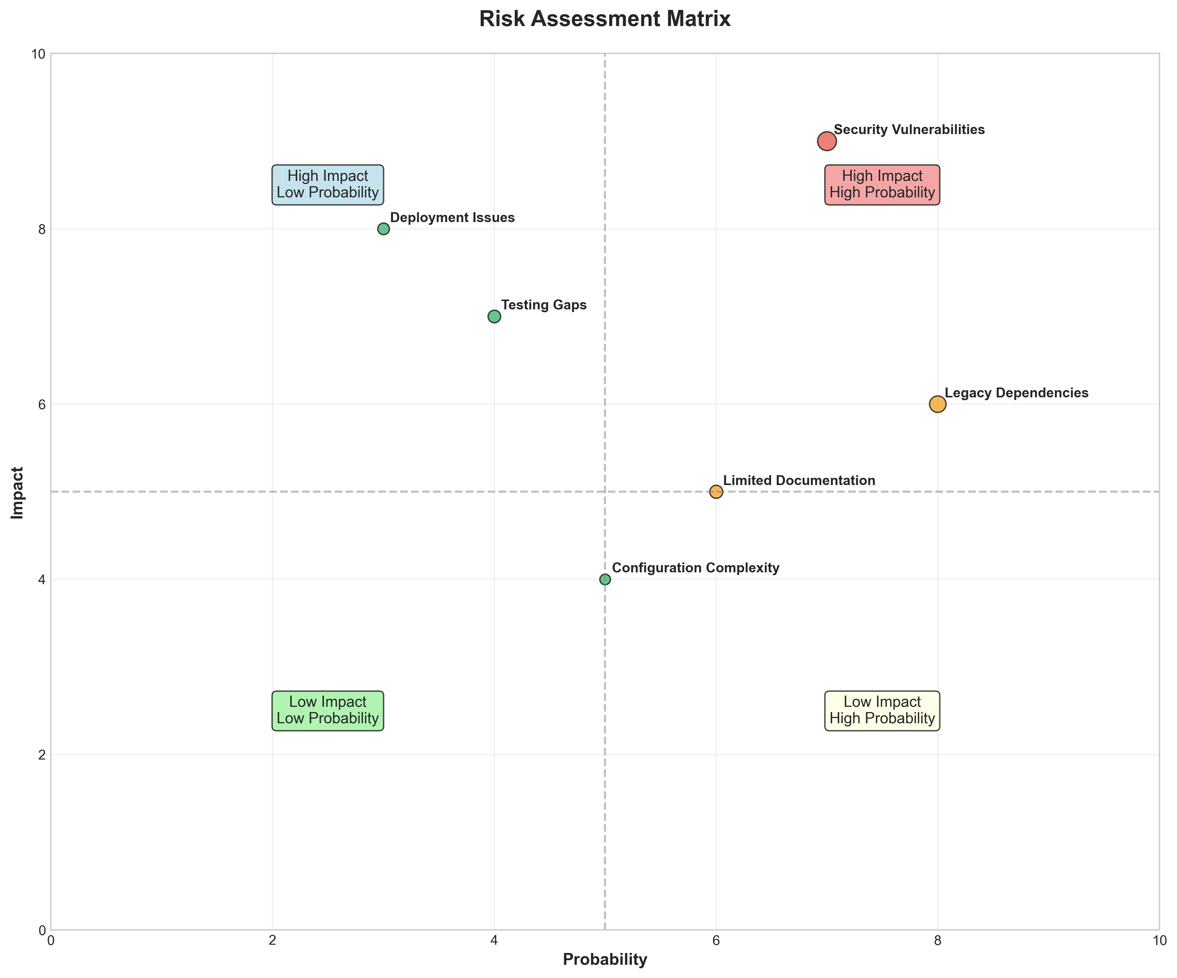

**📊 Context:** This Risk Assessment Matrix provides visual insights into the application's architecture and operational characteristics.

**📊 Key Insights:** The Risk Assessment Matrix illustrates key aspects of the application that support technical decision-making and operational planning.

**📊 Business Impact:** Visual representation supports better understanding of system characteristics and aids in strategic planning.

**📊 Recommendations:** Review diagram insights with technical teams to identify optimization opportunities and action items.

**📊 Technical Details:** Diagram type: Risk Assessment Matrix. Generated from comprehensive application intelligence analysis.

────────────────────────────────────────────────────────────────────────────────

CI/CD Pipeline Overview

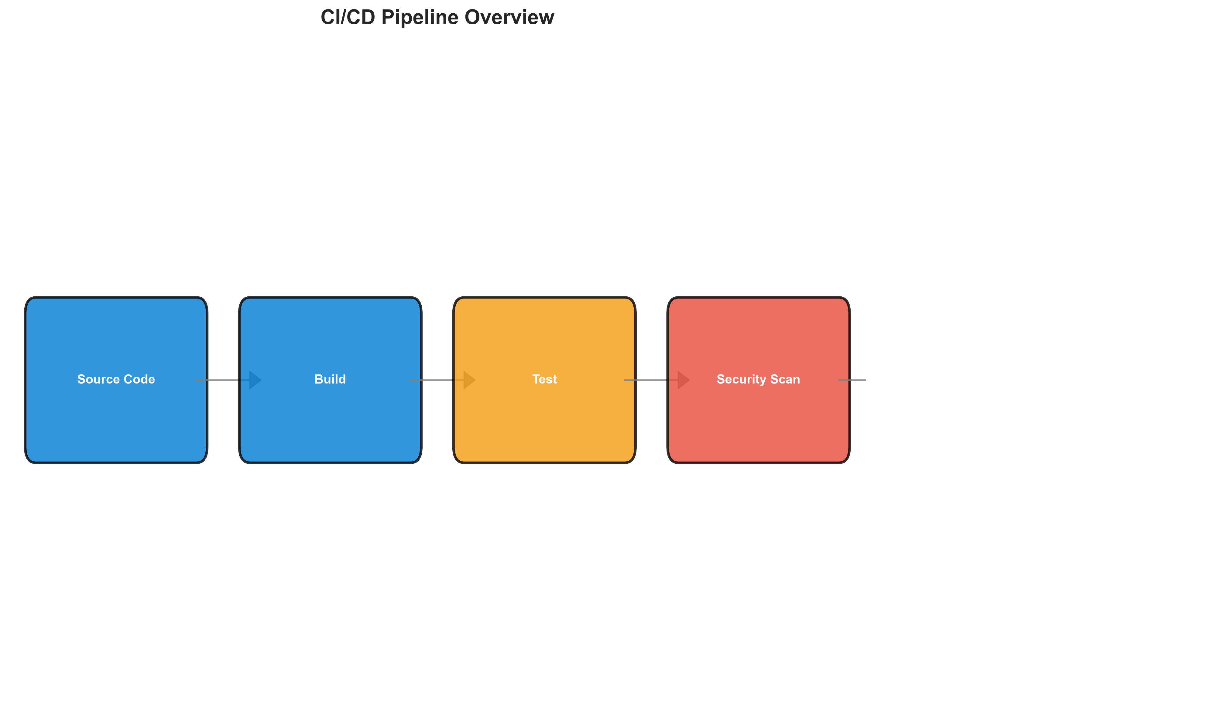

**📊 Context:** This Cicd Pipeline provides visual insights into the application's architecture and operational characteristics.

**📊 Key Insights:** The Cicd Pipeline illustrates key aspects of the application that support technical decision-making and operational planning.

**📊 Business Impact:** Visual representation supports better understanding of system characteristics and aids in strategic planning.

**📊 Recommendations:** Review diagram insights with technical teams to identify optimization opportunities and action items.

**📊 Technical Details:** Diagram type: Cicd Pipeline. Generated from comprehensive application intelligence analysis.

────────────────────────────────────────────────────────────────────────────────

Component Relationships (Graphviz)

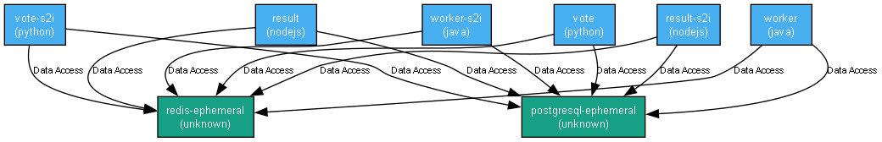

**📊 Context:** This Component Relationship Graph provides visual insights into the application's architecture and operational characteristics.

**📊 Key Insights:** The Component Relationship Graph illustrates key aspects of the application that support technical decision-making and operational planning.

**📊 Business Impact:** Visual representation supports better understanding of system characteristics and aids in strategic planning.

**📊 Recommendations:** Review diagram insights with technical teams to identify optimization opportunities and action items.

**📊 Technical Details:** Diagram type: Component Relationship Graph. Generated from comprehensive application intelligence analysis.

────────────────────────────────────────────────────────────────────────────────

Security Flow Diagram (Mermaid)

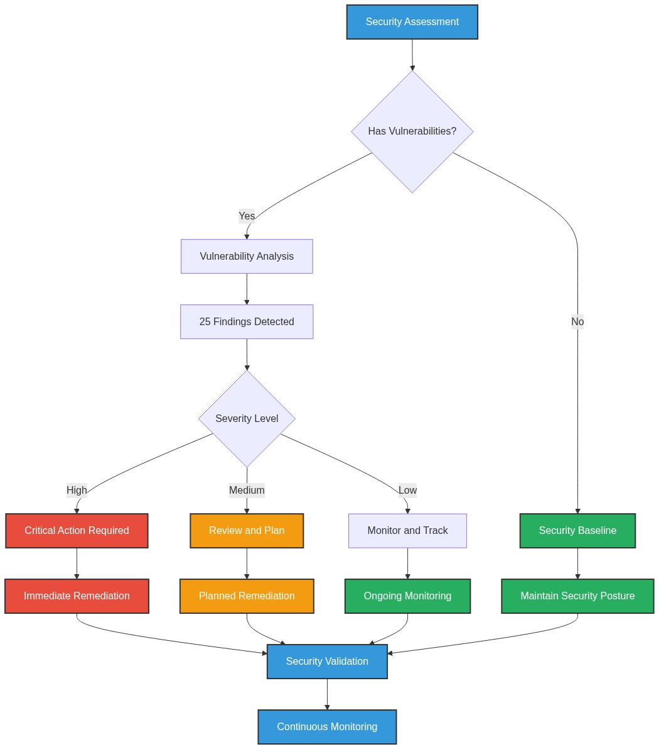

**📊 Context:** This Security Flow Diagram provides visual insights into the application's architecture and operational characteristics.

**📊 Key Insights:** The Security Flow Diagram illustrates key aspects of the application that support technical decision-making and operational planning.

**📊 Business Impact:** Visual representation supports better understanding of system characteristics and aids in strategic planning.

**📊 Recommendations:** Review diagram insights with technical teams to identify optimization opportunities and action items.

**📊 Technical Details:** Diagram type: Security Flow Diagram. Generated from comprehensive application intelligence analysis.

────────────────────────────────────────────────────────────────────────────────

Data Flow Diagram (Graphviz)

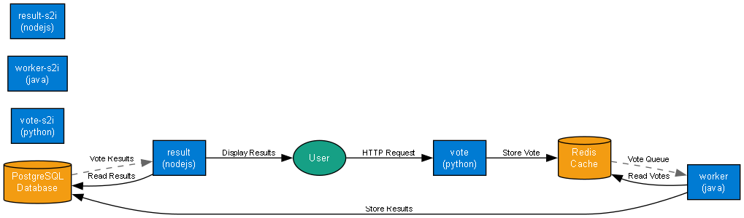

**📊 Context:** This Data Flow Diagram provides visual insights into the application's architecture and operational characteristics.

**📊 Key Insights:** The Data Flow Diagram illustrates key aspects of the application that support technical decision-making and operational planning.

**📊 Business Impact:** Visual representation supports better understanding of system characteristics and aids in strategic planning.

**📊 Recommendations:** Review diagram insights with technical teams to identify optimization opportunities and action items.

**📊 Technical Details:** Diagram type: Data Flow Diagram. Generated from comprehensive application intelligence analysis.

────────────────────────────────────────────────────────────────────────────────

Deployment Architecture (Mermaid)

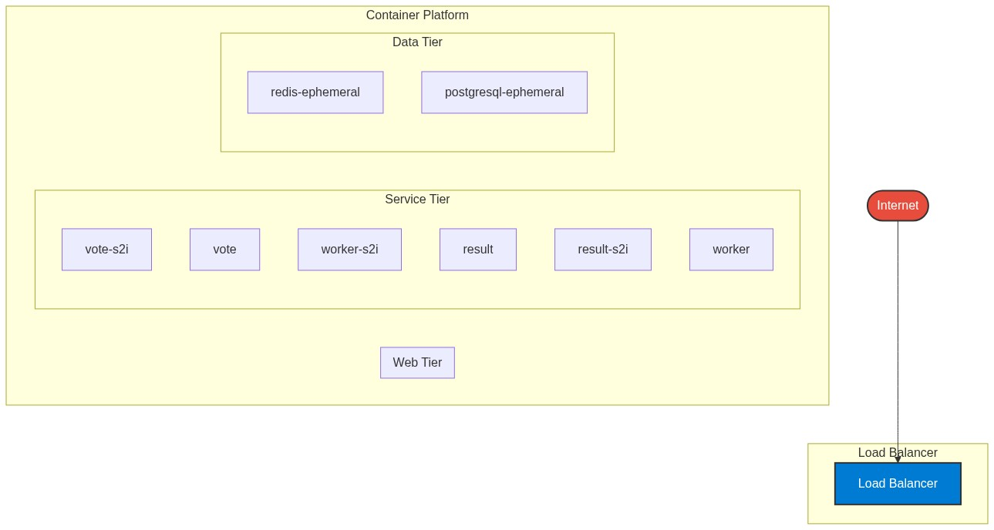

**📊 Context:** This Deployment Architecture provides visual insights into the application's architecture and operational characteristics.

**📊 Key Insights:** The Deployment Architecture illustrates key aspects of the application that support technical decision-making and operational planning.

**📊 Business Impact:** Visual representation supports better understanding of system characteristics and aids in strategic planning.

**📊 Recommendations:** Review diagram insights with technical teams to identify optimization opportunities and action items.

**📊 Technical Details:** Diagram type: Deployment Architecture. Generated from comprehensive application intelligence analysis.

────────────────────────────────────────────────────────────────────────────────

Risk Assessment Flow (Mermaid)

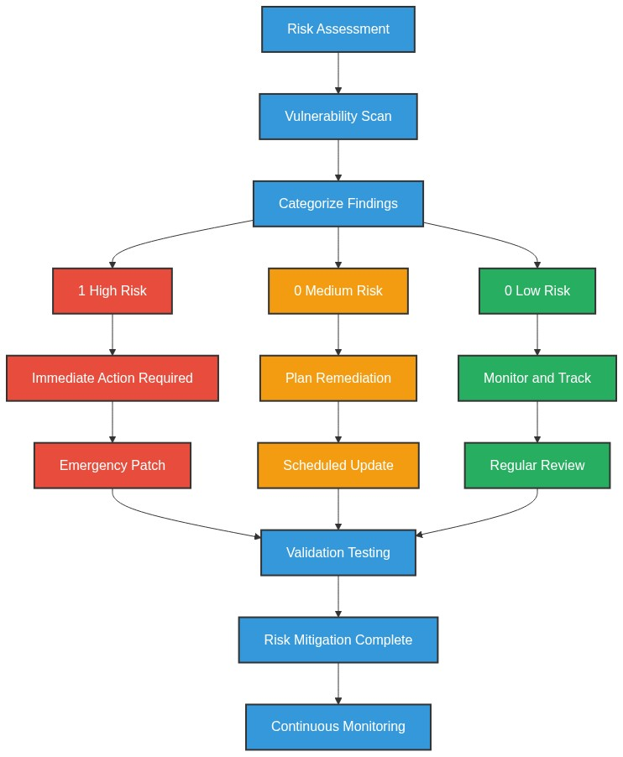

**📊 Context:** This Risk Assessment Flow provides visual insights into the application's architecture and operational characteristics.

**📊 Key Insights:** The Risk Assessment Flow illustrates key aspects of the application that support technical decision-making and operational planning.

**📊 Business Impact:** Visual representation supports better understanding of system characteristics and aids in strategic planning.

**📊 Recommendations:** Review diagram insights with technical teams to identify optimization opportunities and action items.

**📊 Technical Details:** Diagram type: Risk Assessment Flow. Generated from comprehensive application intelligence analysis.

────────────────────────────────────────────────────────────────────────────────

Migration Strategy (Graphviz)

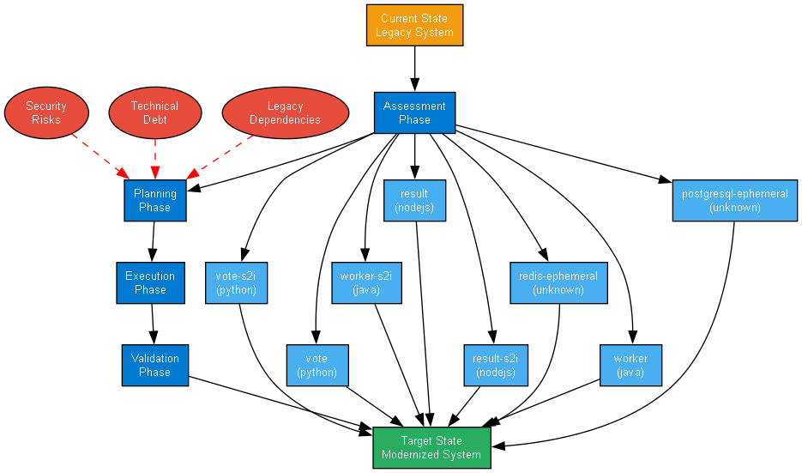

**📊 Context:** This Migration Strategy Diagram provides visual insights into the application's architecture and operational characteristics.

**📊 Key Insights:** The Migration Strategy Diagram illustrates key aspects of the application that support technical decision-making and operational planning.

**📊 Business Impact:** Visual representation supports better understanding of system characteristics and aids in strategic planning.

**📊 Recommendations:** Review diagram insights with technical teams to identify optimization opportunities and action items.

**📊 Technical Details:** Diagram type: Migration Strategy Diagram. Generated from comprehensive application intelligence analysis.

────────────────────────────────────────────────────────────────────────────────