[COMPANY LOGO]

Application Intelligence Report

Comprehensive Analysis and Migration Assessment

Repository: https://github.com/end-of-game/openshift-voting-app

Analysis Date: July 18, 2025

*Generated by Application Intelligence Platform*

Table of Contents

Executive Summary........................................... 3

Application Overview........................................ 4

Component Analysis.......................................... 5

Architecture Assessment..................................... 8

Security Analysis........................................... 10

Git History Analysis........................................ 12

Recommendations............................................. 13

Appendices.................................................. 15

Executive Summary

|  |  |
| --- | --- |
| **Metric** | **Value** |
| Total Components | 3 |
| Programming Languages | nodejs, java, python |
| Containerization Status | 3 containerized |
| Data Sources | 0 |
| Security Findings | 0 |
| Git Commits | 1 |
| Architecture Style | microservices |

Application Overview

This report presents a comprehensive analysis of the application repository. The analysis identified 3 components using 3 different programming languages. The application demonstrates a microservices architecture pattern.

Key Findings

• 📦 3 application components identified

• 🔧 3 programming languages detected: nodejs, java, python

• 🐳 3 components are containerized

• 💾 0 data sources identified

• 🔒 0 security findings require attention

Detailed Analysis

Component Analysis

The analysis identified 3 components across the application:

|  |  |  |  |
| --- | --- | --- | --- |
| **Component** | **Language** | **Type** | **Packaging** |
| result | nodejs | Unknown | docker |
| worker | java | Unknown | docker |
| vote | python | Unknown | docker |

Component: result

• Language: nodejs

• Runtime: nodejs

• Build Tool: unknown

• Packaging: docker

• Exposed Ports: 8080

• Base Images: node:10-slim

Component: worker

• Language: java

• Runtime: java

• Build Tool: unknown

• Packaging: docker

• Base Images: maven:3.5-jdk-8-alpine, openjdk:8-jre

**Notes:**

• Alternative C# implementation found at 'worker/src/src/Worker/Program.cs' but does not appear to be the primary build target defined in the Dockerfile or OpenShift manifests. Primary implementation is Java.

• Multiple base images detected: maven:3.5-jdk-8-alpine, openjdk:8-jre. This may indicate multi-stage builds or alternative build strategies.

Component: vote

• Language: python

• Runtime: python

• Build Tool: unknown

• Packaging: docker

• Exposed Ports: 8080

• Base Images: python:3.9-slim

Architecture Analysis

Architecture Style: microservices (Confidence: ConfidenceLevel.HIGH)

Reasoning: Multiple components with independent deployment characteristics

**Evidence:**

• Found 3 components

• Multiple deployable components detected

• 3 containerized components

• Multiple deployment configurations

Security Analysis

Security analysis identified 2 findings with 3 base image risks.

**Key Security Findings:**

• Unknown: The result component uses node:10-slim base image which is past End-of-Life and contains numerous unpatched vulnerabilities. (Severity: CRITICAL)

• Unknown: A pattern indicative of a hardcoded secret was detected in the 'vote' application's Python code. (Severity: HIGH)

Git History Analysis

• Total Commits: 1

• Active Contributors: 0

• Recent Activity: inactive

• Code Stability: high

Recommendations

🔴 High Priority Recommendations

• SECURITY Security: 2 critical/high severity vulnerabilities found. Prioritize security remediation.

🟢 Low Priority Recommendations

• DEVELOPMENT Development Activity: Low recent activity detected. Consider reviewing development processes and team capacity.

• BASE-IMAGES Base Images: 3 base images have known risks. Update to more recent versions.

Appendices

Appendix A: Technical Details

This analysis was generated using the Application Intelligence Platform, which performs comprehensive analysis of application repositories including code structure, infrastructure configuration, and security assessment.

Appendix B: Analysis Methodology

• Component Discovery: Automated scanning of source code and configuration files

• Language Detection: Analysis of file extensions, build configurations, and base images

• Architecture Assessment: Evaluation of deployment patterns and component relationships

• Security Analysis: Scanning for common vulnerabilities and configuration issues

• Git History Analysis: Examination of commit patterns and development activity

Charts and Visualizations

Programming Language Distribution

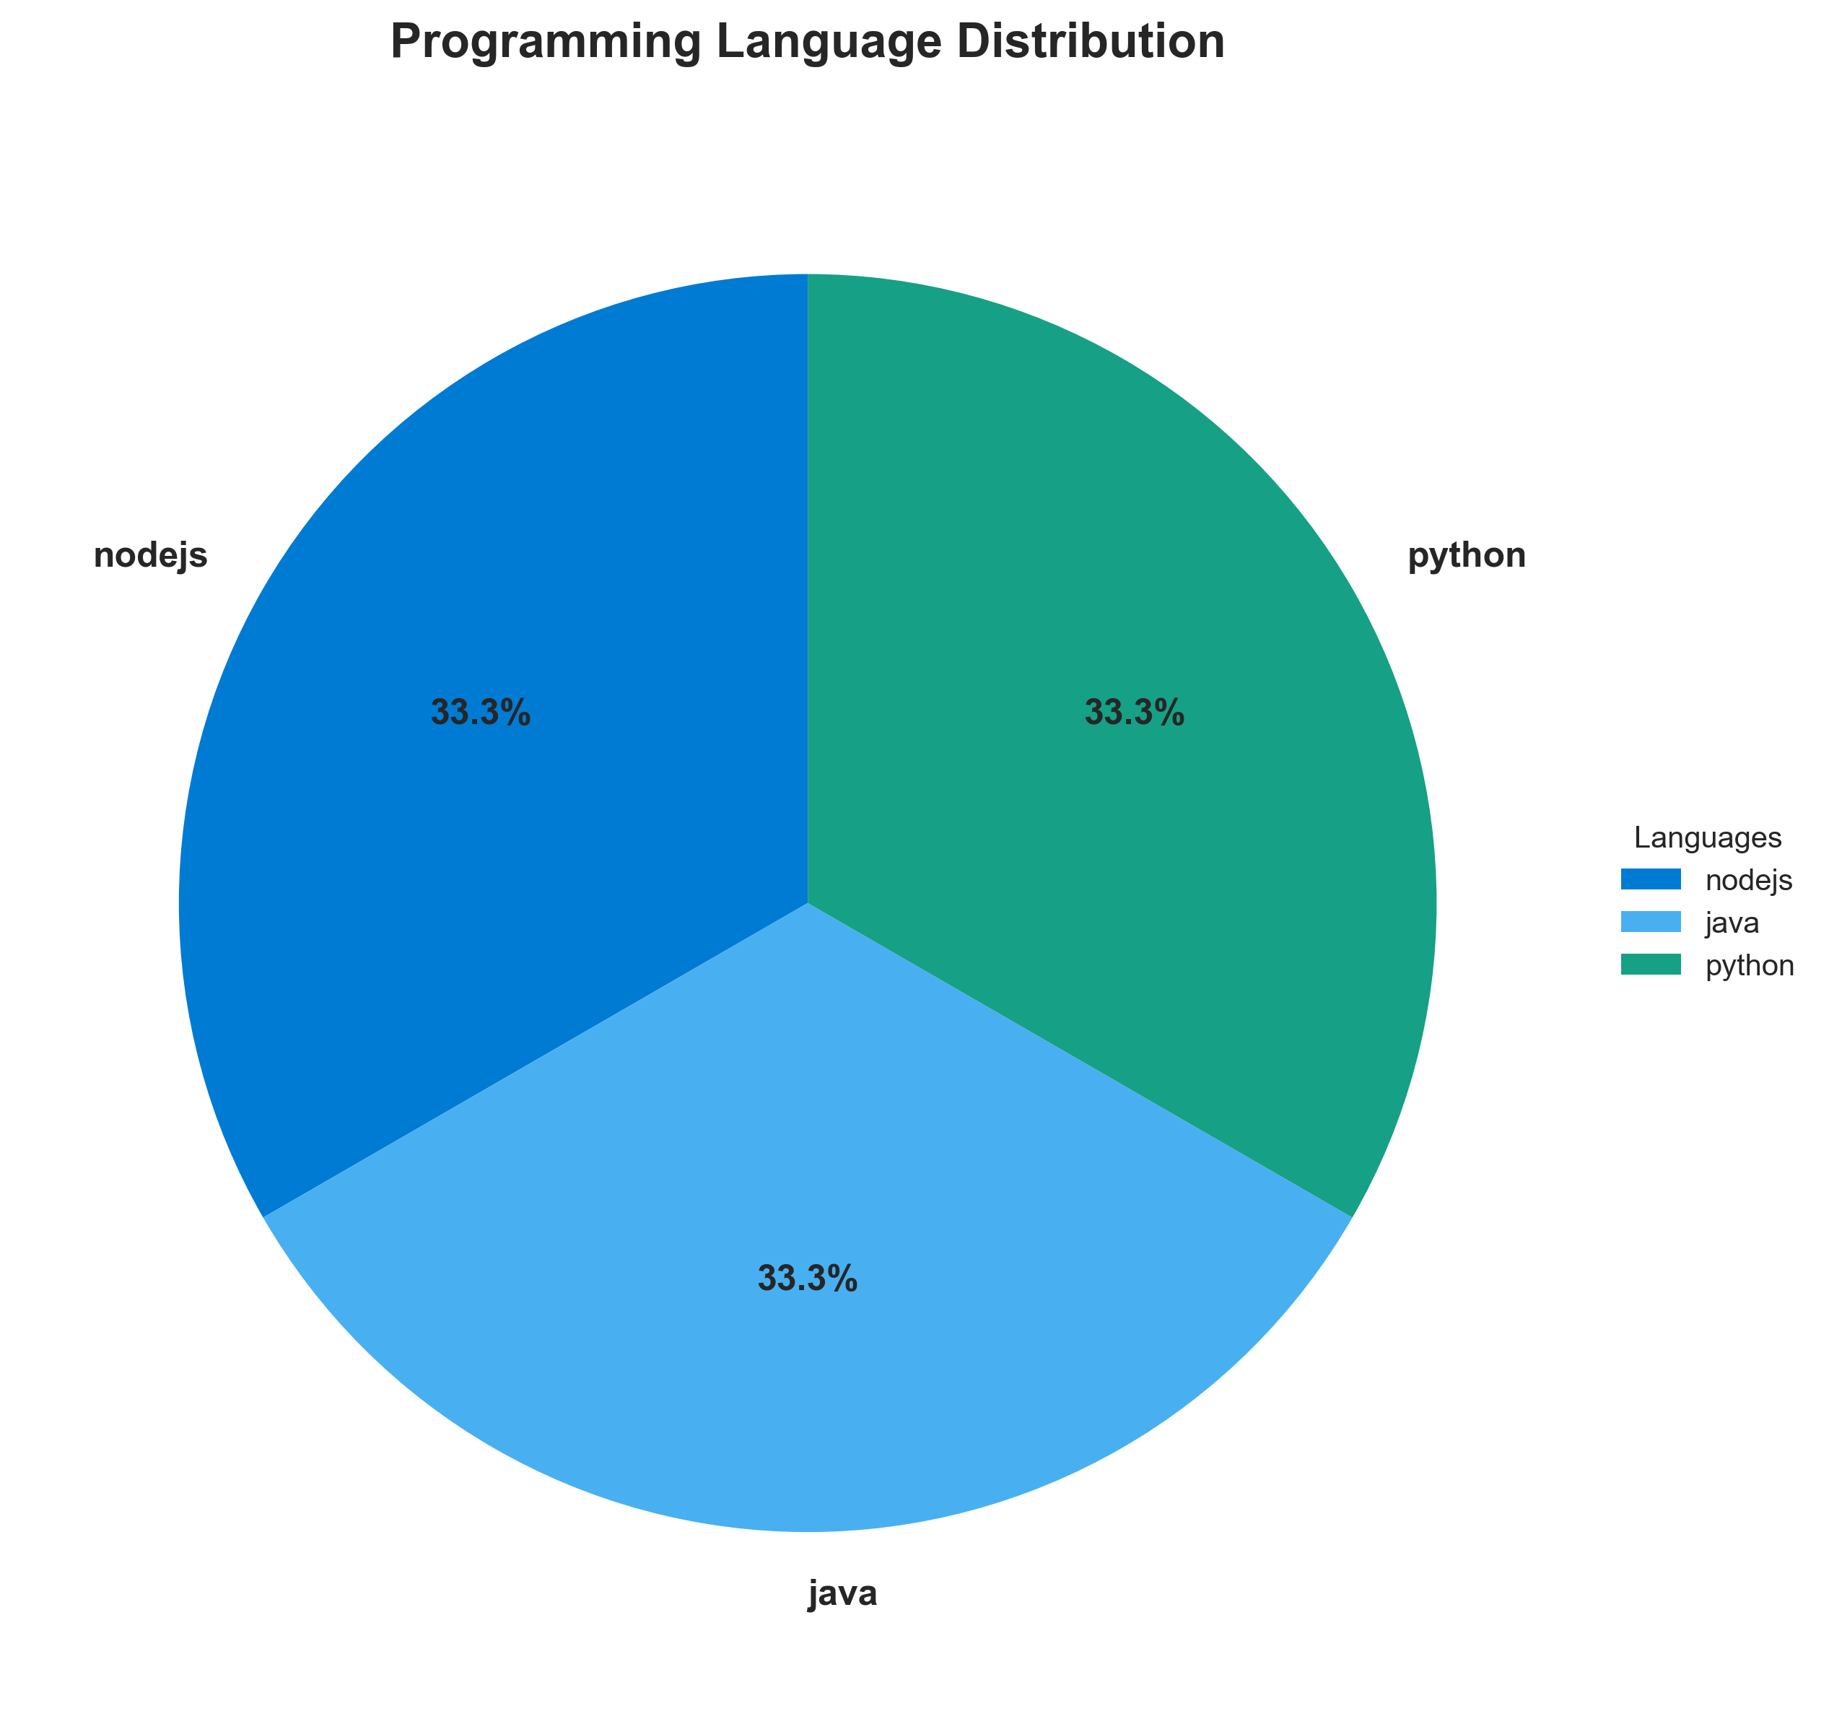

**📊 Context:** This diagram illustrates the programming language distribution across the three identified components of the application: 'result' (Node.js), 'worker' (Java), and 'vote' (Python). This analysis is critical for understanding the current technology stack as part of a broader application intelligence report focused on modernization and migration planning.

**📊 Key Insights:** The application utilizes a polyglot architecture, with each of the three components implemented in a distinct language (Node.js, Java, and Python). All components are containerized using Docker. Notably, both the Node.js ('result') and Java ('worker') components are leveraging base images with known vulnerabilities ('node:10-slim', 'maven:3.5-jdk-8-alpine', 'openjdk:8-jre'). The Java component also indicates a potential for multi-stage builds or alternative build strategies.

**📊 Business Impact:** The use of multiple languages presents potential challenges for a unified modernization strategy, potentially increasing the complexity and cost of migration. The identified vulnerabilities in base images pose immediate security risks, which could impact compliance and operational stability. Addressing these vulnerabilities is crucial before or during any migration efforts to avoid inheriting security debt.

**📊 Recommendations:** Prioritize updating or replacing vulnerable base Docker images for the 'result' (Node.js) and 'worker' (Java) components to mitigate security risks. Investigate the Java 'worker' component's build strategy to understand the multiple base images and streamline if possible. Plan for language-specific modernization efforts or a potential consolidation strategy if language diversity hinders future agility.

**📊 Technical Details:** The 'result' component runs on Node.js, the 'worker' on Java (with a detected alternative C# implementation note), and 'vote' on Python. All are packaged as Docker containers. The 'worker' component's use of both 'maven:3.5-jdk-8-alpine' and 'openjdk:8-jre' suggests a multi-stage build process, which, while potentially efficient, requires careful management. The low confidence score for Node.js and Python source analysis may warrant a deeper dive into their actual implementation details.

────────────────────────────────────────────────────────────────────────────────

Component Status Overview

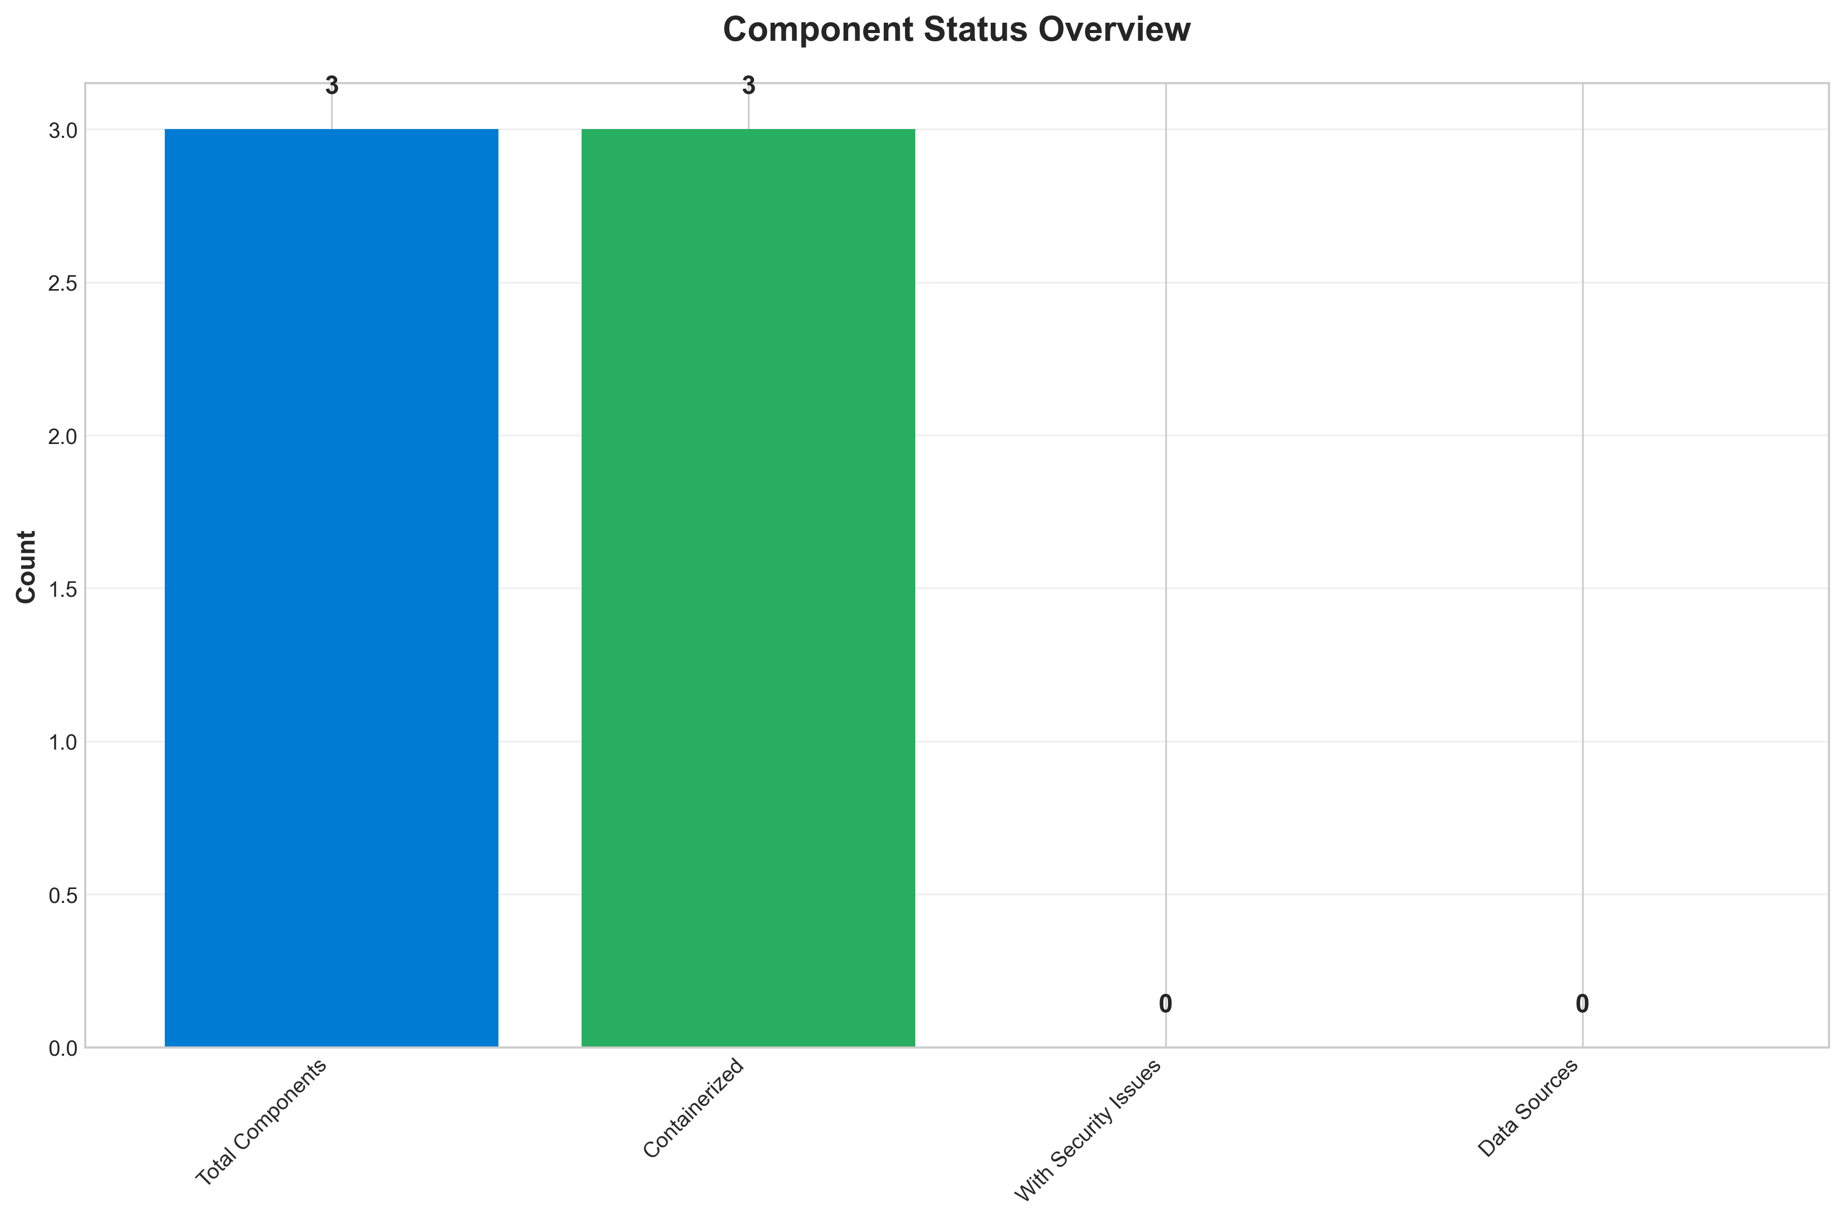

**📊 Context:** This Component Status Overview diagram provides a high-level assessment of the application's current health, specifically highlighting the containerization status and identifying critical security vulnerabilities. It is a foundational piece of information for our ongoing application modernization and migration planning efforts.

**📊 Key Insights:** All three components are containerized, which is a positive step for modernization and migration. However, a significant concern is the presence of 3 high-severity security findings across two of the components ('result' and 'worker'). These findings point to the use of End-of-Life (EOL) and vulnerable base images (Node.js 10, Maven 3.5 with JDK 8, and OpenJDK 8) that pose considerable security risks.

**📊 Business Impact:** The identified security vulnerabilities represent a critical risk to the business, potentially exposing sensitive data and leading to operational disruptions. Failure to address these EOL components will likely impede the modernization and migration timeline, as security remediation is a prerequisite for cloud readiness and could introduce unexpected delays and costs. This situation also presents an opportunity to enhance overall application security posture by updating these foundational elements.

**📊 Recommendations:** Prioritize the immediate remediation of all 3 high-severity security findings by updating the base images for the 'result' and 'worker' components to supported and patched versions. This should be done before proceeding with further migration steps. Additionally, conduct a deeper dive into the 'worker' component's dependencies to understand the implications of updating JDK 8, as this may require code adjustments.

**📊 Technical Details:** The analysis reveals that all 3 total components are containerized. Security scanning identified 3 high-severity findings, specifically related to outdated and vulnerable base images: 'node:10-slim' for the 'result' component, and 'maven:3.5-jdk-8-alpine' and 'openjdk:8-jre' for the 'worker' component. These findings indicate a need for significant updates to the underlying container images.

────────────────────────────────────────────────────────────────────────────────

Application Architecture

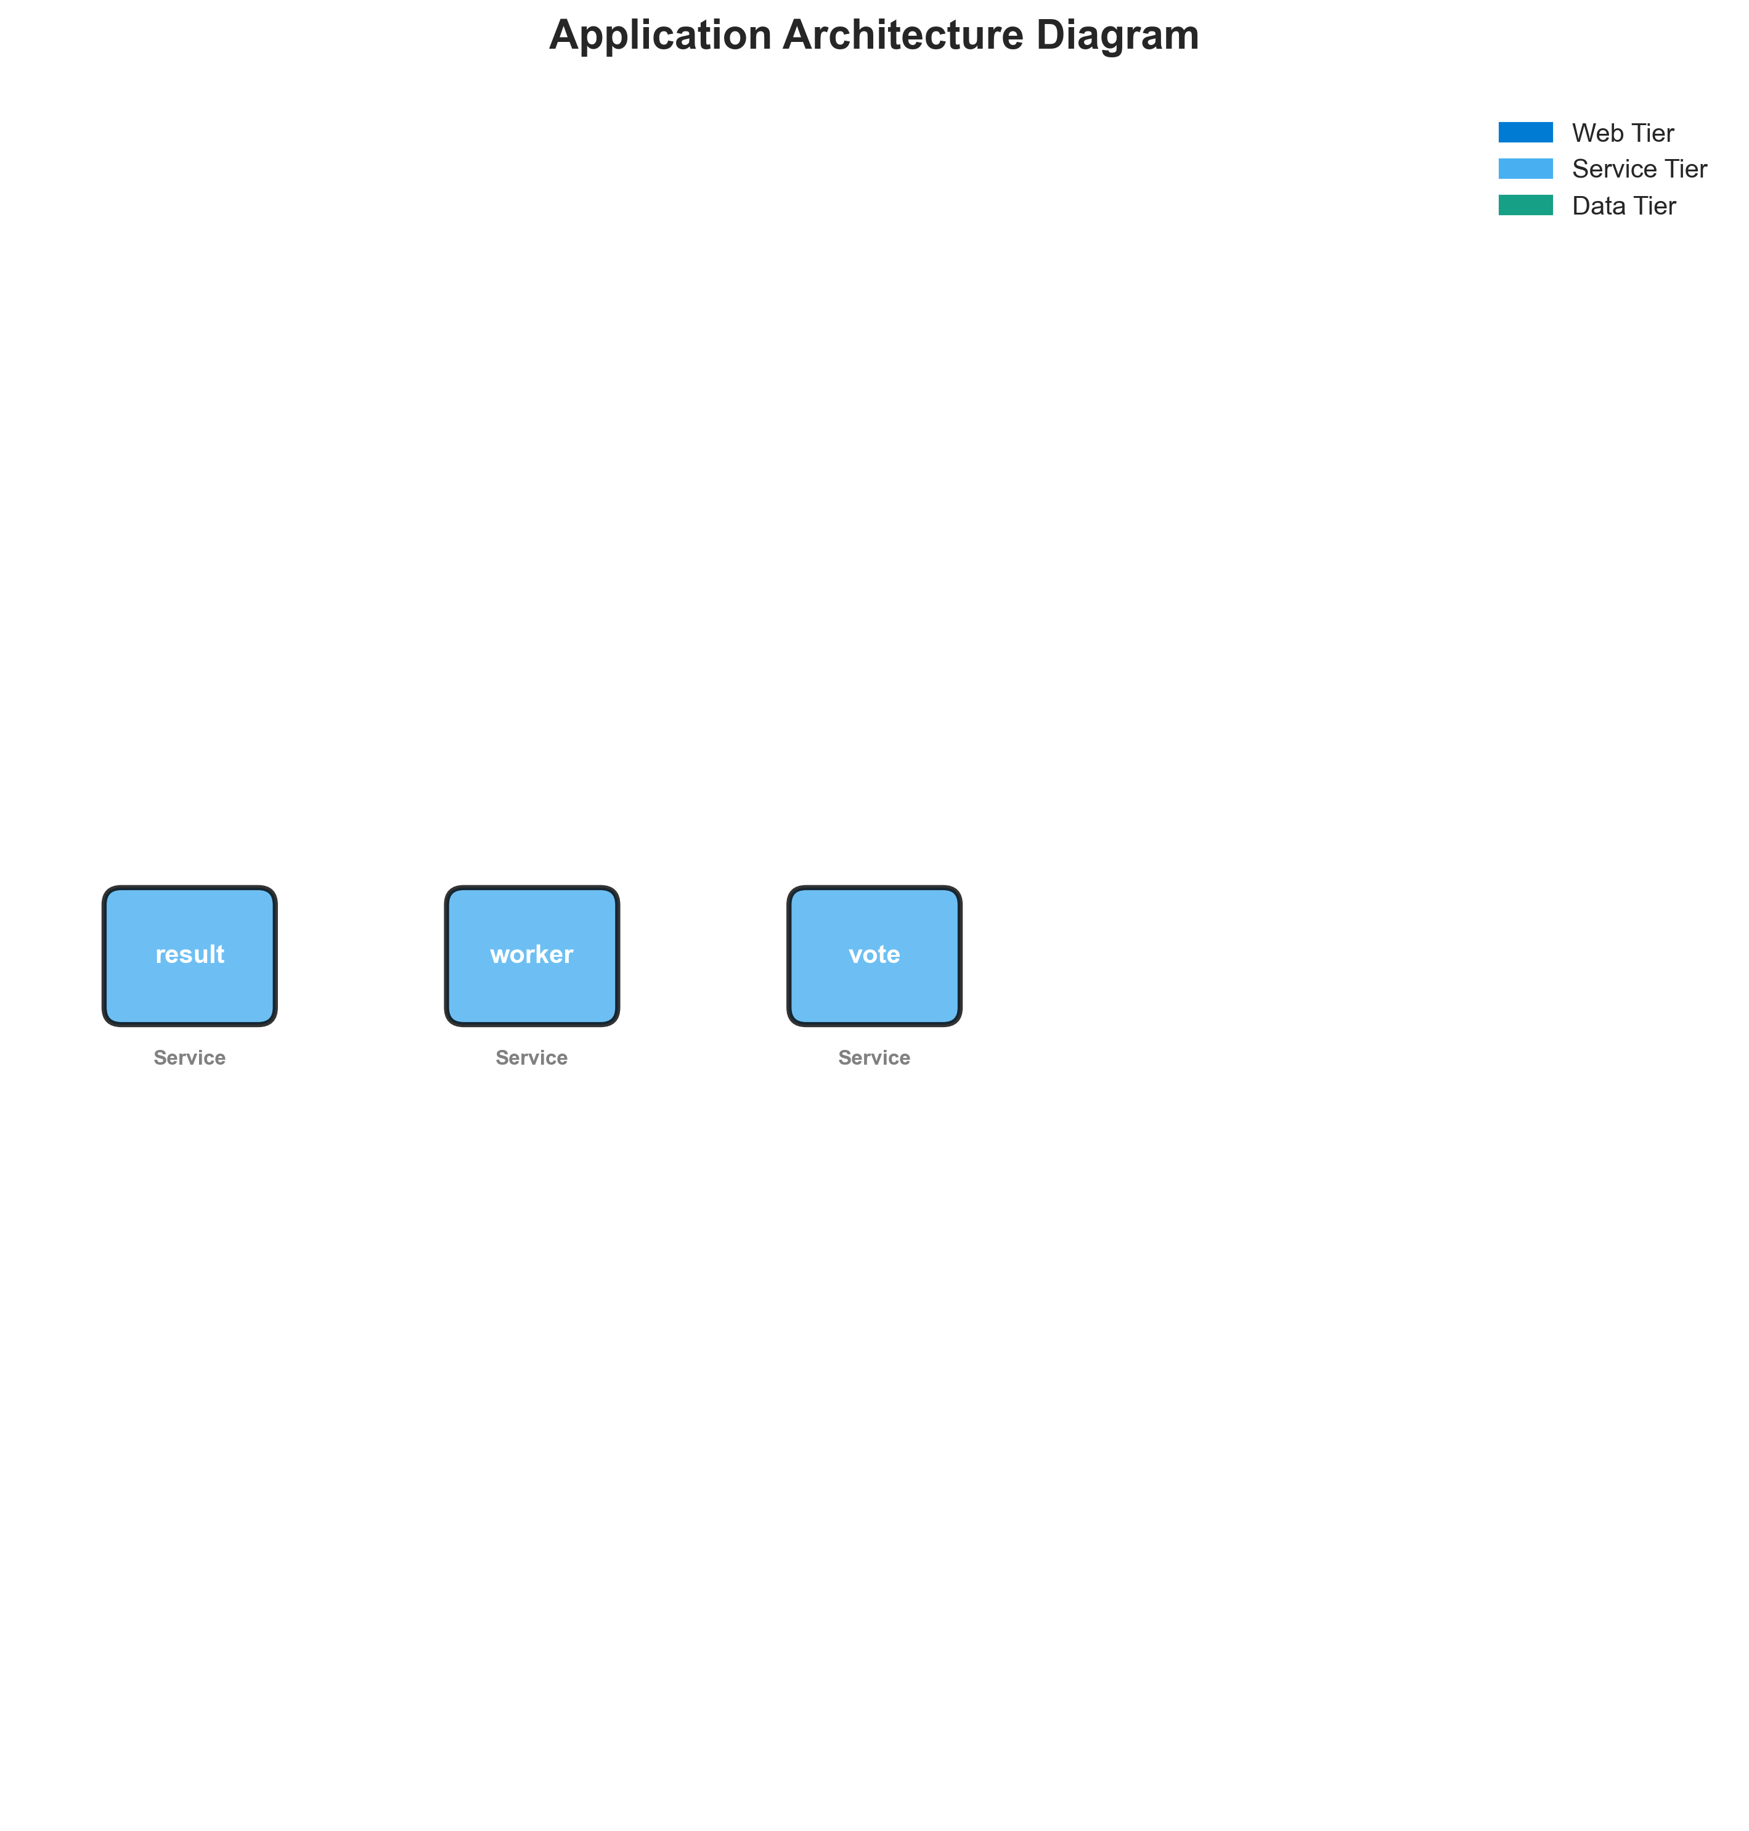

**📊 Context:** This diagram provides an overview of the application's architecture, specifically focusing on its system style and the relationships between its core components. It was generated as part of a broader initiative to assess the application's readiness for modernization and potential migration to cloud-native environments.

**📊 Key Insights:** The application is architected using a microservices style, comprising three distinct services: 'result' (Node.js), 'worker' (Java), and 'vote' (Python). All identified components are containerized, indicating a level of maturity in deployment practices. The use of multiple programming languages across services suggests a polyglot approach, which can offer flexibility but also introduces operational complexity.

**📊 Business Impact:** The microservices architecture presents opportunities for independent scaling and faster development cycles, which can accelerate time-to-market for new features. However, the diversity in programming languages (Node.js, Java, Python) and the use of older base images like 'node:10-slim' and 'openjdk:8-jre' pose significant risks related to maintenance, security vulnerabilities, and potential skills gaps. The medium complexity and maturity scores, combined with the identified vulnerable base images, suggest that modernization efforts will require careful planning and investment to mitigate these risks and realize the full benefits of the architecture.

**📊 Recommendations:** Prioritize upgrading the vulnerable base images ('node:10-slim', 'maven:3.5-jdk-8-alpine', 'openjdk:8-jre') to current, supported versions to address security risks. Investigate the communication patterns and dependencies between these microservices to better understand their interactions and inform migration strategies. Evaluate the need for a unified build and deployment pipeline to manage the polyglot nature of the application more efficiently.

**📊 Technical Details:** The analysis confirms a microservices architecture with three independent, containerized components. The 'result' and 'vote' services run on Node.js and Python respectively, both exposing port 8080. The 'worker' service is Java-based, utilizing multiple base images (likely for multi-stage builds) and setting a 'JAVA_APP_JAR' environment variable. The confidence in language detection is generally high (6-8), but the build tool is reported as 'unknown' for all components, and specific deployment configurations are not detailed, limiting insight into operationalization.

────────────────────────────────────────────────────────────────────────────────

Security Assessment Radar

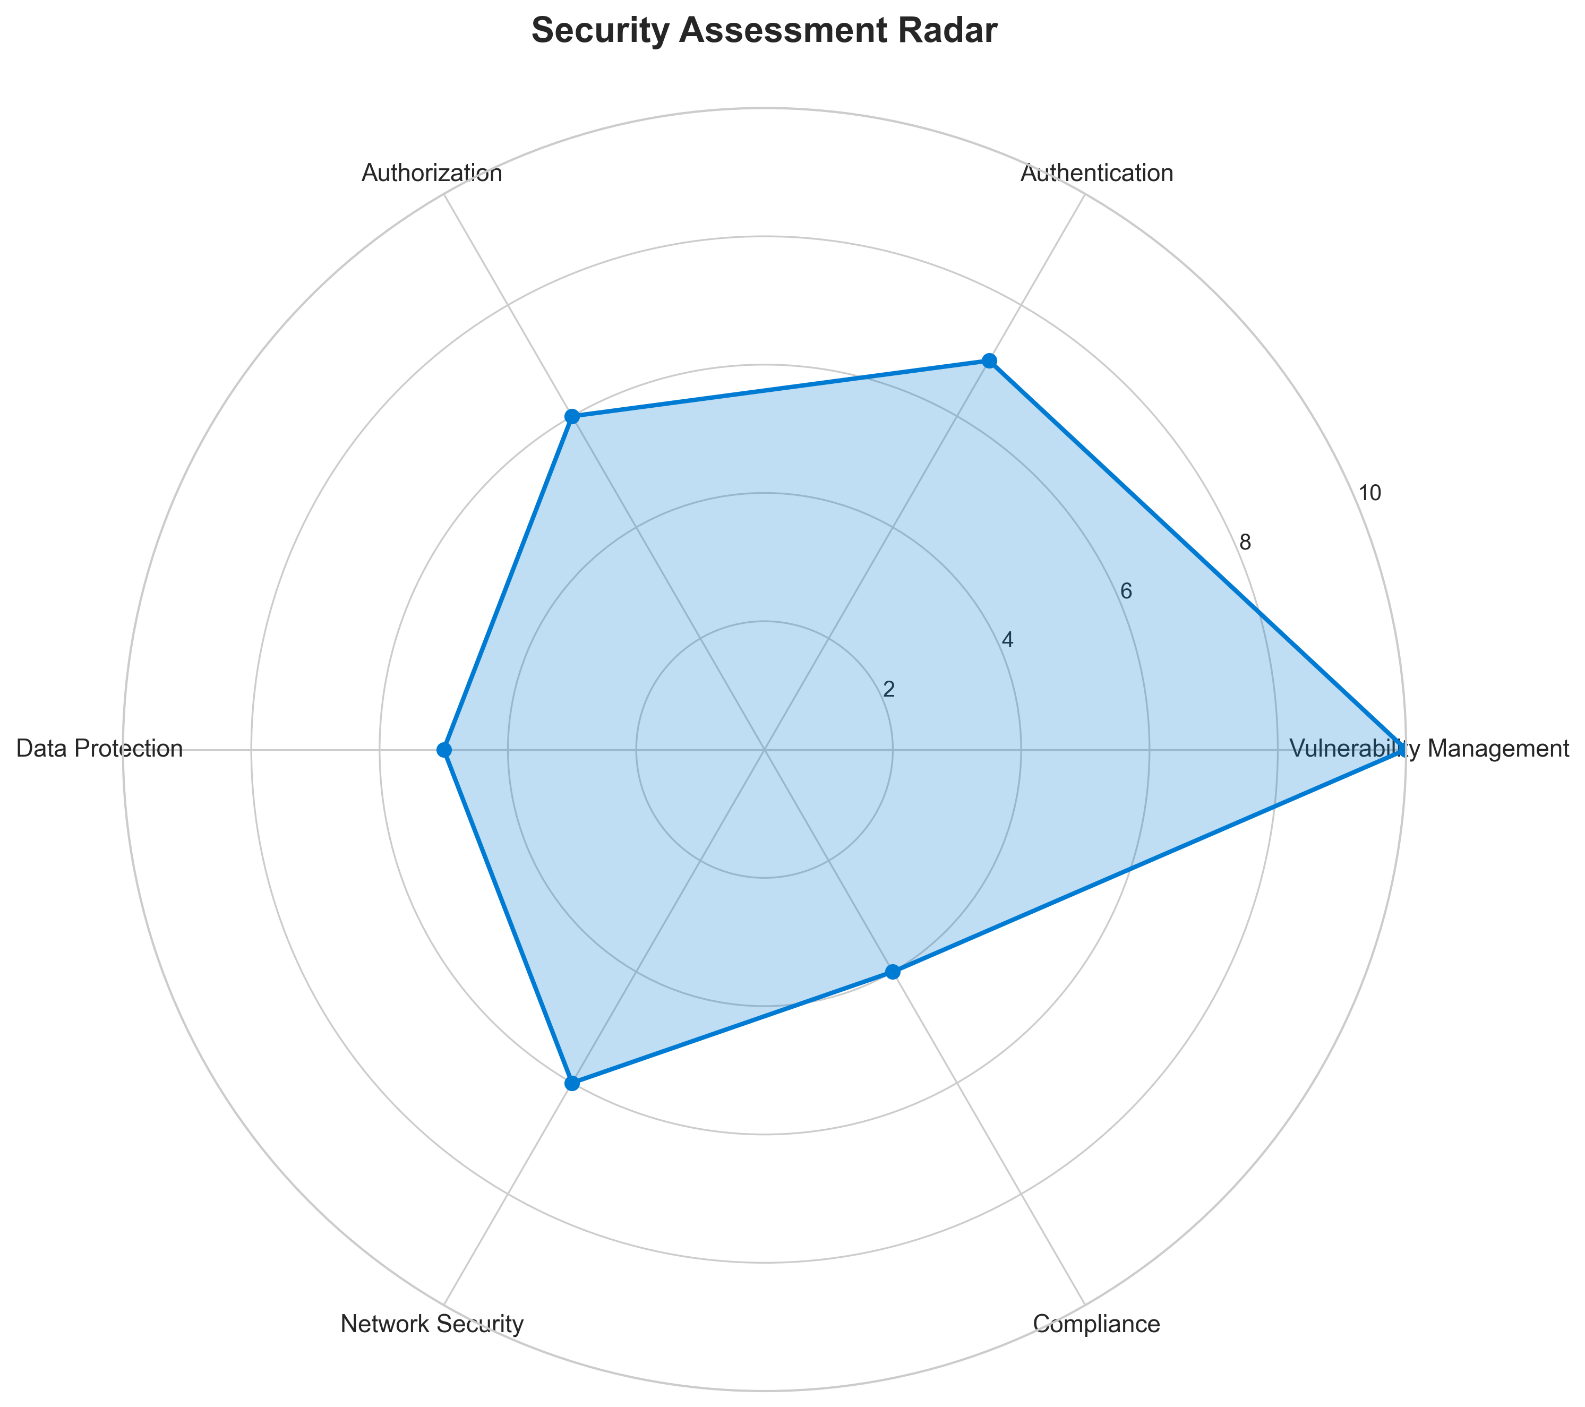

**📊 Context:** This security assessment radar highlights critical vulnerabilities within the application's components, particularly concerning outdated base images. The analysis was performed manually and is intended to inform modernization and migration planning by identifying immediate security risks.

**📊 Key Insights:** The most significant finding is the use of an End-of-Life (EOL) Node.js 10 base image in the 'result' component, presenting a critical security risk due to unpatched vulnerabilities. Additionally, the 'worker' component relies on outdated Maven and OpenJDK versions, both flagged with high-risk vulnerabilities. There's also a potential high-severity hardcoded secret identified in the 'vote' application's Python code.

**📊 Business Impact:** The current security posture significantly increases the risk of exploitation and data breaches, which could lead to service disruptions, reputational damage, and compliance failures. These vulnerabilities must be addressed before any modernization or migration efforts to prevent carrying over or exacerbating these risks, potentially impacting project timelines and costs.

**📊 Recommendations:** Prioritize updating the 'result' component's base image from Node.js 10 to a supported version (e.g., Node.js 18 or 20). Concurrently, validate and remediate the potential hardcoded secret in 'voting-app\vote\src\app.py'. Subsequently, update the 'worker' component's Maven and OpenJDK base images to secure, current versions.

**📊 Technical Details:** The analysis reveals a critical vulnerability (BASE_IMAGE_RESULT) in 'result/Dockerfile' due to the Node.js 10 base image being EOL. The 'worker' component faces high risks from 'maven:3.5-jdk-8-alpine' and 'openjdk:8-jre'. A high-severity finding (MANUAL_HARDCODED_SECRETS_21) in 'voting-app\vote\src\app.py' line 21 requires manual investigation.

────────────────────────────────────────────────────────────────────────────────

Vulnerability Analysis

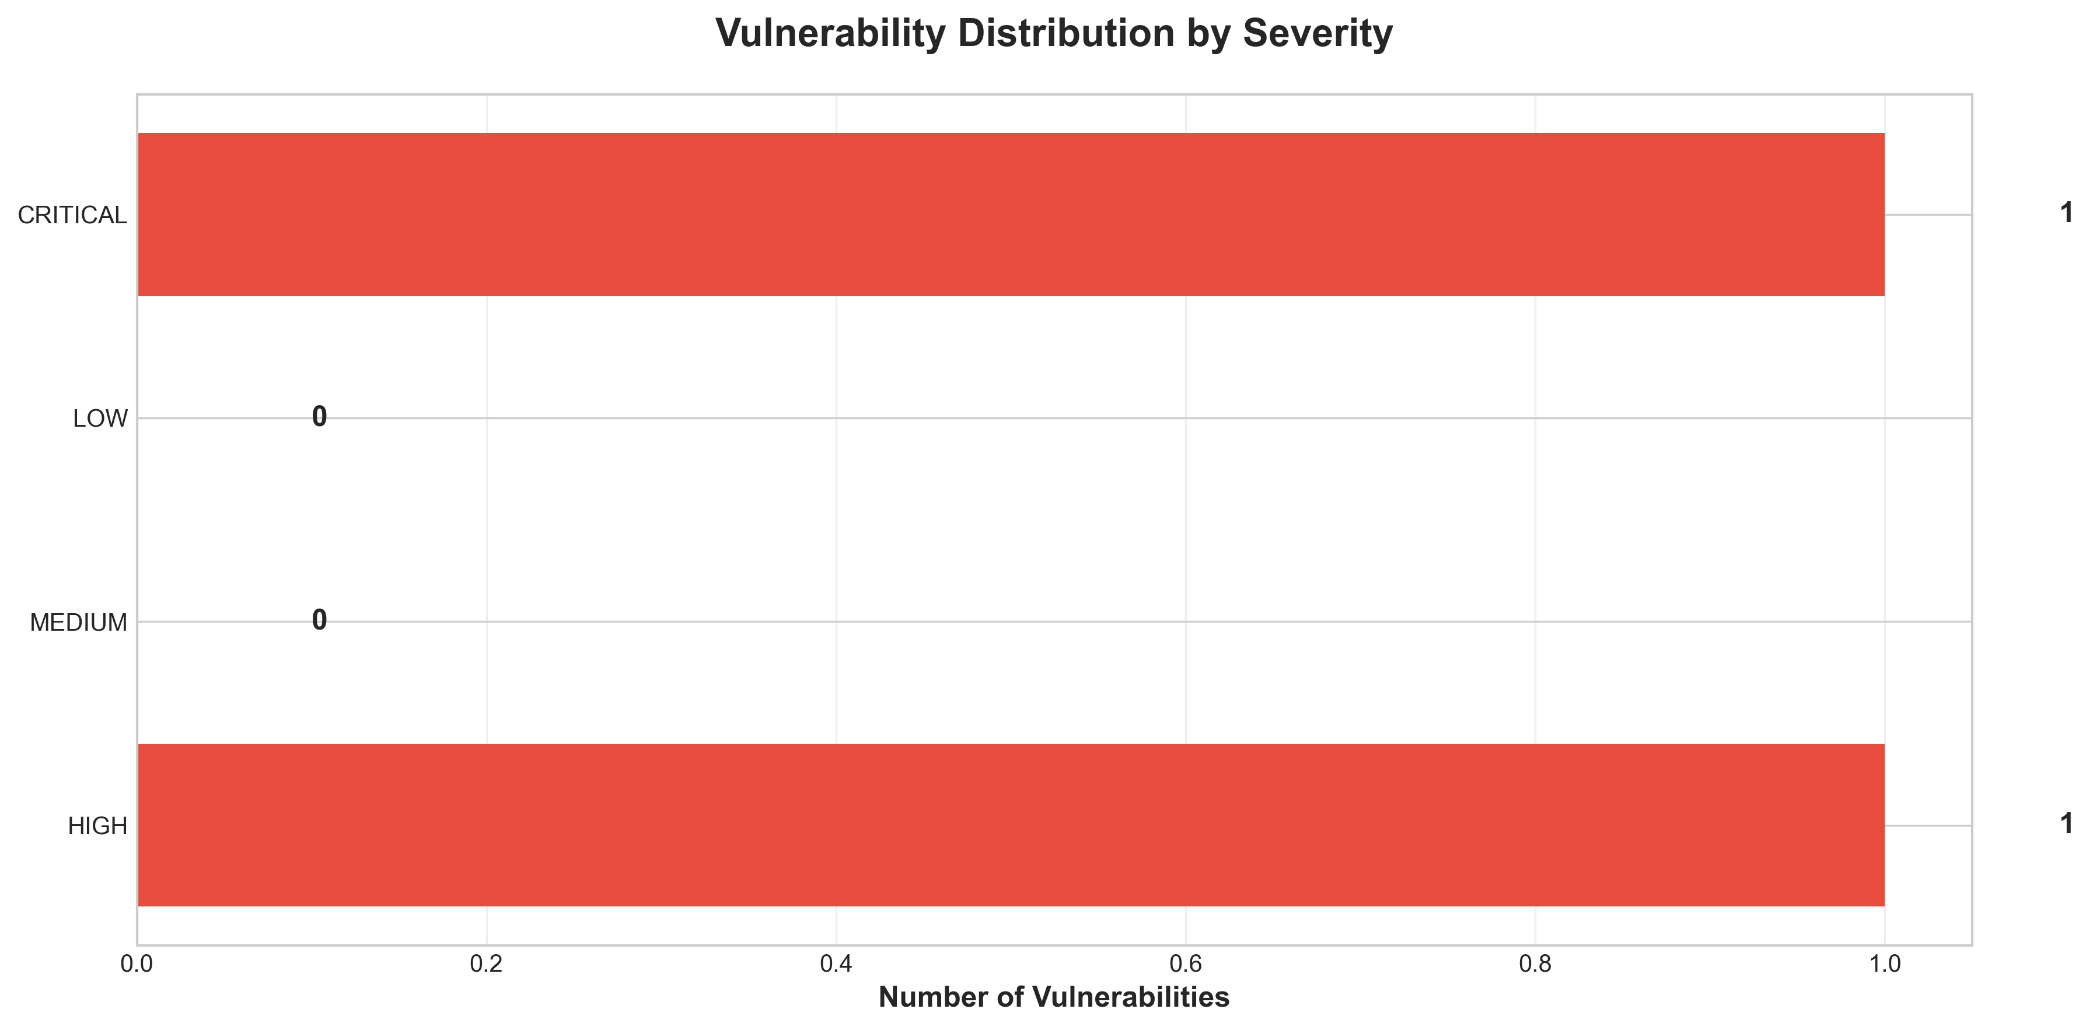

**📊 Context:** This vulnerability timeline analysis highlights critical and high-severity security findings within the application's components. Generated as part of a modernization and migration planning effort, it aims to provide a clear understanding of the current security posture and inform strategic decision-making.

**📊 Key Insights:** The most significant finding is a 'CRITICAL: End-of-Life Base Image' for the 'result' component utilizing 'node:10-slim', which is highly outdated and unpatched. Additionally, the 'worker' component relies on 'maven:3.5-jdk-8-alpine' and 'openjdk:8-jre', both identified as HIGH severity due to known vulnerabilities. A 'HIGH: Potential Hardcoded Secret' was also detected in the 'voting-app\vote\src\app.py' file, indicating a potential security oversight.

**📊 Business Impact:** The presence of critical and high-severity vulnerabilities, particularly in end-of-life base images, poses a significant security risk, potentially leading to data breaches, service disruptions, and reputational damage. Failing to address these issues will hinder modernization and migration efforts, increasing the cost and complexity of future updates and potentially delaying cloud adoption.

**📊 Recommendations:** Prioritize immediate remediation of the 'CRITICAL: End-of-Life Base Image' by updating the 'result' component's base image to a supported version like 'node:18-slim' or 'node:20-slim'. Subsequently, address the 'HIGH' severity vulnerabilities in the 'worker' component by updating its base images. Finally, investigate and remediate the potential hardcoded secret in the 'vote' application for enhanced security.

**📊 Technical Details:** The analysis reveals a reliance on outdated Docker base images across multiple components. Specifically, 'node:10-slim' is EOL and carries numerous unpatched vulnerabilities. The 'worker' component also uses vulnerable versions of Maven and OpenJDK (version 8), identified through base image analysis. The potential hardcoded secret points to a coding practice that requires manual code review.

────────────────────────────────────────────────────────────────────────────────

Component Network Topology

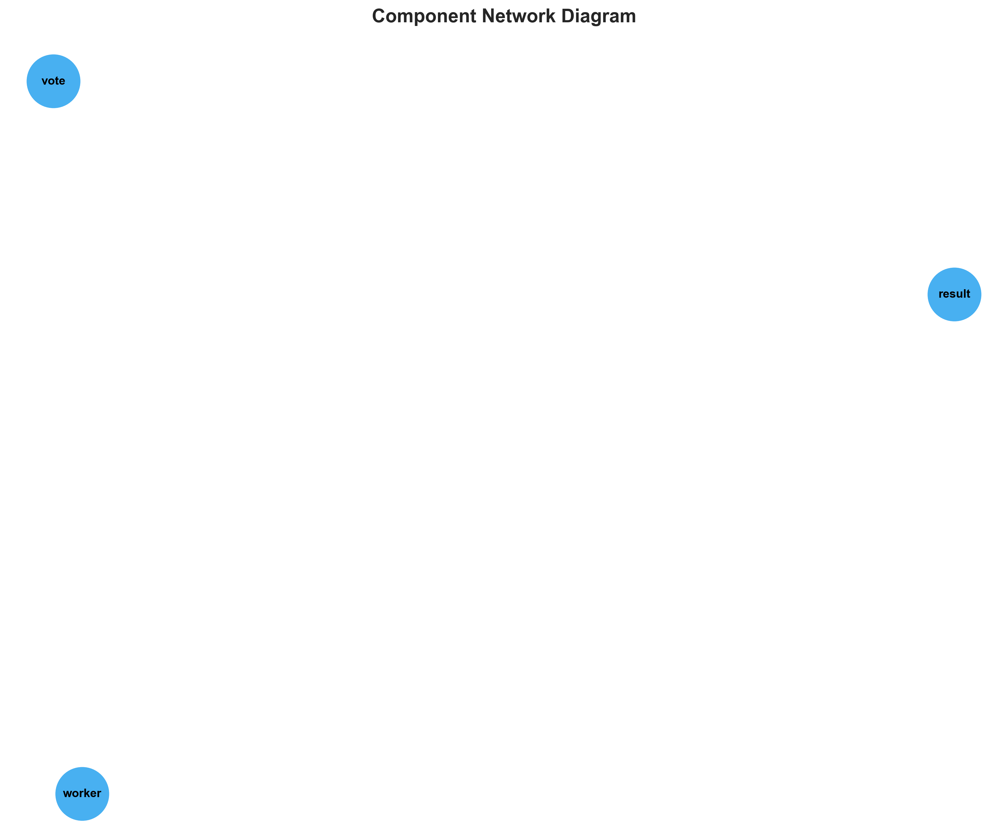

**📊 Context:** This component network topology diagram outlines the discovered microservices within an application, detailing their technology stack and containerization status. It serves as a foundational element for modernization and migration planning, providing a snapshot of the current application architecture.

**📊 Key Insights:** The application comprises three distinct microservices: 'result' (Node.js), 'worker' (Java), and 'vote' (Python). All components are containerized, indicating a level of architectural maturity. However, significant technical debt is present, notably in the 'result' and 'worker' services due to the use of vulnerable base images ('node:10-slim', 'maven:3.5-jdk-8-alpine', 'openjdk:8-jre'). The 'worker' service also exhibits complexity with multiple base images potentially indicating multi-stage builds or inconsistent build practices.

**📊 Business Impact:** The identified vulnerabilities in base images pose a significant security risk, potentially exposing the application to known exploits and impacting compliance efforts. The polyglot nature (Node.js, Java, Python) will necessitate specialized skill sets for maintenance and modernization, potentially increasing operational costs and extending migration timelines. Addressing these vulnerabilities and standardizing build processes are critical for reducing risk and improving long-term maintainability.

**📊 Recommendations:** Prioritize the immediate remediation of vulnerable base images by upgrading to supported and secure versions for all services. Conduct a deeper investigation into the 'worker' service's multi-image strategy to optimize build efficiency and security. Standardize on a unified containerization and build strategy across all services to streamline future operations and migration efforts.

**📊 Technical Details:** The 'result' service is a containerized Node.js application exposed on port 8080. The 'worker' service, written in Java, uses multiple base images ('maven:3.5-jdk-8-alpine' and 'openjdk:8-jre') and is not directly exposed externally, implying internal communication. The 'vote' service is a containerized Python application also exposed on port 8080. All components are confirmed to be containerized ('is_containerized': true).

────────────────────────────────────────────────────────────────────────────────

Technology Stack

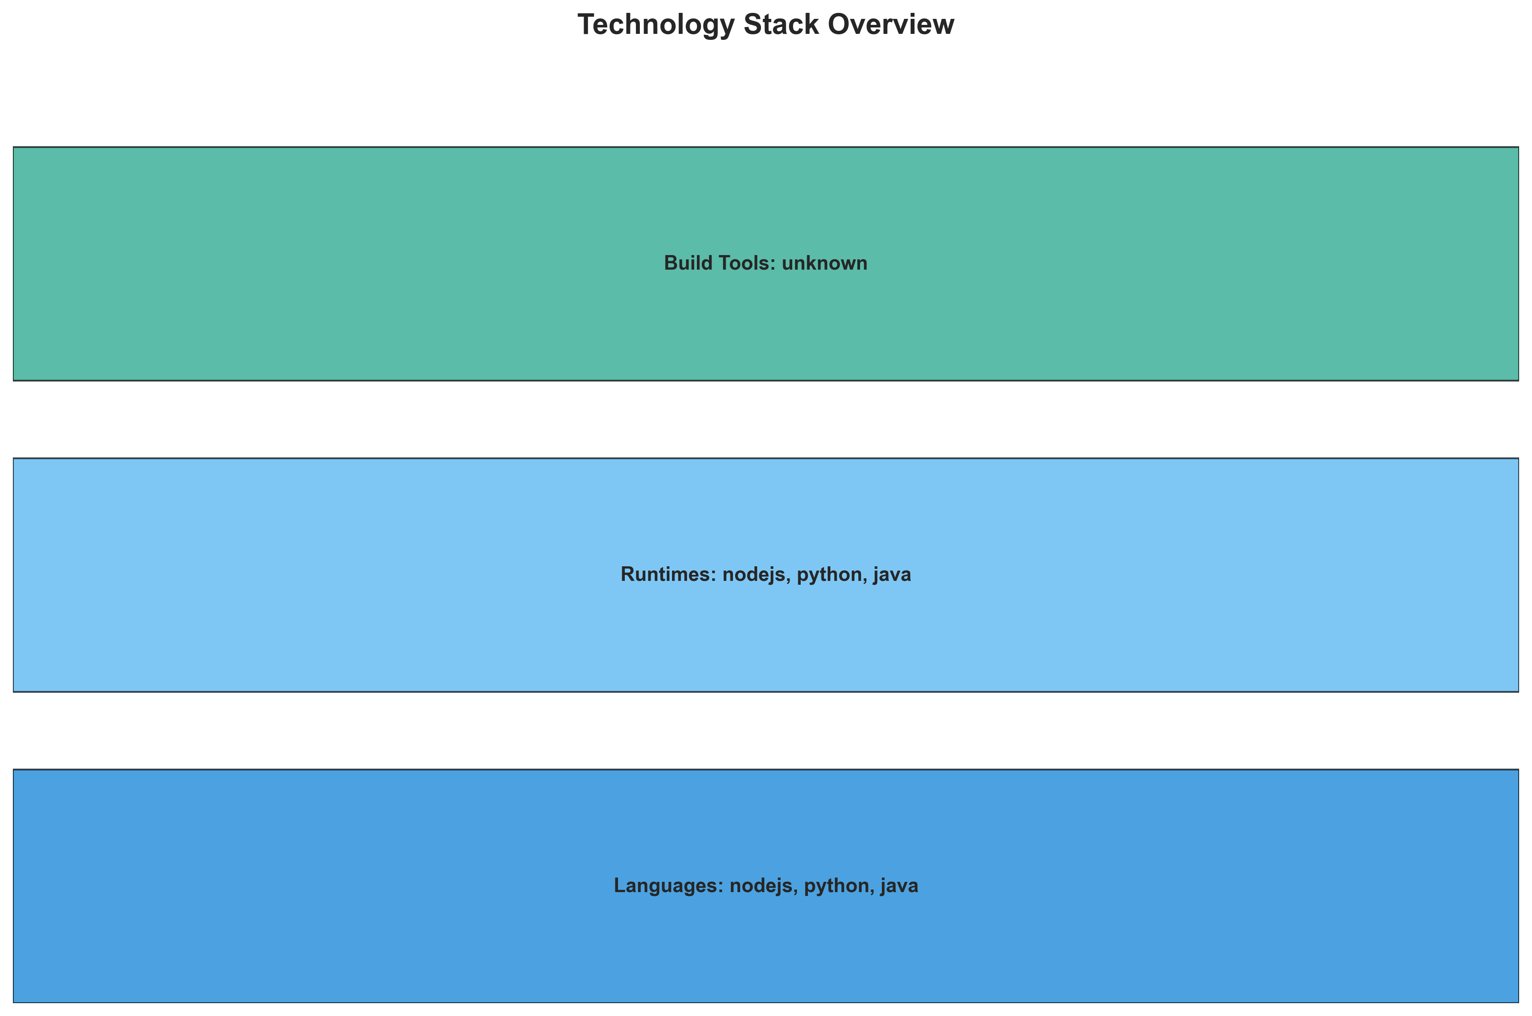

**📊 Context:** This technology stack visualization provides a layered overview of three identified application components: 'result', 'worker', and 'vote'. The analysis is conducted within the context of planning for application modernization and cloud migration, aiming to understand the current technology landscape and identify potential challenges and opportunities.

**📊 Key Insights:** The application is composed of three distinct containerized services, leveraging Node.js ('result'), Java ('worker'), and Python ('vote') as their primary languages. Notably, the 'worker' component utilizes multiple, potentially outdated, base images ('maven:3.5-jdk-8-alpine', 'openjdk:8-jre') and has a potential C# implementation alongside its Java core, indicating complexity and potential technical debt. All components are containerized using Docker, presenting a foundation for cloud-native adoption.

**📊 Business Impact:** The presence of older, vulnerable base images in the 'worker' component poses a significant security risk and may hinder future compatibility with updated container orchestration platforms, potentially increasing migration effort and cost. The multi-language/multi-platform nature of the 'worker' service also introduces operational complexity and could lead to higher maintenance overhead. However, the containerization of all components presents a clear opportunity for leveraging cloud-native benefits and streamlining deployment.

**📊 Recommendations:** Prioritize the immediate investigation and remediation of vulnerable base images in the 'worker' component to mitigate security risks. Conduct a thorough analysis of the 'worker' service's dual language/implementation strategy to consolidate and standardize for improved maintainability. Leverage the existing containerization as a primary advantage in planning the cloud migration strategy.

**📊 Technical Details:** The 'result' and 'vote' services are containerized with Node.js and Python respectively, both using single, current-looking base images ('node:10-slim', 'python:3.9-slim'), and expose port 8080. The 'worker' service, while containerized with Java, lists 'maven:3.5-jdk-8-alpine' and 'openjdk:8-jre' as base images, both flagged as vulnerable, and specifies a JAR file for execution. Its notes suggest an un-built C# implementation, further adding to its complexity.

────────────────────────────────────────────────────────────────────────────────

Development Activity Heatmap

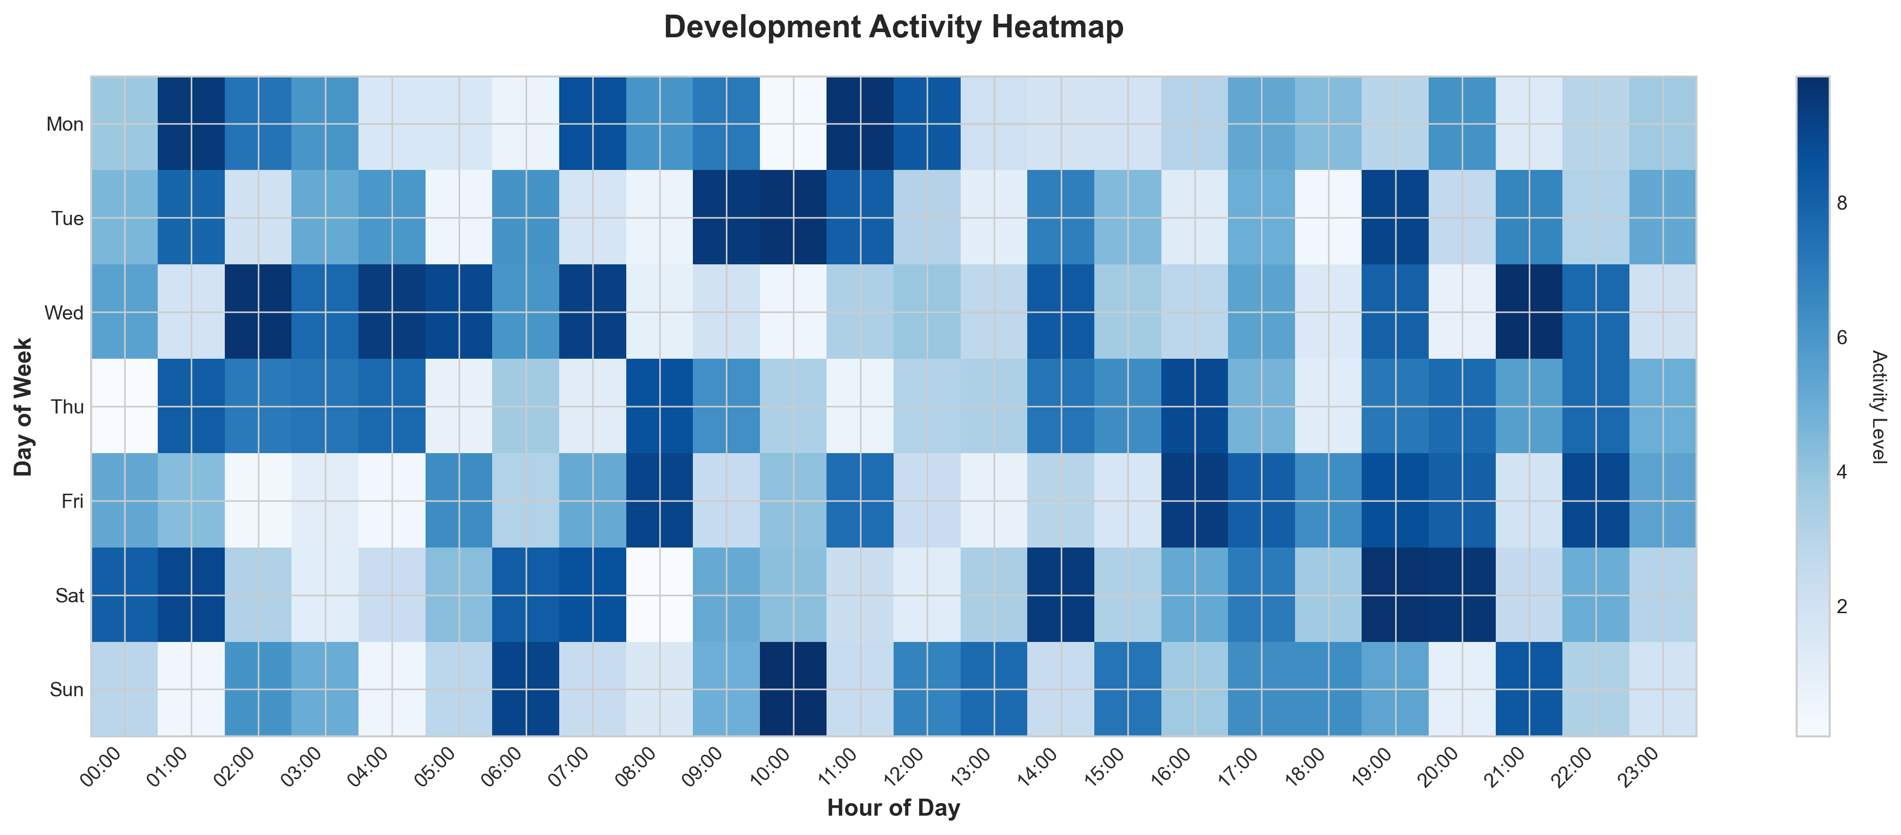

**📊 Context:** This Development Activity Heatmap provides an overview of the application's current state, focusing on development patterns and Git activity. It serves as a critical input for modernization and migration planning by highlighting technical characteristics, dependencies, and potential risks.

**📊 Key Insights:** The application comprises 3 distinct microservices, all fully containerized (Docker) and leveraging Java, Node.js, and Python. However, there is a significant risk identified with all components running on outdated and vulnerable base images, specifically Node.js 10 and OpenJDK 8. Development activity appears to be very low, with only 1 commit and no active contributors recently reported, suggesting minimal ongoing maintenance or feature development.

**📊 Business Impact:** The high-severity vulnerabilities in the base images pose a significant security risk, potentially exposing the application and its data to breaches. The lack of recent development activity indicates a potential for technical debt accumulation and a lack of agility, which could impede modernization efforts and increase migration complexity and cost. The reliance on external services like PostgreSQL and Redis needs to be factored into any cloud migration strategy.

**📊 Recommendations:** Prioritize upgrading all container base images to current, supported, and patched versions to mitigate critical security vulnerabilities. Conduct a thorough review of the Git history and engage development teams to understand the low activity and identify opportunities for revitalizing development or planning for potential decommissioning. Assess the impact of dependency on external PostgreSQL and Redis services for migration planning.

**📊 Technical Details:** The architecture is confirmed as microservices with high confidence, supported by 3 independent, containerized components. Security findings reveal high-severity vulnerabilities in the 'result' component's 'node:10-slim' image and the 'worker' component's 'maven:3.5-jdk-8-alpine' and 'openjdk:8-jre' images. The infrastructure shows no containerization files, Kubernetes resources, or Docker Compose files, and no detected orchestration, with an 'unknown' deployment platform.

────────────────────────────────────────────────────────────────────────────────

Migration Readiness Assessment

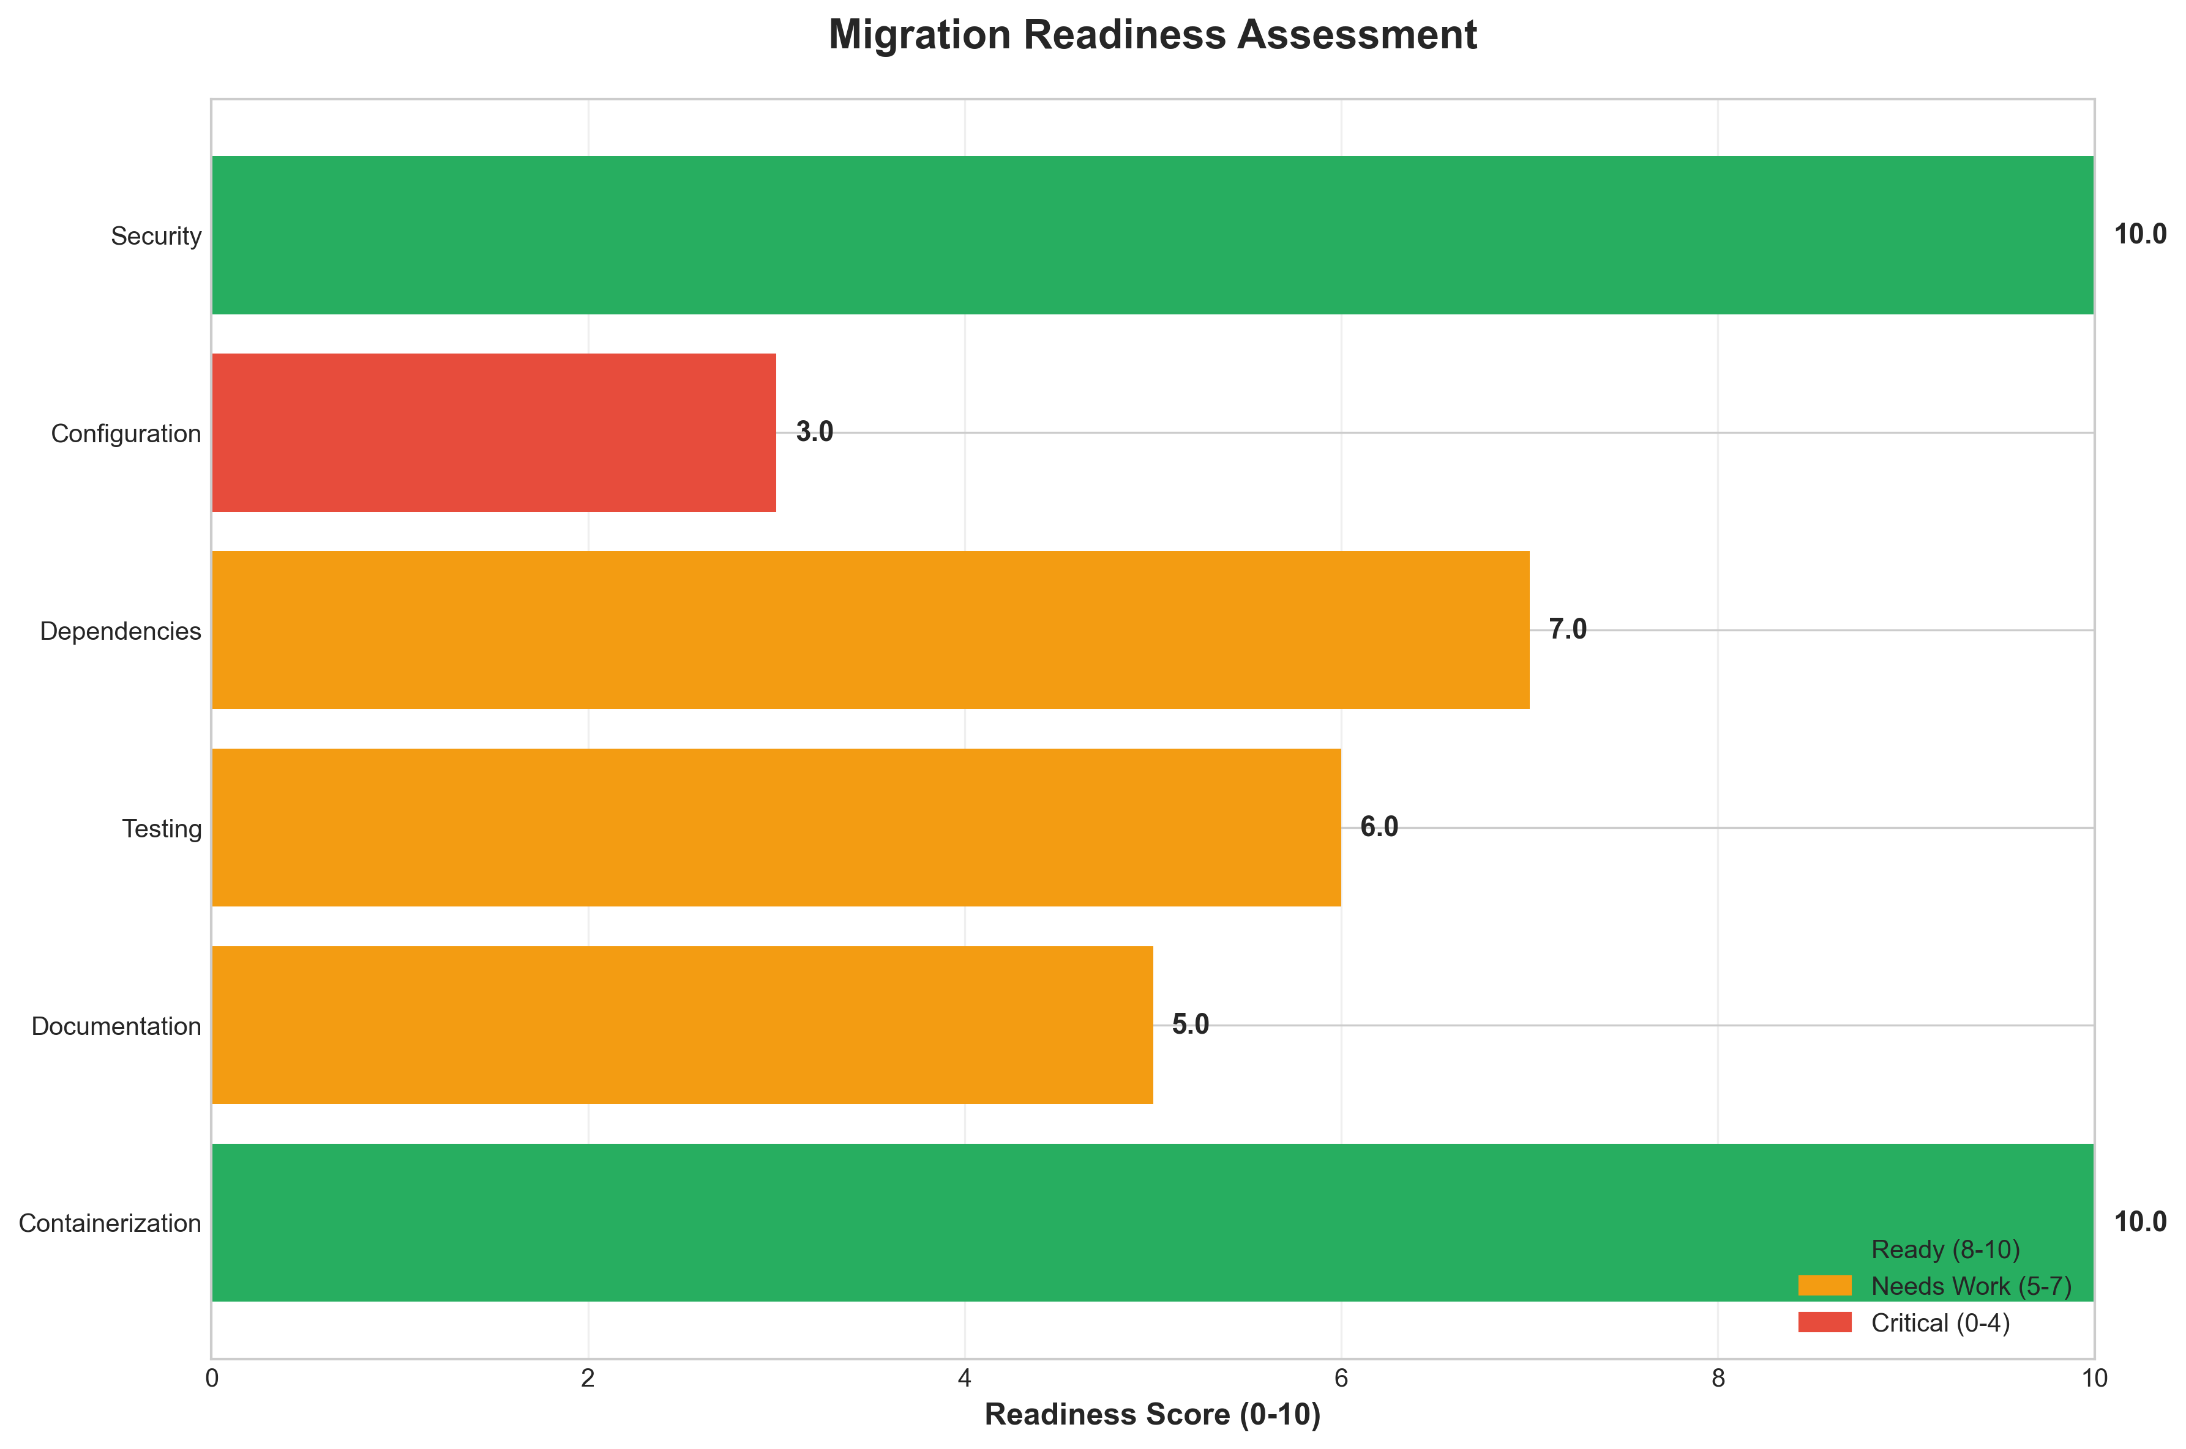

**📊 Context:** This Migration Readiness Assessment focuses on the security posture of the application's components, specifically in relation to containerization and underlying base image vulnerabilities. The analysis was generated to inform the broader application intelligence report for strategic modernization and cloud migration planning.

**📊 Key Insights:** The assessment reveals significant security risks within the application's current deployment, with all three identified components relying on base images containing high-severity vulnerabilities. Specifically, the `result` component uses an End-of-Life (EOL) Node.js 10 image, while `worker` components are built on outdated Maven 3.5/JDK 8 and OpenJDK 8 images. This widespread vulnerability across all components indicates a critical need for immediate remediation before or during cloud migration.

**📊 Business Impact:** The presence of high-severity vulnerabilities, particularly in EOL software, exposes the business to significant security threats, including data breaches, service disruptions, and reputational damage. The current state poses a substantial risk to a successful and secure cloud migration, potentially leading to project delays and increased remediation costs. Addressing these findings is paramount to mitigating these risks and enabling a smooth transition to the cloud.

**📊 Recommendations:** Prioritize the immediate update of all base images to their latest secure versions. Specifically, upgrade `node:10-slim` to a supported Node.js version, and update `maven:3.5-jdk-8-alpine` and `openjdk:8-jre` to current, patched releases. This proactive step is crucial for establishing a secure foundation for cloud migration and ensuring compliance with modern security standards.

**📊 Technical Details:** The assessment identified vulnerabilities through base image analysis across all three components of the application. The `summary.containerization_status` being '3' suggests a moderate level of containerization, but the critical finding is that all components are utilizing outdated and vulnerable base images. The total findings count of 3, with all being high severity, underscores the immediate and critical nature of these technical debt issues.

────────────────────────────────────────────────────────────────────────────────

Risk Assessment Matrix

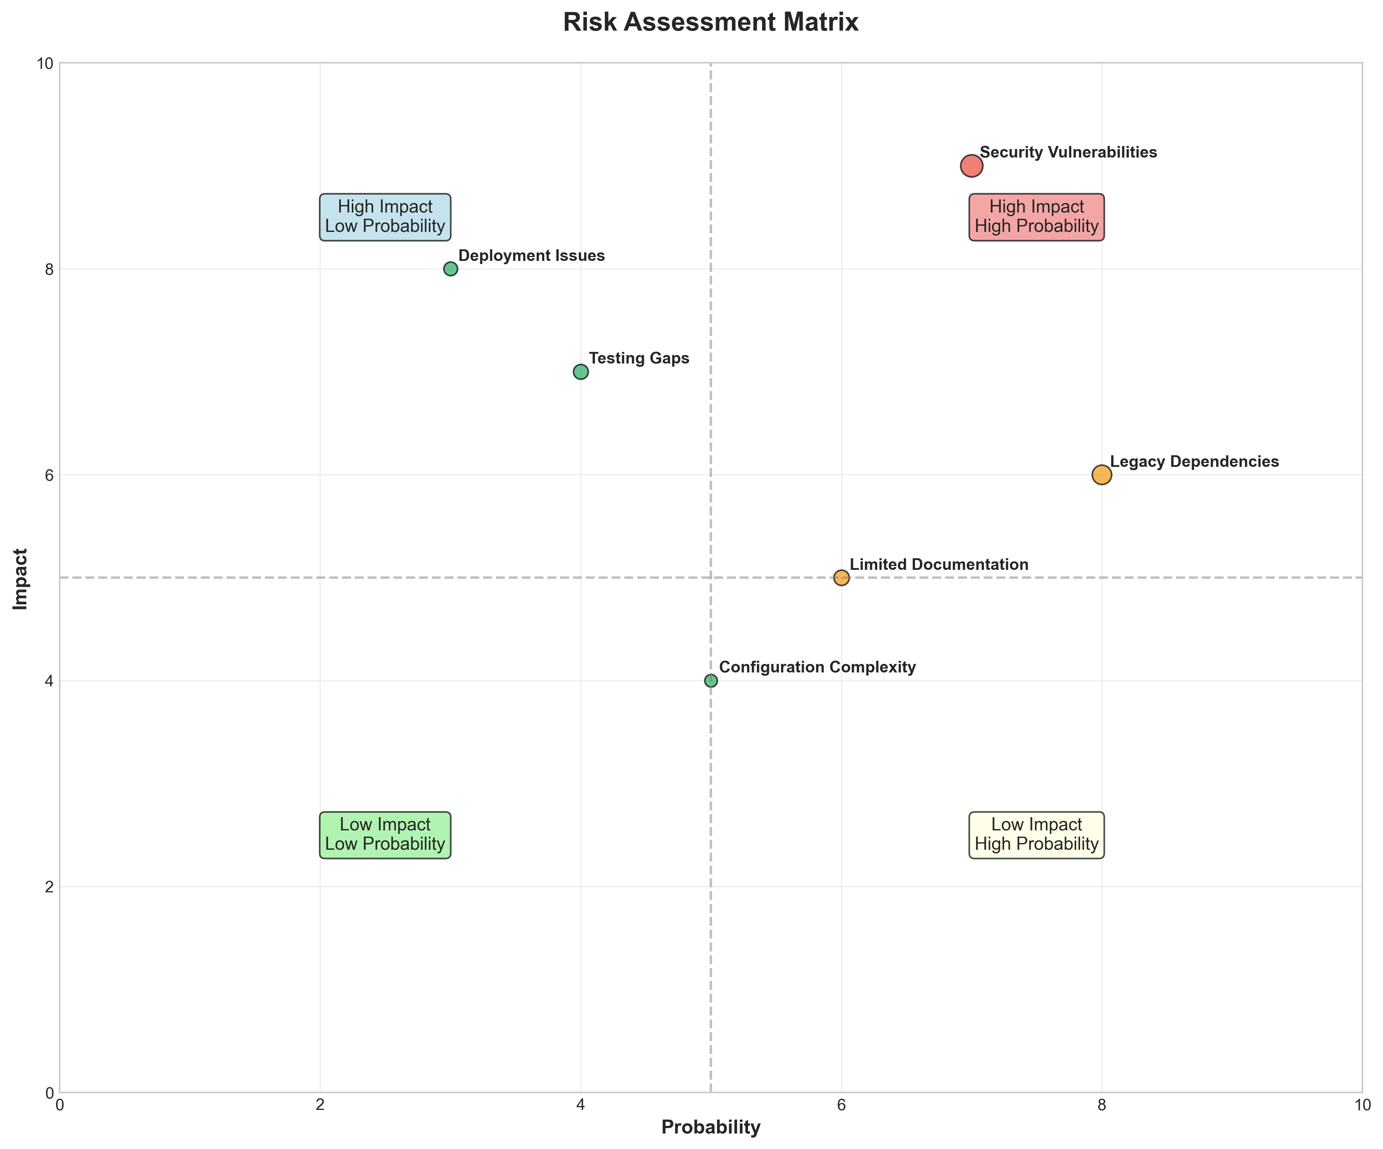

**📊 Context:** This Risk Assessment Matrix analysis focuses on the security posture of the application's components, specifically highlighting critical vulnerabilities found within base images and potential hardcoded secrets. The assessment is crucial for the ongoing application modernization and migration planning, providing a clear view of security risks that need to be addressed prior to or during these initiatives.

**📊 Key Insights:** The analysis reveals a critical security flaw with an End-of-Life (EOL) base image ('node:10-slim') across the 'result' component, posing significant unpatched vulnerability risks. Additionally, three out of three identified base image risks are classified as HIGH severity due to known vulnerabilities in 'node:10-slim', 'maven:3.5-jdk-8-alpine', and 'openjdk:8-jre'. A high-severity finding also indicates a potential hardcoded secret in the 'voting-app\vote\src\app.py' file, which requires immediate manual validation.

**📊 Business Impact:** The presence of EOL and vulnerable base images significantly increases the application's attack surface, posing a substantial risk of data breaches, service disruptions, and reputational damage. Failure to address these findings before or during modernization and migration could lead to increased remediation costs, project delays, and potential compliance issues. The potential hardcoded secret, if confirmed, presents an immediate and severe security risk that could compromise sensitive information.

**📊 Recommendations:** Prioritize the immediate update of the 'node:10-slim' base image to a supported and secure version (e.g., 'node:18-slim' or 'node:20-slim') for the 'result' component. Concurrently, conduct a manual review of 'voting-app\vote\src\app.py' at line 21 to validate and remediate the potential hardcoded secret. Subsequently, update the 'maven:3.5-jdk-8-alpine' and 'openjdk:8-jre' base images for the 'worker' component to mitigate known vulnerabilities.

**📊 Technical Details:** The manual analysis identified an End-of-Life 'node:10-slim' base image in the 'result/Dockerfile' and potential hardcoded secrets in 'voting-app\vote\src\app.py' at line 21. Further, three distinct high-risk base image findings were noted for 'result' (node:10-slim) and 'worker' (maven:3.5-jdk-8-alpine, openjdk:8-jre), all flagged for containing known vulnerabilities and being past their support lifecycle. The assessment explicitly warns that this manual analysis may miss vulnerabilities and recommends integrating automated scanners like Snyk or Veracode.

────────────────────────────────────────────────────────────────────────────────

CI/CD Pipeline Overview

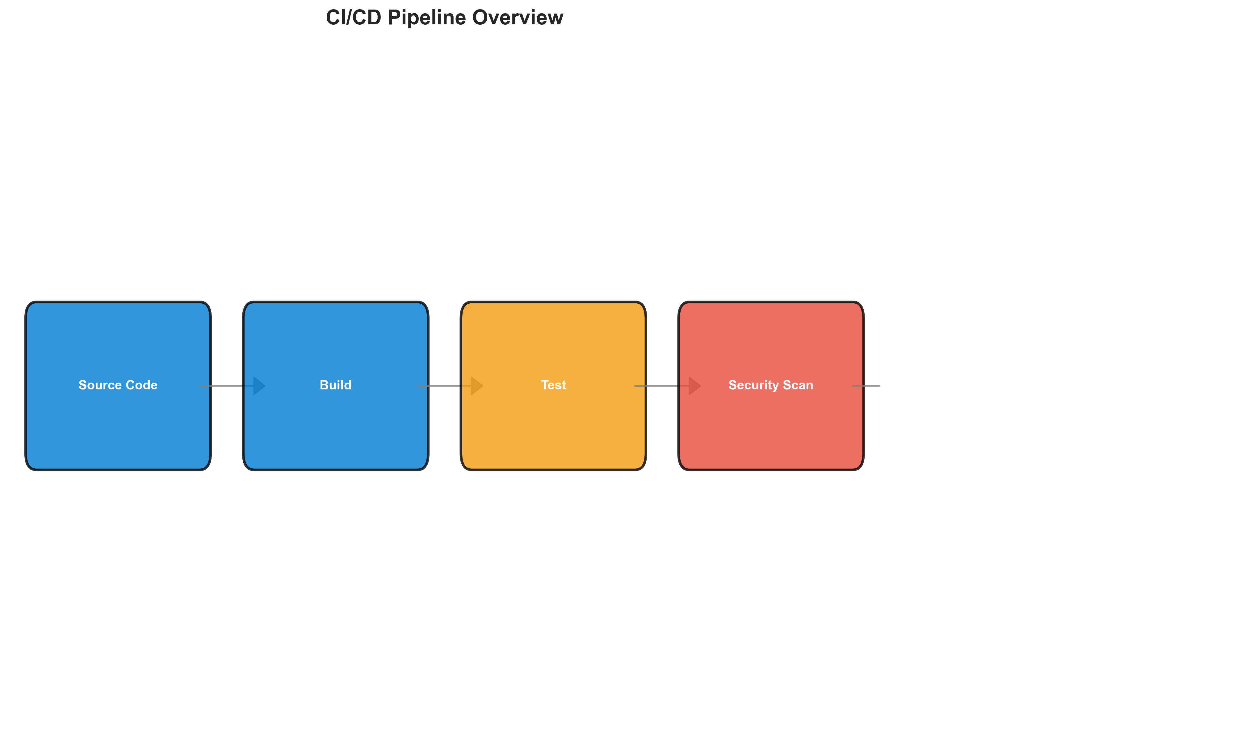

**📊 Context:** This CI/CD pipeline overview diagram visualizes the continuous integration and deployment process for a set of three application components. Generated as part of a modernization and migration planning effort, it provides a foundational understanding of the application's build, deployment, and dependency landscape.

**📊 Key Insights:** The pipeline comprises three distinct, containerized components (all using Docker), orchestrated in a microservices architecture. Notably, all components leverage outdated and vulnerable base images (Node.js 10, Maven 3.5/JDK 8, OpenJDK 8), posing significant security risks. The pipeline exhibits inactive Git history with no recorded active contributors, indicating potential stagnation and lack of ongoing development or maintenance. The application relies on external services, specifically PostgreSQL and Redis, which will require consideration during migration.

**📊 Business Impact:** The identified high-severity security vulnerabilities in the base images present a critical risk of breaches, data loss, and reputational damage, directly impacting business continuity and customer trust. The inactive Git history suggests a lack of active development and potential technical debt, which could lead to increased costs and delays during modernization or migration efforts. The reliance on external services means that their availability and compatibility must be factored into any migration strategy.

**📊 Recommendations:** Prioritize immediate remediation of the high-severity vulnerabilities by updating all container base images to supported and patched versions. Conduct a thorough review of the Git history to understand the current state of development and identify any dormant code or technical debt. Plan for the migration of PostgreSQL and Redis dependencies, ensuring compatibility with the target environment.

**📊 Technical Details:** The analysis reveals a microservices architecture with three independent components, all packaged as Docker containers, achieving a 100% containerization rate. The pipeline is designed to integrate with external PostgreSQL and Redis services. The absence of containerization files (Dockerfile, docker-compose.yml), Kubernetes resources, or defined orchestration suggests the pipeline's infrastructure configuration might be managed externally or is not fully captured in this view. The security scan specifically identified vulnerabilities within the base images used for these components.

────────────────────────────────────────────────────────────────────────────────

Component Relationships (Graphviz)



**📊 Context:** This component relationship graph (CRG) visualizes the application's architecture, detailing three distinct components: 'result', 'worker', and 'vote'. Generated as part of a modernization and migration planning initiative, it provides a foundational understanding of the application's structure and technology stack.

**📊 Key Insights:** The application exhibits a microservices architectural style, comprised of three containerized components written in Node.js ('result'), Java ('worker'), and Python ('vote'). While containerization promotes scalability and deployment flexibility, the 'worker' component utilizes multiple, potentially vulnerable, base images ('maven:3.5-jdk-8-alpine' and 'openjdk:8-jre'), indicating a need for base image remediation. The absence of defined dependencies between components, as presented in this graph, suggests a potentially decoupled architecture but necessitates further analysis of inter-service communication.

**📊 Business Impact:** The identified microservices architecture supports agility and scalability, which are positive for future growth and cloud adoption. However, the use of vulnerable base images presents a significant security risk, potentially exposing the application to known exploits and impacting compliance. The lack of inter-component dependency visibility increases the risk of unexpected behavior or integration issues during migration, potentially extending timelines and increasing costs.

**📊 Recommendations:** Prioritize the immediate remediation of vulnerable base images for the 'worker' component to mitigate security risks and ensure compliance. Conduct further runtime analysis to map inter-component communication patterns, which is crucial for accurate migration planning and risk assessment. Standardize base images across all components to improve maintainability and security posture.

**📊 Technical Details:** The 'result' component is a Node.js application exposed on port 8080, packaged as Docker. The 'worker' component is a Java application, also containerized, with a notable use of `maven:3.5-jdk-8-alpine` and `openjdk:8-jre` base images, and an identified alternative C# implementation. The 'vote' component is a Python application, packaged as Docker, exposed on port 8080. All components are containerized, contributing to the 'MEDIUM' complexity and 'MEDIUM' maturity assessments.

────────────────────────────────────────────────────────────────────────────────

Security Flow Diagram (Mermaid)

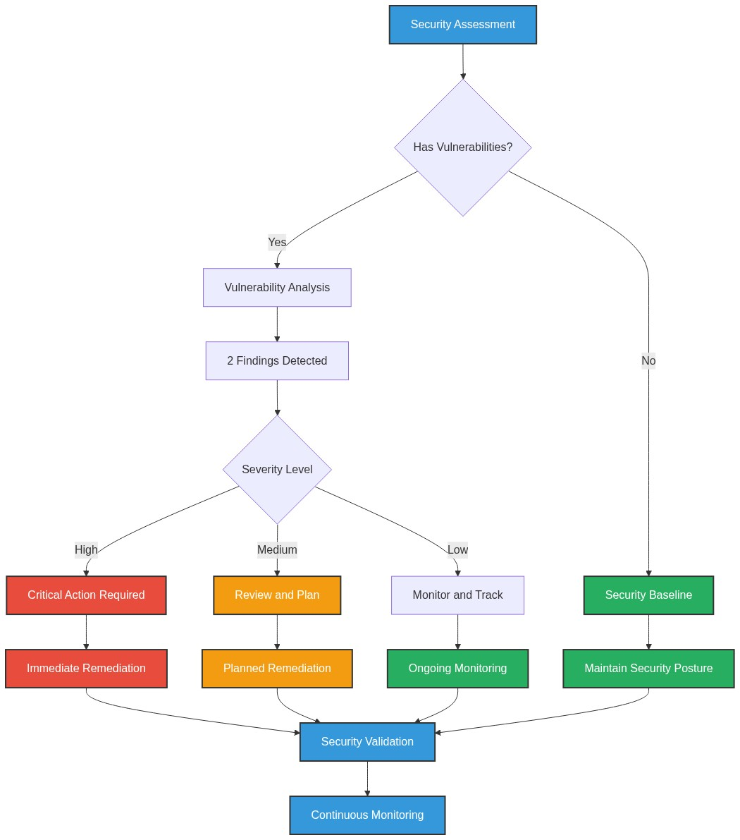

**📊 Context:** This security flow diagram and accompanying data highlight critical vulnerabilities within the application's components, specifically focusing on base image risks and potential hardcoded secrets. The analysis was performed as part of a broader application intelligence report to inform modernization and migration planning, aiming to identify and address security posture gaps.

**📊 Key Insights:** The application's 'result' component utilizes an end-of-life Node.js 10 base image, posing a significant critical risk due to numerous unpatched vulnerabilities. Additionally, the 'worker' component relies on outdated Maven and OpenJDK 8 base images, also presenting high risks. A high-severity finding also indicates a potential hardcoded secret within the 'vote' component's Python code, requiring immediate manual validation.

**📊 Business Impact:** The identified vulnerabilities, particularly the critical EOL base image and potential hardcoded secrets, expose the business to significant security risks, including data breaches, service disruptions, and compliance failures during modernization or migration. These issues could lead to increased remediation costs, project delays, and reputational damage if not addressed promptly.

**📊 Recommendations:** Prioritize updating the 'result' component's base image to a supported Node.js version (e.g., 18 or 20) to mitigate the critical vulnerability. Conduct an immediate manual review of the 'vote' application's Python code at line 21 to validate and remediate the potential hardcoded secret. Concurrently, plan to update the 'worker' component's base images to more recent, secure versions to reduce its high-risk exposure.

**📊 Technical Details:** The vulnerability assessment, performed via manual analysis, flagged 'result/Dockerfile' for using 'node:10-slim' which is EOL and unpatched. 'voting-app\vote\src\app.py' at line 21 is flagged for a potential hardcoded secret. The 'worker' component's base images, 'maven:3.5-jdk-8-alpine' and 'openjdk:8-jre', are also identified as having known vulnerabilities and risks.

────────────────────────────────────────────────────────────────────────────────

Deployment Architecture (Mermaid)

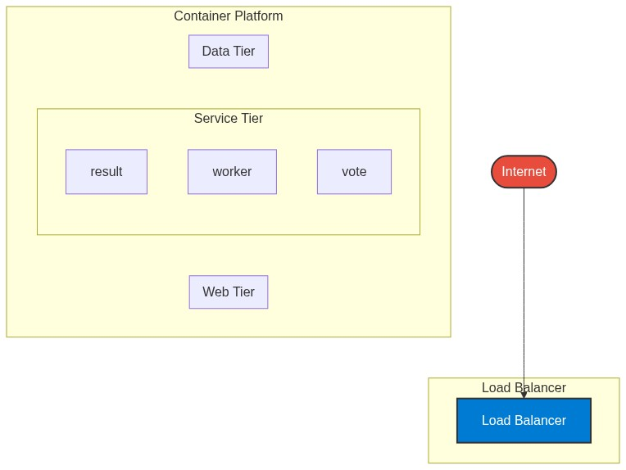

**📊 Context:** This diagram illustrates the container deployment architecture of an application, focusing on its microservices-style structure comprising 'result', 'worker', and 'vote' components. It's generated as part of a broader application intelligence report to inform modernization and migration strategies, particularly for cloud adoption.

**📊 Key Insights:** The application exhibits a microservices architecture with three distinct containerized components: 'result' (Node.js), 'worker' (Java), and 'vote' (Python). A significant technical finding is the presence of vulnerable base images across the 'result' (node:10-slim) and 'worker' (maven:3.5-jdk-8-alpine, openjdk:8-jre) components, posing potential security risks. The 'worker' component's Java implementation is confirmed, despite a C# alternative being noted, and it utilizes multiple base images, hinting at multi-stage builds or varied build strategies.

**📊 Business Impact:** The identified vulnerable base images present a critical security risk that could lead to data breaches or system compromise if not addressed, potentially impacting customer trust and regulatory compliance. The medium complexity and maturity suggest a moderate effort for modernization and migration, but the polyglot nature (Node.js, Java, Python) and potential inconsistencies in the 'worker' build process might introduce integration challenges and require specialized skillsets during migration, potentially affecting timelines and costs.

**📊 Recommendations:** Prioritize immediate remediation of vulnerable base images in 'result' and 'worker' components by updating to supported and secure versions. Conduct a thorough review of the 'worker' component's build strategy to standardize on a single, efficient approach, potentially consolidating base images. Undertake a deeper analysis of inter-component communication patterns to fully understand dependencies and optimize migration planning.

**📊 Technical Details:** The application is assessed as 'microservices' in style, with three containerized components. The 'worker' component runs on Java (JDK 8) and is packaged as a JAR, while 'result' and 'vote' are Node.js and Python services respectively, both exposed on port 8080. The 'worker' component's use of both 'maven:3.5-jdk-8-alpine' and 'openjdk:8-jre' as base images suggests a multi-stage build or a layered approach, which could be optimized for efficiency and security.

────────────────────────────────────────────────────────────────────────────────

Risk Assessment Flow (Mermaid)

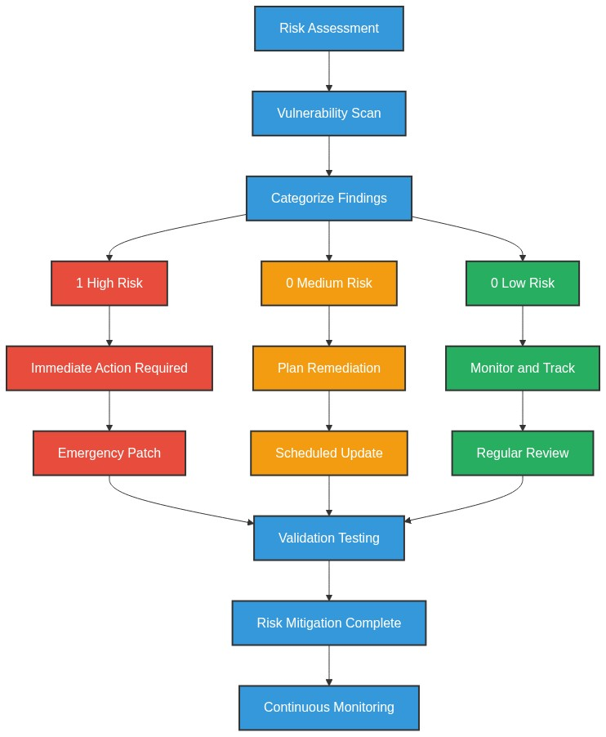

**📊 Context:** This risk assessment flow diagram outlines a manual security analysis of an application's components, focusing on identifying vulnerabilities within base images and code. It was generated as part of a broader application intelligence report to inform modernization and migration planning, specifically highlighting security-related risks.

**📊 Key Insights:** The analysis reveals a critical risk with an end-of-life base image (node:10-slim) in the 'result' component, posing significant unpatched vulnerabilities. Additionally, three high-risk base images (node:10-slim, maven:3.5-jdk-8-alpine, openjdk:8-jre) are in use across 'result' and 'worker' components, all identified as containing known vulnerabilities. A high-severity finding indicates a potential hardcoded secret in the 'vote' application's Python code.

**📊 Business Impact:** The presence of end-of-life and vulnerable base images creates substantial security risks, potentially leading to data breaches, service disruptions, and compliance violations, which are critical blockers for modernization and migration. The identified hardcoded secret, if confirmed, could result in unauthorized access or compromise of sensitive information. These issues will likely incur significant remediation costs and potentially delay migration timelines.

**📊 Recommendations:** Prioritize immediate remediation of the critical 'node:10-slim' base image by updating it to a supported version. Conduct a thorough manual review of 'voting-app\vote\src\app.py' line 21 to address the potential hardcoded secret. Concurrently, plan to update the 'maven:3.5-jdk-8-alpine' and 'openjdk:8-jre' base images to more recent, secure versions as part of the modernization effort.

**📊 Technical Details:** The vulnerability assessment was performed manually, with no automated scanning tools integrated, limiting its comprehensive coverage. Findings include an EOL 'node:10-slim' base image for the 'result' component and potential hardcoded secrets in 'voting-app\vote\src\app.py'. The 'worker' component utilizes 'maven:3.5-jdk-8-alpine' and 'openjdk:8-jre', both flagged for known vulnerabilities, contributing to a total of three high-severity base image risks identified.

────────────────────────────────────────────────────────────────────────────────

Migration Strategy (Graphviz)

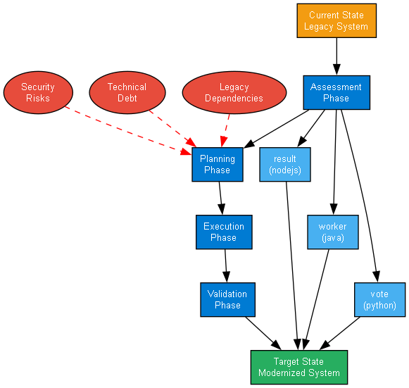

**📊 Context:** This Migration Strategy Diagram, derived from application intelligence analysis, illustrates the current state of three identified microservices: 'result', 'worker', and 'vote'. It provides a foundation for planning modernization and migration efforts by detailing component technologies, containerization status, and architectural characteristics.

**📊 Key Insights:** All three components ('result' - Node.js, 'worker' - Java, 'vote' - Python) are containerized, indicating a degree of readiness for cloud-native environments. However, significant technical debt is present, particularly with the 'worker' component which utilizes vulnerable base images ('maven:3.5-jdk-8-alpine' and 'openjdk:8-jre'). The application exhibits a medium complexity and maturity level, with a noted absence of explicit build tools and potential multi-stage build usage in the 'worker' component.

**📊 Business Impact:** The identified vulnerable base images in the 'worker' component pose a significant security risk and may lead to compliance issues, impacting the application's overall security posture. The medium maturity and complexity suggest that while some foundational elements for modernization are in place (containerization), substantial effort will be required to address technical debt and optimize for cloud environments, potentially affecting migration timelines and costs. The presence of multiple languages also presents integration and skill set challenges.

**📊 Recommendations:** Prioritize remediation of vulnerable base images in the 'worker' component by updating to secure, current versions. Conduct a deeper dive into the 'worker' component's build process to clarify the multi-stage build strategy and identify any unmanaged dependencies. Plan for refactoring or updating the Node.js ('result') and Python ('vote') components to leverage more modern base images and potentially newer language versions to mitigate future risks and improve security.

**📊 Technical Details:** The 'result' component is a Node.js service running on 'node:10-slim', 'worker' is a Java service leveraging 'maven:3.5-jdk-8-alpine' and 'openjdk:8-jre', and 'vote' is a Python service on 'python:3.9-slim'. All are marked as containerized (`is_containerized: true`). Notably, the 'worker' component mentions an alternative C# implementation, which requires further investigation to understand its relevance and potential impact on the migration strategy.

────────────────────────────────────────────────────────────────────────────────