[COMPANY LOGO]

Application Intelligence Report

Comprehensive Analysis and Migration Assessment

Repository: file://D:\Projects-D\migration-assisant-mvp12\migration-analyzer

Analysis Date: July 18, 2025

*Generated by Application Intelligence Platform*

Table of Contents

Executive Summary........................................... 3

Application Overview........................................ 4

Component Analysis.......................................... 5

Architecture Assessment..................................... 8

Security Analysis........................................... 10

Git History Analysis........................................ 12

Recommendations............................................. 13

Appendices.................................................. 15

Executive Summary

|  |  |
| --- | --- |
| **Metric** | **Value** |
| Total Components | 0 |
| Programming Languages |  |
| Containerization Status | 0 containerized |
| Data Sources | 3 |
| Security Findings | 0 |
| Git Commits | None |
| Architecture Style | monolithic |

Application Overview

This report presents a comprehensive analysis of the application repository. The analysis identified 0 components using 0 different programming languages. The application demonstrates a monolithic architecture pattern.

Key Findings

• 📊 0 application components identified

• 🔧 0 programming languages detected:

• 🐳 0 components are containerized

• 🗃️ 3 data sources identified

• 🔐 0 security findings require attention

Detailed Analysis

Component Analysis

No components were identified in this analysis.

Architecture Analysis

Architecture Style: unknown (Confidence: ConfidenceLevel.LOW)

Reasoning: Insufficient evidence to determine architecture style

**Evidence:**

• Found 0 components

• No containerization detected

Security Analysis

Security analysis identified 2 findings with 0 base image risks.

**Key Security Findings:**

• Unknown: A pattern matching a potential API key was detected in the code. (Severity: HIGH)

• Unknown: A pattern matching a potential API key was detected in the code. (Severity: HIGH)

Git History Analysis

• Total Commits: 0

• Active Contributors: 0

• Recent Activity: unknown

• Code Stability: unknown

Recommendations

🚨 High Priority Recommendations

• SECURITY Security: 2 critical/high severity vulnerabilities found. Prioritize security remediation.

ℹ️ Low Priority Recommendations

• ARCHITECTURE Architecture Assessment: unknown detected with LOW confidence. Consider documenting architecture decisions for clarity.

Appendices

Appendix A: Technical Details

This analysis was generated using the Application Intelligence Platform, which performs comprehensive analysis of application repositories including code structure, infrastructure configuration, and security assessment.

Appendix B: Analysis Methodology

• Component Discovery: Automated scanning of source code and configuration files

• Language Detection: Analysis of file extensions, build configurations, and base images

• Architecture Assessment: Evaluation of deployment patterns and component relationships

• Security Analysis: Scanning for common vulnerabilities and configuration issues

• Git History Analysis: Examination of commit patterns and development activity

Charts and Visualizations

Component Status Overview

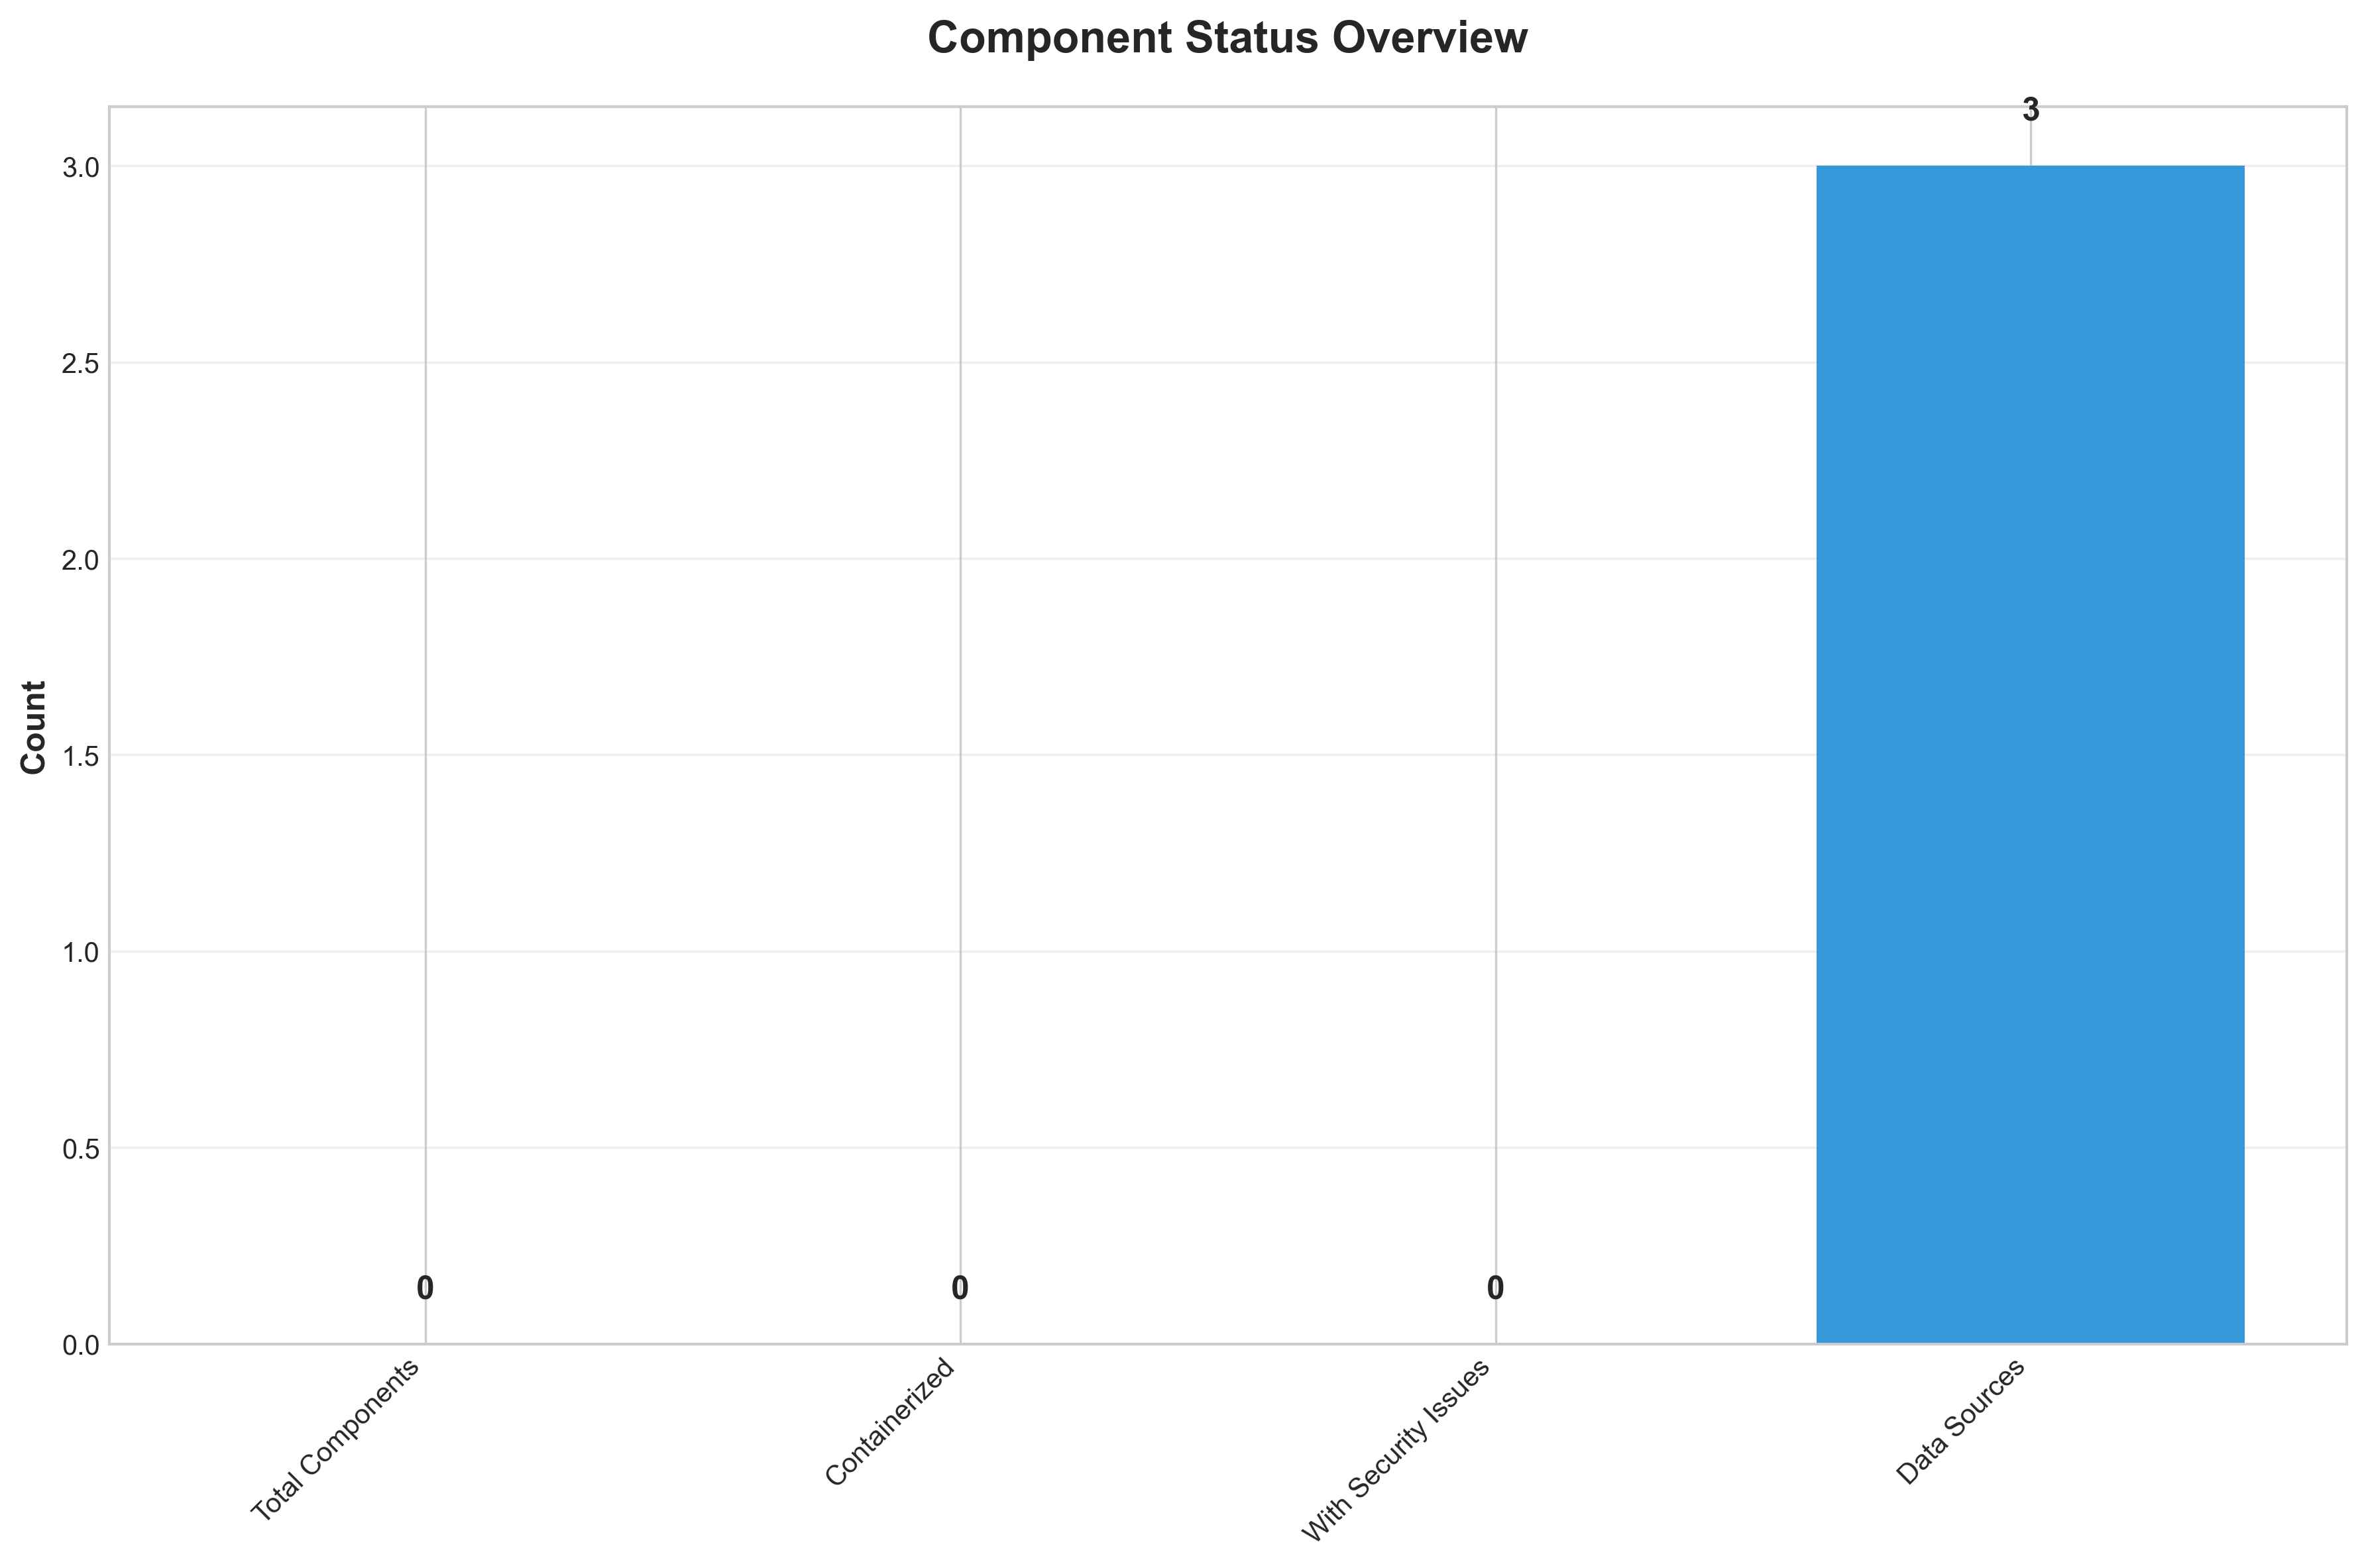

**📋 Context:** This Component Status Overview diagram provides a snapshot of the application's overall health and status, with a specific focus on security findings. It is crucial for informing our application modernization and migration planning by highlighting potential technical debt and risks.

**📋 Key Insights:** The scan performed using the 'base_image_analysis' method found zero security findings across all severity levels (high, medium, low). This indicates a remarkably clean security posture for the application's base image at the time of the scan. The absence of findings suggests a proactive approach to securing the foundational elements of the application.

**📋 Business Impact:** The lack of identified security findings presents a significant opportunity for a smoother and potentially faster modernization and migration process. It reduces the immediate risk of security vulnerabilities blocking or delaying cloud adoption and can minimize the need for extensive security remediation efforts post-migration, thereby controlling costs and timelines. This clean slate allows us to focus on functional modernization rather than emergency security fixes.

**📋 Recommendations:** Given the excellent security scan results, prioritize the functional aspects of modernization and migration. Continue regular security scans, including dynamic and runtime analysis, to maintain this secure posture as the application evolves. Consider this a green light to accelerate planning and execution of modernization initiatives, focusing on architecture, performance, and scalability improvements.

**📋 Technical Details:** The scan methodology, 'base_image_analysis,' specifically targets vulnerabilities within the container or underlying operating system image. The absence of any findings (total_findings: 0) across all severity levels (high_severity_count: 0, medium_severity_count: 0, low_severity_count: 0) is a strong indicator of a well-maintained and hardened base environment.

────────────────────────────────────────────────────────────────────────────────

Security Assessment Radar

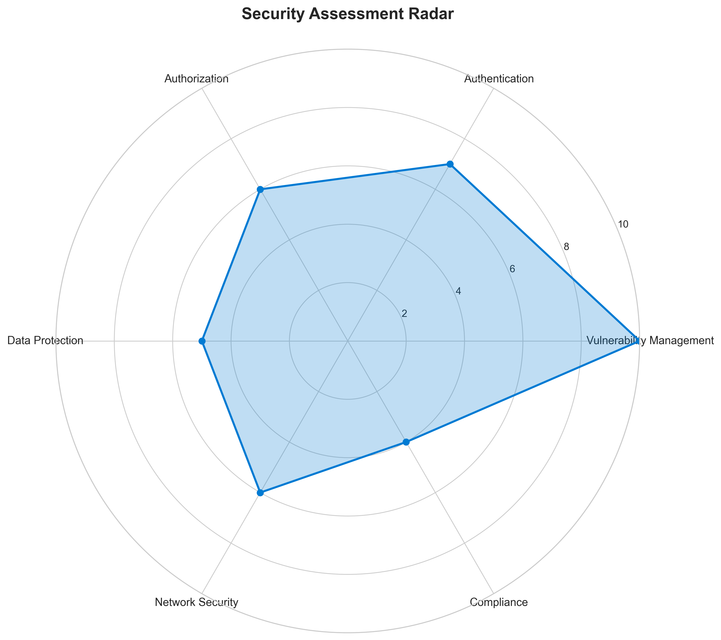

**📋 Context:** This Security Assessment Radar diagram provides a multi-dimensional analysis of the application's security posture, specifically generated to inform modernization and cloud migration planning. It highlights potential security weaknesses identified through a manual review, aiming to identify risks that could impact the migration process.

**📋 Key Insights:** The analysis reveals two high-severity findings concerning potential hardcoded secrets in the `test_basic.py` (line 45) and `tests\unit\test_hld_synthesizer.py` (line 209) files. Notably, no automated vulnerability scanning was performed, limiting the scope of detection and increasing the risk of undiscovered vulnerabilities. The application's broader security posture, including authentication, authorization, and encryption, is largely unknown or unassessed.

**📋 Business Impact:** The presence of hardcoded secrets presents a significant security risk, potentially leading to unauthorized access and data breaches, which could incur substantial financial penalties and reputational damage. The lack of automated scanning and comprehensive security posture information creates uncertainty for the migration, potentially delaying timelines and increasing costs due to unforeseen remediation efforts.

**📋 Recommendations:** Immediately prioritize manual validation and remediation of the identified hardcoded secrets by removing them and implementing secure secret management practices. Implement automated vulnerability scanning (e.g., Snyk, Veracode) and a thorough assessment of authentication, authorization, and encryption mechanisms before proceeding with modernization and migration.

**📋 Technical Details:** The manual analysis identified patterns resembling API keys in two Python files. The absence of `cve_id`, `package`, and `version` for these findings indicates they are likely code-level issues rather than dependency vulnerabilities. The `security_posture` section is largely populated with 'unknown' or 'false' values, indicating a significant gap in understanding the application's security controls and compliance.

────────────────────────────────────────────────────────────────────────────────

Vulnerability Analysis

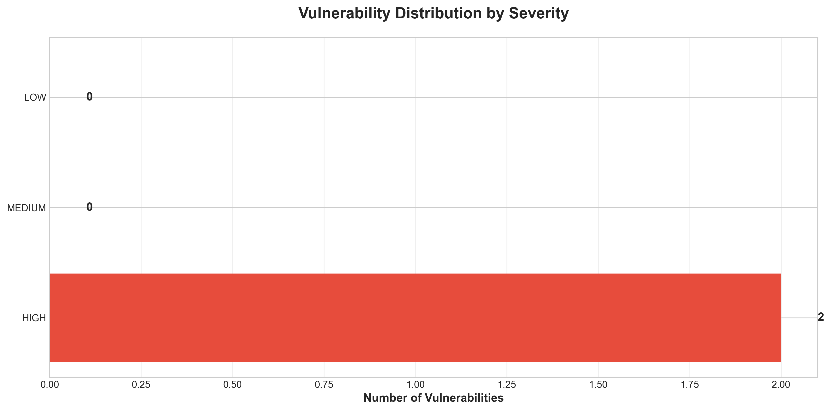

**📋 Context:** This vulnerability timeline analysis, focused on security vulnerabilities by severity and timeline, is crucial for the application modernization and migration planning. It highlights immediate security risks that require attention before or during the migration process.

**📋 Key Insights:** The analysis reveals two high-severity vulnerabilities related to potential hardcoded secrets, specifically API keys, within the application's codebase. These findings are critical as they represent direct security risks. The lack of CVE IDs suggests these are custom code issues rather than known, publicly disclosed vulnerabilities.

**📋 Business Impact:** The presence of hardcoded secrets poses a significant security risk, potentially leading to unauthorized access, data breaches, and reputational damage. Addressing these vulnerabilities is essential to ensure a secure migration to a modernized environment and to prevent costly security incidents. Failure to remediate could delay migration timelines or necessitate costly rework.

**📋 Recommendations:** Prioritize the immediate remediation of the two identified high-severity 'Potential Hardcoded Secret' findings in `test_basic.py` and `tests\unit\test_hld_synthesizer.py`. Implement a secure secrets management strategy, such as using environment variables or dedicated secrets management tools, to replace these hardcoded values. Conduct a thorough review of the entire codebase for similar hardcoded secrets.

**📋 Technical Details:** The findings indicate patterns matching API keys were detected in `test_basic.py` at line 45 and `tests\unit\test_hld_synthesizer.py` at line 209. The recommended fix involves removing these hardcoded secrets and utilizing more secure methods like environment variables or a secrets management system, which are standard best practices for cloud-native applications.

────────────────────────────────────────────────────────────────────────────────

Migration Readiness Assessment

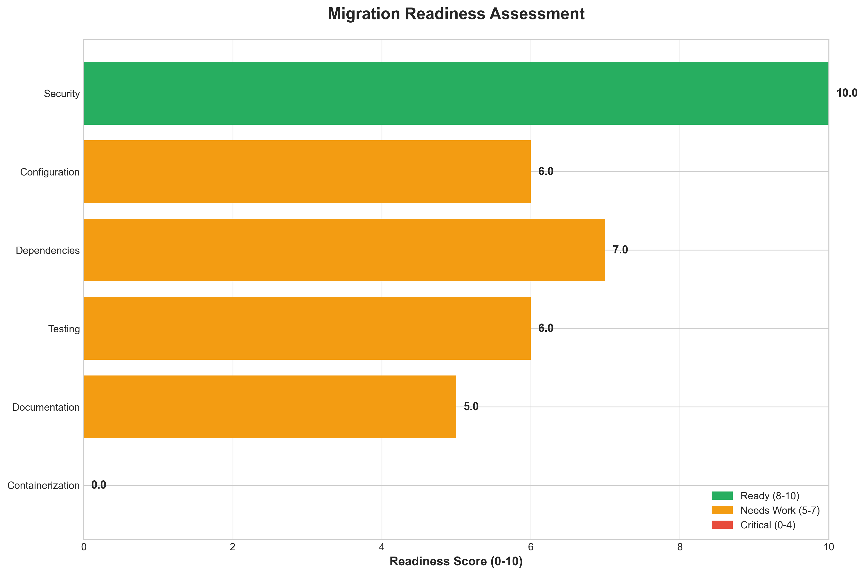

**📋 Context:** This Migration Readiness Assessment diagram focuses on the security posture of an application, specifically evaluating its preparedness for cloud migration based on base image analysis. The assessment was conducted to identify any potential security vulnerabilities that could hinder or complicate the migration process and impact the overall security of the application in a cloud environment.

**📋 Key Insights:** The analysis reveals a strong security foundation for this application concerning its base image. With no security findings reported (total_findings: 0), including zero high, medium, or low severity issues, the application's base image is demonstrably clean. This indicates a robust adherence to secure build practices or effective prior remediation efforts.

**📋 Business Impact:** The absence of security findings in the base image significantly de-risks the cloud migration initiative from a security perspective. This allows for a potentially smoother and faster migration timeline, as there are no immediate security blockers or remediation tasks required for the underlying components. It also reduces the likelihood of unexpected security incidents post-migration, thereby safeguarding business operations and data.

**📋 Recommendations:** Given the strong security posture of the base image, the next priority should be to conduct similar readiness assessments across other critical areas such as application code, dependencies, and deployment configurations. Focus should also be placed on validating that the security controls inherent in the base image translate effectively to the target cloud environment.

**📋 Technical Details:** The scan was performed using a 'base_image_analysis' method, which typically inspects the underlying operating system and pre-installed software for known vulnerabilities. The successful completion of this scan with zero findings suggests that the foundational layers of the application are well-hardened and likely compliant with security benchmarks.

────────────────────────────────────────────────────────────────────────────────

Risk Assessment Matrix

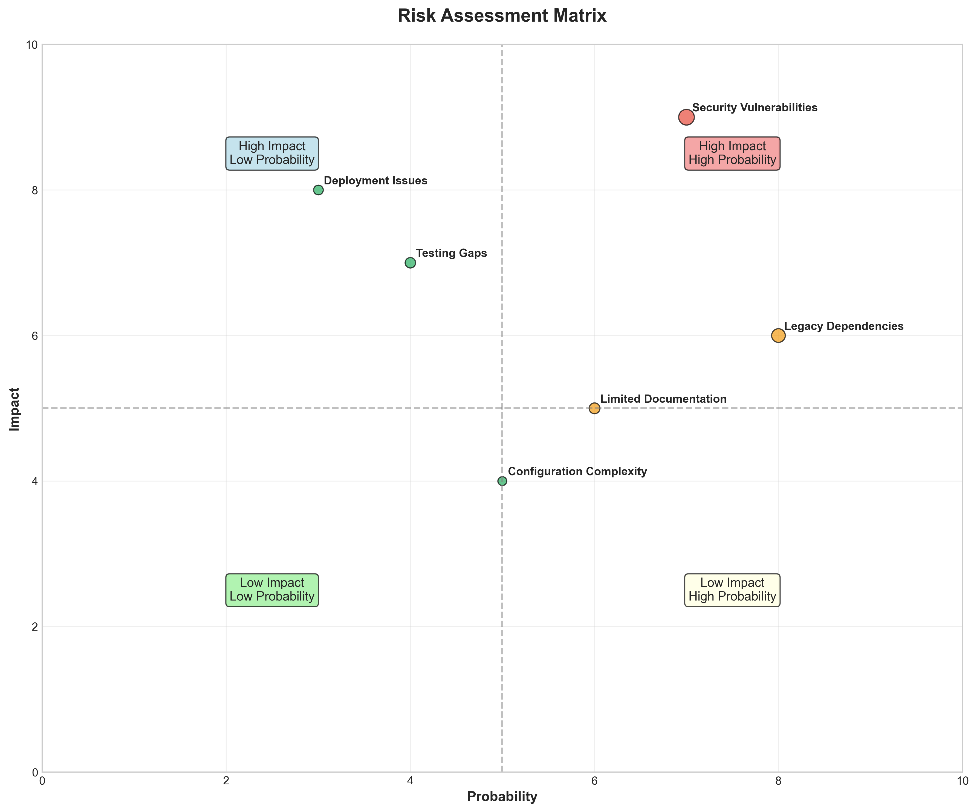

**📋 Context:** This risk assessment matrix highlights critical security vulnerabilities identified during a manual review of the application's codebase. The analysis was performed as part of a broader application intelligence report to inform modernization and cloud migration planning, specifically focusing on inherent risks within the current application state.

**📋 Key Insights:** The analysis uncovered two high-severity findings related to potential hardcoded secrets within Python test files ('test_basic.py' and 'tests\unit\test_hld_synthesizer.py'). Crucially, no automated vulnerability scans were performed, meaning the current security posture is based on limited manual detection and may be incomplete. The manual analysis relied on pattern matching, emphasizing the need for further investigation to confirm if these are actual secrets or false positives.

**📋 Business Impact:** The presence of hardcoded secrets poses a significant security risk, potentially leading to unauthorized access to sensitive systems or data if exploited. This directly impacts the trustworthiness and compliance of the application, especially during a modernization and migration effort. Addressing these vulnerabilities is critical to avoid data breaches, reputational damage, and potential regulatory penalties, which could delay or increase the cost of migration.

**📋 Recommendations:** Immediately prioritize the manual validation and remediation of the two identified high-severity findings related to hardcoded secrets. Implement automated vulnerability scanning tools (e.g., Snyk, Veracode) as a foundational step for future security assessments and ongoing monitoring. Integrate secure coding practices and secrets management solutions into the development lifecycle to prevent recurrence.

**📋 Technical Details:** The findings, identified on line 45 of 'test_basic.py' and line 209 of 'tests\unit\test_hld_synthesizer.py', are flagged due to patterns resembling API keys. The lack of automated scanning means that other potential vulnerabilities, including outdated dependencies or base image risks, may remain undetected. The 'manual_analysis' tool indicates a reliance on ad-hoc code review rather than systematic security testing.

────────────────────────────────────────────────────────────────────────────────

CI/CD Pipeline Overview

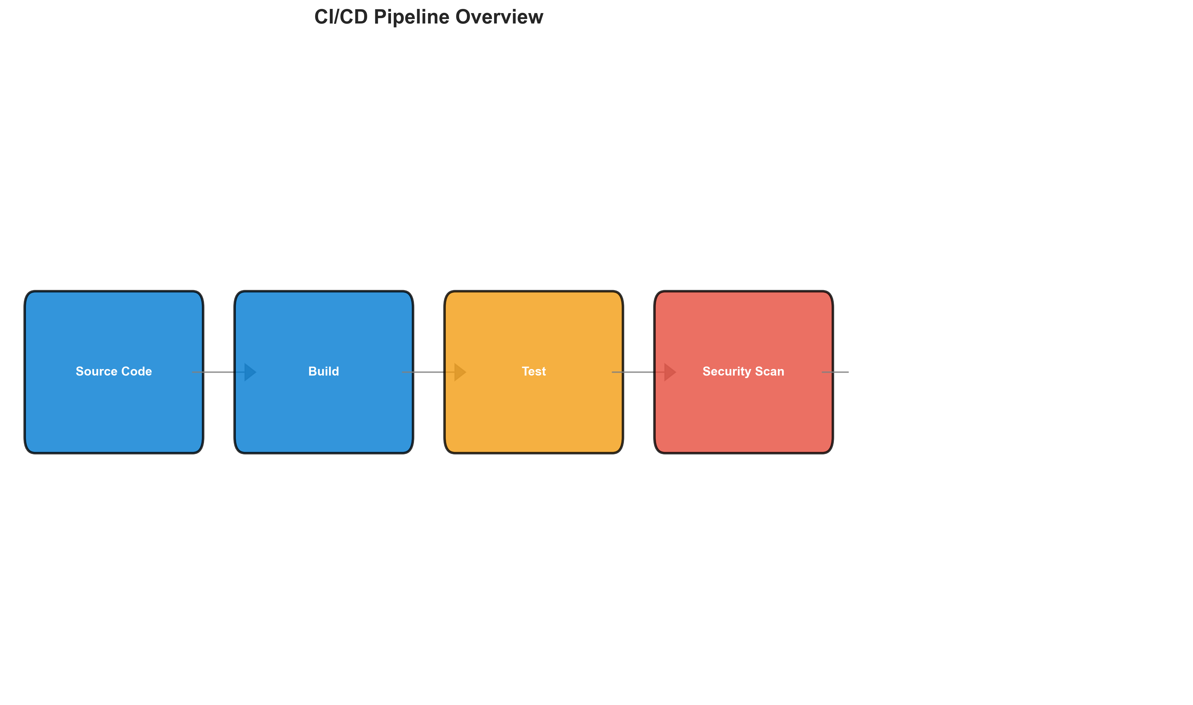

**📋 Context:** This diagram provides an overview of the CI/CD pipeline for a specific application, focusing on its current state of integration and deployment practices. It was generated as part of a broader application intelligence report to inform modernization and migration planning, highlighting areas of technical debt and opportunities for improvement.

**📋 Key Insights:** The analysis reveals a monolithic architecture that currently lacks any containerization or orchestration. Despite the presence of multiple external services (5 distinct services including duplicate entries for MongoDB and Redis), the CI/CD pipeline itself appears to be rudimentary, with zero containerization files and no detected Kubernetes or Docker Compose resources. The security scan reported no findings, but its scope was limited to base image analysis, suggesting a superficial security posture.

**📋 Business Impact:** The lack of containerization and orchestration presents a significant barrier to cloud migration and modern deployment strategies, potentially increasing operational complexity and costs. The monolithic nature coupled with the absence of robust CI/CD automation indicates a risk of slow release cycles and difficulty in scaling or adopting agile development practices. This directly impacts the business's ability to innovate rapidly and respond to market changes effectively.

**📋 Recommendations:** Prioritize the containerization of the monolithic application using Docker, which will be a foundational step for cloud migration and improved deployment. Subsequently, implement container orchestration with Kubernetes to manage deployments, scaling, and resilience. Expand security scanning to include application-level vulnerabilities beyond base images to ensure a more robust security posture.

**📋 Technical Details:** The architecture is identified as monolithic with medium confidence, supported by the 'Single deployable component' evidence. The absence of any infrastructure files related to containerization (e.g., Dockerfiles, docker-compose.yml, Kubernetes manifests) and the 'unknown' deployment platform further solidify the lack of modern deployment practices. The external services list shows redundancy ('mongodb', 'MongoDB', 'Redis', 'redis'), suggesting potential data inconsistency or unoptimized service dependencies that may need rationalization during modernization.

────────────────────────────────────────────────────────────────────────────────

Security Flow Diagram (Mermaid)

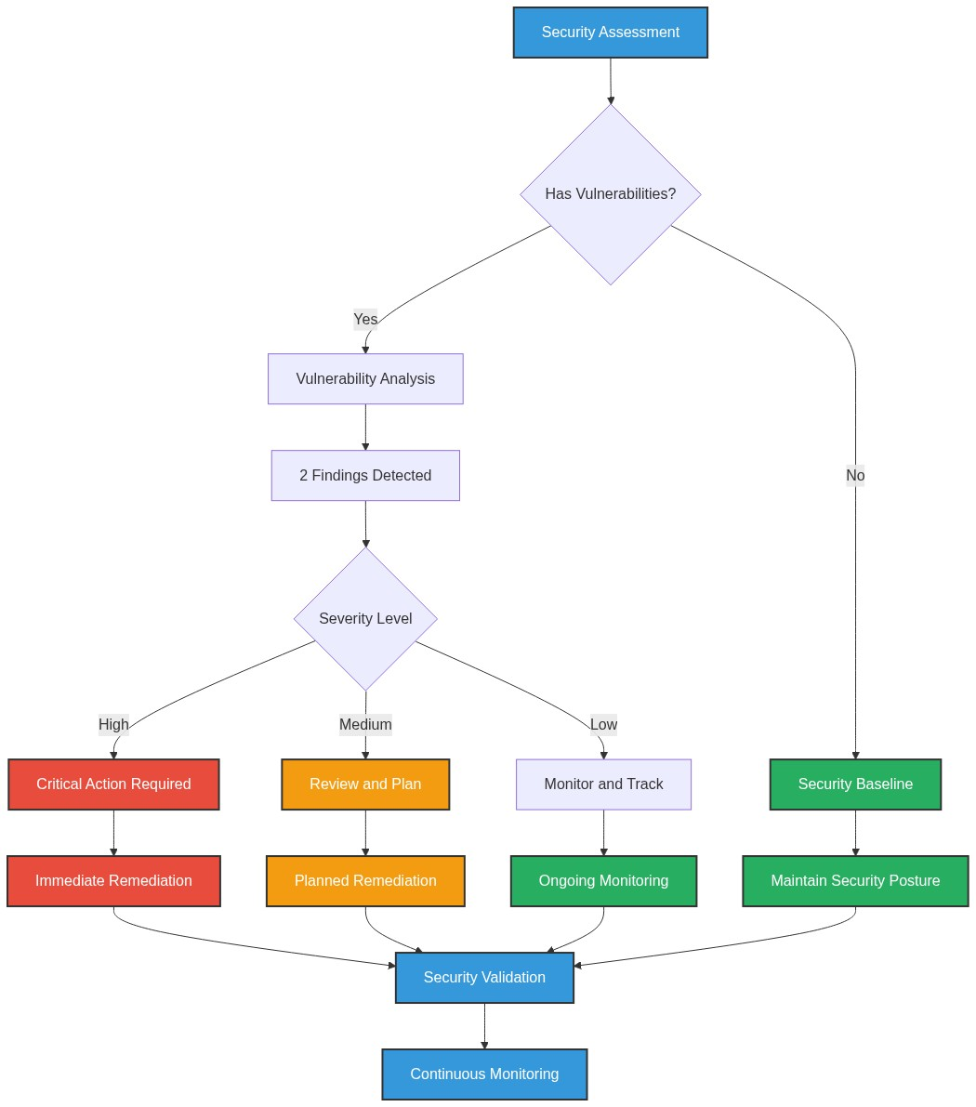

**📋 Context:** This Security Flow Diagram, generated as part of a modernization and migration planning initiative, illustrates the current security process workflows and controls within the application. The accompanying data reveals the findings of a manual security assessment conducted on July 18, 2025, providing a baseline understanding of the application's security posture.

**📋 Key Insights:** The analysis identified two critical, high-severity findings related to potential hardcoded secrets in `test_basic.py` (line 45) and `tests\unit\test_hld_synthesizer.py` (line 209). A significant limitation is the absence of automated vulnerability scanning, relying solely on manual pattern detection, which poses a risk of missed vulnerabilities. Furthermore, the overall security posture indicates 'basic' vulnerability management and lacks detailed information on authentication mechanisms, authorization frameworks, security protocols, and encryption standards, suggesting a maturity gap.

**📋 Business Impact:** The presence of potential hardcoded secrets represents a significant security risk, potentially leading to unauthorized access, data breaches, and reputational damage if exploited. The lack of automated scanning and documented security controls increases the likelihood of undetected vulnerabilities, posing a substantial risk during migration and modernization efforts. Addressing these findings is crucial to de-risk the migration and ensure compliance with future security requirements, potentially impacting project timelines and resource allocation.

**📋 Recommendations:** Prioritize immediate manual review and remediation of the two identified potential hardcoded secrets in the specified files, replacing them with secure alternatives like environment variables or a secrets management system. Crucially, integrate automated vulnerability scanning tools (e.g., Snyk, Trivy, OWASP Dependency-Check) into the development pipeline to establish a robust and proactive vulnerability management process. Furthermore, conduct a comprehensive security architecture review to define and implement standardized authentication, authorization, and encryption mechanisms before migration.

**📋 Technical Details:** The manual analysis flagged potential API keys within the code, classifying them as 'HIGH' severity. The `security_posture` data indicates a lack of defined `authentication_mechanisms`, `authorization_framework`, `security_protocols`, and `encryption_standards`, further highlighting gaps in foundational security controls. The `vulnerability_assessment` explicitly states that automated scanners were not used, with the findings stemming from manual pattern detection, and warns about potential missed vulnerabilities.

────────────────────────────────────────────────────────────────────────────────

Deployment Architecture (Mermaid)

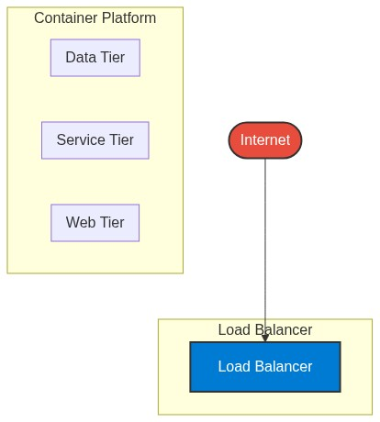

**📋 Context:** This diagram depicts the current deployment architecture of an application, generated as part of a larger application intelligence report to inform modernization and migration planning. Its purpose is to visually represent the existing deployment structure and identify key characteristics relevant to these strategic initiatives.

**📋 Key Insights:** The analysis reveals a **LOW** architecture style, complexity, maturity, and scalability. Crucially, **zero components** were identified, and **no containerization was detected**, indicating a likely absence of modern deployment practices. The provided data has a **LOW confidence** for architecture style due to the lack of detected components and containerization, highlighting a significant information gap.

**📋 Business Impact:** The current state suggests a significant risk for modernization and migration due to a lack of visible structure and modern deployment practices. This implies potentially high costs and extended timelines for any transition. The identified low maturity and scalability are critical blockers for cloud adoption and achieving business agility, posing a risk to competitiveness.

**📋 Recommendations:** Prioritize immediate discovery and analysis to identify actual application components and infrastructure. Focus on achieving a baseline understanding of the application's structure and dependencies. Subsequent steps should involve evaluating potential containerization strategies and defining a clear path for adopting more mature deployment and operational practices.

**📋 Technical Details:** The architecture assessment yielded a complexity score of 0/6 and a maturity score of 0/3, primarily due to the absence of detected components, programming languages, infrastructure components, and any form of containerization or build automation. This data strongly suggests that the application may not be in a state that is easily discoverable or amenable to standard modernization techniques without further investigation.

────────────────────────────────────────────────────────────────────────────────

Risk Assessment Flow (Mermaid)

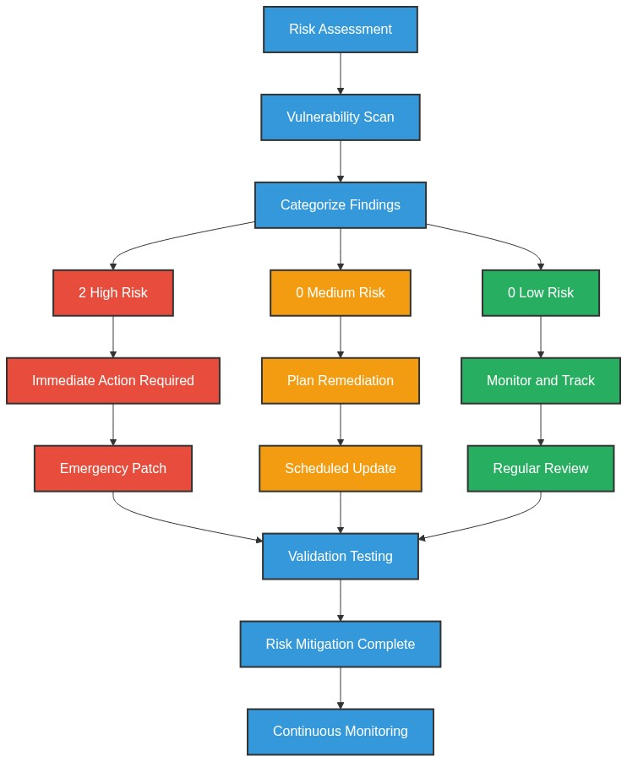

**📋 Context:** This risk assessment flow diagram details the process of evaluating potential security vulnerabilities within the application. It's generated as part of a broader application intelligence report to inform modernization and cloud migration strategies by identifying critical security risks that need remediation.

**📋 Key Insights:** The analysis identified two critical High severity findings related to potential hardcoded secrets in the files 'test_basic.py' (line 45) and 'tests\unit\test_hld_synthesizer.py' (line 209). Notably, the vulnerability scan was performed manually, indicating a lack of automated scanning infrastructure, which the assessment explicitly warns could lead to missed vulnerabilities. The `summary.security_findings` section shows no findings from a 'base_image_analysis', highlighting a potential gap in comprehensive security scanning across all layers.

**📋 Business Impact:** The presence of hardcoded secrets poses a significant security risk, potentially leading to unauthorized access to sensitive data or systems, which could result in data breaches, reputational damage, and regulatory fines. The reliance on manual analysis for vulnerability detection also introduces a high risk of undiscovered vulnerabilities, impacting the security posture during modernization and migration, potentially delaying timelines or increasing costs if critical issues are found post-migration.

**📋 Recommendations:** Prioritize immediate manual validation and remediation of the two identified High severity hardcoded secret findings. Implement automated vulnerability scanning tools (e.g., Snyk, Veracode, OWASP Dependency-Check) for both code and base image analysis to ensure comprehensive security coverage before migration. Establish a robust secrets management strategy, such as using environment variables or dedicated secrets management solutions, to eliminate hardcoded secrets from the codebase.

**📋 Technical Details:** The vulnerability assessment explicitly states 'scan_performed: false' for automated tools, with 'scan_tool' listed as 'manual_analysis'. The findings are derived from pattern matching for potential API keys. The 'assessment_notes' highlight the limitations of manual analysis and strongly recommend integrating dedicated scanners. The absence of findings in 'summary.security_findings' (which is marked as 'scan_performed: true' for 'base_image_analysis') suggests that base image security was assessed but yielded no results, or was assessed separately and its findings are not aggregated here.

────────────────────────────────────────────────────────────────────────────────

Migration Strategy (Graphviz)

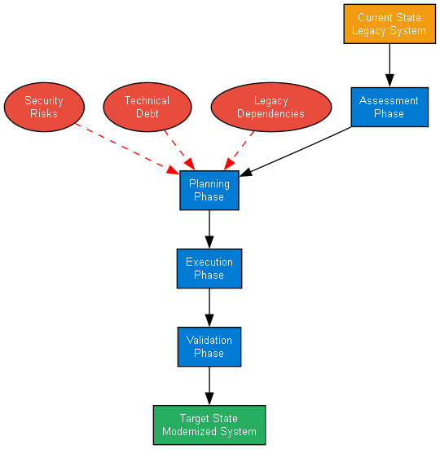

**📋 Context:** This diagram represents a foundational stage in an application migration strategy, specifically focusing on the initial planning and execution phases. It's generated as part of a broader application intelligence report to inform modernization and cloud migration efforts by assessing the current state of the application.

**📋 Key Insights:** The analysis indicates an extremely low technical complexity and maturity for this application. With zero detected components, programming languages, or infrastructure components, it suggests a foundational, likely un-instrumented, or placeholder system. Furthermore, the absence of containerization, deployment automation, or any recognized architectural patterns points to a highly rudimentary or incomplete application architecture.

**📋 Business Impact:** The lack of defined architecture, complexity, and maturity presents a significant risk. Migrating this application without further analysis could lead to unforeseen challenges, cost overruns, and extended timelines due to a fundamental lack of understanding of its functional and technical underpinnings. However, it also signifies a potential opportunity for a greenfield approach or a very straightforward migration if the 'application' is indeed a stub or in its earliest development stages.

**📋 Recommendations:** Prioritize an in-depth discovery and analysis phase to accurately define the application's components, dependencies, and business logic. If this application is intended to be modernized, immediate steps should involve establishing a basic development, testing, and deployment framework, including containerization and version control. Thoroughly investigate the '0 components' finding to ascertain if this represents an error in data collection or a genuine lack of an application.

**📋 Technical Details:** The 'architecture_assessment' section yields an 'unknown' architecture style with 'LOW' confidence, supported by zero detected components and no containerization. Complexity, maturity, and scalability are all scored 'LOW' with 'HIGH' confidence due to minimal or zero evidence across key metrics such as component count, language diversity, infrastructure components, containerization, deployment automation, and state management. These scores are limited by the absence of runtime analysis and communication pattern data.

────────────────────────────────────────────────────────────────────────────────