A

Project Report Submitted

in Fulfilment of the Requirements

for the Degree of

**BACHELOR OF TECHNOLOGY**

**Project Title:**

**Study and Improvisation of Clustering Based Routing Protocol in FANET**

Under the supervision of

**DR. CHIRANJEEV KUMAR**

(Professor Department of CSE)



**Department of Computer Science and Engineering**

**INDIAN INSTITUTE OF TECHNOLOGY**

**( INDIAN SCHOOL OF MINES )**

**DHANBAD**

By

**Avinesh Pratap Singh (20JE0219)**

# **Acknowledgements**

We would like to express our deepest gratitude to our project supervisor, **DR. CHIRANJEEV KUMAR.** Your expertise and encouragement were invaluable in shaping the direction and success of this project.

We are indebted to a number of people for their direct and indirect contributions that helped us in the completion of our project work.

First, I would like to thank our project supervisor, DR. Chiranjeev Kumar, Professor Department of Computer Science and Engineering IIT (ISM), Dhanbad for providing us the opportunity to work on this project under his supervision. It is always a pleasure to work on a project where you can develop your interest.

# **Certificate**

This is to certify that the project report titled **‘Study and Improvisation of Clustering Based Routing Protocol in FANET’** submitted by **Avinesh Pratap Singh(20JE0219)** to the Indian Institute of Technology (ISM), Dhanbad towards partial compliance with the requirements for obtaining the bachelor of technology in Computer Science and Engineering title is a record of the good faith work done by them under my Supervision and guidance during the Monsoon Semester (2023-24).

**DR Chiranjeev Kumar DR Chiranjeev Kumar** (Professor Department ) (Professor Department)

Project Guide CSE Head of Department

**Abstract**

The presented research addresses the challenges faced in disaster response scenarios, where traditional Infrastructure based networks struggle to operate efficiently in harsh ground environments. To overcome this limitation, unmanned aerial vehicles (UAVs) are employed as the preferred carriers to establish a Flying Ad Hoc Network (FANET) for emergency communication. However, operating in a FANET introduces new hurdles, particularly in node localization and data transmission, attributed to the expanded network dimensions and the high mobility of UAVs. Here we work on Improved FANET clustering routing protocol grounded in node location awareness.

The key innovation lies in the Use of an Improved Particle Swarm Optimization (IPSO) algorithm, integrating variable neighbourhood search to enhance UAV localization precision. This algorithm plays a pivotal role in optimizing the positioning of UAVs, addressing the challenges posed by the environment. The clustering aspect of the protocol involves the base station (BS) strategically forming clusters of UAVs based on their locations. The selection of cluster heads takes into account both intra-cluster distance and the residual energy of nodes.

Furthermore, the routing protocol leverages IPSO to determine the optimal next-hop routing strategy. This decision-making process considers factors such as link reliability, distance between nodes, and the distance to the BS. The objective is to ensure timely and reliable data transmission to the base station. The evaluation will encompass various performance metrics, including positioning indicators, energy consumption, delay, and the overall lifetime of the clustering mechanism. This approach shows promise in addressing the complexities of FANETs in disaster scenarios, offering advancements in UAV localization, energy efficiency, and overall network reliability.

**Contents**

**1. Introduction**

1.1 Wireless Network

1.2 FANET

**2.** **Background & Literature Survey**

2.1 Node Localization

2.2 FANET Routing Protocols

2.3 MANET

2.4 Cluster Routing Protocol

2.5 Particle Swarm Optimization (PSO)

**3. Problem Statement**

**4. Methodology**

4.1 Network and Energy Model

4.2 UAV Positioning

4.3 Cluster formation

4.4 Cluster head selection

4.5 Cluster Maintenance

4.6 Next Hope selection

**5. Results**

5.1 Throughput

5.2 End-to-End Delay (E2ED)

5.3 The Packet Delivery Ratio (PDR)

**6. Conclusion**

**7. References**

**1. Introduction**

Before moving to the details of the project lets start with the introduction and Background

**1.1 Wireless Network**

Wireless networks have undeniably transformed communication paradigms, liberating users from the physical tethers of traditional wired setups. The flexibility inherent in wireless connectivity allows users to engage with networks using diverse devices in varied locations. However, this liberation is not without its constraints. Traditional wireless setups face challenges in terms of coverage and adaptability. While they excel in providing mobility within designated coverage areas, users may encounter signal degradation or loss when venturing beyond these bounds. Moreover, the shared frequency bands that enable collaborative connectivity also introduce risks of interference and congestion, particularly in densely populated spaces. Security concerns loom as unauthorized access threatens data integrity. Additionally, adaptability to dynamic network demands can be a hurdle. Despite these challenges, ongoing advancements, such as mesh networks and 5G integration, showcase the industry's commitment to overcoming limitations, promising a future where wireless networks seamlessly balance flexibility with robust and adaptive performance.

**1.2 FANET**

Flying Ad Hoc Networks (FANETs) signify a revolutionary shift in wireless communication, harnessing the capabilities of drones to establish dynamic networks that transcend the limitations of terrestrial infrastructure. In contrast to conventional networks, FANETs employ drones as mobile communication nodes, equipped with wireless transceivers, to create an adaptable and versatile network architecture that extends into the sky. This innovative approach to communication is particularly advantageous in scenarios where traditional infrastructure is impractical or non-existent, such as disaster-stricken areas or large-scale outdoor events. FANETs introduce a dynamic network topology due to the mobility of drones, posing unique challenges and opportunities for routing and communication protocols. The applications of FANETs span across industries, including surveillance, disaster response, environmental monitoring, and communication in remote or challenging terrains. Overcoming challenges associated with varying altitudes, unpredictable weather conditions, and potential obstacles requires specialized routing protocols, with adaptable and on-demand approaches like AODV and OLSR emerging as common solutions. As FANET concepts transition from theory to reality, experiments with drone fleets equipped with communication modules validate the effectiveness of FANET communication in practical scenarios. FANETs are poised to redefine wireless communication, offering a flexible, rapid, and adaptive solution where traditional networks fall short, with ongoing advancements in routing protocols playing a pivotal role in unlocking their full potential.

**The Imperative of FANET:** Revolutionizing Communication in Dynamic Environments

Flying Ad Hoc Networks (FANETs) emerge as indispensable assets, particularly in disaster management and surveillance contexts, where the limitations of ground-based networks are starkly evident. The unique capabilities of FANETs, employing drones as mobile communication nodes, address the challenges posed by dynamic and unpredictable environments. In disaster scenarios, where traditional infrastructure may be compromised or non-existent, FANETs offer a lifeline by swiftly deploying communication networks from the sky. The mobility of drones facilitates rapid adaptability to changing conditions, enabling real-time data collection and efficient coordination of rescue efforts. Similarly, in surveillance applications, FANETs transcend the constraints of ground-based networks, providing a bird's-eye view that is essential for comprehensive monitoring and response. The ability of FANETs to navigate three-dimensional space and establish communication links in real-time positions them as a crucial technological advancement, ensuring reliable communication when and where it is needed most, ultimately enhancing the effectiveness of disaster response and surveillance operations.

**The Versatility of FANET**: Elevating Communication in Critical Scenarios:

Flying Ad Hoc Networks (FANETs) emerge as true communication champions, demonstrating unparalleled versatility in challenging situations such as disasters, surveillance, and rescue missions. In the aftermath of disasters, where traditional communication infrastructure may be compromised, FANETs swiftly establish a reliable network using drones, enabling seamless coordination of rescue efforts and real-time data collection. The aerial perspective provided by FANETs enhances surveillance capabilities, offering a comprehensive and dynamic view of the terrain that is crucial for monitoring and responding to evolving situations. In rescue missions, FANETs become invaluable tools, overcoming ground-based obstacles to swiftly deliver vital information and coordinate operations. Their adaptability and efficiency shine when it truly matters, making FANETs a cornerstone technology in scenarios where rapid and effective communication can be a matter of life and death. As communication lifelines in critical situations, FANETs prove their worth by ensuring connectivity when traditional methods falter, ultimately contributing to more efficient and effective outcomes in the face of adversity.

### 2. Background and Literature Survey

In the realm of disaster response, swift and effective communication among survivors is imperative. Two critical challenges in this context are the design of efficient positioning algorithms and reliable routing protocols. Existing literature is replete with studies addressing node localization and routing schemes, particularly in the three-dimensional (3D) environment.

**2.1 Node Localization**

Kumari et al. conducted extensive surveys on 3D node positioning algorithms, offering comprehensive insights into various approaches [11]. In [12], a distributed distance-free node positioning algorithm is proposed, leveraging genetic algorithms (GA) to enhance accuracy. However, concerns arise regarding the slow convergence speed of GA. Other works, such as [13] and [14], have explored improvements to flower pollination algorithms and integrated methods like the cubic shell intersection into DV-Hop, each with trade-offs between precision and energy consumption [15].

The Particle Swarm Optimization (PSO) algorithm has been integrated into node localization strategies, as seen in [10], [5], and [16]. These approaches demonstrate the versatility of PSO, from multi-objective optimization to mixed dimensions, offering a balance between communication overhead, error variance, and computational complexity.

**2.2 FANET Routing Protocols**

Routing protocols in Flying Ad-Hoc Networks (FANETs) are vital for optimizing communication and network stability. Extensive investigations by Khan et al. and Lakew et al. have compared FANET routing protocols [17], [18]. Clustering-based routing protocols, such as [7], [6], and [19], employ natural and non-natural heuristics, including K-means clustering and delay-tolerant network routing. Each protocol aims to enhance routing efficiency, reduce overhead, and extend cluster lifetime.

Natural heuristic routing algorithms, such as Genetic Algorithms (GA) and Artificial Bee Colony (ABC), have been applied to cluster routing [8], [20]. Other studies, like [9], introduce AntHocNet based on Ant Colony Optimization (ACO), and [21] propose FANET-optimized link-state routing using the Whale Optimization Algorithm (WOA)

In the domain of clustering routing, Swarm Intelligence plays a prominent role. Protocols like SOCS [22], employing glowworm swarm optimization (GSO), and others incorporating Krill Herd (KH) and Grey Wolf Optimizer (GWO) algorithms, exhibit promising results in terms of cluster construction time, network lifetime, and communication efficiency.

The integration of Particle Swarm Optimization (PSO) into clustering protocols, as evidenced in [23] and [24], showcases its adaptability in non-uniform clustering scenarios and dynamic learning factors. These implementations strive to strike a balance between communication efficiency, network lifetime, and data transmission delay.

The Routing Protocols for FANET are traditionally developed from the manet.

**2.3 MANET**

Mobile Ad Hoc Networks (MANETs) are dynamic networks where nodes communicate with each other without a fixed infrastructure. MANET routing protocols play a crucial role in enabling communication within such networks by determining how data is routed from one node to another. There are three main types of MANET routing protocols: Proactive, Reactive, and Hybrid.

* Proactive Routing Protocols:

Also known as table-driven protocols. Maintain up-to-date routing information for all nodes in the network, regardless of whether they are actively involved in communication or not. Periodically exchange routing tables or updates with neighbouring nodes to ensure that the network has the latest information. Examples include: Destination- Sequenced Distance Vector (DSDV), Optimized Link State Routing (OLSR)

* Reactive Routing Protocols:

Also known as on-demand protocols. Route discovery is initiated only when a node has data to send to a destination for which it does not have a route. Do not maintain a complete and up-to-date routing table for all nodes in the network. Examples include: Ad Hoc On-Demand Distance Vector (AODV), Dynamic Source Routing (DSR)

* Hybrid Routing Protocols:

Combine features of both proactive and reactive protocols. Maintain routing information for frequently accessed nodes proactively while using on-demand mechanisms for less frequently accessed destinations. Seek to provide a balance between the overhead of proactive protocols and the potential delays of reactive protocols. Example: Zone Routing Protocol (ZRP)

**2.4 Cluster Routing Protocol**

Clustering Routing Protocols: These are protocols that organize wireless network nodes into clusters for increased efficiency. In a clustered network, nodes are grouped into clusters, and each cluster has a cluster head, which is responsible for managing the communication within the cluster and between clusters.

Benefits:

* Energy Efficiency: Clustering helps in reducing energy consumption by allowing nodes to communicate with a cluster head instead of directly with other nodes, thereby minimizing the overall transmission power.
* Scalability: Clustering improves the scalability of the network by reducing the overhead associated with managing individual nodes. Communication within clusters can be more efficient than in a flat structure, especially as the network grows.
* Network Organization: Clustering provides a structured way to organize the network, making it easier to manage and optimize. It simplifies the routing process and facilitates better coordination among nodes.

Use Cases:

* Wireless Sensor Networks (WSNs): Clustering is commonly used in WSNs to enhance the efficiency of data collection. Sensor nodes can be organized into clusters, with a designated cluster head responsible for aggregating and transmitting data to a base station.
* Mobile Ad Hoc Networks (MANETs): Clustering is applied in MANETs to improve the overall network performance. By dividing the network into clusters, communication between nodes can be more controlled and energy-efficient.

Examples:

* LEACH (Low Energy Adaptive Clustering Hierarchy): LEACH is a well-known clustering protocol designed for WSNs. It enables energy-efficient data aggregation by forming clusters and rotating the role of the cluster head among nodes to distribute energy consumption.
* CBRP (Cluster-Based Routing Protocol): CBRP is an example of a clustering routing protocol used in MANETs. It forms clusters and employs a proactive routing approach to maintain routing information within the clusters.

**2.5 Particle Swarm Optimization (PSO)**

Particle Swarm Optimization (PSO) serves as a compelling bio-inspired optimization method, mirroring the collaborative behaviour observed in nature. The modus operandi of PSO involves a swarm of particles dynamically adjusting their positions within a solution space. This adjustment is influenced not only by the particle's own experiences but also by information gleaned from neighbouring particles. The collective movement of the swarm aims to converge towards optimal solutions in the optimization landscape. The simplicity of implementation and efficiency in continuous optimization scenarios are key strengths of PSO. Its uncomplicated nature allows for straightforward application in various domains, making it an attractive choice for solving complex optimization problems. However, challenges persist, including the absence of a guaranteed mechanism to find the global best solution. Additionally, PSO's sensitivity to parameter settings underscores the importance of careful tuning for optimal performance.

The relevance of PSO extends beyond standalone optimization tasks, finding a meaningful application in the realm of clustering routing protocols. By leveraging PSO, these protocols can benefit from optimized parameter configurations and improved convergence towards efficient network structures. PSO's contribution to refining the performance of clustering routing protocols highlights its adaptability and utility in enhancing the functionality of complex network systems. As the intersection of bio-inspired optimization and networking continues to evolve, PSO remains a valuable tool in the arsenal of optimization techniques for tackling intricate challenges in network management and organization.

**3. Problem Statement**

For communication purposes UAVs use the routing protocols but its limited resources, high mobility and frequently changing topology makes it a very challenging problem.

Therefore, an efficient routing protocol is required to intelligently use the limited resources while at the same time being It Should be adaptable to the challenging network environment.

**Proposed Solution**

The main objective is to study and analyse a suitable routing protocol that will help in stabilizing the communication networks for disaster scenarios by minimizing the overall delay and Energy Utilization.

**4. Methodology**

**4.1 Network and Energy Model**

In this we have constructed a simulation environment to model the dynamic interactions between multiple nodes in a network, specifically focusing on blind nodes and anchor nodes within a three-dimensional space. The network model is configured with 60 blind nodes and 30 anchor nodes. Each node's communication capabilities are simulated within a range of 50 meters.

The 3D space for the simulation is bounded within a cube of 200 meters side length, cantered at the origin. Nodes are distributed randomly within these bounds. The blind nodes are assigned random initial energies, falling between 50 and 100 units, to simulate varying battery levels. Energy consumption and conservation are critical aspects of the study, influencing the nodes' operational longevity and their eligibility for roles such as Cluster Heads (CHs), which are not initially assigned.

Node mobility is modelled through velocities assigned from a normal distribution with a mean of 5 m/s and a standard deviation of 2 m/s, providing realistic node movement within the simulated environment. This mobility adds a dynamic layer to the network's connectivity and the feasibility of consistent communications.

The base station, positioned at the origin of the space, serves as the central point for data aggregation and communication management. Visualization of the network is achieved through a three-dimensional scatter plot, distinguishing blind nodes, anchor nodes, and the base station with unique markers and colours to facilitate clear observation of their distribution and relative positions.

This simulation framework lays the groundwork for further analysis of network protocols, node behaviour under varying energy conditions, and the impact of node mobility on communication efficacy.

The Initial Position of each blind node, anchor node and base station are shown as below:

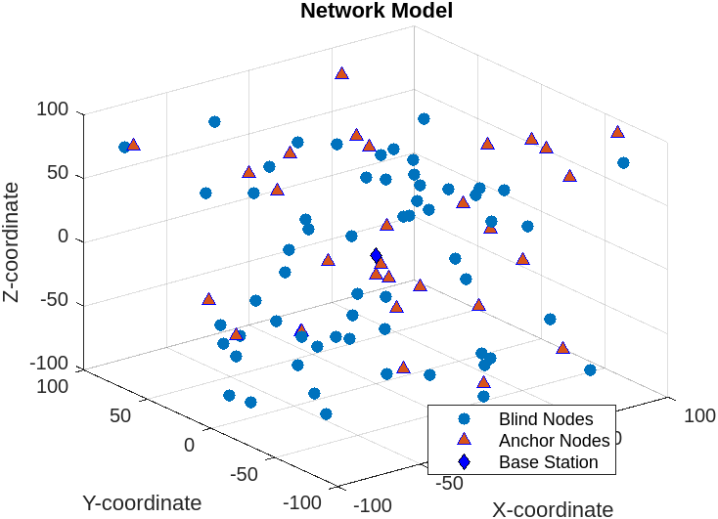

**4.2 UAV Positioning**

We employ an Improved Particle Swarm Optimization (IPSO) algorithm to accurately estimate the positions of blind nodes within a defined three-dimensional space. This technique utilizes a swarm of particles, where each particle represents a potential solution to the node positioning problem. Initially, each particle is randomly placed within the bounds of the simulation environment, and their positions are iteratively adjusted based on both individual (cognitive) and collective (social) learning components.

The IPSO is tailored specifically for our network model, where the position of each blind node is determined based on its relative distance to multiple anchor nodes within its communication range. We implement a fitness function that minimizes the squared difference between the estimated distances from the blind nodes to their neighbouring anchor nodes and the actual distances. The particle's position is continuously updated over a series of iterations, guided by both its own best-known position and the best position discovered by any particle in the swarm.

This iterative process is constrained within the spatial boundaries of the simulation area to ensure that all node estimations remain viable. Additionally, the algorithm includes a novel application of boundary handling to prevent particles from exceeding the simulation space, thereby enhancing the robustness and accuracy of the positioning system.

By leveraging the collective intelligence of the particle swarm and incorporating rigorous fitness evaluations, the IPSO algorithm effectively optimizes the estimated positions of blind nodes, which is critical for maintaining reliable communication links and efficient network operations in UAV-assisted networks. This approach not only enhances the accuracy of node localization but also contributes to the overall robustness and adaptability of the network management system.

The Actual position of blind node and predicted position of bind are shown in the below figure.

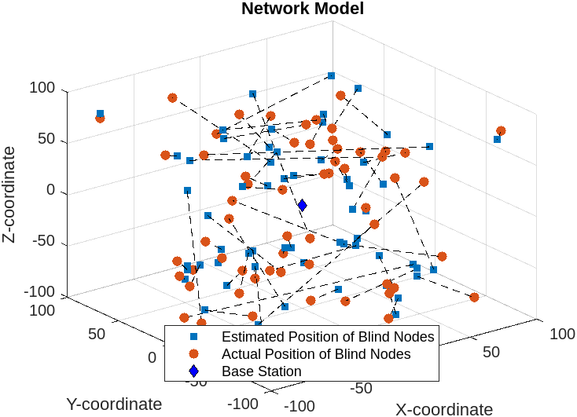

**4.3 cluster formation**

In the development of our network model, we apply K-means clustering to categorize blind nodes into distinct spatial clusters, facilitating more efficient management and analysis of the network. K-means clustering is executed by first extracting the positions of all blind nodes, which are then used as input data points for the clustering algorithm. We choose to define 25 clusters for this model, a parameter that can be adjusted based on specific network requirements or to explore different clustering configurations.

The K-means algorithm iteratively assigns each blind node to one of 25 clusters by minimizing the variance within each cluster, resulting in a set of centroids that represent the geometric centre of the nodes in each cluster. Each blind node is then associated with the nearest centroid, effectively grouping nodes that are close to each other into the same cluster.

To visually represent the results of the clustering, we generate a three-dimensional scatter plot where each node is color-coded according to its cluster assignment. This visualization not only helps in verifying the effectiveness of the clustering but also provides intuitive insights into the spatial distribution of nodes across the network. Distinct colours represent different clusters, enhancing the visual differentiation and understanding of cluster distributions. The base station, the central coordinating unit of the network, is also plotted to provide a reference point for the relative positions of the clusters.

This clustering approach significantly aids in the network's operational strategies by allowing for targeted communication within and between clusters, optimizing resource allocation, and improving overall network efficiency. The use of K-means clustering in this context exemplifies the application of machine learning techniques to improve network management and operational resilience.

The Below figure shows the smaple 25 clusters with their centroid the number of blind nodes is pupose fully have been increaed to a sufficient number so that visulisation should be clear:

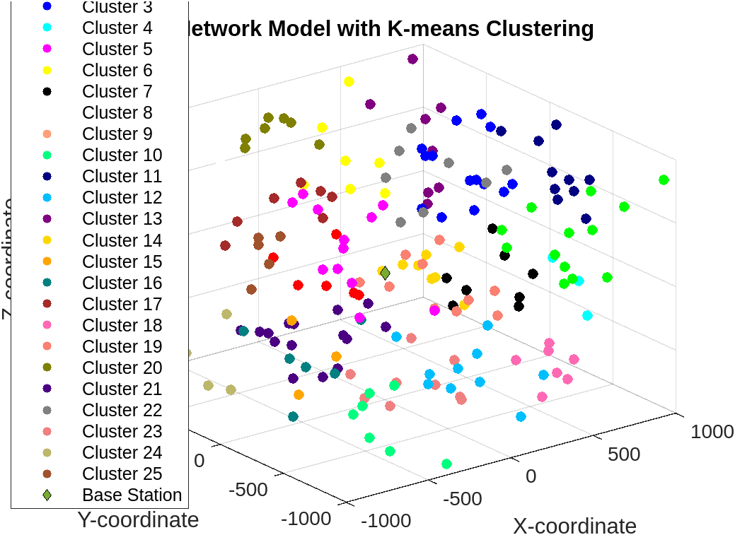

**4.4 Cluster head selection**

In our network model, the selection of cluster heads (CHs) is a critical process for achieving efficient communication and energy utilization within each cluster. To address this, we integrate a modified Particle Swarm Optimization (PSO) algorithm that considers both the spatial positioning and energy levels of nodes. Each cluster undergoes a selection process where potential CHs—represented as particles in the PSO algorithm—are evaluated through a multi-criterion fitness function.

This fitness function incorporates three key metrics: the average distance from the particle to other nodes in the cluster (minimizing this value facilitates better communication within the cluster), the distance from the particle to the base station (minimizing this distance ensures efficient data transmission to and from the base station), and the inverse of the particle’s energy level (promoting the selection of nodes with higher remaining energy to ensure longevity in the CH role).

The PSO algorithm iteratively adjusts the positions and energy levels of particles by simulating a swarm-like collective intelligence, where particles 'learn' from their own experience (personal best) and from others (global best). Throughout this process, particles are constrained within the predefined spatial and energy boundaries of the network to ensure feasible solutions. After a set number of iterations, the particle that exhibits the optimal balance according to the fitness function is designated as the CH for its respective cluster.

Visualization of this process in a three-dimensional plot not only aids in verifying the effectiveness of the CH selection but also provides a clear view of how nodes are organized spatially and functionally within the network. This methodological approach enhances the network's operational efficiency by strategically positioning CHs to optimize both communication efficacy and energy consumption, crucial for maintaining robust network performance over time.

The below are the sample clusters and their head:  
  
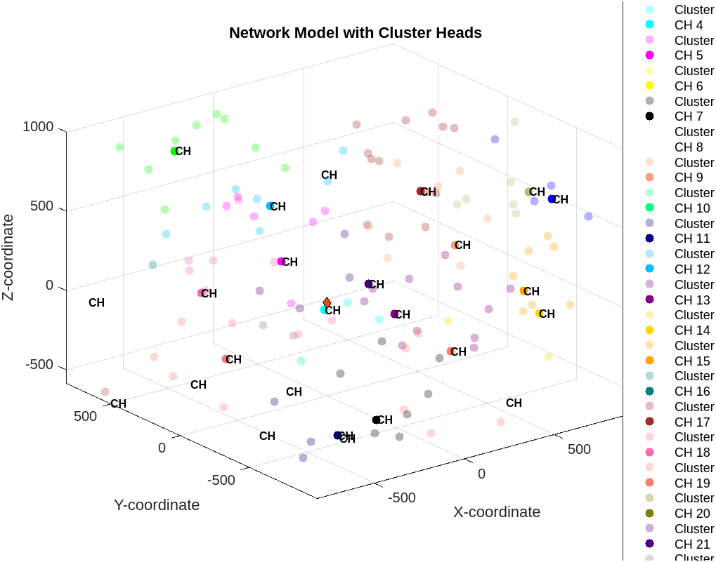

**4.5 Cluster Maintenance**

Cluster maintenance is executed through a series of coordinated interactions between Cluster Heads (CHs) and Cluster Members (CMs), primarily facilitated through the exchange of hello and acknowledgement (ACK) packets. Initially, the CH broadcasts hello packets to all CMs, which in turn respond with ACKs. This exchange not only verifies the presence of each node within the cluster but also updates the respective timers (trH for CH and trM for CMs), critical for tracking the operational status and response times within the network. This mechanism helps in assessing the health and stability of the cluster by monitoring the residual energy of nodes and their response times. If the CH’s energy falls below a pre-defined threshold (Eth, set at 30% in this study) or if the CH fails to receive timely responses (as dictated by the timer tCH), a new CH is elected from among the CMs based on the highest residual energy, thereby ensuring continuity and reducing computational overhead.

Furthermore, the protocol handles the dynamic aspect of node mobility by incorporating procedures for nodes leaving or joining clusters. Nodes that fail to receive hello packets within a specific interval (tCM) are deemed to have left the cluster and either initiate a re-clustering process or join neighbouring clusters, depending on the local clustering status. Conversely, CHs continually assess their cluster’s population against a threshold derived from the overall network’s node density and cluster count. This proactive approach not only mitigates the risk of cluster fragmentation but also adapts the network topology to changing conditions, ensuring that the network remains efficient and robust. This adaptive reconfiguration is essential for maintaining high network performance and reliability in the fast-paced operational environments typical of UAV applications, where timely and reliable data transmission is crucial for mission success.

**4.6 Next Hope selection**

In our FANET model, we incorporate a cluster-based routing protocol that optimizes the selection of next-hop cluster heads based on both spatial positions and velocities, reflecting the high mobility of UAVs. The routing mechanism initiates by identifying neighbouring cluster heads within a predefined communication range of 100 meters. This range is essential to ensure connectivity despite the high speeds of UAVs, and neighbours are identified through the exchange of hello messages.

The next-hop selection is governed by a Particle Swarm Optimization (PSO) algorithm, which operates in a six-dimensional space—three dimensions for position and three for velocity. This approach allows the algorithm to account for both the current location and the projected trajectory of the UAVs, enhancing the prediction accuracy for optimal routing paths. Each cluster head utilizes this algorithm to determine the most suitable next-hop based on a fitness function that integrates the Euclidean distance in both position and velocity space. The fitness function is designed to minimize the combined distance, ensuring that the selected next-hop is not only close in terms of spatial proximity but also moving with a relative velocity that supports sustained communication.

To implement this, the PSO algorithm iteratively adjusts the potential next-hop choices by updating their positions and velocities. Constraints are applied to ensure that these updates remain within the operational boundaries of the network, including spatial limits and velocity norms. The selection process is repeated across all clusters, with each cluster head updating its next-hop choice to adapt to the continually changing network dynamics. This method ensures a robust and adaptive communication backbone for UAV networks, crucial for maintaining efficient operational control and data relay across the network.

The Sampe Next Hope assignment is shown below for 25 cluster head:

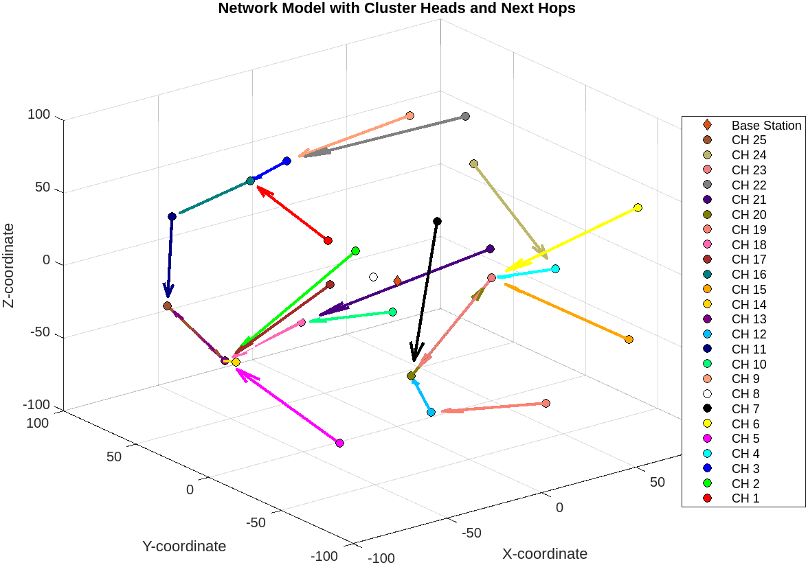

**5. Results**

The performance metrics—Throughput, End-to-End Delay, and Packet Delivery Ratio—are essential for evaluating the effectiveness and reliability of communication protocols within FANETs. Each metric provides critical insights into different aspects of network performance, influencing the overall design and operation of the network

**5.1 Throughput**

Throughput is a fundamental measure of network capacity and efficiency, reflecting the average rate at which bits are successfully delivered to their destination. In the context of FANETs, high throughput is indicative of a reliable and robust communication protocol, especially under varying operational conditions. Mathematically, throughput is quantified as the total number of bits received successfully by all destinations per unit of time, calculated using the formula:

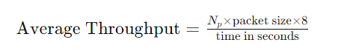

where 𝑁𝑝​ represents the total number of packets successfully received. This measure helps in assessing the capability of the network to handle dense data traffic, which is crucial for applications requiring real-time data exchange such as surveillance or coordinated manoeuvres.

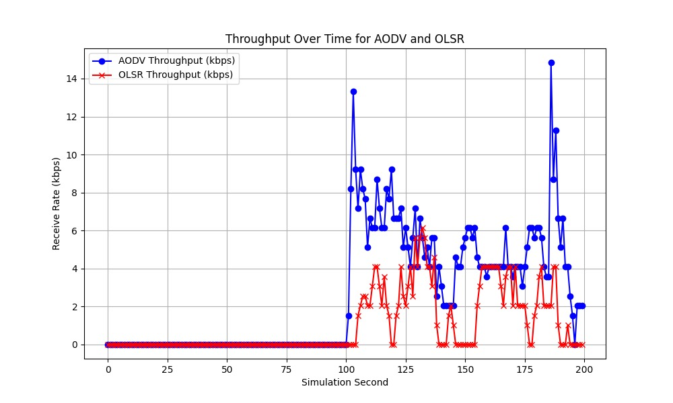

**5.2 End-to-End Delay (E2ED)**

End-to-End Delay is another critical metric, especially for real-time applications within FANETs. It measures the total time taken for a data packet to travel from the source to the destination. This delay includes all forms of latency encountered during the packet's journey, including processing delays at intermediate nodes, buffering delays, and propagation delays. The average E2ED is represented as:



where 𝑇𝑟 is the time when the packet is received and 𝑇𝑠 is the time when the packet is sent. Minimizing E2ED is vital for enhancing the responsiveness of the network, thereby improving operational efficiency and effectiveness in time-sensitive scenarios.

**5.3 The Packet Delivery Ratio (PDR)**

The Packet Delivery Ratio (PDR) is a measure of the reliability and efficiency of the packet delivery over a network. It is defined as the ratio of the number of packets successfully delivered to the destination to the total number of packets sent by the sender, expressed as a percentage:

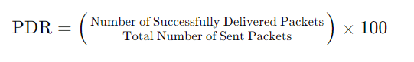

A high PDR indicates a reliable network, where most of the transmitted data reaches its intended destination without being lost or dropped. It is particularly important in FANETs, where the dynamic topology and potential for frequent disconnections pose challenges to data delivery.

**6. Conclusion**

To conclude the project focused on optimizing Flying Ad Hoc Networks (FANETs) in disaster scenarios, the application of Nature-Inspired Algorithms (NIAs) for node clustering and next-hop routing has demonstrated significant improvements in network performance. By tailoring the routing and cluster management protocols specifically for the dynamic and often unpredictable conditions of FANETs, the project has successfully minimized delays and enhanced data transmission efficiency, crucial for time-sensitive operations during disasters.

The study introduced innovative techniques for dynamically adapting cluster structures, selecting energy-efficient cluster heads, and maintaining cluster stability under varying network conditions. These advancements not only bolster the resilience of UAV networks in challenging environments but also pave the way for incorporating more complex adaptive systems, such as real-time machine learning algorithms, into FANET operations. These future directions aim to further refine the responsiveness and reliability of UAV communications, potentially transforming disaster management strategies by enabling more effective deployment and coordination of UAVs.

In essence, this project has made substantial contributions to the field of UAV communications within FANETs, highlighting the importance of specialized routing protocols that accommodate high mobility and rapidly changing network topologies. The outcomes of this research underscore the potential of advanced computational techniques in enhancing the capabilities and performance of UAV networks in critical scenarios, ensuring that they can operate more autonomously and effectively in disaster response and other high-stakes applications.

**7. References**

[1] Sun, G., Qin, D., Lan, T., & Ma, L. (2021). Research on clustering routing protocol based on improved PSO in FANET. IEEE Sensors Journal, 21(23), 27168-27185.

[2] Hogie, L., Bouvry, P., & Guinand, F. (2006). An overview of manet simulation. Electronic notes in theoretical computer science, 150(1), 81-101.

[3]Bekmezci, I., Sahingoz, O. K., & Temel, Ş. (2013). Flying ad-hoc networks (FANETs): A survey. Ad Hoc Networks, 11(3), 1254-1270.

[4]Abolhasan, M., Wysocki, T., & Dutkiewicz, E. (2004). A review of routing protocols for mobile ad hoc networks. Ad hoc networks,2(1), 1-22.

[5] P. Raguraman, M. Ramasundaram, and V. Balakrishnan, “Localization

in wireless sensor networks: A dimension based pruning approach in

3D environments,” Appl. Soft Comput., vol. 68, pp. 219–232, Jul. 2018,

doi: 10.1016/j.asoc.2018.03.039.

[6] F. Aadil, A. Raza, M. F. Khan, M. Maqsood, I. Mehmood, and S. Rho,

“Energy aware cluster-based routing in flying ad-hoc networks,” Sensors,

vol. 18, no. 5, p. 1413, May 2018, doi: 10.3390/s18051413.

[7] M. Y. Arafat and S. Moh, “A survey on cluster-based routing protocols for unmanned aerial vehicle networks,” IEEE Access, vol. 7,

pp. 498–516, 2018, doi: 10.1109/ACCESS.2018.2885539.

[8] K. B. Gurumoorthy and A. Nirmal Kumar, “Mutual constraint based GA

suggested routing algorithm for improving QoS in clustered MANETS,”

Wireless Pers. Commun., vol. 98, no. 3, pp. 2975–2991, Feb. 2018, doi:

10.1007/s11277-017-5011-8.

[9] I. U. Khan, I. M. Qureshi, M. A. Aziz, T. A. Cheema, and

S. Shah, “Smart IoT control-based nature inspired energy efficient

routing protocol for flying ad hoc network (FANET),” IEEE Access,

vol. 8, pp. 56371–56378, 2020, doi: 10.1109/ACCESS.2020.2981531.

[10] V. Kanwar and A. Kumar, “Range free localization for three dimensional

wireless sensor networks using multi objective particle swarm optimization,” Wireless Pers. Commun., vol. 117, no. 2, pp. 901–921, Mar. 2021,

doi: 10.1007/s11277-020-07902-1.

[11] J. Kumari, P. Kumar, and S. K. Singh, “Localization in three-dimensional

wireless sensor networks: A survey,” J. Supercomput., vol. 75, no. 8,

pp. 5040–5083, Aug. 2019, doi: 10.1007/s11227-019-02781-1.

[12] G. Sharma and A. Kumar, “Improved range-free localization for

three-dimensional wireless sensor networks using genetic algorithm,” Comput. Elect. Eng., vol. 72, pp. 808–827, Nov. 2018, doi:

10.1016/j.compeleceng.2017.12.036.

[13] P. Singh and N. Mittal, “An efficient localization approach to locate

sensor nodes in 3D wireless sensor networks using adaptive flower

pollination algorithm,” Wireless Netw., vol. 27, no. 3, pp. 1999–2014,

Apr. 2021, doi: 10.1007/s11276-021-02557-7.

[14] Y. Hua, W. Min, S. Chao, and R. C. Wang, “A three-dimensional

localization algorithm based on DV-Hop in wireless sensor networks,”

Sensors, vol. 21, no. 2, p. 448, 2017, doi: 10.3390/s21020448.

[15] L. Yi and M. Chen, “An enhanced hybrid 3D localization algorithm

based on APIT and DV-Hop,” Int. J. Online Eng., vol. 13, no. 9,

pp. 69–86, 2017, doi: 10.3991/ijoe.v13i09.7255.

[16] W. Wang, Y. Yang, W. Lei, and L. Wei, “PMDV-hop: An effective rangefree 3D localization scheme based on the particle swarm optimization in

wireless sensor network,” KSII Trans. Internet Inf. Syst., vol. 12, no. 1,

pp. 61–80, Jan. 2018, doi: 10.3837/tiis.2018.01.004.

[17] M. F. Khan, K.-L.-A. Yau, R. M. Noor, and M. A. Imran, “Routing schemes in FANETs: A survey,” Sensors, vol. 20, no. 1, p. 38,

Dec. 2019, doi: 10.3390/s20010038.

[18] D. Shumeye Lakew, U. Sa’ad, N.-N. Dao, W. Na, and S. Cho, “Routing

in flying ad hoc networks: A comprehensive survey,” IEEE Commun.

Surveys Tuts., vol. 22, no. 2, pp. 1071–1120, 2nd Quart., 2020, doi:

10.1109/COMST.2020.2982452.

[19] A. Raza, M. F. Khan, M. Maqsood, B. H. Bukhari, and F. Aadil,

“Adaptive K-means clustering for flying ad-hoc networks,” KSII Trans.

Internet Inf. Syst., vol. 14, no. 6, pp. 2670–2685, Jun. 2020, doi:

10.3837/tiis.2020.06.019.

[20] T. Zhang, G. Chen, Q. Zeng, G. Song, C. Li, and H. Duan, “Seamless

clustering multi-hop routing protocol based on improved artificial bee

colony algorithm,” EURASIP J. Wireless Commun. Netw., vol. 2020,

no. 1, p. 75, Apr. 2020, doi: 10.1186/s13638-020-01691-8.

[21] M. Namdev, S. Goyal, and R. Agarwal, “An optimized communication

scheme for energy efficient and secure flying ad-hoc network (FANET),”

Wireless Pers. Commun., vol. 2021, pp. 1291–1312, Apr. 2021, doi:

10.1007/s11277-021-08515-y.

[22] A. Khan, F. Aftab, and Z. Zhang, “Self-organization based clustering scheme for FANETs using glowworm swarm optimization,” Phys. Commun., vol. 36, Oct. 2019, Art. no. 100769, doi:

10.1016/j.phycom.2019.100769.

[23] M. M. Biabani, H. Fotouhi, and N. Yazdani, “An energy-efficient

evolutionary clustering technique for disaster management in IoT networks,” Sensors, vol. 20, no. 9, p. 2647, May 2020, doi: 10.3390/

s20092647.

[24] B. Zhang, S. Wang, and M. Wang, “Area double cluster head APTEEN

routing protocol-based particle swarm optimization for wireless sensor

networks,” EURASIP J. Wireless Commun. Netw., vol. 2020, no. 1,

p. 155, Jul. 2020, doi: 10.1186/s13638-020-01770-w.