DBMS final Project Progress Report

Project Title:

**Hospital Management System**

Database Used: MySQL

**Group members:**

1. Avinesh Pratap Singh -20JE0219

2. Brijesh Kumar                -20JE0279

3. Rashi Kumari                  -20JE0771

4. Ritik Gupta                      -20JE0794

GitHub Repository:

<https://github.com/pratapavinesh/Hospital-Management-System>

**Problem Statement**

Developing a web Application for hospital management to effectively manage most aspects of hospitals such as registering new Patients and Doctors, booking appointments, managing Patient records and keeping medical history of patients.

**Overview**

Hospitals have to deal with a lot of patients regularly and hence a lot of data. Hence it is very important for a hospital to have a DBMS with a frontend that easily allows patients to avail different services and allows doctors and administrators to manage patient.

**Tech Stack Used:**

Frontend: ReactJS, JavaScript

Backend: Node.js

Database: MySQL

**Functional Requirements**

1. **For Patients:** Register, Login, Update Password, Appointments Booking, Appointments Cancelation, View of their Appointments, Updating Appointments.
2. **For Doctors:** Register, Login, Update Password, View of their Appointments, Appointments Cancellation, Patient’s Medical History View, Patient’s Profile, Updating Patient’s Medical History, Updating Prescription and Diagnosis after Appointment.
3. The system should avoid clash of appointments and allow appointments only when a doctor is not already busy or does not have a break.

**ER Diagram**

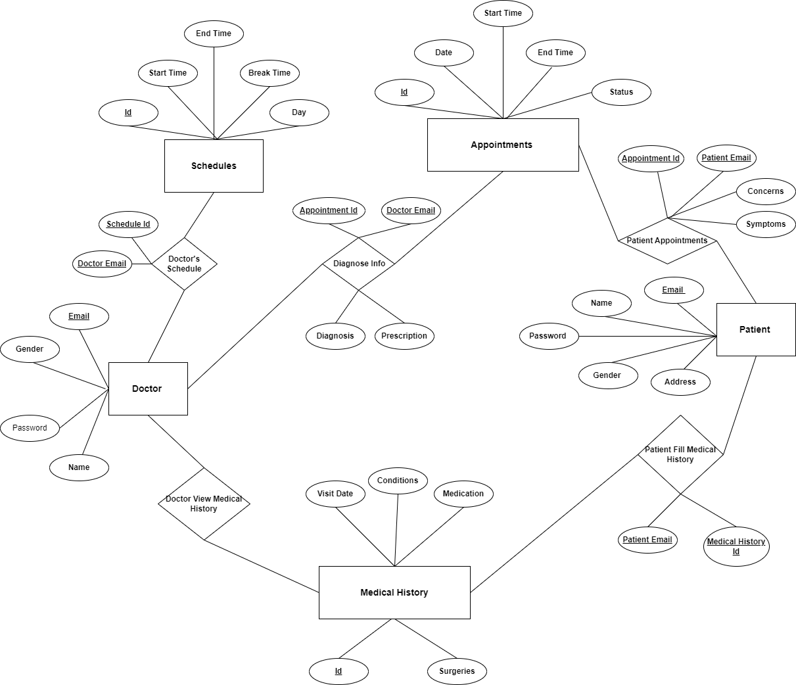

**1. Creation of Database:**



1. **Creation of Patient Information Table**

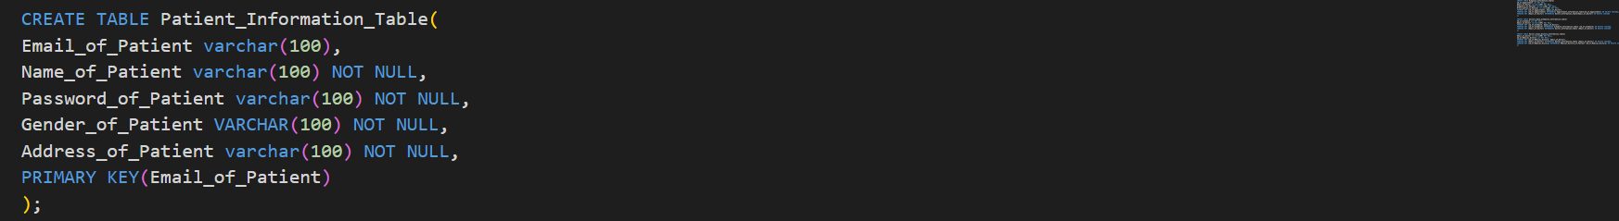

1. **Creation of Doctor Information Table**

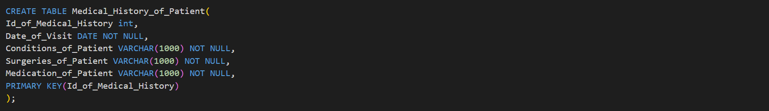

1. **Creation of Medical History of Patient Table**

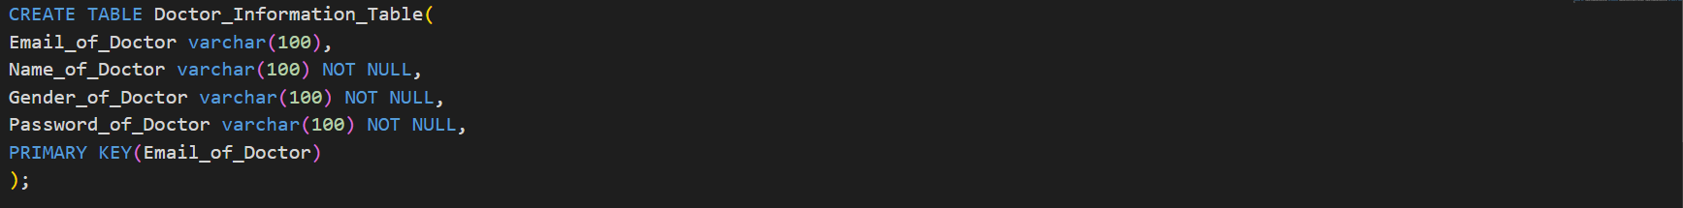

1. **Creation of Appointment Information Table**

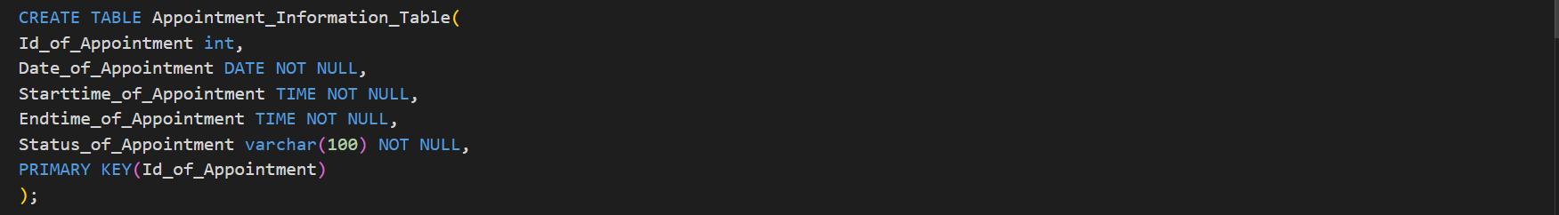

1. **Creation of Patient Attended Appointment Table**

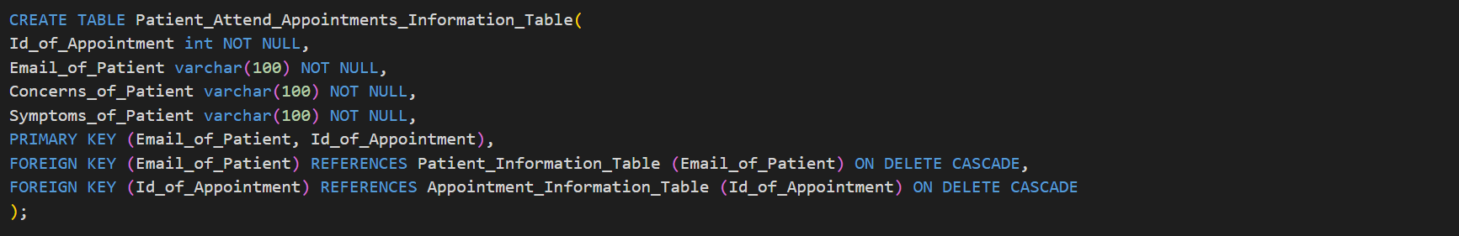

1. **Creation of Schedule Information Table**

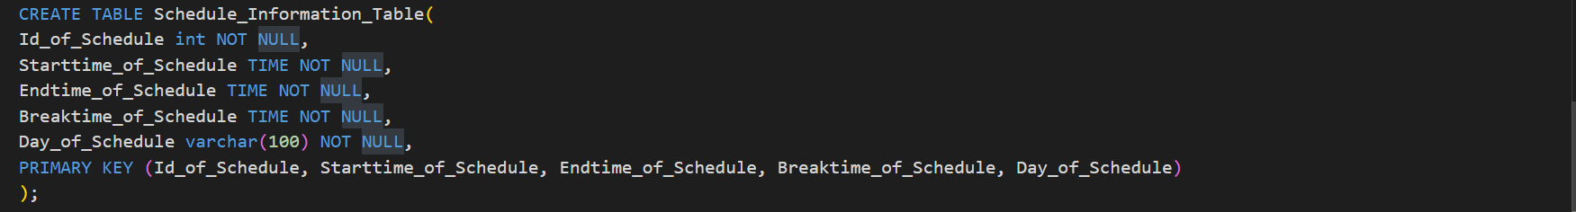

1. **Creation of Patient Filling History Information Table**

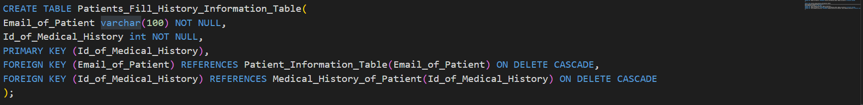

1. **Creation of Diagnose Information Table**

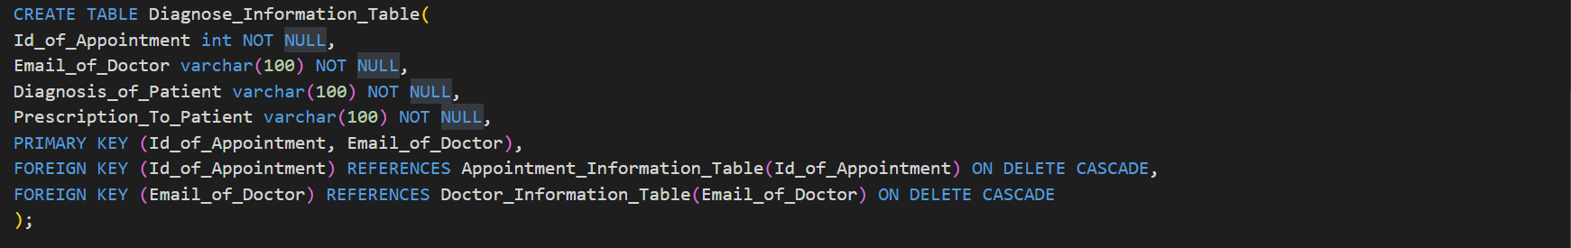

1. **Creation of Schedules of Doctors Table**

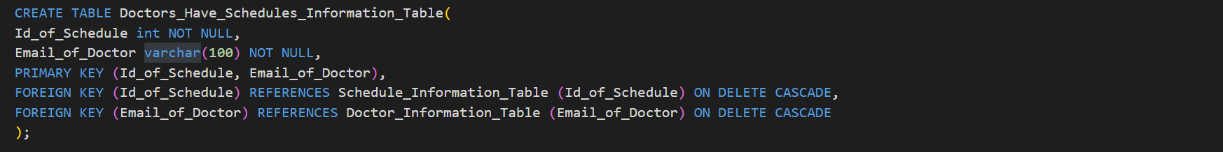

1. **Creation of Doctors viewing Patient History Table**

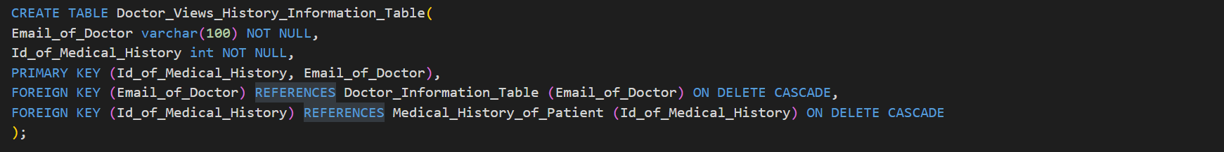

Queries for different Functionalities:

1. **Checking if Patient is already having account:**



1. **Inserting Patient Info to Create Patient’s Account:**



1. **Inserting the Medical History of Patient Info Collected during Account Creation:**



1. **Inserting a row into Patient Fill History Table, relating Patient History table to Patient Info Table:**



1. **Check if Doctor is already having account:**



1. **Inserting Doctor Info to Create Doctor’s Account:**



1. **Inserting Doctor’s Availability Schedule Info:**



1. **Updating Patient’s Password:**



1. **Updating Doctor’s Password:**



1. **Checking Date and Time of Appointment:**



1. **Checking If a Similar Appointments to avoid Clash:**

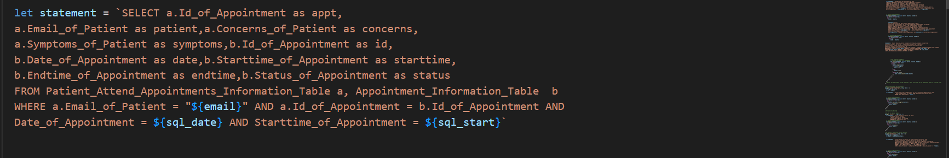

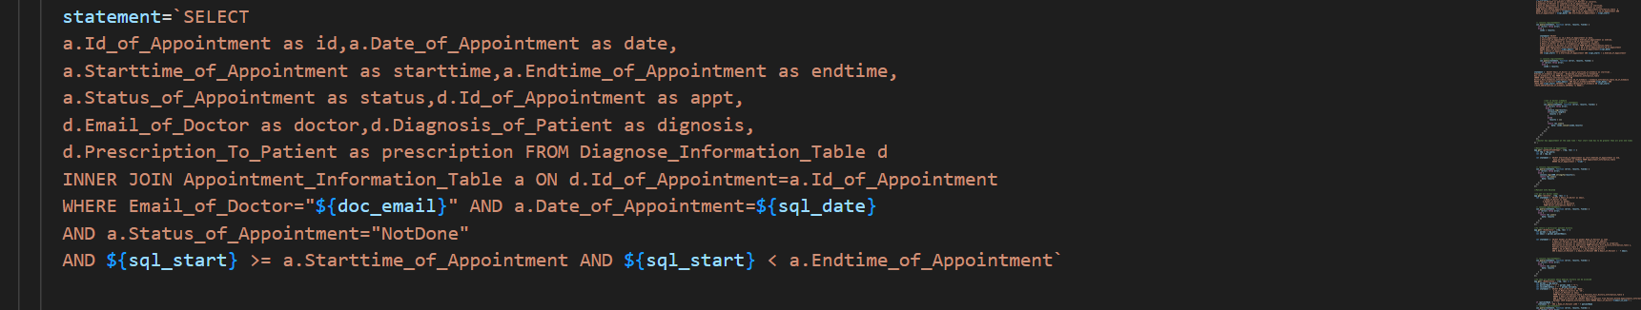

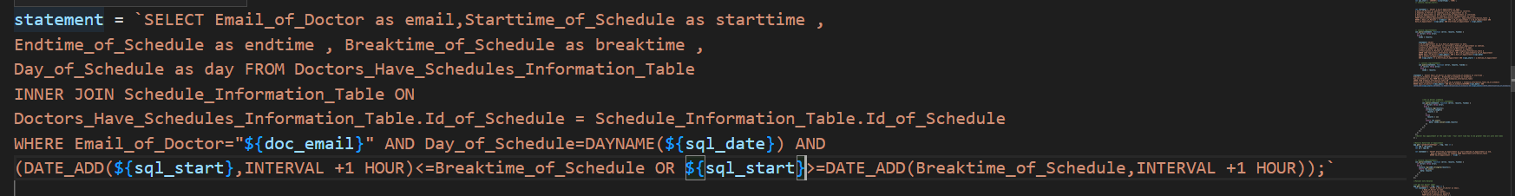

1. **Selecting the Medical History of a particular Patient:**

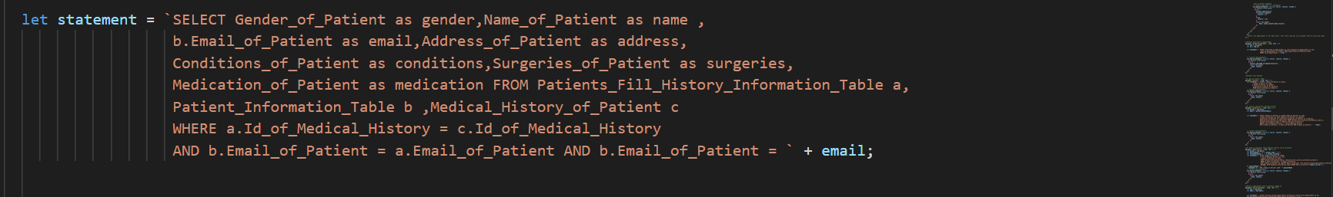

1. **Showing a Patient his/her Appointment’s Info:**

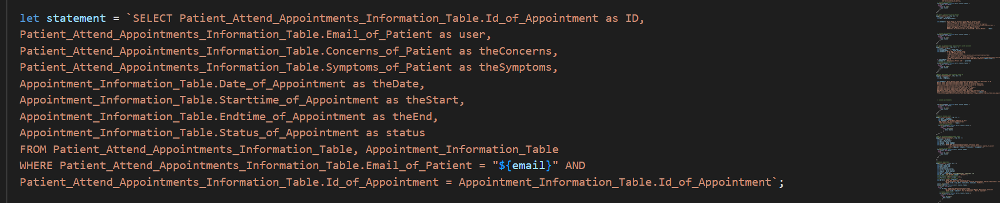

1. **Showing Diagnosis Info which is filled by doctor:**

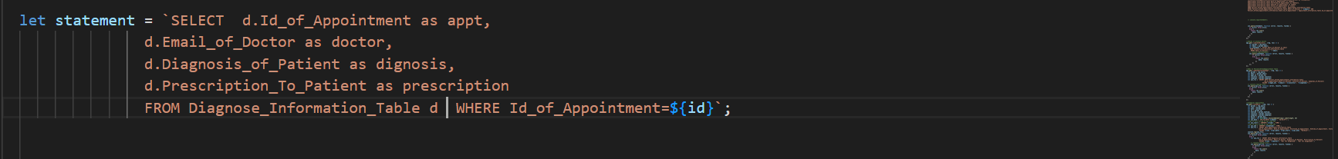

1. **Showing Appointments to a Doctor:**

