**Report writing**

**CSY1018 (web development)**

**Year 1**

**Table of contents**

Submitted to: Northampton University.(NILE).

Submitted by: Suryapratap limbu.

NILE id: 17425102

Starting phase……………………………………………………… 2

Designs…………………………………………………………….. 2

Sketches…………………………………………………… 2

Home page………………………………………… 2

CV page…………………………………………… 3

Contact page……………………………………… 4

Biography page…………………………………… 5

Mobile view………………………………………… 6

Prototypes………………………………………………….. 7

Style tile…………………………………………… 7

Logos……………………………………………………….. 8

Evidence of good practice………………………………………. 9

Page load speed…………………………………………. 9

Html validation……………………………………………. 10

CSS validation…………………………………………….. 11

Progression over 12 weeks………………………………………. 13

(1-4) weeks…………………………………………………. 13

(4-8) weeks………………………………………………… 14

(8-12) weeks………………………………………………… 16

Conclusion…………………………………………………………… 17

Reference……………………………………………………………. 18

**Starting phase**

Before starting my website, I made a time estimation and look up some websites to get some ideas. But, I did not copy form anywhere and did not use any frameworks for code generating. All I did is pure coding of html5 and css3 in atom. During the 12 week of coding I used Github daily for good practice. For making separate 4 webpages, I used four CSS files.

Github link of my website:  <https://prataplimbu.github.io/suryacsy1018assignment/>

These are the websites that I looked to get some idea:

* <https://joel.sh/about>
* <http://www.nagariknews.com/>
* <http://www.esaranepal.com/>

**Designs**

Before coding I design some sketches of my website; it probably helped me a lot by giving specific idea. The sketches I made are below.

**Sketches**

I have created four sketches of all pages for desktop view and one page for mobile view.

**Home page**

My home page will contain one heading, body part and footer containing some div inside it. The logo is animated, which is in all pages and navigation bar. In the body part there will be side navigation bar icons, written contents and photo displayed in a row.

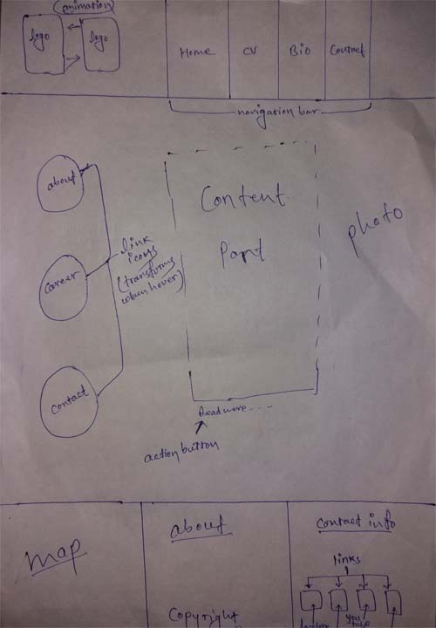**CV page**

The header and footer of CV page will be same as others; but, the main part contains different contents. There is no photo In the main part. All the content is divided into different divisions.

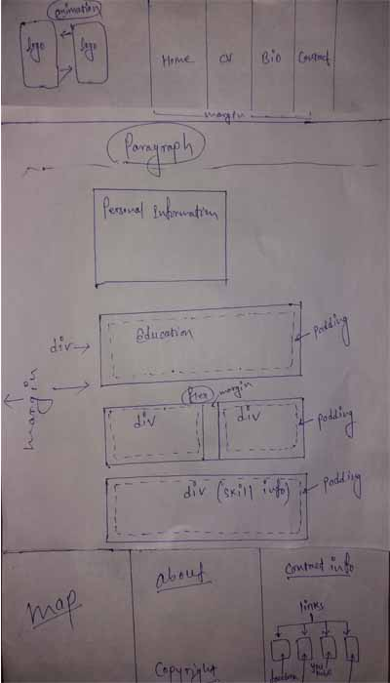**Bio page**

In the main section of bio page, there will be one photo, two navigation icons.

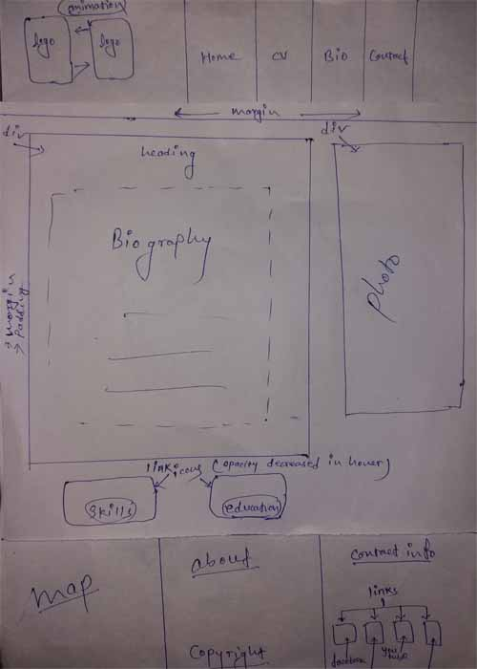**Contact page**

In the contact page there is static form, in which first two fields are required. The message box is there to submit message.

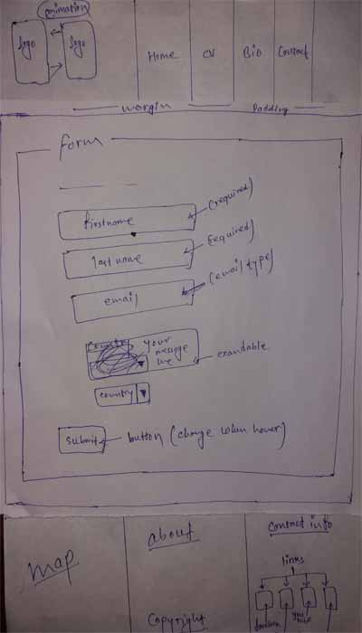**Mobile view**

My website will lool like this in mobile.

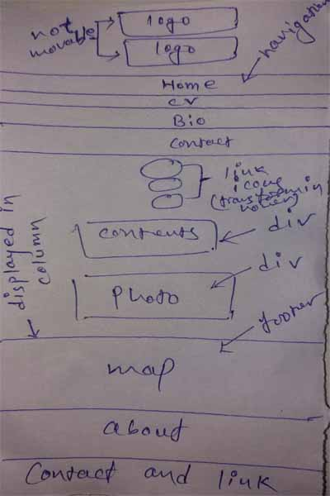**Prototypes**

**Style tile**

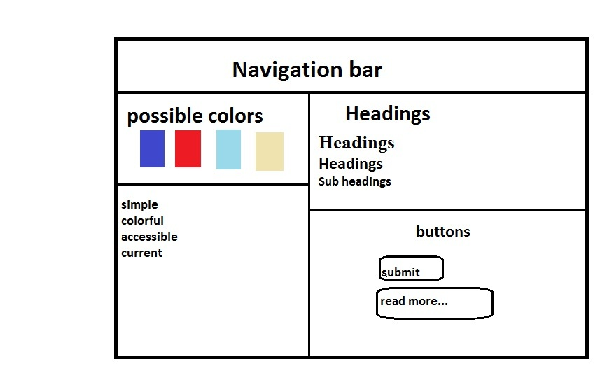**Logos**

I have created some logos for my website so that the page looks more stunning. Some logos are animated and displayed in the corner of the page, and some are used as icons of anchor tag.

Logo for animation:





Logo for links:

These logos works as a link in the website to navigate within the pages.**Evidence of good practice**

To make my website better I went through different approaches. There are many good practices to make it happen. I used speed test, html validation, and CSS validation.

**Page load speed**

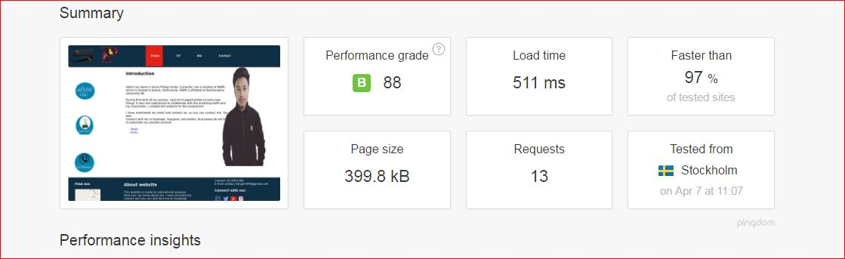We all know that almost every person in the world wants the website to load fast. So, it is one of the best ideas of good practice. I checked my load speed from pingdom.com. The load time of my website is 511ms, which is faster than 97% of the websites. The screenshot of the result is given below for the evidence.

**Html validation**

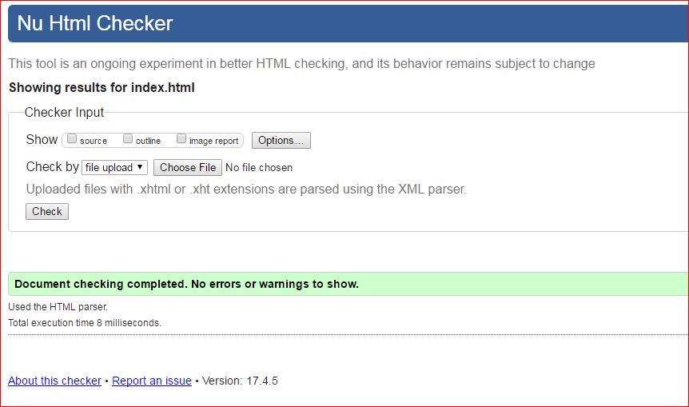Validating the code is one of the best practices. It will help to make error free code. The evidence of the complete validation is below:

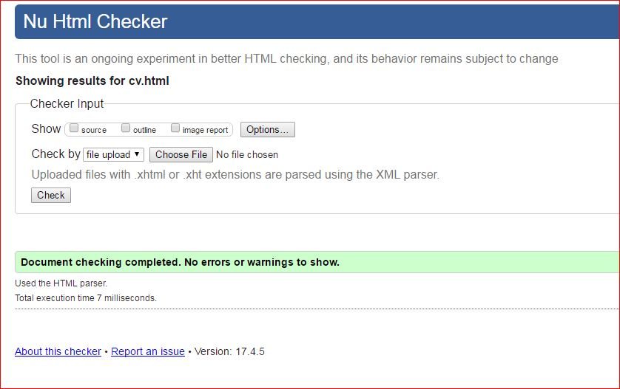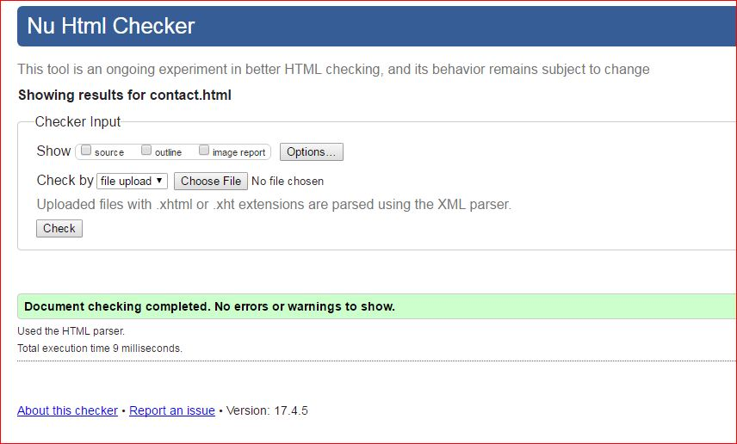

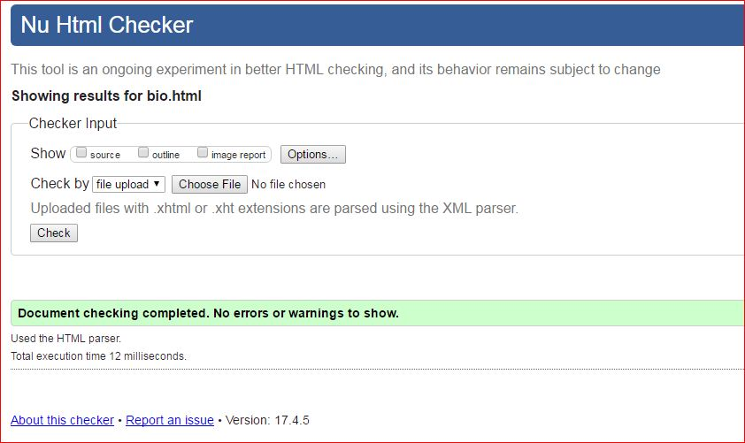

**CSS validation**

Validating the code of css is one of the best practice; I uses w3c css validatior for validating css codes. The evidence of css validation is below:

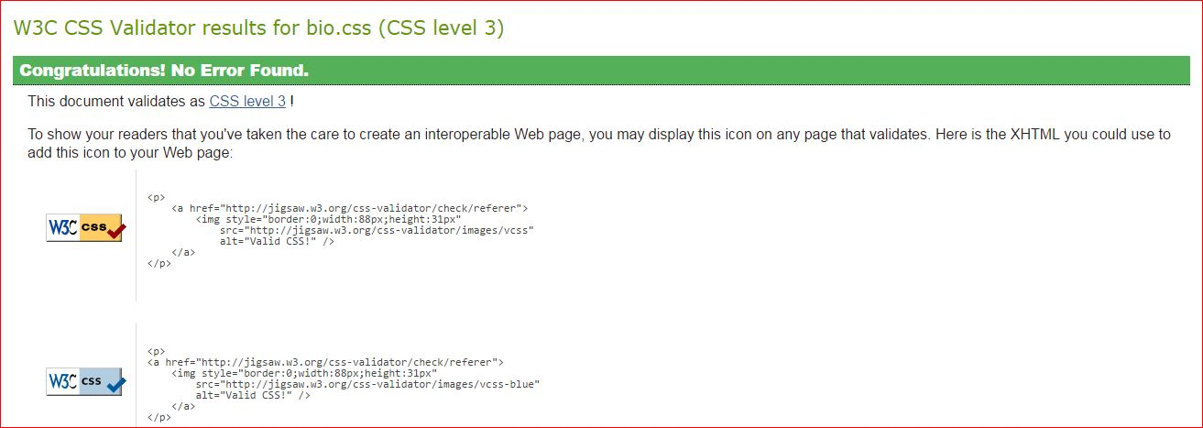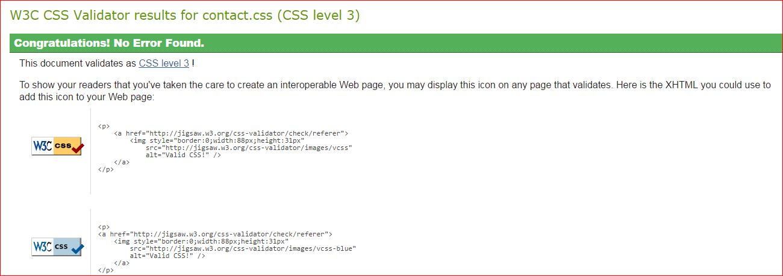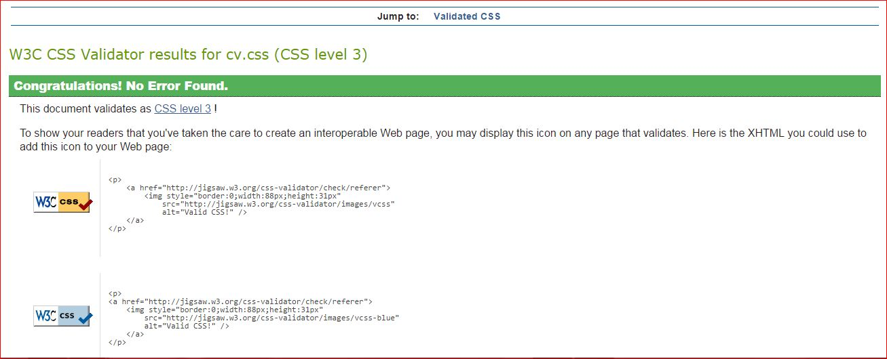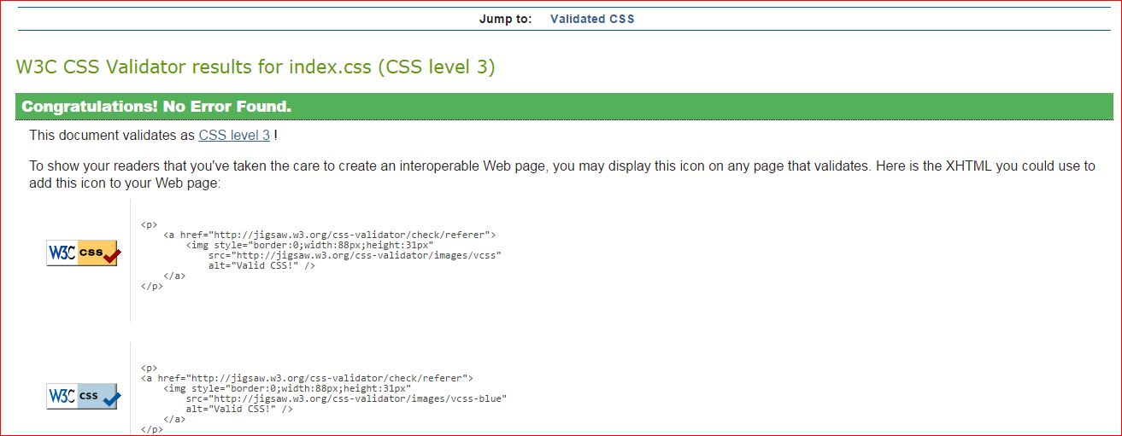

**Progression over 12 weeks**

**Week 1-4**

During week 1-4, I completed basic sketches, header part, and footer part. In the header part there are two logos, which are animated. And there are also navigation bar in the header part. The navigation bar is for navigating within the webpage.

The second part is footer part. In this part there are three containers displayed in a row. In the first container map is displayed, in the second part paragraph about website and copyright is displayed. In the third container there are contact information and social sites icons link.



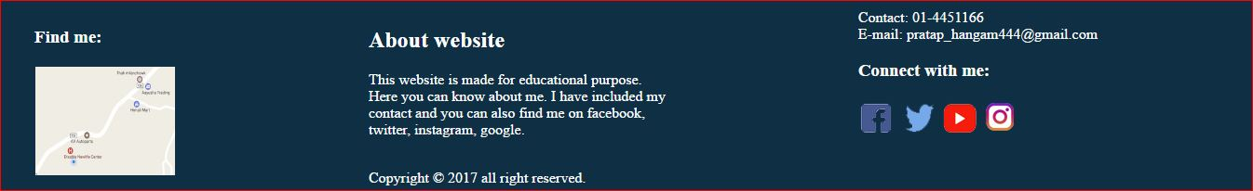**Week 4-8**

Between weeks 4 -8, I created all main body pages. In the main content of home page there are three side navigation icons, and one image. Overall there are three classes; first for side navigation, second for written contents, and third for image. They are displayed in a row using flex property.

The side navigation will be transform in hover and opacity will be decreased. The second class contains written contents, and third part contains my image.

The CV page is also kind of home page but it does not contain images; it contains paragraphs and divisions. Inside the division there are unordered list, which shows the list item.

The next page is biography page; it contains one image, two icons and written content. Written content and the image are displayed in row using flex and the two icons, which help to navigate the page are in the bottom of the page.

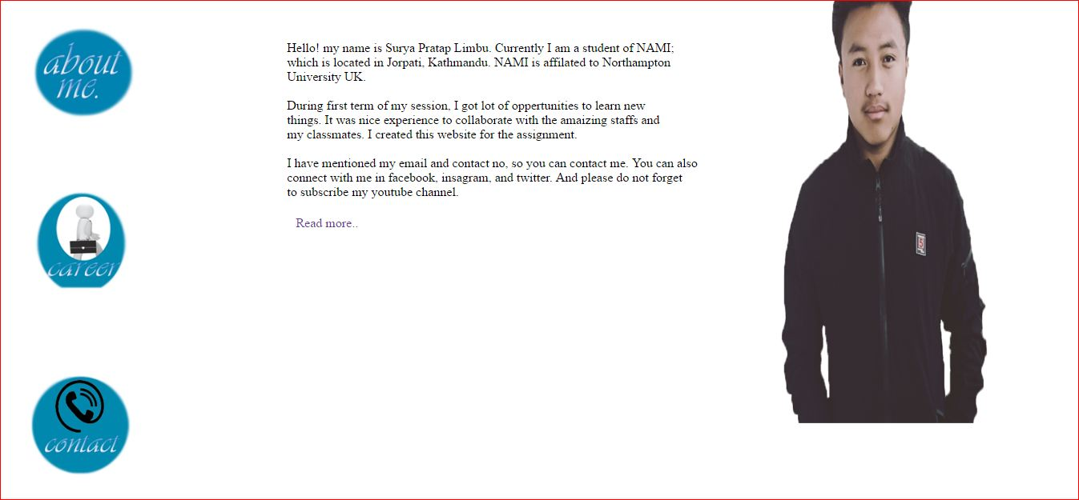The last page is contact page; it contains static form. The form includes first name, last name, email, and country option to fill. And it has a one button called submit.

Home page contents: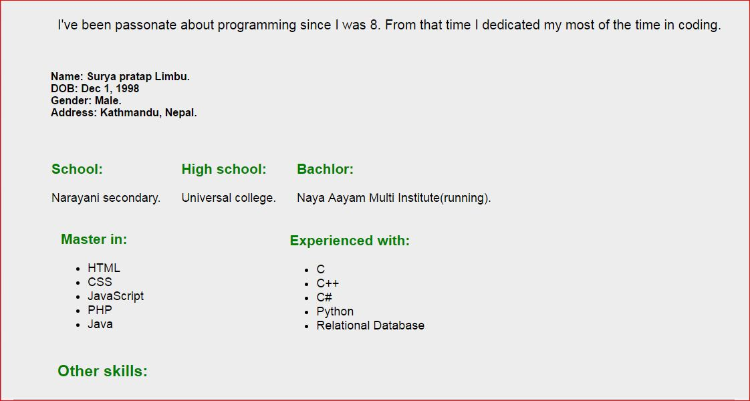cv page contents:

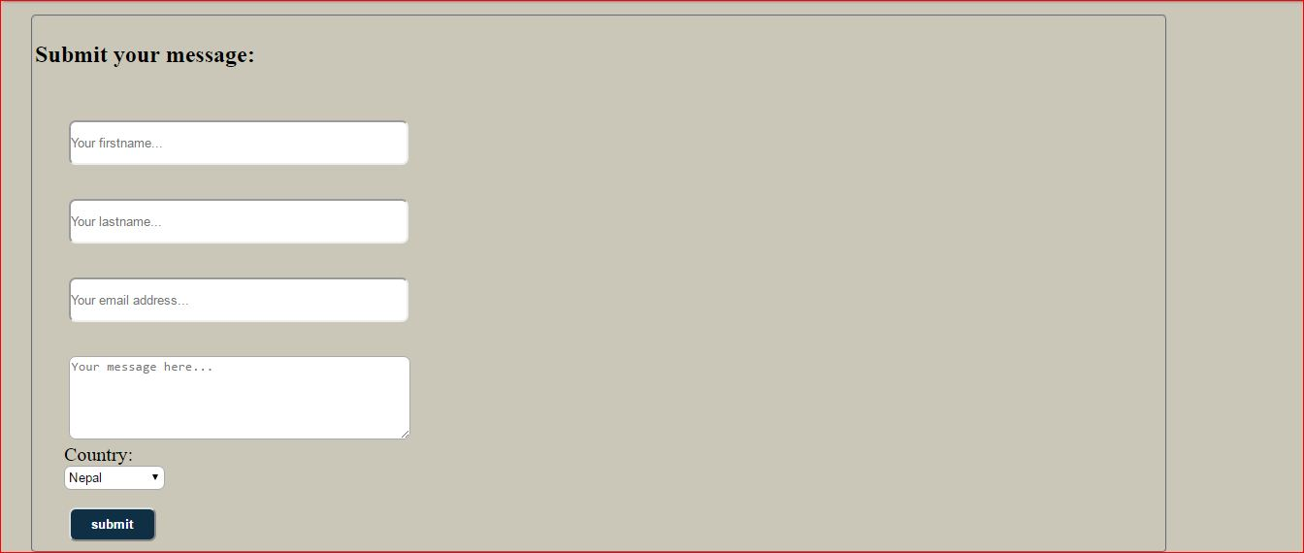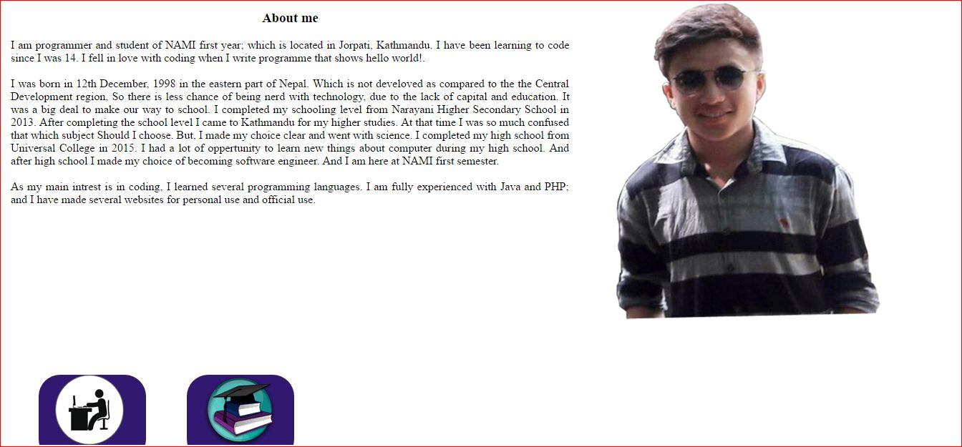Content of bio page:**week 8- 12**

Content of contact page:

Between weeks 8 – 12 I used my time to make the website responsive. The webpages for windows was completed. So, this week was focused on making it responsive.

As we all know, nowadays almost every people used mobile phone. So, it would be wiser to make your website responsive; so that it will be supported by the android phones. Maximum width of 480 pixel android device will support my website, and there will be no any animations of the logo as in windows view; all content of the page are displayed in column.

During these weeks, there were lots of obstacles; it was very challenging to maintain the features of the website in mobile view. So, mobile view does not have as much features as the desktop does.

Home page in mobile:

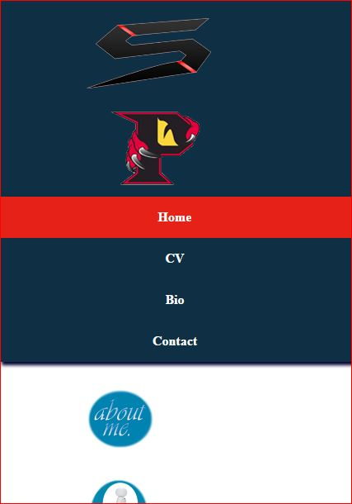

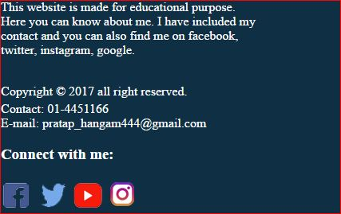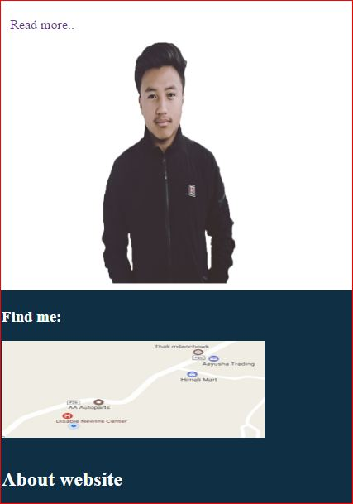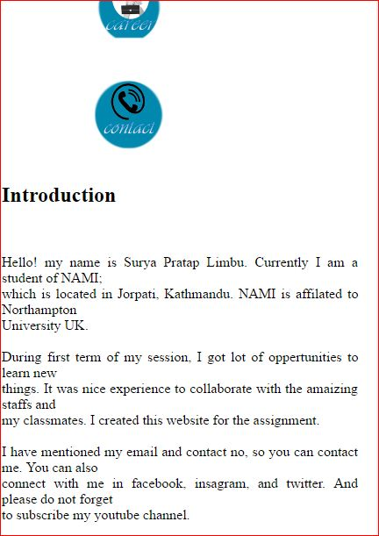**Conclusion**

The website is completed within 12 week, completing the divided tasks in the shorten amount of time. It was challenging at first but obviously, pleasure after completing.

In a conclusion, the website is responsive and will be supported by windows and android device. Mainly, html5 and css3 are focused part of this site; it has animated logos and navigators. The overall page load speed is also good. It is proved that this is faster than the 97% of the websites. And talking about the codes, there are no bugs at all; as evidence I have included the screen shots of the result.

**References:**

W3schools (2017) Online Web Tutorials *W3schools* [online]. Available from : <https://www.w3schools.com/> [Accessed 22/ 03/ 2017 ].