House Price Prediction — Summary of Findings
A regression analysis of 545 residential properties (12 features: size, rooms, amenities, and furnishing) was used to predict sale price and identify the strongest price drivers.

Model Performance
Model | MAE | RMSE | R² Score
Linear Regression | 970,043 | 1,324,507 | 0.653
Random Forest | 1,014,947 | 1,399,769 | 0.612
Linear Regression slightly outperformed Random Forest, indicating the relationship between features and price is largely linear and additive for this dataset.

Top Price Drivers
- Area (square footage) — the single strongest predictor of price in both models.
- Number of bathrooms — a much larger effect than bedroom count.
- Air conditioning and hot water heating — amenities with a sizeable positive impact.
- Preferred area location and number of stories also meaningfully raise price.
- Furnishing status — unfurnished homes sell for clearly less than furnished ones.

Insights & Recommendation
The model explains about 65% of price variation (R² ≈ 0.65) with a typical error under 1,000,000 in the dataset's currency — good for ballpark estimates, not exact pricing. A genuine surprise was how little bedroom count mattered compared to bathrooms, area, and amenities.
Recommendation: Real estate agents should anchor pricing guidance and marketing on area, bathroom count, AC/heating, and location desirability — and consider that low-cost upgrades like adding air conditioning or furnishing a unit before sale may yield outsized returns relative to bedroom-focused renovations.
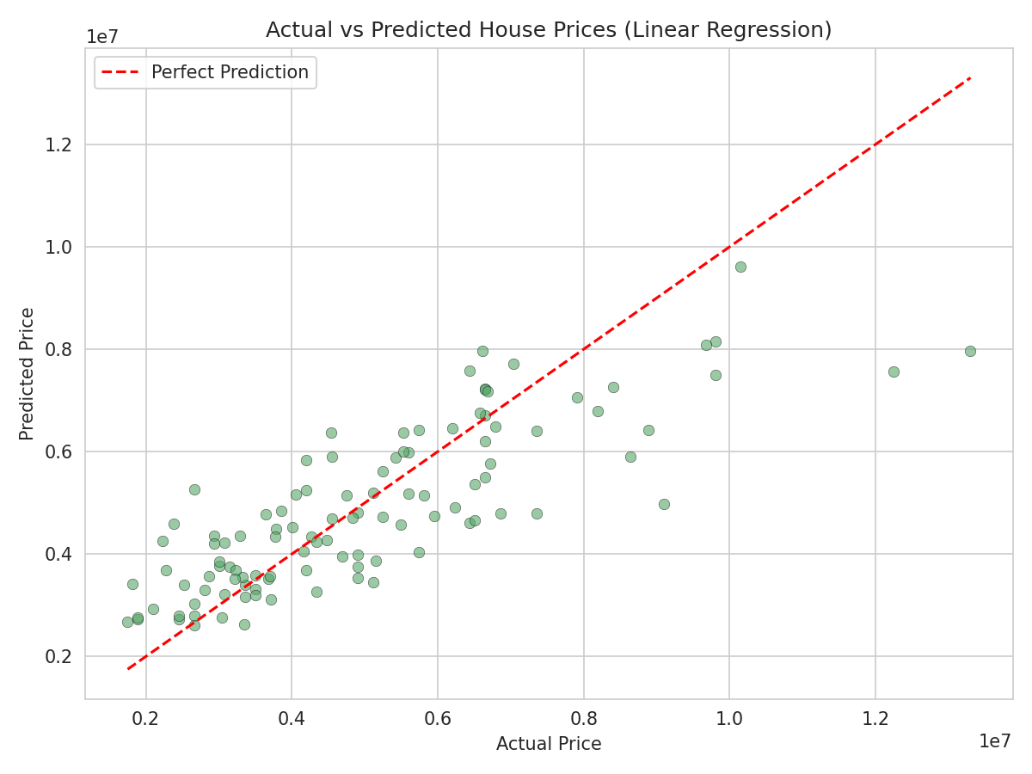
Actual vs. Predicted Price (Linear Regression) — points near the dashed line are accurate predictions.

