**Investigating the Academic Performance of Students**

This report investigates factors affecting student performance across the 3R’s including parent education qualification, test preparation, and gender. Do children whose parents are well-educated perform better? Does undertaking a test preparation course assist a student in obtaining better marks?

The dataset contains student demographic information(gender, group), test scores in maths, reading, and writing as well as factors like parent education qualification and test preparation completion. Furthermore, we have added a few columns. They are the Total score(sum of the scores), Average score(mean of all the scores), and Result column which is based on the average score. It is ‘Distinction’ when the student’s average score is greater than 75, ‘Pass’ when the student scores between 75 and 50, otherwise ‘Fail’.

Let’s analyse and gain insights into student’s performance and explore factors that are influencing their scores.

In the histogram, the bars show the frequency of each subject’s score within the bin. We can infer that each subject score is relatively normally distributed and the peak of the curve or the mean would be around 65-70. This can be validated against the table below which describes the data.

The pie chart clearly showed a nearly equal distribution of students by gender. However, there is a slight majority of female students(51.8%) than males(48.2%).

Now, let us attempt to understand how the parent’s education degree affects the child’s results.

According to the bar graph, students whose parents hold a master’s degree achieved a higher score than the students whose parent’s highest level of education is high school. This suggests that the higher the education level of parents, the more likely the test scores of the students will increase. This may be because educated parents encourage their children to complete the test preparation course or provide guidance accordingly.

Analysing above graph which shows the students results based on their test preparation. We can infer that a greater percentage of students achieve distinction when they have completed test preparation as opposed to when they have not. The absolute indicates fewer students undertake test preparation.

Now, let’s try to find out the relation between the scores with a scatter plot.

From the data points on the plot, we can observe that student scores are positively correlated with each other. If a student scores well in one of the tests, then that student may get a good score in other tests as well and the same is true for lower scores. There are no clear outliers visible meaning the dataset is relatively consistent in terms of test scores. let’s try to understand the correlation between the various scores.

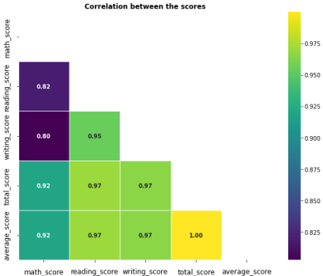

The heatmap depicts that reading and writing scores have a high correlation value of 0.95, which implies that if the reading score is high then the writing score is also high. This is expected as these skills are often related. The maths scores have a correlation value of 0.82 with reading scores and 0.80 with writing scores which are high but slightly less than the correlation between reading and writing scores. The average score has a perfect correlation with the total score as the average is completely dependent on the total score.

To conclude, Mean scores are evenly distributed across the three skills measured. However, a clear correlation can be seen between reading and writing – better reading skills result in improved writing skills. Also, test scores improve when students participate in test preparation courses and student’s scores also improve when parents are well-educated with students whose parent’s qualifications are masters performing the best.

**Referred Dataset:**

<https://www.kaggle.com/datasets/bhavikjikadara/student-study-performance/data>

**Author:** Pratap Bhargav Ponnam

**ID:**23027654