AI Resume Screening System
  - Assignment II: Production Refactoring, API Design, and Quality Assurance
AIMLCZG546 - Software Engineering for Machine Learning
Group No. 179

Group details
BITS ID | Name | Contribution | Percentage
2025AB05113 | Prashant | ML implementation and API, Architecture and code quality
2025AA05032 | Prathap Wagle | ML implementation and API, Architecture and code quality
2024AC05999 | Prasanna R T | Test design, execution and review
2024AC05914 | Pranav Mehrotra | QA evidence and final review

Submission statement. This submission evolves the working Assignment I system without removing its upload, explanation, human-oversight, or audit features.

Assignment compliance mapping
Requirement | Implementation | Verified evidence
1. Modular refactoring | ML, quality, shared application, audit, API, and UI modules | ml/, quality/, services/, app/, streamlit_app.py
2. Research vs production | Inline notebook prototype compared with production clean_text | 179.ipynb, Section 3
3. Logging and errors | INFO/WARNING/ERROR across six critical modules | logging_config.py, logs/
4. Formatting and linting | Recorded initial findings, then Black/isort/Flake8 pass | reports/lint_before.txt and lint_after.txt
5. REST API | Startup model load; typed prediction, health, and metrics | app/api.py, app/schemas.py
6-7. Tests and ML tests | Unit, data, loss, persistence, inference, continuity, API | 35 tests; reports/pytest_report.txt
8. Quality metrics | Accuracy, F1, Brier, top-3, schema, balance, drift helper | reports/metrics_snapshot.json
9. Production and security | Shadow/canary strategy and resume-data controls | Section 9

1. Continuity from Assignment I
Assignment II uses the same HR/recruitment problem, labelled job-role data, TF-IDF and logistic-regression pipeline, keyword explanation, human decision note, and measurable quality goals developed in Assignment I. The monolithic prototype is refactored into production modules and exposed through FastAPI.
Assignment I capability | Preserved Assignment II component
TXT/PDF/DOCX resume upload | ml/ingestion.py
Text normalization and classification | ml/preprocessing.py, ml/trainer.py
Explanation and human oversight | services/scoring.py
Consistent submission orchestration | services/application.py
Audit history without raw resume storage | services/audit.py
Recruiter-facing dashboard | streamlit_app.py
New production inference contract | app/api.py and app/schemas.py

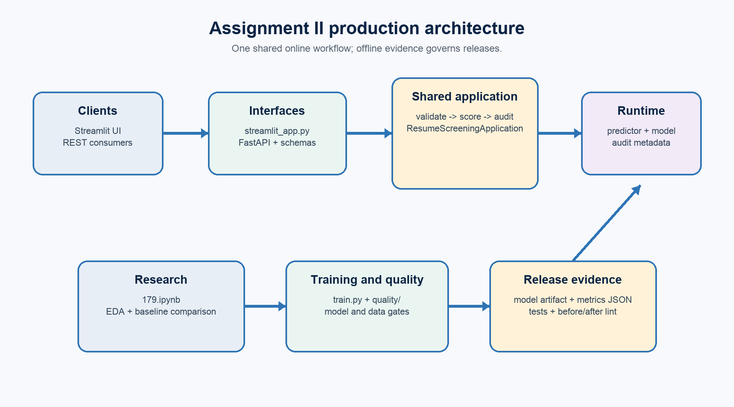
Figure 1. Shared online workflow and evidence-governed offline release.

2. Refactoring with OOP and functional principles
Data and validation. ml/data.py creates the labelled dataset and returns an immutable DataQualityReport after schema, missing-value, duplicate, and class coverage checks.
Ingestion. ml/ingestion.py isolates TXT/PDF/DOCX parsing, file-type checks, empty-file checks, and a 5 MB upload limit.
Training. ml/trainer.py constructs the reusable scikit-learn pipeline, measures validation metrics, enforces release gates, retrains on all data, and persists a versionable artifact.
Inference and services. ModelPredictor owns artifact loading and stable probability output. ResumeScoringService adds explanation and human oversight without coupling those rules to the classifier.
Application boundaries. ResumeScreeningApplication coordinates validate, score, and audit for both FastAPI and Streamlit. AuditRepository stores only metadata.
Quality and configuration. config.py centralizes runtime paths and versioning; quality/ computes model/data metrics and drift signals; training persists metrics JSON.

3. Research code vs production code
The canonical 179.ipynb now demonstrates the same preprocessing component twice. The first version is deliberately notebook-oriented; the second imports the tested production function. It also records class/text-length EDA, compares MultinomialNB with logistic regression on one fixed split, and displays a classification report and confusion matrix before the production hand-off.
# Research prototype in 179.ipynb
def prototype_clean_text(text):
return re.sub(r"\s+", " ", re.sub(r"[^a-z0-9+#. ]", " ", text.lower())).strip()
# Production use
from ml.preprocessing import clean_text
clean_text(" Python TESTING!! ")
Aspect | Research prototype | Production component
Purpose | Rapid feasibility | Repeatable service behavior
Structure | Inline notebook cell | Importable typed function
Validation | Assumes string input | Type, empty, size, semantic checks
Observability | Displayed output | Structured INFO/WARNING/ERROR logs
Quality evidence | Manual inspection | Unit and API integration tests

4. Error handling and logging
Logging is configured centrally and writes to console plus a rotating project-relative file (1 MB, three backups). Raw resume text is neither logged nor stored in the audit CSV.
Critical module | INFO | WARNING / ERROR
ml/preprocessing.py | Input/output character counts | Wrong type, empty, oversized, or unusable content
ml/ingestion.py | Type and extracted length | Unsupported, empty, oversized, or failed extraction
ml/data.py | Rows, schema, quality report | Missing schema/values or insufficient classes
ml/trainer.py | Training rows, artifact, metrics | Fit exception or failed quality gate
ml/predictor.py | Artifact and prediction metadata | Missing artifact or inference exception
app/api.py | Startup model load and successful requests | Invalid request, unavailable model, unexpected error

5. Code formatting and linting
The initial review established a genuine baseline before remediation. The configured tools were then applied to the complete Python codebase and rerun after implementation changes.
BEFORE (2026-07-26)
Black: 15 files needed formatting.
isort: 6 files had incorrectly sorted imports.
Flake8: 29 violations.
AFTER (2026-08-01)
$ black --check . -> PASS
$ isort --check-only .
PASS - no incorrectly sorted imports.
$ flake8 .
PASS - no violations.
Evidence 1. Recorded baseline and reproducible post-remediation results.

6. REST API design
Endpoint | Contract | Status behavior
GET /health | Typed status, model_loaded, and API version | 200 ready; 503 artifact missing
POST /predict and /v1/predictions | Typed candidate and resume request; typed ranking response | 200 success; 422 invalid; 503 model; 500 unexpected
GET /metrics | Persisted model/data release snapshot | 200 available; 404 snapshot missing
GET /docs | Generated OpenAPI/Swagger documentation | Interactive contract documentation

Validation occurs at both schema and domain layers. A punctuation-only resume is rejected after normalization, blank candidate names are rejected, model loading occurs at startup, and readiness fails when the artifact is missing.
POST /v1/predictions -> 200
{candidate_name, predicted_role, confidence,
role_ranking[6], explanation, decision_note}
GET /health with missing artifact -> 503

7. Testing strategy and implementation
Type | Representative checks | Evidence
Unit | Normalization, invalid content, TXT ingestion, audit privacy | test_preprocessing.py, test_continuity.py
Data validation | Schema, missing values, duplicates, class coverage | test_data_quality.py
Model training | Loss decreases, gates, determinism, persistence round-trip | test_training.py
Model inference | Ranking/probability contract, direction, invariance, empty input | test_inference.py
API integration | Lifecycle, aliases, metrics, audit privacy, validation/errors | test_api.py
Quality monitoring | Data summary and text-length drift detection | test_quality_metrics.py

$ pytest -q
................................... [100%]
35 passed in 0.51s
Evidence 2. Automated unit, ML-specific, data, continuity, and API tests.

8. Model and data quality metrics
Category | Metric | Measured | Gate / interpretation
Model | Accuracy | 1.000 | Required >= 0.800
Model | Weighted F1 | 1.000 | Required >= 0.800
Model | Top-3 accuracy | 1.000 | Monitoring metric
Model | Multiclass Brier | 0.725 | Lower is better; monitored
Data | Schema validity | True | Required columns present
Data | Missing-value rate | 0.000 | Required = 0
Data | Missing required values | 0 | Required = 0
Data | Duplicate rows | 0 | Monitored for evaluation bias
Data | Minority-class fraction | 0.167 | Balanced 6-class set

The evaluation uses 12 stratified validation rows from a deliberately small 24-row synthetic dataset. The results prove that measurement and release gates are implemented; they are not production-performance claims. A reusable text-length drift check flags batches beyond three reference standard deviations.

9. Testing in production and security

9.1 Shadow and canary strategy
A candidate model would receive copies of production requests while the current model remains recruiter-visible. The team would compare latency, error rate, class distribution, confidence, disagreement, and manually reviewed correctness. Promotion would require predefined gates, followed by a small canary with automatic rollback thresholds.

9.2 Security and privacy
Resume content is sensitive personal data. The implementation enforces type, length, semantic-content, file-type, and upload-size validation; does not log or persist raw resume text; and separates audit metadata. Operational monitoring should also detect keyword stuffing, input length drift, confidence shifts, and unexpected role distributions. Production deployment additionally requires TLS, authentication, rate limiting, malware scanning, isolated parsing, encryption, retention limits, and least-privilege access to data and model artifacts.

10. Reproducible execution
python -m venv .venv
source .venv/bin/activate
pip install -r requirements.txt
python train.py
pytest -q
black --check .
isort --check-only .
flake8 .
python run_api.py
# API docs: http://127.0.0.1:8000/docs
# Preserved UI: streamlit run streamlit_app.py

11. Conclusion
The Assignment I prototype has been evolved into a feature-preserving, production-style ML system. The final package demonstrates explicit research-to-production separation, modular architecture, persistent artifacts, structured logging, robust validation, a typed REST API, multi-level automated testing, quality gates, privacy-aware audit history, and production experimentation planning.

Appendix A - Canonical submission artifacts
The following files form the canonical submission. Earlier draft artifacts remain only as working history and are not required for grading.
Artifact | Purpose
179.ipynb | Canonical implementation notebook
179_executed.ipynb | Notebook with verified outputs
179.docx and 179.pdf | Submission report
app/, ml/, quality/, services/ | Production source package
streamlit_app.py | Preserved Assignment I recruiter workflow
tests/ | 35 automated tests
reports/ | Pytest, lint, and metric evidence
models/resume_classifier.joblib | Trained model artifact
README.md and requirements.txt | Setup and dependencies

Final submission checklist
Check | Verified result
Canonical notebook name | 179.ipynb
Notebook execution | 179_executed.ipynb completes successfully
Automated tests | 35 passed
Model/data quality gates | All required gates pass
Code quality | Black, isort, and Flake8 pass
Report render | DOCX and PDF visually inspected page by page

