**DATA**

The Business problem needs data of coordinates of each neighborhoods. Also, we need access to Foursquare API to get the list of nearby venues for each coordinates. The list of coordinates of the neighborhoods in Barcelona for the present problem is obtained from the, website <https://www.aggdata.com/free/spain-postal-codes>. The data looks like the following

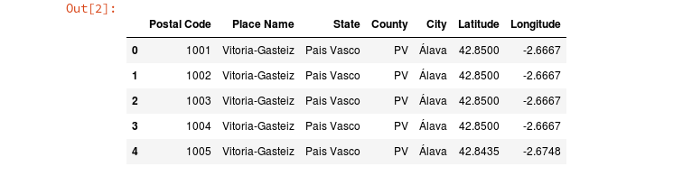The data consists of coordinates of the Barcelona city as well as the suburban regions. It is filtered to get only the neighborhood data of the main city. Further, data of the rent prices are obtained through [https://www.opendata-ajuntament.barcelona.cat](https://www.opendata-ajuntament.barcelona.cat/). The table consists of prices per square meter of houses (average) for each district.



Foursquare API data is used to get the list of venues neraby a particular coordinates. The results are obtained as json file wherein the details of venue (for eg., venue name, rating, price point, type, users, etc.). We will use this Foursquare API data to get the list of top10 venues around a neighborhood. The list looks something like this,

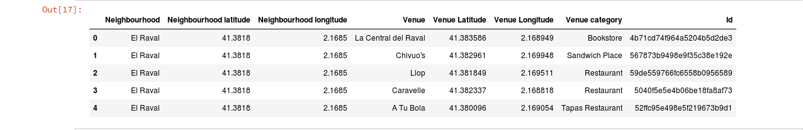

This will be used to cluster the neighborhoods based on similar or dissimilar they are.