GearGrid
Grow More, Own Less.
A peer-to-peer marketplace that lets small farmers rent farm equipment from nearby owners instead of buying it.

Submission details
Challenge | Tata Young Social Innovators Challenge (TYSIC)
Sector | Agriculture
Problem statement | How can small farmers share expensive equipment instead of owning it?
Document | Solution submission: Proof of Concept (design, flows, architecture, plan)
Applicant | Prateek Saha
Version / date | 1.0 | September 2026

This document describes the problem, the proposed solution, every user flow, the trust and payment model, the technical design and the delivery plan for GearGrid. Diagrams are included throughout; a full list of pages, data tables and phases is in the relevant sections.

Contents
1 Executive summary
2 The problem
3 The solution
4 Who it serves and the impact
5 Product design: roles, features and pages
6 Booking lifecycle, slot calendar and extensions
7 The trust layer: handover, fraud prevention and ratings
8 Payments, deposits and invoicing
9 Technical Design: architecture, data flow and database
10 Reuse from an existing codebase
11 Landscape and differentiation
12 Pilot plan and success measures
13 Monetization
14 Risks, limitations and future work
15 Conclusion

1. Executive summary
Small and marginal farmers often cannot afford tractors, tillers, harvesters or sprayers, so they either go without mechanization or pay informal middlemen. At the same time, machines owned by larger farmers sit idle for much of the year. GearGrid connects the two: owners list idle equipment, nearby farmers rent it, and the whole exchange is protected by a booking calendar, a digital agreement, OTP confirmation, condition photos and reliability scores.
At a glance
Problem | Small farmers cannot afford equipment; owners' equipment sits idle; informal rentals are hard to find and unfairly priced.
Solution | A reverse-marketplace: owners list equipment, renters browse or post a need, owners choose from bids, and bookings are locked on a slot calendar.
Users | Equipment owners, small and marginal farmers who rent, and rural youth who can earn as owner-operators.
What is different | Slot-based scheduling with overlap-aware bidding, a two-party digital handover protocol, itemised invoices and per-role reliability scores.
Payments (POC) | No money moves through the app. Renter and owner pay each other directly; both confirm each payment in the app.
Technology | React, FastAPI, Supabase (PostgreSQL and Auth), Cloudinary, Render and Vercel. Voice input through the browser's Web Speech API.
Delivery | Concept and design complete. Build follows submission, reusing an existing marketplace codebase: about 61 to 82 hours, roughly 11 to 15 working days.

2. The problem
Farm mechanization improves productivity, but the machines are expensive and are used only in short seasonal windows. That mismatch creates three linked problems.
- Access. Small and marginal farmers cannot justify buying a tractor or harvester for a few days of use a year, so many skip mechanization and lose productivity.
- Idle assets. Owners of equipment use it during their own season and then it stands unused, representing capital that earns nothing.
- Informal markets. Renting today usually means asking around locally. Availability is uncertain, prices vary, and there is no record of who borrowed what, in what condition, or whether it came back.
A solution has to do more than list machines. Because farm equipment is high-value, physically handed over and used over time, it needs scheduling, proof of condition and a trust mechanism that works for people who are not strangers to fraud but also cannot afford to lose a machine.

3. The solution
GearGrid is a peer-to-peer equipment-sharing marketplace built around a reverse-marketplace model: renters can browse listings or post a specific request, and owners choose from the bids they receive. Because equipment is a reusable, time-shared asset rather than a one-time sale, every rental is a booking on a slot calendar. The same machine can be rented by different farmers on different, non-overlapping dates, and the system prevents double-booking.
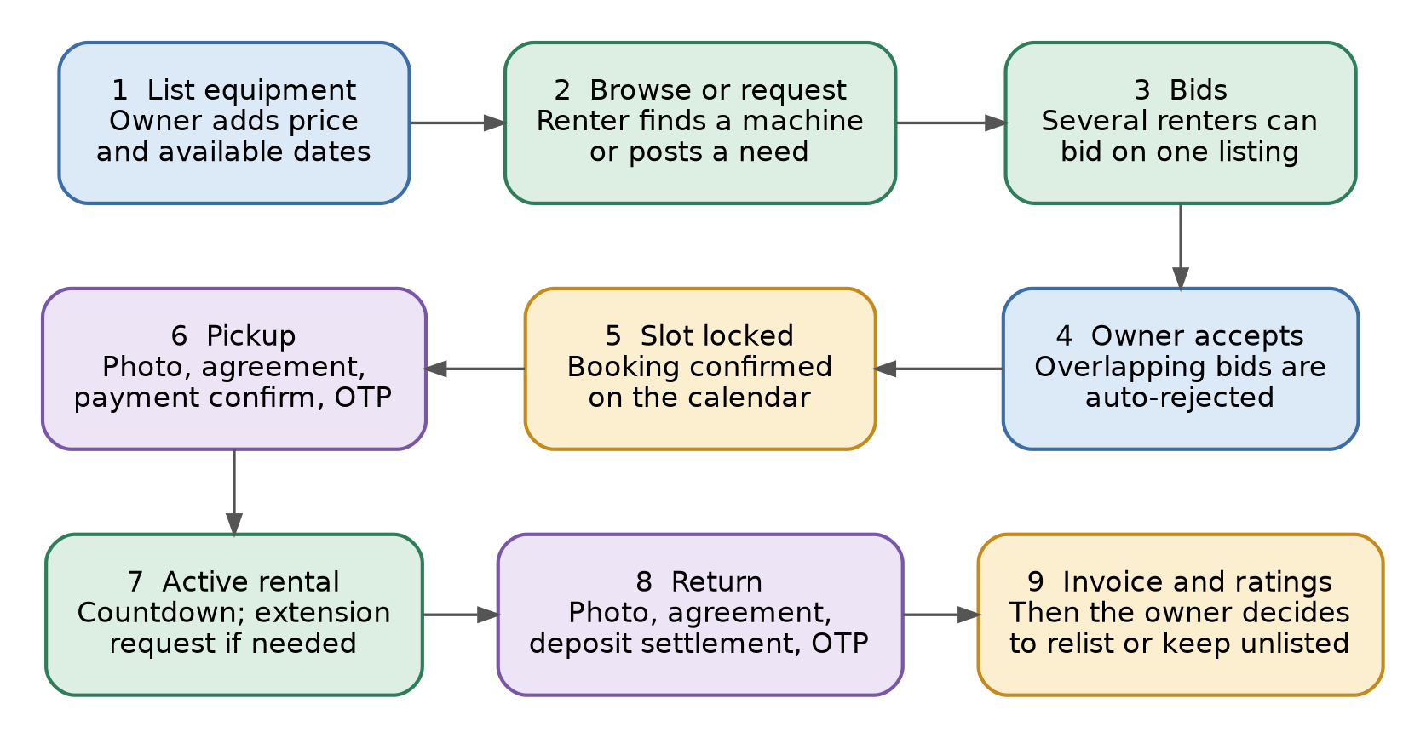
Figure 1. End-to-end rental lifecycle, from listing to invoice and relisting.
Three design decisions shape the whole product:
- Roles belong to listings, not accounts. One account can be an owner on one screen and a renter on another, as real farmers switch roles by season.
- Trust is built into every handover. Each pickup and return has a signed agreement, an OTP and a condition photo, giving both sides a timestamped record.
- The owner stays in control. Owners approve bids and extensions, and decide whether to relist after each rental. The platform never assumes a machine should always be earning.

4. Who it serves and the impact
User | Who they are | What GearGrid gives them
Equipment owners | Mid-size farmers with idle tractors, tillers, harvesters, sprayers, pumps or tools | Extra income from idle assets, protection through deposits and records, control over availability
Renters | Small and marginal farmers who cannot afford to own equipment | Affordable, nearby access to machinery, fair price discovery through bids, clear records
Rural youth | Young people with operating skills but no equipment or capital | A path to earn as owner-operators, and later as operators-for-hire

Social impact follows directly from the model:
- Lowers the cost barrier to mechanized farming for small landholders.
- Creates a new income stream for owners during otherwise idle periods.
- Reduces dependence on informal, sometimes exploitative rental middlemen.
- Encourages community resource-sharing, so productivity gains reach farmers who could not afford their own machinery.

5. Product design: roles, features and pages

5.1 One account, roles per listing
There is no "owner" or "renter" choice at signup. A user is the owner of any equipment they list and the renter on any request or bid they place. Reliability is tracked separately for each role, because being a good lender is not the same as being a good borrower. After login the user goes straight to the Dashboard; a banner invites them to complete their profile, and the check only happens when they try to add a listing or place a bid.

5.2 Core features (minimum viable product)
Feature | What it does
Listings with categories | Owners list equipment with photos, price per day and available dates. Fields adapt to the type: handheld tools (age, condition), vehicles (brand, model, year, registration number, fuel, horsepower) and stationary equipment (power source, capacity).
Requests and bids | Renters browse nearby listings (pincode matching) or post a request, including by voice. Multiple renters can bid on the same listing.
Slot calendar | Accepted bids lock dates. Overlapping bids are auto-rejected; non-overlapping bids can all be accepted.
Digital handover | Condition photo, e-signed agreement and OTP at pickup and again at return.
Deposit and payment confirmation | Deposit and payments are made directly between the parties; each event is marked paid by one side and confirmed received by the other.
Itemised invoice | Generated at return for every transaction: price, extensions, commission, taxes, deposit position and total.
Extensions | Renters can ask for more days; owners approve or decline, and calendar conflicts are blocked automatically.
Manual relist | After return the owner chooses relist now, relist later or keep unlisted.
Two-stage ratings | Both parties rate each other at pickup and at return; scores feed separate owner and renter reliability.
Notification centre | One feed for bids, extension requests, return reminders and rating prompts.
Voice input | A microphone button on the request form uses the browser's Web Speech API, so low-literacy users can speak a request.
Non-return handling | Owners can flag non-return; the renter is frozen from new bookings and an evidence record is kept.

5.3 Page flow and navigation
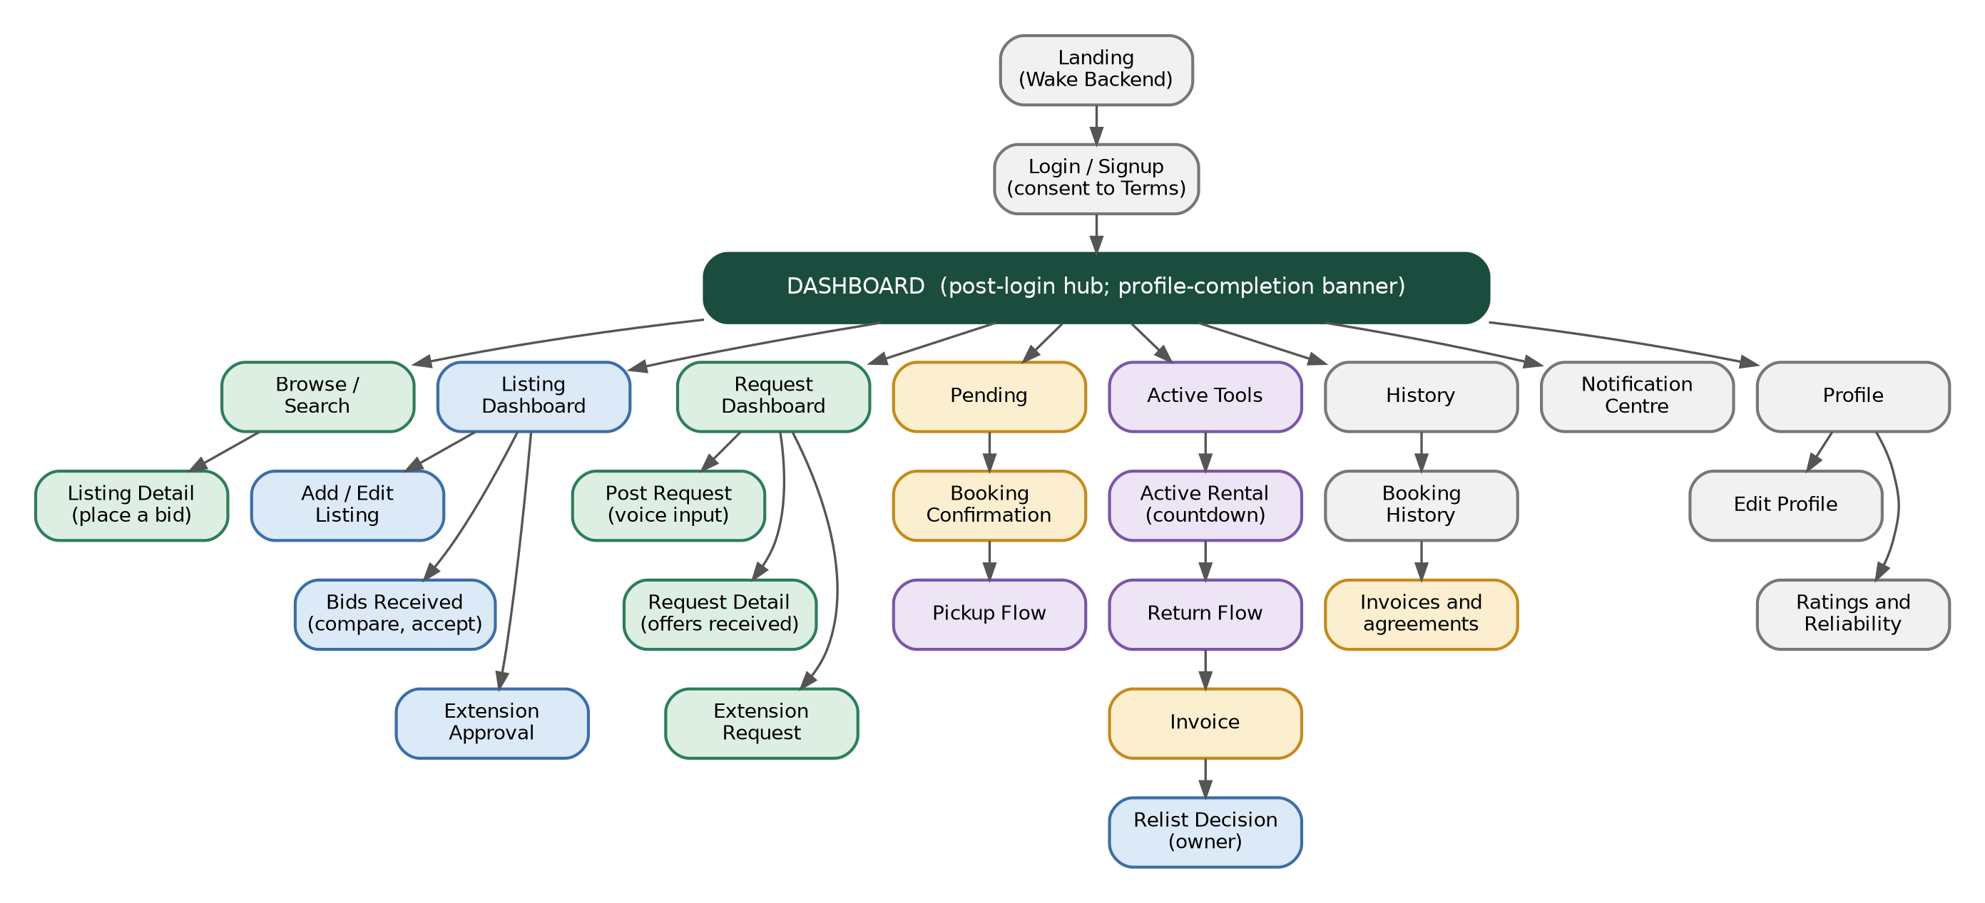
Figure 2. Navigation map: every page is reachable from the Dashboard hub. Colours show the owner side (blue), renter side (green), booking and handoff (amber, purple) and account pages (grey).
Shared pages used across flows: Success and Error status pages (driven by a status flag on each action), the Terms and Consent page, and the Wake-Backend state on the landing page.

5.4 The 26 pages
Group | Pages
Public and access | Landing (with Wake Backend button), Login / Signup, Terms and Consent, Backend-Connecting state
Dashboard hub | Dashboard (My Listings, My Requests, Browse Nearby, Active Tools, Pending, History), Notification Centre
Discovery | Browse / Search, Listing Detail
Owner side | Add / Edit Listing, Listing Dashboard (calendar and Bids Received), Extension Approval, Relist Decision
Renter side | Post Request, Request Detail, Request Dashboard, Extension Request
Booking and handoff | Booking Confirmation, Pickup Flow, Active Rental, Return Flow, Invoice
Account and records | Profile, Edit Profile, Reliability and Ratings History, Booking History
System states | Success Status, Error Status

The Dashboard's Pending area has two views: Pending Decisions (bids placed and bids received awaiting a response) and Won / Confirmed, Awaiting Handoff (accepted bookings ready for the pickup agreement). Owners manage listings from the Listing Dashboard, which shows each listing's status, days left on any active booking, an indicator when the renter has asked for an extension, and a per-listing calendar with Bids Received.

6. Booking lifecycle, slot calendar and extensions

6.1 Booking status
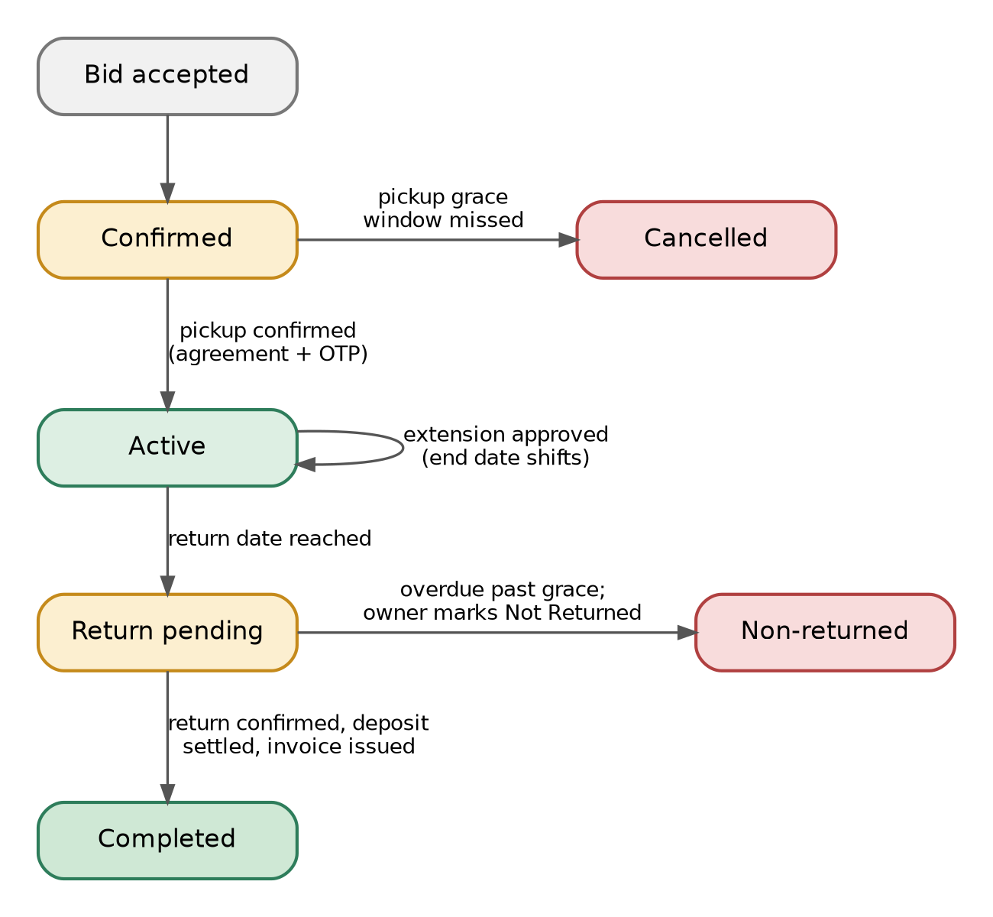
Figure 3. Booking status transitions from an accepted bid to completion, cancellation or non-return.

6.2 Overlap-aware bidding on one listing
This is the main technical difference from a simple listing board. A single machine is a re-bookable asset, so the calendar decides whether accepted bids can coexist. Once the owner accepts a bid, that date range is locked and any pending bid that overlaps is automatically rejected and the renter notified. Bids for other dates remain valid and can also be accepted.
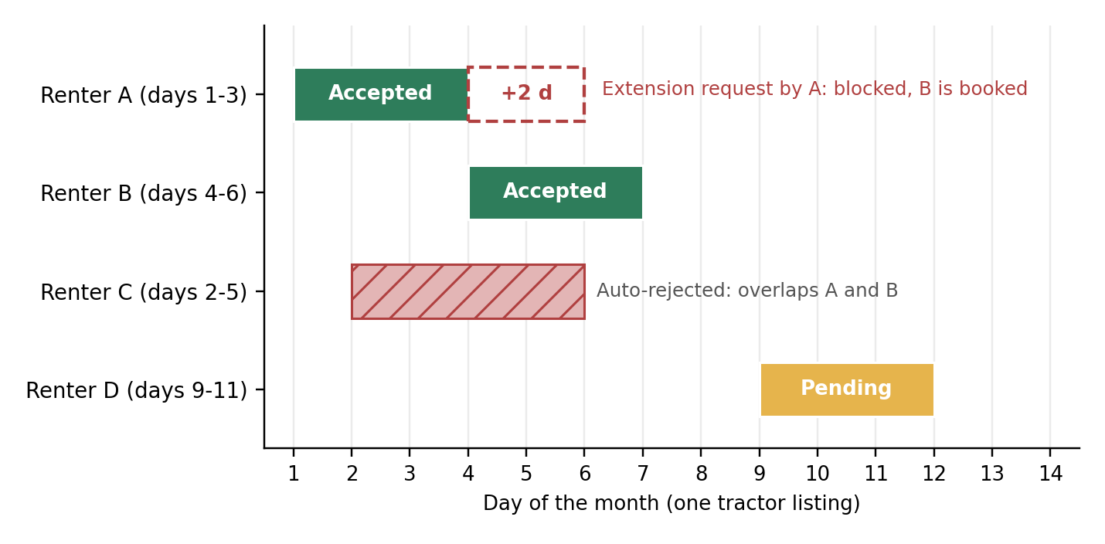
Figure 4. Example: A and B are accepted for different dates, C overlaps both and is auto-rejected, and A's extension request is blocked because B is already booked.

6.3 Extensions
- The renter taps Request Extension before the return date and chooses the extra days.
- The system checks the calendar. If another confirmed booking overlaps the extra days, the request is blocked and the reason is shown.
- Otherwise the owner gets an Approve / Decline prompt (also in the Notification Centre) showing the days, the fee and any conflict.
- On approval the return date moves, the calendar shifts, and the extra fee is added to the booking total and to the final invoice.
- If declined, the original return date stands, and a late return triggers the non-return flow.

7. The trust layer: handover, fraud prevention and ratings

7.1 Handover protocol
Equipment stays local, so the renter physically collects it. Both pickup and return follow the same pattern (photo, agreement, confirmation, OTP), which makes the process easy to learn and gives a symmetrical evidence trail.
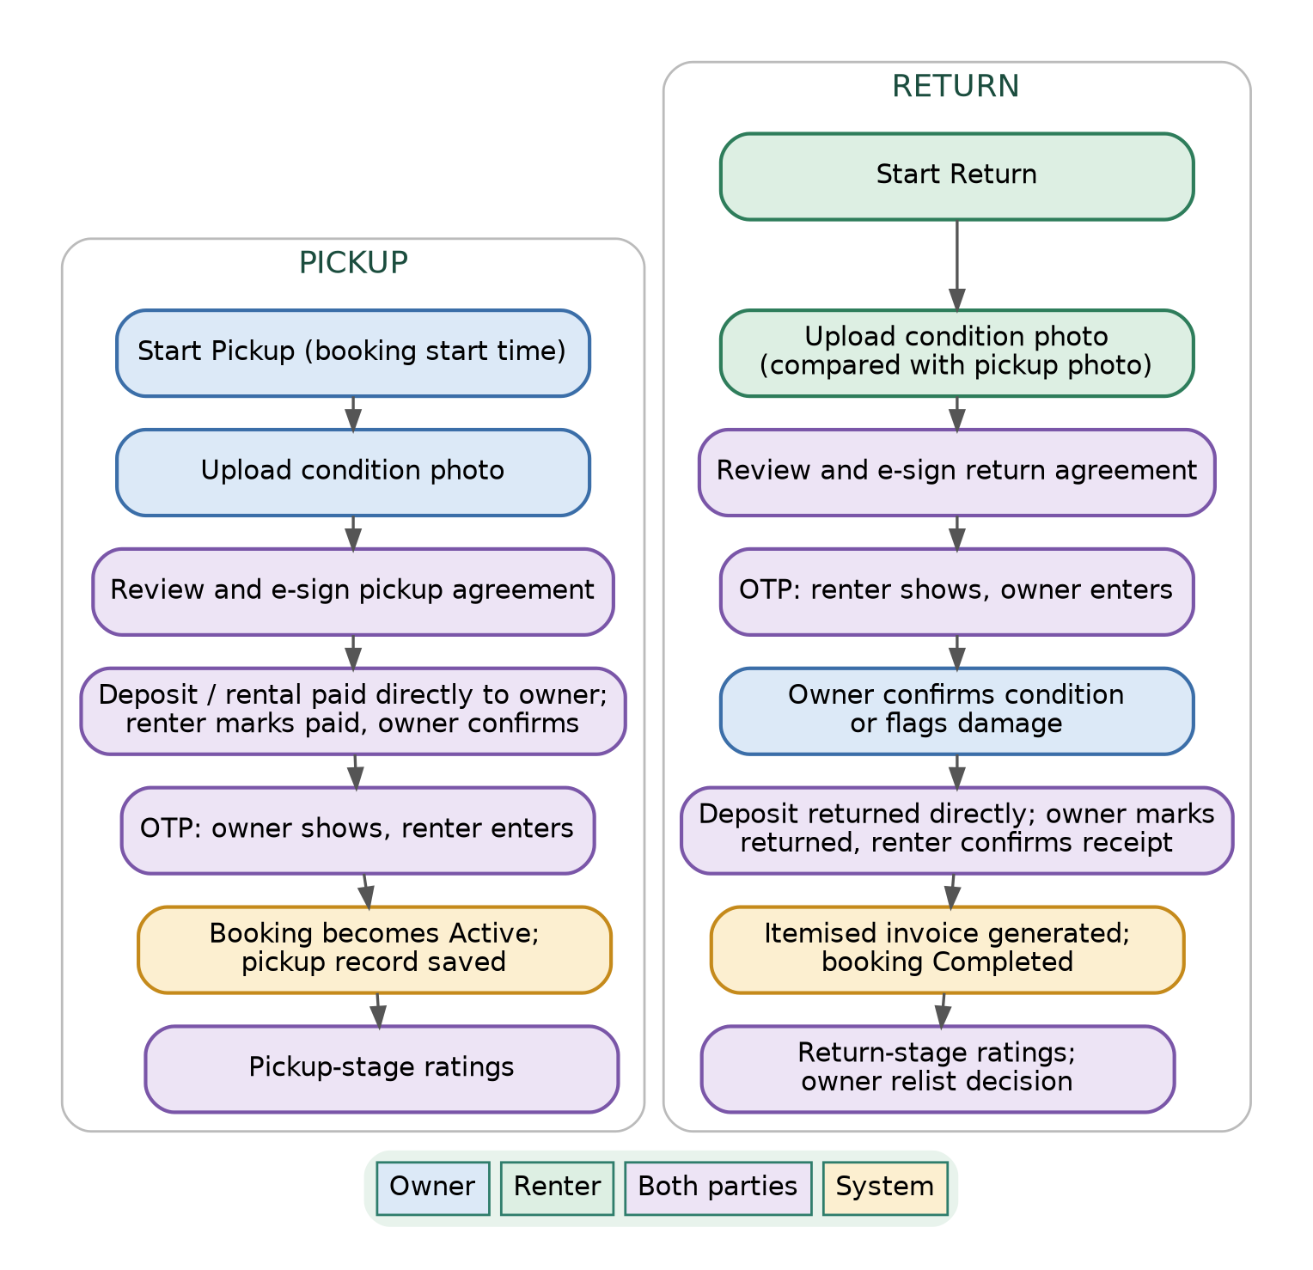
Figure 5. Pickup and return steps, coloured by who acts. Both sides e-sign an agreement and exchange an OTP at each handover.
- Pickup: the owner starts pickup, uploads a condition photo, both e-sign the agreement, the payment of the deposit and any amount due is confirmed, and an OTP confirms the physical handover. The booking becomes Active. If pickup does not happen within a grace window, the booking cancels and the slot is released.
- Return: the renter uploads a condition photo, shown next to the pickup photo; both e-sign a return agreement that references the pickup agreement; an OTP confirms receipt; the owner confirms condition or flags damage; the deposit is settled; the invoice is generated.
- After return the equipment is set to Returned, Not Listed. The owner decides whether to relist now, relist later or keep it unlisted.

7.2 Fraud prevention and non-return
Stage | Safeguards
Prevention | Security deposit proportional to equipment value, recorded and confirmed by both parties. ID verification at signup so every user is traceable. Reliability-score gating: new or low-score users can face higher deposits or owner-restricted access.
Detection | Automatic reminders before the return date and again if overdue. A grace-period countdown before escalation. The owner can mark equipment Not Returned, which immediately freezes the renter from new bookings.
Escalation | Reliability score reset and platform ban for confirmed non-return. Deposit retained by the owner and recorded as forfeited. A formal evidence record (agreements, photos, OTP timestamps, booking ID, contact details) that the owner can use for a police complaint. Non-return flags are visible to future owners.

GearGrid provides evidence, not legal recovery. Full dispute handling is planned for a later phase; the agreements, photos and ratings already captured are designed to support it without changes to the data model.

7.3 Ratings and reliability
Ratings happen twice per transaction, once at pickup and once at return, for both parties, so behaviour is captured at each stage rather than as a single end-of-rental impression.
- At pickup: was the equipment as described, was the other party on time, was communication smooth.
- At return: was the equipment returned in the agreed condition, was the return on time, was the overall experience positive.
- Results feed two separate scores per user, an owner score and a renter score, shown on bids and profiles so decisions are informed.

8. Payments, deposits and invoicing
No money moves through the app in this POC
Renter and owner pay each other directly (cash or UPI). GearGrid records each payment event and asks both parties to confirm it. A payment gateway with escrow is planned for a later phase.

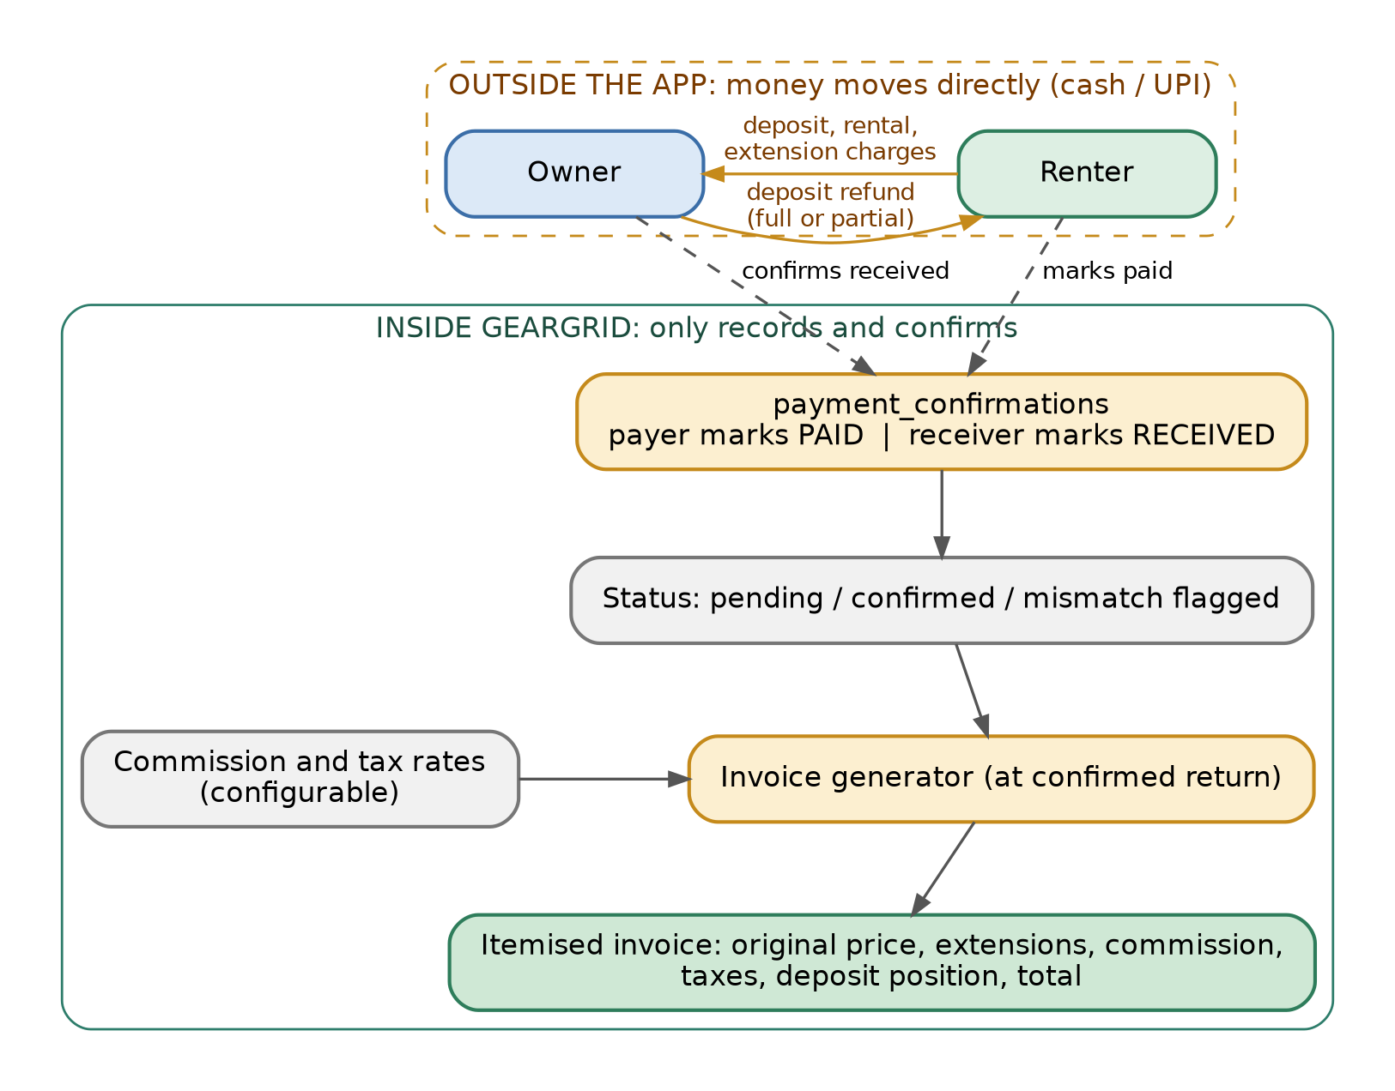
Figure 6. Money moves outside the app; GearGrid records and confirms each event and generates the invoice.

8.1 Payment events and two-party confirmation
- Events tracked: security deposit paid (renter to owner, at pickup), rental amount paid, extension charges paid, and security deposit returned (owner to renter, at return, in full or in part).
- Each event has a payer confirmation and a receiver confirmation and stays pending until both are recorded.
- If only one side confirms after a set window, the other party receives a reminder. If the two disagree (for example the amount retained from the deposit), the event is flagged for manual review.

8.2 The itemised invoice
An invoice is generated for every transaction when the return is confirmed. It is shown to both parties and stored in History. Commission and taxes are calculated and displayed from day one; collecting the commission requires a payment gateway and follows later.
Invoice line (illustrative figures) | Amount (INR)
Original rental: 3 days at 1,500 per day | 4,500
Extension: 1 day at 1,500 | 1,500
Rental subtotal | 6,000
Platform commission (placeholder rate 5%) | 300
Taxes on commission (placeholder rate 18%) | 54
Total charges shown | 6,354
Security deposit paid / returned / retained | 5,000 / 5,000 / 0
Net deposit position | 0

Commission and tax rates above are configurable placeholders for illustration; correct rates and their applicability will be confirmed before launch.

9. Technical design: architecture, data flow and database

9.1 System architecture
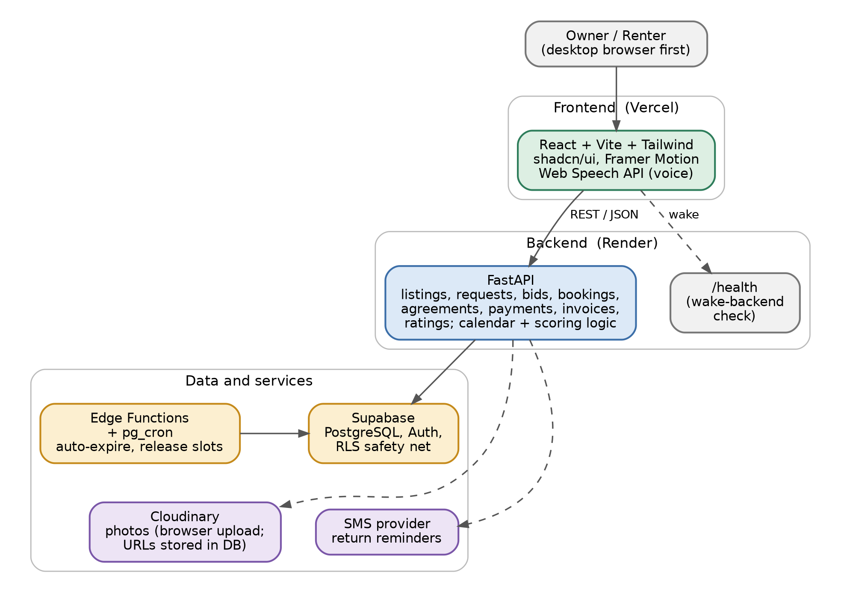
Figure 7. System architecture: a React frontend, a FastAPI backend, Supabase for data and auth, and Cloudinary and an SMS provider for supporting services.
Layer | Technology and role
Frontend | React with Vite, Tailwind CSS, shadcn/ui and Framer Motion. Desktop web first. Web Speech API for voice input.
Backend | FastAPI (Python): routes for listings, requests, bids, bookings, agreements, payments, invoices and ratings; services for calendar logic, matching, scoring and invoicing. Authorization is enforced in the API, with row-level security as a second safety net.
Database and auth | Supabase: PostgreSQL and Auth.
Scheduled jobs | Supabase Edge Functions with pg_cron: auto-expire unfilled requests and release unused or overdue slots.
Photo storage | Cloudinary for listing, profile and condition photos; only URLs are stored in the database.
Messaging | SMS provider for return reminders (more reliable than push in low-connectivity areas).
Hosting | Render (backend) and Vercel (frontend). A Wake Backend button on the landing page pings a /health endpoint and confirms the server is online before the user proceeds, avoiding errors from free-tier cold starts.

9.2 Data flow
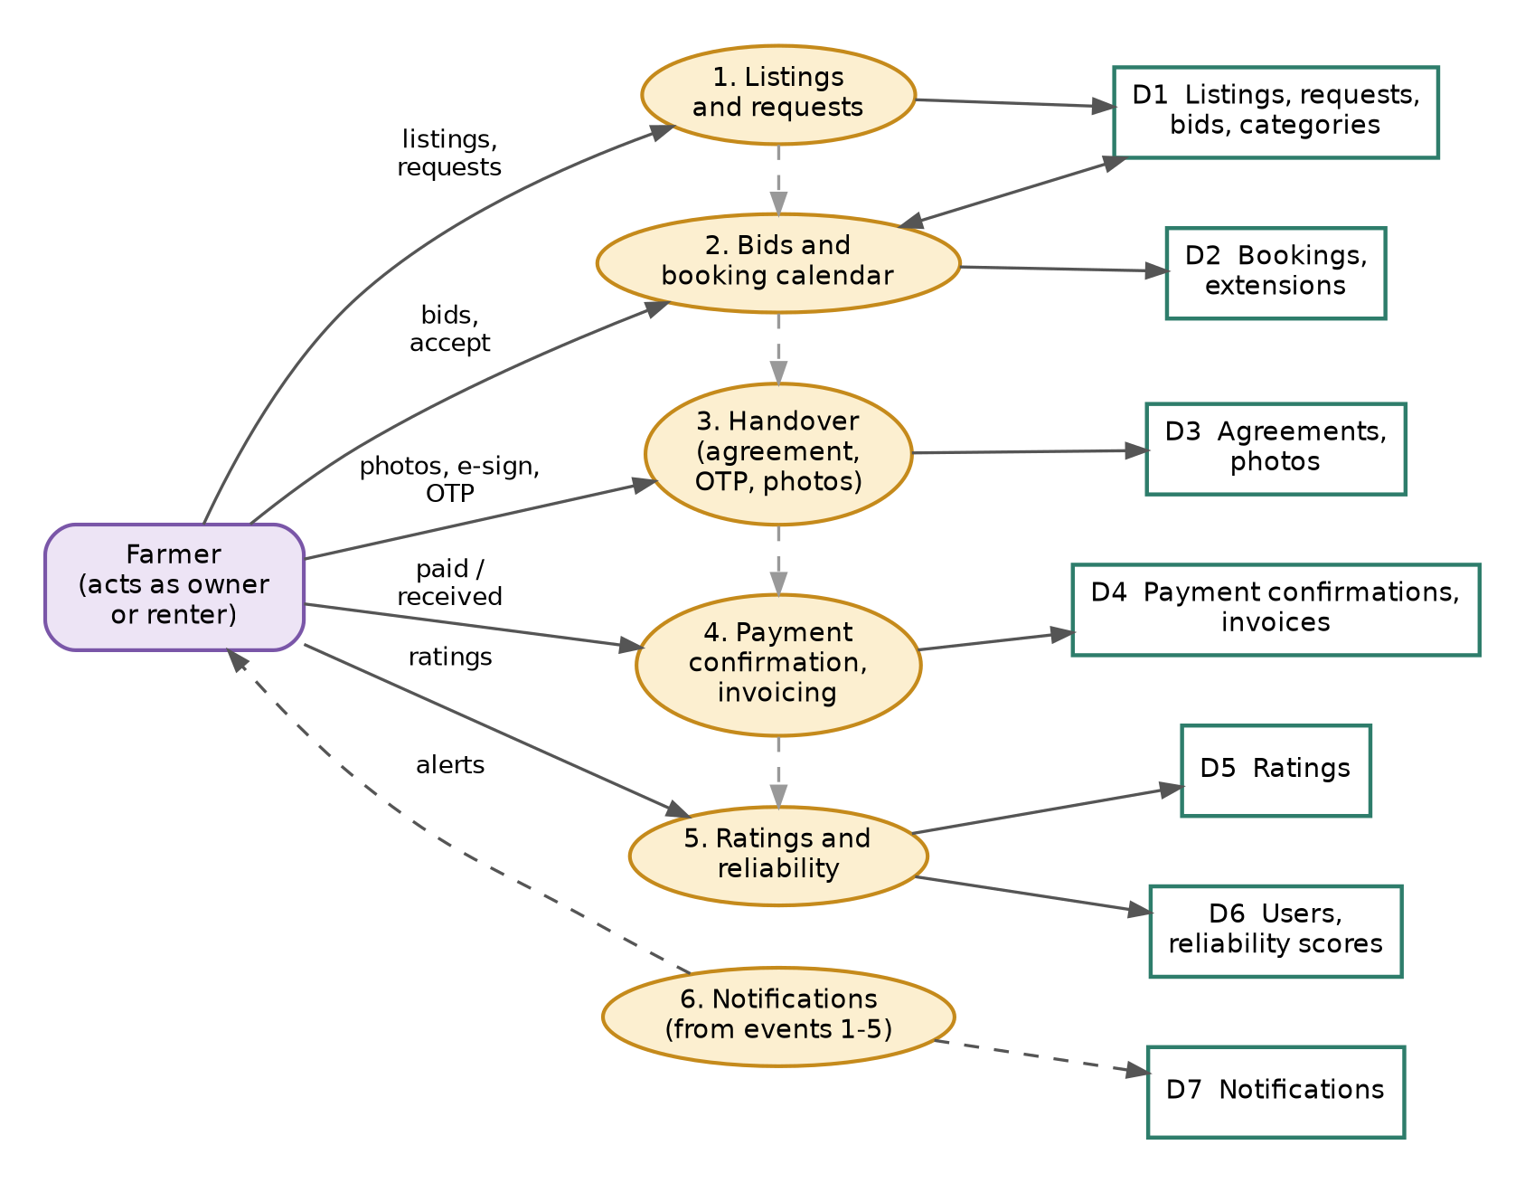
Figure 8. Level-1 data flow: a farmer, acting as owner or renter, interacts with six processes that read and write seven data stores.
Every process writes to its own store, which keeps modules independent and makes each phase of the build testable on its own. Notifications are generated as a side effect of events in the other five processes.

9.3 Database
The schema has 13 tables on PostgreSQL. The next two pages show the entity relationships in two views: the marketplace core, and the records that hang off each booking.

9.3 Database: marketplace core
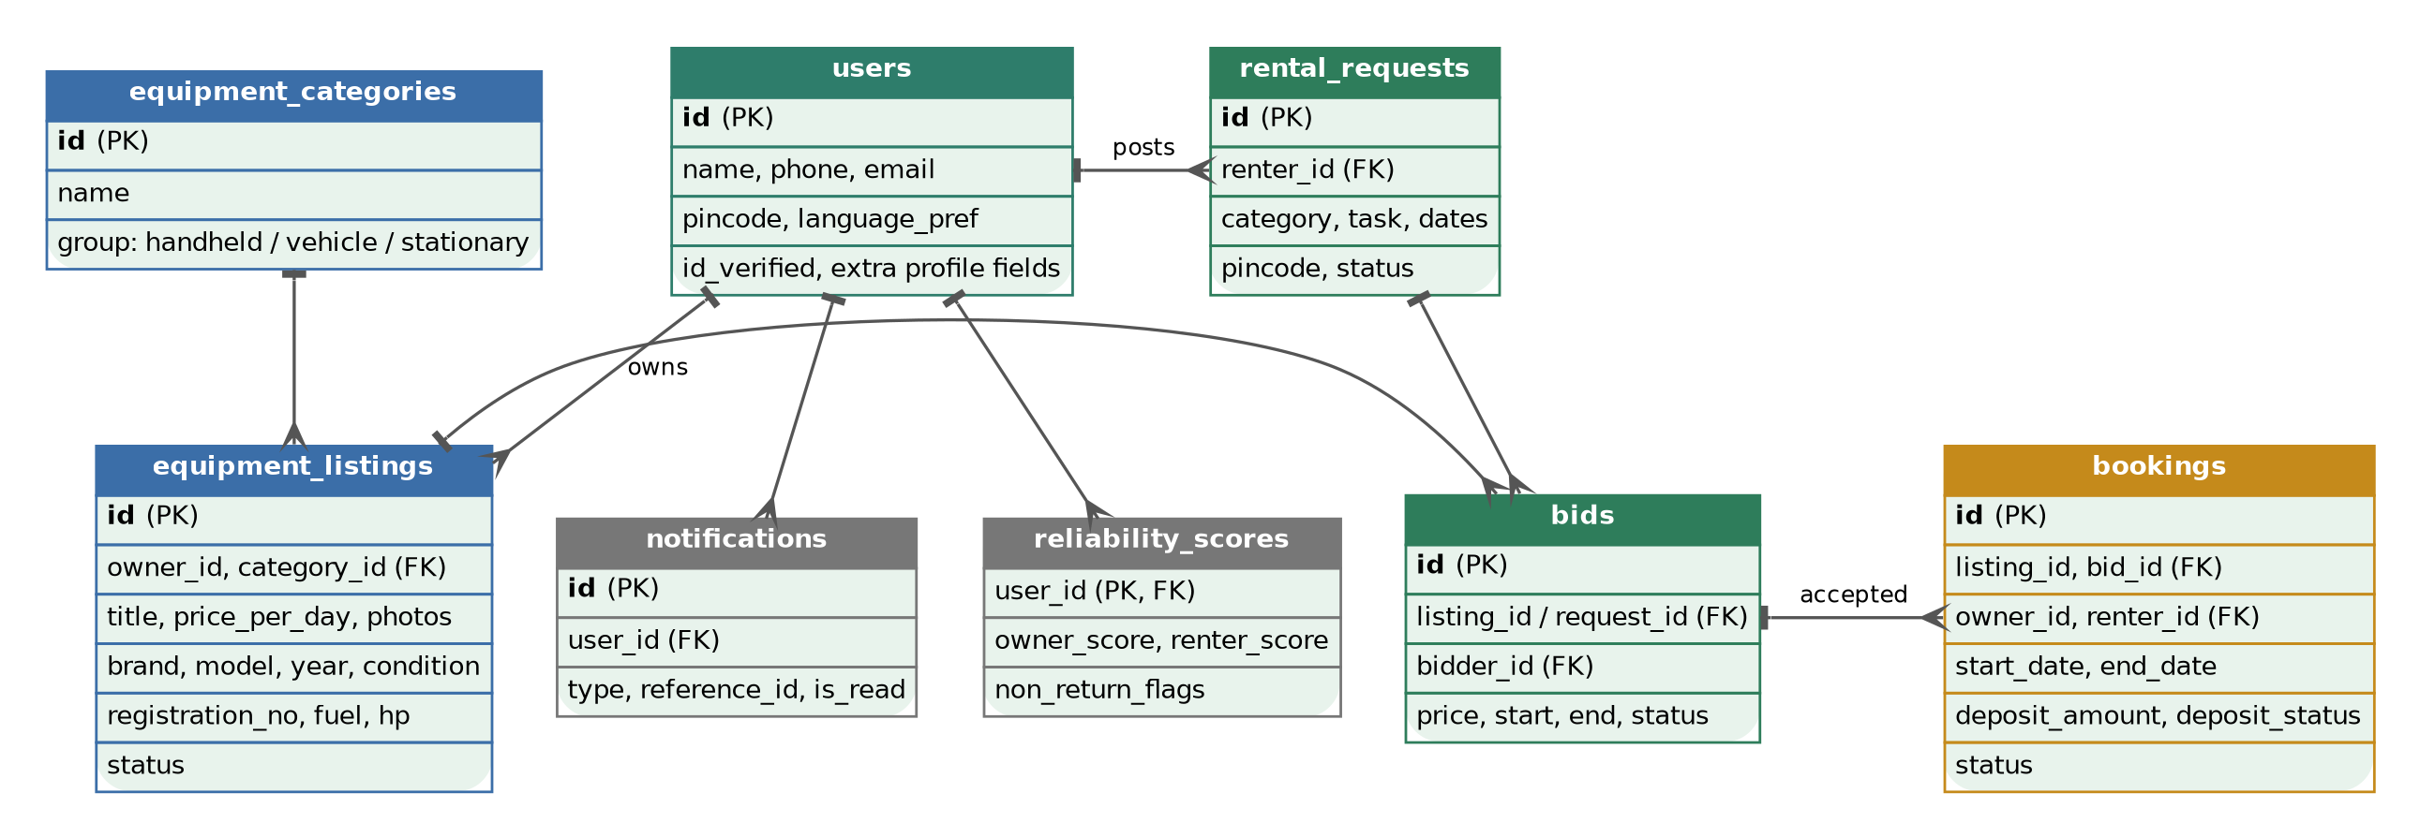
Figure 9. Entity relationships, part 1: users, categories, listings, requests, bids and bookings, plus reliability scores and notifications.
Table | Purpose | Table | Purpose
users | Unified profile with optional farm and payment placeholders | bids | Offers against a listing or a request, with status
equipment_categories | Handheld / vehicle / stationary grouping that drives which fields apply | bookings | Confirmed slot tying listing, owner, renter, dates and deposit status
equipment_listings | Equipment for rent, with category-specific fields | reliability_scores | Owner and renter scores and non-return flags
rental_requests | A renter's posted need | notifications | Feed for the Notification Centre

9.3 Database: records around a booking
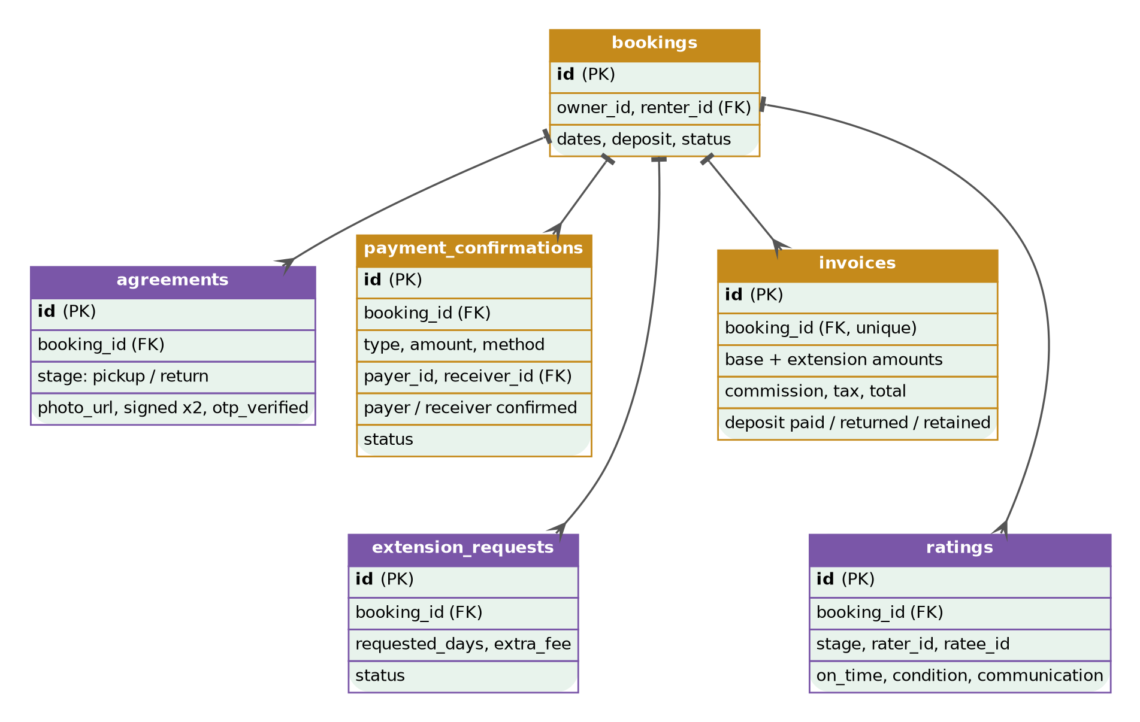
Figure 10. Entity relationships, part 2: every booking can have agreements, payment confirmations, one invoice, extension requests and ratings.
Table | Purpose | Table | Purpose
agreements | Pickup and return records: photo, two signatures, OTP result | extension_requests | Extra days requested, fee and decision
payment_confirmations | One row per payment event with payer and receiver confirmation | ratings | Two-stage ratings from both parties
invoices | Itemised breakdown, one per booking

10. Reuse from an existing codebase
GearGrid adapts the architecture of MarketFlip, an existing reverse marketplace the applicant has already built (buyers post requests and local shop owners bid), which has a working proof of concept and a v2 in progress. This is what makes the build realistic within the challenge timeline.
Component | Status | Notes
Request and bid lifecycle | Reused | Core schema and endpoints, adapted to listings and bookings
Pincode-based local matching | Reused | Same filtering for nearby equipment
Reliability scoring | Adapted | Split into owner and renter scores
Delivery confirmation flow | Adapted | Becomes pickup and return confirmation
Auto-expiry (Edge Function and pg_cron) | Reused | Also releases unused slots
Supabase auth, FastAPI authorization with RLS | Reused | Same approach
Deployment pipeline (Render and Vercel) | Reused | Same setup
UI foundation (Tailwind, shadcn/ui, Framer Motion) | Reused | Same component patterns
Success and error status pages | Reused | Driven by a status flag per action
Roles | Changed | Fixed buyer / shop-owner roles become per-listing roles
Slot calendar and overlap-aware bidding | New | Core technical difference
Digital agreements, OTP, condition photos | New | Trust layer
Payment confirmation and invoices | New | Two-party confirmation and itemised invoice
Extensions, manual relist, two-stage ratings | New | Lifecycle completeness
Voice input, Wake Backend button | New | Accessibility and reliability

11. Landscape and differentiation
Farmers today rent equipment through government-supported custom hiring centres, informal local arrangements, and a small number of private rental apps. These approaches typically depend on fixed locations, personal contacts or one-off bookings, and none of them offers a shared, verifiable record of condition, payment and return.
Aspect | Typical alternatives | GearGrid
Who supplies the equipment | A central centre or a dealer | Nearby farmers with idle machines (peer to peer)
Finding equipment | Visit, call or ask locally | Search by category, distance and dates; or post a request and receive bids
Scheduling | Manual or first come, first served | Slot calendar with overlap-aware bids and extension checks
Trust and proof | Personal relationships | Agreements, OTP, condition photos, deposits, two-role reliability scores
Records | Rarely any | Itemised invoice and history for every rental
Access | Text-heavy forms | Voice input, and SMS reminders for low connectivity

12. Pilot plan and success measures

12.1 Launch plan
- Start with one cluster of 5 to 10 villages rather than a broad launch, to avoid the two-sided cold-start problem.
- Onboard 10 to 15 equipment owners in person first, so listings exist before renters arrive.
- Partner with a local farmer producer organization or agricultural extension office for credibility and first-user trust.
- Launch in Hindi and English with a language toggle; add other languages after the core flow is proven.

12.2 Success measures
Measure | What it shows
Equipment utilization rate | Share of listed days that are actually booked
Idle-time reduction per asset | Whether owners earn from previously idle machines
Completed bookings per month | Real adoption in the pilot area
Renter cost savings | Savings compared with informal rental rates or buying
Repeat usage rate | Whether farmers come back, a sign of trust
On-time return and dispute rate | Health of the trust layer

13. Monetization
The launch model adds no upfront cost for early rural adopters.
- Primary: commission per completed booking. Calculated and shown on every invoice from day one; collected once a payment gateway is integrated.
- Secondary: extension fees. A per-day charge whenever a renter extends a booking, added to the invoice.
- Later options: owner subscriptions for unlimited listings and priority placement; an optional damage-protection or insurance add-on; boosted listings; anonymized regional demand data for cooperatives and manufacturers; referral partnerships with agri-input companies.

14. Risks, limitations and future work
Risk or limitation | How it is handled
Cold start (needs owners and renters in the same area) | Village-cluster pilot with manual onboarding of owners first
Booking conflicts under simultaneous requests | Database-level locking and conflict checks in the calendar logic; tested explicitly in phase E
Payments are recorded, not processed | Two-party confirmation and evidence records in the POC; payment gateway with escrow is future work
Commission cannot be collected without a gateway | Shown on invoices now; collection follows the gateway. Tax rates to be verified before launch
Damage or non-return disputes | Photos, agreements and OTP timestamps are stored; a full dispute workflow is future work
Poor rural connectivity | SMS reminders, upload retry and clear error states; offline queuing is future work
Voice input accuracy across dialects | Browser speech API in the POC; accuracy across regional languages to be tested
Free-tier hosting limits | Wake Backend button now; scaling plan if usage grows
Accident liability and insurance | Out of scope for the POC; needs an insurance partner
Smartphone-only access | SMS or IVR fallback is future work
Legal terms and consent | A temporary drafted version for the POC; proper legal review before any real launch

Planned later: group pooling (neighbours co-book and split cost), smart ranked matching, demand prediction by crop season, predictive maintenance alerts, barter of equipment hours, farmer producer organization integration, weather-aware scheduling, skill-linked rentals with an operator, reliability badges, and a carbon and cost-saved impact tracker.

15. Conclusion
GearGrid turns idle farm equipment into shared, income-earning capacity and gives small farmers a fair, trusted way to use machines they cannot own. The design is complete end to end: roles, pages, booking lifecycle, handover protocol, payment confirmation, invoicing, data model and architecture. It builds on an existing, working marketplace codebase, adds the genuinely new pieces this use case needs (slot scheduling, two-party handovers and invoices), and has a phased plan that delivers a working core quickly and layers extras on top.

