**Block coding kit**

**Aim:** To program for basic block coding and understand the advantages of it.

**Required Tools:**

2. Laptop/PC

3. Mblock Software

4. LED

4. USB cable and connecting wires

**Procedure : Example program of simple LED blink.**

1.1 Open the mblock software.



1.2 Add your controller board by doing click on add.

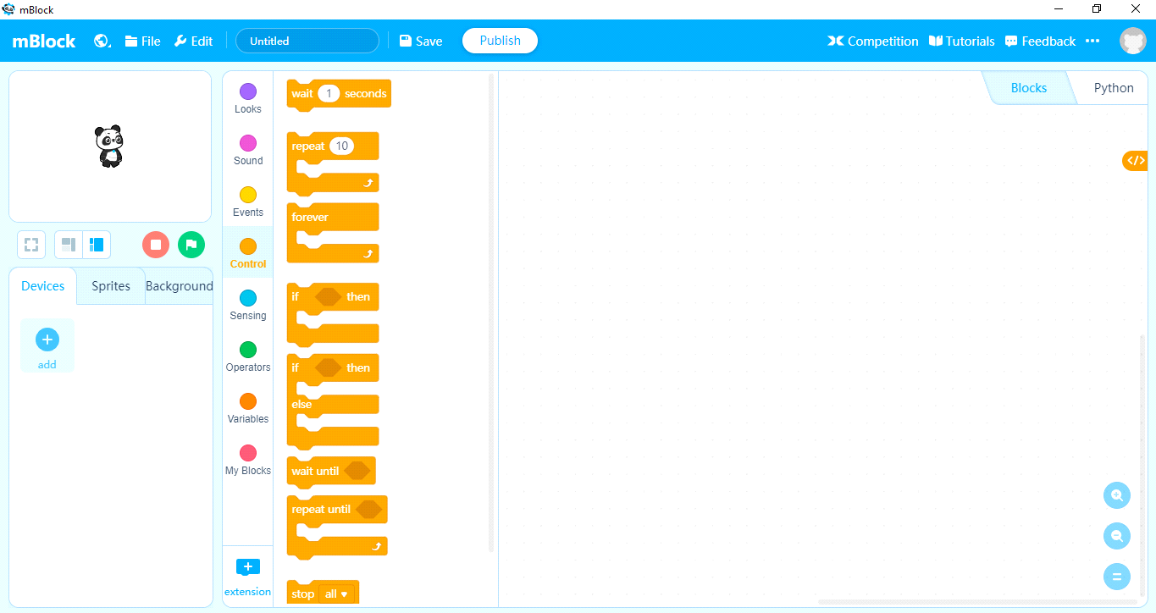

1.3 Select your controller (Ex : Arduino Uno) and click on OK.

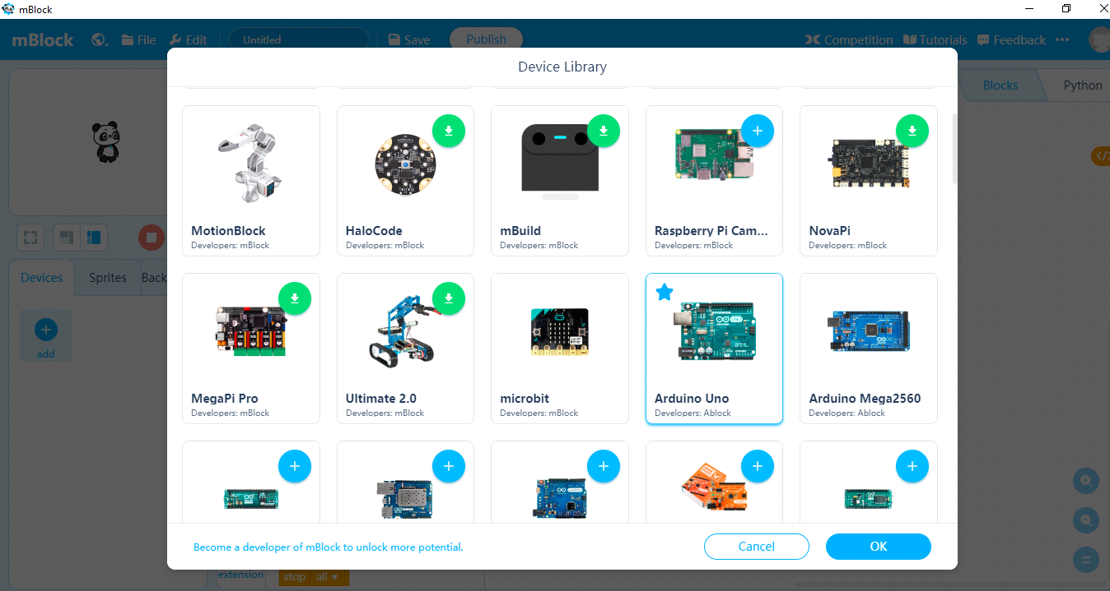

2. Click on Events and drag the 'When arduino Uno starts up' block to the Blocks area

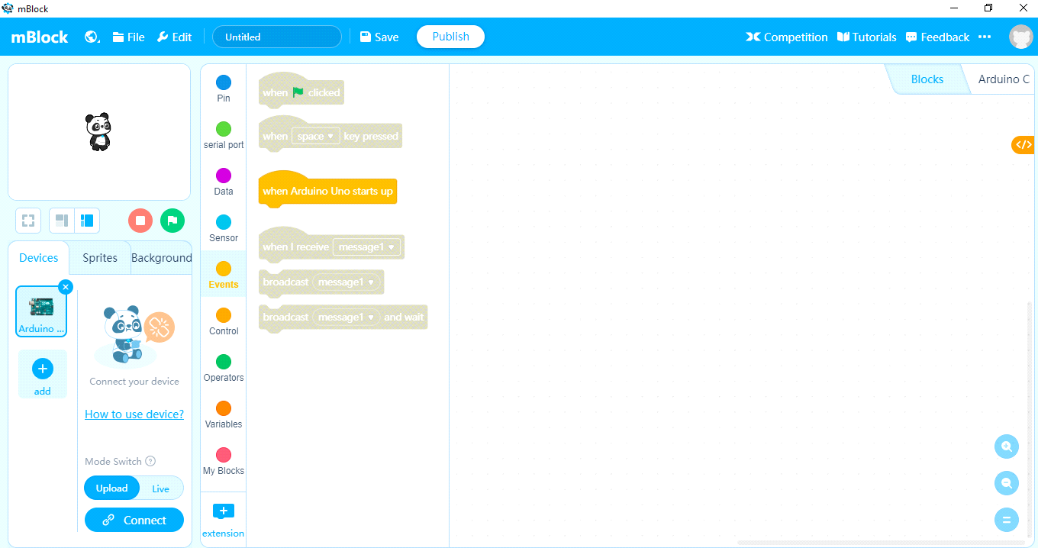

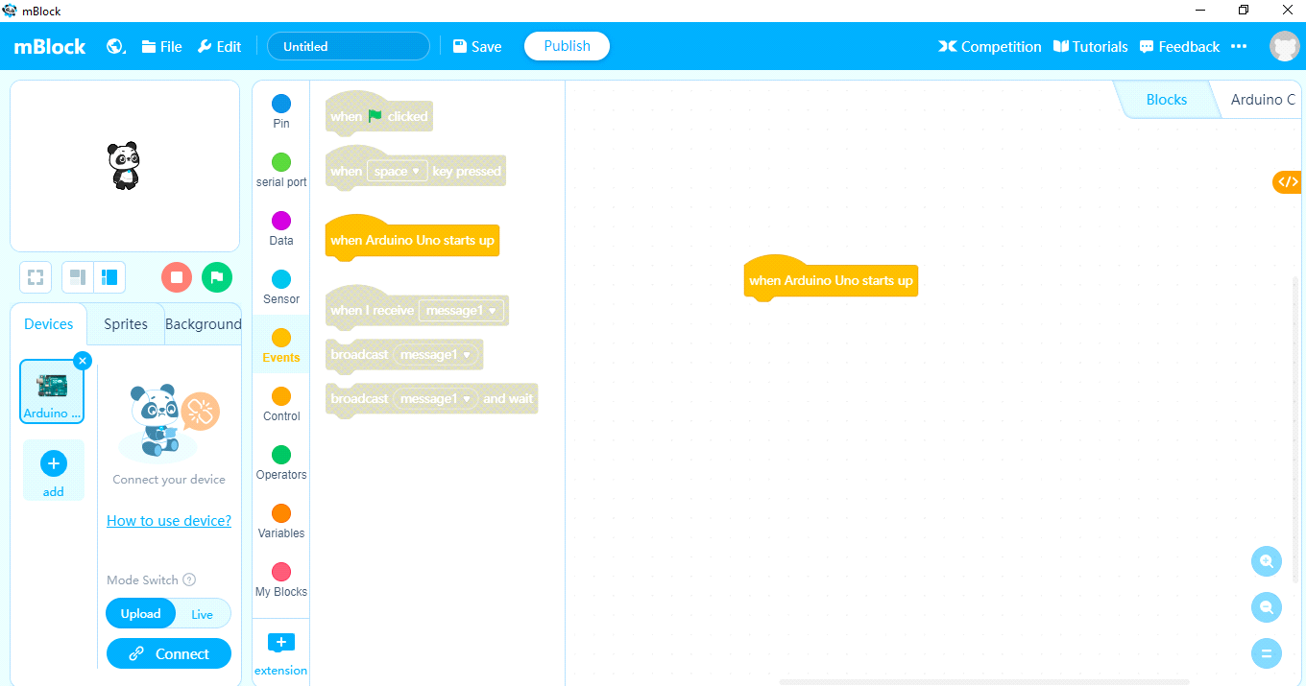

3. Click on Control and drag the 'forever' block to the block area below the 'When arduino Uno starts up' block.

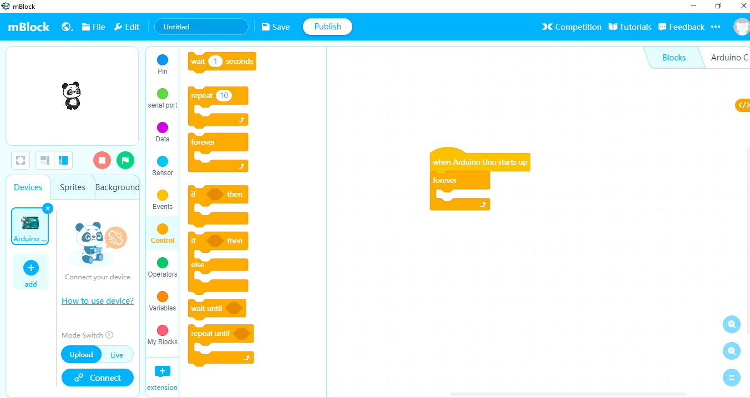

4. Click on Pin and drag the 'set digital pin 9 output as high' block to the block area with in the 'forever' block.

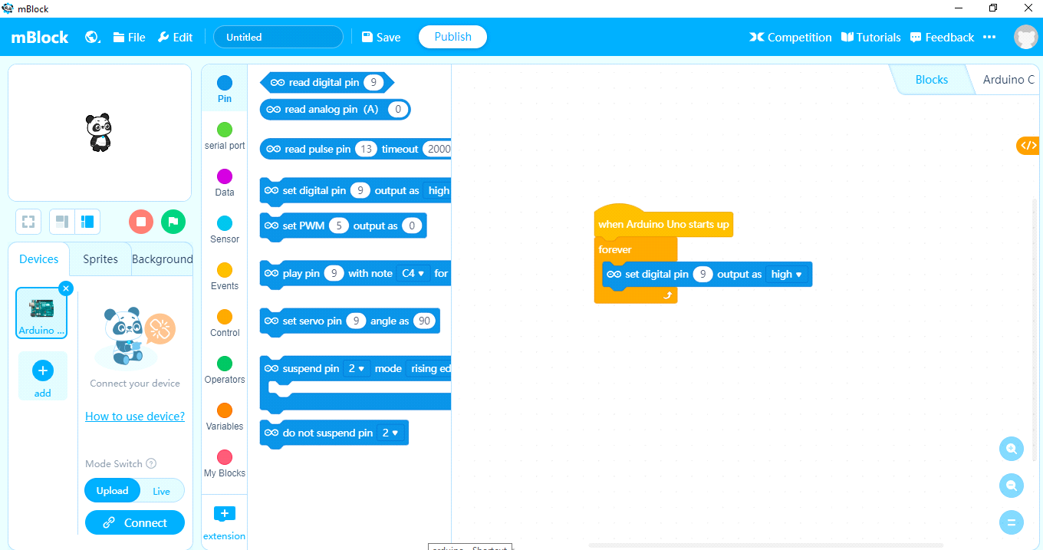

5. Change the 'set digital pin 9' to '13' also 'output as high' (default 'high').

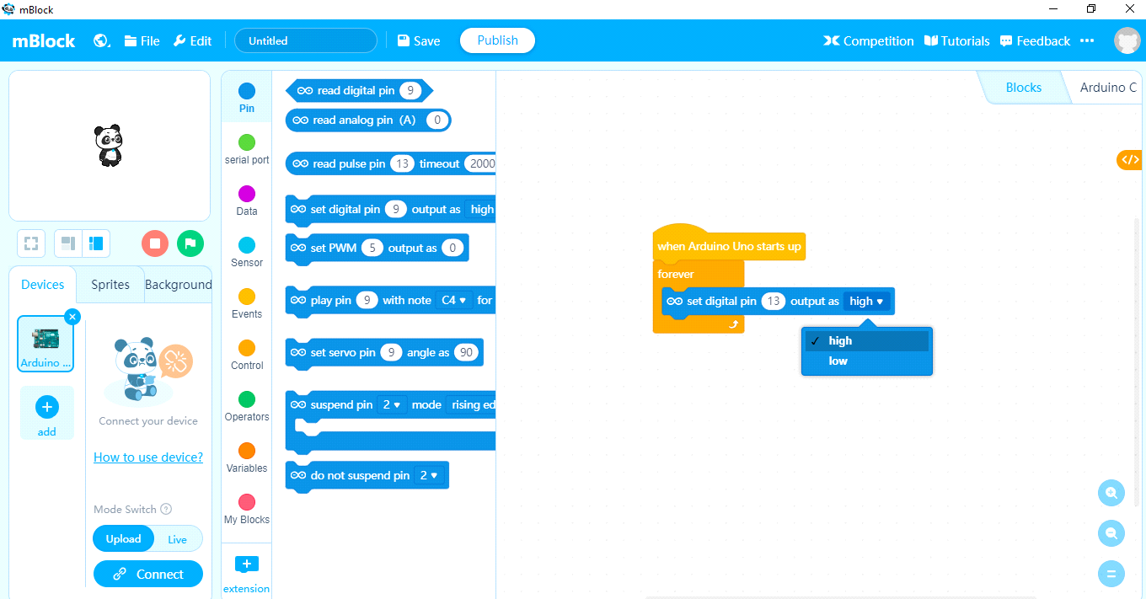

6. Click on control and drag the 'wait 1 seconds' block to the block area below the 'set digital pin 13 output as high' block

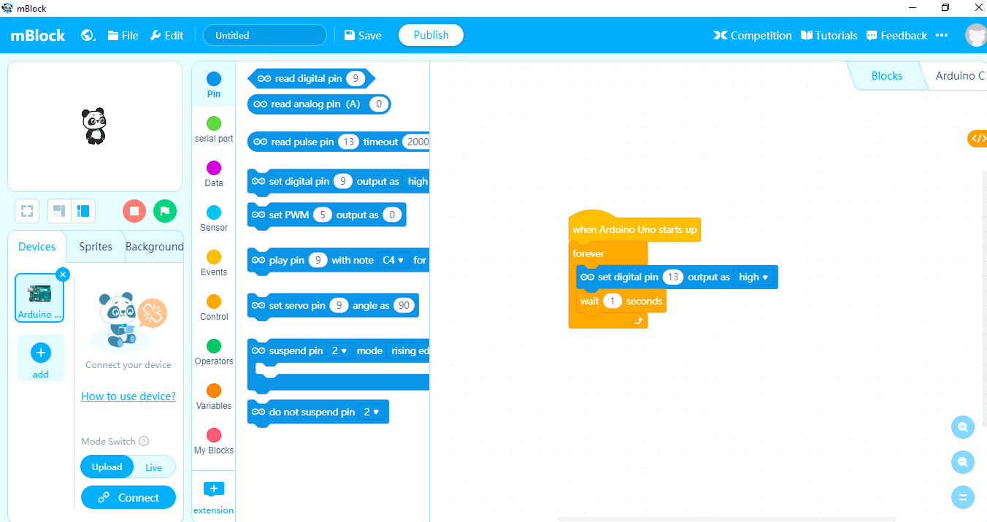

7. Do the same (step 4,5,6) one more time (Except 'output as low') then your block code looks as below.

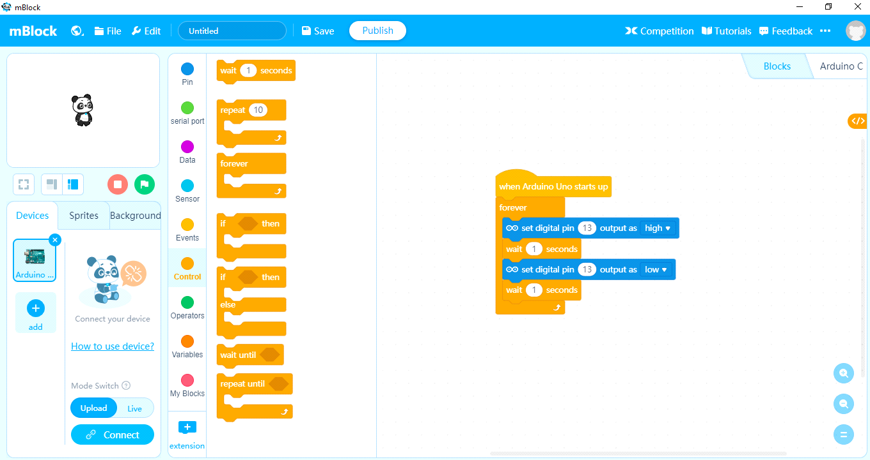

8. Connect your 'Arduino Uno' to your laptop/PC using USB Cable and Click on Connect icon. then your Screen looks like as below

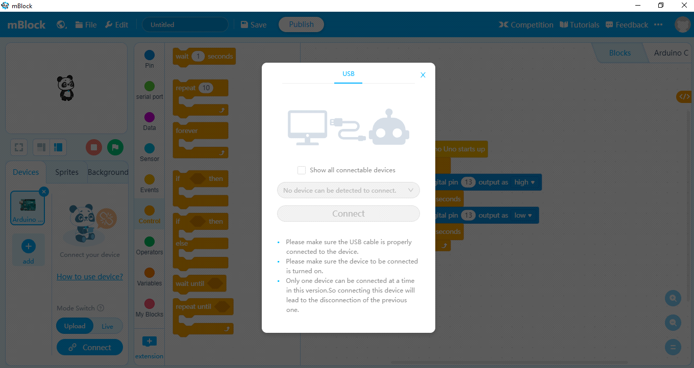

9. Enable the check box 'Show all connectable devices'

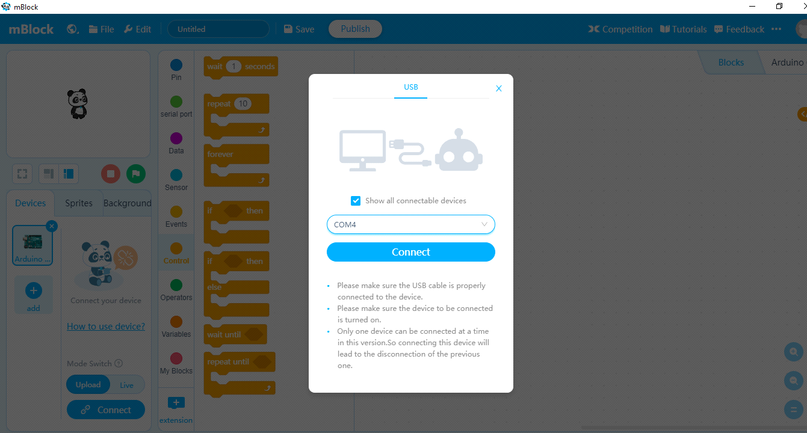

10. Click on Connect. then your Screen looks like as below.

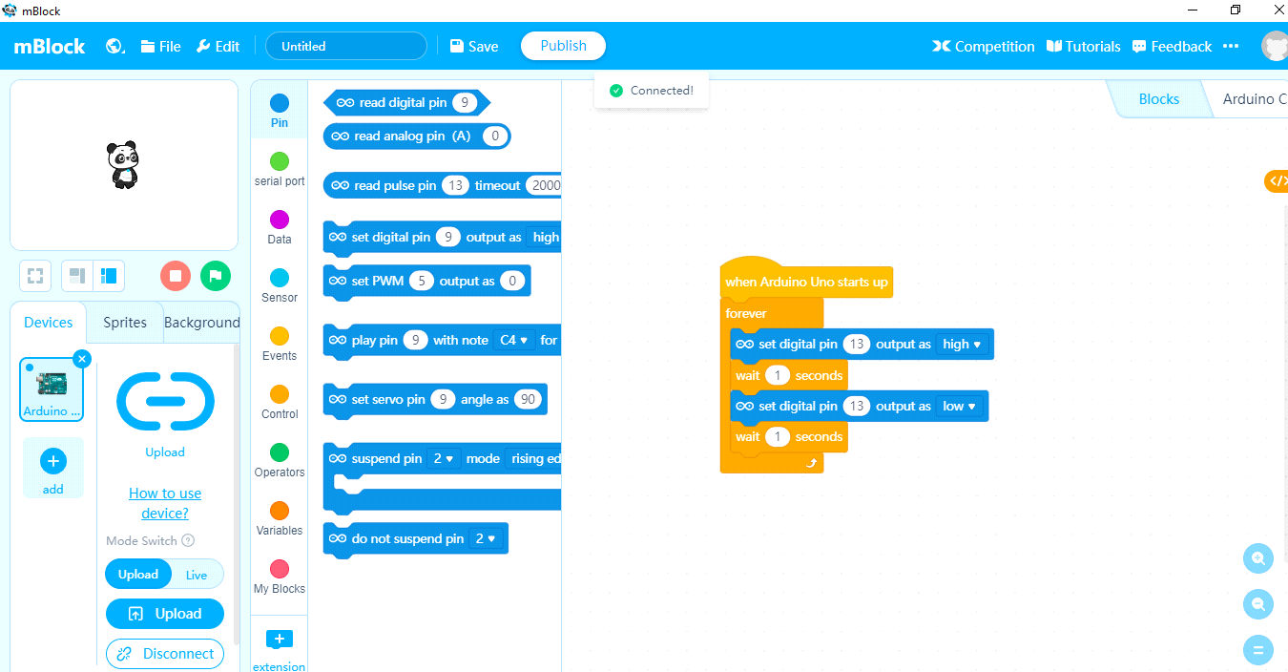

11. Upload your code by click on the Upload icon.then your Screen looks like as below.

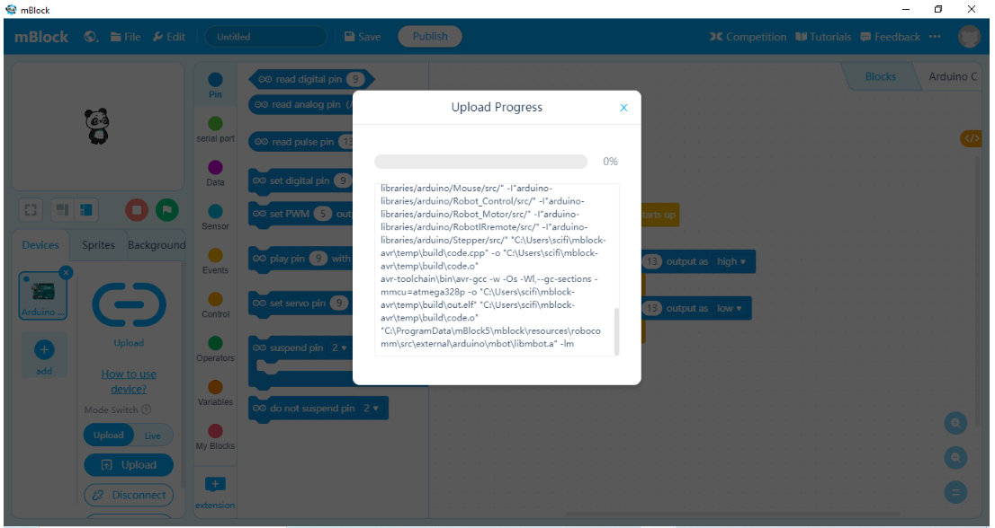

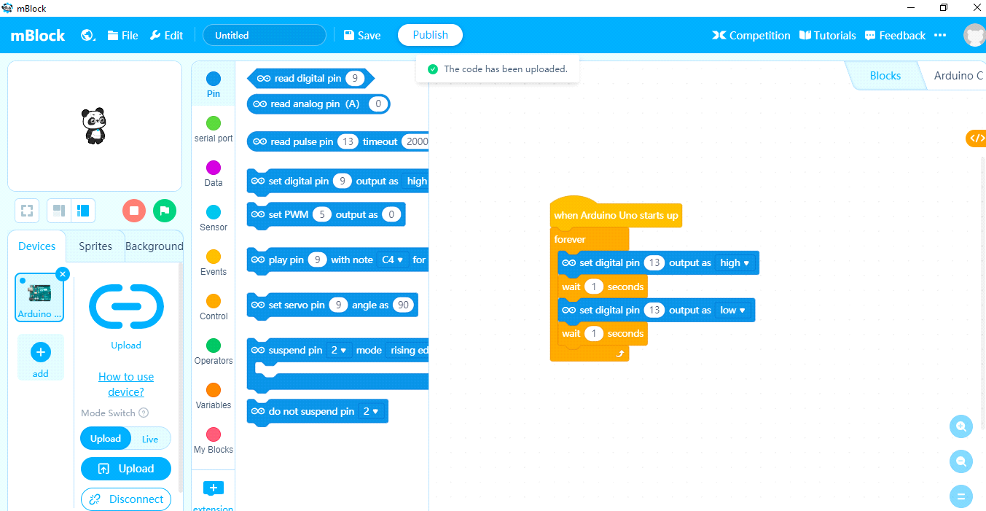

12. Enjoy your output.

**Program :**

**1. Blinking LED.**

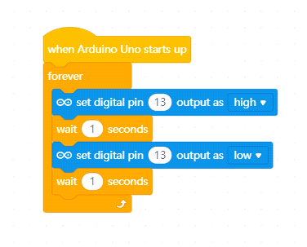

**2. Obstacle avoiding bot.**

**Note :**

**1. If-else block available in '*Control*' block.**

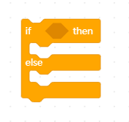

**2. Ultrasonic sensor block available in '*Sensor*' block.**

**\*Change the trig pin 1 to 2 similarly echo pin 1 to 3**

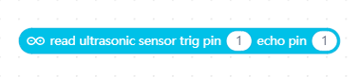

**3. 'Comparator Opertor' block available in '*Operators*' block.**



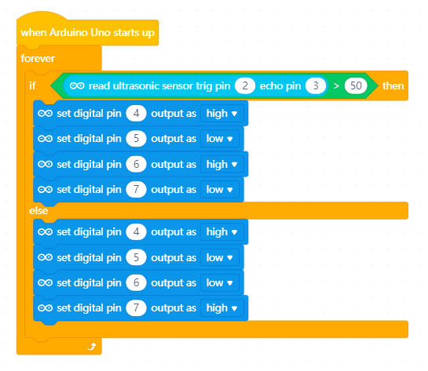

**3. Line following Bot.**

**Note :**

**1. 'read digital pin' 2 and 3 blocks are available in the '*Pin*' block**

**\*Change pin 9 to 2**

**\*Change pin 9 to 3**

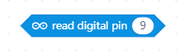

**2. 'Logical Opertor' and 'not Opertors' blocks are available in '*Operators*' block.**

