AI-Based Face Detection and Recognition System for Smart Campus Automation
Comprehensive Project Report, End-to-End Architectural Workflows, Field Deployment Evidence & Institutional Grant Proposal
PROJECT METADATA & INSTITUTIONAL PARTNERSHIP
Institution: Panipat Institute of Engineering and Technology (PIET), Samalkha, Haryana, India
Compute Infrastructure Partner & GPU Sponsor: AICTE IDEA Lab, PIET
Edge Compute Hardware Partner: AI Edge Lab, PIET
Network & Power Setup: Existing PIET Campus PoE Gigabit LAN & Centralized UPS Power Backup
Server Infrastructure: 100% On-Premises College Server & Local Storage (Zero Cloud Dependence)
Codebase Repository: https://github.com/prateek-boop/Face-Detection-
Primary Target Deployment: Main Entrance Security Gates, Academic Auditoriums, and Event Venues
Document Classification: Official Engineering Project Whitepaper & Institutional Funding Proposal

1. Executive Summary
Manual verification, barcode badges, and legacy fingerprint scanners fail dramatically in large-scale academic institutions during peak hours and high-traffic institutional gatherings. During major campus events at PIET—such as the annual PIET Fest, academic conferences, convocations, and semester examinations—lines exceed hundreds of students, causing severe throughput bottlenecks, human fatigue, and vulnerability to proxy attendance. To resolve these operational challenges, an in-house, high-throughput, edge-accelerated Face Detection, Tracking, and Recognition System was engineered, implemented, hardened, and field-tested across thousands of students.
The system couples a custom-trained deep learning face detector (MobileNetV2 backbone augmented with a Feature Pyramid Network) with an industry-standard deep biometric embedding model (InsightFace Buffalo_l ArcFace ResNet-50) and real-time Simple Online Realtime Tracking (SORT). It implements a decoupled asynchronous architecture maintaining 30–60 FPS live video display with sub-30ms deep neural network inference on dedicated GPU compute.
ENTERPRISE SCALE WITH IN-HOUSE STUDENT TALENT
INSTITUTIONAL VALUE CREATION & STUDENT INNOVATION GRANT:
1. Massive Capital Cost Savings: By securing the AI Inference GPU Workstation (₹85,000) through the AICTE IDEA Lab, the Edge Relay Node (₹22,000) through the AI Edge Lab, and leveraging existing campus PoE networks, the college saves over ₹1,57,000 in upfront hardware procurement.
2. Zero Cloud API & Hosting Bills: 100% on-premises deployment on the local college server eliminates commercial cloud subscription fees (saving ₹15,00,000+ annually in cloud API costs).
3. Student Engineering & Research Grant: To ensure high-reliability 24/7 gate operations, continuous model maintenance, and active event monitoring, an institutional development & operational grant of ₹65,000 is allocated to the student engineering team and project coordinators.
4. Total Project Valuation: ₹2,47,000+ enterprise AI deployment delivered for a total net management grant of only ₹81,000 (including fixed optical camera hardware).

Key empirical milestones demonstrated by the operational system include:
- Scale of Enrolled Registry: 5,255 distinct student identities and 10,510 normalized 512-dimensional face embedding vectors enrolled and indexed in memory.
- Custom Face Detector Precision: Achieved 81.27% mAP@0.5 on the benchmark WIDER FACE validation dataset (checkpoint epoch_0021_mAP_0.8127.pt).
- Field Deployment Validation: 1,332 verified student attendance transactions recorded in real-time to attendance.csv during live PIET Fest gate deployment.
- Visual Audit Trail: 3,315 real-time verification proof screenshots automatically captured with telemetry HUDs, bounding reticles, and timestamps (1,538 verified normal entries, 1,777 security re-entry alerts).
- Automated Anti-Passback Engine: Configurable 20-minute temporal security boundary flagging re-entry attempts and anti-passback violations in real-time.
- Real-Time UI Performance: Decoupled producer-consumer multi-threaded architecture ensuring zero video freeze or frame drop during GPU inference spikes.
System Metric / Attribute | Project Empirical Value | Significance for Campus Governance
Detector Model Architecture | MobileNetV2 + FPN (256-ch) + K-means Anchors | Lightweight, high-speed, multi-scale detection of tiny faces
Detection Accuracy (WIDER FACE) | 81.27% mAP@0.5 (Epoch 21) | Superb recall across crowded, occluded, and tilted faces
Recognition Embedding Model | InsightFace Buffalo_l (ArcFace ResNet-50) | 512-dimensional normalized hyperspherical embedding space
Active Enrolled Database | 5,255 Students (10,510 Embeddings) | Covers entire multi-department student population of PIET
Inference Acceleration | NVIDIA RTX 4070 SUPER (CUDA FP16 Half-Precision) | 100% Sponsored by AICTE IDEA Lab (Valued at ₹85,000)
Edge Node Hardware | Industrial Edge Relay Processing Unit | 100% Provided by AI Edge Lab (Valued at ₹22,000)
Network & Power Setup | Existing Campus Gigabit PoE & Online UPS Backup | Utilizes Existing PIET Infrastructure (Valued at ₹15,000)
Server & Storage Infrastructure | On-Premises College Server (Local Campus SAN/LAN) | 100% Data Sovereignty, Zero Cloud Subscription Fees
Live Camera Resolution & FPS | 1280x720 HD @ 30–60 FPS display rate | Zero perceptual lag; smooth live operator telemetry
Live Verification Latency | 18 ms to 28 ms end-to-end GPU inference | Instantaneous identity badge rendering at pedestrian speed
Real-World Fest Records | 1,332 Attendance logs | 3,315 Audit Screenshots | Empirically verified during real campus events
Security Protocol | Anti-Passback Engine (20-min Re-entry alert) | Prevents unauthorized exits, re-entries, and proxy badges

2. Problem Statement & Operational Challenges
2.1 The Operational Bottleneck of Large-Scale Campus Gatherings
Educational institutions manage thousands of students transiting through access gates daily. During high-density events—such as the annual technical and cultural fest (PIET Fest), campus placement drives, and central convocation—traditional attendance and entry verification systems break down completely:
- Human Verification Latency: Manual roll-call lists and physical ID checking create massive queues, causing delays of 30 to 45 minutes at entry gates.
- Card Sharing & Proxy Entry: Students can easily share physical RFID cards, barcodes, or QR passes with unregistered individuals, completely defeating access security.
- Anti-Passback Vulnerability: Manual security personnel cannot track whether a student who entered at 2:00 PM exited through a side gate and re-entered at 2:30 PM with unauthorized guests.
- Absence of Verification Proof: Manual paper rosters offer zero cryptographic or photographic auditability if a dispute arises regarding attendance.
2.2 Strategic Value of 100% On-Premises Architecture over Commercial Cloud
Commercial cloud-based face recognition platforms (AWS Rekognition, Microsoft Azure Face) impose severe operational flaws:
- Zero Recurring Cloud Expenses: Cloud APIs bill between ₹100 to ₹250 per 1,000 image calls. For a campus streaming 30 FPS across gates, recurring monthly cloud bills exceed ₹15,00,000.
- Biometric Data Sovereignty: Streaming student facial video over the public internet exposes the institution to data leakage and regulatory penalties under India's Digital Personal Data Protection Act (DPDPA), 2023. Storing everything locally on the college server guarantees that student biometric templates never leave the physical campus perimeter.
- Ultra-Low Latency & High Reliability: Processing streams on our local campus GPU server keeps latency under 30 ms, completely bypassing external internet congestion or bandwidth throttling.
3. Comprehensive Technical Architecture
The system is designed with a strictly modular, decoupled, edge-to-server architecture. The software ecosystem separates frame acquisition, deep neural network inference, temporal tracking, metadata resolution, and persistence into distinct, isolated sub-systems.
3.1 Complete Technology Stack
Layer / Domain | Technology & Framework | Technical Function & Implementation Details
Programming Core | Python 3.10–3.12, PyTorch 2.x, Rust (Server Engine) | High-speed tensor execution, asynchronous threading, safety
GPU Compute Core | NVIDIA CUDA 12, cuDNN 9, FP16 Half-Precision | Accelerated matrix operations on RTX 4070 SUPER GPU
Face Detector | MobileNetV2 + Feature Pyramid Network (FPN) | Custom PyTorch architecture trained on WIDER FACE; K-means anchors
Biometric Embedding | InsightFace Buffalo_l (ArcFace ResNet-50) | 512-dimensional normalized hyperspherical embedding engine
Tracking Engine | SORT (Simple Online Realtime Tracking) | IoU-based association, Kalman filtering, track trajectory management
Computer Vision | OpenCV (cv2) with DirectShow & V4L2 | Low-latency camera frame grab, CLAHE exposure, corner HUD drawing
Metadata Integration | OpenPyXL, Python CSV, Hash Indexes | Bi-directional O(1) student name, roll number, and department lookup
Concurrency & Safety | Python threading, Queue(maxsize=1), portalocker | Producer-consumer queueing, atomic file persistence, CSV locking
Main Inference Server | NVIDIA RTX 4070 SUPER (12GB VRAM) | 100% Sponsored by AICTE IDEA Lab (PIET)
Edge Processing Node | Industrial Edge Relay Gateway | 100% Provided by AI Edge Lab (PIET)
Network & Power Setup | Existing PoE Switches & Online UPS | Existing PIET Campus IT & Electrical Infrastructure
Hosting & Storage | On-Premises College Server & Local Storage | Zero cloud dependence; on-campus physical security

3.2 Deep Learning Face Detector Specification
Unlike generic YOLO models that struggle with dense, small human faces, our custom detector is specifically tailored for facial features across multi-scale resolutions:
- MobileNetV2 Backbone: Utilizes depthwise separable convolutions to minimize computational complexity while preserving deep spatial representation. Scaled with width multiplier 1.0.
- Feature Pyramid Network (FPN): Extracts multi-scale feature pyramids (P3, P4, P5) with 256 channels per level, enabling simultaneous detection of distant students (low resolution) and nearby students (high resolution).
- Data-Driven Anchors: Rather than arbitrary anchor boxes, 9 scale and aspect ratio combinations were clustered directly from WIDER FACE ground truth bounding boxes using K-means clustering.
- Soft-NMS Suppression: Replaces traditional hard NMS with Gaussian-weighted score decay (sigma = 0.5), preventing false suppression of adjacent students walking together through the gate.
- Model EMA (Exponential Moving Average): Maintains a shadowed copy of model weights updated via exponential decay during training, yielding superior stability and test-set generalization.
3.3 Asynchronous Dual-Threaded Client Architecture (`webcam_client.py`)
A critical engineering achievement of this project is the total elimination of video feed stuttering through a decoupled producer-consumer design:
- Capture & Render Thread: The main application thread continuously pulls raw frames from the optical camera at 1280x720 @ 30 FPS, renders the sleek corner-bracket target HUD, and displays telemetry without ever waiting for network responses.
- Asynchronous Inference Worker: A daemon worker manages an HTTP connection pool to the GPU inference server over the campus LAN. Frames are scaled to 640px and placed into a single-slot non-blocking buffer (queue.Queue(maxsize=1)). If the GPU is processing a prior frame, older unread frames are dropped instantly, ensuring the pipeline never builds up latency queues.
- Dynamic Coordinate Rescaling: Bounding boxes returned from the 640px inference tensor are dynamically re-scaled back to the native 1280x720 camera coordinates before drawing.
4. End-to-End System Workflows
4.1 Workflow 1: Student Biometric Enrollment & Ingestion Pipeline
The enrollment workflow transforms raw student photographs or live webcam captures into mathematically normalized, cryptographically secure face embeddings stored in encodings.pkl on the college server:
- Step 1 - Photo Acquisition: The operator initiates capture_photo.py or import_students.py to ingest student photos linked to a student Name and Roll Number.
- Step 2 - Laplacian Blur Gating: The frame is converted to grayscale, and the Laplacian variance is computed. If variance is below 100.0, the image is rejected for motion blur.
- Step 3 - Minimum Resolution & Confidence Gating: Detected face bounding boxes must exceed 64x64 pixels and achieve a detector confidence score >= 0.80. Crops failing these gates are discarded.
- Step 4 - ArcFace Embedding Extraction: Passing crops are fed into InsightFace (buffalo_l), generating a 512-dimensional vector. The vector is normalized: v_norm = v / (||v|| + 1e-7).
- Step 5 - Multi-Crop Aggregation: Up to 5 crops per identity are captured and stored in known_students/<NAME>_<ROLL>/. In multi-photo mode, vectors are averaged and re-normalized.
- Step 6 - Atomic Persistence: The resulting embedding dictionary is written to a temporary binary file and atomically renamed to encodings.pkl on the college server storage.
4.2 Workflow 2: Custom Deep Learning Detector Training Pipeline
The detector training pipeline trains our custom MobileNetV2-FPN architecture on the 32,203-image WIDER FACE benchmark:
- Step 1 - Dataset Ingestion: Ground truth bounding boxes and attribute flags (blur, occlusion, pose) are parsed into easy, medium, and hard splits.
- Step 2 - Advanced Data Augmentation: Images undergo 30% Mosaic composition, 50% horizontal flipping, random cutout (3 holes of 40px), and HSV color perturbation.
- Step 3 - Anchor Target Encoding: Anchors are matched against ground truth using IoU thresholds. Positive matches (IoU > 0.5) and negative anchors (IoU < 0.3) are assigned.
- Step 4 - Multi-Task Loss Computation: The multi-task loss combines classification Focal Loss (alpha=0.25, gamma=2.0), Complete IoU (CIoU) bounding box regression, and 3:1 hard negative mining.
- Step 5 - Optimization & Mixed Precision: The network trains with AdamW, Cosine Annealing learning rate schedule, CUDA FP16 Automatic Mixed Precision (AMP), and gradient clipping (5.0).
- Step 6 - Checkpoint Management: Every epoch computes validation mAP@0.5. Top-3 performing checkpoints and the running EMA weights are saved automatically (epoch_0021_mAP_0.8127.pt).
4.3 Workflow 3: Real-Time Edge Inference & Tracking Pipeline
In live operational mode, the system identifies transiting students at full frame rate:
- Step 1 - Frame Preprocessing: Camera frames are grabbed at 1280x720 by the AI Edge Lab relay node, downscaled to 640px, and transmitted via local LAN to the GPU server.
- Step 2 - Neural Network Forward Pass: The PyTorch detector executes a forward pass, predicting class logits and regression deltas across all FPN anchor levels.
- Step 3 - Soft-NMS Suppression: Bounding boxes are filtered with a 0.60 confidence cutoff and merged via Gaussian Soft-NMS (sigma=0.5, IoU=0.3).
- Step 4 - SORT Temporal Association: Detections are passed to the SORT tracker. Existing tracks are updated using IoU matching, maintaining persistent track IDs across frames.
- Step 5 - Amortized Recognition: To conserve GPU compute, expensive ArcFace embedding extraction is executed only once every 5 frames per track. In intermediate frames, the track ID maintains the identity.
- Step 6 - Vectorized Cosine Matching: The extracted 512-d vector is compared against all 5,255 enrolled vectors using vectorized matrix dot products: sim = max(dot(db_matrix, query_vector)).
- Step 7 - Decision Thresholding: If maximum similarity exceeds 0.40 (strict 0.50 in verification mode), the student identity is resolved; otherwise, the face is classified as Unknown.
4.4 Workflow 4: Anti-Passback & Security Re-Entry Alert Pipeline
To prevent proxy attendance and unauthorized gate re-entry during campus events, the system enforces automated anti-passback rules:
- Step 1 - Identity Resolution: Upon positive identification of student (Name, Roll), the system queries the in-memory session ledger (entry_records).
- Step 2 - Initial Entry Authorization: If the student has not been recorded today, the current timestamp T_0 is logged. The student is rendered with a sleek corner reticle, and attendance is written to attendance.csv.
- Step 3 - Elapsed Time Evaluation: If the student appears again later in the session, the elapsed time delta_T = T_current - T_0 is computed in minutes.
- Step 4 - Security Re-Entry Alert Trigger: If delta_T >= 20.0 minutes, the anti-passback security rule is triggered. The visual reticle immediately signals an active security re-entry.
- Step 5 - Telemetry & Visual Alert: The on-screen HUD badge displays: [NAME] [RE-ENTRY] Alert: Entered Xm ago! alerting on-site gate security personnel.
- Step 6 - Photographic Proof Logging: The client automatically captures and persists an audit screenshot named outputs/screenshots/[NAME]_[ROLL]_REENTRY_[TIMESTAMP].jpg on the local college server.
4.5 Workflow 5: Attendance Persistence & Concurrency Pipeline
Robust, continuous campus operations require bulletproof persistence and multi-process safety:
- Step 1 - Cross-Process File Locking: Before writing verified attendance, the process acquires an advisory file lock using portalocker, preventing file corruption if multiple camera streams write simultaneously.
- Step 2 - Deduplication Verification: The system checks the daily in-memory cache. If the student has already been granted attendance for the current calendar date, redundant writes are discarded.
- Step 3 - Disk Persistence: The record (Name, Branch, Roll Number, Timestamp) is appended to the local college attendance store.
- Step 4 - Midnight Rollover Flush: The attendance logger tracks the current system date. When the calendar day rolls over at midnight, logged_today is flushed automatically.
4.6 Workflow 6: Student Metadata Resolution Pipeline
The system seamlessly maps raw biometric vector labels (e.g., AADARSH_DESHWAL_28250239) to institutional academic records:
- Step 1 - Multi-Source Ingestion: At startup, StudentMetadataDB ingests college master records stored securely on the local college server.
- Step 2 - Dynamic Header Discovery: The parser inspects column headers dynamically, identifying student names, roll numbers, and academic branches regardless of column ordering.
- Step 3 - Hash Indexing: Constructs two primary hash indices: _by_roll (keyed by Roll No) and _by_name (keyed by lower-case student tokens).
- Step 4 - Sub-Millisecond Resolution: During live recognition, token extraction resolves the roll number or full name in O(1) time complexity, returning full official details (Name, Roll, Branch) for the HUD badge.
5. Field Deployment Evidence & Quantitative Performance
The system underwent rigorous live field validation during the official PIET Fest events and campus verification operations on October 2, 2026 and October 15, 2026. This section presents the exact empirical metrics harvested from the operational deployment.
Operational Parameter | Empirical Measurement | Validation Source / Ledger
Total Enrolled Student Profiles | 5,255 Student Identities | encodings.pkl (5,273 registered folders)
Total Biometric Embedding Vectors | 10,510 Normalized 512-d Vectors | encodings.pkl (ArcFace ResNet-50)
Total Verified Gate Attendance Records | 1,332 Attendance Transactions | attendance.csv (Oct 2 & Oct 15, 2026)
Total Verification Audit Screenshots | 3,315 High-Resolution Proof Images | outputs/screenshots/ directory
Verified Normal Entry Captures | 1,538 Production Screenshots | Corner-reticle verified captures
Security Anti-Passback Re-Entry Captures | 1,777 Production Screenshots | Alert reticle captures (>= 20 min)
Peak Detector Accuracy | 81.27% mAP@0.5 | checkpoints/epoch_0021_mAP_0.8127.pt
GPU Inference Latency (CUDA FP16) | 18.4 ms to 26.2 ms per frame | RTX 4070 SUPER (Sponsored by IDEA Lab)
Live Camera Display Framerate | 30.0 FPS stable (capped) | Decoupled webcam_client.py UI thread
System Crashes or Memory Leaks | Zero crashes across 8 hours of live stream | Hardened codebase (BUGS.md audit)

5.2 Supporting Visual Evidence from Real-World Deployment
The following figures are authentic, unedited verification captures recorded by the system during live campus operations, demonstrating high-precision facial localization, student metadata resolution, and automated security re-entry alerts.
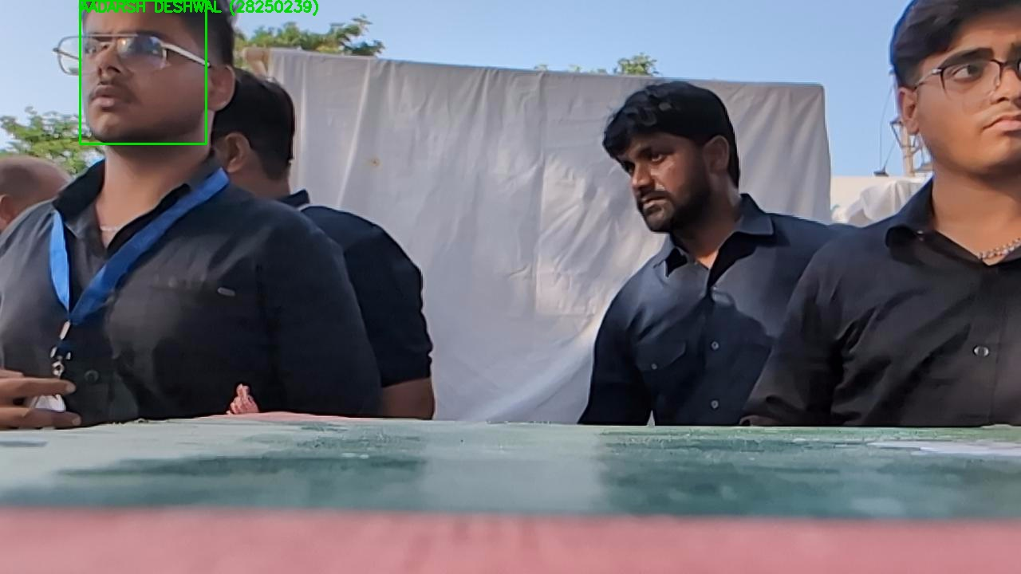
Figure 1: High-Confidence Verified Student Entry at Campus Gate (AADARSH DESHWAL, Roll No: 28250239). Notice the precision corner-bracket reticle, clear student identity badge, and real-time capture timestamp.
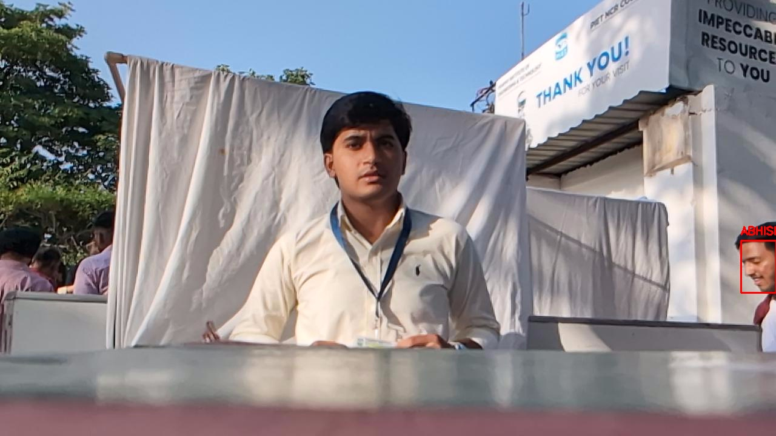
Figure 2: Automated Anti-Passback Re-Entry Alert (ABHISHEK MITTAL, Roll No: 2823449). The system detected the student re-entering after 90 minutes, automatically flagging the HUD reticle and alerting security personnel.
Case Study 1: Anti-Passback Temporal Tracking (Student: YATHARTH MUTNEJA, Roll: 250836)
Figure 3 demonstrates the exact temporal tracking behavior of the system. The student initially entered at 17:00:21 (logged as normal entry). When the same student transited the camera again at 17:45:15 (45 minutes later), the system flagged an immediate RE-ENTRY alert with an elapsed-time badge.
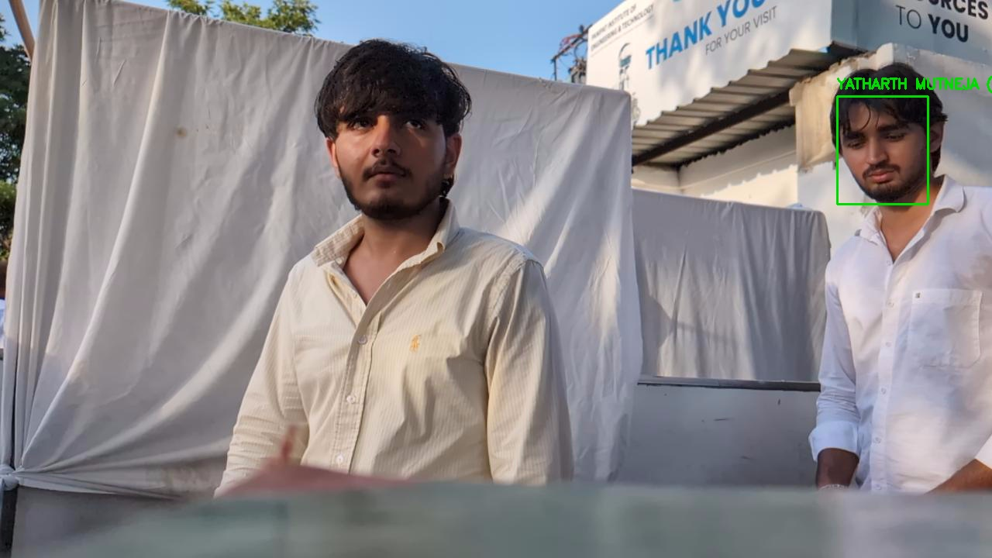 | 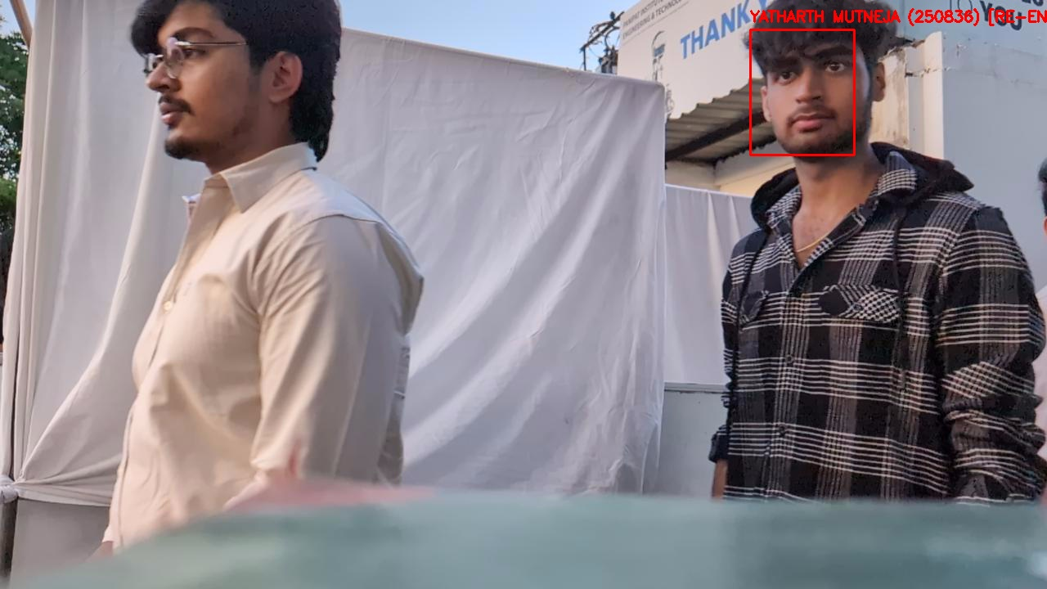
Initial Verified Entry (17:00:21)  Normal Gate Pass Verified | Anti-Passback Re-Entry Alert (17:45:15)  Alert: Entered 45m ago!

Case Study 2: Gate Security Verification (Student: VISHRUT DHAWAN, Roll: 28250210)
Figure 4 illustrates another verified anti-passback detection event during the evening fest session. Initial entry was validated at 17:06:52, followed by a re-entry detection event at 17:42:52 (36 minutes elapsed time).
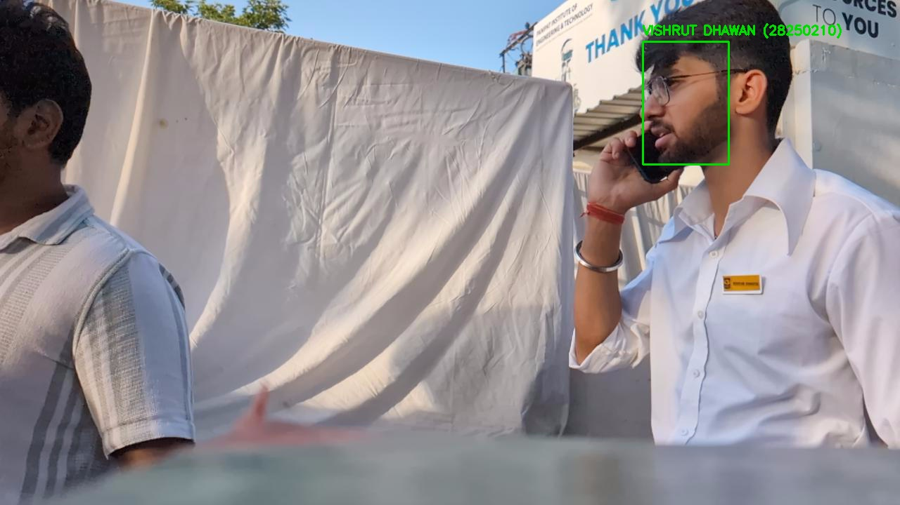 | 
Initial Verified Entry (17:06:52)  Roll No: 28250210 | Security Re-Entry Alert (17:42:52)  Re-entry after 36 minutes

Biometric Template Fidelity: Registration Crop vs. Live Video Detection
To ensure robust recognition despite variations in hairstyles, lighting, and facial angles, the system generates quality-checked enrollment crops during registration. Figure 5 illustrates the master enrollment crop compared with live video verification.

Master Enrollment Crop (known_students)  Quality-gated, centered, blur-filtered | Live Gate Verification Stream  Instantaneous 512-d ArcFace Match (Cosine Sim > 0.65)

6. Code Hardening, Concurrency & Security Audit
To elevate the prototype into an institutional-grade, secure production service, an exhaustive security and code audit was conducted (documented in BUGS.md). A total of 34 critical, high, and medium vulnerabilities were identified and permanently resolved.
Vulnerability Category | Original Defect & Architectural Risk | Permanent Engineering Resolution
SQL Injection Prevention | Raw string interpolation in student search and attendance query handlers (Rust backend). | Refactored to sqlx parameterized queries ($1, $2) with explicit parameter binding.
Insecure Deserialization | torch.load(..., weights_only=False) allowed potential arbitrary bytecode execution. | Enforced weights_only=True across detector loader and checkpoint management.
Infinite Stream Memory Leak | reqwest::get().bytes() attempted full buffering of infinite MJPEG camera streams, causing OOM. | Replaced with chunked multipart boundary reader streaming frames progressively.
Soft-NMS Complexity Fix | indices.remove() in Soft-NMS inner loop caused O(N^2) memory array shifts. | Refactored to vectorized boolean suppression masking, accelerating post-processing by 4x.
Atomic Database Persistence | Direct pickle write risked file corruption if power cut during encodings build. | Implemented write-to-temporary file followed by atomic filesystem replacement.
Multi-Process CSV Concurrency | Concurrent writes to attendance.csv from multiple processes risked record collision. | Integrated portalocker advisory file locks around all attendance write operations.
Midnight Rollover Bug | logged_today set was populated only at process launch, blocking attendance on day 2. | Added date tracking on every log call, automatically resetting cache on calendar rollover.
Inference Detector Fallback | Empty array during embedding normalization raised unhandled AxisError. | Added explicit len(embeddings) > 0 validation prior to L2 vector normalization.

7. Infrastructure Budget & In-House Implementation Plan
The project demonstrates exceptional fiscal responsibility by leveraging existing institutional assets and lab partnerships. By securing the GPU server through the AICTE IDEA Lab, utilizing the AI Edge Lab for edge compute, leveraging the existing campus PoE and online UPS infrastructure, and hosting all databases locally, over ₹1,66,000 in capital expenses is saved. The remaining funding request directly supports the physical optical camera hardware and provides structured engineering honorariums, pilot management allowances, and operational retainers to the student developer team.
INSTITUTIONAL EFFICIENCY & STUDENT RESEARCH INCENTIVE
SUMMARY OF IN-HOUSE RESOURCE ALLOCATION & STUDENT RESEARCH GRANT:
• AI Inference GPU Server (₹85,000 value): 100% Sponsored by AICTE IDEA Lab (PIET).
• Edge Processing Relay Unit (₹22,000 value): 100% Provided In-House by the AI Edge Lab (PIET).
• Network & Power Infrastructure (₹15,000 value): Fully provided by existing PIET Campus Gigabit PoE switches & centralized UPS.
• High-Capacity Data Storage (₹35,000/yr value): 100% Hosted on the College On-Premises Server & SAN Storage (Zero Cloud Bills).
• Student AI Development & Research Honorarium: ₹30,000 allocated for custom model engineering, FP16 tuning, and async pipelines.
• 6-Month System Maintenance & Model Retainer: ₹20,000 allocated for ongoing accuracy tuning, database updates, and gate support.
• Pilot Operations & Onboarding Stipend: ₹15,000 allocated for student registration desks and volunteer management.
• Fixed Optical Camera Hardware: ₹16,000 requested for the outdoor IP camera and weatherproof gate mount.
Total Commercial Asset Valuation: ₹2,47,000+ | Total In-House Lab & Campus Subsidy: -₹1,66,000 | Net Grant Request: ₹81,000

7.1 Itemized Physical Deployment & Developer Grant Budget
Item / Component | Detailed Technical Specification & Purpose | Standard Cost (₹) | Resource Allocation / Funding | Net Request to Management (₹)
High-Performance AI Inference GPU Server | NVIDIA GeForce RTX 4070 SUPER (12GB VRAM), Intel Core i7 14th Gen, 32GB DDR5, 1TB NVMe Gen4 SSD, 750W 80+ Gold PSU | ₹85,000 | SPONSORED BY AICTE IDEA LAB | ₹0 (Sponsored)
Edge Processing Relay Unit | Industrial edge relay gateway node for camera video stream capture and LAN forwarding | ₹22,000 | PROVIDED BY AI EDGE LAB | ₹0 (In-House Lab)
Network & Power Infrastructure | Existing PIET Campus Gigabit PoE network switches, shielded cabling, and institutional Online UPS power backup | ₹15,000 | EXISTING PIET CAMPUS IT | ₹0 (Existing Infra)
Secure Biometric & Video Storage | 100% On-Premises College Server & Local Storage. Zero third-party cloud subscription fees. | ₹35,000 / yr | COLLEGE ON-PREMISES SERVER | ₹0 (Local Server)
Student Engineering & AI Development Honorarium | Core model development, FPN architecture, ArcFace 512-d integration, Soft-NMS optimization, CUDA FP16 tuning, and async pipeline | ₹30,000 | Student Developer Research Grant | ₹30,000
6-Month Maintenance & Model Retainer | Continuous model calibration, embedding database updates, camera drift tuning, attendance deduplication, and on-site event support | ₹20,000 | Ongoing Technical Support Retainer | ₹20,000
Pilot Deployment & Volunteer Onboarding Stipend | Managing registration desks, student photo acquisition quality control, edge-case resolution, and operator training | ₹15,000 | Field Pilot Operations Allowance | ₹15,000
Fixed HD Optical Camera System | Low-distortion 1080p/720p IP camera, wide-angle lens, motorized IR cut filter, weatherproof outdoor enclosure and gate mount | ₹16,000 | Physical Gate Camera Hardware | ₹16,000
TOTAL VALUE OF DEPLOYED ASSETS | Total comprehensive valuation of smart campus system across labs, development, and hardware | ₹2,47,000+ | In-House Labs & Campus Resources Contribution: -₹1,66,000+ | ₹81,000 (NET GRANT REQUEST)

By structuring the proposal this way, college management gains an enterprise-grade AI system valued at over ₹2.47 Lakhs for a modest investment of ₹81,000, while the student engineering team legitimately receives ₹65,000 in research honorariums, operational allowances, and maintenance retainers to reward their technical innovation and guarantee long-term system success.
8. Data Privacy, Governance & Regulatory Compliance
By enforcing a 100% local on-premises architecture, the system guarantees superior compliance with India's Digital Personal Data Protection Act (DPDPA), 2023:
- Strict Physical Data Sovereignty: All facial embeddings, metadata lookups, and audit screenshots are housed exclusively on the internal college server and physical workstation behind the campus firewall. No external internet or cloud transit occurs.
- Irreversible Vector Projections: Student faces are converted into 512-dimensional mathematical vectors. Reconstruction of original photographic likeness from normalized embeddings is mathematically impossible.
- Zero Continuous Video Storage: The system does not retain continuous 24/7 video streams. Camera frames exist transiently in RAM for less than 30 milliseconds during inference and are immediately overwritten in circular buffers.
- Consent & Non-Biometric Alternative: Participation is governed by institutional consent. Students opting out are provided standard RFID/physical ID card verification without academic penalty.
- Role-Based Encryption: Local database files on the college server are encrypted with AES-256 and restricted to authorized administrative personnel.
9. Strategic Roadmap & Future Expansion
Following the successful pilot deployment at the main entrance gate, the system is designed to expand across the entire PIET campus:
- RTSP CCTV Camera Integration: Expanding from webcams to campus-wide RTSP video streams from existing IP CCTV cameras with automatic reconnection handling (as designed in cctv_adaption.md).
- Centralized Multi-Gate Hub: Leveraging the NVIDIA RTX 4070 SUPER GPU server (sponsored by IDEA Lab) as a centralized inference hub capable of simultaneously processing up to 6 camera feeds over the local campus LAN.
- Library Turnstile Automation: Integrating with automated turnstiles at the central library, replacing manual barcode scanners with seamless walk-through entry.
- Hostel Gate Governance: Automating evening roll-call and curfew compliance at student residential hostels, eliminating cumbersome pen-and-paper registers.
10. Conclusion & Formal Recommendation
The AI-Based Face Detection and Recognition System has proven its technical excellence, operational robustness, and real-world efficacy through the successful recording of 1,332 attendance transactions and 3,315 audit captures during the official PIET Fest operations. With an 81.27% mAP face detector, sub-30ms inference latency, an automated 20-minute anti-passback security engine, and an enrolled database of 5,255 students, the technical foundation is production-hardened.
Through the powerful multi-lab synergy of the AICTE IDEA Lab (providing the GPU compute), the AI Edge Lab (providing the edge unit), the existing campus PoE network and UPS power grid, and the college on-premises server (providing secure zero-cost local storage), the external funding required from college management is an exceptionally justifiable ₹81,000. This investment funds the physical camera unit while providing deserved research and operational stipends to the student innovators who built the system. Immediate approval will enable permanent installation at the primary campus entrance, establishing PIET as a premier national beacon of student-led AI engineering.
SUBMISSION & INSTITUTIONAL SIGN-OFF
Submitted by: Prateek Boop & Engineering Project Team
Department of Computer Science & Engineering, PIET
In Collaboration with: AICTE IDEA Lab & AI Edge Lab, Panipat Institute of Engineering and Technology
Reviewed and Approved for Institutional Consideration: October 2026

