**Supply Chain Management Report**

**Supply Chain Concepts**

**Orders and Lines**

-> Orders are nothing but a unique request placed by a customer on a given date.  
  
-> Within an order, a customer could request multiple items. Each of these items requested within the order is called an order line.

**Measuring Line Fill Rate & Volume Fill Rate**

-> Line Fill Rate is an important metric for the supply planning team to understand how many lines they shipped out of the total lines ordered. This metric does not consider the delivery time of the order.  
  
-> Volume fill rate or case fill rate is a similar metric useful for the supply planning team to understand the total quantity they are able to ship for a customer per order or for a given period of time.

**Measuring On Time delivery %**

-> Unlike Line Fill Rate, this measure is measured at the order level. It determines if an order is delivered as per the agreed time with the customer.

-> This metric is important for the warehouse & distribution team.

-> An order is On Time only when all the line items inside the order is delivered on time.

**Measuring In Full delivery %**

-> Unlike Line Fill Rate, this measure is measured at the order level. It determines if an order is delivered in full as per the requested quantity by the customer.

-> This metric is important for the supply planning team.

-> An order is In Full only when all the line items inside the order are delivered In Full.

**Measuring On Time In Full (OTIF) %**

-> Unlike Line Fill Rate, this measure is measured at the order level. It determines if an order is delivered BOTH in full and On Time as per the customer order request.

-> This metric is important for all the sub functions in the supply chain team.

-> An order is OTIF only when all the line items inside the order are delivered In Full and ON Time. This is a hard metric which measures the reliability of an order from customer's point of view.

**Workflow Created on N8N –  
  
 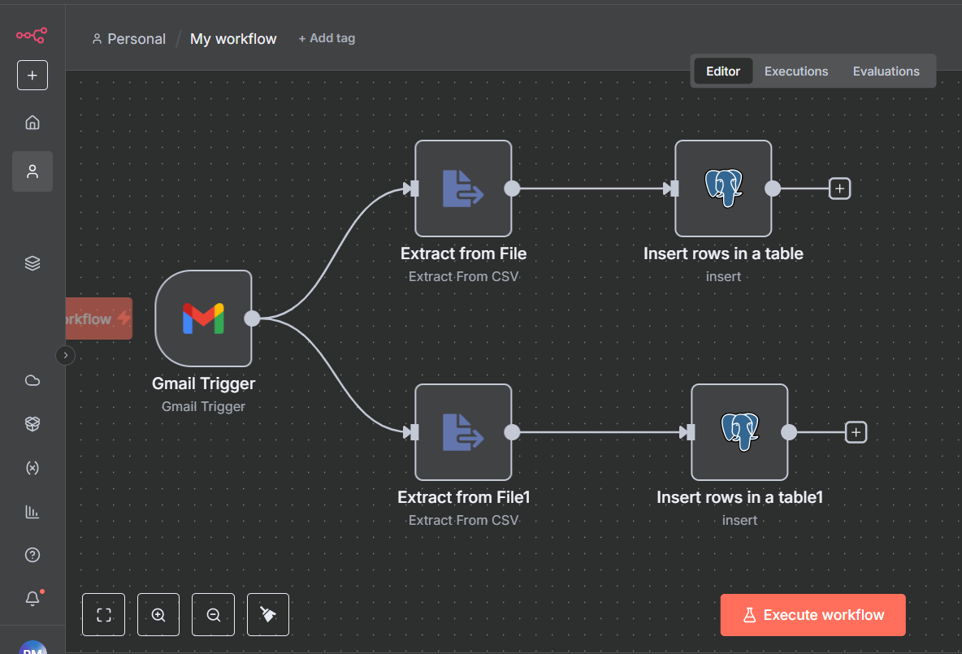**

* Gmail Node in n8n connects to Gmail via the API, allowing retrieval and processing of emails (e.g., extracting unread messages, parsing content).
* Supabase Node handles authentication and database interactions using Supabase session/API parameters for secure connections to PostgreSQL.
* The pipeline can include AI components (like OpenAI/GPT) to read, summarize, and categorize extracted data before insertion into Postgres, enabling intelligent automation

**Supabase Tables (Postgres) –**

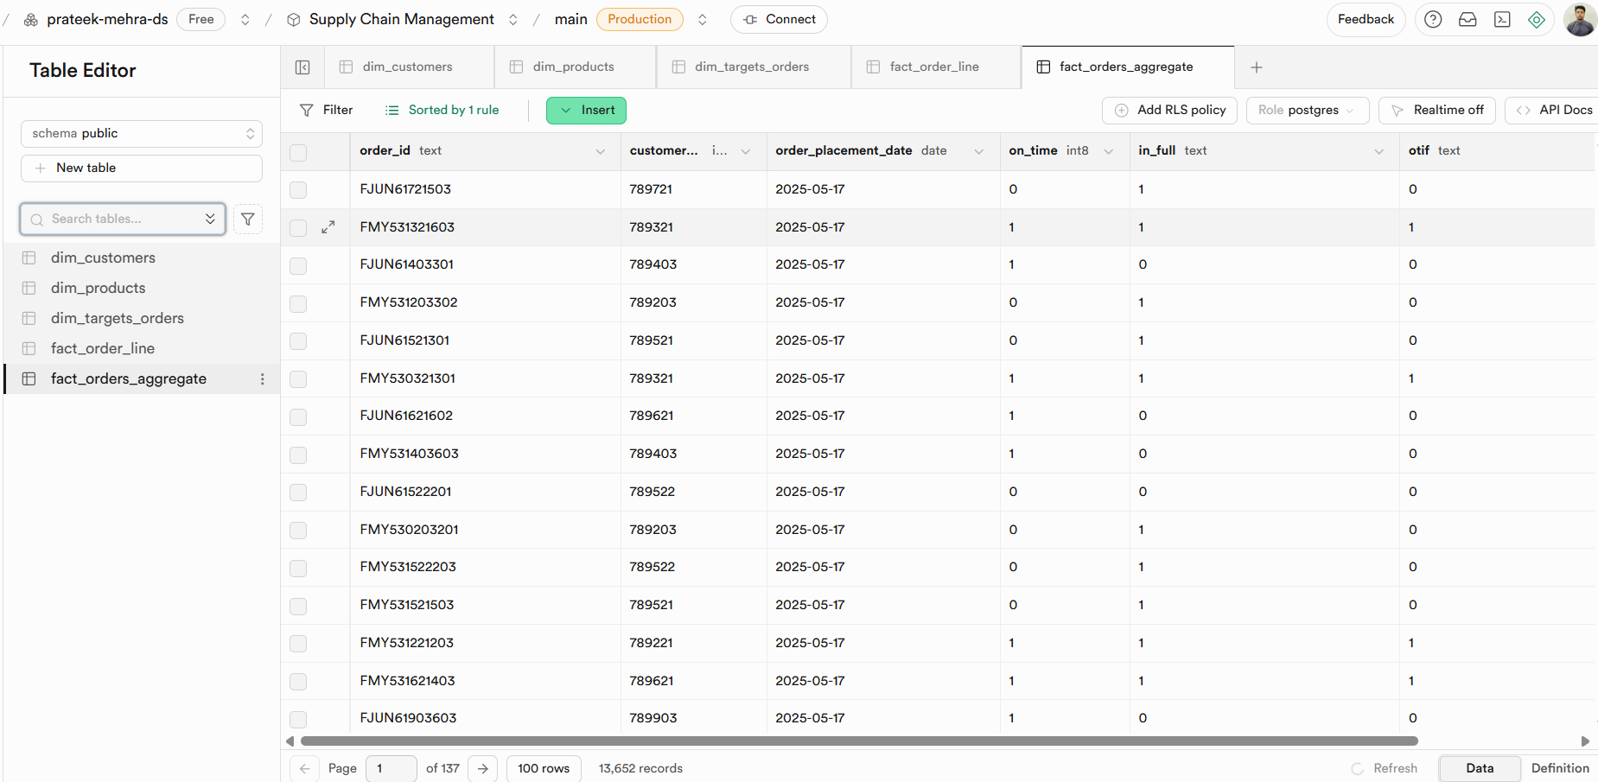

**KPIs Metric –**

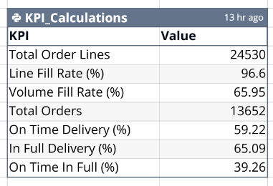

This KPI calculation is done by prompting in quadratic (uses the chat sheet functionality).

“””*Use this Prompt:   
Create the following KPIs   
1. Total Order Lines   
2. Line Fill Rate   
3. Volume Fill Rate   
4. Total Orders   
5. On Time Delivery %   
6. In Full Delivery %   
7. On Time In Full %* “””

**Dashboard –**

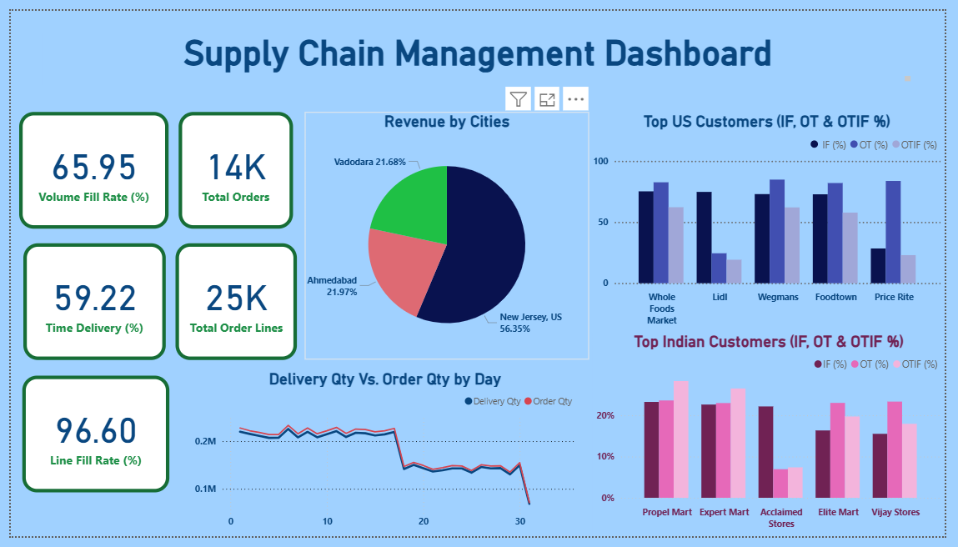

**Insights -**

1. New jersey contributes the highest revenue in the business
2. Line Fill Rate is 96.6% which means most of the demands are supplied and can approach the business partner for more scalability.