**All API Testing and MongoDB Screenshots**

Register: TestUser

Login:TestUser

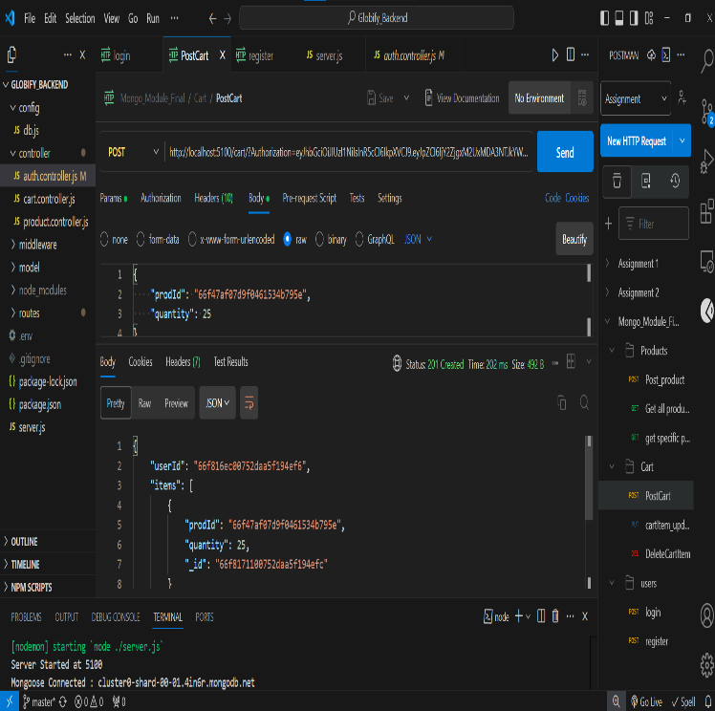Accessing Cart with Login:

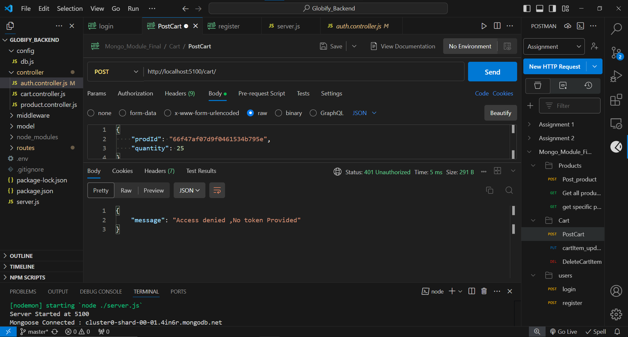Accessing Cart without Login/Token(error)

Updating Item with Login:

Updating without Login(error)

Deleting User’s cart Item with login:

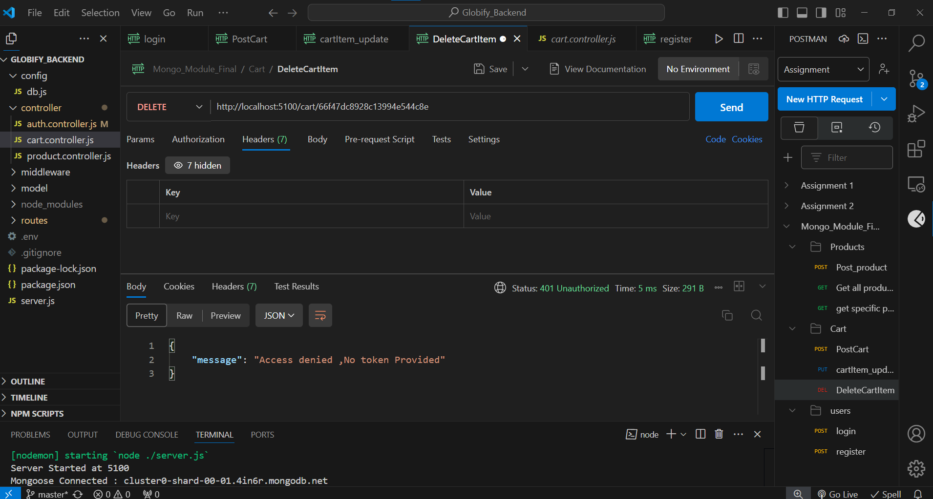Deleting User’s Cart Item without Token(Error):

Getting All products:

Getting Specific Product:

MongoDB Screenshots



