**Data Visualizations**

**GRAPHS:**

1.This bar graph, made using D3.js, can be used to easily interpret the changes seen in the GDP of Spain in 1970s.

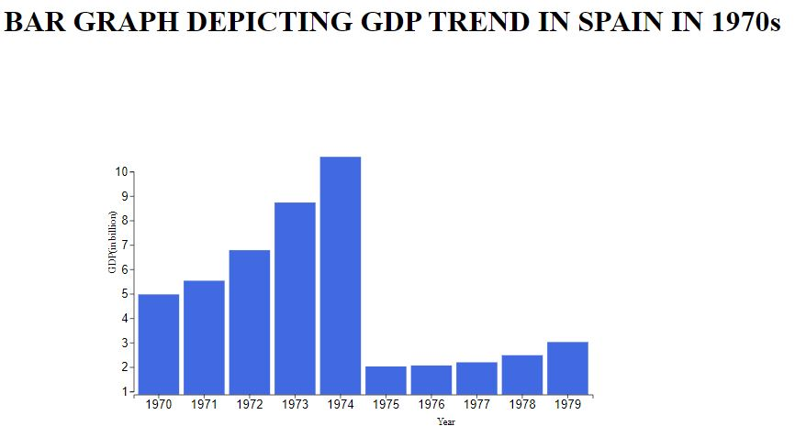

2. Choropleth Map in D3.js is a map chart type that is used to show divided geographical areas — countries, regions, and others — that are colored, patterned, or shaded in relation to a variable.

This plot color codes countries based on the range in which its population falls.

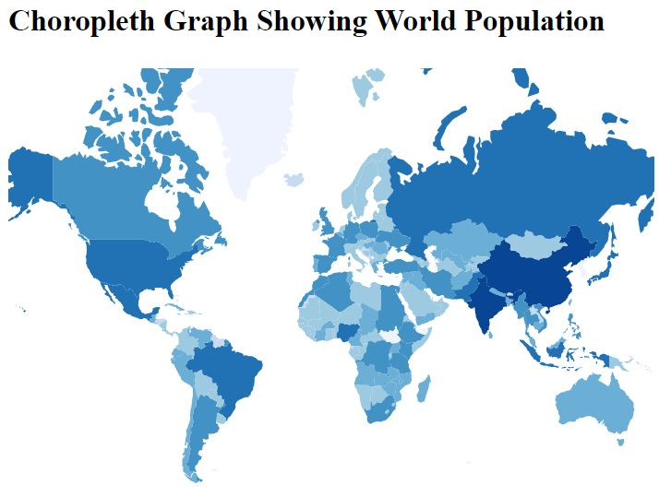

3.This count plot shows the number distribution of income groups in all regions around the world. For this I used python libraries pandas to read csv file and seaborn to make the count plot.

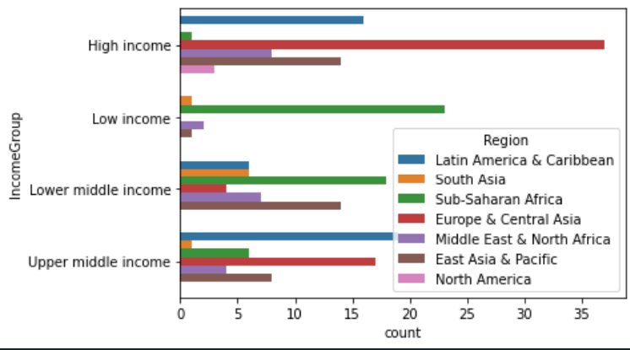

4.This bubble plot made in D3.js is used to show world population using radius of bubbles as a parameter. 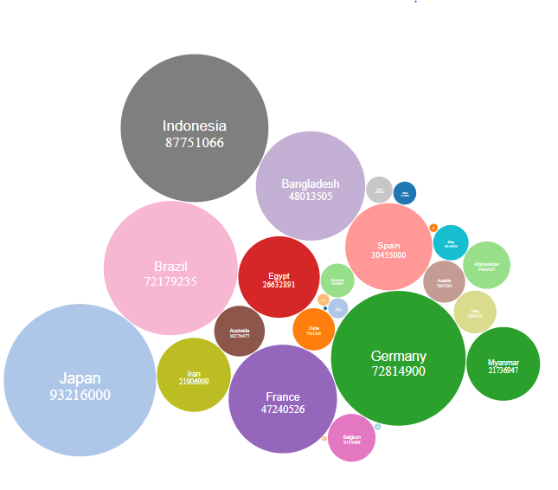

**Alternatives:**

1.A pie chart can be used to show the income group distribution of a region.

2.Line plots can be used to show how GDP of a country evolved or to analyze the rate of evolution of world population.

3.Density plots can be used to visualize the location-wise distribution of income groups around the globe.

**Methodology Used:**

1.First the csv files were analyzed to establish meaningful relations between entities to make useful plots.

2.Then I browsed through various plots that D3 offers and chose plots that were best for representing the established relations.

3.Code was written using HTML, CSS, D3.js for each plot.

**Challenges Faced:**

1.Faced difficulty while running the plots on browser while loading local files of the provided dataset as chrome does not allow loading external data due to web security reasons.

2.Made the count plot using python libraries as it offers easier solutions to code such complex plots with simple functions.

**Future Scope:**

1.These plots can be made interactive by adding tooltips to show extra information only on hovering over the plot.

2.An entire dashboard can be created containing drop-down menus for the user to browse through various options like choose years, country-wise plots, region-wise plots, etc. or checkboxes can be added for the user to apply filters.