**UNIX Command**

**Unix commands, which are the instructions or programs used to interact with a Unix-based operating system, including systems like Linux and macOS, through the command line interface. These commands allow users to perform tasks such as managing files, directories, processes, and more. Here’s a brief overview of some commonly used Unix commands:**

1. **mkdir -** Creates a new directory.

Example: mkdir new_folder creates a new directory called new_folder

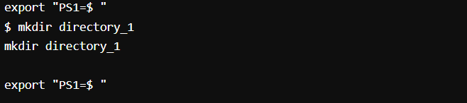

1. **ls -** Lists the contents of a directory.

Example: ls lists all files and directories in the current directory.

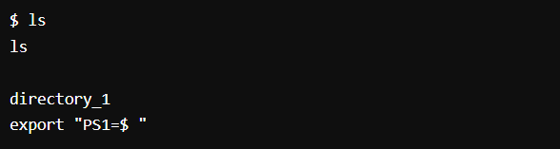Example: ls -l lists in long format with detailed information.

1. **cd -** Changes the current directory.

Example: cd Documents changes the current directory to the Documents folder.

Example: cd .. moves up to the parent directory.

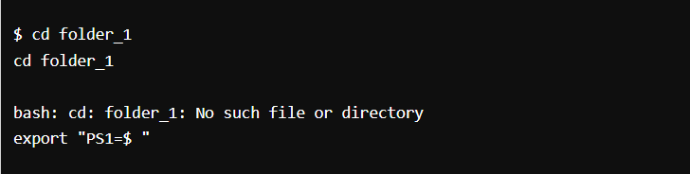

1. 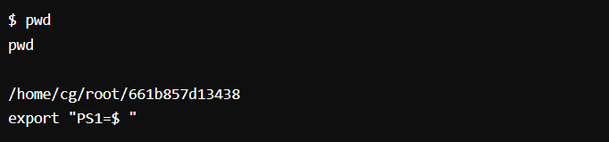**pwd** - Prints the current working directory.
2. **Touch** - is used primarily to change the file timestamps—specifically, the access and modification times of a file or directory.

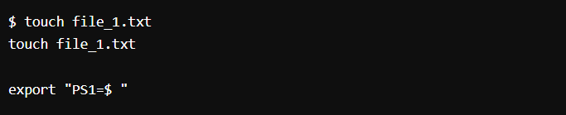

1. 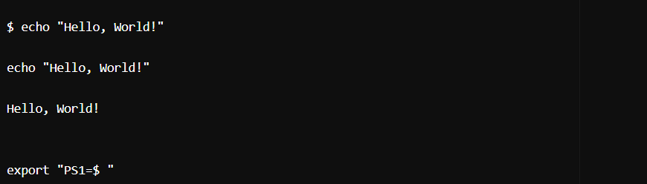**Echo** - is a fundamental utility used to display lines of text or string values to the standard output, which is typically the terminal screen.
2. **cat** - Concatenates and displays files.

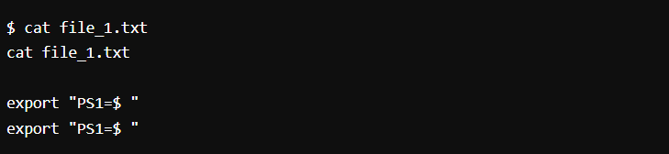Example: cat file.txt displays the contents of file.txt.

1. **rm** - Removes files or directories.

Example: rm file.txt deletes the file.txt.

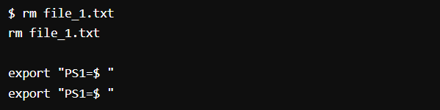

1. **cp** - Copies files or directories.

Example: cp source.txt destination.txt copies source.txt to destination.txt.

1. **grep** - Searches for patterns in text.

Example: grep "hello" file.txt searches for the word "hello" in file.txt.