**Indoor Air Pollution and Stunting Among Indian Children**

Anca Balietti and Prateek Mittal

Follow @EPoDHarvard

[4.3 million](http://www.who.int/mediacentre/factsheets/fs292/en/) people die each year due to indoor air pollution. The conversation on air quality, however, has been focused largely on outdoor air pollution. Our analysis of 2005-2006 National Family Health Survey (NFHS-3) data finds strong evidence that the exposure to indoor air pollution from burning solid fuels increases the probability of stunting among Indian children.

**Stunting is big in India**

A child is regarded as stunted if her height-for-age is below certain [thresholds](http://www.who.int/nutrition/healthygrowthproj_stunted_videos/en/) set as per the WHO Child Growth Standards. Stunted children tend to have both physical and cognitive [developmental delays](http://onlinelibrary.wiley.com/doi/10.1111/mcn.12080/full), including delayed walking, impeded speech development, and diminished school performance. They also experience higher rates of [mortality and morbidity](https://www.ncbi.nlm.nih.gov/pubmed/23426036), including diabetes and hypertension.

According to the NFHS-3 data, as many as 43% of Indian children under the age of five were stunted as of 2006. Despite high economic growth during the last few decades, India still has the highest prevalence of stunting among all South Asian economies with the exception of war-stricken Afghanistan. The sheer magnitude of the problem is apparent in the fact that India has 61 million stunted children, more than any other country.

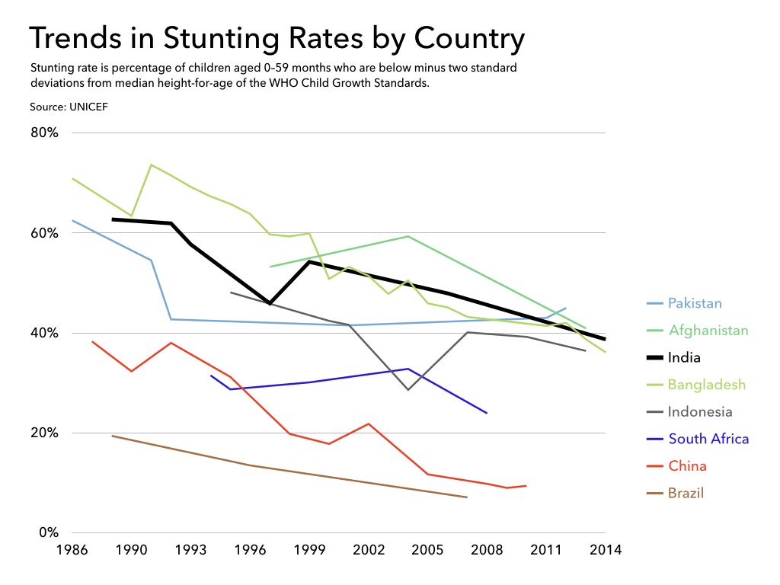

*[Trend in stunting rate among the BRICS and South Asian countries, 1986 – 2014](https://rawgit.com/prateek149/data_visualization/master/air_pollution_stunting/stunting_country.html)*

**The connection between stunting and solid cooking fuels**

While stunting is most commonly associated with poor nutrition, there is an emerging body of research that links exposure to poor air quality to stunting. In many households in India, solid fuels­–such as coal, wood, crop residue and dung-are used for cooking. These fuels release particulate matter, carbon monoxide, formaldehyde and other toxins, at a much higher rate than non-solid fuels such as kerosene and LPG. Children’s lungs are still developing and are therefore particularly susceptible to irritation and contamination from the fumes of solid cooking fuels; when children’s bodies must repeatedly fight off the respiratory infections these fumes provoke, their growth suffers.

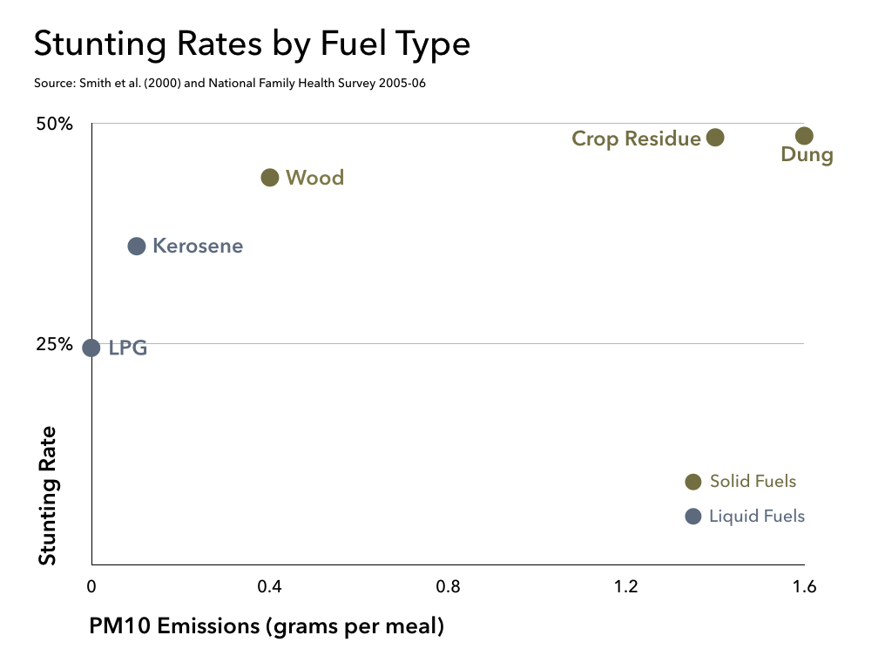

*[The association between fuel used for cooking and stunting rates](The association between fuel used for cooking and stunting rates (https://rawgit.com/prateek149/data_visualization/master/air_pollution_stunting/stunting_fuel.html))*

We analyzed NFHS-3 data to identify the main drivers of stunting among Indian children. Controlling for nutrition, recent illnesses, and other socio-economic factors, living in a household that burns solid fuels is associated with 6.5% of stunting cases in Indian children below three years old. In fact, in our analysis, fuel type comes out to be almost half as influential as malnutrition in terms of impact on stunting.

**Breaking the link between indoor air pollution and childhood stunting**

In May 2016, the Indian government began providing below-poverty-line households with [liquefied petroleum gas](http://www.pmujjwalayojana.in/) (LPG) connections. At the same time, many NGOs and local institutions are working to replace traditional cookstoves with more efficient ones, which would reduce the total quantity of fuel consumed and emissions produced per hour of usage.

Although a transition to cleaner fuels and technology is perhaps the only long-term solutions that addresses the indoor air pollution problem at its roots, we find that there is a second option that has the potential to tackle stunting. Having appropriate ventilation mechanisms can considerably mitigate the negative impact of solid fuel smoke exposure on child stunting. The simple presence of a window in households burning solid fuels is associated with a 3.4% lower prevalence of stunting. Having separate kitchen and living areas reduces the chance of stunting by 4%. As the data capture only whether households possess the different ventilation options and not their actual usage, so the benefits of using ventilation consistently and strategically are probably greater.

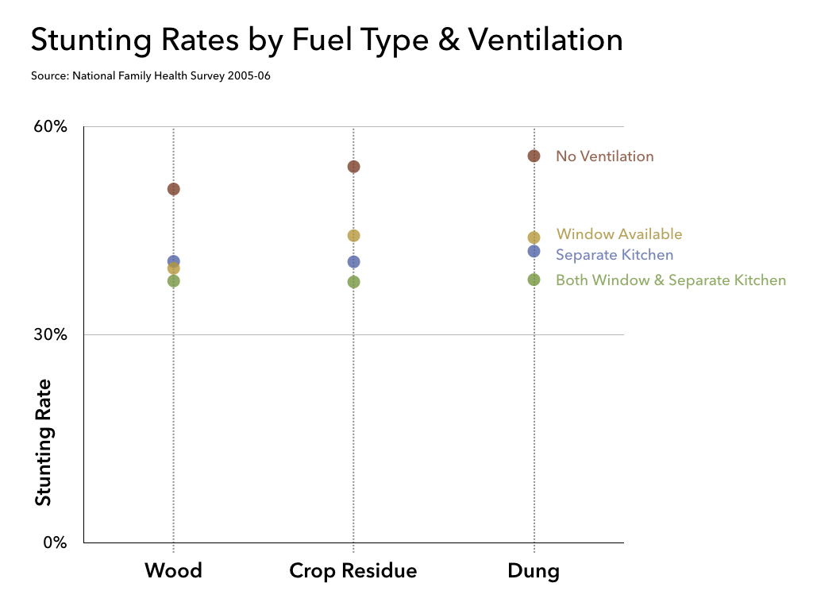

[*Stunting frequency for different ventilation options*](https://rawgit.com/prateek149/data_visualization/master/air_pollution_stunting/stunting_fuel_venting.html)

In order to be free of the health risks associated with air pollution, citizens need clean air both at home and in their communities. A permanent transition to cleaner fuels is perhaps the only solution that will improve India’s air quality—both indoors and outdoors. In the meantime, low-cost ventilation solutions have the potential to mitigate the impact of solid fuel burning on stunting, and should be integrated into health promotion campaigns.

____

**Anca Balietti** is a is a postdoctoral Research Fellow at [Evidence for Policy Design](https://epod.cid.harvard.edu) (EPoD) at Harvard Kennedy School. **Prateek Mittal** is a Senior Research Associate for [EPoD India at IFMR](https://epod.cid.harvard.edu/india), a joint initiative by EPoD and the Institute for Financial Management and Research. The study was done in collaboration with Dr. Souvik Datta of Glasgow University