Q1. Create a Restful API using Spring Boot for Student.

Solution

Student.java

package ​com.spring.springBootDemo.entities;

public class ​Student {
private​ int rollNumber​;​
private​ String​ name​;​
private​ String​ course​;​

​public ​Student() {
}

​public int ​getRollNumber() {
​return ​rollNumber​;

}

​public void ​setRollNumber(​int ​rollNumber) {
this​.​rollNumber​ =​ rollNumber;

}

​public ​String getName() {
return​ name​;​

}

​public void ​setName(String name) {
this​.​name​ =​ name;

}

​public ​String getCourse() {
return​ course​;​

}

​public void ​setCourse(String course) {
this​.​course​ =​ course;

}

​public ​Student(​int ​rollNumber, String name, String course) { ​this​.​rollNumber ​= rollNumber;
​this​.​name ​= name;
​this​.​course ​= course;
}

}

StudentController.java

package ​com.spring.springBootDemo.controllers;

import ​com.spring.springBootDemo.entities.Student;
import ​com.spring.springBootDemo.services.StudentService; import ​org.springframework.beans.factory.annotation.​Autowired​;
import ​org.springframework.web.bind.annotation.​RequestMapping​; import ​org.springframework.web.bind.annotation.​RestController​;

import ​java.util.List;

@RestController
public class ​StudentController {
@Autowired​
StudentService​ studentService​;​
​@RequestMapping​(​"/getStudents"​)
​public ​List<Student> getStudentsList()

{
​return ​studentService​.getStudentsList();

}

}

StudentService.java

package ​com.spring.springBootDemo.services;

import ​com.spring.springBootDemo.entities.Student;
import org.springframework.stereotype.​Service​;​

import ​java.util.Arrays;
import java.util.List;​

@Service
public class ​StudentService {
​public ​List<Student> getStudentsList()
{
​return ​Arrays.​asList​(
​new ​Student(​1​,​"Prateek"​,​"MCA"​),
new​ Student(​2​,​"Vagish"​,​"MCA"​)​
);

}

}
Q2. Run Spring Boot Application with all the three ways Solution

1)Right click on the class marked with @SpringBootApplication containing main method-->Click on run SpringBootDemoApplication.main()
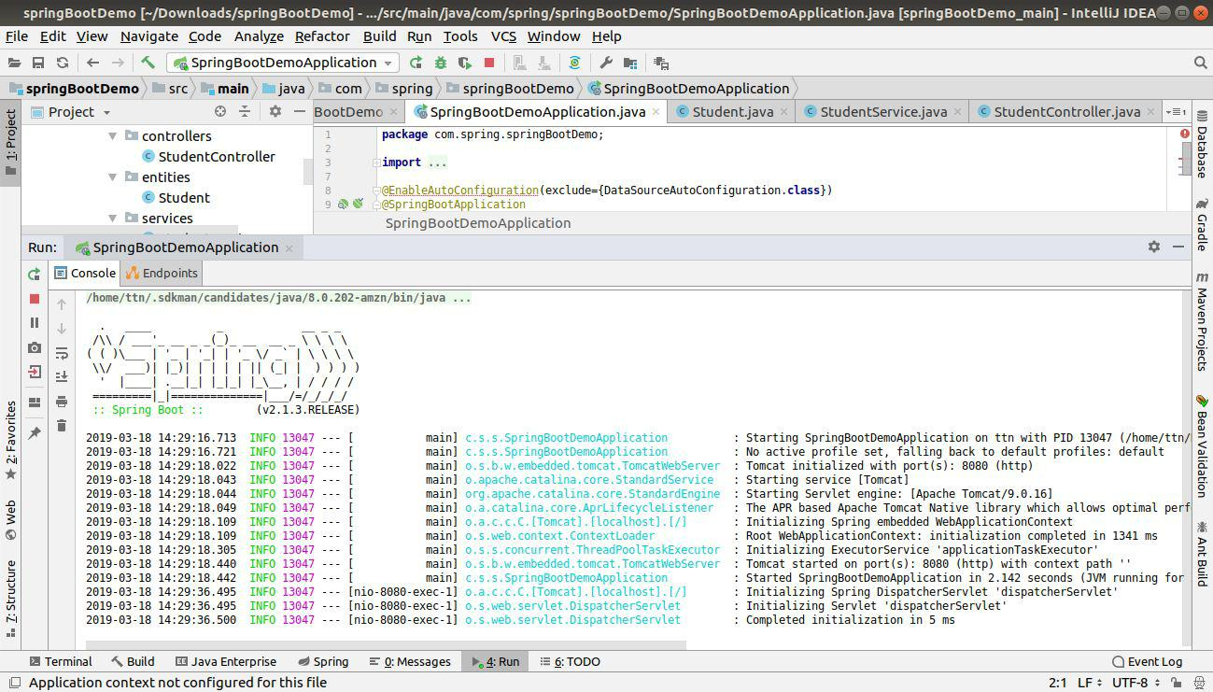

2)Execute bootRun gradletask

Open terminal→ gradle bootRun’

Or in the gradle tool window double click on bootRun task
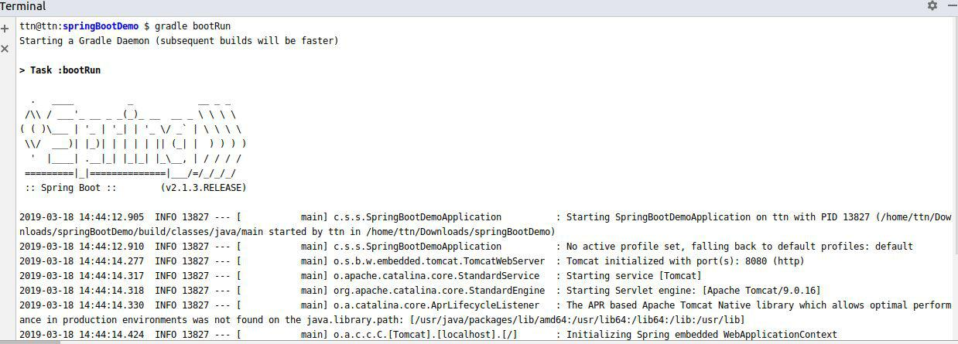
3)Execute bootJar task from gradle window

Go to terminal

Cd build/libs

Run java -jar <jarname>
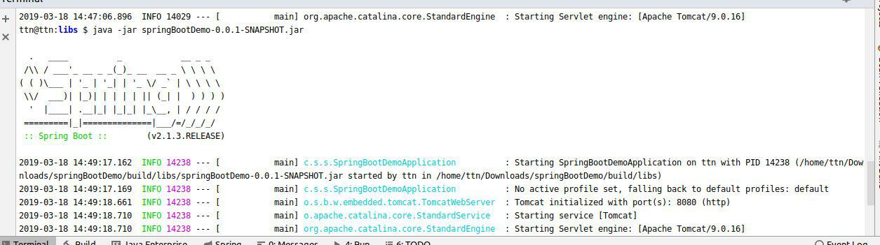
Q3. Create Bean User containing two field username and password with Spring

Context File

Solution

Users.java

package ​com.spring.springBootDemo.entities;

import ​org.slf4j.Logger;
import org.slf4j.LoggerFactory;​
import ​org.springframework.beans.factory.annotation.​Autowired​;

public class ​Users {
private​ String​ username​;​
private​ String​ password​;​

Logger ​logger​= LoggerFactory.​getLogger​(Users.​class​); ​public ​Users() {
​logger​.info(​"User Bean Created"​);
}

​public ​String getUsername() {
return​ username​;​

}

​public void ​setUsername(String username) {
this​.​username​ =​ username;

}

​public ​String getPassword() {
return​ password​;​

}

​public void ​setPassword(String password) {
this​.​password​ =​ password;

}

}

SpringBootDemoApplication.java

package ​com.spring.springBootDemo;

import ​com.spring.springBootDemo.entities.Users;
import org.springframework.boot.SpringApplication;​
import ​org.springframework.boot.autoconfigure.​EnableAutoConfiguration​; import ​org.springframework.boot.autoconfigure.​SpringBootApplication​;

import ​org.springframework.boot.autoconfigure.jdbc.DataSourceAutoConfiguration; import ​org.springframework.context.annotation.​Bean​;

@EnableAutoConfiguration​(exclude={DataSourceAutoConfiguration.​class​})
@SpringBootApplication

public class ​SpringBootDemoApplication {
@Bean
Users​ user()

{
Users user=​new ​Users();
user.setUsername(​"prateek.nagar@tothenew.com"​);
user.setPassword("Hello"​);​
​return ​user;

}
​public static void ​main(String[] args) {
SpringApplication.run​(SpringBootDemoApplication.​class​,​ args);

}

}

Q4.Create a Bean Database with two fields port and name and Access its values

using application.properties

Solution

Application.properties
database.name​=​"mysql"
database.port=​3306​

Database.java

package ​com.spring.springBootDemo.entities;

import ​org.springframework.beans.factory.annotation.​Value​; import ​org.springframework.stereotype.​Component​;

@Component
public class ​Database {
@Value​(​"​${database.name}")​
private​​String name​;​
@Value​(​"​${database.port}")​
private​​int​ port​;​

​public ​String getName() {
return​ name​;​

}

​public int ​getPort() {
return​ port​;​

}

}

DatabaseService.java

package ​com.spring.springBootDemo.services;

import ​com.spring.springBootDemo.entities.Database;
import ​org.springframework.beans.factory.annotation.​Autowired​; import ​org.springframework.stereotype.​Service​;

import ​javax.xml.crypto.Data;
@Service
public class ​DatabaseService {
@Autowired​
​Database ​database​;
​public ​String getDataBaseConfig()

{
​return ​database​.getName()+​" "​+​database​.getPort();

}

}

DatabaseController.java

package ​com.spring.springBootDemo.controllers;
import ​com.spring.springBootDemo.entities.Database;
import ​com.spring.springBootDemo.services.DatabaseService; import ​org.springframework.beans.factory.annotation.​Autowired​; import ​org.springframework.stereotype.​Controller​;

import ​org.springframework.web.bind.annotation.​RequestMapping​; import ​org.springframework.web.bind.annotation.​ResponseBody​; import ​org.springframework.web.bind.annotation.​RestController​;

@RestController
public class ​DatabaseController {
@Autowired​
DatabaseService​ databaseService​;​

​@RequestMapping​(​"/databaseConfig"​)
public​ String​ databaseConfig()

{
​return ​databaseService​.getDataBaseConfig();

}

}

Q5. Configure environment specfic values for Database Bean

Solution

application-prod.properties
database.port​=​8826
database.name=​oracle​

Database.java

Same as previous question

1)Using

Java -jar <jarname> --spring.profiles.active=prod

2)Using java -jar <jarname>

Q6. Apply Logging whereever you feel is necessity DatabaseController.java
package ​com.spring.springBootDemo.controllers;

import ​com.spring.springBootDemo.entities.Database;
import ​com.spring.springBootDemo.services.DatabaseService;
import org.slf4j.Logger;​
import org.slf4j.LoggerFactory;​

import ​org.springframework.beans.factory.annotation.​Autowired​; import ​org.springframework.stereotype.​Controller​;

import ​org.springframework.web.bind.annotation.​RequestMapping​; import ​org.springframework.web.bind.annotation.​ResponseBody​; import ​org.springframework.web.bind.annotation.​RestController​;

@RestController
public class ​DatabaseController {
@Autowired​
DatabaseService​ databaseService​;​

Logger ​logger​= LoggerFactory.​getLogger​(DatabaseController.​class​);

​@RequestMapping​(​"/databaseConfig"​)
public​ String​ databaseConfig()

{
​//Question6 |  | "​);
​logger​.info(​"------ | Calling databaseService.getDataBaseConfig()------- | "​);
​return ​databaseService​.getDataBaseConfig();
}

}

StudentController.java

package ​com.spring.springBootDemo.controllers;

import ​com.spring.springBootDemo.entities.Student;
import ​com.spring.springBootDemo.services.StudentService;
import org.slf4j.Logger;​
import org.slf4j.LoggerFactory;​

import ​org.springframework.beans.factory.annotation.​Autowired​; import ​org.springframework.web.bind.annotation.​RequestMapping​; import ​org.springframework.web.bind.annotation.​RestController​;

import ​java.util.List;

@RestController

public class ​StudentController {
​@Autowired
​StudentService ​studentService​;

Logger ​logger​= LoggerFactory.​getLogger​(StudentController.​class​); ​@RequestMapping​(​"/getStudents"​)
​public ​List<Student> getStudentsList()

{
​//Question6 |  | "​);
​logger​.info(​"............ | Calling studentService.getStudentsList()................. | "​);
​return ​studentService​.getStudentsList();

}

}

DatabaseService.java

package ​com.spring.springBootDemo.services;

import ​com.spring.springBootDemo.entities.Database;
import org.slf4j.Logger;​
import org.slf4j.LoggerFactory;​
import ​org.springframework.beans.factory.annotation.​Autowired​; import ​org.springframework.stereotype.​Service​; import ​sun.rmi.server.LoaderHandler;

@Service
public class ​DatabaseService {
@Autowired​
​Database ​database​;

Logger ​logger​= LoggerFactory.​getLogger​(DatabaseService.​class​); ​public ​String getDataBaseConfig()
{
​//Question6 |  | "​);
​logger​.info(​"....... | In studentService.getDataBaseConfig method......... | "​);
​return ​database​.getName()+​" "​+​database​.getPort();

}

}

StudentService.java

package ​com.spring.springBootDemo.services;

import ​com.spring.springBootDemo.entities.Student;
import org.slf4j.Logger;​
import ​org.slf4j.LoggerFactory;
import ​org.springframework.stereotype.​Service​;

import ​java.util.Arrays;
import java.util.List;​

@Service
public class ​StudentService {
Logger ​logger​= LoggerFactory.​getLogger​(StudentService.​class​); ​public ​List<Student> getStudentsList() {

​//Question6

​logger​.info(​".........In studentService.getStudentsList() method..........."​);
​return ​Arrays.​asList​(
​new ​Student(​1​,​"Prateek"​,​"MCA"​),
new​ Student(​2​,​"Vagish"​,​"MCA"​)​

);

}

}

Q7. Bootstrap Data for Student Domain

Solution

Student.java

package ​com.spring.springBootDemo.entities;

import ​javax.persistence.​Entity​;
import javax.persistence.​Id​;​

//added annotations for question7

@Entity
public class ​Student {
@Id​
​private int ​rollNumber​;
private​ String​ name​;​
private​ String​ course​;​

​public ​Student() {
}

​public int ​getRollNumber() {
return​ rollNumber​;​

}

​public void ​setRollNumber(​int ​rollNumber) {
this​.​rollNumber​ =​ rollNumber;

}

​public ​String getName() {
return​ name​;​

}

​public void ​setName(String name) {
this​.​name​ =​ name;

}

​public ​String getCourse() {
return​ course​;​

}

​public void ​setCourse(String course) {
this​.​course​ =​ course;

}

​public ​Student(​int ​rollNumber, String name, String course) { ​this​.​rollNumber ​= rollNumber;
​this​.​name ​= name;
​this​.​course ​= course;
}

}

StudentRepository.java

package ​com.spring.springBootDemo.repositories;

import ​com.spring.springBootDemo.entities.Student;
import ​org.springframework.data.repository.CrudRepository;

public interface ​StudentRepository ​extends ​CrudRepository<Student,Integer> {
}

Bootstrap.java

package ​com.spring.springBootDemo.events;

import ​com.spring.springBootDemo.repositories.StudentRepository; import ​com.spring.springBootDemo.entities.Student;

import ​org.springframework.beans.factory.annotation.​Autowired​; import ​org.springframework.context.event.ContextRefreshedEvent; import ​org.springframework.context.event.​EventListener​; import ​org.springframework.stereotype.​Component​;

import ​java.util.Iterator;

@Component
public class ​BootStrap {
@Autowired​
​StudentRepository ​studentRepository​;
​@EventListener​(ContextRefreshedEvent.​class​)
public​ void insertData()​

{
Iterator<Student>studentIterator=​studentRepository​.findAll().iterator();
if​(!(studentIterator.hasNext()))​

{
​for​(​int ​i=​0​;i<​5​;i++)

{
Student student=​new ​Student(i+​1​,​"Student"​+i,​"MCA"​);
studentRepository​.save(student);​
System.out​.println(​"student"​+i+​"​ created");​

}

}

}

}
Output
