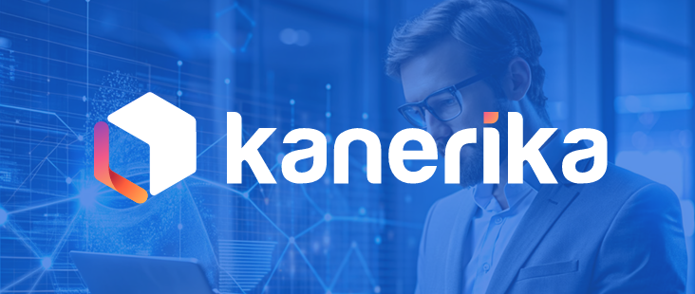
Prateek Dave

pdave7758@gmail.com

EDUCATION

B.E. in Information Technology M.B.M University

Jodhpur 2022 - Present

SKILLS
•{'technical': ['C', 'C++', 'Python', 'JavaScript', 'HTML', 'CSS', 'React', 'Node.js', 'Flask', 'MySQL', 'MongoDB', 'OpenCV', 'Numpy', 'Pandas', 'Mediapipe', 'Matplotlib', 'Git', 'GitHub', 'YOLO v5', 'YOLO v7', 'LangChain', 'Twilio', 'OpenAI GPT-4o'], 'soft': ['Data Structure', 'Operating Systems', 'Networking', 'OOPS']}

CERTIFICATIONS

PROFILE
Enthusiastic and skilled Information Technology student with practical experience in data science and machine learning. Proven ability to develop innovative solutions and contribute to impactful projects, as demonstrated through internships and personal projects. Eager to apply technical expertise and contribute to a challenging role.

PROFESSIONAL EXPERIENCE

Data Science Intern at Celebal Technologies May 2025 - Jul 2025
Responsibilities:

• Built an RAG-based chatbot for a Loan Approval System using Python, LangChain, and vector databases.

• Developed an anomaly detection system to identify unusual network traffic patterns using Isolation Forest.

• Worked on end-to-end ML workflows across 6+ datasets using supervised and unsupervised learning.

Intern at Defense Research and Development Organization Jun 2024 - Jul 2024
Responsibilities:

• Developed a defense-oriented image processing project utilizing YOLO v5, and v7 models with 86% accuracy .

• Employed Python and advanced machine learning techniques for vehicle detection and classification.

• Used data science methodologies including preprocessing, model training, and evaluation.

ACHIEVEMENTS

PROJECTS:

Projects

Mousetastic

Developed an AI-powered virtual mouse using Python and OpenCV, achieved 95% gesture recognition accuracy. Enabled control of cursor, volume, selection, dragging, and gaming using finger gestures. Enhanced accessibility and hands-free interaction using computer vision.

Talk2DB

Developed SQLChat AI, allowing interaction with SQL databases using natural language. Utilized Langchain’s SQL toolkit and AgentType to process 15,000+ queries monthly. Reduced query processing time by 40 and enabling seamless data access for non-technical users.

Iota AI : SBI calling agent

Built a voice-based AI banking Agent using Twilio and OpenAI GPT-4o for offline access via phone calls. Implemented secure PIN authentication and multilingual support for personalized, compliant user interactions. Fine-tuned AI for accurate banking queries, investment advice, and user friendly communication.

